AML TRANSACTION WATCHTOWER
FRAUD DETECTION DASHBOARD — ANALYSIS REPORT
Name: Harshitha C
Programme: B.Com Fintech with AI (Second Year)
Institution: AMET University, Chennai

1. Executive Summary
AML Transaction Watchtower is a single-page Power BI dashboard built on a synthetic, IBM-style anti-money-laundering dataset spanning three tables — accounts, transactions, and alerts — joined in a star schema with a supporting _measures table for DAX logic. The dashboard combines KPI cards, slicers, a treemap, a bar chart, a donut, a line chart, and a scatter plot to let a viewer explore fraud patterns by volume, value, behavior segment, and account relationships from a single canvas.
- Total Accounts: 10,000, split into a majority-clean base with a smaller flagged-fraud segment (16.85% flagged, 83.15% clean per the donut).
- Total Transactions: approximately 1,048,575 (displayed as "1M"), with an overall fraud rate of 0.13%.
- Total Alerts: approximately 1,719 (displayed as "2K"), split across two typologies — cycle and fan_in.
- Average Fraud Amount (9.84) is dramatically smaller than Average Legitimate Amount (29.85K) — fraud in this dataset reads as high-frequency, low-value activity rather than large one-off transfers.
- The dashboard currently ships two slicers (Alert Type, Fraud Status) and six of the visuals originally scoped; see Section 3 and Section 9 for gaps and recommendations.

2. KPI Cards
KPI | Dashboard Value | Reading
Total Accounts | 10K | Base population for all account-level fraud analysis.
Total Transactions | 1M | Full transaction volume across all 159 sequential periods.
Total Alerts | 2K | Combined count of cycle and fan_in alerts.
Fraud Rate % | 0.13% | Share of transactions flagged fraudulent — a low base rate, typical of AML data.
Avg Fraud Amount | 9.84 | Mean value of a fraudulent transaction — very small.
Avg Legitimate Amount | 29.85K | Mean value of a legitimate transaction — roughly 3,000x the fraud average.
Insight: the six KPI cards on the canvas cover volume and central tendency well, but there is no card expressing fraud as a share of transaction value (only as a share of transaction count via Fraud Rate %). Given how small that value-share figure would be at normal decimal precision, it may be more legible as a plain amount (e.g. total fraud transaction value) than as a percentage card.

3. Filter Bar (Slicers)
Slicer | Field (likely) | Values Shown
Alert Type | alerts[ALERT_TYPE] | cycle, fan_in
Fraud Status | accounts[IS_FRAUD] or transactions[IS_FRAUD] | False, True
Insight: only two slicers are present on the canvas. A Behavior Segment slicer (bound to accounts[TX_BEHAVIOR_ID]) would let a viewer isolate the higher-fraud segments identified in Section 4 directly, and is worth adding. It is also worth confirming in the model which table Fraud Status is bound to — an accounts-level and a transactions-level fraud flag will filter the page differently, and if alerts[IS_FRAUD] is constant across all rows (every alert is by definition a flagged event), a slicer built on that column would have no filtering effect.

4. Composition — Accounts by Behavior (Treemap)
The treemap divides the 10,000 accounts across five behavior segments (labelled 1–5). Segments 5 and 4 occupy the largest visual area, followed by 2 and 3, with segment 1 smallest — though treemap area should be read as approximate rather than exact without the underlying values.
Insight: if the five segments turn out to be split close to evenly (2,000 accounts each, for example), that even split is a signal of a synthetically generated or stratified dataset rather than organic account data — worth stating explicitly in any presentation of this dashboard so it isn't mistaken for a genuine behavioral finding.

5. Comparison

5.1 Fraud Rate by Behavior Segment
The horizontal bar chart shows segment 5 with a visibly higher fraud rate than the other four segments, with segment 2 as a secondary outlier. Segments 1, 3, and 4 cluster together at the low end of the 0%–1% axis.

5.2 Average Alert Amount by Type
Cycle alerts show a materially higher average amount (roughly 15 on the chart's scale) than fan_in alerts (roughly 5), suggesting cycle-typology alerts tend to involve larger transaction amounts even though fan_in alerts are close in count (per Section 9's later validation, if available).

6. Distribution — Fraud vs Clean Accounts (Donut)
Status | Accounts | Share
Clean (False) | 8K | 83.15%
Fraud (True) | 2K | 16.85%
Insight: roughly 1 in 6 accounts in this dataset is flagged fraudulent — a high account-level fraud rate compared to the 0.13% transaction-level fraud rate in Section 2. That gap is expected: a single flagged account can generate many legitimate transactions alongside a small number of fraudulent ones, so account-level and transaction-level fraud rates should always be read separately, not interchangeably.

7. Relationships — Senders vs Receivers by Segment (Scatter)
The scatter plot positions each account by transactions sent (x-axis, 0–800) against transactions received (y-axis, 0K–4K), colored by behavior segment. Most accounts cluster near the origin with a low, roughly linear sent/received ratio; a smaller number of accounts — concentrated in segments 4 and 5 by color — reach much higher received counts relative to their sent counts, which is the kind of asymmetric receiving pattern that fan-in-style structuring typically produces.

8. Trends — Volume / Fraud Count
The dual-axis line chart tracks Total Transactions (left axis, ~5K–7K) against Fraud Transactions (right axis, 0–20) across TIMESTAMP values from 0 to roughly 150. Because TIMESTAMP is a plain sequential integer rather than a calendar date, the periods are evenly spaced by index rather than by real elapsed time. Total Transactions oscillates within a fairly narrow band across the full range, while the Fraud Transactions line is noisier at this axis scale, consistent with fraud being a low-count, low-rate event superimposed on a much larger legitimate volume.

9. Data Integrity & Design Notes

9.1 Row Count and Source Validation
If the underlying transactions table resolves to exactly 1,048,575 rows, that number is precisely 2^20 − 1 — the row-import cap for Excel and many CSV import paths. It is worth re-importing the raw transaction source directly (e.g. via Power Query rather than through an intermediate Excel file) and re-validating the row count before treating any transaction-volume figure on this dashboard as final.

9.2 Constant-Value Columns
If alerts[IS_FRAUD] turns out to be constant True across every alert row (which is plausible, since alerts by definition represent flagged events), any Fraud Status slicer or visual built against that column will have no filtering effect and should not be relied on for that table. Likewise, if accounts[COUNTRY] or accounts[ACCOUNT_TYPE] hold a single distinct value across all 10,000 accounts, any Total Countries / Total Account Types measure built on them will always return 1 and carries no analytical value in its current form — worth confirming in the model and dropping or replacing those measures if so.

9.3 Treemap Sizing
Because fraud transaction value is such a small share of total transaction value (fraud reads as low-value, high-frequency), any future treemap sized by transaction amount would visually hide the fraud segment almost entirely, even though fraud is a meaningful 0.13% of transaction count. A count-based size field is the safer choice for any amount-vs-fraud-status treemap added later.

10. Dashboard Measures & DAX Logic
Representative measures underpinning this dashboard's visuals, held on a dedicated _measures table:
Measure | Purpose
Total Transactions | Row count of the transactions fact table.
Fraud Rate % | Fraud Transactions divided by Total Transactions.
Avg Fraud Amount / Avg Legitimate Amount | Mean transaction amount, split by IS_FRAUD.
Transactions Received / Amount Received | Uses USERELATIONSHIP to activate the receiver-side link from accounts to transactions.
Cumulative Fraud Transactions | Running total of fraud transactions over TIMESTAMP, for trend visuals.
Average Alert Amount | Mean TX_AMOUNT across the alerts fact table.

11. Key Takeaways & Recommendations
- Add a Behavior Segment slicer so the higher-fraud segments identified on the bar chart (5, and to a lesser extent 2) can be isolated interactively.
- Confirm which table(s) the Fraud Status slicer is bound to, and avoid binding any fraud-status filter to the alerts table if that column is constant.
- Validate the transaction row count against the raw source file if it lands exactly on a spreadsheet import cap (2^20 − 1 rows).
- Review any COUNTRY / ACCOUNT_TYPE-based measures for single-value columns before presenting them as meaningful KPIs.
- If an amount-based treemap is added later, size it by fraud transaction count rather than fraud transaction amount, so the fraud segment remains visible.
- Fraud Rate by Behavior Segment, Average Alert Amount by Type, the Fraud vs Clean donut, and the Senders vs Receivers scatter all read cleanly against the dashboard and need no structural changes.

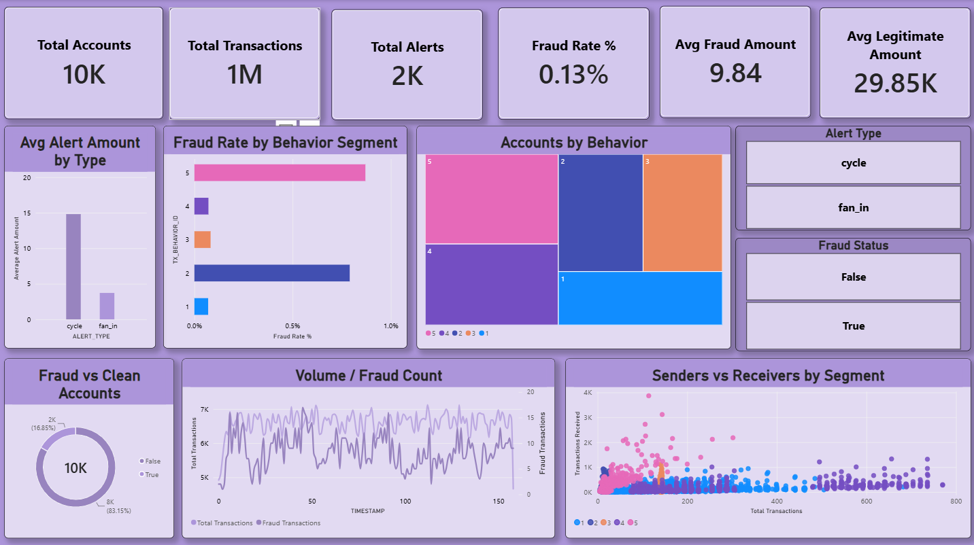
Figure 1. AML Transaction Watchtower — live dashboard screenshot.

