SMART VISITOR COUNTER
A Course Product Report
Submitted in the partial fulfillment of the completion of the course
CLOUD COMPUTING
In II Year – CSE
Submitted by
B. Arun Reddy (2503a51155)
A. Harshitha (2503a51156)
B. Preethi (2503a51159)
P. Trishul (2503a51164)
Arshiya Taranum (2503a51175)
Under the supervision of the faculty
<Faculty Name>
Designation, Department of CSE
Academic Year 2026–2027
Department of Computer Science and Engineering
SR University
Warangal, Telangana, India

CONTENTS
Abstract
1. Introduction
2. Problem Statement
3. Objectives
4. Product Overview
5. Technologies and AWS Services Used
6. System Architecture
7. Implementation Details
8. Product Features and Functionalities
9. Working Demonstration and Screenshots
10. Testing and Results
11. AWS Service Utilization
12. Challenges Faced and Solutions
13. Conclusion
14. Future Enhancements
16. Individual Contribution
18. References
19. Appendix

Abstract
The Smart Visitor Counter is a cloud-connected software prototype that monitors the number of people entering and leaving a location. An ESP32 board is represented in the Wokwi simulator and connected to two push buttons: one for entry and one for exit. When a button is pressed, the simulated device sends an HTTPS POST request to an AWS Lambda Function URL. The Lambda function processes the event, updates the current visitor count in Amazon DynamoDB, and stores an event record. A browser-based dashboard retrieves the latest count and daily hourly activity and presents the information in a clear visual format. The prototype was tested for Wi-Fi connectivity, entry, exit, zero-count protection, database storage and dashboard refresh. All six planned test cases passed in the observed simulation and cloud tests.

1. Introduction
Counting visitors is useful in places such as libraries, laboratories, offices, shops and event venues. Manual counting can be difficult to maintain continuously, especially when several people enter and leave over time. The Smart Visitor Counter demonstrates how a connected device and cloud services can automate the recording of entry and exit events and make the current occupancy visible through a web interface.
This project uses Wokwi for ESP32 simulation, AWS Lambda for request processing, DynamoDB for persistent storage, CloudWatch for execution logs, and an HTML, CSS and JavaScript dashboard for visualization.

2. Problem Statement
Manual visitor counting may result in missed entries or exits, inaccurate occupancy totals and a lack of easily accessible historical records. A simple system is required to record each entry and exit event, calculate the current number of visitors, retain event history and present updated information to a user.
The proposed prototype addresses this problem by connecting simulated entry and exit controls to a cloud backend and a live dashboard. The system also includes a boundary condition so that an exit event cannot reduce the visitor count below zero.

3. Objectives
- To simulate visitor entry and exit using an ESP32 and two push buttons in Wokwi.
- To connect the simulated device to Wi-Fi and send event data through HTTPS.
- To process entry and exit requests using AWS Lambda.
- To maintain the current visitor count in Amazon DynamoDB.
- To store individual visitor events with identifiers, action values and timestamps.
- To prevent the visitor count from becoming negative.
- To display current occupancy and hourly visitor activity on a web dashboard.
- To test and validate the end-to-end software prototype.

4. Product Overview
The Smart Visitor Counter is a visitor monitoring prototype. The entry button represents a person entering the monitored area, while the exit button represents a person leaving. The ESP32 simulation sends the selected action and device ID to the cloud backend. The backend updates the count and stores the event. The dashboard reads the latest information and displays it to the user.

4.1 Working Concept
- An entry or exit button is pressed in the Wokwi simulation.
- The ESP32 prepares a JSON request containing the device ID and action.
- The request is sent to the Lambda Function URL using HTTPS.
- The Lambda function validates the action and updates the visitor count.
- The event is stored in DynamoDB and dashboard APIs provide the latest data.

4.2 Application Area and Target Users
The concept can be applied to libraries, classrooms, laboratories, offices, shops, small venues and other locations where a basic occupancy count is useful. The intended users are staff or administrators who need a quick view of current occupancy and visitor activity.

4.3 Expected Outcome
The expected outcome is a working software demonstration in which entry and exit actions update a persistent count and the browser dashboard reflects the latest visitor information. Physical sensor deployment is considered future work.

5. Technologies and AWS Services Used
S. No. | Component / AWS Service | Purpose
1 | ESP32 (simulated in Wokwi) | Represents the visitor counter device and reads entry/exit button presses.
2 | Wokwi | Simulates the ESP32 circuit and provides a virtual environment for testing.
3 | Arduino C++ | Implements button handling, Wi-Fi connection and HTTP request logic.
4 | WiFi.h | Connects the ESP32 simulation to the Wokwi guest Wi-Fi.
5 | HTTPClient.h / WiFiClientSecure.h | Sends HTTPS POST requests from the ESP32 simulation.
6 | AWS Lambda – visitor-http-ingest | Processes entry and exit events and updates the visitor count.
7 | AWS Lambda – visitor-hourly-activity | Provides hourly daily-entry activity for the dashboard.
8 | AWS Lambda – dashboard read function | Provides current visitor information to the dashboard.
9 | Amazon DynamoDB – VisitorCounter | Stores the current visitor count by device ID.
10 | Amazon DynamoDB – VisitorEvents | Stores event history with event ID, action, increment and timestamp.
11 | Amazon CloudWatch | Displays Lambda execution lifecycle logs and runtime information.
12 | HTML, CSS and JavaScript | Builds the Visitor Insights / Visitor Command Center dashboard.

Note: AWS IoT Core and Amazon S3 are not listed as implemented services because they were not part of the tested prototype workflow described in the project evidence.

6. System Architecture
The system uses an event-driven architecture. The Wokwi ESP32 simulation is the event source. The event is sent to an AWS Lambda Function URL, where it is processed and persisted in DynamoDB. The dashboard uses read endpoints to retrieve current occupancy and hourly activity.
Architecture layer | Component | Description
Device layer | ESP32 in Wokwi | Entry button on GPIO 22 and exit button on GPIO 18.
Communication layer | Wi-Fi and HTTPS | Transfers JSON event requests to the backend.
Processing layer | AWS Lambda | Validates entry/exit actions and performs database updates.
Storage layer | DynamoDB | Maintains current count and a separate event history.
Monitoring layer | CloudWatch | Shows function invocation lifecycle and execution metrics.
Presentation layer | Web dashboard | Shows current visitors, online status, last update, daily visitors and hourly activity.

6.1 Communication Between Device and Cloud
The ESP32 connects to the Wokwi-GUEST Wi-Fi network. It uses an HTTPS client to send a POST request to the visitor-http-ingest Lambda Function URL. The JSON body includes deviceId and action. The backend returns an HTTP status and a JSON response.

6.2 Data Flow and Processing
- Button press is detected by the ESP32 simulation.
- The device sends a POST request with deviceId and action.
- Lambda checks whether the action is entry or exit.
- For entry, the visitor count is incremented by one.
- For exit, the count is decremented only if it is at least one.
- The updated count is stored in VisitorCounter and an event record is stored in VisitorEvents.
- The dashboard retrieves and displays current count and hourly entry activity.

7. Implementation Details

7.1 ESP32 and Wokwi Simulation
The circuit contains an ESP32 and two push buttons. The entry button is connected to GPIO 22 and the exit button to GPIO 18. The buttons are configured with INPUT_PULLUP and connected so that a press is detected as a LOW state. The code connects to Wokwi-GUEST Wi-Fi and sends an HTTPS request when an entry or exit action is detected.

7.2 AWS Cloud Configuration
Three Lambda responsibilities were used in the prototype: event ingestion, current dashboard data retrieval and daily hourly-activity retrieval. The visitor-http-ingest function accepts POST requests. Function URLs are used as the HTTP endpoints. DynamoDB permissions are assigned to the Lambda execution role so the function can update VisitorCounter and write to VisitorEvents. CloudWatch captures execution lifecycle logs.
The zero-count test was run using a separate test device ID so that the main visitor-counter-01 record was not reset. The test returned HTTP 200 with the message 'No visitors available to exit' and visitorCount 0.

7.3 Application Development
The backend receives JSON requests, processes the action and updates DynamoDB. The dashboard is developed using HTML, CSS and JavaScript. It retrieves current visitor data and hourly activity from the corresponding Lambda Function URLs. It displays Current Visitors, Counter Status, Last Update, Today's Visitors, a Visitor Activity chart and Recent Updates.

7.4 Database and Storage Configuration
DynamoDB table | Key structure | Stored data
VisitorCounter | Partition key: deviceId (String) | Current visitor count for each device.
VisitorEvents | Partition key: deviceId (String); sort key: eventId (String) | Individual entry/exit events, action, increment value and timestamp.

7.5 Product Deployment
The ESP32 firmware was run in the Wokwi browser-based simulator. The backend functions were deployed in AWS Lambda and exposed through Function URLs. DynamoDB tables were configured for count and event storage. The dashboard was opened in a browser and configured with the read API endpoints. The final prototype was validated by generating events in Wokwi and checking the resulting dashboard updates.
Deployment status: the software prototype was demonstrated successfully in the simulation and cloud environment. Physical hardware deployment was not performed.

8. Product Features and Functionalities
Feature | How it works
Visitor entry | Pressing the entry button sends an entry event; the current count increases by one.
Visitor exit | Pressing the exit button sends an exit event; the current count decreases by one when the count is above zero.
Zero-count protection | An exit at zero returns 'No visitors available to exit' and preserves zero.
Current occupancy | The dashboard retrieves and displays the current visitor count.
Daily visitor total | The dashboard shows the number of entry events recorded for the current day.
Hourly visitor activity | The daily activity function groups entry events by hour in Asia/Kolkata time.
Event history | DynamoDB stores event records for later inspection.
Status and last update | The dashboard displays counter status and the latest update time.

9. Working Demonstration and Screenshots
The following evidence items document the observed working prototype. Inserted screenshots are from the testing session.
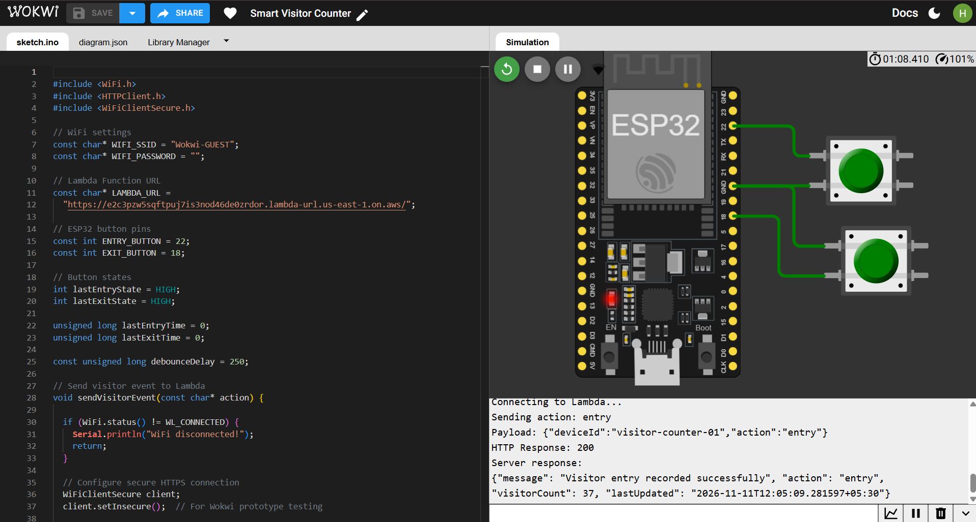
Figure 1. Wokwi ESP32 simulation showing a successful visitor entry request and HTTP 200 response.
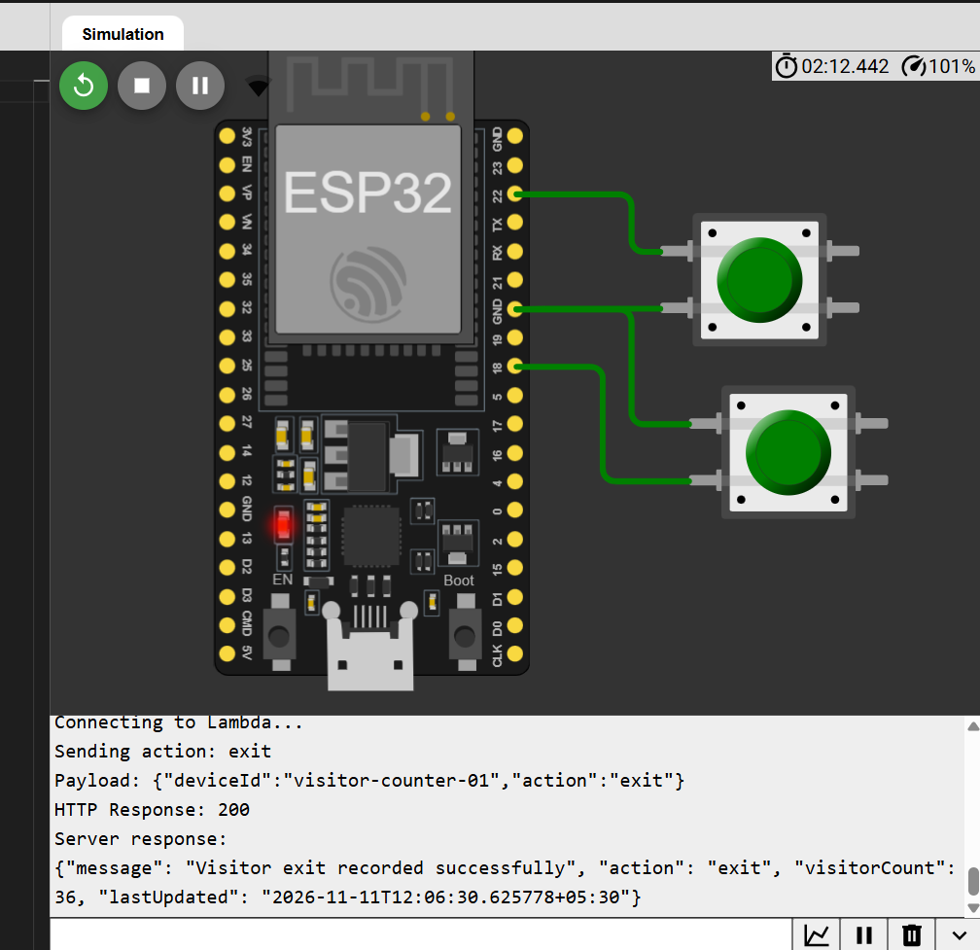
Figure 2. Wokwi Serial Monitor showing a successful visitor exit request and the visitor count changing from 37 to 36.
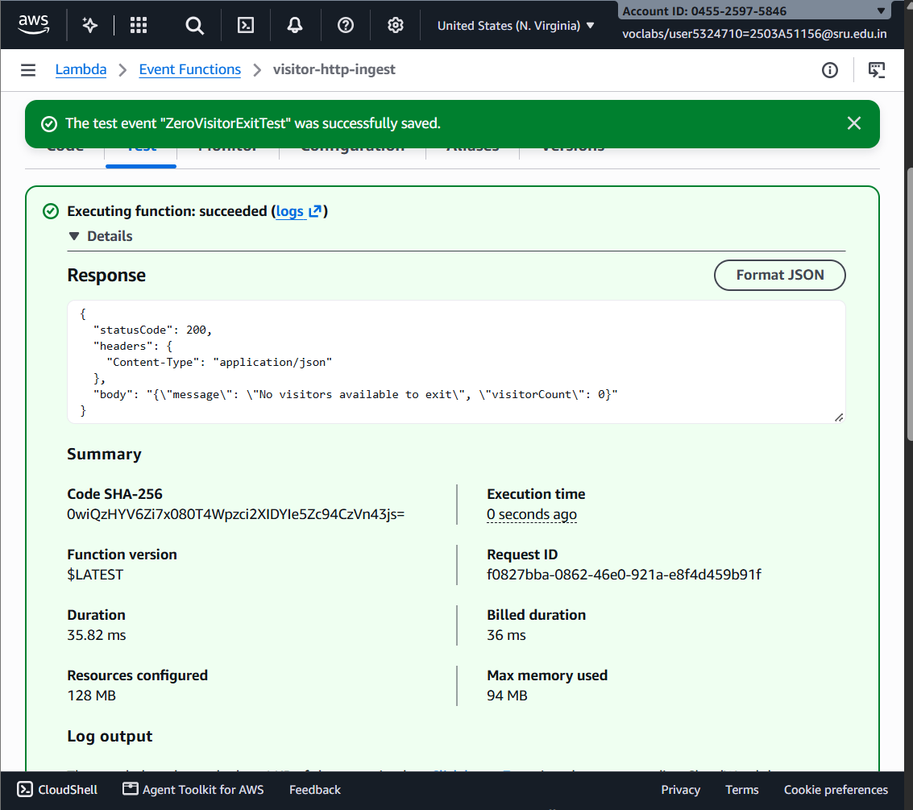
Figure 3. Lambda zero-visitor exit test showing HTTP 200, 'No visitors available to exit' and visitorCount 0.
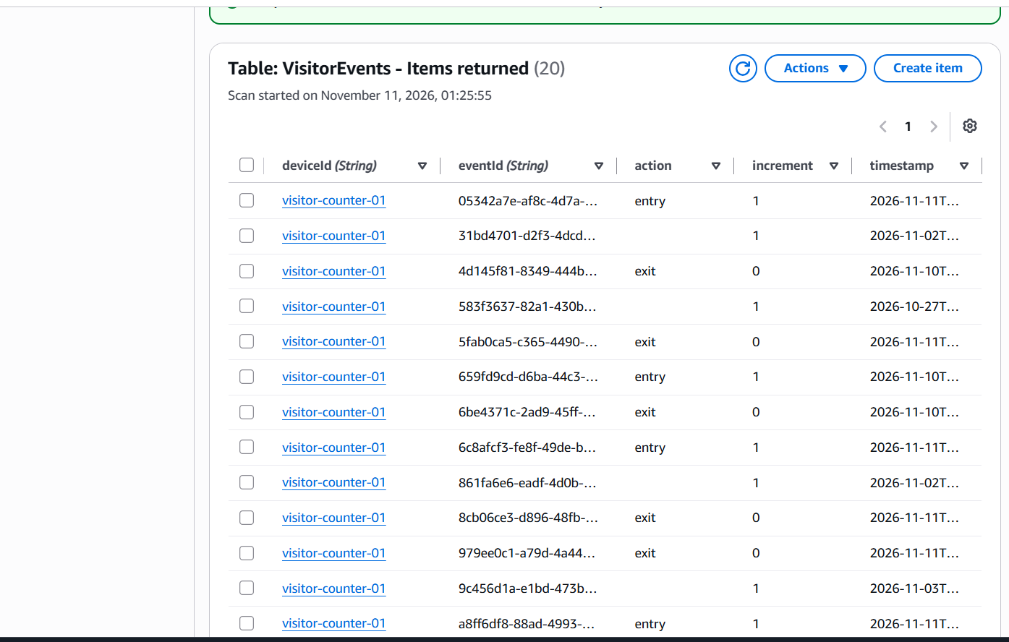
Figure 4. DynamoDB VisitorEvents table showing 20 returned event records.
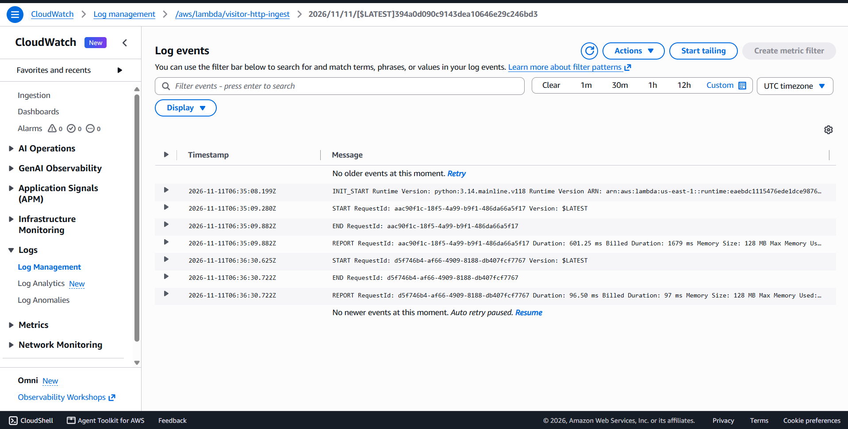
Figure 5. CloudWatch log stream showing Lambda START, END and REPORT lifecycle events.
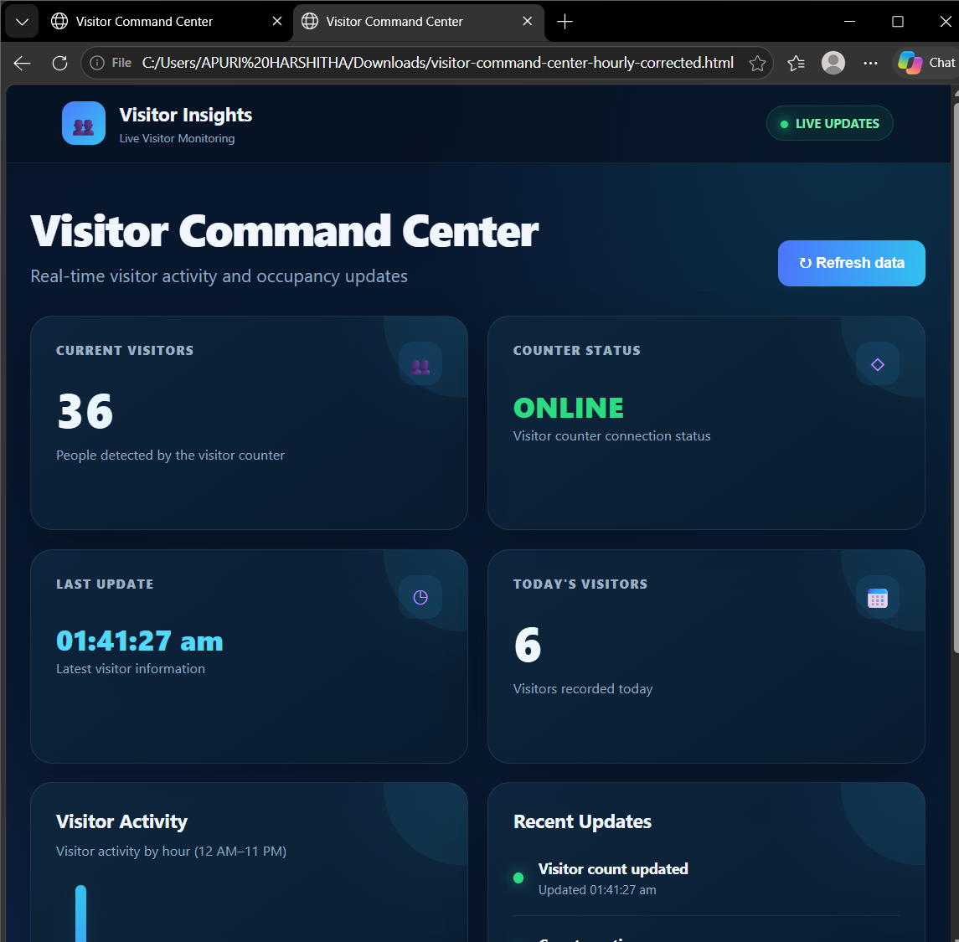
Figure 6. Dashboard validation screenshot showing 36 current visitors and 6 today's visitors.

10. Testing and Results
The following test cases were executed during validation. The actual results are based on the captured Wokwi, Lambda, DynamoDB and dashboard observations.
Test Case | Input / Action | Expected Output | Actual Output | Status
TC01 – Wi-Fi | Start Wokwi simulation | ESP32 connects to Wi-Fi | Simulation connected and proceeded to backend communication | PASS
TC02 – Entry | Press Entry once | Count increases by 1 | Entry request returned HTTP 200 and count increased | PASS
TC03 – Exit | Press Exit once | Count decreases by 1 | Exit returned HTTP 200; captured count changed 37 to 36 | PASS
TC04 – Exit at zero | Send exit for separate zero-count test device | Count stays at 0; no negative value | HTTP 200; 'No visitors available to exit'; visitorCount 0 | PASS
TC05 – Database | Inspect VisitorEvents | Event records are stored | 20 records were visible in the table view | PASS
TC06 – Dashboard | Generate a new entry event | Dashboard refreshes to latest values | Current Visitors 35 to 36; Today's Visitors 5 to 6 | PASS

Overall result: 6 out of 6 planned test cases passed in the observed software-prototype tests.

10.1 Interpretation of Dashboard Metrics
Current Visitors represents current occupancy. Today's Visitors represents the number of entry events recorded during the current day. Exit events reduce current occupancy but do not subtract from the daily entry total.

11. AWS Service Utilization
AWS service | Role in this product | Evidence / use
AWS Lambda | Runs event ingestion and dashboard data retrieval logic. | HTTP 200 entry/exit responses and successful dashboard data retrieval.
AWS Lambda Function URLs | Expose the Lambda functions as HTTPS endpoints. | ESP32 POST requests and dashboard API requests.
Amazon DynamoDB | Persists current occupancy and event history. | VisitorCounter and VisitorEvents table inspection.
Amazon CloudWatch | Captures function invocation lifecycle logs and execution reports. | START, END and REPORT log events observed.

AWS IoT Core and Amazon S3 were not used in the demonstrated implementation. They may be considered in a future version if MQTT-based device messaging or image/file storage becomes necessary.

12. Challenges Faced and Solutions
Challenge | Solution implemented
HTTP 400 because the request did not include a valid action | Updated the JSON request to include deviceId and action with entry or exit.
HTTPS request failed from ESP32 simulation | Used WiFiClientSecure with HTTPClient and the Wokwi prototype's HTTPS configuration.
GET request to the ingestion endpoint returned HTTP 405 | Confirmed that the ingestion endpoint is POST-only and used POST for event submission.
Exit request could reduce count below zero | Added conditional exit handling; zero-count test returned a no-visitors message.
Dashboard needed current and daily analytics | Used separate read endpoints for current count and hourly daily-entry activity.
CloudWatch view showed lifecycle logs rather than response JSON | Used Wokwi Serial Monitor and Lambda test response as direct evidence of HTTP status and response body.

Production note: the prototype used setInsecure() for the Wokwi HTTPS test. A production device should validate server certificates and follow secure credential and access-management practices.

13. Conclusion
The Smart Visitor Counter project demonstrates an end-to-end visitor monitoring workflow using an ESP32 simulation, AWS Lambda, Amazon DynamoDB and a browser-based dashboard. The observed tests verified Wi-Fi connectivity, entry and exit processing, zero-count protection, event storage and live dashboard refresh. The project provided practical experience in microcontroller simulation, HTTP communication, serverless cloud processing, database integration, dashboard development and software testing. The demonstrated prototype meets its stated software objectives and can be extended to physical hardware in future work.

14. Future Enhancements
- Connect a physical ESP32 with suitable IR, break-beam or other visitor-detection sensors.
- Add offline event buffering and automatic synchronization after connectivity returns.
- Implement certificate validation, authentication and stronger device identity management.
- Add configurable occupancy limits and notifications when capacity is reached.
- Provide daily, weekly and monthly reports with comparison charts.
- Add device-health monitoring, retry handling and structured application-level logs.
- Evaluate MQTT and AWS IoT Core if the system is expanded to multiple deployed devices.

16. Individual Contribution
The following is the proposed distribution of responsibilities across the five-member team. It should be reviewed and confirmed by all team members so that the final submission accurately reflects the work each person performed.
Student Name | Roll Number | Contribution
A. Harshitha | 2503a51156 | Project lead and integration coordinator; coordinated the end-to-end prototype, validated ESP32-to-Lambda communication, oversaw backend/database and dashboard integration, coordinated system testing, and consolidated project documentation.
B. Arun Reddy | 2503a51155 | ESP32/Wokwi circuit setup support; entry and exit button wiring review; simulation checks and assistance with device-side testing.
B. Preethi | 2503a51159 | DynamoDB data design support; review of VisitorCounter and VisitorEvents records; verification of event fields and stored visitor history.
P. Trishul | 2503a51164 | AWS Lambda workflow support; review of entry/exit request processing; assistance with zero-count exit validation and backend execution checks.
Arshiya Taranum | 2503a51175 | Visitor dashboard presentation and usability review; review of current-count, daily-visitor and hourly-activity displays; support for screenshot collection and report presentation.

18. References
- AWS Documentation – AWS Lambda Developer Guide: https://docs.aws.amazon.com/lambda/
- AWS Documentation – Amazon DynamoDB Developer Guide: https://docs.aws.amazon.com/amazondynamodb/
- AWS Documentation – Amazon CloudWatch User Guide: https://docs.aws.amazon.com/AmazonCloudWatch/latest/monitoring/
- Wokwi Documentation: https://docs.wokwi.com/
- Arduino ESP32 documentation: https://docs.espressif.com/projects/arduino-esp32/
- MDN Web Docs – HTML, CSS and JavaScript: https://developer.mozilla.org/

19. Appendix
The appendix may contain the complete ESP32 source code, Lambda source code, DynamoDB key configuration, dashboard HTML/CSS/JavaScript files, Wokwi project share link, and deployed dashboard or API URLs. Add the actual project links and source files before final submission.
Submission details to be completed by the team: faculty supervisor name and designation, course code (if required), exact semester designation, and any additional SR University formatting requirements.

