EXPERIMENT-6
DCL Commands – GRANT, REVOKE

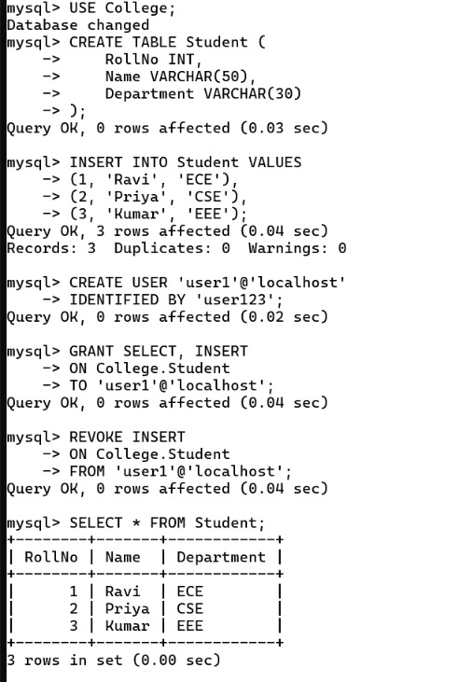
EXPERIMENT-7
SELECT with various clauses – WHERE, pattern matching
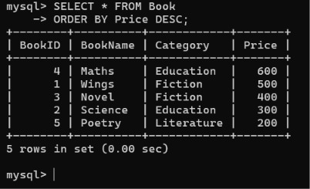
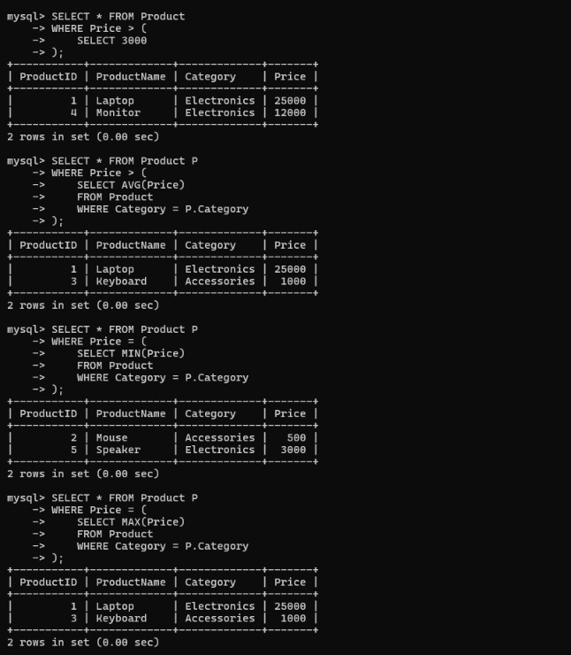
EXPERIMENT-8
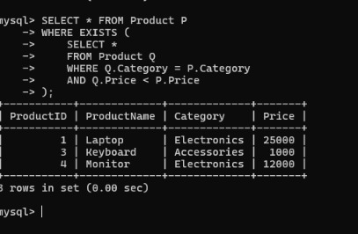
SELECT with various clauses – BETWEEN, IN, Aggregate Function
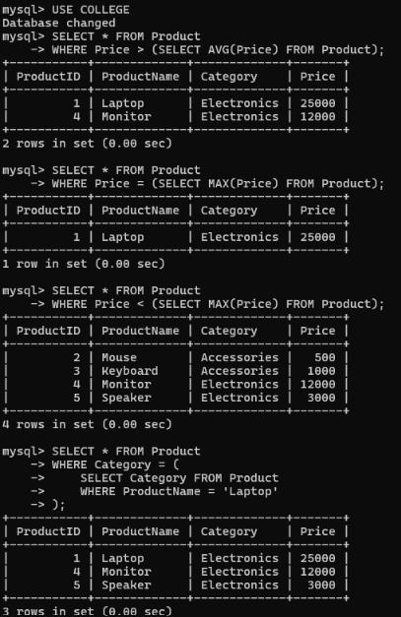
EXPERIMENT-9
SELECT with various clauses – GROUP BY, HAVING, ORDER BY
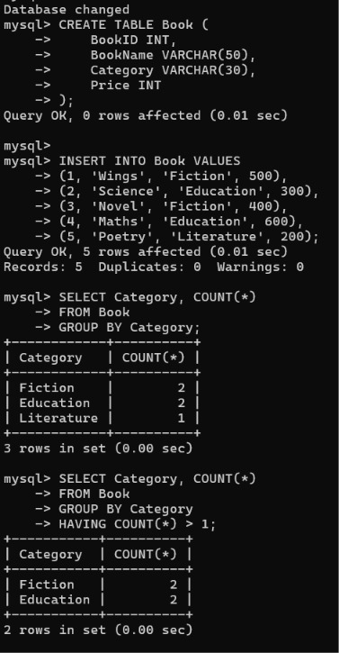

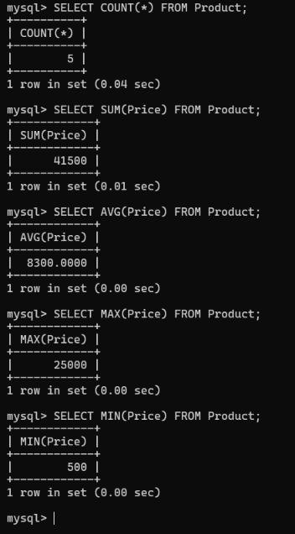
EXPERIMENT-10
Query with SubQuery& Correlated Query
