Exercise 3: Responsive Web Page and Git History Exploration
Your manager has asked you to make the webpage mobile-friendly and explore the Git history to track changes for auditing purposes.
1. Modify the existing HTML page to include:
o A responsive image.
In execise.html
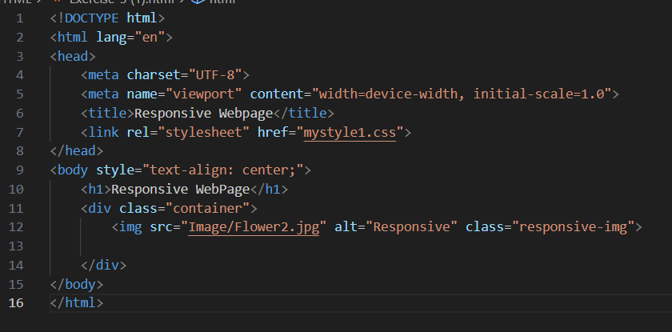
o A layout that adapts to screen size using CSS media queries.
In style.css
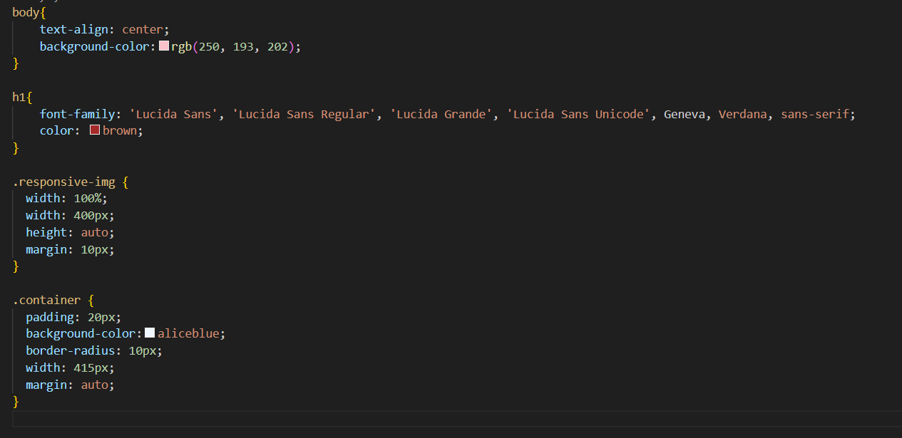
2. Add a CSS file (style.css) and link it to the HTML file.
<link rel="stylesheet" href="style.css">

3. Track changes using git add, commit, and use git status throughout.
git add Exercise_3.html mystyle1.css
git commit -m “Added Files”

git status
4. Use git log, git diff, git checkout, and git reset to demonstrate version control and history exploration.
git reset


