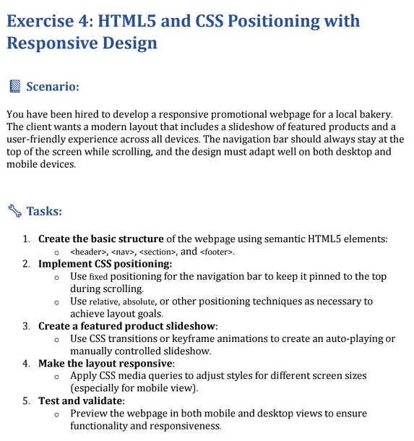
<!DOCTYPE html>
<html>
<head>
<title>SH Bakery</title>
<style>
body {
margin: 0;
font-family: Arial, sans-serif;
background: #fff8f0;
}
nav {
position: fixed;
top: 0;
left: 0;
width: 100%;
background: brown;
color: white;
padding: 15px 0;
}
nav ul {
display: flex;
justify-content: center;
gap: 25px;
margin: 0;
padding: 0;
}
nav a {
text-decoration: none;
color: white;
font-weight: bold;
}
#slideshow {
margin-top: 60px;
height: 200px;
background: #ffe5b4;
display: flex;
overflow: hidden;
}
.slides {
display: flex;
width: 300%;
animation: move 9s infinite;
}
.slide {
flex: 1 0 100%;
text-align: center;
font-size: 24px;
line-height: 200px;
}
@keyframes move {
0% { transform: translateX(0); }
33% { transform: translateX(-100%); }
66% { transform: translateX(-200%); }
100% { transform: translateX(0); }
}
nav a:hover {
color: #ffe6cc;
}
header {
margin-top: 60px;
background: url("https://wallpaperaccess.com/full/1076692.jpg") no-repeat center/cover;
height: 300px;
display: flex;
align-items: center;
justify-content: center;
color: white;
font-size: 36px;
font-weight: bold;
}

section {
padding: 40px;
text-align: center;
}
header{
color: rgb(242, 233, 233);
text-align: center;
}
.products {
display: flex;
justify-content: center;
gap: 20px;
margin-top: 20px;
}
.products img {
width: 220px;
height: 160px;
border-radius: 10px;

}
.products img:hover {
transform: scale(1.08);
}
footer {
background: brown;
color: white;
text-align: center;
padding: 12px;
margin-top: 20px;
}
</style>
</head>
<body>
<nav>
<ul>
<li><a href="#home">Home</a></li>
<li><a href="#products">Products</a></li>
<li><a href="#contact">Contact</a></li>
</ul>
</nav>
<header id="home">
Welcome to SH Bakery
</header>
<div id="slideshow">
<div class="slides">
<div class="slide"> Cake Special</div>
<div class="slide">Fresh Croissants</div>
<div class="slide"> Donuts & Coffee</div>
</div>
</div>
<section id="products">
<h2>Our Products</h2>
<p>Freshly baked with love </p>
<div class="products">
<img src="c:\Users\HARSHITHA\Desktop\FE\html\images\chocolate-cake.jpg" alt="Cake">
<img src="c:\Users\HARSHITHA\Desktop\FE\html\images\Croissants.jpg" alt="Croissant">
<img src="c:\Users\HARSHITHA\Desktop\FE\html\images\doughnuts.jpg" alt="Donut">
<img src="c:\Users\HARSHITHA\Desktop\FE\html\images\White-bread.jpg" alt="Bread">
</div>
</section>
<footer>
<p>©SH Bakery | Fresh Taste Everyday</p>
<p> contact:9182649669</p>
</footer>
</body>
</html>

OUTPUT
