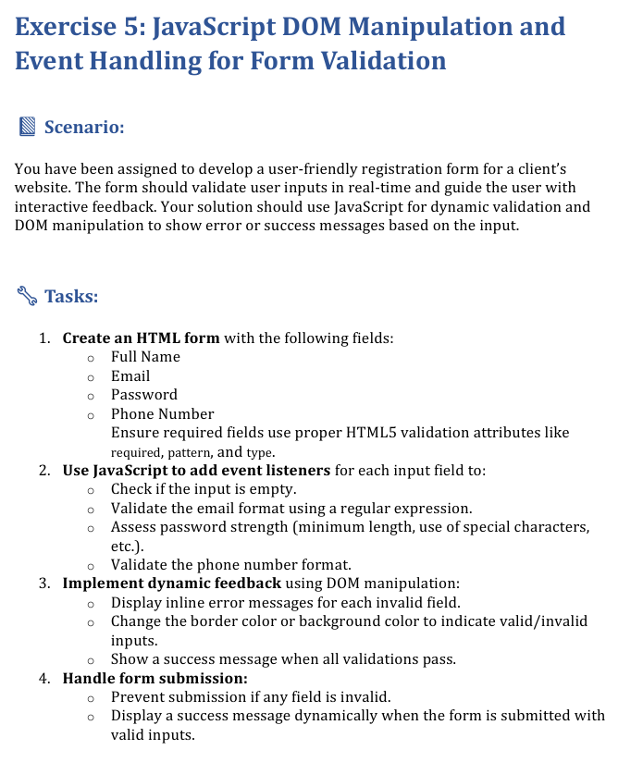
<!DOCTYPE html>
<html>
<head>
<title>Student Registration Form with concept Event Handling</title>
<style>
.error{
color: red;
font-weight: bold;
}
.success{
color: rgb(23, 219, 79);
font-weight: bold;
}
.invalid{
border:2px solid red;
}
.valid{
border:2px solid green;
}
.container{
background-color: rgb(229, 183, 243);
width:50%;
margin-left:25%;
padding:2px;
}
</style>
</head>
<body style="text-align: center; background-color:azure">
<h2 style="color: brown; font-family: 'Segoe UI', Tahoma, Geneva, Verdana, sans-serif;">STUDENT REGISTRATION FORM - EVENT HANDLING</h2><br>
<div class="container">
<form id="regForm">
<label class="fn" for="name">Full Name:</label>
<input type="text" id="name" name="FullName" placeholder="Full Name"><br><br><br>
<label class="e" for="email">Email-Id:</label>
<input type="email" id="email" name="email" placeholder="Enter your college email id"><br><br><br>
<label class="p" for="password">Password:</label>
<input type="password" id="password" name="password" placeholder="Enter your password" pattern="[A-Za-z]{3,8}"><br><br><br>
<label>Phone Number:</label>
<input type="number" id="phoneno" name="Phone" placeholder="Enter your phone number"><br><br>
<input type="submit" id="submit" value="Submit">
</form>
</div>
<p id="message"></p>
<script>
const form=document.getElementById("regForm");
const msg=document.getElementById("message");
const nameInput=document.getElementById("name");
const emailInput=document.getElementById("email");
const passwordInput=document.getElementById("password");
const phoneInput=document.getElementById("phoneno")
function validateField(field,condition,message){
if(condition){
field.classList.remove("invalid");
field.classList.add("valid");
}
else{
field.classList.remove("valid");
field.classList.add("invalid");
}
}
nameInput.addEventListener("input",function(){
validateField(nameInput,nameInput.value.trim().length>=3,"Name must be at least 3 characters");
});
emailInput.addEventListener("input",function(){
validateField(emailInput, emailInput.value("@") && emailInput.value.trim() !== "","email should be required");
});
passwordInput.addEventListener("input",function(){
validateField(passwordInput,passwordInput.value.trim()!="","Password should consist of minimum 8 characters");
});
phoneInput.addEventListener("input",function(){
validateField(phoneInput,phoneInput.value.trim().length==10,"Phone number must be of 10 characters");
});
form.addEventListener("submit",function(event){
event.preventDefault();
const name=nameInput.value.trim();
const email=emailInput.value.trim();
const password=passwordInput.value.trim();
const phone=phoneInput.value.trim();
if (name.length < 3 ) {
msg.innerHTML = "Name must be at least 3 characters";
msg.className = "error";
return false;
}
if (email === "") {
msg.innerHTML = "Email is required!";
msg.className = "error";
return false;
}
if (!password) {
msg.innerHTML = "Password must be at least 8 characters";
msg.className = "error";
return false;
}
if (phone.length == 10) {
msg.innerHTML = "Phone number must be of 10 characters";
msg.className = "error";
return false;
}
msg.innerHTML = "Details submitted successfully";
msg.className = "success";
return true;
form.reset();
form.querySelectorAll('input,textarea,select').forEach(el=>{
el.classList.remove("valid");
el.classList.remove("invalid")
});
return true;
});
</script>
</body>
</html>

OUTPUT
