# Week – 2

# PLSQL Exercises

# Exercise 1: Control Structures - PLSQL_Exercises

Scenario:You want to input an employee name and simulate a control structure in PL/SQL to print a greeting.

Code:

VARIABLE emp_name VARCHAR2(50)

VARIABLE years NUMBER

BEGIN

    :emp_name := 'Ramesh';

    :years := 8;

END;

/

DECLARE

    bonus NUMBER;

BEGIN

    IF :years < 2 THEN

        bonus := 0;

    ELSIF :years BETWEEN 2 AND 5 THEN

        bonus := 5000;

    ELSIF :years BETWEEN 6 AND 10 THEN

        bonus := 10000;

    ELSE

        bonus := 20000;

    END IF;

    DBMS_OUTPUT.PUT_LINE('--- Bonus Details ---');

    DBMS_OUTPUT.PUT_LINE('Employee Name: ' || :emp_name);

    DBMS_OUTPUT.PUT_LINE('Years of Experience: ' || :years);

    DBMS_OUTPUT.PUT_LINE('Bonus Amount: ₹' || bonus);

END;

/

OUTPUT:

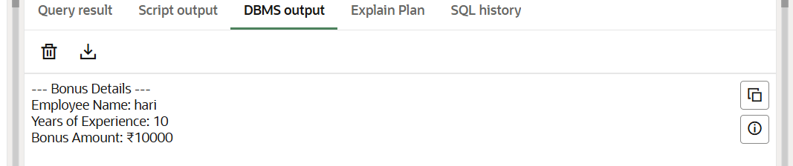

# Exercise 3: Stored Procedures

Scenario:  
You want to create a procedure that displays the salary of an employee given their ID.

Code:

SET SERVEROUTPUT ON;

BEGIN

  EXECUTE IMMEDIATE 'DROP TABLE employees CASCADE CONSTRAINTS';

EXCEPTION

  WHEN OTHERS THEN

    NULL;

END;

/

CREATE TABLE employees (

  emp_id NUMBER PRIMARY KEY,

  emp_name VARCHAR2(50),

  salary NUMBER

);

/

BEGIN

  INSERT INTO employees VALUES (101, 'Amit', 50000);

  INSERT INTO employees VALUES (102, 'Nithya', 60000);

  INSERT INTO employees VALUES (103, 'Rahul', 70000);

  COMMIT;

END;

CREATE OR REPLACE PROCEDURE update_salary (

  p_emp_id IN NUMBER,

  p_percentage IN NUMBER

) AS

BEGIN

  UPDATE employees

  SET salary = salary + (salary * p_percentage / 100)

  WHERE emp_id = p_emp_id;

  IF SQL%ROWCOUNT = 0 THEN

    DBMS_OUTPUT.PUT_LINE('❌ Employee ID ' || p_emp_id || ' not found.');

  ELSE

    DBMS_OUTPUT.PUT_LINE('✅ Salary updated for Employee ID: ' || p_emp_id);

  END IF;

EXCEPTION

  WHEN OTHERS THEN

    DBMS_OUTPUT.PUT_LINE('Error: ' || SQLERRM);

END;

/

BEGIN

  update_salary(102, 10); -- Increase Nithya’s salary by 10%

END;

/

SELECT * FROM employees;

Output:

