1.Cover Page:

Projecy Title :CareerHub –MERN Stack Job Portal

Name:Harshitha Valluru

Course:Full Stack Development

Submission Date:3-08-2026

-----------------------------------------Table-of-contents--------------------------------------

1.Introduction

2. Techincal Stack

3.Project Structure

4.Features And Functionalities

5.Screenshots And Visuals

6.Database Structure

7.Challenges Faced

8.Conclusion

9.Github Repository

1.Introduction:

CareerHub is a MERN stack job portal web apppliactions allows user to apply for the jobs and can view the jobs and apply for it and can get the respective emails.Admin can manage the jobs and users and can see the emails send by user.

2.Technologies:

* Frontend:

-React.js with Tailwind CSS and Ant Design,Axios

* Backend:

-Node.js,Express.js,MongoDB,multer ,nodemailer

* Authentication:

-JWT-based system with tokens and cookies

* Tools:

-Insomania,Git,GitHub,VS Code,GoggleChrome

-

3.Project Structure:

/CareerHub   
├── /frontend # React frontend (Vite-based)  
│ ├── /src  
│ │ ├── /components # Reusable UI components  
│ │ ├── /pages # All route pages (Home, Login, Product, etc.)  
│ │ ├── /services # Axios API services  
│ │ ├── App.jsx  
│ │ └── main.jsx  
│ └── index.html  
├── /backend # Node.js + Express server  
│ ├── /controllers  
│ ├── /models # Mongoose models: Product, User, Order, Category  
│ ├── /routes # Express routes  
│ ├── /middleware # Auth middleware  
│ ├── uploads/ # Folder for storing uploaded images  
│ └── server.js # Entry point  
├── package.json # Root-level dependencies  
└── README.md # Project documentation

These folders having there respective files .

Components folder includes:

* AdminPanel
* AdminProtectedRoute
* AuthContext
* JobCard
* Navbar
* ProtectedRoute

Pages Folder includes:

* Admin folder :AdminContact,AdminJobs,AdminUsers
* Contact
* Hone
* JobDetail
* Login
* My_forms
* MyAplication
* PostJob
* Register

Services Folder includes:

* AdminServices
* ApplicatonServices
* AuthServices
* ContactServices
* JobServices

Utils folder has:

* GetUSerDeatil

---------------------------------------------------------------------------------------------------------------------

For Backend:

Config includes:

* Db config

Controller Folder includes:

* AppliactionController
* ContactController
* JobController
* UserController

MiddleWare Includes:

* authMiddleware
* chechId
* UploadMiddleware

Models Includes:

* ApplicationModel
* ContactModel
* JobModel
* UserModel

Routes Includes:

* ApplicationRoutes
* ContactRoutes
* JobRoutes
* USerRoutes

Utils Includes:

* CreateToken
* SendEMail

4.Features and Functionalities:

* User Features:

-Login/Register/Logout

-Email Verification

-Searching Jobs

-Apply Jobs

-View Jobs

-Profile

* Admin Features:

-Login/Register/Logout

-Dashboard Access

-Searching Jobs

-Manage Users

-Mange Jobs

-Can see emails send by users

-Profile

* User Side(Job-seekers):

- View All Job lists

- View Individual Job details

- Apply jobs(localStorage-based Appliacation tracking)

- View applied jobs(My Applications)

* General :

-Respossive UI

-Toast Notifications

-Dynamic routes with react router

-Scrollable sections(Home,Jobs,About,Contact) with smooth Scroll

-Contact form(submits to backend)

5.Screenshots::

### Home Page

[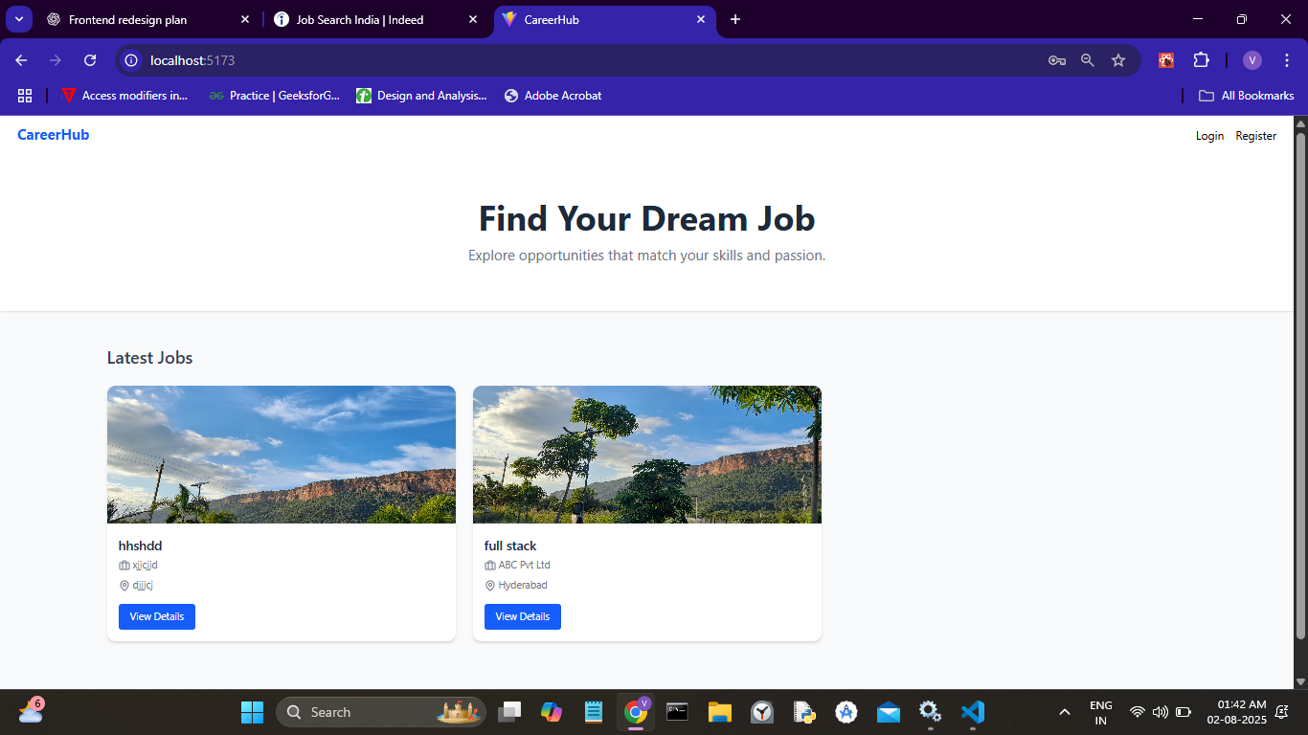](https://github.com/harshitha937/CareerHub/blob/main/Screenshots/Home.png)

Login page [[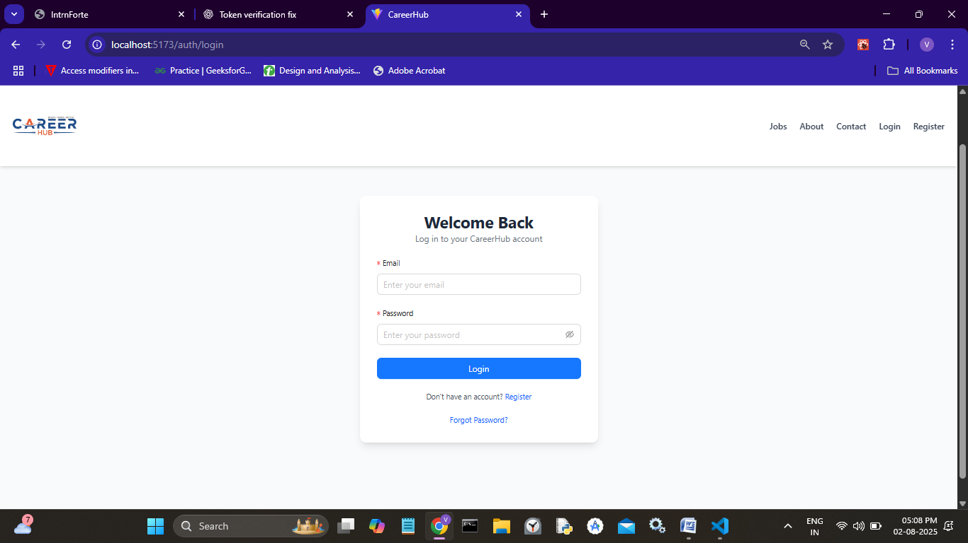](https://github.com/harshitha937/CareerHub/blob/main/Screenshots/Login.png)](https://github.com/harshitha937/CareerHub/blob/main/Screenshots/Login.png)

### Register page

[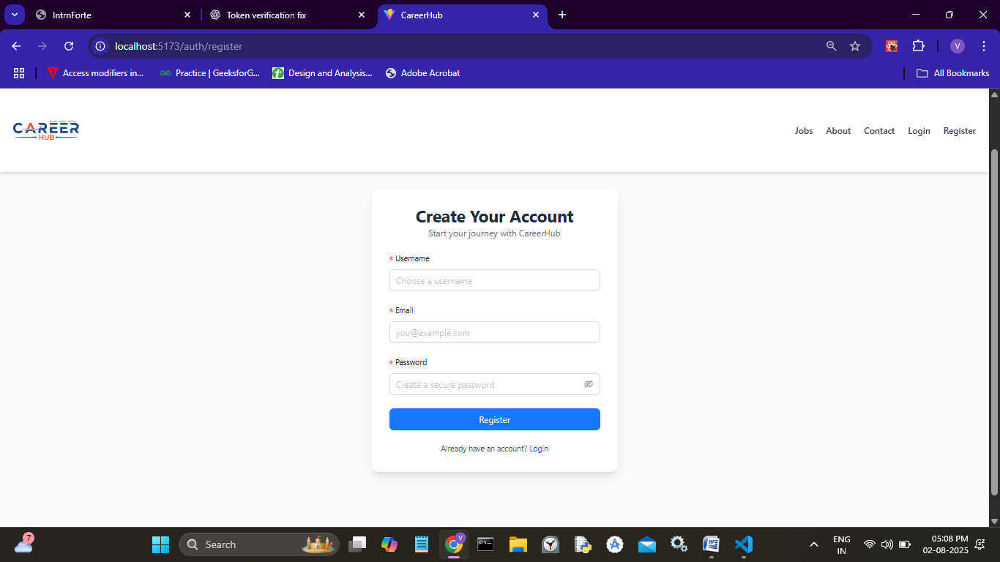](https://github.com/harshitha937/CareerHub/blob/main/Screenshots/Register.png)

### User Homepage

[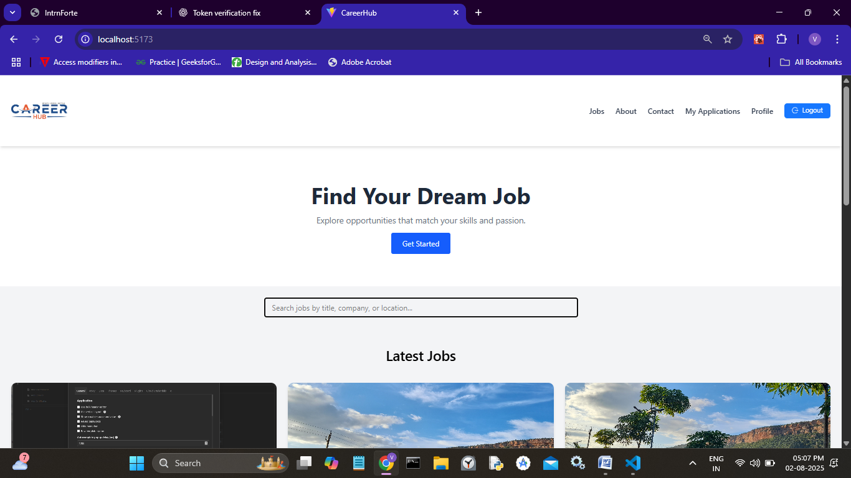](https://github.com/harshitha937/CareerHub/blob/main/Screenshots/Userlogin.png)

### Job

[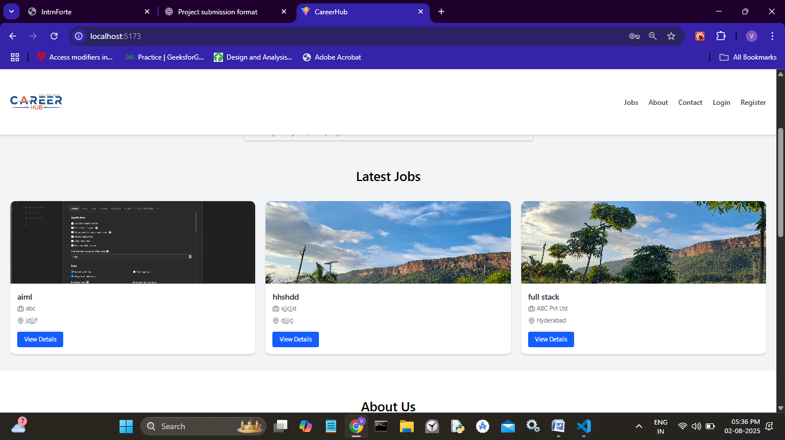](https://github.com/harshitha937/CareerHub/blob/main/Screenshots/Jobs.png)

### About

[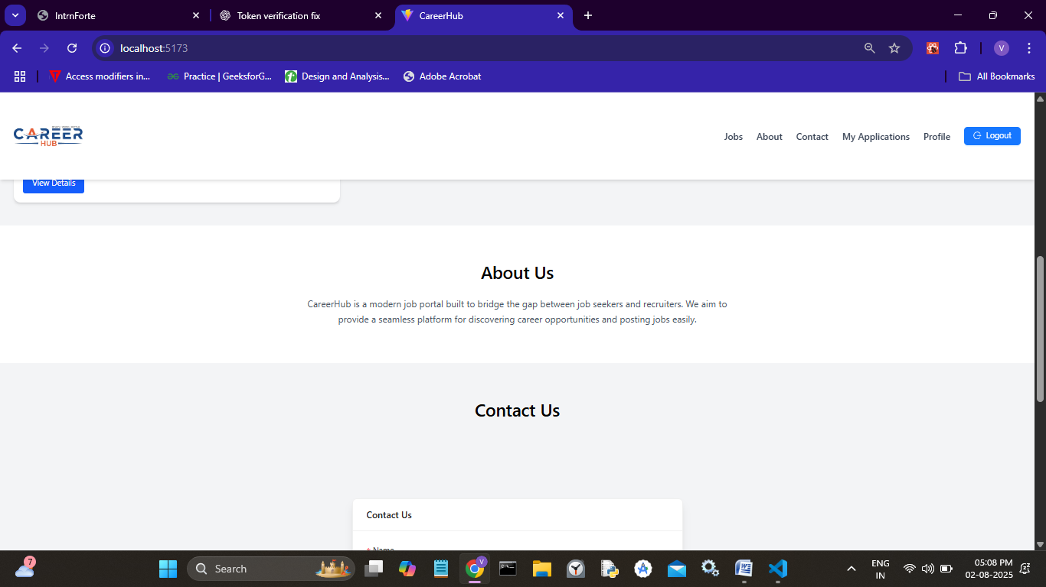](https://github.com/harshitha937/CareerHub/blob/main/Screenshots/Aboutus.png)

### Contact

[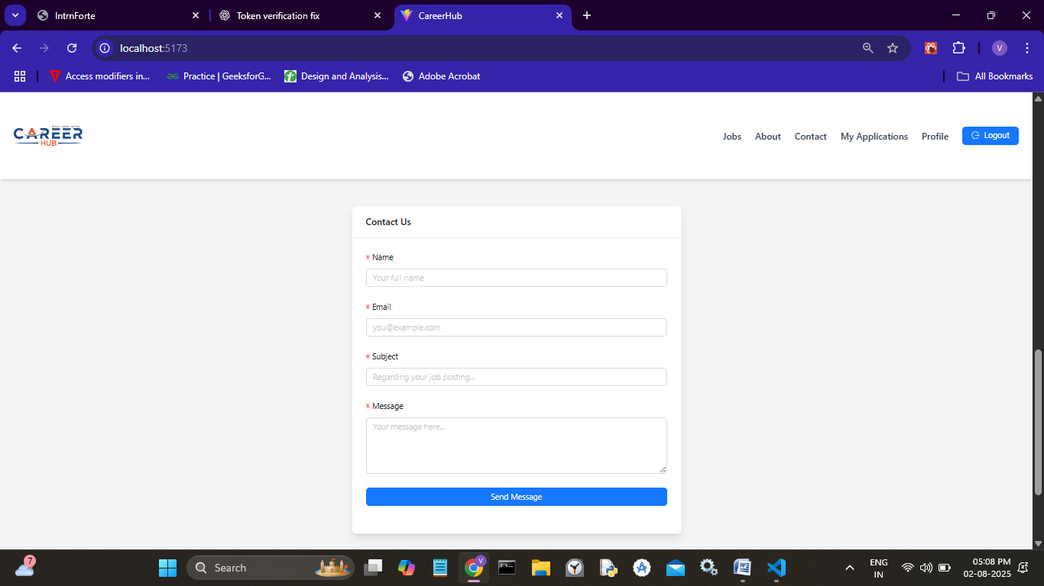](https://github.com/harshitha937/CareerHub/blob/main/Screenshots/Contact.png)

### Footer

[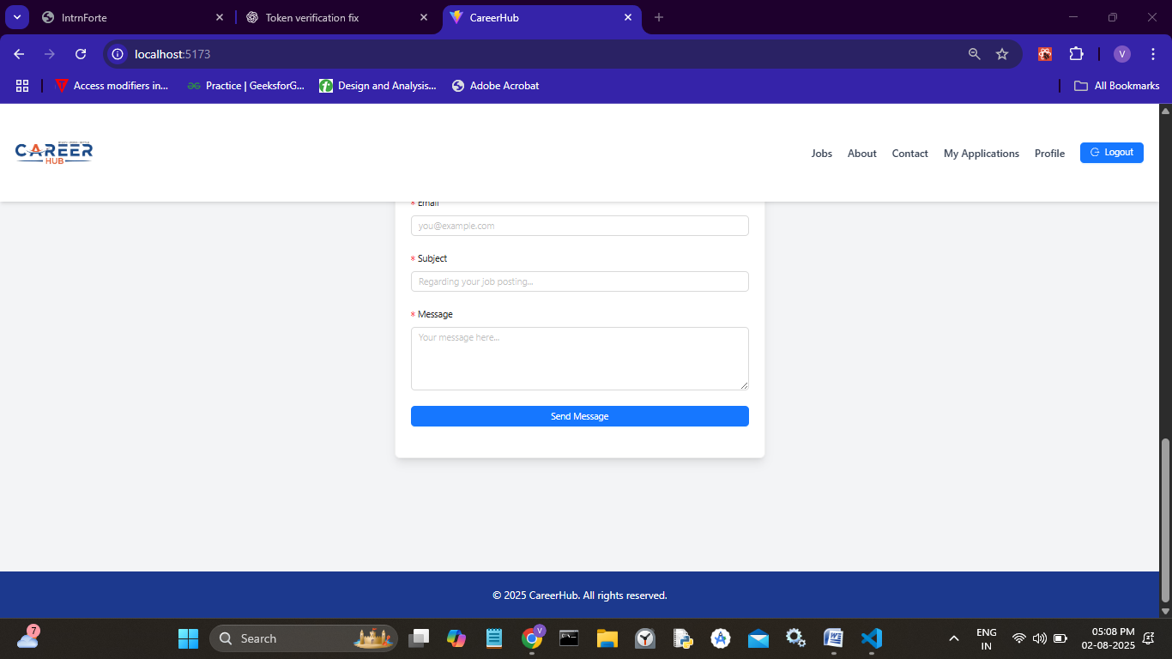](https://github.com/harshitha937/CareerHub/blob/main/Screenshots/Footer.png)

### JobDetails

[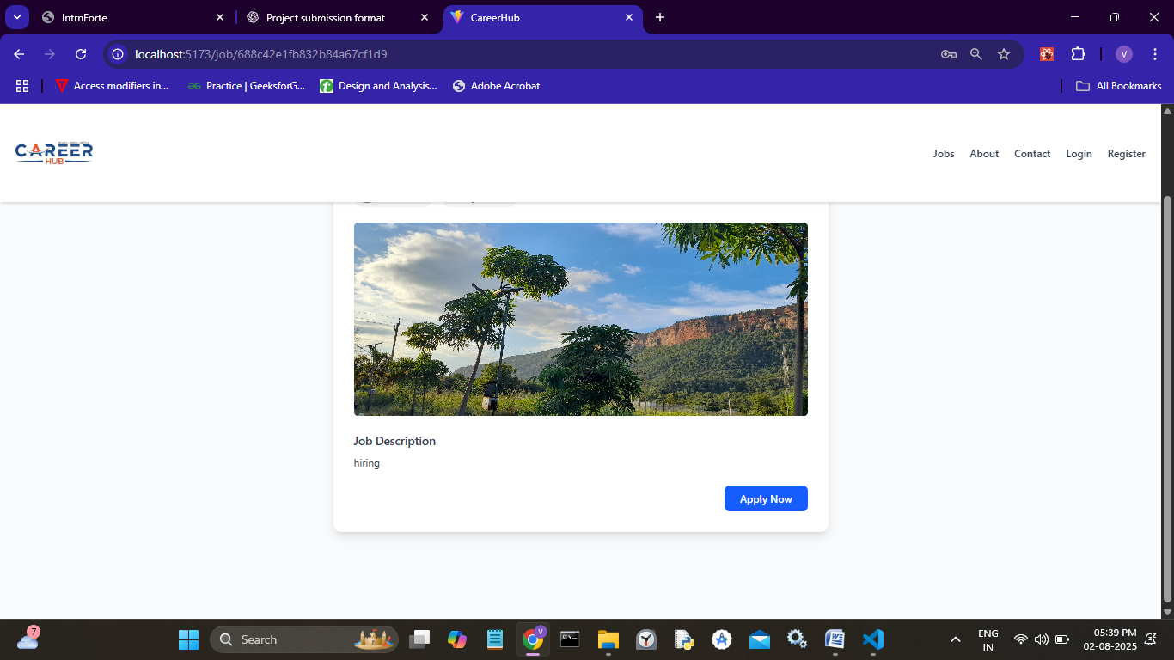](https://github.com/harshitha937/CareerHub/blob/main/Screenshots/JobDetails.png)

### Apply

[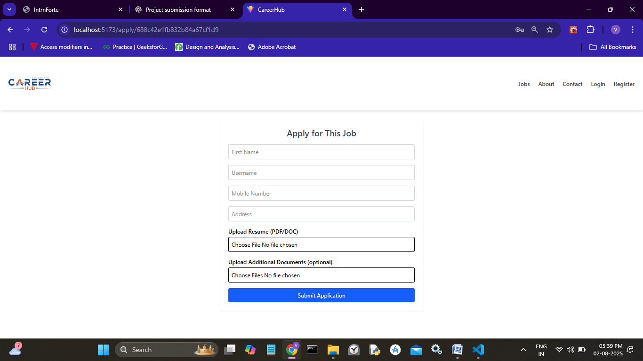](https://github.com/harshitha937/CareerHub/blob/main/Screenshots/Apply.png)

### MyApplication

[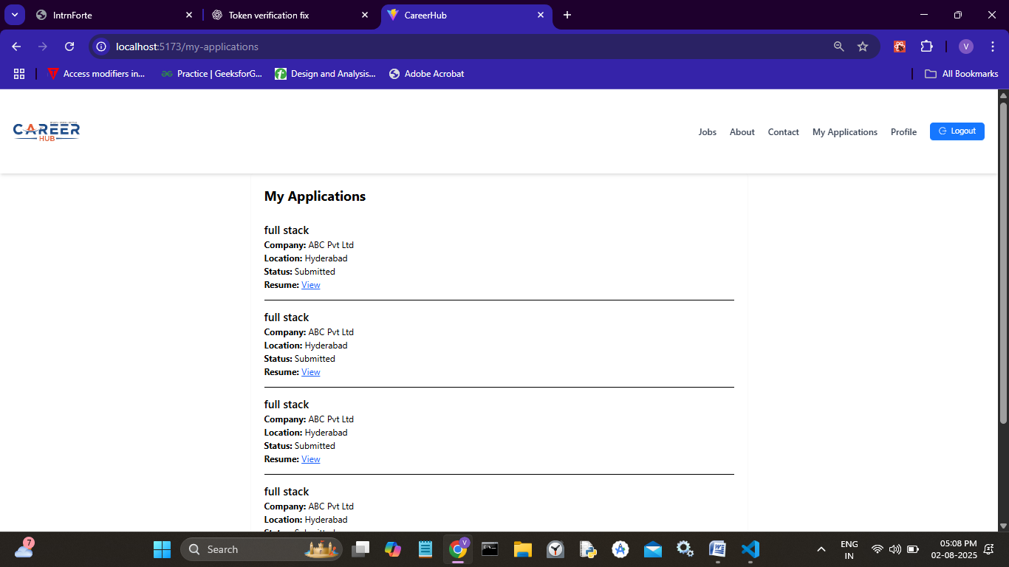](https://github.com/harshitha937/CareerHub/blob/main/Screenshots/MyAppliactions.png)

### USerProfile

[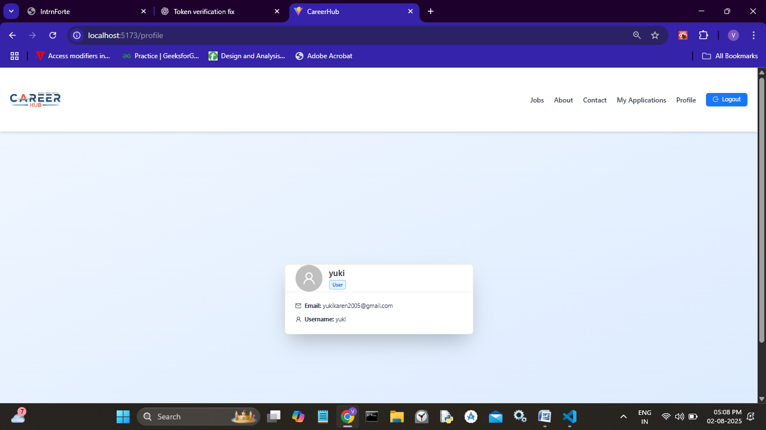](https://github.com/harshitha937/CareerHub/blob/main/Screenshots/UserPRofile.png)

### Admin Homepage

[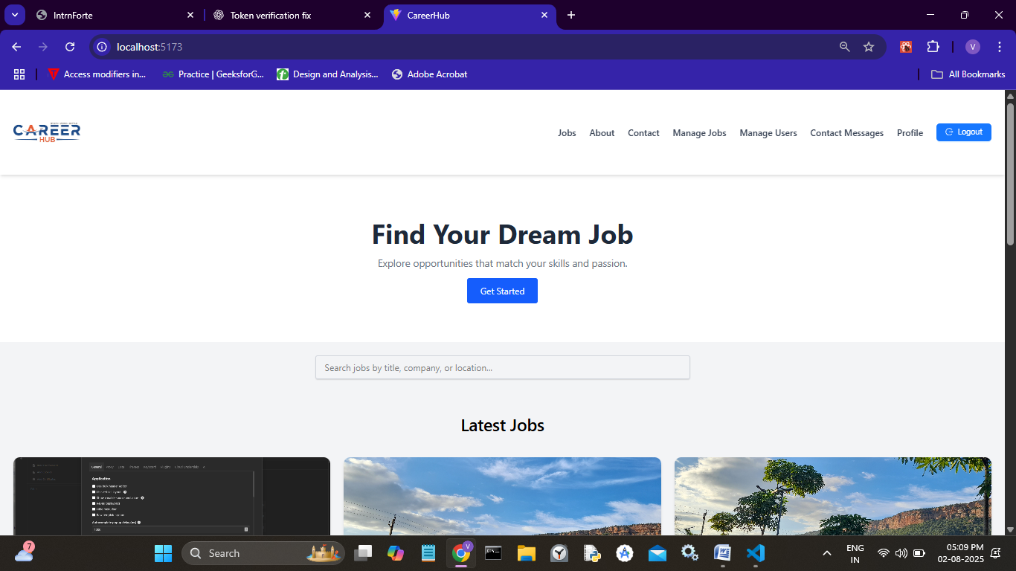](https://github.com/harshitha937/CareerHub/blob/main/Screenshots/adminHome.png)

### Manage Jobs

[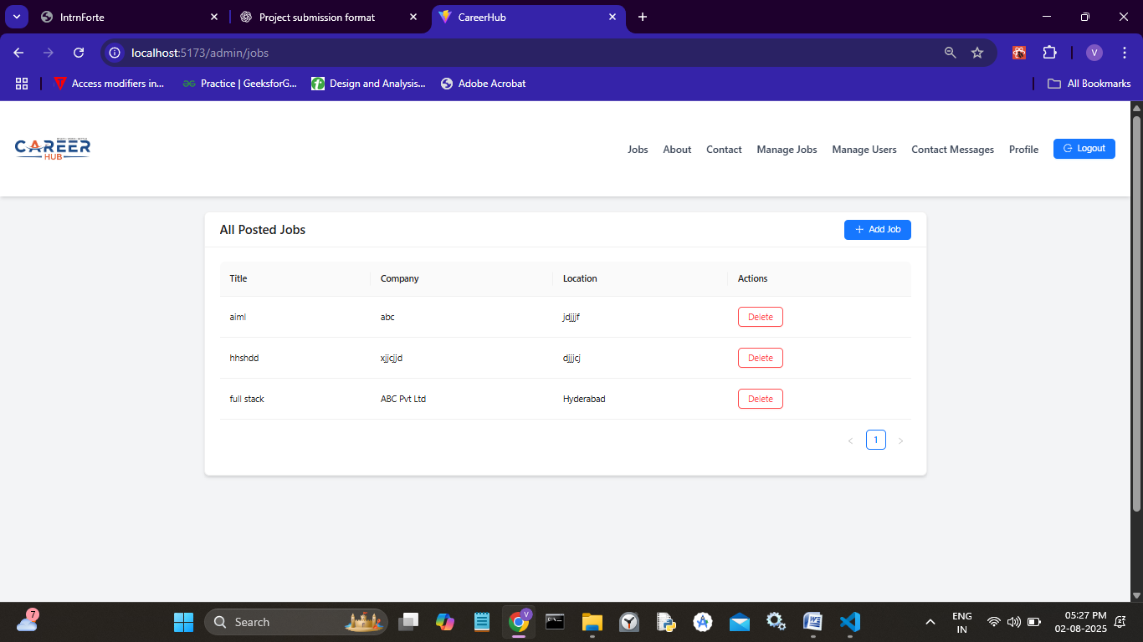](https://github.com/harshitha937/CareerHub/blob/main/Screenshots/ManageJobs.png)

### Add Job

[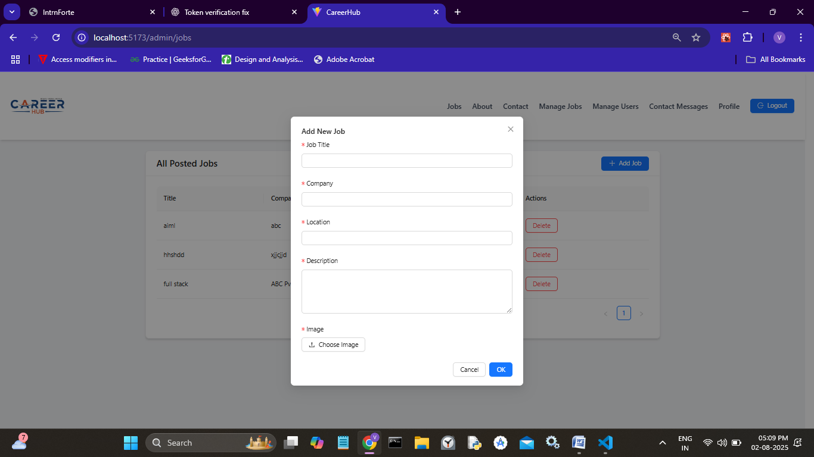](https://github.com/harshitha937/CareerHub/blob/main/Screenshots/PostJob.png)

### Manage Users

[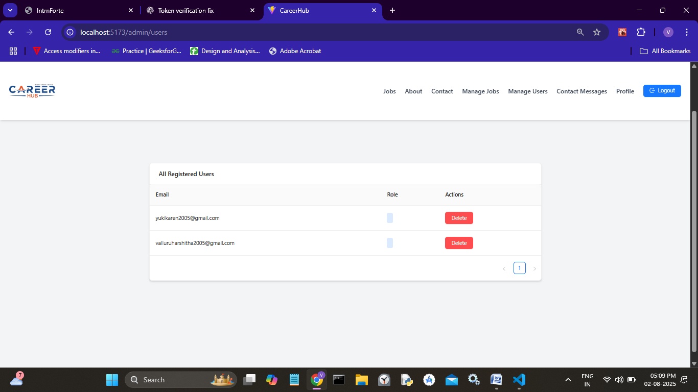](https://github.com/harshitha937/CareerHub/blob/main/Screenshots/Manageusers.png)

### Contact Messages

[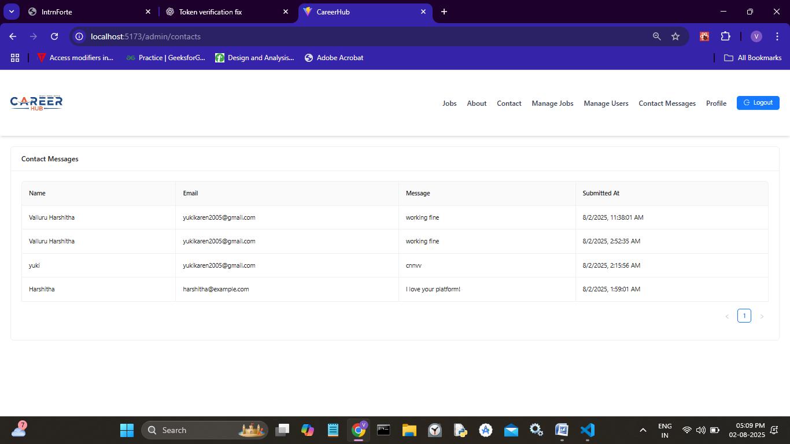](https://github.com/harshitha937/CareerHub/blob/main/Screenshots/ContactResult.png)

### Admin Profile

[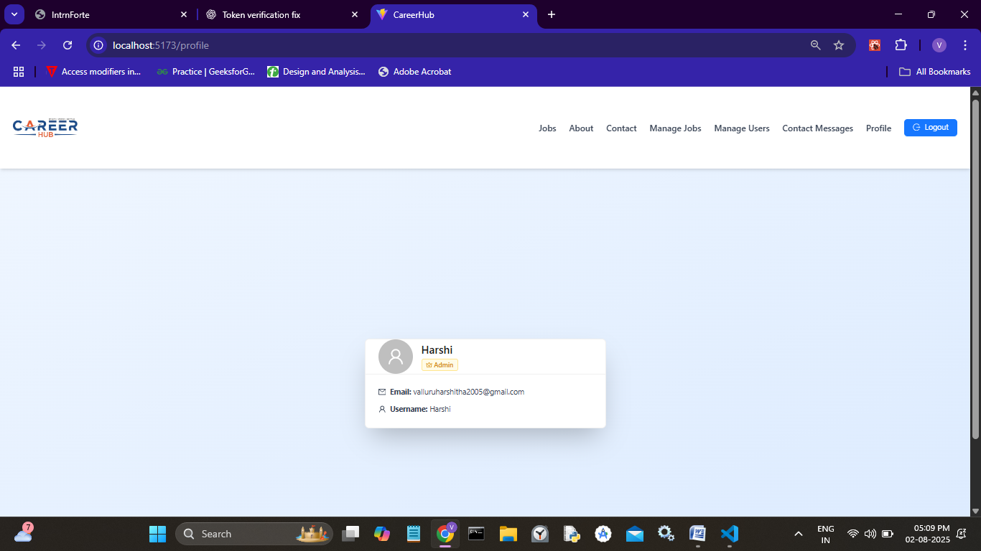](https://github.com/harshitha937/CareerHub/blob/main/Screenshots/AdminProfile.png)

6.DataBase Stucture:

* Users:

-name,Email,PasswordHash,IsVerified

* Jobs:

-title,description,company,location,salary,posetedBy

* Appliactions:

-user,firstname,username,mobile,address,resume,documents

* Contacts:

-name,email,message

7.Challenges Faced:

-Uploading images using mutler.

-Multi role based navigation

-localstorage-based application

-validations and feedback managing froms

8.Conclusion:

CareerHub is a real-world job platform for job seekers and employes.

9.GitHub Repository:

[https://github.com/harshitha937/CareerHub]( https://github.com/harshitha937/CareerHub