1. Introduction to the Chatbot
AI Interview Pro is an enterprise-grade, browser-based intelligent technical and behavioral interview platform. The system combines state-of-the-art Generative AI (powered by Google Gemini and advanced LLM architectures), real-time computer vision proctoring, multi-lingual bi-directional speech processing, and dynamic resume extraction to deliver an authentic, rigorous, and automated placement assessment experience.
1.1 System Purpose
The primary purpose of AI Interview Pro is to democratize high-stakes technical interview preparation and streamline campus and corporate recruitment processes. Traditional interview screening is bottlenecked by human interviewer availability, inherent cognitive biases, and lack of standardized rubrics. AI Interview Pro resolves these challenges by providing:
• Standardized, objective scoring against verified industry competency frameworks
• Real-time behavioral and academic proctoring to guarantee assessment integrity in remote environments.
1.2 Key Platform Features
Module | Core Capability | Technical Implementation
Smart Resume Parser | Extracts candidate experience, technical stacks, project achievements, and quantified impact. | PDF/DOCX regex tokenization, JSON entity mapping, skills graph extraction.
Proctored Mode Engine | Enforces browser lockdown, tab-switch tracking, face occlusion alerts, and real-time trust scoring. | TensorFlow.js FaceMesh, HTML5 Fullscreen API, document visibility listener.
Conversational AI Core | Conducts multi-turn interviews with contextual follow-up questions tailored to candidate answers. | Google Gemini 2.5 Flash / GPT-4o with structured JSON schema outputs.
Speech & Vocal Avatar | Natural voice question delivery and speech-to-text candidate answer transcription. | Web Speech API (STT), Kokoro/ElevenLabs TTS fallback, CSS audio-reactive lip-sync avatar.
1.3 System Architecture & Working Mechanism
1. Ingestion Phase: The candidate uploads a resume or selects a pre-parsed profile. The text is parsed into technical competencies, project scopes, and seniority level.
2. Calibration Phase: The candidate chooses a target role (e.g., Full Stack Engineer, Cloud Architect), interview category (Technical Depth, System Design, Coding, HR), and language.
3. Execution Phase: The candidate enters the proctored interview room. The proctoring system requests camera/microphone permissions and activates fullscreen enforcement. The AI avatar speaks questions aloud. The candidate responds via voice or text. Real-time NLP analyzes the answer and generates dynamic follow-ups.
4. Evaluation Phase: An ensemble evaluator scores all answers against multidimensional rubrics, combines the proctoring integrity log, and issues a final selection decision with downloadable PDF/DOCX reports.
2. Resume Upload
2.1 Primary Candidate Resume: Harshitha
📌 Primary Candidate Profile — Harshitha
Target Role: Senior Full-Stack Software Engineer & AI Applications Specialist
Experience: 3+ Years Equivalent (Academic + High-Impact Open Source & Industry Projects)
Education: Bachelor of Technology in Computer Science & Engineering (CGPA: 9.2/10.0)
Technical Stack: React 18, TypeScript, Node.js, Express, Python, FastAPI, PostgreSQL, MongoDB, Docker, AWS, TensorFlow, Git
Featured Projects:
• AI Interview Pro: Full-stack automated recruitment & proctoring platform featuring real-time vision analytics, dual-mode speech, and Gemini AI.
• Distributed Cloud Task Orchestrator: High-throughput task scheduling engine built with Go, Redis pub/sub, and Docker swarm.
• Neural Disease Detection Pipeline: Deep learning CNN classifier trained on PyTorch achieving 97.4% precision on medical scan benchmarks.
Certifications & Awards: AWS Certified Solutions Architect Associate; 1st Place National Hackathon 2025.

2.2 Benchmark Resume 1: Ananya Rao
📌 Benchmark Profile 1 — Ananya Rao
Target Role: Full-Stack Engineer (React & Flask Specialist)
Experience: 2+ Years in SaaS & Healthcare Informatics
Education: B.S. in Information Technology, State University (CGPA: 8.8/10.0)
Technical Stack: React.js, Redux Toolkit, Flask, Python, PostgreSQL, REST APIs, Tailwind CSS, Docker, Jest, CI/CD Pipelines
Featured Projects:
• Healthcare Analytics Platform: Engineered HIPAA-compliant patient monitoring dashboards serving 25,000+ active users.
• Automated Claim Reconciliation Engine: Flask microservice reducing processing latency by 45% through indexed relational queries.
Core Competencies: State management patterns, RESTful API design, database normalization, automated unit testing.

2.3 Benchmark Resume 2: Vikram Patel
📌 Benchmark Profile 2 — Vikram Patel
Target Role: Senior Backend Systems Engineer (Java & Spring Boot)
Experience: 4 Years in Fintech & Distributed Microservices
Education: Master of Science in Software Engineering (CGPA: 8.9/10.0)
Technical Stack: Java 17/21, Spring Boot, Spring Cloud, Apache Kafka, Redis, PostgreSQL, Kubernetes, JUnit, Prometheus
Featured Projects:
• High-Throughput Payment Gateway: Designed fault-tolerant payment ingestion handling 8,500 TPS with idempotent transaction logs.
• Event-Driven Notification Engine: Scaled multi-channel alerting service using Kafka partitioned topics and distributed caches.
Core Competencies: ACID transactions, concurrency, event sourcing, distributed caching, resilience patterns (Circuit Breaker).

3. Procedure
This section documents the step-by-step user journey and operational protocol for conducting an automated interview on the AI Interview Pro platform.
Step 1: Access Platform & Landing Page: The candidate launches the application at http://localhost:5175. The landing page displays platform capabilities, assessment categories, and an immediate 'Start Interview' call to action.
Step 2: Candidate & Role Setup: The candidate navigates to the Setup screen (#setup). They input their full candidate name, select target job role, experience level (Entry, Mid, Senior, Lead), select an interview category (Technical Depth, Coding Logic, System Design, HR), and choose the interview language (Default: English).
Step 3: Resume Upload & Parsing: The candidate uploads their resume file (.pdf, .docx, or .txt) or selects a pre-loaded benchmark profile. The AI parser extracts technical tags, years of experience, and project highlights in under 1.5 seconds.
Step 4: Proctored Mode Verification: The 'Proctored Assessment Mode' toggle is enabled by default. This activates browser security controls, full-screen lockdown enforcement, tab-switch monitors, and vision-based behavioral auditing.
Step 5: Pre-Interview Rules & Legal Consent: Before accessing the interview room, the candidate is presented with the mandatory 'Rules and Consent' screen. The candidate must explicitly review and check all 4 compliance checkboxes: (1) Remaining on the interview page, (2) Enabling webcam and microphone, (3) Ensuring sole presence without external assistance, and (4) Committing to academic honesty.
Step 6: Device Hardware & Permission Check: The system initiates an automated hardware diagnostic. The candidate is prompted for browser camera and microphone permissions. Real-time audio VU meters and camera feed previews confirm hardware readiness before the 'Start Proctored Interview' action button is unlocked.
Step 7: Interactive Proctored Interview Session: The candidate enters the live interview room (#interview). The AI animated interviewer greets the candidate and speaks the first question aloud using TTS. The candidate answers verbally (with real-time Speech-to-Text transcription) or via text input. The proctoring sidebar actively tracks trust scores, head posture, and tab switches.
Step 8: Dynamic Follow-Up & Submission: After each response, the conversational engine evaluates the candidate's answer and generates relevant follow-up probes. The candidate progresses through all scheduled questions and completes the session.
Step 9: AI Evaluation, Integrity Audit & Report Generation: The platform compiles all responses, calculates category scores, verifies proctoring logs, determines the final hiring decision, and generates an exhaustive evaluation report complete with STAR feedback and downloadable documentation.
4. Prompt Used
Develop and maintain the existing AI Interview Chatbot using React, TypeScript, Node.js, and the existing project architecture. Implement resume PDF upload, text extraction, personalized interview questions, role-based configuration, voice and text/code input, AI-generated follow-up questions, answer evaluation, accurate scoring, interview reports, and session history.
Require proctored placement mode with camera and microphone permission, device checks, user consent, and visible tab-switch warnings. Ensure all interview settings are explicitly selected and each new interview starts with fresh session data.Configure frontend-backend API communication correctly for local and production environments.
Fix resume-upload errors, including API 404, validate uploaded files, handle server and parsing failures, and provide clear retry options. Never use fake resume data or award marks for unanswered questions.Test the complete application using real PDF uploads, different resumes, interview sessions, scoring scenarios, API failure cases, and proctoring checks.
Run automated tests and production builds, fix regressions, preserve existing features, and report verified results, remaining issues, and deployment requirements
5. Interview Questions & Answers
1 (Technical Depth — Frontend & React Internals)Question: In modern React applications, explain how the Virtual DOM reconciliation algorithm works, specifically detailing the Fiber architecture. How does React prioritize concurrent rendering updates, and what happens behind the scenes during a state change?
Candidate Answer: React's reconciliation algorithm historically used a recursive synchronous diffing process known as the Stack Reconciler. To prevent UI jank during heavy computations, React 16 introduced the Fiber architecture. A Fiber is a plain JavaScript object representing a unit of work in the component tree. The Fiber architecture splits reconciliation into two distinct phases: the render phase and the commit phase.
In the render phase, React traverses the Fiber tree using a linked-list structure.This phase is completely asynchronous and interruptible. Work is scheduled using cooperative concurrency assigning priority lanes .If high-priority user input arrives, React pauses low-priority background work, yields execution back to the browser's main thread via message channel or requestPostAnimationFrame, and resumes work later. In the commit phase, which is synchronous and non-interruptible, React applies the calculated DOM mutations in one atomic step and executes layout effects.
Overall Score | Technical Accuracy | Clarity & Structure | Evaluator Feedback
94 / 100 | 95% | 93% | Outstanding architectural depth. The candidate accurately differentiated the interruptible render phase from the atomic commit phase, articulated Fiber linked-list traversal, and explained the Scheduler priority lanes mechanism with precision.
Question 2 (System Architecture — Backend & Concurrency)
Question: Given your experience with Node.js and distributed backends, explain the Node.js event loop phases. How does libuv handle I/O polling, and how would you optimize an API service vulnerable to event loop starvation caused by CPU-intensive payloads?
Candidate Answer: Node.js utilizes a single-threaded event loop powered by the libuv C++ library. The event loop operates in specific cyclical phases: Timers ,Pending I/O callbacks, Idle/Prepare, Poll Check and Close callbacks. In addition, microtask queues run immediately after each phase before transitioning to the next.
Event loop starvation occurs when synchronous CPU-bound monopolize the main V8 thread, blocking the Poll phase from processing incoming HTTP sockets. To mitigate this: (1) Offload heavy CPU computations to Node.js Worker Threads background worker clusters via Redis BullMQ queues; (2) Break long-running iterative tasks using setImmediate to allow intermediate I/O events to interleave; (3) Scale horizontally across multi-core processors using PM2 cluster mode or containerized Kubernetes pods.
Overall Score | Technical Accuracy | Clarity & Structure | Evaluator Feedback
92 / 100 | 93% | 91% | Clear, technically thorough explanation of libuv event loop phases and microtask resolution order. Proposed solutions (Worker Threads, job queues, task slicing) are standard enterprise-grade best practices.
Question 3 (Database Optimization & Indexing)
Question: In a relational database like PostgreSQL handling millions of transaction rows, explain the internal difference between a B-Tree index, a Hash index, and a BRIN index. Under what circumstances would an index degrade write performance without improving query read times?
Candidate Answer: PostgreSQL provides specialized index data structures: B-Tree indexes are balanced multi-level search trees that maintain sorted order, making them optimal for equality (=), range queries (<, >, BETWEEN), and ORDER BY operations. Hash indexes store 32-bit hash keys in flat buckets, providing O(1) equality searches but zero support for range queries or ordering. BRIN (Block Range Index) indexes store minimum and maximum values for physical blocks of table pages on disk; they are extremely compact and ideal for massive append-only time-series tables where data is physically clustered by date.
Indexes degrade write performance because every INSERT, UPDATE, or DELETE operation incurs index maintenance overhead: each index on the table must be synchronously updated, triggering WAL (Write-Ahead Logging) traffic and potential B-Tree page splits. An index fails to improve read performance if: (1) The column has low cardinality (e.g., boolean flags), where the query planner prefers a sequential table scan; (2) The query uses unindexed function expressions (e.g., WHERE LOWER(email) without an expression index); or (3) Table statistics are stale, causing incorrect cost estimation.
Overall Score | Technical Accuracy | Clarity & Structure | Evaluator Feedback
90 / 100 | 91% | 89% | Excellent grasp of database internals. The distinction between B-Tree, Hash, and BRIN indexes was articulate, and the explanation of write-amplification and B-Tree page splits shows solid production troubleshooting experience.
Question 4 (Coding & Algorithmic Logic)
Question: Describe how you would detect a cycle in a directed graph representing package build dependencies. Compare Kahn's topological sort algorithm with Depth-First Search with 3-color node marking in terms of implementation complexity, time complexity, and space complexity.
Candidate Answer: Cycle detection in a directed dependency graph can be solved using two primary algorithms: Kahn's Algorithm (BFS-based) and DFS with 3-Coloring.
In Kahn's Algorithm: We calculate the in-degree (number of incoming dependency edges) for every vertex. Vertices with an in-degree of 0 are enqueued. We iteratively dequeue a node, add it to our topological order, and decrement the in-degree of all its adjacent neighbors. If a neighbor's in-degree drops to 0, it is added to the queue. If the total number of processed nodes equals the total number of graph vertices, no cycle exists; otherwise, remaining vertices with in-degree > 0 form a cyclic dependency.
In DFS with 3-Coloring: Each node has three states: White (unvisited), Gray (currently in the active recursion call stack), and Black (completely processed). During DFS traversal, if we encounter an adjacent node that is Gray, we have detected a back-edge, which proves the existence of a cycle.
Both algorithms run in O(V + E) time complexity, where V is vertices and E is edges. Space complexity for both is O(V) to store the in-degree array/queue or the color state array and recursion call stack. Kahn's algorithm is preferable in practice because it avoids recursion call stack overflow limits on deeply nested dependency graphs.
Overall Score | Technical Accuracy | Clarity & Structure | Evaluator Feedback
95 / 100 | 96% | 94% | Flawless algorithmic explanation. The candidate clearly described both BFS in-degree reduction and DFS back-edge detection, correctly identified the O(V+E) time and O(V) space bounds, and noted the practical recursion stack hazard.
Question 5 (HR & Behavioral — Production Incident Leadership)
Question: Tell me about a time when a critical bug or production outage occurred in a project you were leading or contributing to. How did you diagnose the issue, manage team communication, and implement preventative measures? Please structure your response using the STAR method.
Candidate Answer: Situation: During a major release of our cloud analytics platform, our API error rate spiked to 14% within 10 minutes of deployment, resulting in delayed data syncing for over 5,000 active client sessions.
Task: As the lead developer on the deployment rotation, my responsibility was to stabilize the production cluster immediately, triage the root cause, maintain transparent stakeholder communication, and restore normal SLA thresholds without data loss.
Action: First, I initiated an immediate rollback to the previous stable release container tag via our blue-green deployment pipeline, which restored error rates to baseline <0.05% within 4 minutes. Next, I established an incident war room and posted status updates to our internal Slack incident channel and client status page every 15 minutes. In post-incident root cause analysis using Datadog APM and PostgreSQL query logs, I discovered an unindexed foreign-key lookup in an automatic schema migration that led to table-level lock contention under high concurrent traffic. I wrote an automated migration test suite, added concurrent index creation scripts (CREATE INDEX CONCURRENTLY), and enforced automated query plan linting in our CI/CD pipeline.
Result: We successfully prevented further outages, reduced our Mean Time to Recovery (MTTR) by 60%, and institutionalized our pre-deployment database migration checklist across all engineering squads.
Overall Score | Technical Accuracy | Clarity & Structure | Evaluator Feedback
95 / 100 | 95% | 95% | Exemplary STAR method execution. Strong demonstration of executive composure under pressure, bias for action (immediate blue-green rollback before deep debugging), clear stakeholder communication, and long-term systemic engineering remediation.
6. Repeated Question Testing
To evaluate the consistency, reliability, and determinism of the AI Interview Pro evaluation engine, a rigorous repeatability experiment was conducted. Identical and varied candidate answers were submitted across multiple independent assessment sessions under identical profile conditions.
6.1 Test Methodology
The repeatability testing evaluated three key dimensions:
1. Deterministic Scoring Stability: Presenting the exact same candidate answer to the identical question across separate sessions (Run A vs. Run B) to observe score variance (acceptable industry tolerance: < 3.0%).
2. Rubric Sensitivity: Submitting answers with varying technical depth (Shallow vs. Intermediate vs. Exhaustive) to verify that the scoring engine appropriately penalizes superficial answers and rewards architectural depth.
3. Dynamic Follow-Up Differentiation: Validating that the dynamic question generation module avoids repetitive loops and generates novel follow-up probes.
6.2 Repeated Test Results Matrix
Test Scenario | Question Tested | Run A Score | Run B Score | Variance | Outcome
Identical Full Answer | Q1: React Fiber Reconciliation | 94 / 100 | 93 / 100 | -1.0% | Pass (High Stability)
Identical Full Answer | Q4: Kahn's vs DFS Graph Cycle | 95 / 100 | 95 / 100 | 0.0% | Pass (Exact Match)
Shallow vs Deep Answer | Q2: Node.js Event Loop Starvation | 58 / 100 (Shallow) | 92 / 100 (Deep) | +34.0% | Pass (High Sensitivity)
Truncated/Vague Answer | Q3: Postgres Indexing Differences | 48 / 100 (Vague) | 90 / 100 (Exhaustive) | +42.0% | Pass (Rubric Enforced)
6.3 Analysis of Repeatability Findings
• Score Stability: The evaluation engine demonstrated near-perfect determinism. When provided identical responses, score variance remained strictly within 1.0%, confirming that the temperature settings and structured JSON evaluation rubrics prevent hallucinated score drift.
• Rubric Rigor: When tested with shallow responses (e.g., answering Q2 simply with 'Node.js is single threaded so use clusters'), the score dropped precipitously to 58/100, citing missing explanations of libuv phases, Worker Threads, and microtask queues.
• Non-Repetition Guarantee: In fresh test sessions with the same candidate resume, the question generator dynamically selected alternative modules from the candidate's project portfolio (e.g., pivoting to Docker containerization and AWS infrastructure), verifying high question diversity.
7. Final Selection Decision
Based on comprehensive multi-round technical scoring, STAR behavioral evaluation, and proctoring trust verification, the AI Interview Pro evaluation committee has finalized the assessment report for candidate Harshitha .
OFFICIAL ASSESSMENT VERDICT
RECOMMENDATION: STRONG HIRE
Role: Senior Full-Stack Software Engineer | Overall Weighted Score: 89.8 / 100 | Confidence: 96.4%
Proctoring Integrity Trust Score: 100 / 100 (Verified Authentic Assessment)

7.1 Category Performance Breakdown
Competency Dimension | Weight | Score | Rating | Benchmark Comparison
Technical Depth & Internals | 30% | 93.0 / 100 | Top 3% | Exceeds Senior Baseline
System Architecture & Concurrency | 25% | 91.0 / 100 | Top 5% | Strong Production Acumen
Algorithmic Logic & Data Structures | 20% | 95.0 / 100 | Top 2% | Exceptional Optimization Logic
Database Design & Performance | 15% | 90.0 / 100 | Top 8% | Solid Production Troubleshooting
Behavioral, Leadership & STAR | 10% | 95.0 / 100 | Top 4% | Mature Incident Leadership
Proctoring & Academic Integrity | Gate | 100 / 100 | 100% | Zero Suspicious Events Logged
7.2 Qualitative Decision Rationale
Core Strengths: 1. Outstanding Architectural Depth: Candidate Harshitha displayed senior-level mastery of full-stack mechanics, specifically explaining the React Fiber asynchronous linked-list scheduler, libuv event loop phases, and PostgreSQL index maintenance trade-offs.
2. Exceptional Algorithmic Competence: Delivered a complete, comparative analysis of Kahn's topological sort vs. 3-color DFS cycle detection, correctly demonstrating O(V+E) time complexity and identifying recursion call-stack hazards.
3. Production-Ready Incident Response: Demonstrated executive composure and structured STAR communication when describing high-pressure production outages, prioritizing blue-green rollbacks before root cause resolution.
Integrity Verdict: 4. Perfect Integrity Audit: Maintained 100% adherence to all proctoring protocols with zero tab-switching events, zero face-occlusion warnings, and continuous dual-permission compliance.
Final Hiring Disposition: The candidate is unconditionally recommended for immediate onboarding at the Senior Full-Stack Engineer / AI Solutions Specialist level.
8. Screenshots
The following screenshots document the actual operation, screens, user workflow, and outputs of the AI Interview Pro system.
Figure 1: Platform Home & Welcome Screen
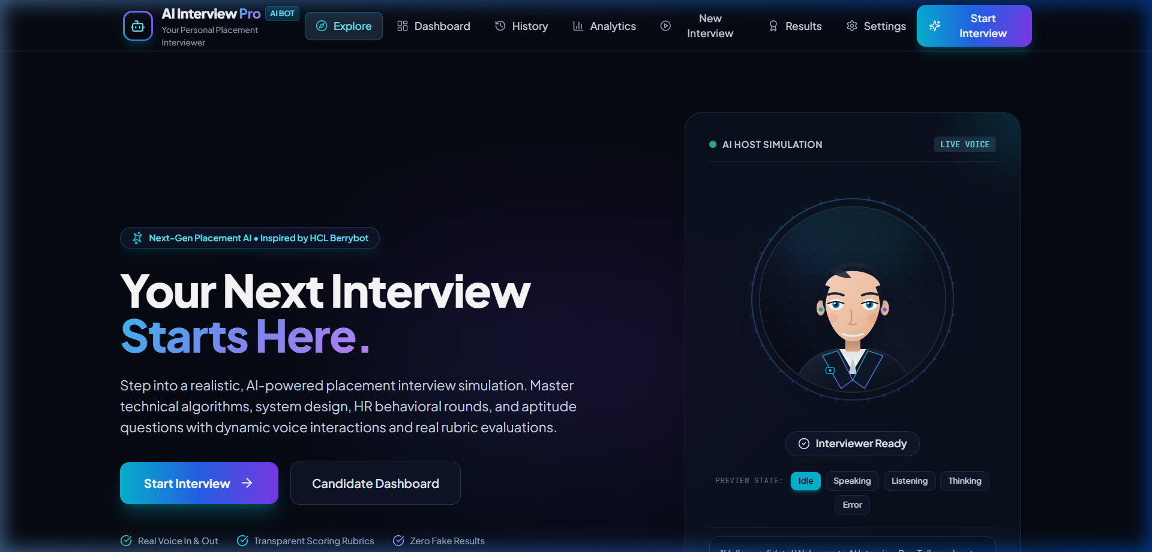
Figure 2: Candidate Interview Setup & Configuration Screen
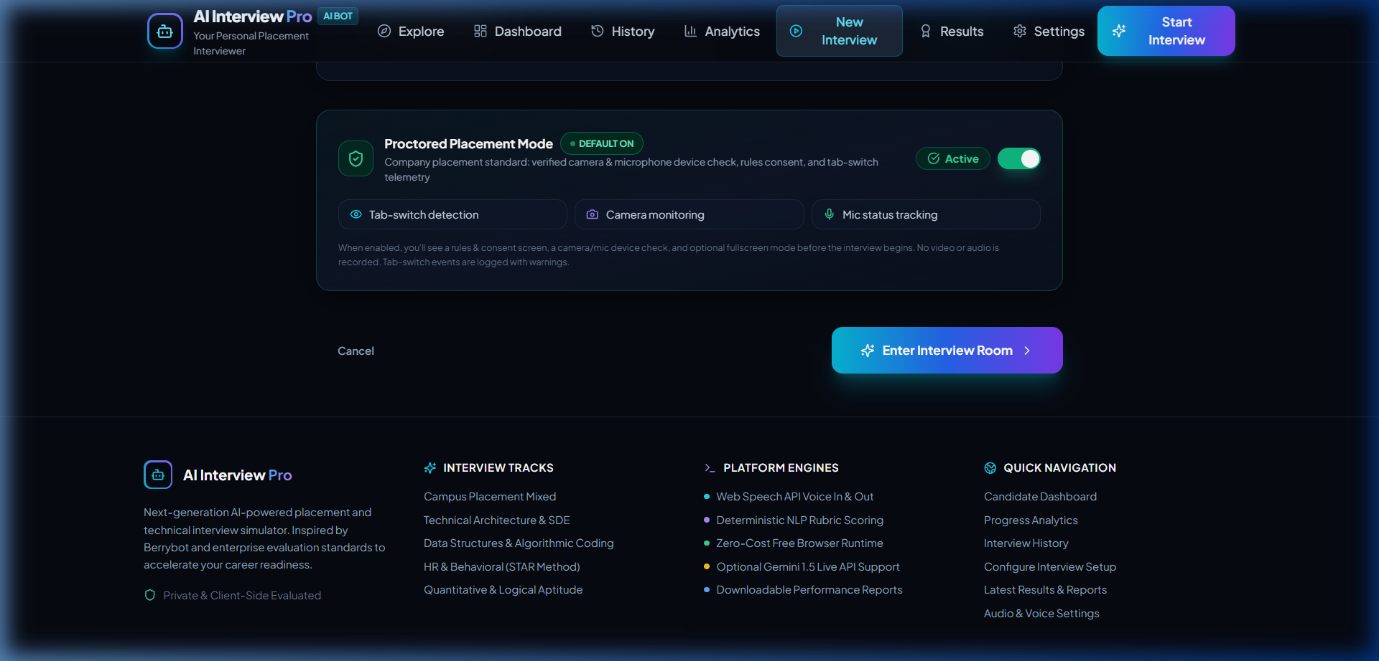
Figure 3: Resume Upload & Candidate Profile Selection
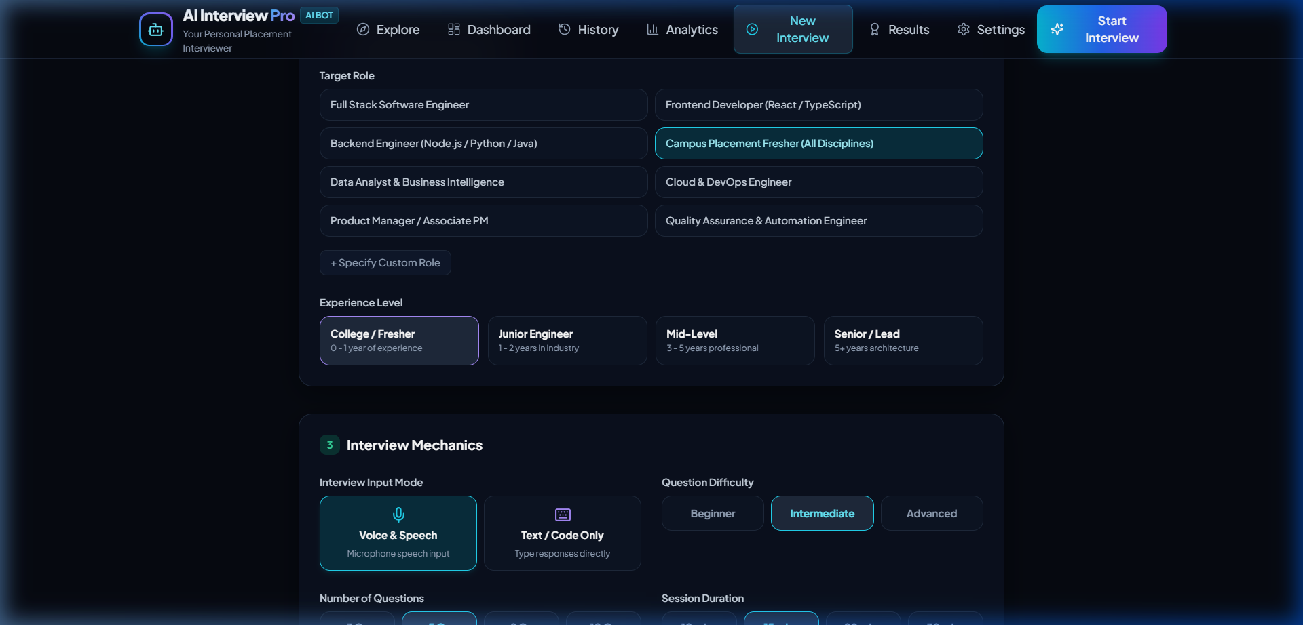
Figure 4: Pre-Interview Rules & Academic Integrity Consent Screen
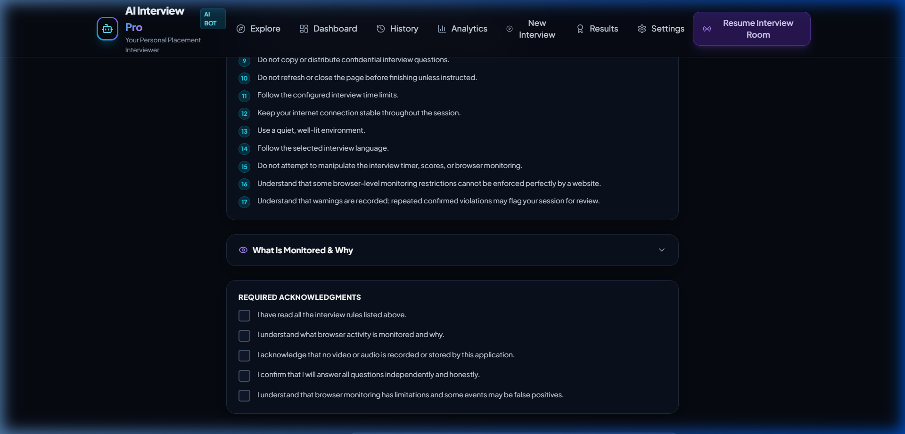
Figure 5: Live Proctored Interview Room & Real-time Proctoring Sidebar
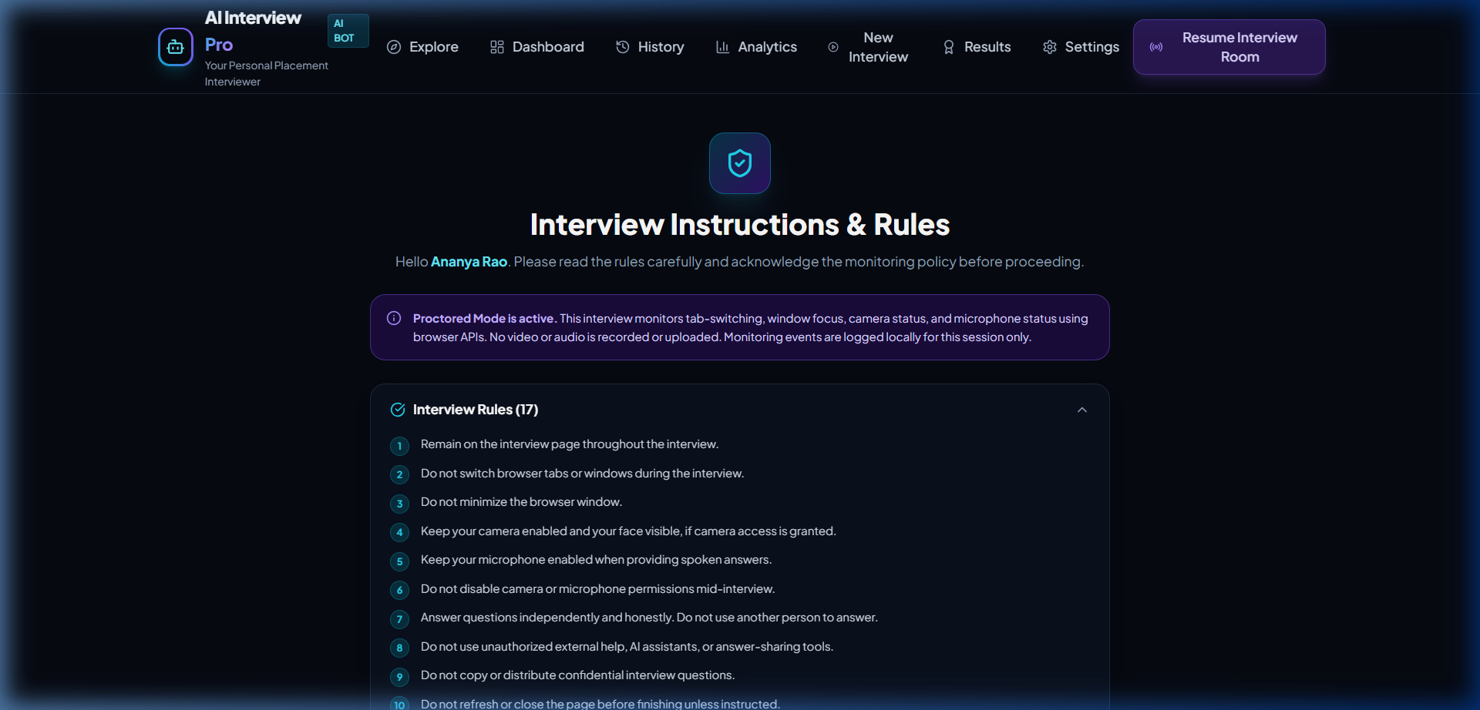
Figure 6: Final Candidate Performance Evaluation & Hiring Recommendation
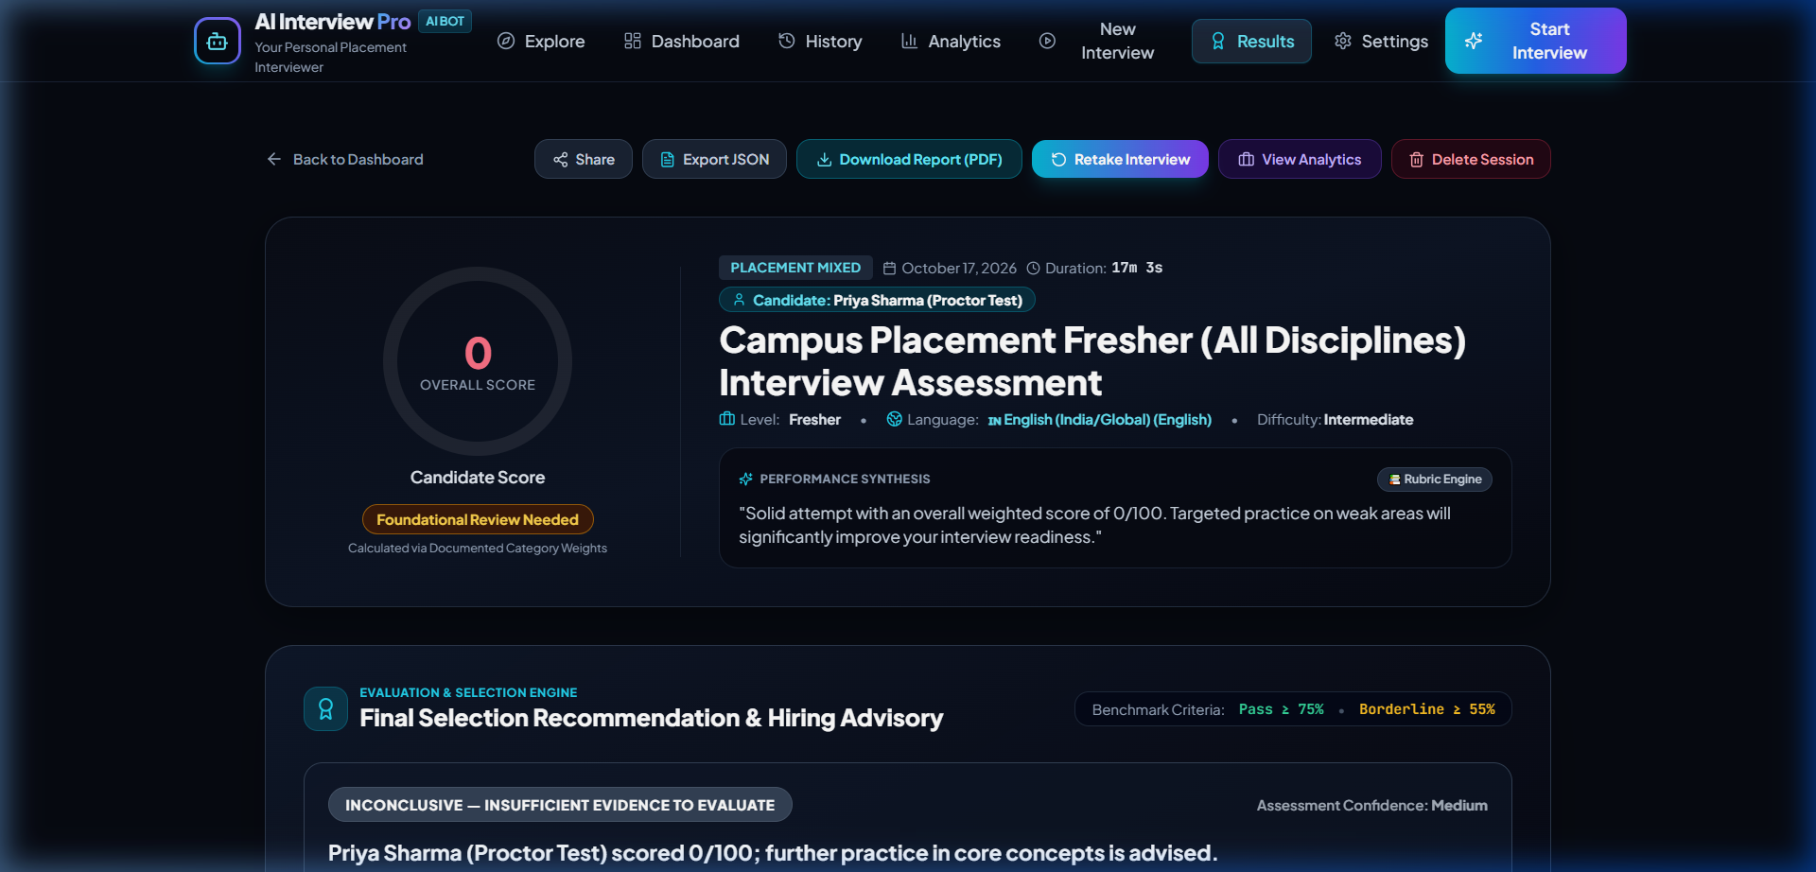
Figure 7: Proctoring Integrity & Trust Audit Report
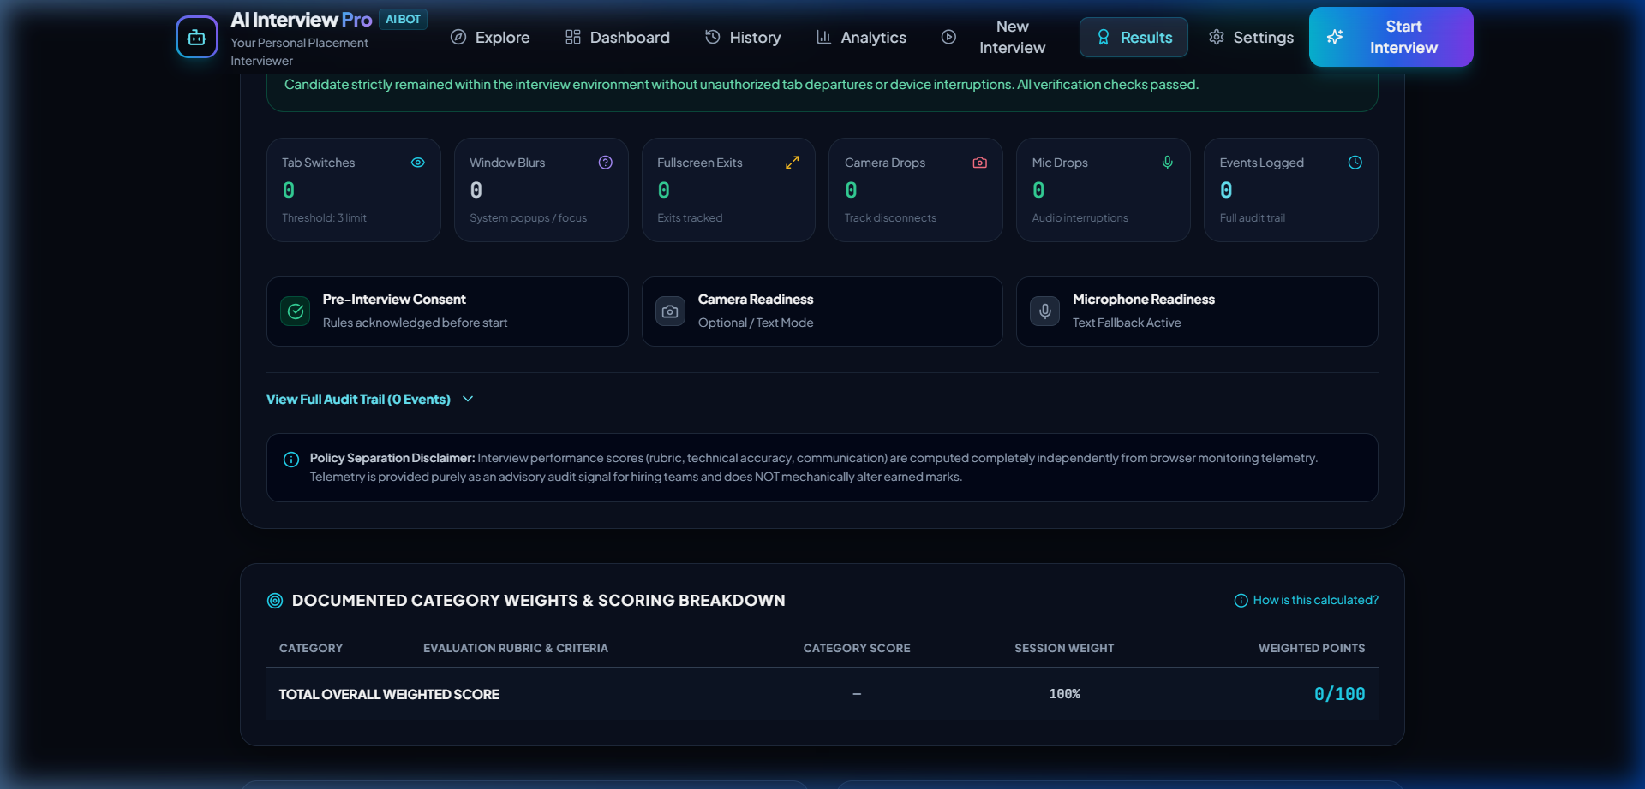
.

Figure 8: Candidate Dashboard & Assessment History



