Activity-7:

QUICK UNION:

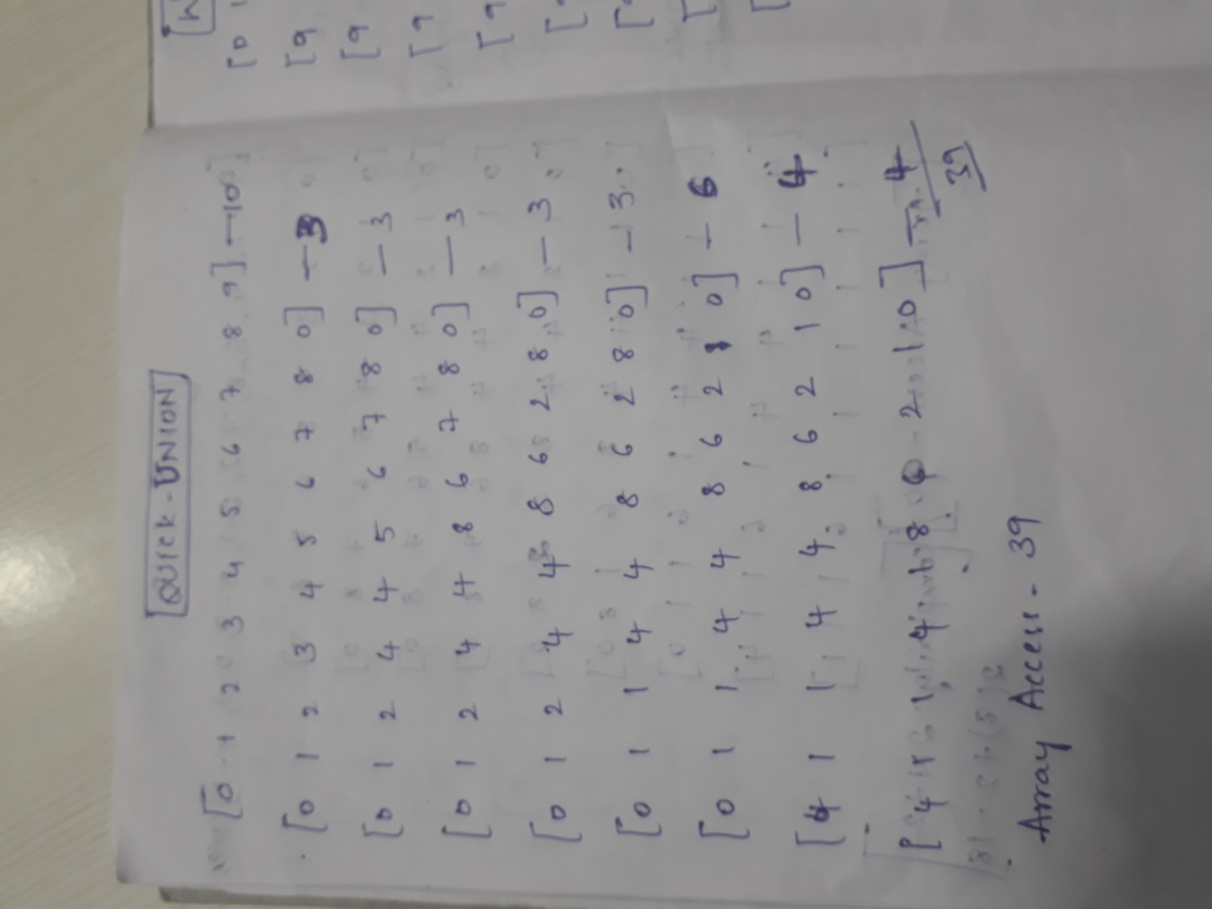

QUICK FIND:

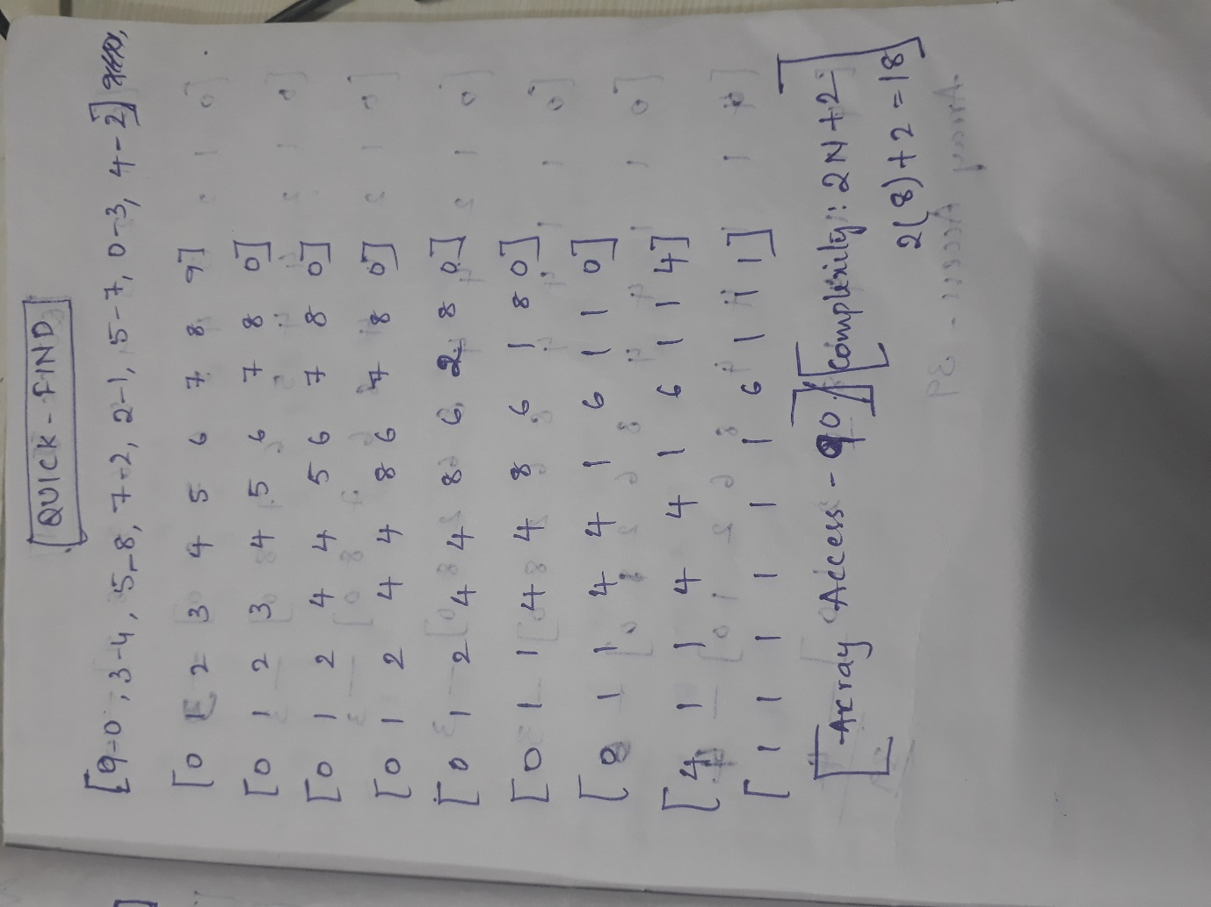

WEIGHTED QUICK UNION:

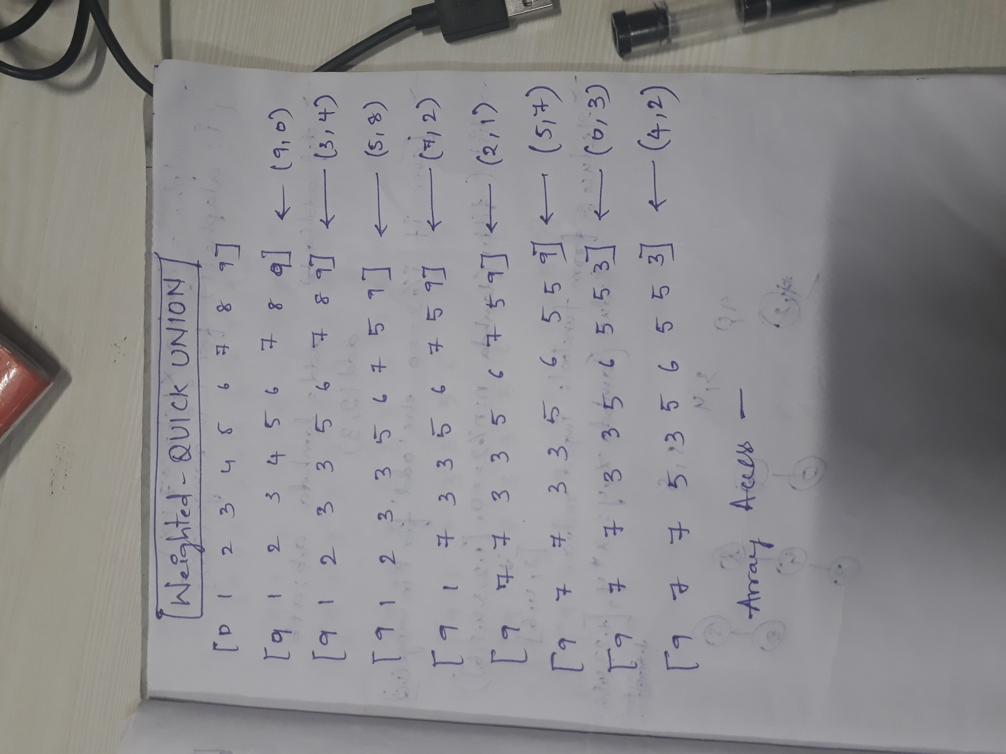

WEIGHTED QUICK UNION WITH PATH COMPRESSION:

