**Roll No**  **:** CB.SC.I5DAS21079

**Name**  **:** HARSHITHA.T

**Timeline :**

**Topics: SQL Statements, Relational Algebra, Schema Diagram**

**Name of the Application:** Big Basket

**Explain about the application in a paragraph:**

Big Basket is an online grocery shopping application which enables users to shop groceries at the ease of their homes. It delivers products to customers at doorstep. This application has disrupted the country’s grocery industry. It claims its products are procured directly from farmers thereby making it farm fresh. It helps all working professionals save time in procuring groceries from nearby supermarket where they must wait in long queue just for billing the purchased products. It is simply developed to make life much easier and more productive.

**List of Operations that is expected to be done in application with the Database:**

|  |  |  |
| --- | --- | --- |
| **Display** | **Search** | **Report** |
| Customer details | Health and Hygiene | Order date |
| Product details | Beauty | Delivery date |
| Discounts & Offers | Personal care | Slot time |

**Users in the application:**

* Restaurants
* Working professionals
* Students
* IT Staff
* Housewife

**Technologies:**

**Front End:** Java 20

**Scripting Language:** JavaScript - ECMAScript 2021

**Back End:** MySQL - 8.0

**Application Server:** SQL Server - 16.0.4025.1

**Reporting Tool:** Oracle Hyperion Interactive Reporting-11.2.12.0.000

**List of tables:**

|  |  |
| --- | --- |
| **Table Name** | **Category (Master/Transaction)** |
| Customer details | Master Table |
| Product details | Master Table |
| Vendor details | Master Table |
| Order details | Master Table |
| Payment method | Master Table |
| Order item | Transaction Table |
| Cart items | Transaction Table |
| Delivery status | Transaction Table |
| Review details | Transaction Table |
| Promotion details | Transaction Table |
| Vendor inventory details | Transaction Table |

**MASTER TABLES:**

* **Customer details**: Customer_ID (Primary Key), Name,Email,PhoneNumber,Address,Date of Birth,loyality points
* **Product details :** Product_ID (Primary Key),Product Name,Category,Description,Price,Unit of Measurement (e.g., kg, item),Stock Quantity.
* **Vendor details :** Vendor_ID (Primary Key),Vendor Name,Contact Information,Address,Delivery Area,Vendor Rating
* **Order details:** Order_ID (Primary Key),Customer_ID (Foreign Key),Order Date,Delivery Address,Order Status (e.g., Pending, Delivered),Total Amount
* **Payment method** : PaymentMethod_ID (Primary Key),Customer_ID (Foreign Key),Payment Type

**TRANSACTION TABLES:**

* **Order items:**Order_Item_ID (Primary Key),Order_ID (Foreign Key),Product_ID (Foreign Key),Quantity,Unit Price,Subtotal
* **Cart items:**Cart_Item_ID (Primary Key),Customer_ID (Foreign Key),Product_ID (Foreign Key),Quantity
* **Delivery status:** Delivery_Status_ID (Primary Key),Order_ID (Foreign Key),Status (e.g., En Route, Delivered),Status Update Timestamp
* **review details:** Review_ID (Primary Key),Customer_ID (Foreign Key),Product_ID (Foreign Key),Rating,Review Text,Review Date
* **Promotion details:** Promotion_ID (Primary Key),Product_ID (Foreign Key, if applicable),Discount Percentage,Start Date,End Date
* **Vendor inventory**: Vendor_Inventory_ID (Primary Key),Vendor_ID (Foreign Key),Product_ID (Foreign Key),Stock Quantity,Price,Last Updated Date

**Datatypes:**

* + Number
  + Varchar
  + Decimal
  + Date

**Constraint**

* + Primary key
  + Not null

**Table details :** User

**Table name :** user_dt

create table user_dt (user_id varchar(50) primary key,user_name varchar(50) not null ,email varchar(100) unique not null,password varchar(50) not null);

**1.Table Details:** Master Table

**Table Name:** Customer details

**Purpose:** It provides details of the customer using Big basket app

|  |  |  |
| --- | --- | --- |
| **Column Name** | **Data Type** | **Constraint** |
| customer_id | INT | Primary key |
| name | VARCHAR (225) | Not null |
| email | VARHAR(225) | Not null |
| Phone_number | VARCHAR(15) | Not null |
| Address | VARCHAR(225) | Not null |
| Loyality_points | INT | Not null |
| Date_of_birth | DATE | Not null |

**Creation of table :**

CREATE TABLE Customers ( Customer_ID INT PRIMARY KEY, Name VARCHAR(255), Email VARCHAR(255), PhoneNumber VARCHAR(15), Address VARCHAR(255), Date_of_Birth DATE, Loyalty_Points INT );

**Insertion of values:**

INSERT INTO Customers values (1, 'Rajesh Kumar', 'rajesh@gmail.com', '9876543210', '123 Main St, Delhi, India', to_date('1985-05-10','yyyy-mm-dd'), 50);

INSERT INTO Customers values (2, 'Sneha Patel', 'sneha@gmail.com', '9988776655', '456 Elm St, Mumbai, India', to_date('1990-08-20','yyyy-mm-dd'), 75);

INSERT INTO Customers values (3, 'Amit Singh', 'amit@gmail.com', '9871234567', '789 Oak St, Bangalore, India', to_date('1988-04-15','yyyy-mm-dd') ,30);

INSERT INTO Customers values (4, 'Neha Gupta', 'neha@gmail.com', '8877665544', '321 Birch St, Kolkata, India', to_date('1995-02-25','yyyy-mm-dd'), 100);

INSERT INTO Customers values (5, 'Priya Sharma', 'priya@gmail.com', '9988771122', '567 Pine St, Chennai, India',to_date('1992-09-12','yyyy-mm-dd'), 80) ;

INSERT INTO Customers values (6, 'Sanjay Verma', 'sanjay@gmail.com', '7778889999', '987 Cedar St, Hyderabad, India', to_date('1980-12-08','yyyy-mm-dd'), 120);

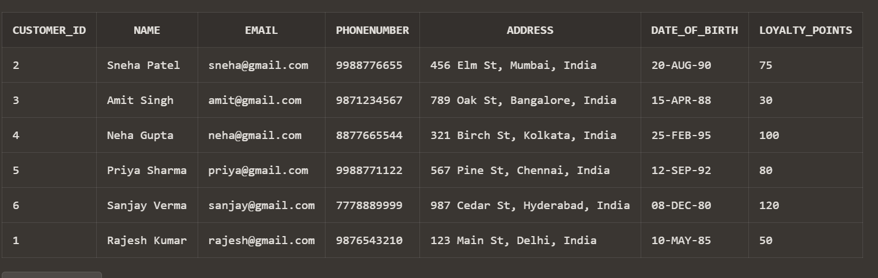

**2.Table Details:** Master Table

**Table Name:** Product details

**Purpose:** It provides the detailed description of the products listed in the app

|  |  |  |
| --- | --- | --- |
| **Column Name** | **Data Type** | **Constraint** |
| product_id | VARCHAR(20) | Primary key |
| product_name | VARCHAR (225) | Not null |
| category | VARCHAR (225) | Not null |
| description | TEXT | Not null |
| Price | DECIMAL(10,2) | Not null |
| Unit_of_Measurement | VARCHAR(20) | Not null |
| Stock_quantity | INT | Not null |

**Creation of table**:

CREATE TABLE Products (

Product_ID VARCHAR(20) PRIMARY KEY,

Product_Name VARCHAR(255),

Category VARCHAR(255),

Description CHAR(50),

Price DECIMAL(10, 2),

Unit_of_Measurement VARCHAR(20),

Stock_Quantity INT

);

**Insertion of values** :

INSERT INTO Products (Product_ID, Product_Name, Category, Description, Price, Unit_of_Measurement, Stock_Quantity)

VALUES ('P01', 'Apples', 'Fruits', 'Fresh and juicy apples', 2.99, 'kg', 100);

INSERT INTO Products (Product_ID, Product_Name, Category, Description, Price, Unit_of_Measurement, Stock_Quantity)

VALUES ('P02', 'Bananas', 'Fruits', 'Ripe bananas', 1.49, 'kg', 75);

INSERT INTO Products (Product_ID, Product_Name, Category, Description, Price, Unit_of_Measurement, Stock_Quantity)

VALUES ('P03', 'Milk', 'Dairy', '1-liter carton of milk', 2.49, 'item', 50);

INSERT INTO Products (Product_ID, Product_Name, Category, Description, Price, Unit_of_Measurement, Stock_Quantity)

VALUES ('P04', 'Bread', 'Bakery', 'Whole wheat bread', 3.29, 'item', 120);

INSERT INTO Products (Product_ID, Product_Name, Category, Description, Price, Unit_of_Measurement, Stock_Quantity)

VALUES ('P05', 'Chicken Breast', 'Meat', 'Boneless chicken breast', 5.99, 'kg', 60);

INSERT INTO Products (Product_ID, Product_Name, Category, Description, Price, Unit_of_Measurement, Stock_Quantity)

VALUES ('P06', 'Eggs', 'Dairy', 'Dozen eggs', 1.99, 'item', 90);

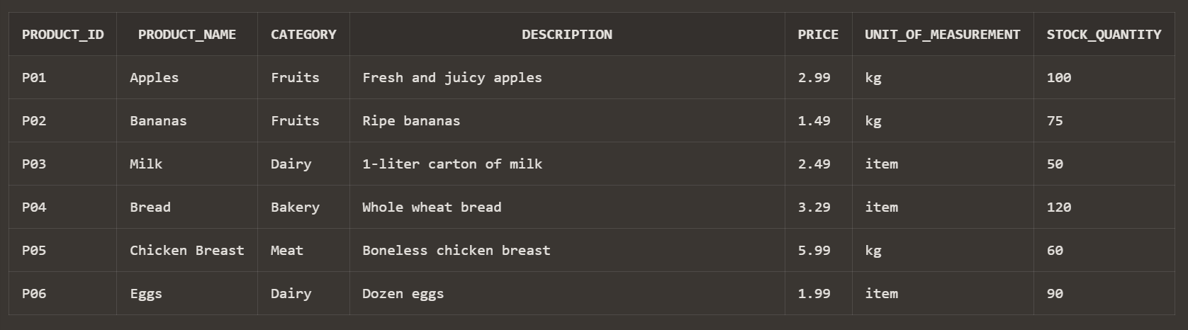

Delete

DELETE FROM Products WHERE Product_ID = 'P01';

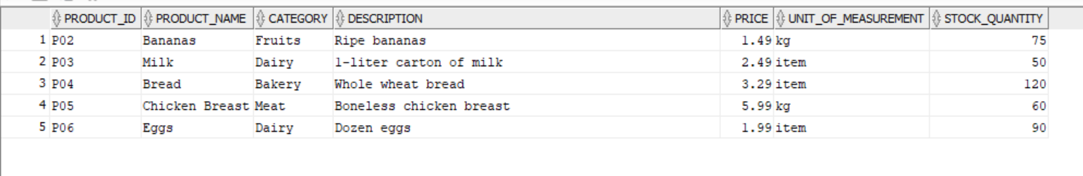

Update

UPDATE Products SET Price = 2.99 WHERE Product_Name = 'Milk';

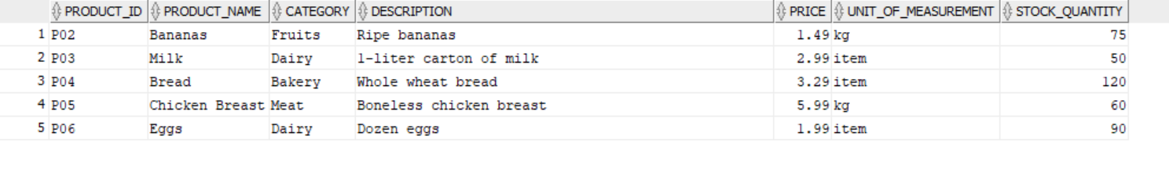

**3.Table Details:** Master Table

**Table Name:** Vendor details

**Purpose:** It provides the information about the vendor

|  |  |  |
| --- | --- | --- |
| **Column Name** | **Data Type** | **Constraint** |
| vendor_id | INT | Primary key |
| Vendor name | VARCHAR(225) | Not null |
| Contact infomation | VARCHAR(225) | Not null |
| Address | VARCHAR(225) | Not null |
| Delivery area | VARCHAAR(225) | Not null |
| Vendor rating | DECIMAL(3,1) | Not null |

**Creation of table** :

CREATE TABLE Vendors (

Vendor_ID INT PRIMARY KEY,

Vendor_Name VARCHAR(255),

Contact_Information VARCHAR(255),

Address VARCHAR(255),

Delivery_Area VARCHAR(255),

Vendor_Rating DECIMAL(3, 1)

);

**Insertion of values** :

INSERT ALL

INTO Vendors (Vendor_ID, Vendor_Name, Contact_Information, Address, Delivery_Area, Vendor_Rating)

VALUES (1, 'Fresh Mart', 'contact@freshmart.com', '123 Grocery St, City, Country', 'City Area', 4.5)

INTO Vendors (Vendor_ID, Vendor_Name, Contact_Information, Address, Delivery_Area, Vendor_Rating)

VALUES (2, 'Green Grocers', 'info@greengrocers.com', '456 Produce Ave, City, Country', 'Suburb Area', 4.2)

INTO Vendors (Vendor_ID, Vendor_Name, Contact_Information, Address, Delivery_Area, Vendor_Rating)

VALUES (3, 'Farm to Table', 'support@farmtotable.com', '789 Farm Road, City, Country', 'Rural Area', 4.7)

INTO Vendors (Vendor_ID, Vendor_Name, Contact_Information, Address, Delivery_Area, Vendor_Rating)

VALUES (4, 'Super Saver Mart', 'info@supersavermart.com', '101 Discount Dr, City, Country', 'City Area', 3.9)

INTO Vendors (Vendor_ID, Vendor_Name, Contact_Information, Address, Delivery_Area, Vendor_Rating)

VALUES (5, 'Organic Oasis', 'info@organicoasis.com', '222 Organic Lane, City, Country', 'City Area', 4.8)

INTO Vendors (Vendor_ID, Vendor_Name, Contact_Information, Address, Delivery_Area, Vendor_Rating)

VALUES (6, 'Local Grocers', 'contact@localgrocers.com', '333 Community St, City, Country', 'Suburb Area', 4.0)

SELECT * FROM dual;

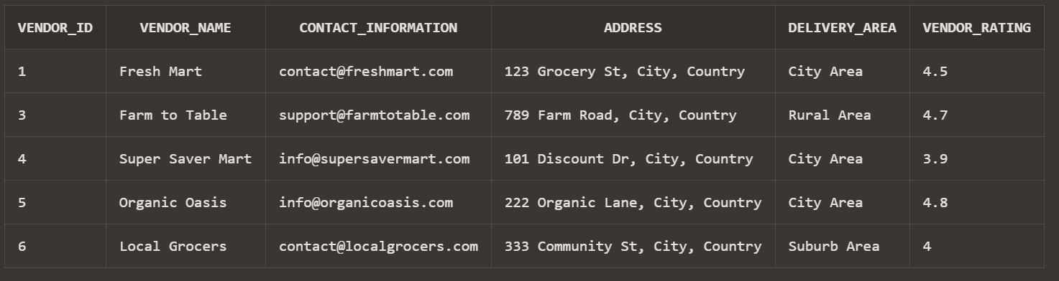

**4.Table Details:** Master Table

**Table Name:** Order details

**Purpose:** It provides the information about the order placed

|  |  |  |
| --- | --- | --- |
| **Column Name** | **Data Type** | **Constraint** |
| order_id | INT | Primary key |
| Customer_id | INT | Not null |
| Order_date | DATE | Not null |
| Delivery address | VARCHAR(225) | Not null |
| Order status | VARCHAR(20) | Not null |
| Total amount | DECIMAL(10,2) | Not null |

**Creation of table:**

CREATE TABLE Orders (

Order_ID INT PRIMARY KEY,

Customer_ID INT,

Order_Date DATE,

Delivery_Address VARCHAR(255),

Order_Status VARCHAR(20), Total_Amount DECIMAL(10, 2), FOREIGN KEY (Customer_ID) REFERENCES Customers(Customer_ID)

);

**Insertion of Values** :

INSERT INTO Orders VALUES (1, 1, to_date('2023-10-01','yyyy-mm-dd'), '123 Main St, City, Country', 'Pending', 50.99);

INSERT INTO Orders VALUES (2, 2,to_date( '2023-10-02','yyyy-mm-dd'), '456 Elm St, City, Country', 'Delivered', 35.75);

INSERT INTO Orders VALUES (3, 3,to_date( '2023-10-03','yyyy-mm-dd'), '789 Oak St, City, Country', 'Pending', 75.50),

INSERT INTO Orders VALUES (4, 4,to_date( '2023-10-04','yyyy-mm-dd'), '321 Birch St, City, Country', 'Delivered', 90.25),

INSERT INTO Orders VALUES (5, 5, to_date('2023-10-05','yyyy-mm-dd'), '567 Pine St, City, Country', 'Delivered', 65.00),

INSERT INTO Orders VALUES (6, 6, to_date('2023-10-06','yyyy-mm-dd'), '987 Cedar St, City, Country', 'Pending', 120.75);

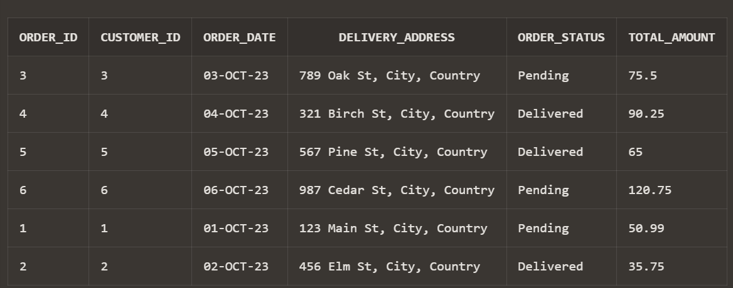

**5.Table Details:** Master Table

**Table Name: P**ayment methods

**Purpose:** It provides information about method of payment

|  |  |  |
| --- | --- | --- |
| **Column Name** | **Data Type** | **Constraint** |
| Payment method id | INT | Primary key |
| customer_id | INT | Not null |
| Payment type | VARCHAR (50) | Not null |

**Creation of table** :

CREATE TABLE PaymentMethods (

PaymentMethod_ID INT PRIMARY KEY,

Customer_ID INT,

Payment_Type VARCHAR(50),

FOREIGN KEY (Customer_ID) REFERENCES Customers(Customer_ID)

);

**Insertion of values** :

insert into PaymentMethods values(1, 1, 'Credit Card');

insert into PaymentMethods values (2, 2, 'Debit Card');

insert into PaymentMethods values (3, 3, 'Credit Card');

insert into PaymentMethods values (4, 4, 'Cash');

insert into PaymentMethods values (5, 5, 'Debit Card');

insert into PaymentMethods values (6, 6, 'Credit Card');

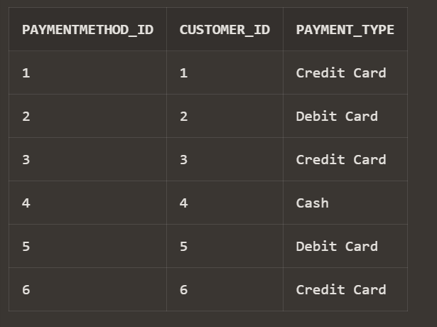

**TRANSACTION TABLES**

**6.Table Details:** Transaction Table

**Table Name:** order item details

**Purpose:** It provides information about items that has been ordered

|  |  |  |
| --- | --- | --- |
| **Column Name** | **Data Type** | **Constraint** |
| Order_item_id | INT | Primary key |
| order_id | INT | Not null |
| Product_id | VARCHAR(20) | Not null |
| quantity | INT | Not null |
| Unit price | DECIMAL(10,2) | Not null |
| Sub total | DECIMAL(10,2) | Not null |

**Creation of table:**

CREATE TABLE Order_Items (

Order_Item_ID INT PRIMARY KEY,

Order_ID INT,

Product_ID VARCHAR(20),

Quantity INT,

Unit_Price DECIMAL(10, 2), Subtotal DECIMAL(10, 2), FOREIGN KEY (Order_ID) REFERENCES Orders(Order_ID),

FOREIGN KEY (Product_ID) REFERENCES Products(Product_ID)

);

**Insertion of values:**

INSERT INTO Order_Items (Order_Item_ID, Order_ID, Product_ID, Quantity, Unit_Price, Subtotal)

VALUES (1, 1, 'P01', 2, 2.99, 5.98);

INSERT INTO Order_Items (Order_Item_ID, Order_ID, Product_ID, Quantity, Unit_Price, Subtotal)

VALUES (2, 1, 'P02', 3, 1.49, 4.47);

INSERT INTO Order_Items (Order_Item_ID, Order_ID, Product_ID, Quantity, Unit_Price, Subtotal)

VALUES (3, 2, 'P03', 1, 2.49, 2.49);

INSERT INTO Order_Items (Order_Item_ID, Order_ID, Product_ID, Quantity, Unit_Price, Subtotal)

VALUES (4, 2, 'P04', 2, 3.29, 6.58);

INSERT INTO Order_Items (Order_Item_ID, Order_ID, Product_ID, Quantity, Unit_Price, Subtotal)

VALUES (5, 3, 'P05', 4, 5.99, 23.96);

INSERT INTO Order_Items (Order_Item_ID, Order_ID, Product_ID, Quantity, Unit_Price, Subtotal)

VALUES (6, 3, 'P06', 1, 1.99, 1.99);

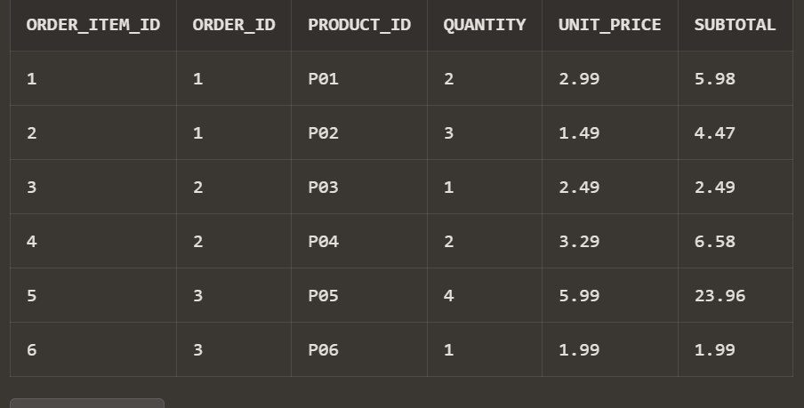

**7. TABLE NAME :** Transaction details

**TABLE DETAILS :** cart item details

**Purpose:** It provides information about items in the cart

|  |  |  |
| --- | --- | --- |
| **Column Name** | **Data Type** | **Constraint** |
| Cart_item_id | INT | Primary key |
| Customer_id | INT | Not null |
| Product_id | VARCHAR(20) | Not null |
| quantity | INT | Not null |

**Creation of table:**

CREATE TABLE Cart_Items (

Cart_Item_ID INT PRIMARY KEY,

Customer_ID INT,

Product_ID VARCHAR(20),

Quantity INT,

FOREIGN KEY (Customer_ID) REFERENCES Customers(Customer_ID),

FOREIGN KEY (Product_ID) REFERENCES Products(Product_ID)

);

**Insertion of values**:

INSERT INTO Cart_Items (Cart_Item_ID, Customer_ID, Product_ID, Quantity) VALUES (1, 1, 'P01', 2);

INSERT INTO Cart_Items (Cart_Item_ID, Customer_ID, Product_ID, Quantity) VALUES (2, 1, 'P02', 3);

INSERT INTO Cart_Items (Cart_Item_ID, Customer_ID, Product_ID, Quantity) VALUES (3, 2, 'P03', 1);

INSERT INTO Cart_Items (Cart_Item_ID, Customer_ID, Product_ID, Quantity) VALUES (4, 2, 'P04', 2);

INSERT INTO Cart_Items (Cart_Item_ID, Customer_ID, Product_ID, Quantity) VALUES (5, 3, 'P05', 4);

INSERT INTO Cart_Items (Cart_Item_ID, Customer_ID, Product_ID, Quantity) VALUES (6, 3, 'P06', 1);

select * from Cart_Items;

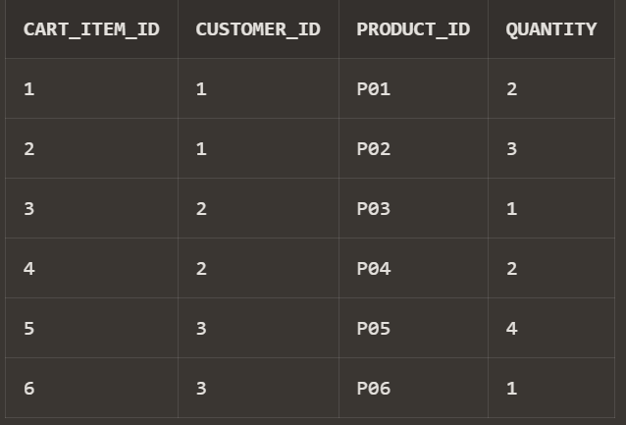

**8. TABLE NAME :** delivery_status

**TABLE DETAILS :** Transaction table

**Purpose :** this table is to track the delivery status

|  |  |  |
| --- | --- | --- |
| **Column Name** | **Data Type** | **Constraint** |
| Delivery_status_id | INT | Primary key |
| Order_id | INT | Not null |
| status | VARCHAR (20) | Not null |
| Status_Update_Timestamp | TIMESTAMP | Not null |

**Creation of table:**

CREATE TABLE Delivery_Status (

Delivery_Status_ID INT PRIMARY KEY,

Order_ID INT,

Status VARCHAR(20), Status_Update_Timestamp TIMESTAMP, FOREIGN KEY (Order_ID) REFERENCES Orders(Order_ID)

);

**Insertion of values:**

INSERT INTO Delivery_Status (Delivery_Status_ID, Order_ID, Status, Status_Update_Timestamp)

SELECT 1, 1, 'En Route', TO_TIMESTAMP('2023-10-01 14:30:00', 'YYYY-MM-DD HH24:MI:SS') FROM DUAL UNION ALL

SELECT 2, 2, 'Delivered', TO_TIMESTAMP('2023-10-02 10:15:00', 'YYYY-MM-DD HH24:MI:SS') FROM DUAL UNION ALL

SELECT 3, 3, 'En Route', TO_TIMESTAMP('2023-10-03 16:45:00', 'YYYY-MM-DD HH24:MI:SS') FROM DUAL UNION ALL

SELECT 4, 4, 'Delivered', TO_TIMESTAMP('2023-10-04 12:20:00', 'YYYY-MM-DD HH24:MI:SS') FROM DUAL UNION ALL

SELECT 5, 5, 'Delivered', TO_TIMESTAMP('2023-10-05 09:55:00', 'YYYY-MM-DD HH24:MI:SS') FROM DUAL UNION ALL

SELECT 6, 6, 'En Route', TO_TIMESTAMP('2023-10-06 17:10:00', 'YYYY-MM-DD HH24:MI:SS') FROM DUAL;

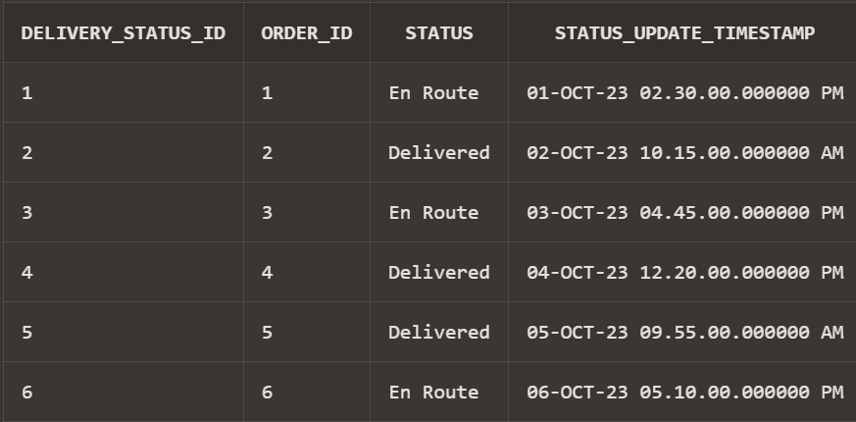

**9. TABLE NAME :**Review details

**TABLE DETAILS :** Transaction table

**Purpose:** this table provides the review details

|  |  |  |
| --- | --- | --- |
| **Column Name** | **Data Type** | **Constraint** |
| review_id | INT | Primary key |
| customer_id | INT | Not null |
| Product_id | VARCHAR(20) | Not null |
| Rating | INT | Not null |
| Review text | TEXT | Not null |
| Review date | TEXT | Not null |

**Creation of table:**

CREATE TABLE Product_Reviews (

Review_ID INT PRIMARY KEY,

Customer_ID INT,

Product_ID VARCHAR(20),

Rating INT,

Review_Text CHAR(50),

Review_Date DATE,

FOREIGN KEY (Customer_ID) REFERENCES Customers(Customer_ID),

FOREIGN KEY (Product_ID) REFERENCES Products(Product_ID)

);

**Insertion of values:**

INSERT INTO Product_Reviews (Review_ID, Customer_ID, Product_ID, Rating, Review_Text, Review_Date)

SELECT 1, 1, 'P01', 4, 'Great product, fresh and delicious!', TO_DATE('2023-10-01', 'YYYY-MM-DD') FROM DUAL UNION ALL

SELECT 2, 2, 'P02', 5, 'Excellent quality, highly recommended!', TO_DATE('2023-10-02', 'YYYY-MM-DD') FROM DUAL UNION ALL

SELECT 3, 3, 'P03', 3, 'Average product, could be better.', TO_DATE('2023-10-03', 'YYYY-MM-DD') FROM DUAL UNION ALL

SELECT 4, 4, 'P04', 4, 'Good value for the price.', TO_DATE('2023-10-04', 'YYYY-MM-DD') FROM DUAL UNION ALL

SELECT 5, 5, 'P05', 5, 'Absolutely love it, will buy again!', TO_DATE('2023-10-05', 'YYYY-MM-DD') FROM DUAL UNION ALL

SELECT 6, 6, 'P06', 4, 'Decent product, does the job.', TO_DATE('2023-10-06', 'YYYY-MM-DD') FROM DUAL;

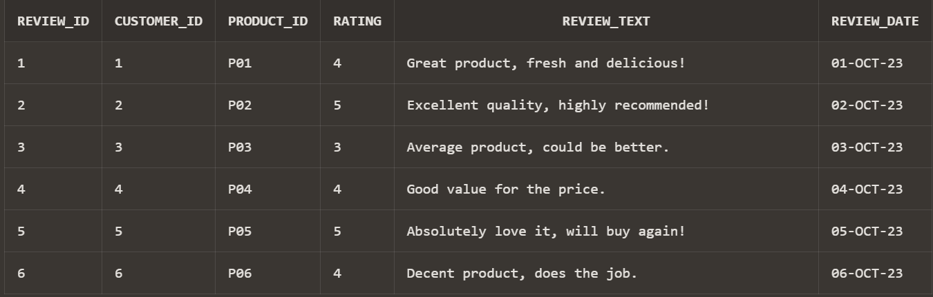

**10. TABLE NAME :** promotion details

**TABLE DETAILS :** Transaction table

**Purpose**: This shows the details of promotion

|  |  |  |
| --- | --- | --- |
| **Column Name** | **Data Type** | **Constraint** |
| Promotion id | INT | Primary key |
| Product id | INT | Not null |
| Discount percentage | DECIMAL(5,2) | Not null |
| Start date | DATE | Not null |
| End date | DATE | Not null |

**Creation of table:**

CREATE TABLE Promotions (

Promotion_ID INT PRIMARY KEY,

Product_ID VARCHAR(20), Discount_Percentage DECIMAL(5, 2), Start_Date DATE,

End_Date DATE

);

**Insertion of values** :

VALUES (1, 'P01', 10.00, TO_DATE('2023-10-01', 'YYYY-MM-DD'), TO_DATE('2023-10-15', 'YYYY-MM-DD'));

INSERT INTO Promotions (Promotion_ID, Product_ID, Discount_Percentage, Start_Date, End_Date)

VALUES (2, NULL, 15.00, TO_DATE('2023-10-05', 'YYYY-MM-DD'), TO_DATE('2023-10-20', 'YYYY-MM-DD'));

INSERT INTO Promotions (Promotion_ID, Product_ID, Discount_Percentage, Start_Date, End_Date)

VALUES (3, 'P02', 5.00, TO_DATE('2023-10-10', 'YYYY-MM-DD'), TO_DATE('2023-10-25', 'YYYY-MM-DD'));

INSERT INTO Promotions (Promotion_ID, Product_ID, Discount_Percentage, Start_Date, End_Date)

VALUES (4, NULL, 20.00, TO_DATE('2023-10-15', 'YYYY-MM-DD'), TO_DATE('2023-10-30', 'YYYY-MM-DD'));

INSERT INTO Promotions (Promotion_ID, Product_ID, Discount_Percentage, Start_Date, End_Date)

VALUES (5, 'P03', 12.50, TO_DATE('2023-10-20', 'YYYY-MM-DD'), TO_DATE('2023-11-05', 'YYYY-MM-DD'));

INSERT INTO Promotions (Promotion_ID, Product_ID, Discount_Percentage, Start_Date, End_Date)

VALUES (6, 'P04', 8.00, TO_DATE('2023-10-25', 'YYYY-MM-DD'), TO_DATE('2023-11-10', 'YYYY-MM-DD'));

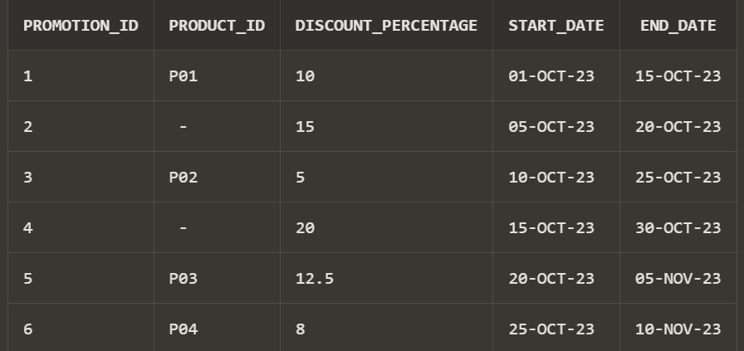

**11. TABLE NAME :** Vendor_inventory details

**TABLE DETAILS :** Transaction table

**Purpose : T**his table provides the information about the vendor inventory.

|  |  |  |
| --- | --- | --- |
| **Column Name** | **Data Type** | **Constraint** |
| Vendor inventory id | INT | Primary key |
| Vendor id | INT | Not null |
| Product id | VARCHAR(20) | Not null |
| Stock quantity | INT | Not null |
| Price | DECIMAL(10,2) | Not null |
| Last updated date | DATE | Not null |

**Creation of table**:

CREATE TABLE Vendor_Inventory (

Vendor_Inventory_ID INT PRIMARY KEY,

Vendor_ID INT,

Product_ID VARCHAR(20),

Stock_Quantity INT,

Price DECIMAL(10, 2), Last_Updated_Date DATE,

FOREIGN KEY (Vendor_ID) REFERENCES Vendors(Vendor_ID),

FOREIGN KEY (Product_ID) REFERENCES Products(Product_ID)

);

**Insertion of values** :

INSERT INTO Vendor_Inventory (Vendor_Inventory_ID, Vendor_ID, Product_ID, Stock_Quantity, Price, Last_Updated_Date)

VALUES(1, 1, 'P01', 200, 2.99, TO_DATE('2023-10-01', 'YYYY-MM-DD'));

INSERT INTO Vendor_Inventory (Vendor_Inventory_ID, Vendor_ID, Product_ID, Stock_Quantity, Price, Last_Updated_Date)

VALUES (2, 2, 'P02', 150, 1.49, TO_DATE('2023-10-02', 'YYYY-MM-DD'));

INSERT INTO Vendor_Inventory (Vendor_Inventory_ID, Vendor_ID, Product_ID, Stock_Quantity, Price, Last_Updated_Date)

VALUES (3, 3, 'P03', 100, 2.49, TO_DATE('2023-10-03', 'YYYY-MM-DD'));

INSERT INTO Vendor_Inventory (Vendor_Inventory_ID, Vendor_ID, Product_ID, Stock_Quantity, Price, Last_Updated_Date)

VALUES (4, 4, 'P04', 120, 3.29, TO_DATE('2023-10-04', 'YYYY-MM-DD'));

INSERT INTO Vendor_Inventory (Vendor_Inventory_ID, Vendor_ID, Product_ID, Stock_Quantity, Price, Last_Updated_Date)

VALUES (5, 5, 'P05', 80, 5.99, TO_DATE('2023-10-05', 'YYYY-MM-DD'));

INSERT INTO Vendor_Inventory (Vendor_Inventory_ID, Vendor_ID, Product_ID, Stock_Quantity, Price, Last_Updated_Date)

VALUES (6, 6, 'P06', 90, 1.99, TO_DATE('2023-10-06', 'YYYY-MM-DD'));

