AGENTIC AI SDR
Sales Development Representative

Prepared for: Salesforce Compass Program
Duration: 8 Weeks
Team Size: 3

1. Executive Summary

The Agentic AI SDR is an autonomous multi-agent software system that performs the complete top-of-funnel sales workflow — from company research through to meeting booking — without continuous human involvement. A human provides a list of target companies; the system does everything else.

1.1 The Problem Being Solved
A Sales Development Representative (SDR) spends the majority of their working day on four activities that are repetitive, time-consuming, and do not require human judgment: researching companies, finding decision-maker contact details, writing personalised outreach emails, and managing follow-up sequences. Studies consistently show that SDRs spend less than 30% of their time actually talking to prospects — the rest is grunt work.
This is the problem the system solves.

1.2 What the System Does
Given a CSV file containing company names, the system autonomously:
- Researches each company — website, recent news, industry, inferred pain points
- Finds the right decision-maker and their verified email address
- Writes a personalised cold email tailored to that specific company
- Sends the email via Gmail
- Monitors for replies, classifies intent (interested / not interested / needs follow-up)
- Sends a follow-up if there is no reply after 3 days
- Drafts a meeting booking email when intent is classified as positive

The human only needs to appear when a meeting is ready to be confirmed. Every step before that is autonomous.

1.3 Precise Definitions
The following terms are used specifically throughout this document:
Term | Definition
Autonomous | The system executes a step without waiting for a human to trigger or approve it, provided confidence thresholds are met
Personalised | The email references a specific, verifiable fact about that company (recent news, product, industry-specific pain point) — not just the company name
Qualified Lead | A company in the CSV that has a reachable decision-maker email and whose industry is not on the excluded list
Decision Maker | The most senior person in a Sales, Marketing, or Operations role at the company, as identified via Hunter.io or Apollo free tier
Intent Classification | A label applied to an inbound reply: INTERESTED, NOT_INTERESTED, or NEEDS_FOLLOW_UP, assigned by the Reply Handler agent with a confidence score

1.4 Operational Boundaries
What this system replaces: manual research, contact discovery, email drafting, email sending, follow-up scheduling, and reply triage.
What this system assists with (human still involved): final meeting confirmation, pricing discussions, enterprise security/legal questions, and any reply the system classifies below 75% confidence.
What this system does not touch: CRM data entry, phone calls,, contract negotiation, or anything after the first meeting is booked.

2. Product Scope

2.1 In Scope (Version 1 — Contest Demo) – Revise this according to free tier resources
- CSV ingestion of up to 30 company records
- Company website scraping and Google News search per company
- Decision-maker name and email discovery via Hunter.io free tier
- Personalised cold email generation using Claude API (claude-sonnet-4-20250514)
- Email delivery via Gmail API using OAuth 2.0
- Open and reply tracking via Gmail API polling
- Intent classification of inbound replies
- Automated 3-day follow-up if no reply
- Meeting booking email draft when intent = INTERESTED
- Simple React dashboard showing lead status, emails sent, replies received
- Human approval queue for low-confidence decisions

2.2 Out of Scope (Version 1)
- Processing more than 30 leads simultaneously — not enough API quota on free tiers
- Phone/SMS/WhatsApp outreach (LinkedIn also possible?)
- LinkedIn messaging
- Multi-language email support
- CRM integration (Salesforce, HubSpot, etc.)
- Payment or contract handling
- GDPR consent collection flows
- Custom domain email sending (spam deliverability engineering)
- A/B testing of email copy

2.3 Future Scope (Post-Contest Roadmap)
- Scale to 500+ leads with queue-based parallel processing
- LinkedIn and Twitter signal monitoring
- Native Salesforce CRM integration via REST API
- Multi-language support (Spanish, French, German)
- Custom sending domain with warm-up sequences
- Analytics dashboard with conversion funnel metrics

3. Agent Architecture

The system is composed of five specialised agents, each with a strictly defined responsibility. Agents communicate only through a shared database (Supabase) – Please check if this database is free, can be designed to handle our schema and data forwarding), never by calling each other directly. This design prevents cascading failures and makes each agent independently testable.

Design principle: Every agent reads from the database, performs one job, and writes its output back to the database. No agent calls another agent directly.

3.1 Agent Overview
Agent ID | Name | One-Line Responsibility | Input | Output
A1 | Research Agent | Gather public intelligence on a company | Company name from CSV | Summary, industry, pain points, confidence score
A2 | Contact Agent | Find decision-maker name and email | Company name + domain | Contact name, email, role, confidence score
A3 | Email Writer Agent | Draft a personalised outbound email | Research output + contact details | Email subject + body text
A4 | Sender & Tracker Agent | Send email and monitor for responses | Drafted email + Gmail credentials | Sent timestamp, open event, reply text
A5 | Reply Handler Agent | Classify reply intent and decide next action | Reply email text | Intent label, confidence score, recommended action

3.2 Agent Boundaries — What Each Agent Cannot Do
These constraints are enforced in code, not just policy. Each agent is a separate module with no imports from other agent modules.
Agent | Strictly Prohibited Actions
A1 — Research Agent | Cannot access Gmail. Cannot write to the contacts table. Cannot trigger email sending.
A2 — Contact Agent | Cannot scrape website content or interpret news. Cannot write email drafts.
A3 — Email Writer Agent | Cannot send emails. Cannot access Gmail API directly. Can only write to the drafts table.
A4 — Sender & Tracker Agent | Cannot modify email content after it is passed to it. Cannot classify replies.
A5 — Reply Handler Agent | Cannot book meetings autonomously — it only drafts the booking email and flags for human review if confidence is below 80%.

3.3 Orchestration Engine
A lightweight orchestration layer (built using LangGraph) manages the workflow state for each lead. The orchestrator does not make business decisions — it only reads the current state of a lead record and triggers the appropriate next agent.

Diagram 1: Agent Interaction Flow
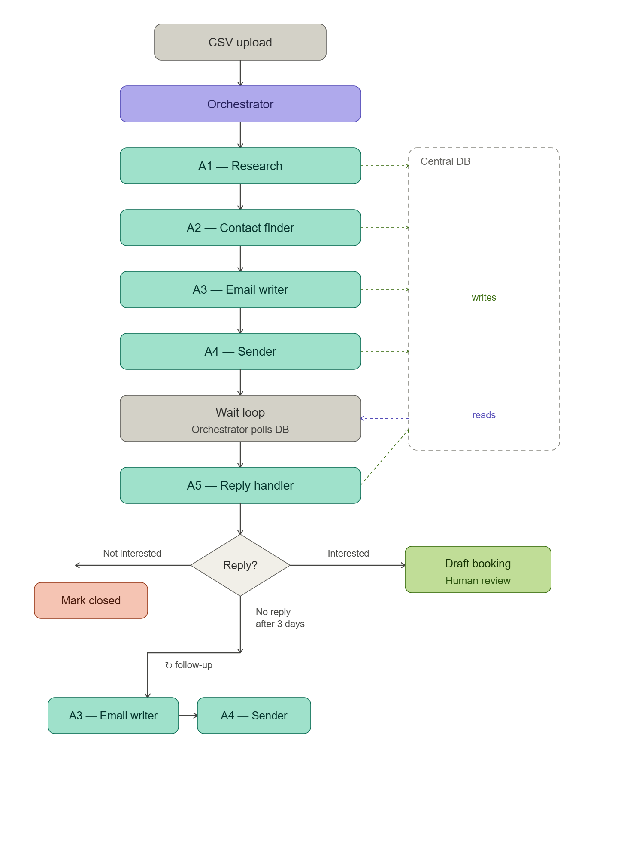

Diagram 2: System Architecture Overview
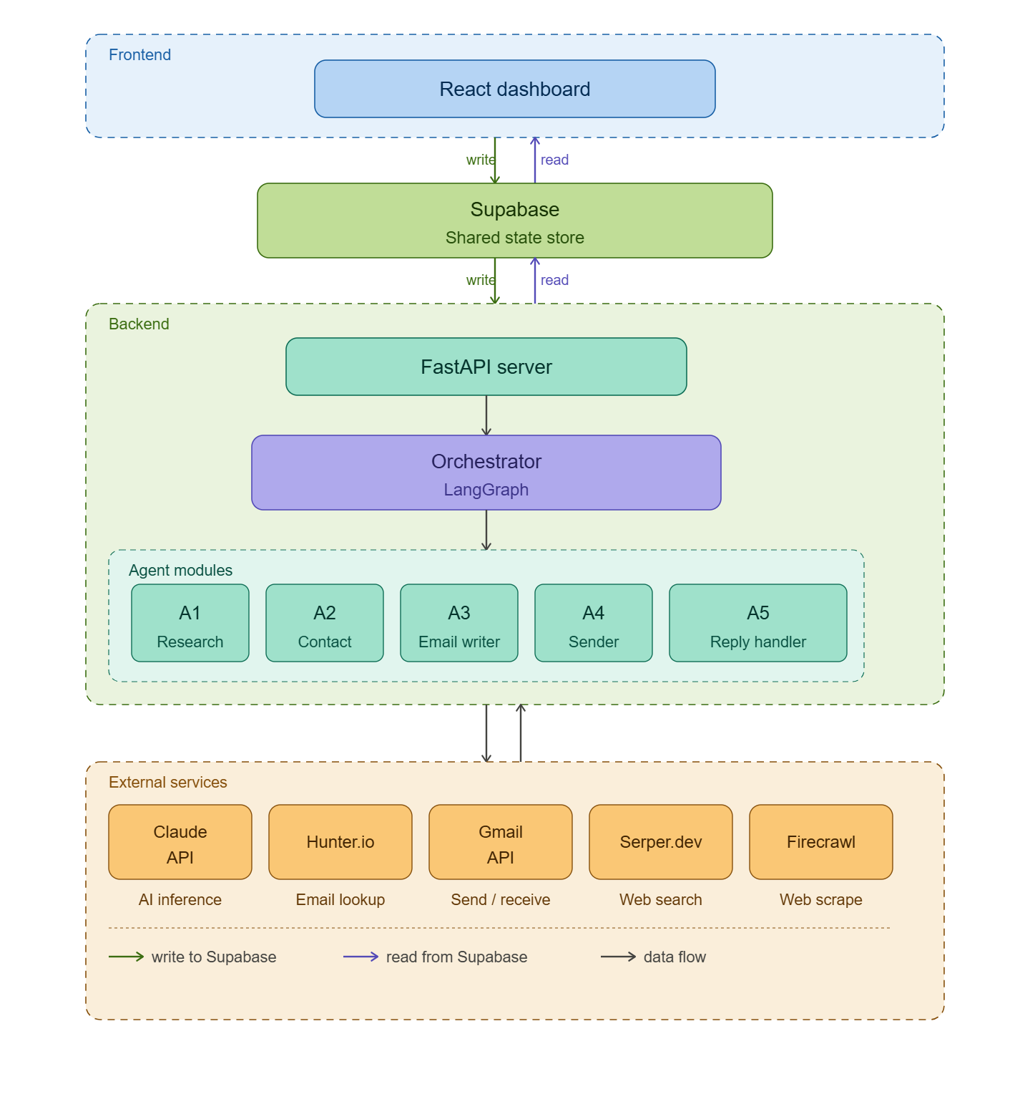 (Please adjust it according to the decided free-tier models)

4. Functional Requirements

Each feature is documented with its trigger, inputs, outputs, failure modes, and success criteria.

FR-01: CSV Lead Ingestion
Field | Detail
Trigger | User uploads a CSV file via the dashboard UI
Required CSV Columns | company_name (required), website (optional), industry (optional) (any more?)
Validation | Reject rows missing company_name. Flag duplicates. Cap at 30 rows for v1.
Output | Each valid row inserted into the leads table with status = UPLOADED
Failure Mode | Invalid CSV format, missing required column, or file > 1MB
Failure Handling | Return clear error message to UI. Do not partially ingest.
Success Criteria | All valid rows inserted within 5 seconds of upload

FR-02: Company Research (Agent A1)
Field | Detail
Trigger | Lead status transitions to RESEARCH_PENDING
Inputs | company_name, website (if provided in CSV)
Process | 1. Fetch homepage via Firecrawl. 2. Run Google News search via Serper.dev. 3. Pass scraped content to Claude API with structured output prompt.
Output Schema | { company_summary, industry, employee_size_estimate, pain_points: [], recent_news: [], confidence_score }
Confidence Threshold | If confidence_score < 0.65, flag lead for human review before continuing
Failure Modes | Website blocked by bot detection, domain not found, Claude API timeout
Retry Logic | Retry up to 2 times with 10-second delay. After 2 failures, set status = RESEARCH_FAILED and alert human.
Success Criteria | Research completed in under 45 seconds per lead with confidence_score >= 0.65

FR-03: Contact Discovery (Agent A2)
Field | Detail
Trigger | Lead status = RESEARCH_COMPLETE
Inputs | company_name, company domain extracted from website
Process | Query Hunter.io Domain Search API. Select contact with highest seniority in Sales, Marketing, or Operations roles.
Output | { contact_name, contact_email, contact_role, email_verified, confidence_score }
Failure Modes | Company not in Hunter.io database, free tier quota exhausted (25/month), unverifiable email
Fallback | If Hunter.io returns no result, attempt Apollo.io free tier. If both fail, mark lead as NO_CONTACT_FOUND and skip — do not send to unknown email.
Success Criteria | Verified contact email found for at least 60% of leads in the batch

FR-04: Email Drafting (Agent A3)
Field | Detail
Trigger | Lead status = CONTACT_FOUND
Inputs | Research output (pain points, recent news), contact name and role
Process | Send structured prompt to Claude API requesting a cold email. Output validated against schema.
Personalisation Requirement | Email must reference at least one specific fact from the research output (not just company name). Validated by checking that pain_points or recent_news items appear in the body.
Output | { subject_line, email_body, personalisation_fact_used, word_count }
Guardrails | Email must be under 200 words. Must not contain pricing claims. Must not impersonate a human without disclosure. Must include unsubscribe line.
Failure Mode | Claude API returns output that fails schema validation or guardrail check
Retry Logic | Re-prompt once with stricter constraints. If second attempt fails, route to human draft queue.
Success Criteria | Draft passes all guardrail checks and is under 200 words

FR-05: Email Sending & Tracking (Agent A4)
Field | Detail
Trigger | Lead status = DRAFT_READY (and human_approval_required = false, or human has approved) is human loop-in required here?
Inputs | Drafted email, recipient email address, Gmail OAuth token
Process | Send via Gmail API. Record sent timestamp and Gmail message ID. Poll Gmail inbox every 15 minutes for reply or bounce.
Idempotency | Before sending, check that no email has already been sent to this address in the last 7 days. Hard block if duplicate detected.
Output | { sent_at, gmail_message_id, status: SENT }
Follow-up Logic | If no reply detected after 72 hours (3 days), trigger Agent A3 to write a follow-up and send once. Maximum 1 follow-up per lead.
Failure Mode | Gmail API quota exceeded, OAuth token expired, bounce received
Failure Handling | Token expiry triggers re-auth flow notification to human. Bounce marks lead as INVALID_EMAIL.
Success Criteria | Email delivered (no bounce) within 60 seconds of trigger

FR-06: Reply Handling (Agent A5)
Field | Detail
Trigger | Gmail poller detects a new reply to a sent email
Inputs | Reply email text, original email context, lead data
Process | Send reply text to Claude API with classification prompt. Receive structured intent label and confidence score.
Intent Labels | INTERESTED (wants to learn more, asks for demo/call), NOT_INTERESTED (explicit decline, unsubscribe), NEEDS_FOLLOW_UP (ambiguous, out-of-office, question that needs human answer)
Confidence Thresholds | INTERESTED with score >= 0.80 → auto-draft booking email. Any label with score < 0.75 → escalate to human queue. NOT_INTERESTED with score >= 0.80 → mark lead CLOSED_LOST.
Output | { intent, confidence_score, recommended_action, booking_email_draft (if applicable) }
Human Escalation | All escalated replies appear in the dashboard with full context. Human selects action from predefined options.
Success Criteria | Intent correctly classified (validated manually in demo) with >= 85% accuracy

5. Workflow State Machine

Every lead record has a status field. The orchestrator reads this field and decides which agent to trigger next. No agent can write an arbitrary status — each can only write the specific transition it is responsible for.

5.1 Valid Lead States
Status | Meaning | Set By
UPLOADED | Lead ingested from CSV, not yet processed | CSV Ingestion module
RESEARCH_PENDING | Research agent queued | Orchestrator
RESEARCH_COMPLETE | Company data gathered successfully | Agent A1
RESEARCH_FAILED | Research could not complete after retries | Agent A1
CONTACT_FOUND | Decision-maker email verified | Agent A2
NO_CONTACT_FOUND | No usable email found from any source | Agent A2
DRAFT_READY | Email drafted, ready to send (or awaiting approval) | Agent A3
SENT | Email delivered to recipient | Agent A4
FOLLOW_UP_SENT | One follow-up email delivered | Agent A4
REPLY_RECEIVED | Inbound reply detected in Gmail | Gmail poller
INTERESTED | Reply classified as buying interest | Agent A5
BOOKING_DRAFTED | Meeting booking email ready for human to send | Agent A5
CLOSED_LOST | Lead explicitly declined or disqualified | Agent A5 or Human
HUMAN_REVIEW | Agent confidence too low; awaiting human decision | Any agent
INVALID_EMAIL | Email bounced — address does not exist | Agent A4

5.2 Allowed State Transitions
The following transitions are the only valid ones. The orchestrator rejects any transition not on this list.
(How often should human review state exist?)
From | To | Condition
UPLOADED | RESEARCH_PENDING | Always (orchestrator queues immediately)
RESEARCH_PENDING | RESEARCH_COMPLETE | A1 returns confidence >= 0.65
RESEARCH_PENDING | HUMAN_REVIEW | A1 returns confidence < 0.65
RESEARCH_PENDING | RESEARCH_FAILED | A1 fails after 2 retries
RESEARCH_COMPLETE | CONTACT_FOUND | A2 finds verified email
RESEARCH_COMPLETE | NO_CONTACT_FOUND | A2 exhausts all sources
CONTACT_FOUND | DRAFT_READY | A3 produces valid email draft
CONTACT_FOUND | HUMAN_REVIEW | A3 fails guardrail check twice
DRAFT_READY | SENT | A4 delivers email, no bounce
SENT | FOLLOW_UP_SENT | 72 hours elapsed, no reply
SENT | REPLY_RECEIVED | Gmail poller detects inbound message
FOLLOW_UP_SENT | REPLY_RECEIVED | Gmail poller detects inbound message
REPLY_RECEIVED | INTERESTED | A5 classifies intent, confidence >= 0.80
INTERESTED | BOOKING_DRAFTED | A5 produces meeting booking email
REPLY_RECEIVED | CLOSED_LOST | A5 classifies NOT_INTERESTED, confidence >= 0.80
REPLY_RECEIVED | HUMAN_REVIEW | A5 confidence < 0.75
SENT | INVALID_EMAIL | Bounce notification received from Gmail
FOLLOW_UP_SENT | CLOSED_LOST | No reply after further 72 hours
HUMAN_REVIEW | Any valid state | Human selects action from dashboard

Diagram 3: State Machine Diagram
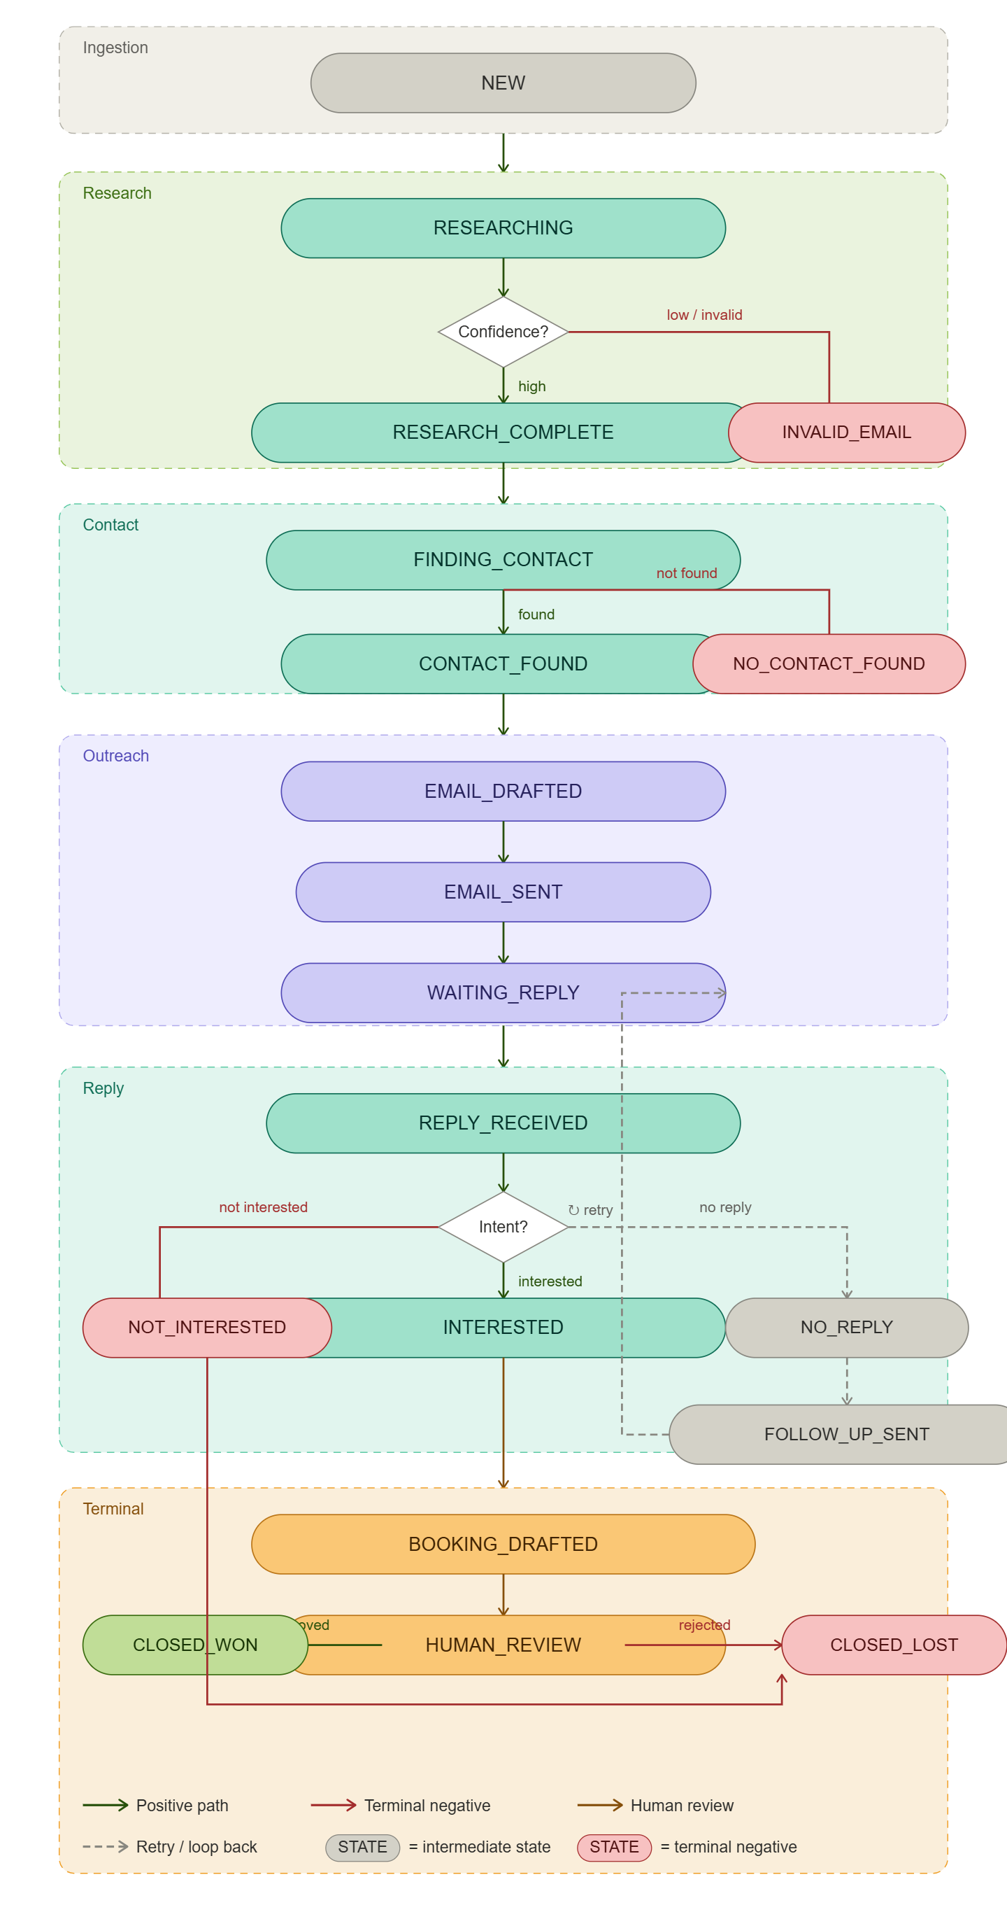
6. Prompt Engineering Specification

Prompts are treated as system components, not ad hoc text. Each agent that calls the Claude API has a versioned, documented prompt with a defined output schema. Changes to prompts require a version increment.

6.1 Agent A1 — Research Prompt
System Prompt
You are a business intelligence analyst. Given the content of a company website and recent news articles, produce a structured JSON summary. Be factual — only include information that is clearly supported by the provided content. Do not invent details. If information is unavailable, use null.

Output Schema
{ "company_summary": "string (max 100 words)", "industry": "string", "employee_size_estimate": "string (e.g. 50-200)", "pain_points": ["string"], "recent_news": ["string"], "confidence_score": "float 0.0-1.0" }

Hallucination Prevention
- Prompt explicitly instructs: only use information from the provided content
- Output validated — if pain_points array is empty, confidence_score must be below 0.70
- Any proper noun in the output is cross-checked against the input text before dispatch

6.2 Agent A3 — Email Writer Prompt
System Prompt
You are a sales copywriter. Write a cold outreach email from the perspective of a sales representative. The email must: (1) be under 200 words, (2) reference one specific fact about the recipient's company from the research data provided, (3) include a single clear call to action, (4) end with "To opt out, reply STOP." Do not mention pricing. Do not claim the email is from a human if it was generated by AI.
(At what point do we reveal that it was generated by AI, if necessary at all?)

Output Schema
{ "subject_line": "string", "email_body": "string", "personalisation_fact_used": "string", "word_count": "integer" }

6.3 Agent A5 — Reply Classification Prompt
System Prompt
You are an email intent classifier for a B2B sales system. Classify the following email reply into exactly one of: INTERESTED, NOT_INTERESTED, NEEDS_FOLLOW_UP. Provide a confidence score between 0.0 and 1.0. INTERESTED means the person wants to continue the conversation or book a meeting. NOT_INTERESTED means explicit decline or unsubscribe. NEEDS_FOLLOW_UP means anything else — ambiguous, out of office, or a question that requires a human answer.

Output Schema
{ "intent": "INTERESTED | NOT_INTERESTED | NEEDS_FOLLOW_UP", "confidence_score": "float 0.0-1.0", "reasoning": "string (max 50 words)" }

7. Data Contracts

These are the exact data structures passed between agents via the database. Every agent reads and writes only to its designated fields. Schema changes require all dependent agents to be updated simultaneously.

7.1 Leads Table (Primary State Store)
Field | Type | Set By | Description
id | UUID | System | Primary key, auto-generated
company_name | string | CSV Ingestion | As provided in CSV
website | string | null | CSV Ingestion | Optional, used by A1
status | enum | Orchestrator / Agents | Current workflow state (see Section 5)
research_output | JSON | A1 | Full output of research agent
contact_name | string | null | A2 | Decision-maker full name
contact_email | string | null | A2 | Verified email address
contact_role | string | null | A2 | Job title
email_draft | JSON | null | A3 | { subject_line, email_body, personalisation_fact_used }
gmail_message_id | string | null | A4 | Used to thread replies correctly
sent_at | timestamp | null | A4 | UTC timestamp of send
reply_text | string | null | Gmail poller | Raw text of inbound reply
intent | enum | null | A5 | INTERESTED / NOT_INTERESTED / NEEDS_FOLLOW_UP
intent_confidence | float | null | A5 | 0.0 to 1.0
human_approval_required | boolean | Any agent | Flags lead for human review queue
created_at | timestamp | System | Auto-set on record creation
updated_at | timestamp | System | Auto-updated on any change

7.2 Invalid Data Handling
Scenario | Detection | Handling
Null or empty company_name | CSV validation at ingestion | Row rejected, user notified with row number
Malformed email address | Regex check before A4 sends | Lead flagged INVALID_EMAIL, not sent
Duplicate company in same batch | Checked on ingestion | Second occurrence rejected, user notified
Research returns empty pain_points array | A1 output validation | Confidence score auto-capped at 0.60, may route to HUMAN_REVIEW
Email body exceeds 200 words | A3 output validation | Agent re-prompts once. If still fails, routes to human draft queue
Hunter.io returns unverified email | A2 checks 'email_verified' field in API response | Only verified emails are used. Unverified are discarded.

8. External Integrations

The system depends on the following external services. All are available at no cost for demo-scale usage (up to 30 leads per batch). – Revise this table according to final research.

Service | Purpose | Free Tier Limit | Failure Handling | Fallback
Claude API (Sonnet) | Email drafting, research structuring, intent classification | Pay-as-you-go; ~$5-10 for full demo | Retry 3x with exponential backoff | Route to human queue after 3 failures
Serper.dev | Google News and web search for company research | 100 free searches/month | Cache results; avoid redundant searches | Skip news enrichment, use website only
Firecrawl | Website content scraping | 100 pages/month free tier | Timeout after 10s; retry once | Use meta description only if scrape fails
Hunter.io | Decision-maker email discovery | 25 searches/month (free) | Switch to Apollo.io if quota hit | Mark lead NO_CONTACT_FOUND after both exhausted
Apollo.io | Fallback contact discovery | 50 exports/month (free tier) | Log exhaustion; notify operator | Mark lead NO_CONTACT_FOUND
Gmail API | Send emails, poll for replies | Standard Gmail quota (500 emails/day) | Notify human if token expires; pause sending | No fallback — email required
Supabase | Database and real-time state store | 500MB free tier | Retry on transient errors; alert if down | Local SQLite fallback for demo resilience

Diagram 4: Integration Data Flow
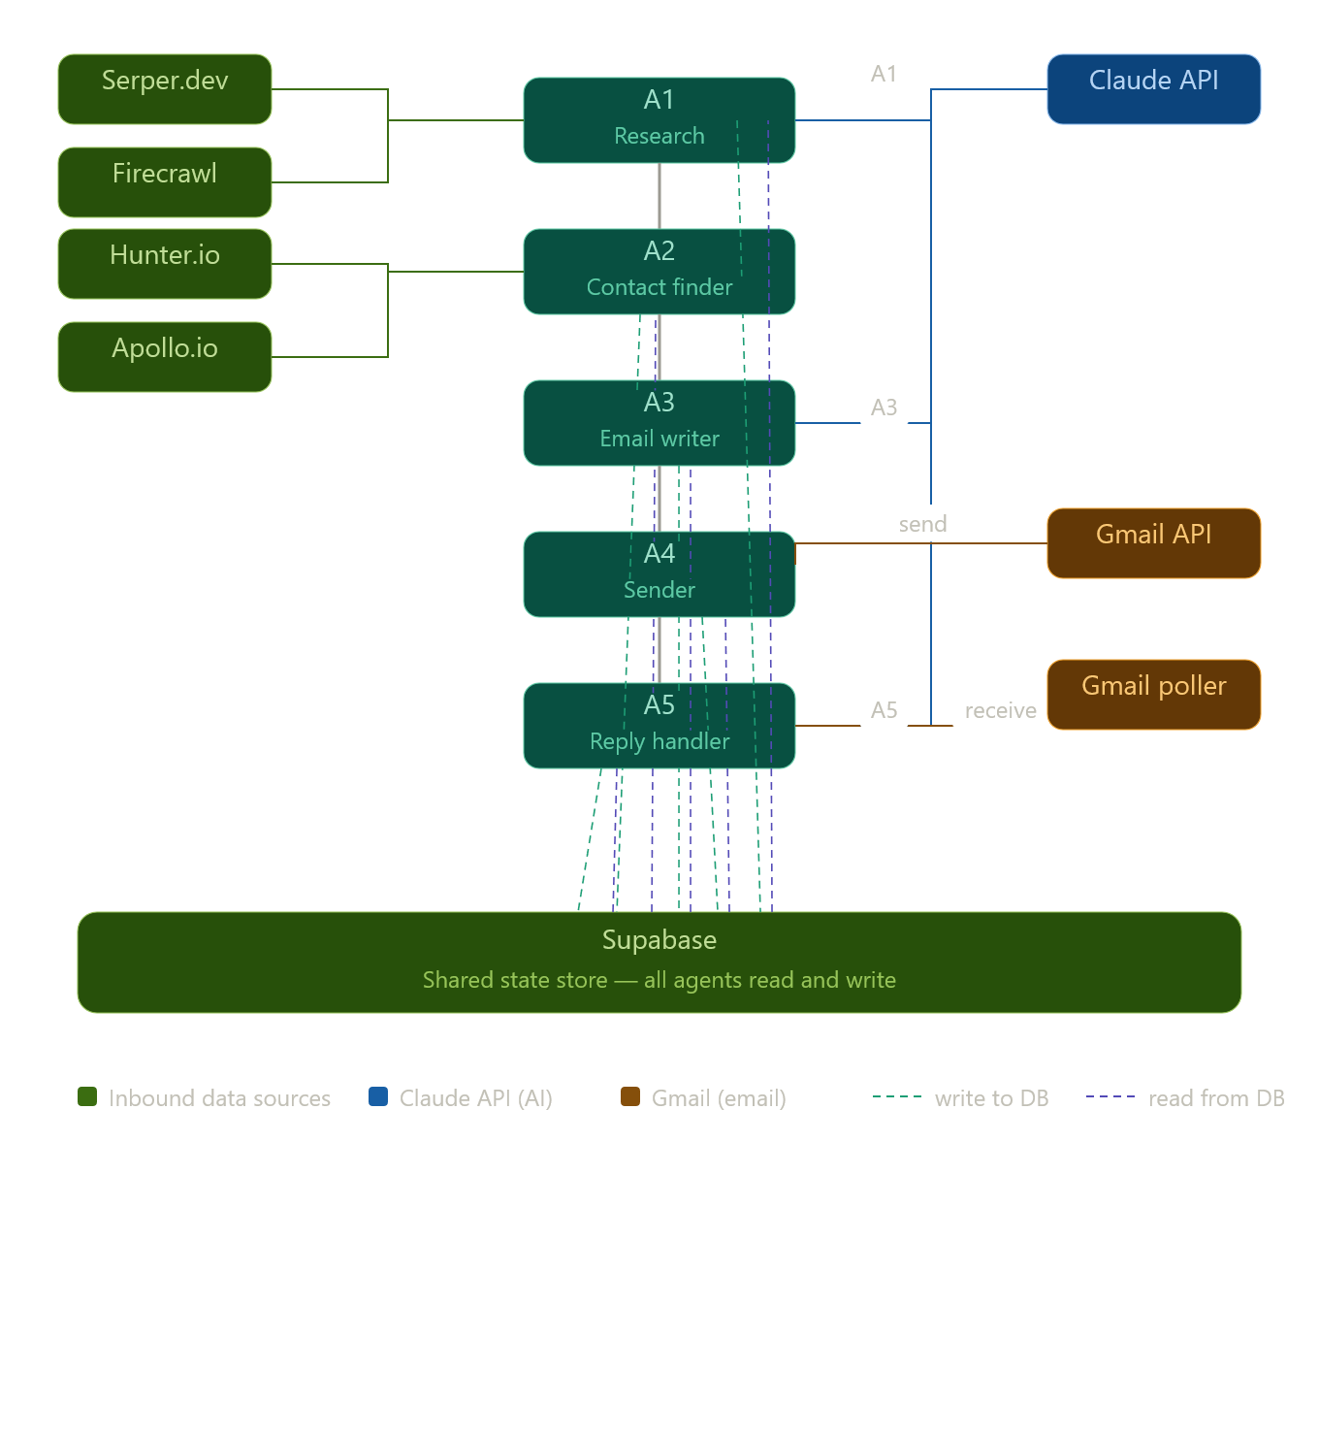
Self explanatory I guess, diagram might not be necessary

9. Failure & Recovery

Design principle: The system must fail safely rather than continue autonomously under uncertain conditions. When in doubt, pause and escalate to a human.

9.1 Failure Matrix
Failure | Likely Cause | Detection | Recovery Action
Website scrape returns empty | Bot protection or JavaScript-rendered site | Content length < 100 chars | Retry with simplified fetch; use meta description only
Hunter.io returns no contacts | Company too small or not indexed | Empty results array | Try Apollo.io; if also empty, mark NO_CONTACT_FOUND
Claude API timeout | Service overload or network issue | Response > 30 seconds | Retry up to 3x with 5s delay; route to human after 3 failures
Email bounce received | Invalid or defunct email address | Gmail bounce notification | Mark INVALID_EMAIL; do not retry sending
Duplicate send attempt | Race condition in orchestrator | Idempotency check on gmail_message_id | Hard block; log the attempt; alert operator
Research confidence < 0.65 | Insufficient public data for company | Confidence score check after A1 | Route to HUMAN_REVIEW with raw scraped content for human to assess
Reply intent confidence < 0.75 | Ambiguous reply text | Confidence score check after A5 | Route to HUMAN_REVIEW with reply text and AI reasoning shown to human
Gmail OAuth token expired | 24-hour token expiry | 401 response from Gmail API | Pause all sending; push re-authentication notification to dashboard
Supabase connection lost | Network or service interruption | Connection error on any DB write | Retry 5x with backoff; if persistent, halt orchestrator and alert operator

9.2 Idempotency Strategy
Before any email is sent, Agent A4 checks the leads table for an existing gmail_message_id for that lead. If one exists, the send is blocked regardless of the current workflow status. This prevents duplicate sends caused by orchestrator retries or system restarts.

9.3 Partial Workflow Recovery
If the system restarts mid-run (e.g. demo server restart), the orchestrator reads all lead records on startup and resumes any lead that is in a non-terminal, non-human-review state. Because all state is persisted in Supabase after every step, no work is lost.

10. Decision-Making Framework

Every decision the system makes autonomously is governed by a confidence threshold. Below the threshold, the system stops and hands control to a human. This is not a limitation — it is a feature that makes the system trustworthy in an enterprise context.

10.1 Confidence Thresholds
Decision Point | Agent | Autonomous Threshold | Human Escalation Threshold
Proceed with research output | A1 | >= 0.65 | < 0.65
Send outbound email | A4 | N/A — always requires DRAFT_READY status | If human_approval_required = true
Classify reply as INTERESTED | A5 | >= 0.80 | < 0.80
Classify reply as NOT_INTERESTED | A5 | >= 0.80 | < 0.80
Draft meeting booking email | A5 | >= 0.80 on INTERESTED classification | < 0.80 on any classification
Mark lead CLOSED_LOST | A5 | >= 0.85 | < 0.85

10.2 Human Escalation Decision Tree
When any lead enters HUMAN_REVIEW status, the dashboard presents the human with the following context and options:
- Full lead data (company, contact, all previous actions)
- The AI's output that triggered escalation (e.g. raw research, classified intent)
- The AI's reasoning (confidence score and brief explanation)
- Predefined action buttons: Approve and Continue / Edit and Continue / Mark Closed / Skip
The human's choice is logged with a timestamp and their user ID for audit purposes.

11. Compliance & Ethics (necessary?)

Cold email outreach is regulated in most jurisdictions. The system is designed to be compliant with CAN-SPAM (US), GDPR (EU), and CASL (Canada) at demo scale. Full compliance for a production deployment would require additional legal review.

11.1 CAN-SPAM Compliance (US)
- Every email includes a plain-text opt-out instruction: 'To opt out, reply STOP.'
- The sender name and email address are never spoofed
- Subject lines do not use deceptive language
- Opt-out requests are processed within 24 hours — the lead is marked CLOSED_LOST and removed from all follow-up queues

11.2 GDPR Considerations (EU)
- For demo purposes, only publicly available business contact information is used (Hunter.io surfaces data from public sources)
- No personal data is stored beyond what is necessary for the workflow
- Lead data is not shared with any third party beyond the API services listed in Section 8
Note: A production deployment targeting EU companies would require a formal legitimate interest assessment and a Data Processing Agreement with each API provider. This is out of scope for the contest demo.

11.3 AI Disclosure Policy (Look into this.)
The system does not claim that emails are written by a human. Email drafts generated by Agent A3 include no false attribution. The opt-out line is always present. If asked directly by a prospect whether they are communicating with an AI system, the Reply Handler escalates to a human rather than answering autonomously.

11.4 Ethical Scraping Boundaries
- The system only scrapes publicly accessible web pages — no login-walled content
- Scraping rate is throttled to one request per 3 seconds per domain
- robots.txt is respected by the Firecrawl integration
- No personal social media profiles are scraped — only company websites and news sources

12. Security Requirements

Because the system handles Gmail OAuth tokens, API keys, and contact email addresses, basic security hygiene is non-negotiable even for a contest demo.

Requirement | Implementation
API key storage | All API keys (Claude, Serper, Firecrawl, Hunter.io) stored as environment variables. Never hardcoded. Never committed to version control.
Gmail OAuth token | Stored in Supabase with row-level security. Token is never exposed to the frontend. Backend acts as proxy.
Least privilege access | Gmail OAuth scope is limited to gmail.send and gmail.readonly only. No access to contacts, calendar, or Drive.
Frontend data exposure | The dashboard never displays raw email addresses in the URL or in client-side state accessible via browser dev tools.
Audit trail | Every autonomous action (email sent, intent classified, status changed) is logged with timestamp, agent ID, and input/output summary.
Demo data isolation | Demo run uses a dedicated Gmail account, not a personal account. Credentials are rotated after the contest.

13. Non-Functional Requirements

These are the measurable performance, cost, and reliability targets for the contest demo. They are intentionally scoped to what is achievable with a 3-person team and free-tier services.

Category | Requirement | Target | Notes
Performance | Research completion time per lead | < 45 seconds | Includes website scrape + news search + Claude structuring
Performance | Email draft generation time | < 10 seconds | Claude API call only
Performance | Reply classification time | < 8 seconds | Claude API call only
Throughput | Leads processed per batch (v1) | Up to 30 | Limited by Hunter.io free tier (25/month) and demo stability
Reliability | Workflow completion rate | >= 90% | % of leads that reach a terminal state without manual intervention (demo batch)
Cost | Total API spend for demo run (30 leads) | < $15 USD | Dominated by Claude API calls
Cost | Cost per lead processed | < $0.50 USD | Acceptable for demo; production cost would be lower at scale
Observability | All agent actions logged | 100% | Every state transition recorded with timestamp
Availability | Dashboard uptime during demo | 100% | Demo is a controlled environment; no SLA beyond demo day

14. Technology Stack

Every tool listed here has a free tier sufficient for the contest demo. Total infrastructure cost is zero.
(Update this table accordingly)

Layer | Technology | Why This Choice
Agent Orchestration | LangGraph (Python) | Purpose-built for stateful multi-agent workflows. Graph-based state machine maps directly to our workflow design. Open source.
LLM | Claude API — claude-sonnet-4-20250514 | Best-in-class instruction following and structured JSON output. Reliable schema adherence reduces validation failures.
Backend API | FastAPI (Python) | Lightweight, fast, excellent async support needed for concurrent agent execution. Well-documented.
Database / State Store | Supabase (PostgreSQL) | Free tier, real-time subscriptions (useful for dashboard live updates), built-in auth. No infrastructure to manage.
Web Scraping | Firecrawl | Handles JavaScript-rendered pages, respects robots.txt, free tier sufficient for 30-lead demo.
Web Search | Serper.dev | Google Search API wrapper. 100 free searches/month. Simple REST API.
Contact Discovery | Hunter.io + Apollo.io (fallback) | Hunter.io free tier: 25 searches/month. Apollo.io free tier: 50 exports/month. Combined, sufficient for demo.
Email Infrastructure | Gmail API (OAuth 2.0) | Free. Reliable. Reply threading via message IDs works well. No custom domain needed for demo.
Frontend Dashboard | React + TailwindCSS | Fast to build, well-suited for a real-time status dashboard with Supabase subscriptions.
Deployment | Render.com (free tier) | Zero-cost hosting for the FastAPI backend and React frontend during the contest period.

15. 8-Week Sprint Plan

Three team members are assumed, each comfortable across backend and frontend. Tasks are distributed to run in parallel where possible.
(Update this table)
Week | Focus | Key Deliverables | Owner(s)
Week 1 | Foundation | Project setup, repo, Supabase schema, API keys configured, CSV ingestion working end-to-end | All 3
Week 2 | Agent A1 — Research | Firecrawl integration, Serper.dev search, Claude research prompt v1, output schema validated | P1 + P2
Week 2 | Agent A2 — Contact | Hunter.io integration, Apollo fallback, email verification logic | P3
Week 3 | Agent A3 — Email Writer | Claude email prompt v1, guardrail checks (word count, no pricing, opt-out line), draft storage | P1 + P3
Week 3 | Orchestrator v1 | LangGraph state machine wired for A1 → A2 → A3 flow. Basic state transitions working. | P2
Week 4 | Agent A4 — Sender | Gmail API OAuth setup, send logic, idempotency check, bounce detection, Gmail poller | P1 + P2
Week 4 | Dashboard v1 | React dashboard showing lead list, current status, email preview panel | P3
Week 5 | Agent A5 — Reply Handler | Intent classification prompt, confidence thresholds, human escalation queue in dashboard | P1 + P3
Week 5 | Orchestrator v2 | Full state machine: A1 through A5. Follow-up trigger at 72 hours. Human review flow. | P2
Week 6 | Integration Testing | End-to-end run with 10 real companies. Fix edge cases. Validate all state transitions. | All 3
Week 7 | Hardening & Polish | Retry logic, failure matrix implementation, logging, dashboard live updates, cost tracking | All 3
Week 8 | Demo Preparation | Prepare 20-30 lead demo CSV. Rehearse demo flow. Record backup video. Write pitch narrative. | All 3

Diagram 5: 8-Week Gantt Chart
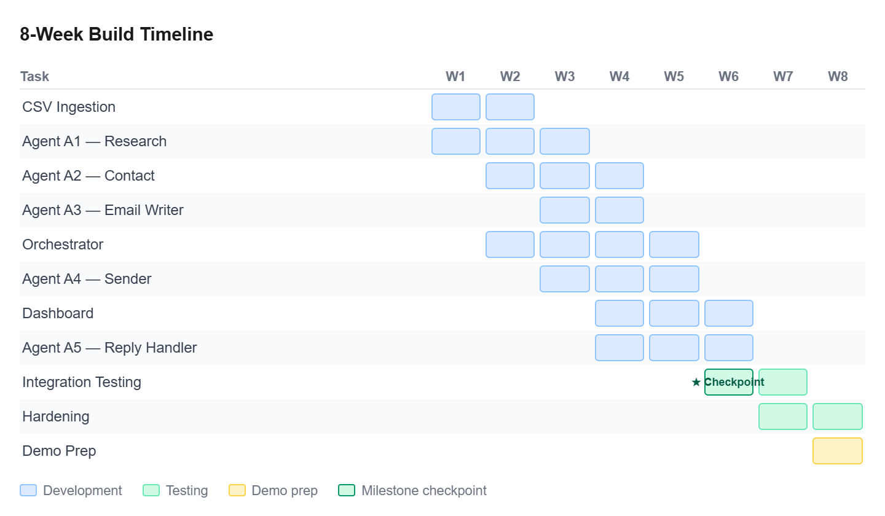

16. Demo Flow

The contest demo should tell a clear story in under 5 minutes. The goal is to show autonomous action — not configuration screens.

16.1 Demo Script
- Open the dashboard. Show an empty lead list.
- Upload a pre-prepared CSV of 10 real companies (researched in advance to ensure Hunter.io has contacts for them).
- Watch the dashboard live-update as leads move through statuses: RESEARCH_PENDING → RESEARCH_COMPLETE → CONTACT_FOUND → DRAFT_READY → SENT.
- Click on one lead to show the full email draft — point out the specific personalisation fact pulled from the company's website.
- Trigger a pre-staged reply (sent from a test inbox) and show the Reply Handler classifying it as INTERESTED in real time.
- Show the BOOKING_DRAFTED state and the meeting email draft ready for the human to send.
- Show the cost tracker — total API spend for the batch — to demonstrate operational efficiency.

16.2 Demo Safeguards
- Use a pre-run batch for the live demo — the 10-lead batch should have been successfully processed the day before so results are guaranteed
- Have a recorded screen capture as backup in case of API failures on demo day
- Pre-stage one reply email in the test inbox so the Reply Handler demonstration is instant and reliable
- Use a dedicated Gmail account, not a personal account

The story to tell: 'You gave it a list. You walked away. Every step — research, writing, sending, reading replies — happened without you. The only thing left for you is the conversation that matters.'

17. Assumptions & Constraints

These are the conditions that must be true for the system to work as described. If any assumption is violated, the corresponding component may need redesign.

Assumption / Constraint | Impact If Violated
All target companies have publicly accessible websites | A1 research quality degrades; confidence scores will be lower; more leads route to HUMAN_REVIEW
Hunter.io free tier (25 searches/month) is sufficient for demo batch | If demo batch exceeds 25, Apollo.io fallback is used. If both exhausted, leads are marked NO_CONTACT_FOUND.
All leads are B2B companies (not individuals or consumers) | Reply Handler and email prompts are calibrated for B2B context only
Outreach is in English only | All prompts, guardrails, and intent classification are English-language only for v1
Gmail account used for sending is not already rate-limited or flagged for spam | If the sending account has a poor reputation, deliverability will be affected
Claude API maintains current performance and pricing during the contest period | If pricing changes significantly, the $15 cost estimate for the demo run may not hold
Supabase free tier (500MB) is sufficient | At ~5KB per lead record, 500MB supports approximately 100,000 lead records — not a concern for v1
Demo judges understand what an SDR is | The pitch narrative should briefly explain the SDR role before demonstrating the system — do not assume domain knowledge

18. Autonomy Limits (IMPORTANT SECTION TO READ)

This section defines where the system stops and the human begins. An agentic system without defined autonomy limits is not a product — it is a liability.

18.1 What the System May Do Autonomously
- Research any company in the uploaded lead list using public web sources
- Look up business contact information using Hunter.io and Apollo.io
- Draft personalised cold outreach emails using the Claude API
- Send outbound emails from the configured Gmail account
- Send one follow-up email per lead if there is no reply after 72 hours
- Classify inbound reply intent when confidence score is >= 0.80
- Mark a lead as CLOSED_LOST when NOT_INTERESTED classification confidence is >= 0.85
- Draft a meeting booking email when INTERESTED classification confidence is >= 0.80

18.2 What Requires Human Approval Before Action
- Sending any email when human_approval_required = true (set by low-confidence draft generation)
- Responding to any reply where confidence score is < 0.75
- Any reply that contains the words: pricing, contract, security, legal, GDPR, compliance, or enterprise
- Any reply that asks whether the outreach is AI-generated
- Booking a meeting — the system drafts the email but the human sends it
- Marking a lead as CLOSED_LOST when confidence is between 0.75 and 0.85

18.3 What the System Will Never Do
- Send more than one follow-up per lead (hard-coded maximum)
- Send an email to an unverified address
- Send an email to the same address more than once in a 7-day window
- Claim to be a human in any email or reply
- Continue processing a lead if the recipient has replied STOP or similar opt-out language
- Access any data outside the leads table for a given workflow run

19. Observability & Monitoring

All autonomous actions must be observable, reversible where possible, and attributable to the specific agent and prompt version that produced them.

19.1 What is Logged for Every Agent Action (redundant subsection?)
Log Field | Description
action_id | UUID for this specific action — used to trace the full execution path of a lead
lead_id | Foreign key to the leads table
agent_id | Which agent produced this action (A1, A2, A3, A4, A5)
status_before | Lead status before this action
status_after | Lead status after this action
prompt_version | Version string of the prompt used (e.g. 'email-writer-v2')
model_used | Claude model string (e.g. 'claude-sonnet-4-20250514')
input_summary | First 200 characters of input passed to the LLM (for debugging)
output_summary | First 200 characters of LLM output received (for debugging)
confidence_score | Agent's confidence in the output (where applicable)
token_count | Input + output tokens used (for cost tracking)
latency_ms | Time taken for the agent to complete this action
timestamp | UTC timestamp of action completion

19.2 Dashboard Metrics (Live During Demo)
- Total leads: uploaded / in progress / completed / failed
- Current status breakdown (pie or bar chart by status)
- Emails sent today / replies received / meetings booked
- Estimated API cost for the current batch run
- Human review queue: count of leads awaiting human decision

20. Why This Matters to Salesforce (Necessary section? – maybe for team reference during the pitch only)

This section is intentionally written for a Salesforce audience — judges, mentors, or recruiters evaluating the project.

20.1 The Direct Business Connection
Salesforce's core product is a CRM that manages the sales pipeline. The biggest friction point in that pipeline is the top of the funnel — getting qualified leads into the system in the first place. This is exactly the problem the Agentic AI SDR solves.
Every company that uses Salesforce Sales Cloud employs SDRs. Every SDR spends the majority of their time on tasks that are rule-based, repetitive, and do not require human judgment. This system automates those tasks.

20.2 The Agentforce Connection
Salesforce's biggest strategic bet right now is Agentforce — their platform for deploying autonomous AI agents across the enterprise. The architecture we have built is philosophically identical to what Agentforce enables: state-managed, multi-step, autonomous workflows with defined human escalation points.
This project is a working proof of concept of the Agentforce vision, built independently and from first principles. That is the story worth telling.

20.3 What This Project Demonstrates to Salesforce Engineers
- We understand agentic system design — not just LLM prompting
- We designed for failure, not just the happy path
- We defined autonomy limits — which is enterprise-grade thinking
- We built with cost awareness and operational constraints in mind
- We can scope, architect, and ship a complex system in 8 weeks

The pitch is not 'we built a chatbot that sends emails.' The pitch is: 'We built an autonomous multi-agent workflow system that executes an entire enterprise sales function — and we defined exactly where it stops and the human begins. That is what responsible agentic AI looks like.'

