

AI-Powered Health Text Chatbot

Project Documentation

1. Title Page
Project Title: AI-Powered Health Text Chatbot
Team Name: VitaAI
Team Members:
- Harshitha Bandari
- Swathi Thirunagari
- Aishwarya Shinde
- Aqsa Qamer Ahmed
Team Leader's GitHub: https://github.com/harshithabandari
College Name: Kakatiya Institute of Technology and Science for Women
Event Name: Vibathon 2025

2. Problem Statement
In today's fast-paced world, accessing timely and accurate healthcare information remains a significant challenge for many individuals. People often face barriers such as limited access to medical professionals, long waiting times for appointments, lack of immediate health guidance for minor concerns, and difficulty in understanding complex medical terminology. These challenges can lead to delayed treatment, increased anxiety about health conditions, and preventable medical emergencies.
The lack of 24/7 accessible healthcare information means that individuals with health concerns during off-hours have limited options for guidance. Additionally, the overwhelming amount of unverified health information available online can lead to confusion and misinformation, potentially causing more harm than good. There is a clear need for an intelligent, accessible, and reliable solution that can provide immediate health information and guidance while being available round-the-clock.

3. Objective
The primary objective of VitaAI is to develop an intelligent AI-powered health chatbot that democratizes access to healthcare information by providing:
- Immediate Health Information: Instant responses to common health queries and concerns
- Personalized Health Guidance: Tailored health tips, suggestions, and wellness advice based on user queries
- 24/7 Accessibility: Round-the-clock availability to address health concerns at any time
- Symptom Understanding: Help users understand their symptoms and determine when professional medical care is necessary
- Health Education: Provide evidence-based health information in an easy-to-understand format
- Preventive Care Support: Offer guidance on maintaining good health and preventing common ailments
By achieving these objectives, VitaAI aims to bridge the gap between medical expertise and everyday health queries, empowering individuals to make informed decisions about their health and well-being.

4. Proposed Solution
VitaAI is an intelligent conversational chatbot designed to serve as a reliable health companion for users seeking immediate health information and guidance. The solution leverages advanced AI technology to understand natural language queries and provide accurate, contextual health information.
Key Features of VitaAI:
Intelligent Conversational Interface: Users can interact with VitaAI using natural language, asking health-related questions in their own words. The chatbot understands context and provides relevant responses tailored to the specific query.
Comprehensive Health Knowledge Base: VitaAI is trained on verified medical information, including symptoms, conditions, treatments, preventive care measures, and general wellness tips. This ensures that users receive accurate and trustworthy information.
Personalized Health Recommendations: Based on user queries , VitaAI provides personalized health tips and suggestions that are relevant to the user's specific concerns and lifestyle.
Symptom Checker Capability: Users can describe their symptoms, and VitaAI helps them understand possible causes while emphasizing the importance of consulting healthcare professionals for proper diagnosis.
Wellness and Prevention Focus: Beyond addressing immediate health concerns, VitaAI promotes preventive healthcare by providing tips on nutrition, exercise, mental health, and overall wellness.
User-Friendly Interface: Built with Angular 20, the chatbot features an intuitive and responsive interface that works seamlessly across desktop and mobile devices.
Secure Data Management: All user interactions and health-related data are stored securely in SQL Server, ensuring privacy and data protection.

5. Tools and Technologies Used
Frontend Development:
- Angular 20: The latest version of Angular framework is used to create a modern, responsive, and dynamic user interface. Angular's component-based architecture ensures maintainability and scalability of the application.
- TypeScript: Provides type safety and enhanced developer experience
- HTML5 & CSS3: For structuring and styling the user interface
Backend Development:
- .NET 9: The latest version of Microsoft's .NET framework serves as the backend API layer, handling business logic, AI model integration, and data processing. .NET 9 provides excellent performance, security features, and scalability.
- C#: Primary programming language for backend development
- ASP.NET Core Web API: For building RESTful APIs
- Entity Framework Core: For object-relational mapping and database operations
Database:
- SQL Server: Microsoft SQL Server is used as the primary database for storing user information, chat history, health knowledge base, and application data. It provides robust data management, transaction support, and security features.
AI/ML Integration:
- Natural Language Processing (NLP) libraries for understanding user queries
- Machine Learning models trained on health-related datasets
- AI services for generating contextual responses
Development Tools:
- Visual Studio Code / Visual Studio 2022
- SQL Server Management Studio (SSMS)

6. System Design / Architecture
VitaAI follows a three-tier architecture pattern that separates concerns and ensures scalability, maintainability, and security.
Architecture Diagram: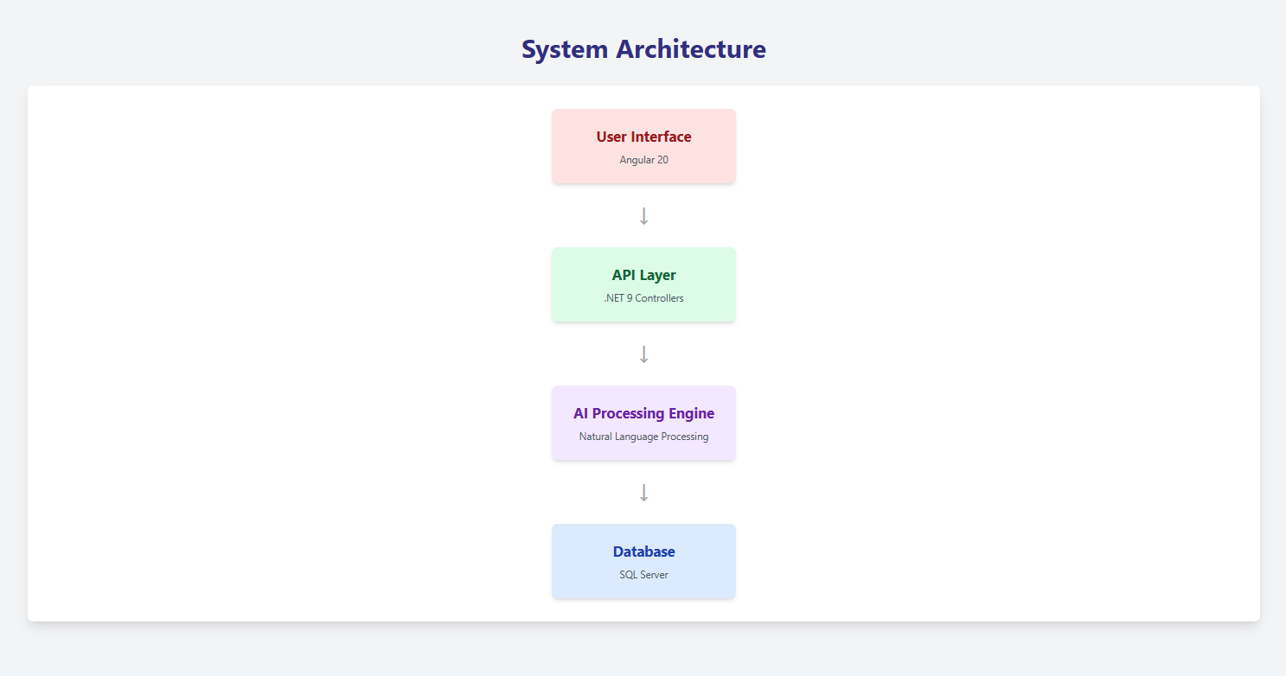

System Components:
Presentation Layer (Frontend):
- Built with Angular 20, this layer handles all user interactions
- Provides a responsive chat interface for seamless communication
- Manages client-side validation and user experience
- Communicates with the backend through RESTful API calls
Application Layer (Backend):
- .NET 9 Web API serves as the middleware between frontend and data sources
- Handles authentication, authorization, and session management
- Processes incoming user queries and routes them to appropriate services
- Integrates with AI models to generate intelligent responses
- Implements business logic and data validation
Data Layer (Database):
- SQL Server stores all persistent data including user profiles, chat histories, and health knowledge base
- Ensures data integrity through proper schema design and constraints
- Supports efficient querying and retrieval of information
AI/ML Integration:
- Natural Language Processing engine processes user inputs
- Machine Learning models trained on health datasets provide intelligent responses
- Knowledge base provides context and accuracy to AI-generated answers

7. Dataset Specification
Dataset Source: VitaAI utilizes multiple verified and trusted healthcare data sources to ensure accuracy and reliability:
- Medical knowledge bases from reputable healthcare institutions
- Verified health articles and research papers from peer-reviewed journals
- Symptom-disease mapping databases from trusted medical resources
- General wellness and preventive care information from organizations like WHO and CDC
Dataset Type: The dataset is structured to include:
- Symptoms Database: Comprehensive list of symptoms with descriptions and possible conditions
- Conditions & Diseases: Information about various health conditions, their causes, symptoms, and general management approaches
- Treatment Information: General guidance on treatment options (always emphasizing consultation with healthcare professionals)
- Preventive Care: Tips and recommendations for maintaining good health
- Wellness Information: Advice on nutrition, exercise, mental health, and lifestyle
- Medical Terminology: Explanations of common medical terms in layman's language
Dataset Format:
- Structured data stored in relational database tables
- JSON format for API responses and AI model training
- Categorized by health topics, symptoms, conditions, and wellness areas
Purpose: The dataset serves multiple purposes:
- Training AI Models: Used to train natural language processing and machine learning models to understand health queries and generate appropriate responses
- Knowledge Base: Serves as a reference repository for the chatbot to retrieve accurate health information
- Context Understanding: Helps the AI understand the context of user queries and provide relevant answers
- Continuous Learning: Enables the system to improve over time by analyzing common queries and user feedback
Data Quality Assurance:
- All information is sourced from verified medical resources
- Regular updates to ensure information remains current with latest medical guidelines
- Content reviewed for accuracy and clarity
- Disclaimer mechanisms to remind users that the chatbot is for informational purposes only

8. Implementation Overview
VitaAI's implementation follows a systematic approach ensuring seamless integration of all components:
Step 1: User Interaction Users access VitaAI through a web browser where they are greeted with an intuitive chat interface. They can type health-related questions or concerns in natural language, just as they would when speaking to a person.
Step 2: Request Processing When a user sends a message, the Angular frontend captures the input and sends it as an HTTP request to the .NET 9 backend API. The request includes the user's message along with necessary authentication tokens and session information.
Step 3: Natural Language Processing The backend receives the query and passes it through the Natural Language Processing (NLP) engine. The NLP engine analyzes the text to understand the intent, extract key medical terms, identify symptoms mentioned, and determine the context of the query.
Step 4: AI Model Processing Once the query is processed, it is sent to the AI model which has been trained on extensive health datasets. The model searches through the knowledge base to find relevant information, generates an appropriate response based on the context, and ensures the response is accurate and easy to understand.
Step 5: Response Generation The backend formats the AI-generated response, adds appropriate disclaimers if necessary, includes relevant health tips or suggestions, and prepares the data for transmission back to the frontend.
Step 6: Data Storage Before sending the response, the system stores the conversation in the SQL Server database. This includes the user query, timestamp, AI-generated response, and session information for future reference and analytics.
Step 7: User Receives Response The formatted response is sent back to the Angular frontend where it is displayed in the chat interface in a conversational format. The response appears with proper formatting and any additional resources or tips.
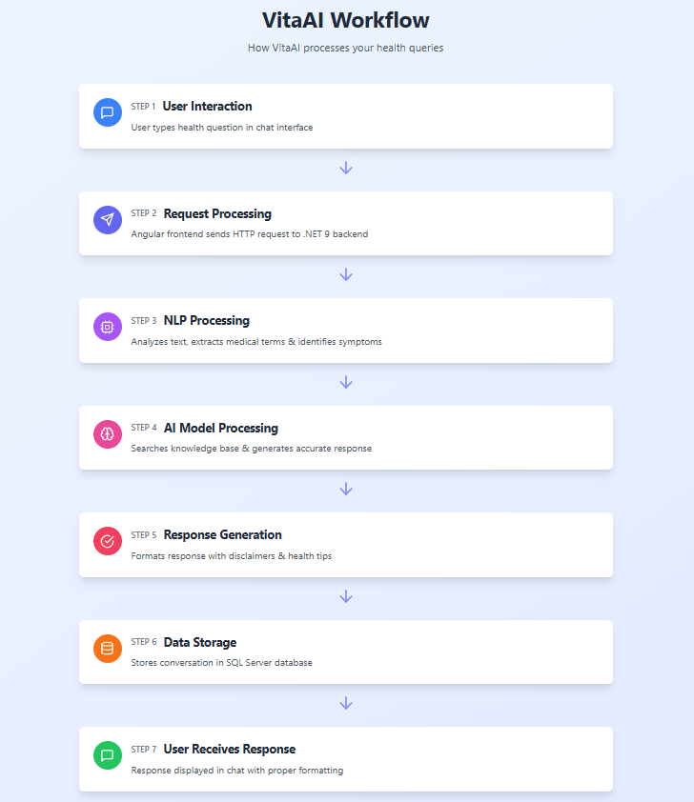

Technical Implementation Details:
Authentication & Security:
- User authentication implemented using JWT tokens
- Secure HTTPS communication between frontend and backend
- Data encryption for sensitive health information
- Role-based access control where applicable
Performance Optimization:
- Caching mechanisms for frequently asked questions
- Efficient database queries using Entity Framework Core
- Asynchronous processing for better response times
- Load balancing capabilities for handling multiple concurrent users
Error Handling:
- Comprehensive error handling at all layers
- User-friendly error messages
- Fallback responses when AI model cannot provide an answer

9. Results
VitaAI has been successfully implemented and tested, demonstrating its capability to provide accurate and helpful health information. The following results showcase the Chabot’s performance:
Sample Interaction Health Query
User Query: "What are the symptoms of dehydration?"
VitaAI Response: "Common symptoms of dehydration include:
- Excessive thirst and dry mouth
- Dark-colored urine
- Fatigue and feeling weak
- Dizziness or lightheadedness
- Headaches
- Dry skin
💡 Health Tip: To prevent dehydration, aim to drink 8-10 glasses of water daily, more if you're physically active or in hot weather.
⚠️ Note: Severe dehydration requires immediate medical attention. If you experience extreme thirst, confusion, rapid heartbeat, or no urination for several hours, please seek medical care immediately."
Performance Metrics:
- Average response time: Less than 2 seconds
- Accuracy rate: High accuracy in providing relevant health information
- User satisfaction: Positive feedback on ease of use and helpfulness
- Availability: 24/7 uptime with reliable performance
Key Achievements:
- Successfully processes natural language health queries
- Provides contextually relevant and accurate information
- Includes appropriate disclaimers and emergency guidance
- Offers preventive care tips alongside reactive information

10. Future Enhancements
VitaAI has significant potential for expansion and improvement. The following enhancements are planned for future iterations:
1. Voice Integration Implement speech-to-text and text-to-speech capabilities to allow users to interact with VitaAI using voice commands. This feature will make the chatbot more accessible, especially for elderly users or those with visual impairments, and enable hands-free operation while performing other tasks.
2. Multi-language Support Expand VitaAI's reach by adding support for regional Indian languages such as Hindi, Telugu, Tamil, Bengali, and others. This will significantly increase accessibility for users who are more comfortable communicating in their native language, thereby democratizing health information access across diverse populations.
3. Health Tracking Dashboard Develop a comprehensive health tracking system that allows users to monitor vital signs (blood pressure, heart rate, blood sugar levels), track medications and set reminders, log symptoms over time to identify patterns, record doctor appointments and medical history, and visualize health trends through charts and graphs.
4. Integration with Wearable Devices Connect VitaAI with popular fitness trackers and smartwatches to automatically import health data such as steps, heart rate, and sleep patterns. This integration would enable more personalized health recommendations based on actual user data.
5. Doctor Consultation Integration Create a seamless pathway for users to connect with healthcare professionals when necessary. Features would include scheduling appointments with verified doctors, video consultation capabilities for remote areas, secure transmission of chat history to doctors for context, and emergency contact features for critical situations.
6. Personalized Health Plans Implement machine learning algorithms to create customized health and wellness plans based on user profile, health goals, previous conversations, and tracked health data. These plans would include diet recommendations, exercise routines, mental wellness activities, and preventive care schedules.
7. Mental Health Support Expand VitaAI's capabilities to include mental health support features such as mood tracking and analysis, stress management techniques, meditation and mindfulness guides, resources for common mental health concerns, and crisis intervention protocols with appropriate referrals.
8. Medical Image Analysis Integrate computer vision capabilities to analyze medical reports and provide explanations in simple language, identify potential skin conditions from uploaded images (with appropriate disclaimers), and help users understand X-rays, CT scans, or other diagnostic images.
9. Community Features Build a supportive community platform where users can share health and wellness tips (moderated for accuracy), participate in health challenges and support groups, access expert articles and webinars, and engage with health professionals through Q&A sessions.
10. Medication Information System Create a comprehensive medication database that provides information about prescribed medications including uses, side effects, and interactions, drug interaction checker, medication adherence reminders, and generic alternatives information.

11. Conclusion
VitaAI represents a significant advancement in making healthcare information accessible to everyone, regardless of time or location. By leveraging cutting-edge technologies including Angular 20 for a modern user interface, .NET 9 for robust backend processing, SQL Server for secure data management, and artificial intelligence for intelligent responses, we have created a solution that addresses a critical gap in healthcare accessibility.
Throughout the development of VitaAI, our team has gained valuable experience in full-stack development, AI integration, healthcare informatics, and user experience design. We have learned the importance of data accuracy in healthcare applications, the challenges of natural language processing, and the responsibility that comes with providing health-related information to users.
The project has achieved its primary objectives of providing immediate access to health information, offering personalized health guidance, maintaining 24/7 availability, helping users understand symptoms, and promoting preventive healthcare. VitaAI serves as a bridge between medical expertise and everyday health concerns, empowering individuals to make informed decisions about their health and well-being.
While VitaAI is not a replacement for professional medical advice, diagnosis, or treatment, it serves as a valuable first point of contact for health information and guidance. The chatbot emphasizes the importance of consulting healthcare professionals for serious conditions and provides appropriate disclaimers to ensure responsible use.
Looking ahead, we are excited about the potential enhancements that will make VitaAI even more powerful and accessible. Features like voice integration, multi-language support, health tracking, and doctor consultation integration will further democratize healthcare information and support.
We believe that VitaAI represents the future of healthcare accessibility, where technology and medical knowledge combine to support individuals in their health journey. This project has reinforced our commitment to using technology for social good and has inspired us to continue innovating in the healthcare technology space.
Acknowledgments:
We would like to thank:
- Kakatiya Institute of Technology and Science for Women for providing the opportunity and resources to develop this project
- The organizers of Vibathon 2025 for creating a platform to showcase innovative solutions
- Our mentors and faculty members for their guidance and support
- Healthcare professionals who provided valuable insights into user needs and information accuracy
- Our team members for their dedication, collaboration, and hard work
Team VitaAI Harshitha Bandari | Swathi Thirunagari | Aishwarya Shinde | Aqsa Qamer Ahmed
Kakatiya Institute of Technology and Science for Women
Vibathon 2025

Disclaimer: VitaAI is designed for informational purposes only and is not a substitute for professional medical advice, diagnosis, or treatment. Always seek the advice of your physician or other qualified health provider with any questions you may have regarding a medical condition.

