SCHOOL OF COMPUTER SCIENCE AND ARTIFICIAL INTELLIGENCE |  |  |  |  | DEPARTMENT OF COMPUTER SCIENCE ENGINEERING
ProgramName:B. Tech |  |  |  | Assignment Type: Lab |  |  | AcademicYear:2025-2026
CourseCoordinatorName |  |  |  | Venkataramana Veeramsetty
Instructor(s)Name |  |  |  | Dr. V. Venkataramana (Co-ordinator)  Dr. T. Sampath Kumar  Dr. Pramoda Patro  Dr. Brij Kishor Tiwari  Dr.J.Ravichander  Dr. Mohammand Ali Shaik  Dr. Anirodh Kumar  Mr. S.Naresh Kumar  Dr. RAJESH VELPULA  Mr. Kundhan Kumar  Ms. Ch.Rajitha  Mr. M Prakash  Mr. B.Raju  Intern 1 (Dharma teja)  Intern 2 (Sai Prasad)  Intern 3 (Sowmya)  NS_2 ( Mounika)
CourseCode |  |  | 24CS002PC215 | CourseTitle |  | AI Assisted Coding
Year/Sem |  |  | II/I | Regulation |  | R24
Date and Day  of Assignment |  |  | Week3 - Wednesday | Time(s)
Duration |  |  | 2 Hours | Applicableto  Batches
AssignmentNumber:6.3(Present assignment number)/24(Total number of assignments)
 | Q.No. | Question |  |  |  |  |  | ExpectedTime  to complete
 | 1 | Lab 6: AI-Based Code Completion – Classes, Loops, and Conditionals  Lab Objectives:  - To explore AI-powered auto-completion features for core Python constructs.  - To analyze how AI suggests logic for class definitions, loops, and conditionals.  - To evaluate the completeness and correctness of code generated by AI assistants.  Lab Outcomes (LOs):  After completing this lab, students will be able to:  - Use AI tools to generate and complete class definitions and methods.  - Understand and assess AI-suggested loops for iterative tasks.  - Generate conditional statements through prompt-driven suggestions.  - Critically evaluate AI-assisted code for correctness and clarity.  Task Description#1 (Classes)  - Use AI to complete a Student class with attributes and a method.  - Check output  - Analyze the code generated by AI tool  Expected Output#1  - Class with constructor and display_details() method  Prompt-1: Create a python function complete a Student class with attributes and a method. • Class with constructor and display_details() method.  CODE:  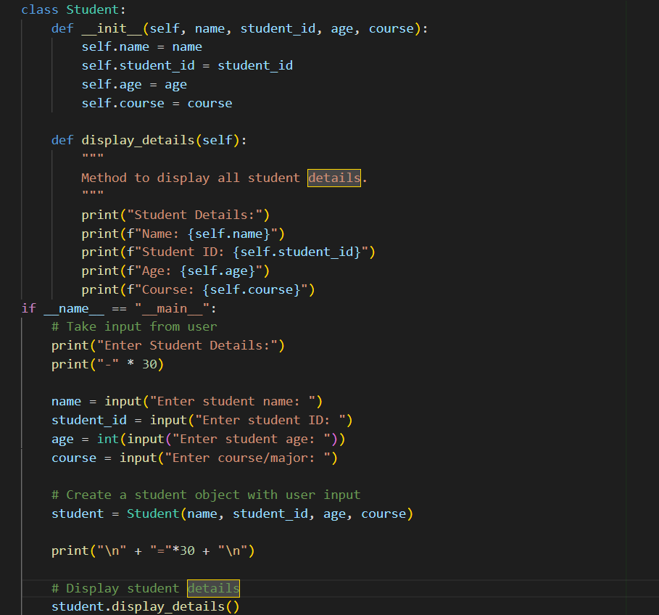  OUTPUT:  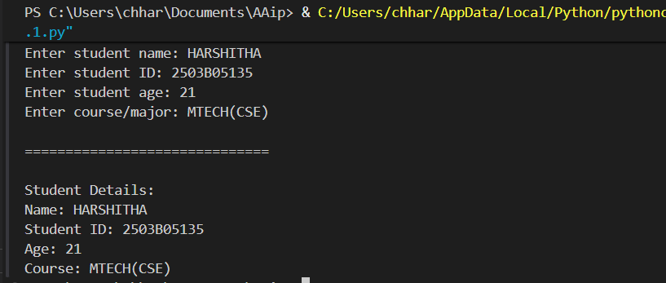  Task Description#2 (Loops)  - Prompt AI to complete a function that prints the first 10 multiples of a number using a loop.  - Analyze the generated code  - Ask AI to generate code using other controlled looping  Expected Output#2  - Correct loop-based implementation  Prompt: create a python a function that prints the first 10 multiples of a number using a loop  And generate code using other controlled looping.  CODE:  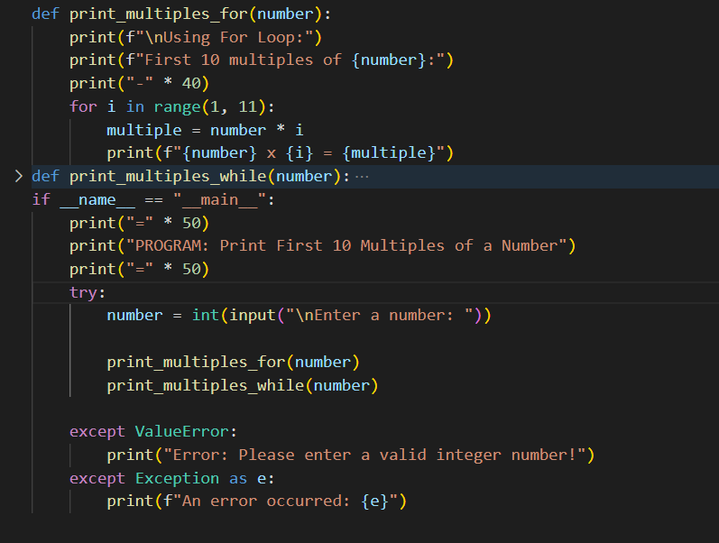  OUTPUT:  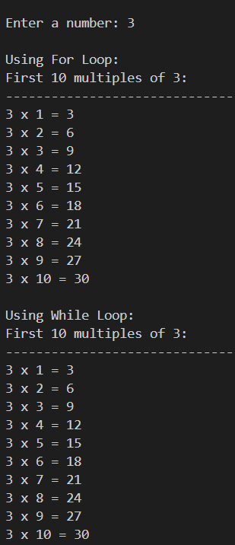  Task Description#3 (Conditional Statements)  - Ask AI to write nested if-elif-else conditionals to classify age groups.  - Analyze the generated code  - Ask AI to generate code using other conditional statements  Expected Output#3  - Age classification function with appropriate conditions and with explanation  Prompt-1: create a python code nested if-elif-else conditionals to classify age groups.  CODE:  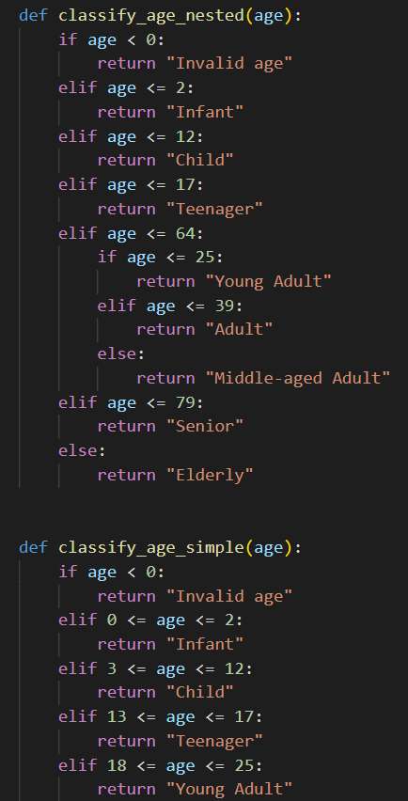  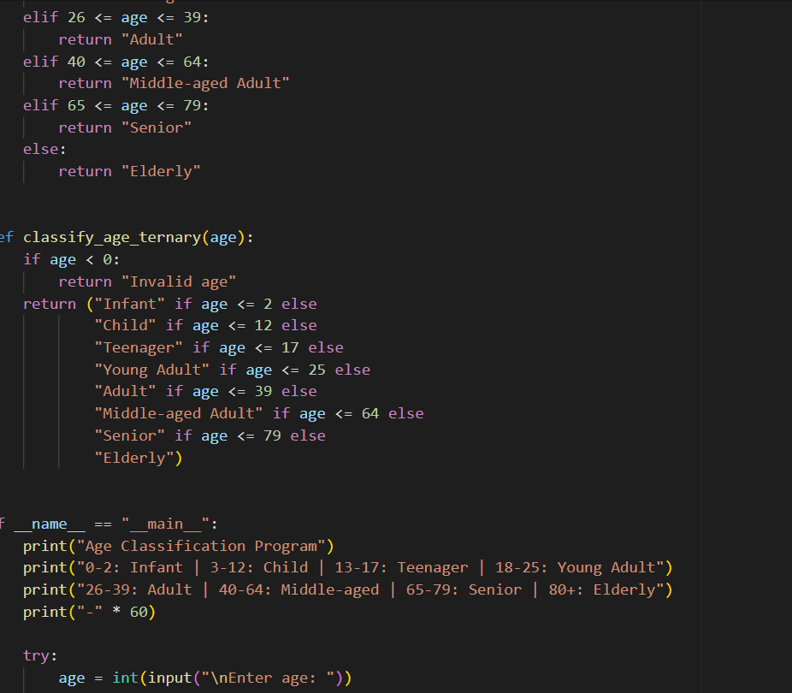  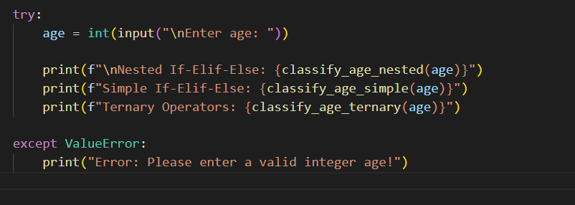  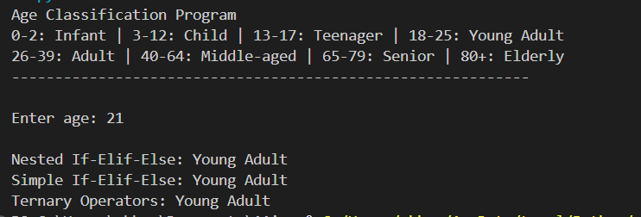  Explaination:  1. NESTED IF-ELIF-ELSE:  - Uses nested conditions within elif blocks  - Allows for hierarchical decision making  - More complex structure but provides fine-grained control  - Example: First checks if age <= 64, then nested if checks sub-categories  2. SIMPLE IF-ELIF-ELSE:  - Sequential conditions with explicit ranges  - Each condition uses 'and' to specify range boundaries  - Easy to read and understand  - Most common approach for age classification  TERNARY OPERATORS:  - Uses chained ternary operators (conditional expressions)  - Compact one-liner solution  - Less readable for complex conditions  - Pythonic but can be hard to maintain  Task Description#4 (For and While loops)  - Generate a sum_to_n() function to calculate sum of first n numbers  - Analyze the generated code  - Get suggestions from AI with other controlled looping  Expected Output#4  - Python code with explanation  Prompt: Generate a sum_to_n() function to calculate sum of first n numbers  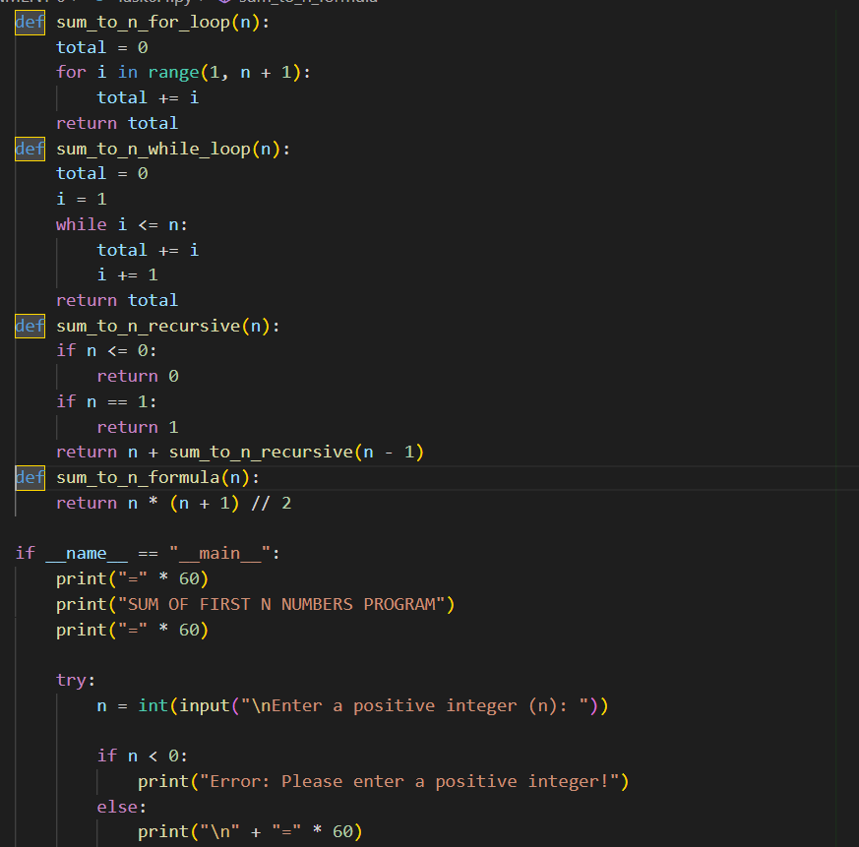  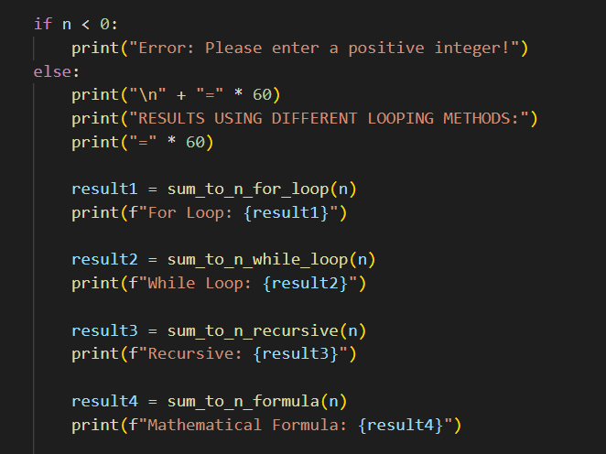  OUTPUT:  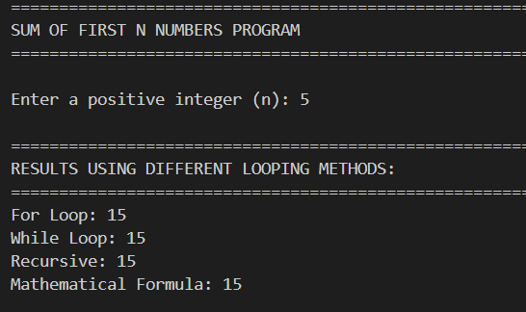  EXPLANATION:  1. FOR LOOP:  - Iterates from 1 to n using range(1, n+1)  - Accumulates sum in a variable  - Simple and readable  - Time Complexity: O(n)  - Space Complexity: O(1)  2. WHILE LOOP:  - Uses counter variable initialized to 1  - Continues until counter > n  - Manual counter incrementation  - Time Complexity: O(n)  - Space Complexity: O(1)  3. RECURSIVE:  - Breaks problem into smaller subproblems  - Base case: n <= 0 returns 0, n == 1 returns 1  - Recursive case: n + sum(n-1)  - Time Complexity: O(n)  - Space Complexity: O(n) due to call stack  4. MATHEMATICAL FORMULA:  - Uses formula: n * (n + 1) / 2  - Most efficient method  - No loops needed  - Time Complexity: O(1)  - Space Complexity: O(1)  Task Description#5 (Class)  - Use AI to build a BankAccount class with deposit, withdraw, and balance methods.  - Analyze the generated code  - Add comments and explain code  Expected Output#5  - Python code with explanation  Prompt: a BankAccount class with deposit, withdraw, and balance methods.  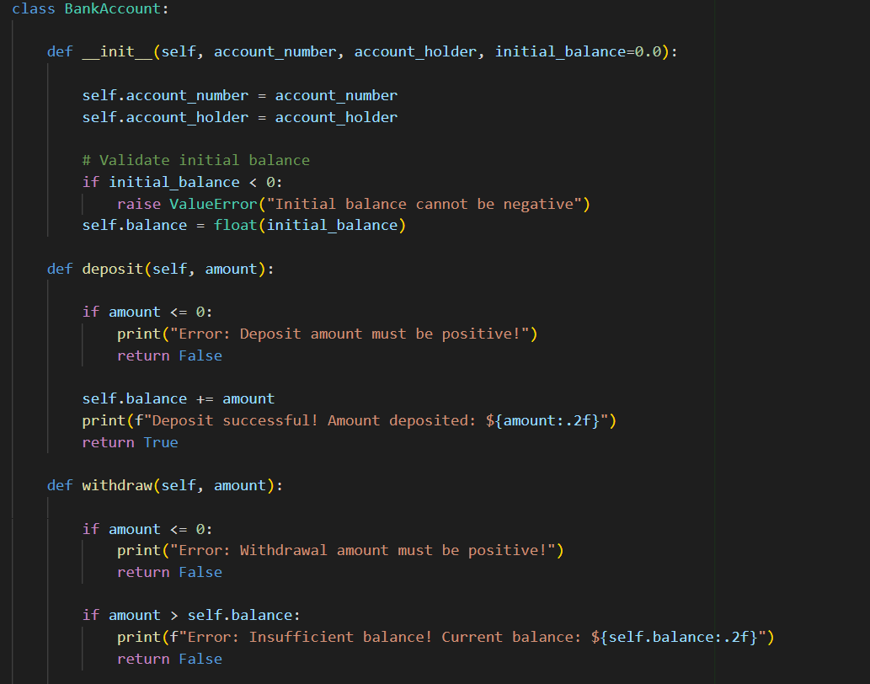  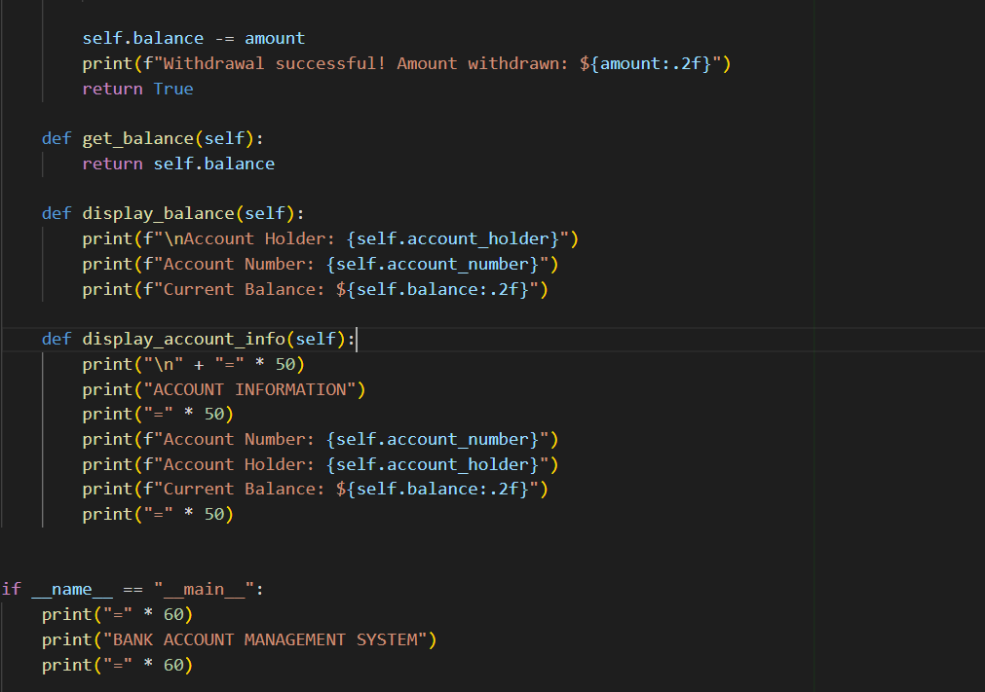  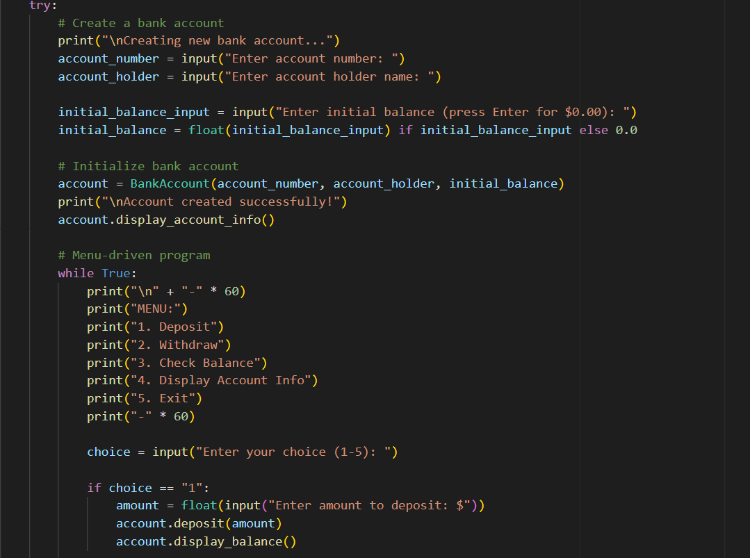  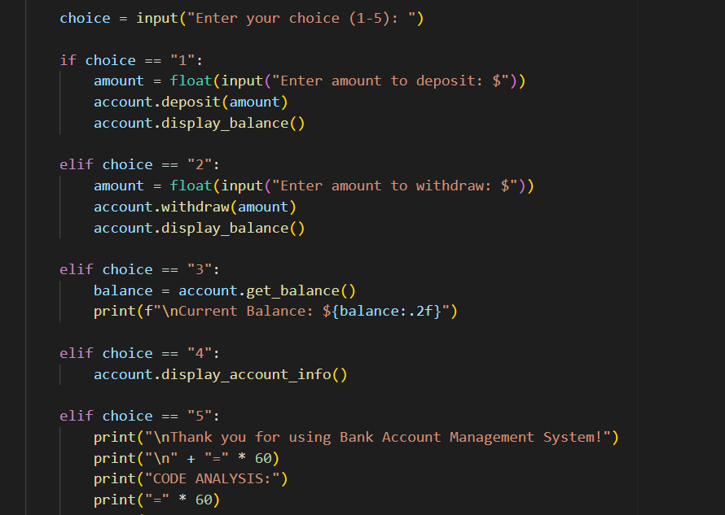  OUTPUT:  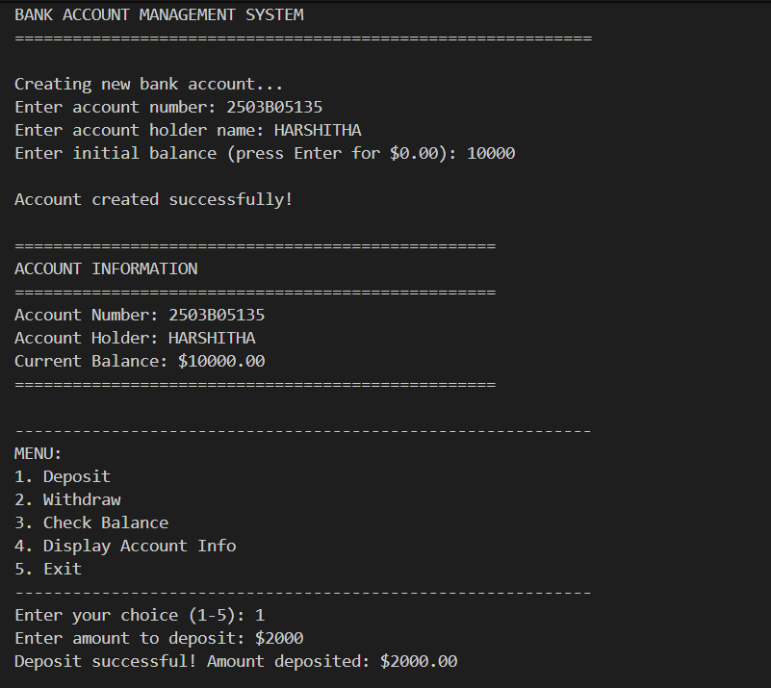  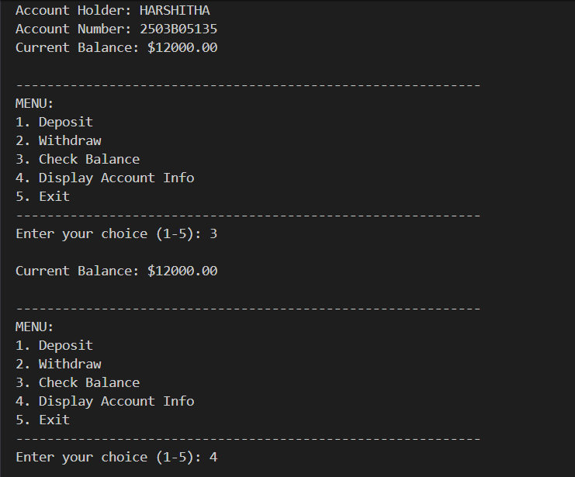  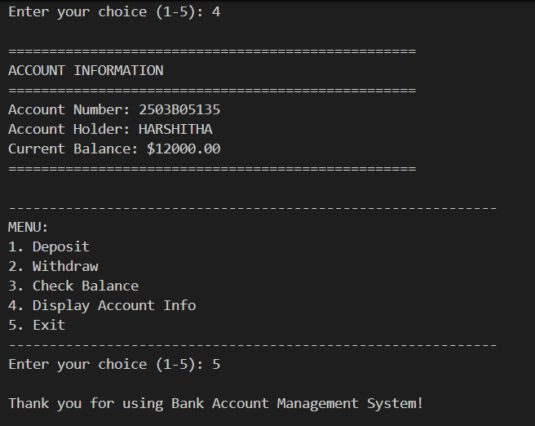  Explaination:  CLASS STRUCTURE:  1. __init__ (Constructor):  - Initializes account with account_number, account_holder, and balance  - Validates initial_balance to prevent negative values  - Uses encapsulation to store account data as instance variables  - Default parameter allows creating account with zero balance  2. deposit(amount):  - Validates deposit amount (must be positive)  - Updates balance by adding deposit amount  - Provides user feedback on success  - Returns boolean for programmatic success checking  3. withdraw(amount):  - Validates withdrawal amount (must be positive)  - Checks for sufficient balance before withdrawal  - Prevents overdraft (withdrawal > balance)  - Updates balance by subtracting withdrawal amount  - Provides user feedback on success/failure  4. get_balance():  - Getter method to retrieve current balance  - Provides controlled access to balance attribute  - Returns float value of balance  5. display_balance():  - Formats and displays balance information  - Shows account holder and account number  - User-friendly output format  6. display_account_info():  - Displays complete account information  - Formatted output for account summary  KEY CONCEPTS:  1. ENCAPSULATION:  - Account data (balance, account_number, account_holder) is stored as instance variables  - Methods provide controlled access to account data  - Prevents direct modification of balance without validation  2. DATA VALIDATION:  - All methods validate input before processing  - Prevents invalid operations (negative deposits, overdraft, etc.)  - Provides error messages for invalid operations  3. METHOD DESIGN:  - Each method has a single responsibility  - Methods return boolean values for success/failure  - User-friendly error messages  4. OOP PRINCIPLES:  - Encapsulation: Data and methods bundled together  - Abstraction: Hides implementation details  - Data hiding: Balance accessed through methods  TIME COMPLEXITY:  ----------------  - deposit(): O(1) - Constant time operation  - withdraw(): O(1) - Constant time operation  - get_balance(): O(1) - Constant time operation  - All operations are constant time, making them efficient  SPACE COMPLEXITY:  -----------------  - O(1) - Only stores account data (3 attributes)  Note: Report should be submitted a word document for all tasks in a single document with prompts, comments & code explanation, and output and if required, screenshots  Evaluation Criteria:  Criteria Max Marks  Class 1.0  Loops 1.0  Conditional Statements 0.5  Total 2.5 Marks |  |  |  |  |  | Week3 - Wednesday

