SCHOOL OF COMPUTER SCIENCE AND ARTIFICIAL INTELLIGENCE |  |  | DEPARTMENT OF COMPUTER SCIENCE ENGINEERING
Program Name: M. Tech/MCA |  | Assignment Type: Lab |  |  | AcademicYear:2025-2026
Course Coordinator Name |  | Venkataramana Veeramsetty
Course Code |  | Course Title |  | AI Assisted Problem Solving Using Python
Year/Sem | I/I | Regulation |  | R24
Date and Day  of Assignment | Week1 - TUESDAY | Time(s)
Duration | 2 Hours | Applicable to  Batches |  | M. Tech/MCA
AssignmentNumber:2.3(Present assignment number)/24(Total number of assignments)

Lab 2: Exploring Additional AI Coding Tools – Gemini (Colab) and Cursor AI

Task Description#1
- Use Google Gemini in Colab to write a function that reads a CSV file and calculates mean, min, max.
Expected Output#1
- Functional code with output and screenshot

PROMPT-1: Write a python function that reads a CSV file and calculates mean, min, max.

CODE:

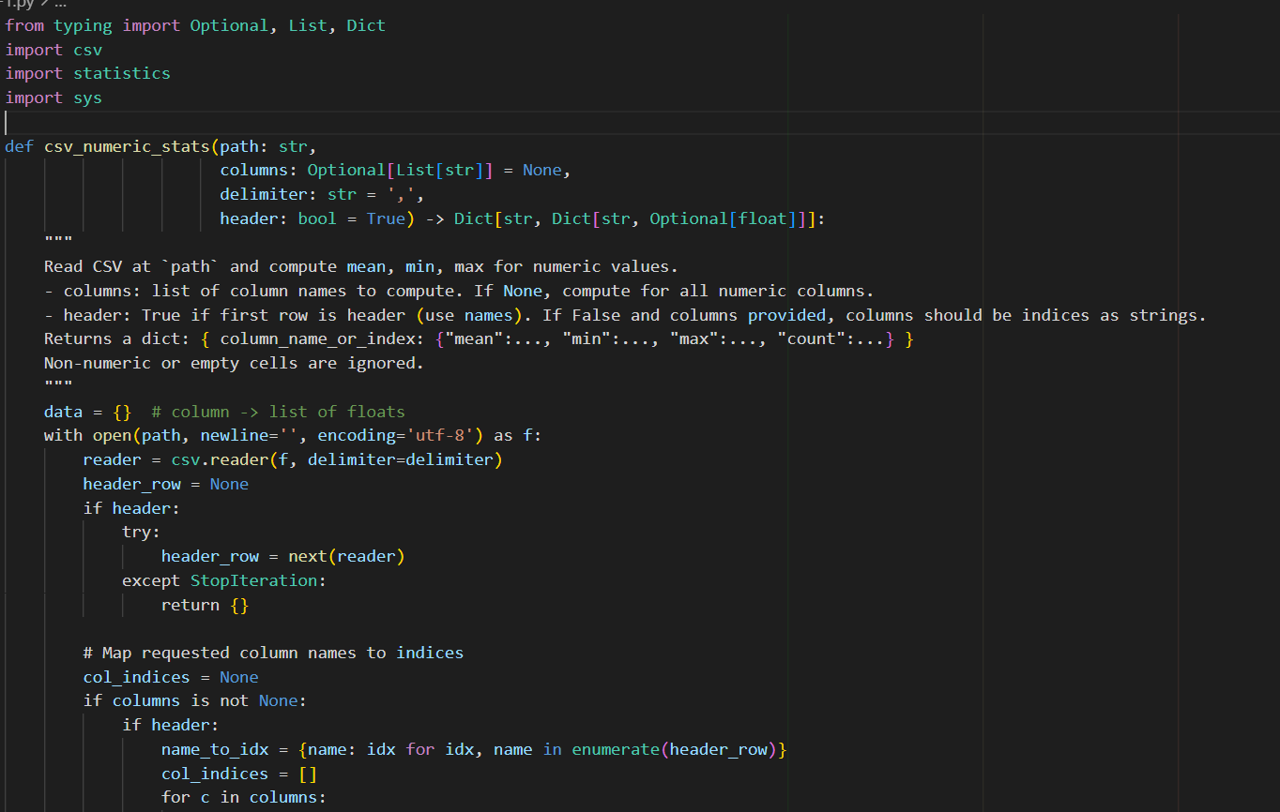

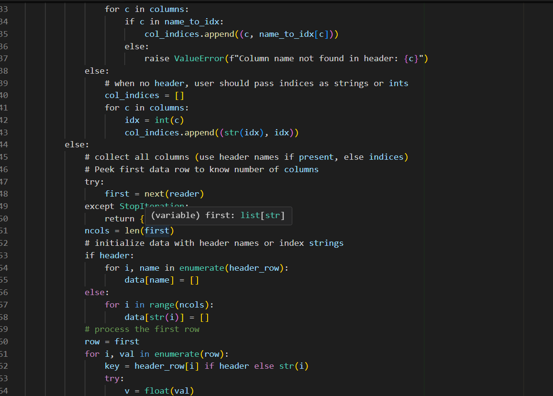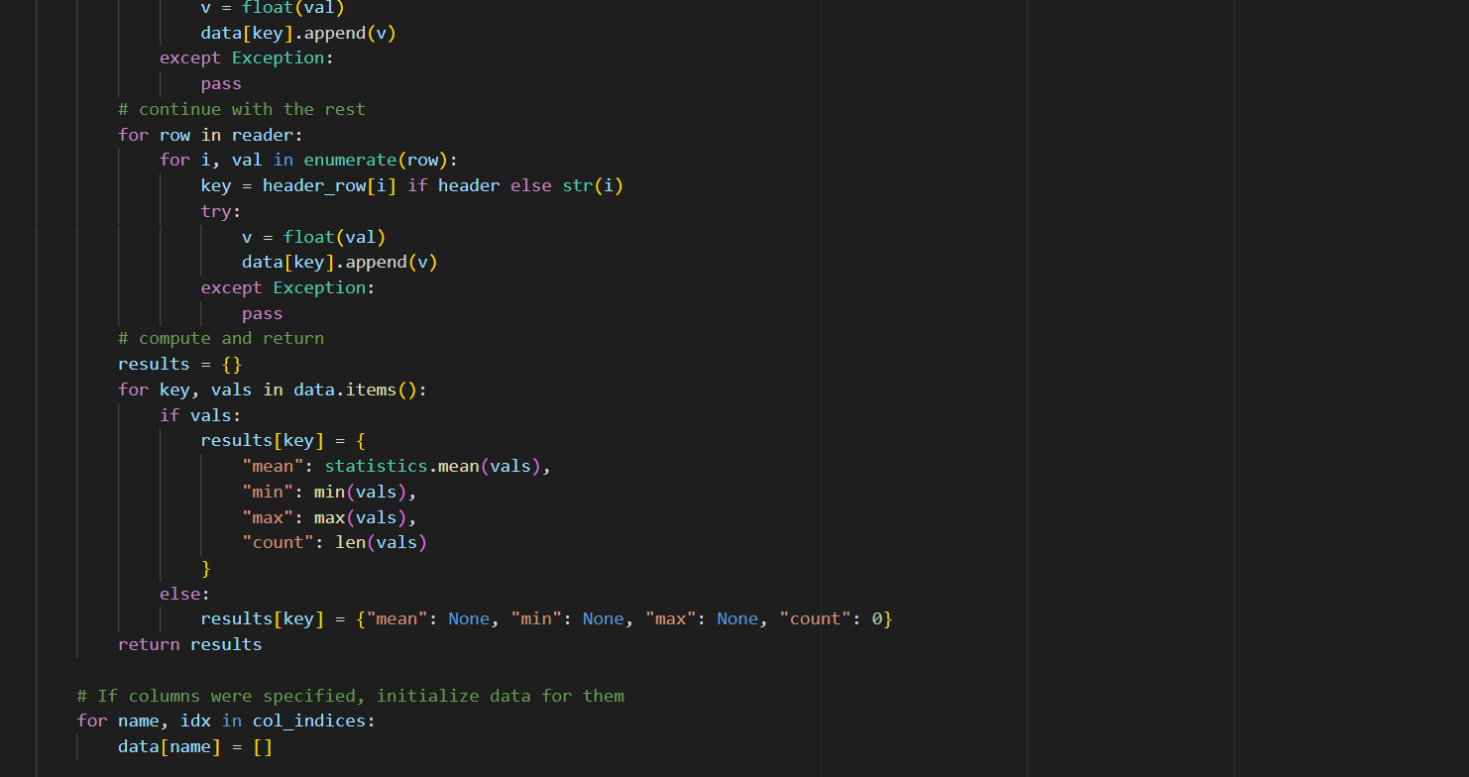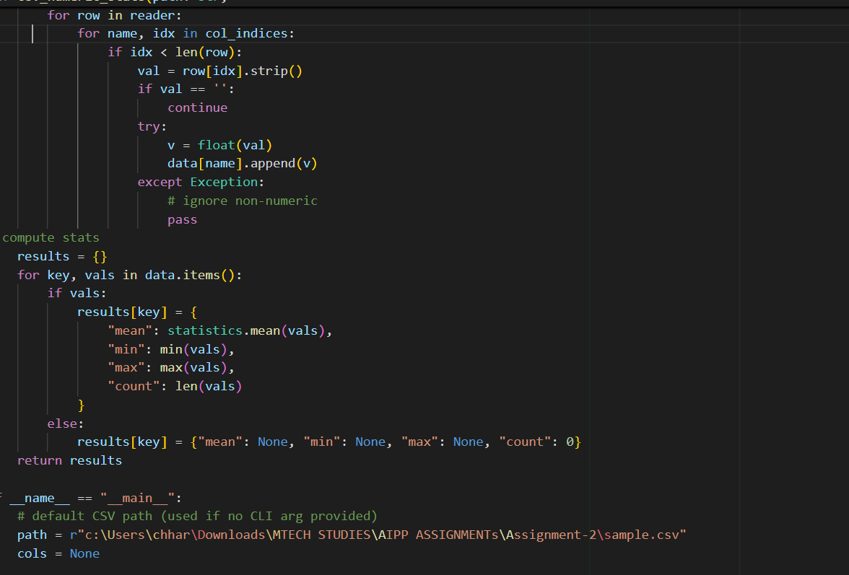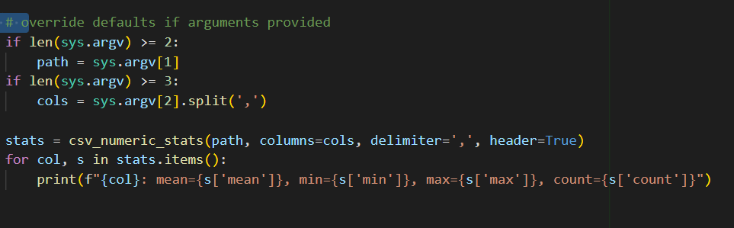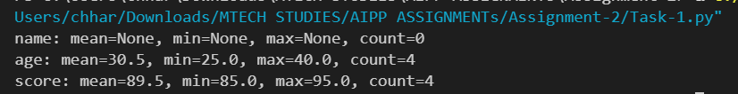
Task Description#2
- Compare Gemini and Copilot outputs for a palindrome check function.
Expected Output#2
- Side-by-side comparison and observations

PROMPT-1: write a python function for a palindrome check function.

Copilot Code:
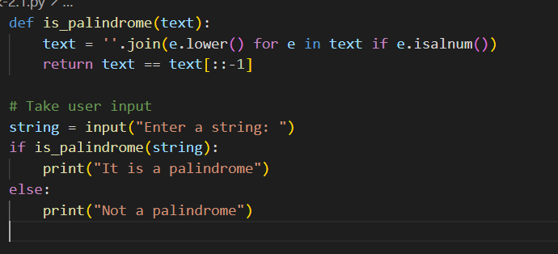
Explanation:
- Converts all characters to lowercase.
- Removes all non-alphanumeric characters (punctuation, spaces, etc.).
- Compares the cleaned string with its reverse.
- Returns True if palindrome, otherwise False

Gemini Code:
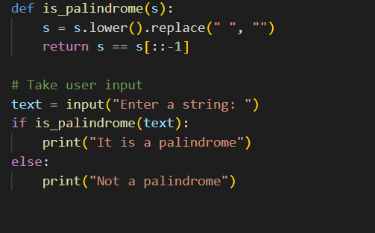
Explanation:
- Converts the string to lowercase.
- Removes spaces.
- Compares the string with its reverse (s[::-1]).
- Returns True if both are equal; otherwise, False.

Observations
- Gemini’s version is simpler and best suited for basic palindrome checks (like “madam” or “racecar”).
- Copilot’s version is more robust, handling cases like punctuation and numbers (e.g., “A man, a plan, a canal: Panama”).
- Both produce correct results for simple inputs, but Copilot’s approach is more production-ready due to better input sanitization.

Side-by-Side Comparison
Feature / Aspect | Gemini Output | Copilot Output
Variable Name | s | text
Cleaning Method | Removes spaces only | Removes all non-alphanumeric characters
Case Handling | Converts to lowercase | Converts to lowercase
Reversal Method | s[::-1] | text[::-1]
Accuracy | sentences without punctuation | Works for sentences with punctuation and numbers
Code Length | Shorter and simpler | Slightly longer but more robust
Readability | Easy to understand | Slightly complex but cleaner input handling

Task Description#3
- Ask Gemini to explain a Python function (to calculate area of various shapes) line by line..
Expected Output#3
- Detailed explanation with code snippet

PROMPT-1: explain a Python function (to calculate area of various shapes) line by line.Detailed explanation with code snippet
PROMPT-2: Take Input from User

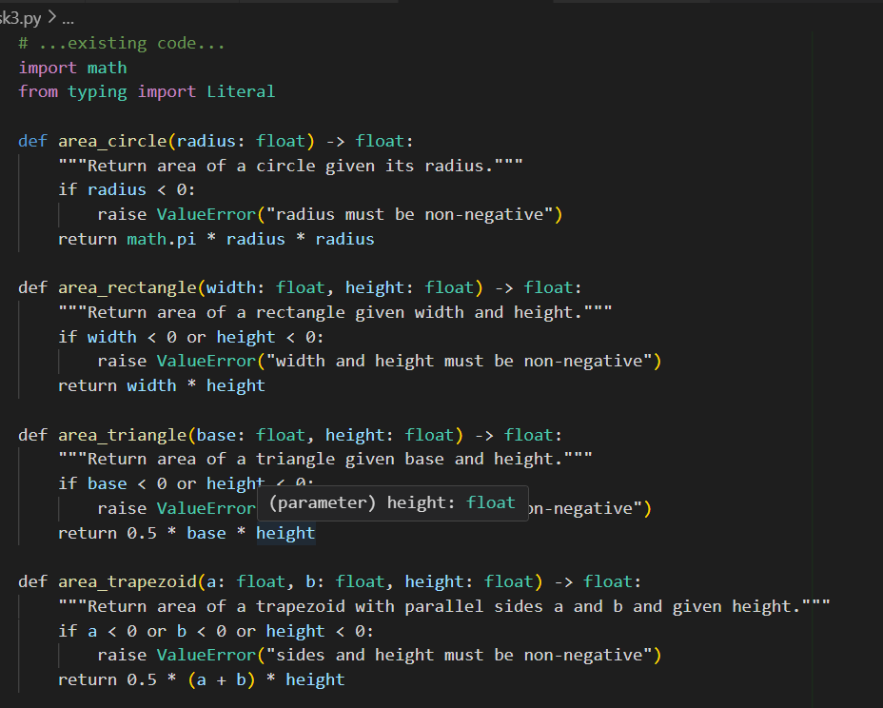
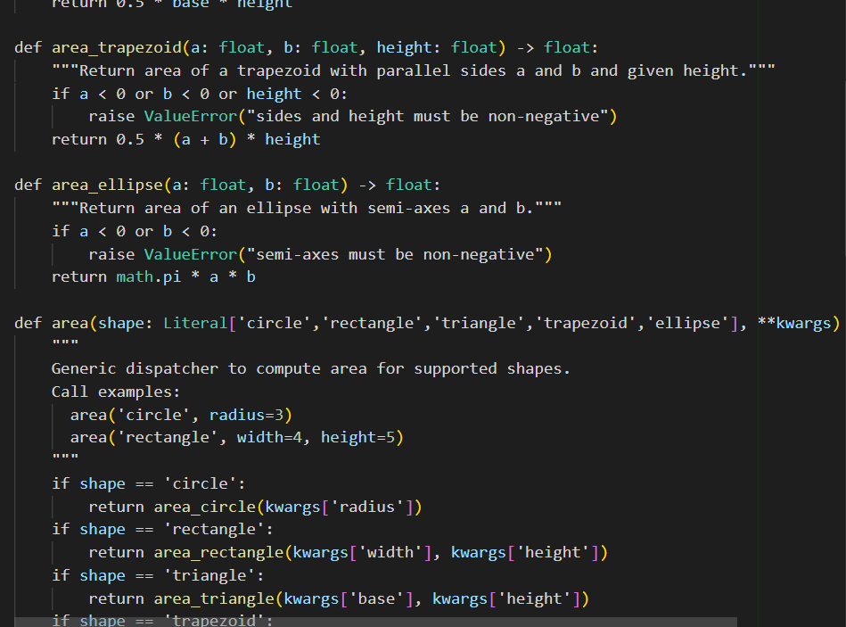
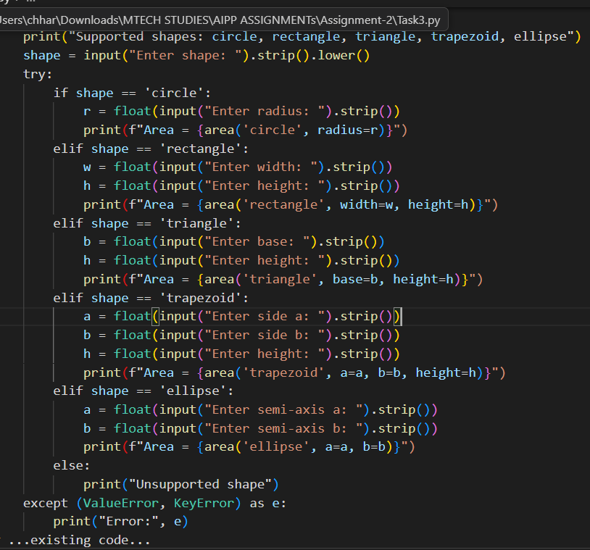Explaination:

- import math
  - Pulls in the math module to use math.pi for accurate π and other math utilities.
- from typing import Literal
  - Imports Literal for the shape parameter type hint in the dispatcher (constrains allowed shape strings).
- def area_circle(radius: float) -> float:
  - Declares function name, a typed parameter radius, and a typed return value float.
- """Return area of a circle given its radius."""
  - Docstring briefly describing the function.
- if radius < 0:
raise ValueError("radius must be non-negative")
  - Validates input and raises a clear error on invalid (negative) radius.
- return math.pi * radius * radius
  - Calculates and returns area using formula π * r^2.
- def area_rectangle(width: float, height: float) -> float:
  - Function to compute rectangle area with width and height parameters.
- if width < 0 or height < 0:
raise ValueError("width and height must be non-negative")
  - Input validation for non-negative dimensions.
- return width * height
  - Computes area as width × height.
- def area_triangle(base: float, height: float) -> float:
  - Function to compute triangle area.
- if base < 0 or height < 0:
raise ValueError("base and height must be non-negative")
  - Validate inputs.
- return 0.5 * base * height
  - Computes triangle area 1/2 × base × height.
- def area_trapezoid(a: float, b: float, height: float) -> float:
  - Function to compute trapezoid area with parallel sides a and b.
- if a < 0 or b < 0 or height < 0:
raise ValueError("sides and height must be non-negative")
  - Validate inputs.
- return 0.5 * (a + b) * height
  - Area formula: average of parallel sides times height.
- def area_ellipse(a: float, b: float) -> float:
  - Function for ellipse area using semi-axes a and b.
- if a < 0 or b < 0:
raise ValueError("semi-axes must be non-negative")
  - Validate inputs.
- return math.pi * a * b
  - Ellipse area formula π × a × b.
- def area(shape: Literal[...], **kwargs) -> float:
  - Generic dispatcher function. shape selects shape; kwargs holds required numeric arguments.
- The series of if shape == ... lines
  - Each branch extracts expected keyword arguments from kwargs and calls the specific shape function.
  - If a required kwarg is missing, Python raises KeyError — making missing inputs explicit.
  - This keeps the dispatcher small and delegates validation to the specific functions.
- raise ValueError(f"Unsupported shape: {shape}")
  - If the provided shape string is not supported, a clear error is raised

Task Description#4
- Install and configure Cursor AI. Use it to generate a Python function (e.g., sum of squares).
Expected Output#4
- Screenshots of working environments with few prompts to generate python code

PROMPT: Generate a python code to find sum of squares and take input from user

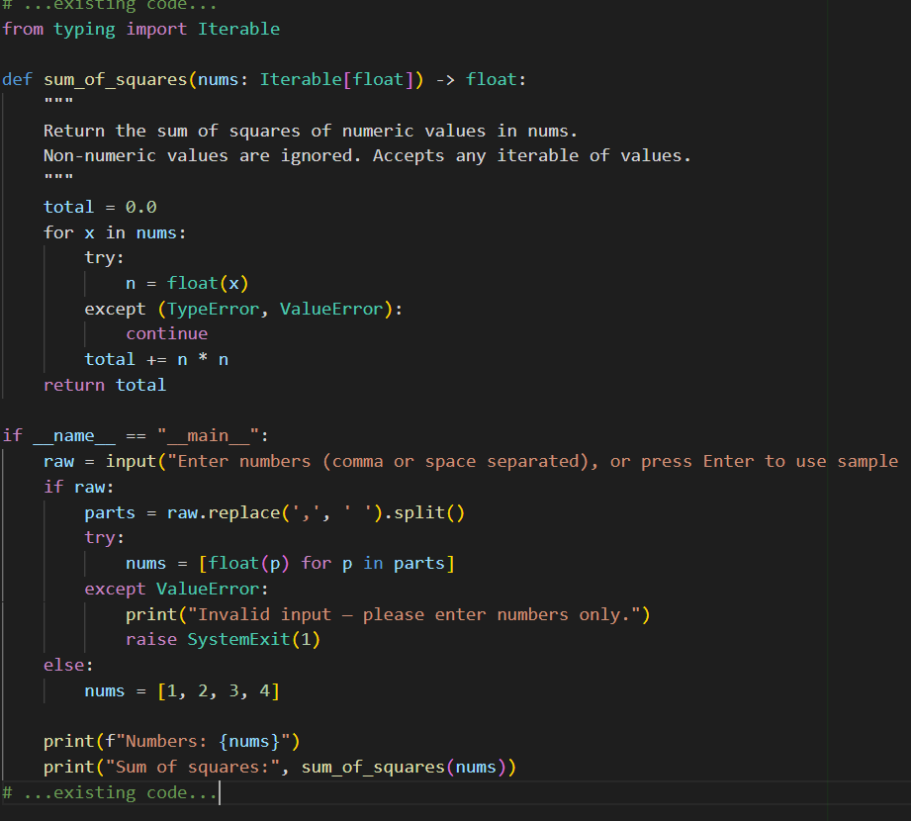
OUTPUT:
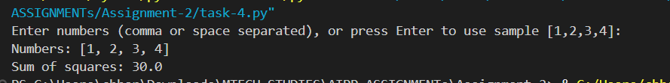

Task Description#5
- Student need to write code to calculate sum of add number and even numbers in the list
Expected Output#5
- Refactored code written by student with improved logic

PROMPT-1: generate a code to calculate the sum of odd numbers and even numbers in the list and take input from user

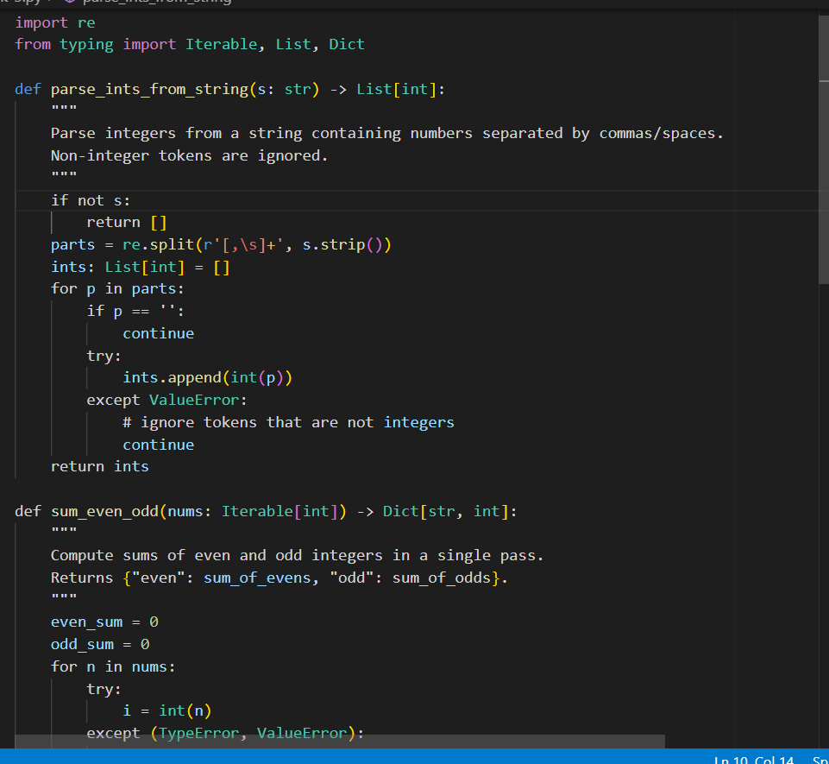
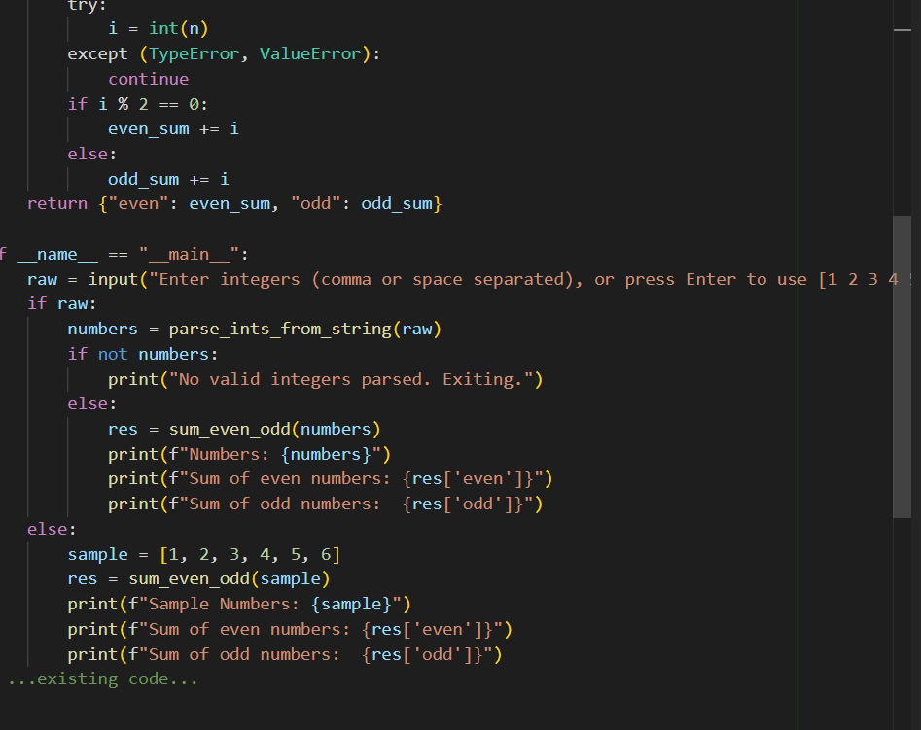

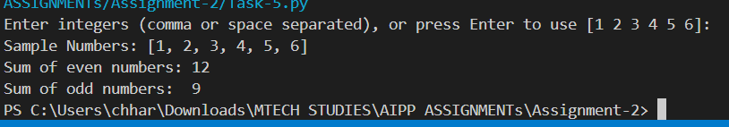

Evaluation Criteria:

Criteria | Max Marks
Successful Use of Gemini in Colab (Task#1 & #2) | 2.5
Code Explanation Accuracy (Gemini) (Task#3) | 2.5
Cursor AI Setup and Usage (Task#4) | 2.5
Refactoring and Improvement Analysis (Task#5) | 2.5
Total | 10 Marks

