MODERN OPERATING SYSTEM AND COMPUTER NETWORK
ASSIGNMENT -3

NAME: CH HARSHITHA
HALL TICKET NUMBER: 2503B05135 MTECH(CSE)
________________________________________________________________________
Task:1

Problem-01:
A bit stream 1101011011 is transmitted using the standard CRC method. The generator polynomial is x 4 +x+1. What is the actual bit string transmitted?

CODE:
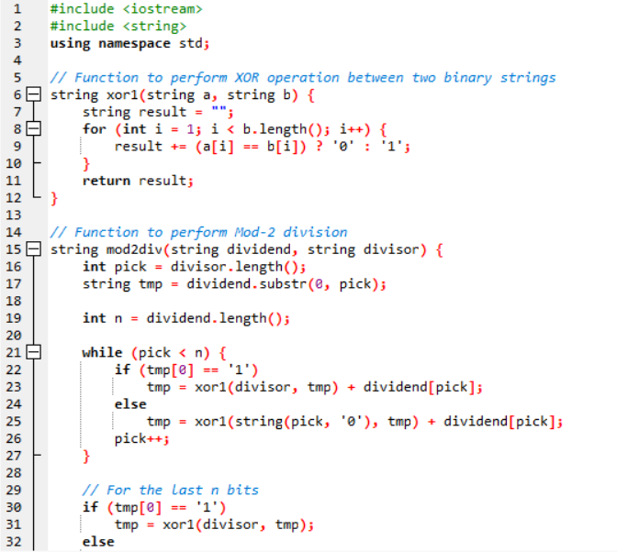
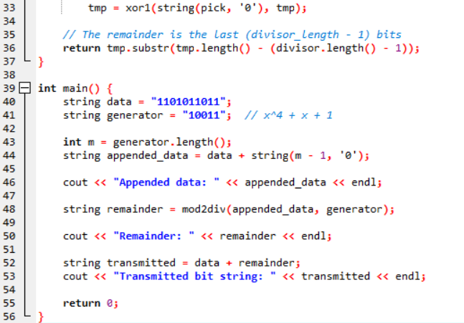

OUTPUT:
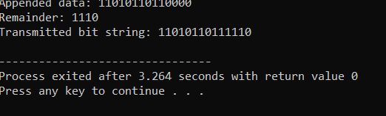

Task:2
Problem-02:
A bit stream 10011101 is transmitted using the standard CRC method. The generator polynomial is x3+1. 1. What is the actual bit string transmitted? 2. Suppose the third bit from the left is inverted during transmission. How will receiver detect this error?

CODE:
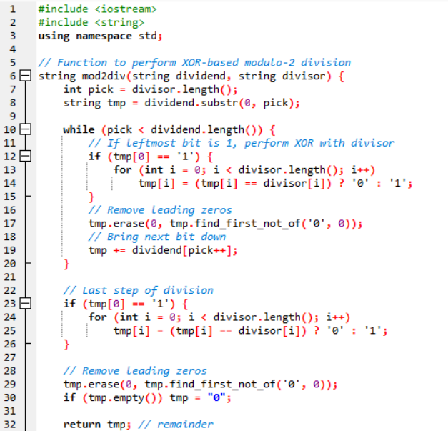
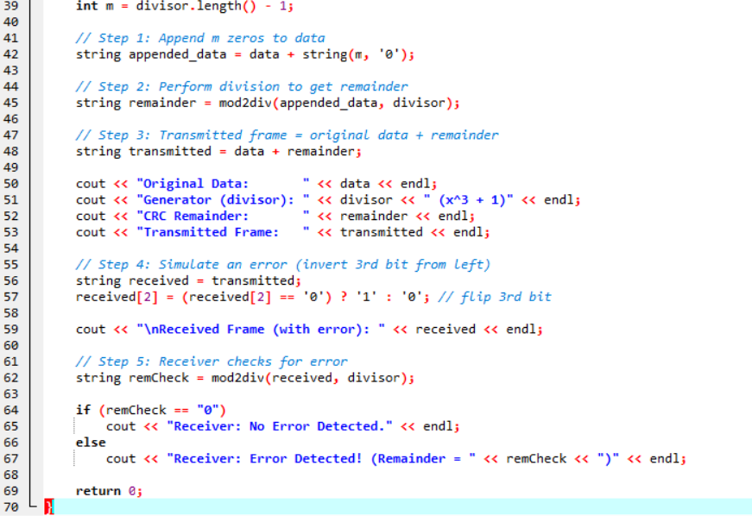

OUTPUT:
