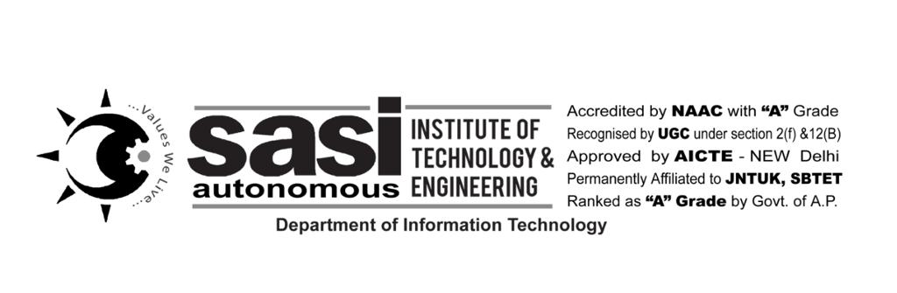A

SEMINAR REPORT ON

**IOT**

PRESENTED

BY

GANDHAM HARSHITHA

(19K61A1215)

SUBMITTED TO:

Dr. A.V.N. CHANDRA SEKHAR

PROFESSOR

DEPARTMENT OF INFORMATION TECHNOLOGY

**DECLARATION:**

I hereby declare that the report embodied in this dissertation entitled “IoT” is carried out by me during the year 2022-2023 for a seminar is to gain knowledge on the curriculum courses.

**BY:**

**G. HARSHITHA**

**19K61A1215**

**CONTENTS:**

1. **Abstract**
2. **Components of IoT**
3. **Why IoT**
4. **How IoT helps?**
5. **Scope of IoT**
6. **Applications of IoT**
7. **Advantages**
8. **Disadvantages**
9. **Conclusion**
10. **ABSTRACT**

The Internet of Things (IoT) refers to the ever-growing network of physical objects that feature an IP address for internet connectivity, and the communication that occurs between these objects and other Internet-enabled devices and systems, in simple words, Internet of Things (IoT) is an ecosystem of connected physical objects that are accessible through the internet. It is also referred to as Machine-to-Machine (M2M), Skynet or Internet of Everything.

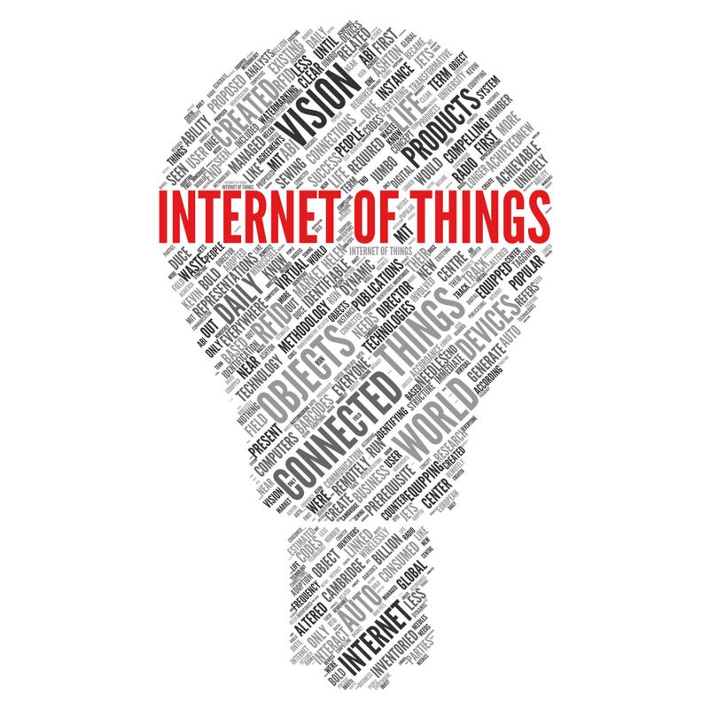

1. **COMPONENTS OF IOT**

Smart Systems and Internet of Things are driven by a combination of:

1. Sensors
2. Connectivity
3. People & Processes

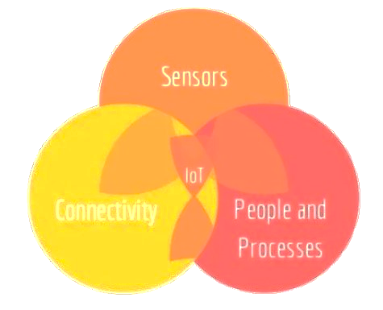

1. **WHY IOT?**

* Dynamic control of industry and daily life.
* Improves the resource utilization ratio.
* Integrating human society and physical systems.
* Flexible configuration.
* Acts as technology integrator.
* Universal inter-networking.

1. **SCOPE OF IOT**

Internet of Things can connect devices embedded in various systems to the internet. When devices/objects can represent themselves digitally, they can be controlled from anywhere. The connectivity then helps us capture more data from more places, ensuring more ways of increasing efficiency.

1. **APPLICATIONS OF IOT**
2. Smart Home: If you could switch on air conditioning before reaching home or switch off lights even after you have left home.
3. Wearable's: Wearable devices are installed with sensors and software's which collect data and information about the users, these devices broadly cover fitness, health.
4. Smart Cities: Powerful application of IoT, Smart surveillance, automated transportation, smarter energy management systems, water distribution, urban security and environmental monitoring.
5. IoT in agriculture (Smart farming): Sensing for soil moisture and nutrients, controlling water usage for plant growth and determining custom fertilizer are some simple uses.
6. **ADVANTAGES**
7. Control over all gadgets
8. Comfortable home settings
9. Emerging Smart Cities
10. Performance and efficiency
11. Improve monitoring
12. **DISADVANTAGES**
13. Lack of security on privacy
14. Unemployment
15. Losing control of your life
16. **CONCLUSION**

Projections for the impact of loT on the Internet and economy are impressive, with some anticipating as many as 100 billion connected loT devices and a global economic impact of more than $11 trillion by 2025, the potential economic impact of lot is huge, but the journey to loT adoption is not a seamless one. There are many challenges that face companies looking to implement IoT solutions. However, the risks and disadvantages associated with loT can be overcome.