A

SEMINAR REPORT ON

**KEEP DATA SECURE IN A RECRUITING APP**

PRESENTED

BY

GANDHAM HARSHITHA

(19K61A1215)

SUBMITTED TO:

**Dr. A.V.N. CHANDRA SEKHAR**

PROFESSOR

DEPARTMENT OF INFORMATION TECHNOLOGY

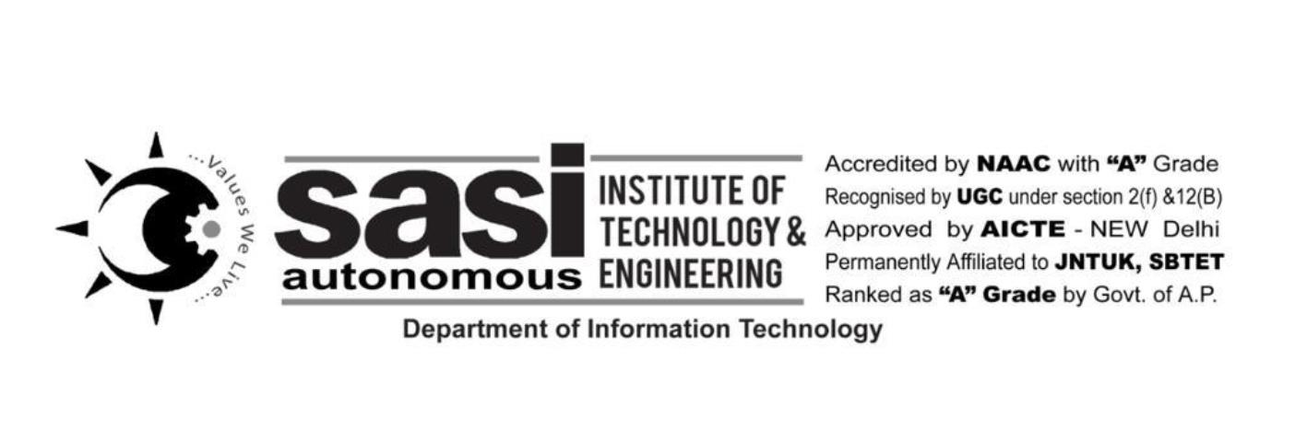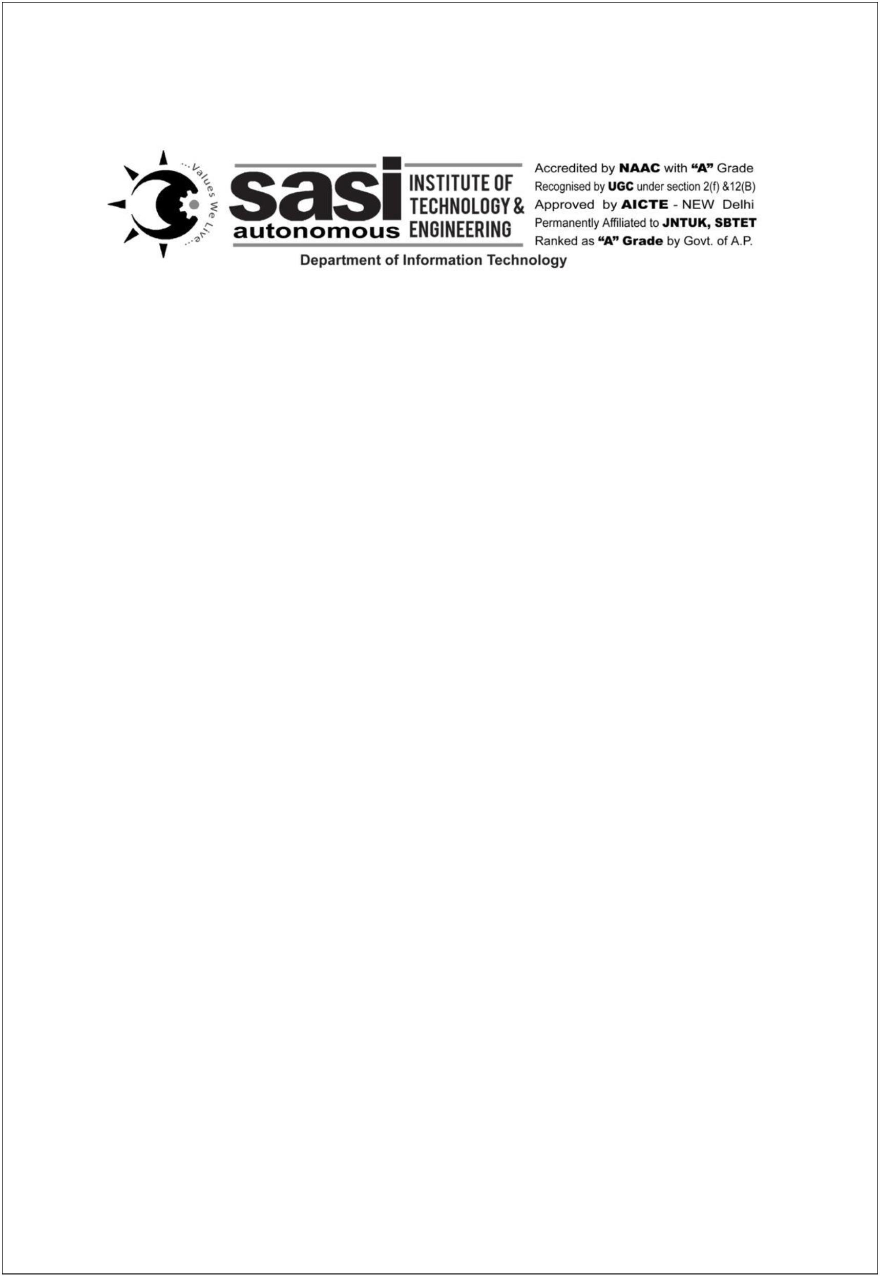

**DECLARATION:**

I hereby declare that the report embodied in this dissertation entitled “IoT”

is carried out by me during the year 2022-2023 for a seminar is to gain

knowledge on the curriculum courses.

**BY:**

**G. HARSHITHA**

**19K61A1215**

