A

SEMINAR REPORT ON

OPEN CV

PRESENTED BY

GANDHAM HARSHITHA

(19K61A1215)

SUBMITTED TO:

Dr. A V N CHANDRA SEKHAR

PROFESSOR

DEPARTMENT OF INFORMATION TECHNOLOGY



ACADEMIC YEAR: 2022-2023

## DECLARATION:

I hereby declare that the report embodied in this dissertation entitled “Open CV” is carried out by me during the year 2022- 2023 for a seminar is to gain knowledge on the curriculum courses.

## Gandham Harshitha

**(19K61A1215)**

## CONTENTS

1. Abstract
2. Why OpenCV
3. Features of OpenCV
4. OpenCV Modules
5. Functionalities of OpenCV
6. Applications of OpenCV
7. Conclusion

**1.ABSTRACT**

OpenCV (Open Source Computer Vision Library) is an open source computer vision and machine learning software library. OpenCV was built to provide a common infrastructure for computer vision applications and to accelerate the use of machine perception in the commercial products. Being an Apache 2 licensed product, OpenCV makes it easy for businesses to utilize and modify the code.

The library has more than 2500 optimized algorithms, which includes a comprehensive set of both classic and state-of-the-art computer vision and machine learning algorithms. These algorithms can be used to detect and recognize faces, identify objects, classify human actions in videos, track camera movements, track moving objects, extract 3D models of objects, produce 3D point clouds from stereo cameras, stitch images together to produce a high resolution image of an entire scene, find similar images from an image database, remove red eyes from images taken using flash, follow eye movements, recognize scenery and establish markers to overlay it with augmented reality, etc. OpenCV has more than 47 thousand people of user community and estimated number of downloads exceeding 18 million. The library is used extensively in companies, research groups and by governmental bodies

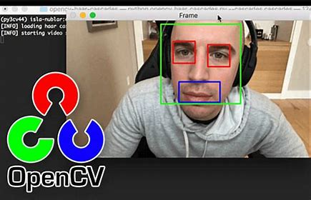

## 2.Why OpenCV?

* OpenCV is the huge open-source library for the computer vision, machine learning, and image processing and now it plays a major role in real-time operation which is very important in today's systems. By using it, **one can process images and videos to identify objects, faces, or even handwriting of a human**.
* Free for use under the license which makes it easy for businesses to utilize and modify the code and supports the Deep Learning Frameworks TensorFlow, Torch/PyTorch and Caffe.
* By using it, one can process images and videos to identify objects, faces, or even handwriting of a human.
* When it integrated with various libraries, such as NumPy, python is capable of processing the OpenCV array structure for analysis.
* To Identify image pattern and its various features we use vector space and perform mathematical operations on these features.
* The first OpenCV version was 1.0. OpenCV is released under a BSD license and hence it’s free for both academic and commercial use.
* It has C++, C, Python and Java interfaces and supports Windows, Linux, Mac OS, iOS and Android.
* When OpenCV was designed the main focus was real-time applications for computational efficiency.
* All things are written in optimized C/C++ to take advantage of multi-core processing.

.

# 3.Features of OpenCV

* Read and write images
* Capture and save videos
* Image processing such as filtering and transformation
* Feature detection
* Video or image object detection such as human body parts, cars, signage, etc.
* Video analysis
* Computer Vision overlaps significantly with the following fields −
* **Image Processing** − It focuses on image manipulation.
* **Pattern Recognition** − It explains various techniques to classify patterns.
* **Photogrammetry** − It is concerned with obtaining accurate measurements from images.

## 4.OpenCV Modules

### Core Functionality:

The core functions of the OpenCV library cover the basic data structures such as Scalar, Point, Range, etc. To store images, it has the multidimensional array *Mat*.

### Image Processing:

This module covers various image processing operations such as image filtering, geometric image transformations, color space conversion, histograms, etc.

### Video:

This module covers the video analysis concepts such as motion estimation, background subtraction, and object tracking.

### Video I/O:

This module explains the video capturing and video codecs using the OpenCV library.

### Calib3d:

This module includes algorithms regarding basic multiple-view geometry algorithms, single and stereo camera calibration, object pose estimation, stereo correspondence, and elements of 3D reconstruction.

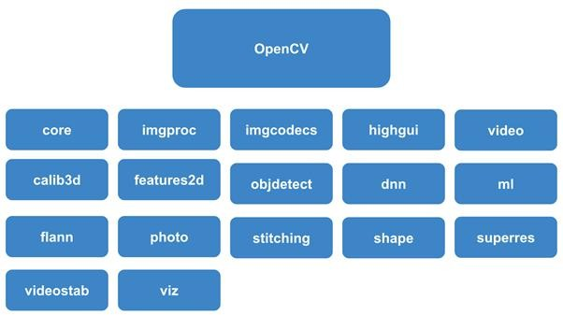

## 5.Functionalities of OpenCV

* + Image/video I/O, processing, display (core, imgproc, highgui)
  + Object/feature detection (objdetect, features2d, nonfree)
  + Geometry-based monocular or stereo computer vision (calib3d, stitching, videostab)
  + Computational photography (photo, video, superres)
  + Machine learning & clustering (ml, flann)
  + CUDA acceleration (gpu)

## 6.Applications of OpenCV

There are lots of applications which are solved using OpenCV, some of them are listed below

* + Face recognition
  + Automated inspection and surveillance
  + number of people – count (foot traffic in a mall, etc)
  + Vehicle counting on highways along with their speeds
  + Interactive art installations
  + Anomaly (defect) detection in the manufacturing process (the odd defective products)
  + Street view image stitching
  + Video/image search and retrieval
  + Robot and driver-less car navigation and control
  + object recognition
  + Medical image analysis
  + Movies – 3D structure from motion
  + TV Channels advertisement recognition.
  + Localization − Determine robot location automatically
  + Navigation
  + Obstacles avoidance
  + Assembly (peg-in-hole, welding, painting)
  + Manipulation (e.g. PUMA robot manipulator)
  + Human Robot Interaction (HRI) − Intelligent robotics to interact with and serve people

## 7.Conclusion

Finding the passion and vision for image processing and computer vision applications allow entrepreneurs to empower their clients. With the demand for image-based search engines, both entrepreneurs and software developers will emerge victorious using tools such as OpenCV.

Computer vision is not just an interesting field but a revenue-generating business. However, the realistic woes that most entrepreneurs faced are expenses and scarcity of resources. Despite the massive interest, there are still areas under computer vision that has limitations. All these issues will be addressed intelligently by our pool of project managers, engineers, and software developers.

