
BVRIT HYDERABAD
College of Engineering for Women
Department of Information Technology
Major Project - Academic Year 2022-23
Abstract
In today’s world there is a continuous need for automated appliances, with the increase in the living standard, there is an immediate need for developing circuit that would change the complexity of life to simplicity. The model is designed in order to count the visitors of an offices, auditoriums, hall, sport venue. When a person enters the room, count would be increased, whereas on leaving, the count would decrease. This count will be very accurate and it will beep a warning alarm if the number of people exceeds the limit. The aggregate number of people will appear on the LCD. In the circuit an Arduino UNO Board is utilized. This will help in the accurate measurement of the visitors and is less complex compared to a microcontroller. The Arduino will get signals from the sensors and those signals work under the control of a programming code which is put away in the ROM of the Arduino. The Infrared Receivers will continuously monitor any entity which passes both outside the building and inside the building.

IoT based Bidirectional Visitor Counter

Modules
Visitor Counter
Device Automation
Environment Monitoring
Buzzer
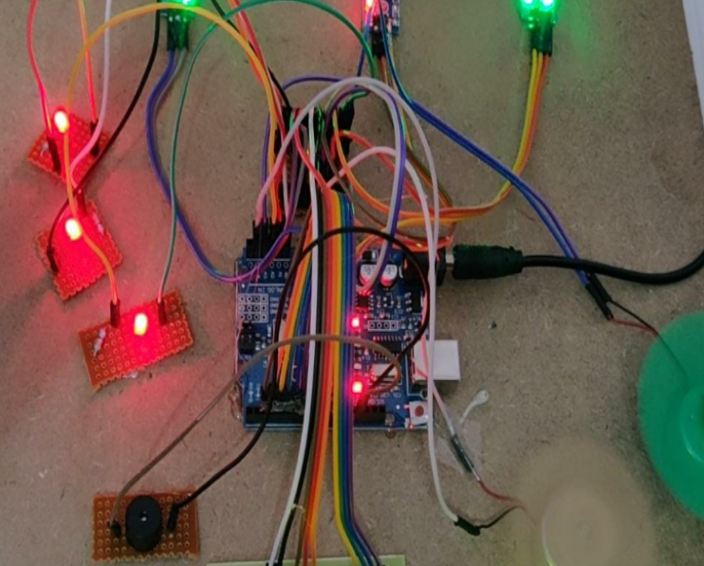

Architecture
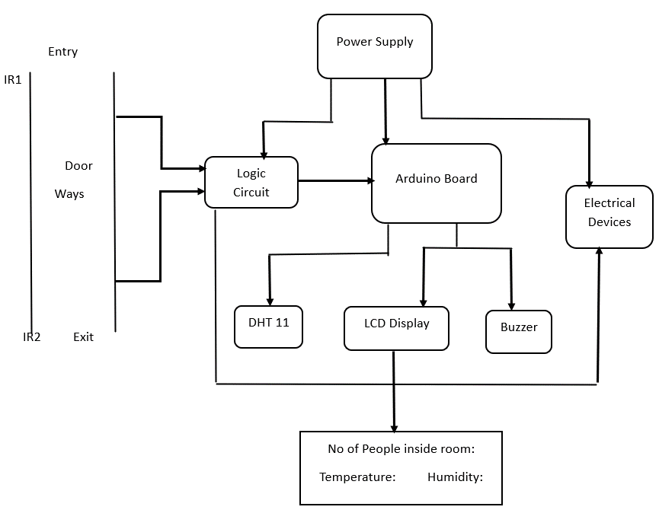

Tools and Technologies
- Arduino Programming Language
- IR Sensor
- DHT11 Sensor
- Buzzer
Conclusion and Future Scope
It is an efficient and automated solution. By combining various modules the system accurately counts visitors and saves electricity. It can be used in saving electricity in large scale industries, malls, education sectors.

TEAM
05
Guide
Mr.Ch.Anil Kumar
Assistant Professor
anilkumar.ch@bvrithyderabad.edu.in

Team

19WH1A1221 19WH1A1231 19WH1A1233 19WH1A1257
G. Esha P.Preethi M. Harshini I. Harshitha

Github Link
1. https://github.com/Esha1221/Major_project/tree/main/Bidirectional_visitor_counter
2. https://github.com/Preethi1231/Major_project/tree/main/Bidirectional_visitor_counter
3. https://github.com/harshini825/Major_project/tree/main/Bidirectional_visitor_counter
4. https://github.com/harshithaibathula/Major_project/tree/main/Bidirectional_visitor_counter

