**RoboMetrix Remote Control App**

**PROPOSAL**

*Project Overview*

In this project, a Computer Science student will develop a remote control application for a RoboMetrix VisitorBot. The app will produce dual-tone multi-frequency signaling (DTMF) tones to control the robots motion, speaker, and microphone. RoboMetrix will provide funding for the student developing the application and a grant-in-kind of a Robometrix VisitorBot for testing purposes.

*Application Specification*

When the application is first loaded, a splash screen will appear for a few seconds.

The splash screen will contain a logo and version number, e.g.:

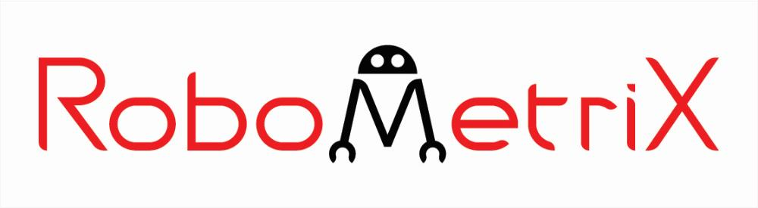

version 1.0

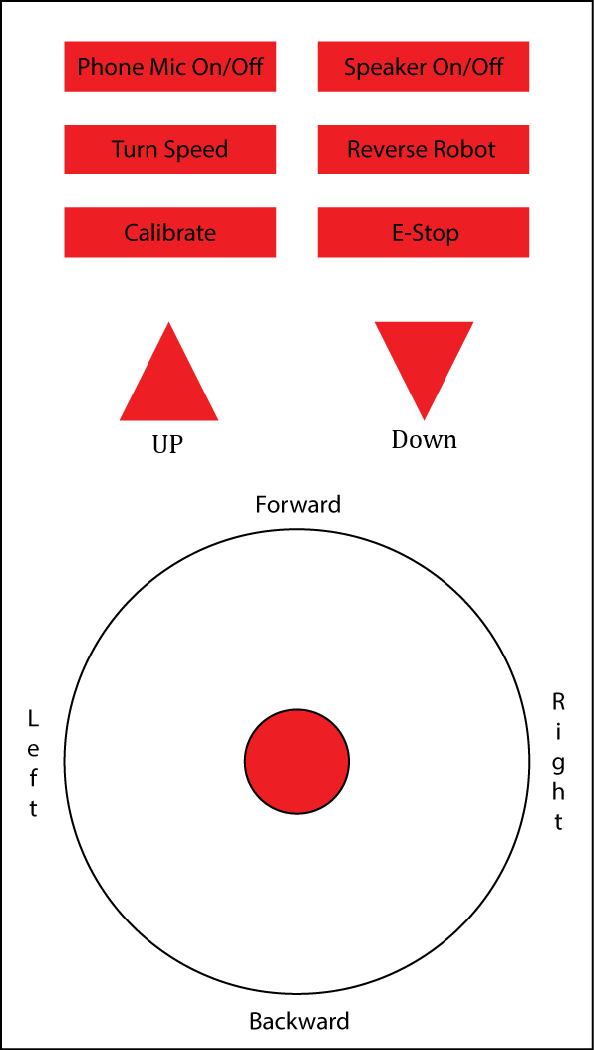

The remote control view will then appear, formatted as in the figure on the right. The RED components of the figure will be the interactive portions of the app.

The red circle is to be dragged to either of the four cardinal directions. Doing so will result in the app producing DTMF tones for the appropriate commands:

* 2: Forward
* 4: Left
* 6: Right
* 8: Backward

These tones should be repeated every 3 seconds while the operator is still holding the “Joystick”. Once an operator lets go of the screen a 0 tone will be produced.

The “Up” and “Down” arrows will move the camera. Tapping “Up” or “Down” will produce the appropriate tones:

* 3: Up
* 9: Back

The phone will take audio from the microphone and pass it through the headphone jack along with DTMF tones. The “Phone Mic on/off” button will toggle the microphone in the phone.

The “Speaker On/Off” button will produce a 5 tone.

The “Turn Speed” button will produce a * tone.

The “Reverse Robot” button will produce a 1 tone.

The app should reflect the current status of features by changing the color of the button. For example, the “Speaker On/Off” button could turn green when pressed to turn on the robot speaker and turn red when pressed again to turn it off. However, due to the lost packets over VoIP connection, commands may not be received by the robot. So, on occasion, the user will need to press the “Calibrate” button to reset the apps buttons/sliders to their default position. When “Calibrate” is pressed, it will also need to send a # tone to make the robot calibrate itself.

The “E-Stop” button should produce a 0 tone.

In addition, there will be a Help screen that is accessible via the Action Overflow menu. This Help screen will display the application name, version number, and contact information for RoboMetrix.

*Supported Hardware*

The application will be developed for platforms supporting the Android v. 4.0 and greater. The application will contain two versions of the GUI – a small one to support small screens on phones and a larger one to support tablet screens. We will make every attempt to support a wide range of hardware that uses these platform versions. However, because of the wide range of device manufacturers, it is possible that some features, in particular those dealing with the microphone and the joystick action, may not be supported by all hardware.

The application will specifically be tested on the following hardware platforms:

* Samsung Galaxy S3
* Nexus 7

*Project Budget*

The budget will cover 10 hours per week for 15 weeks for the student. In addition, RoboMetrix will provide a VisitorBot and training in the code base valued at $300.

*Proposed Timeline and Deliverables*

This timeline assumes a start date of January 13, 2013. Tentative dates for the deliverables are:

Week of January 27th: Word document showing the Application Wireframe showing screenshots of the screen layouts for the Splash screen, Main screen, and Help screen for the phone and tablet versions of the application.

Week of February 3rd: Revised Word Document showing changes to screenshots incorporated into the application, based on discussions from previous week.

Week of February 17th: Alpha v0.1 application with the following functionality:

* Splash Screen
* Main Screen supporting click events, but not joystick functionality
* Appropriate DTMF tones generation
* Application Icon
* About/Help Screen available via the Settings

Week of March 17th: Alpha v0.2 with joystick functionality implemented, and possible bug fixes from the v0.1.

Week of April 7th: Alpha v.0.3 with Microphone pass-through to speaker.

Week of May 1st: Beta v.0.4 released.

Week of June 1st: v.1.0 released.