Adult Income Data Cleaning and EDA Report

1. Project Summary
This project analyzes the UCI Adult Income dataset to understand which demographic, education, and work-related characteristics are associated with annual income above USD 50K.

2. Problem Statement
Which demographic, education, and work characteristics are associated with an annual income above USD 50K in this census dataset?

3. Dataset Overview
The dataset is the Adult Income dataset from the UCI Machine Learning Repository. The training and testing files were combined for analysis.
Total records: 48,842
Original features: 14
Target variable: income

4. Data Cleaning
- Combined adult.data and adult.test datasets.
- Added source_split to identify train and test records.
- Replaced '?' missing-value markers with NaN.
- Replaced missing workclass, occupation, and native_country values with 'Unknown'.
- Removed the trailing period from income labels in the test dataset.
- Created the high_income numeric variable.
- Created age_group and hours_group variables.
- Created net_capital using capital_gain minus capital_loss.
- Counted duplicate records without removing them.

5. Exploratory Data Analysis
The analysis examined income distribution and relationships between income and education, occupation, age, workclass, sex, working hours, and capital-related variables.

Income Distribution
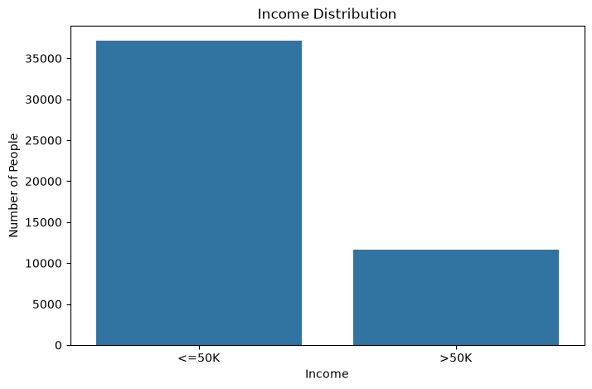

Income by Education
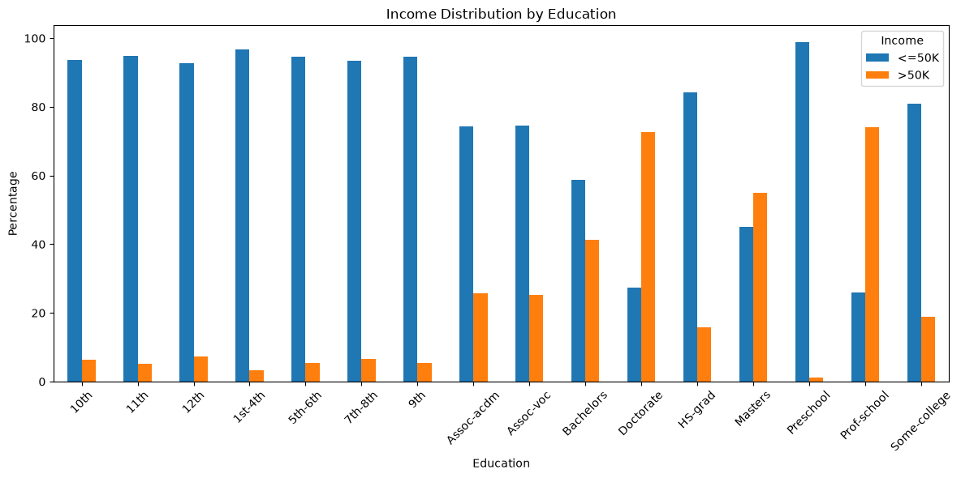

Income by Occupation
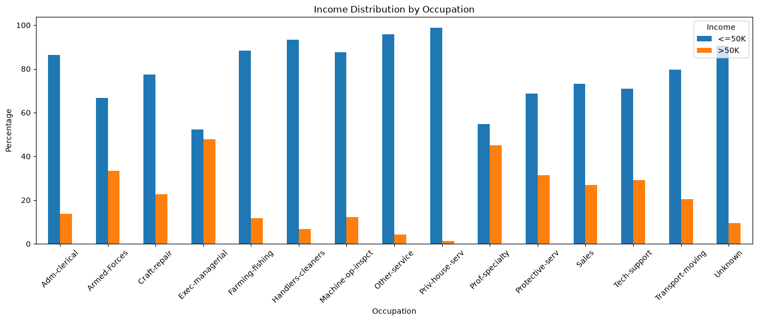

Income by Age Group
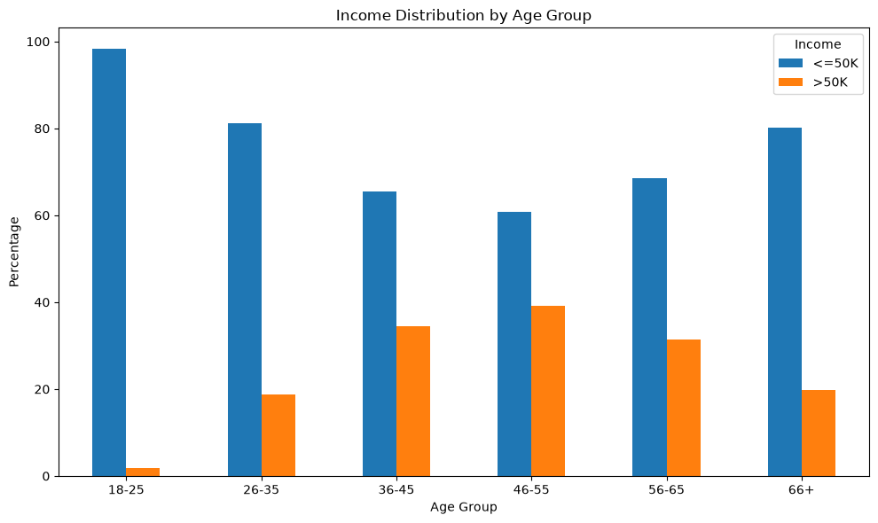

Income by Workclass
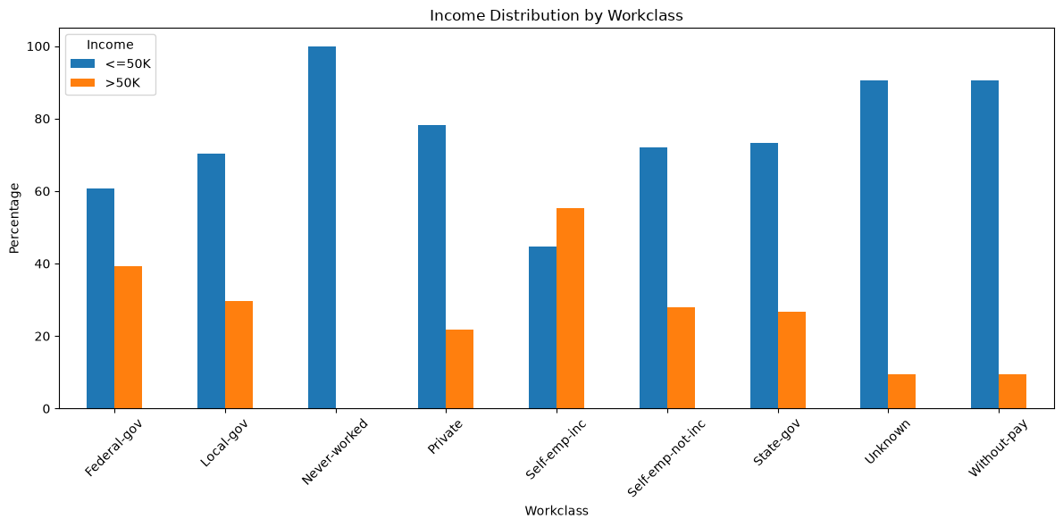

Income by Sex
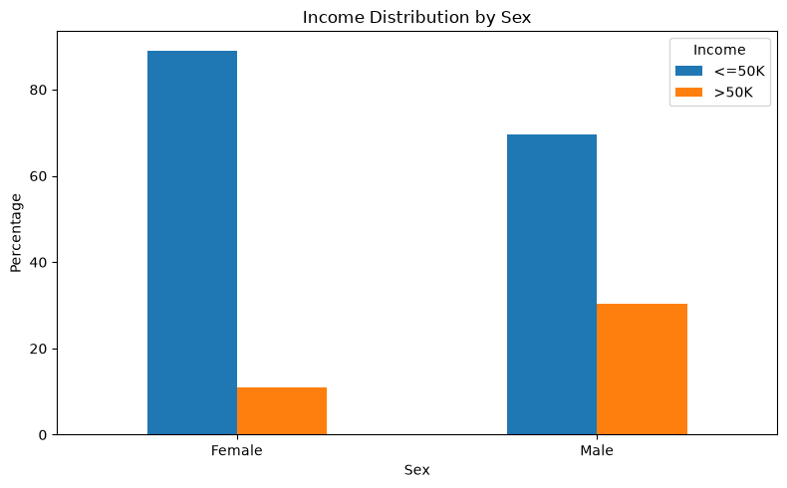

Weekly Working Hours by Income
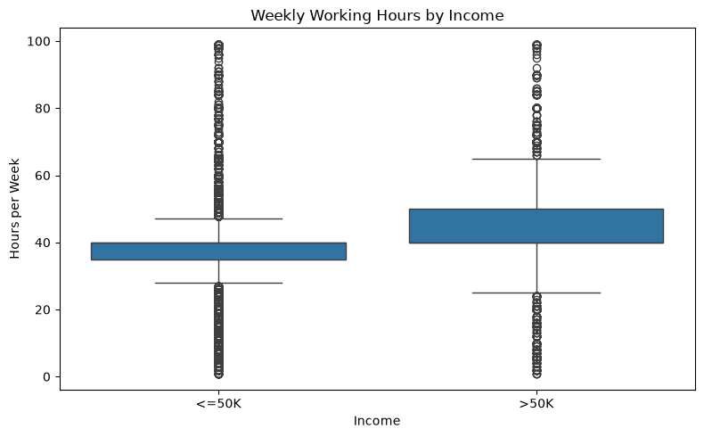

Income by Working-Hour Group
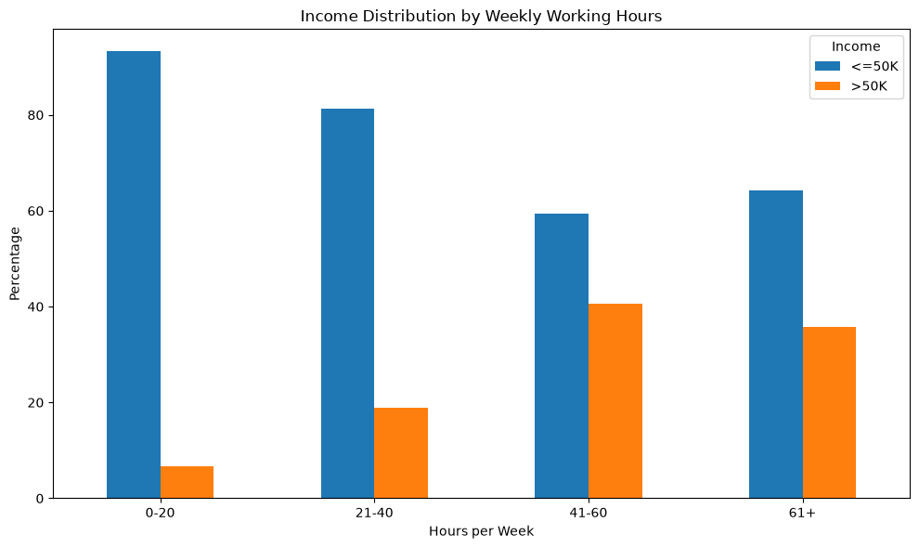

Correlation Heatmap
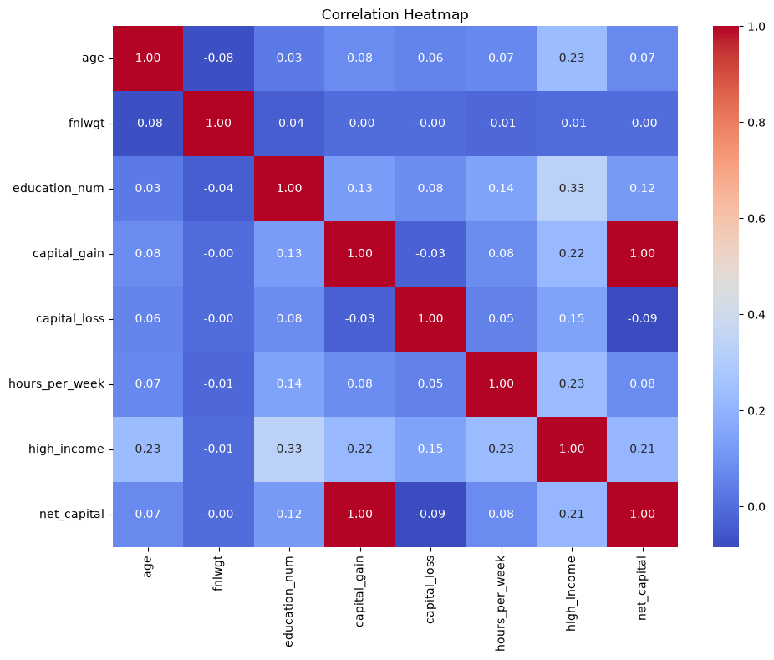

6. Limitations
This analysis describes associations in the dataset and does not establish causal relationships. The Adult dataset is historical and contains demographic attributes. The visualizations are descriptive and are not weighted to represent a modern population.

7. Conclusion
The exploratory analysis provides an overview of how education, occupation, age, workclass, sex, working hours, and capital-related variables are associated with income levels in the Adult dataset. The cleaned dataset and EDA results can be used as the foundation for the machine-learning stage of the project.

