

CP5046 ICT project 1

Assessment TASK 1: Project Documentation

**Lecturer: Laura Antochi**

**Students**

Anastasia Verchak ID 13446694

Charanpreet Kaur ID 13543377

Harshitha Paderu ID 13539782

## Group members

|  |  |  |
| --- | --- | --- |
| **Name** | **Project role(s)** | **Individual contributions** |
| Anastasia Verchak | Project manager, tester | * Client agreement * Communication with client * Prototypes * Testing tools |
| Charanpreet Kaur | Developer | * Project tools * Milestones * Configuration management |
| Harshitha Paderu | Developer | * Justification of the project |
|  |  |  |

## Justification for the project

Information about the School

1. Most of the Russian language school websites are NOT responsive.

2. They provide different and lesser information on their English version when compared to more information on their Russian version.

3. No website has a login portal for staff/students

4. No website has a SSL certificate and so are not be trusted

5. No website meets the standard layout that all business websites follow these days.

And now we can only brag about how our website is going to be better compared to all these limitations.

1. It will have no bias. It will provide same information in the English/ Russian version.

2. We will provide all contact details, I.e; phone number, email, social media links

3. It will be responsive

4. It’s going to be secure.

5. It’ll be easy for visitors to understand

## Project goals

To develop a responsive website for Russian language school Romashka (Daisy) to create centralised solutions to school management

Marketing

promotion

Online presense

**Milestones:**

**Milestone 1**

|  |  |  |
| --- | --- | --- |
| User story | Priority | Time frame |
| Home page | 10 | 12/12/18 – 27/12/18 |
| Login page(student) | 10 |
| Login page(staff) | 10 |

**Milestone 2:**

|  |  |  |
| --- | --- | --- |
| User story | Priority | Time frame |
| Dashboard | 10 | 28/12/18 – 12/01/19 |
| Enrollment page | 10 |
| Payment page | 10 |

**Milestone 3**:

According to given timeline, the schedule looks little ambitious but, with combination of execution and communication we are sure that we can finish the project on time.

|  |  |  |
| --- | --- | --- |
| User story | Priority | Time frame |
| About Us page | 20 | 13/01/19 – 28/01/19 |
| Contact Us page | 20 |
| Blog(Admin) | 40 |
| Event page | 40 |
| Blog (visitor) | 50 |

## Project scope

Alpha-release

|  |  |  |  |
| --- | --- | --- | --- |
| **Title** | **Description** | **Client Priority** | **Time estimate (days)** |
| Login page (student) | Access to the profile for checking the study progress and upload a homework, paying fees and etc | 10 | 5 |
| Login page (staff) | Access to the profile, edit students, classes | 10 | 5 |
| Home page | Access to the whole web-site, main page with news, greetings and main menu | 10 | 5 |
| Registration page | Registration to the school | 10 | 3 |
| Dashboard | Student has an access to his study activities | 10 | 5 |
| Payment page | To pay fees through credit card. | 10 | 5 |
| Enrollment page | Students can enroll by selecting subjects from the list of different subjects and confirm their enrollment. | 10 | 5 |
| Contact us page | Access to the contact details of the school to find its location, phone number for any queries. | 20 | 2 |
| About us page | Access to the information about the school involving teaching programs, events ,etc. | 20 | 5 |

Final-release

|  |  |  |  |
| --- | --- | --- | --- |
| Title | Description | Client Priority | Time estimate (days) |
| Blog(Admin) | Allows the admin to post articles about school that visitors can read. | 40 | 3 |
| Events Page | Allows visitors to check upcoming event details, and register if necessary | 40 | 1 |
| Blog(Visitor) | Allows visitors to read the blogs posted by the admin(like or dislike and comment on it) | 50 | 3 |
| Gallery | Allows all visitors to view images of school, events conducted,etc | 50 | 1 |

## Project sponsor

|  |  |
| --- | --- |
| **Name** | GOLD COAST RUSSIAN LANGUAGE SCHOOL  "ROMASHKA" LTD |
| **ABN** | 67622453034 |
| **Contact person** | Victor Ovchinnikov, principal |
| **Contact email** | [info@schoolromashka.com.au](mailto:info@schoolromashka.com.au) |
| **Contact phone** | 468296494 |

Client agreement is attached as Attachment 1.

## Configuration management

1. **GitHub:**

GitHub is an online version control service which stores our work in versioned fashion. We can revert to any version at any point in time. Multiple users can use a repository to store their work.

Link

Code

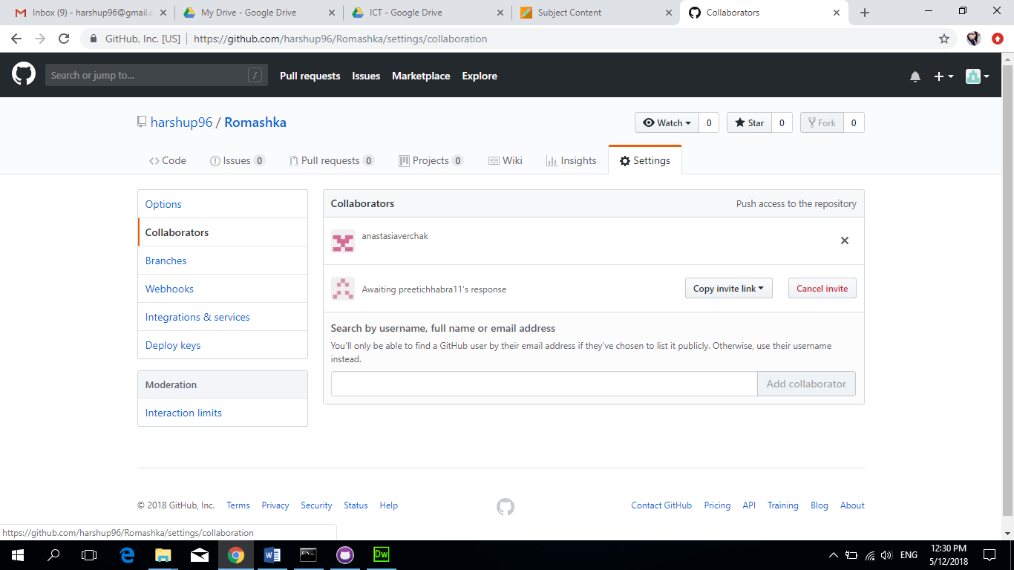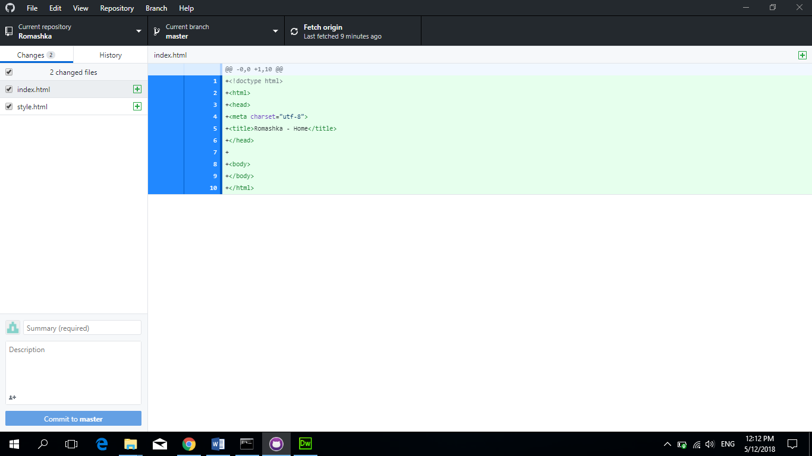

1. **Google Drive:**

Google drive is a cloud storage solution for Internet giant Google. We can use it to collaborate and work on documents simultaneously in real time. Initially, Google provides 15GB of free space and it can extended with subscription. We used Google Drive to share large files initially then, we started using git.

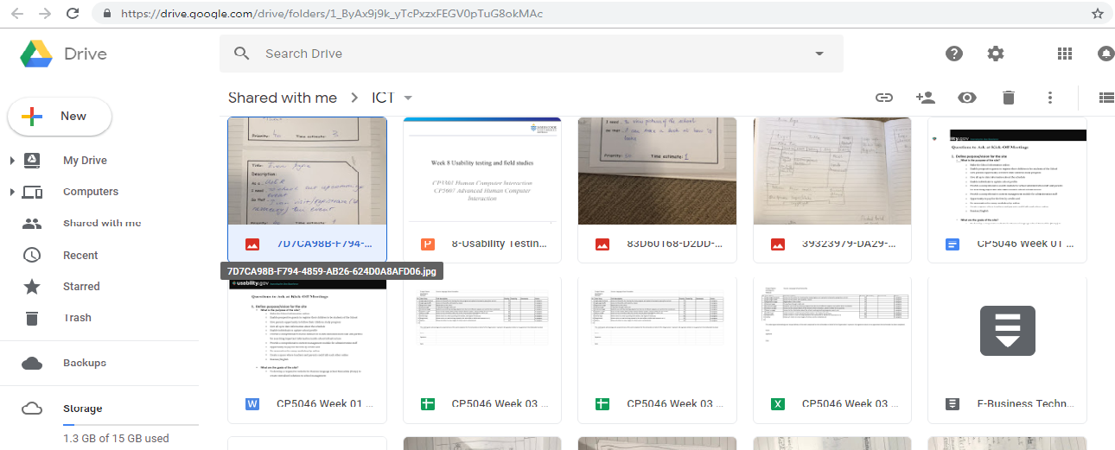

**Project Tools:**

1. **Adobe Dreamweaver:**

It is a comprehensive tool developed by Adobe for web designers. We used Dreamweaver for designing our HTML and CSS pages. The integration with Git makes it flawless. It also supports JavaScript, PhP.

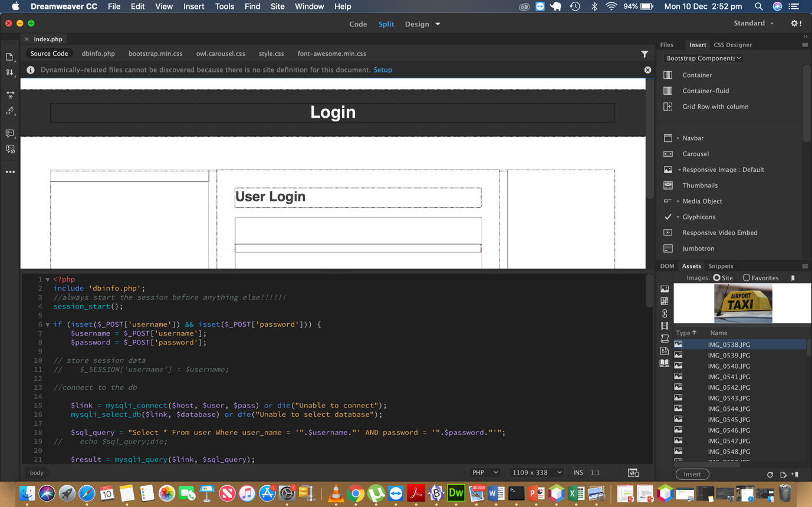

1. **HTML:**

HTML stands for Hypertext Markup Language. It supports tags for various elements of a web page.

1. **CSS:**

CSS is basically a styling language. It works in tandem with HTML for create beautiful webpages.



1. **Microsoft Access: (mySQL) + PHP for coding**

Microsoft Access is relational database management tool developed by Microsoft. Access is a part of Microsoft’s overall data management strategy. We use Microsoft Access to write and execute MySQL statements which helps in save and retrieving data from databases.

If a new team member adds up in later phases, they have to install Dreamweaver, Access on their laptops. The previously developed versions can be found on git.

## Testing tools

All test cases are attached as Attachment 2.

|  |  |  |  |
| --- | --- | --- | --- |
| Test case number | User story | Description | Testing type |
| RLSR_001 | School login screen | Verify login with valid username and password | Manual, database testing |
| RLSR_002 | School home screen | Verify that domain name is working and home page is available | Manual, domain name testing |
| RLSR_003 | School registration screen | Verify that registration is working | Manual, database testing |
| RLSR_004 | About us screen | Page About us is available and readable | Manual |
| RLSR_005 | Student dashboard screen | Verify that dashboard is working | Manual |
| RLSR_006 | Logout function | Verify that user had been log out from the system | Manual |
| RLSR_007 | Contact us screen | Verify that Contact us page is working, text is readable, map is correct | Manual |
| RLSR_008 | Enrolment page | Verify that Enrolment page is working | Manual, database testing |
| RLSR_009 | Payment page | Verify that Payment page is working | Manual, database testing |

## Prototypes

|  |
| --- |
|  |
| User story: About us |
|  |
| User story: Contact us |
|  |
| User story: Blog (guest) |
|  |
| User story: Enrolment |
|  |
| User story: Dashboard |
|  |
| User story: Payment |
|  |
| User story: Event page |
|  |
| User story: Blog (add news) |
|  |
| User story: Registration |
|  |
| User story: Login page |
|  |