TASK 1: MACHINE LEARNING CLASSIFICATION PROJECT
Objective
- To develop a supervised machine learning classification model.
- To preprocess and prepare the dataset for machine learning.
- To divide the dataset into training and testing sets.
- To train classification algorithms on the prepared dataset.
- To evaluate model performance using suitable evaluation metrics.
- To generate predictions using the trained model.
- To save the trained model for future deployment.
Project Description
The ML Classification Project is a supervised machine learning project developed using Python and Scikit-learn. The objective of the project is to classify data into different categories based on the available features.
The project uses the Breast Cancer dataset provided by Scikit-learn. The dataset is loaded and analyzed before performing the required preprocessing. The data is divided into training and testing sets to train and evaluate the machine learning model.
A Random Forest Classifier is trained using the training data. The trained model is then used to make predictions on the test data. The performance of the model is evaluated using metrics such as accuracy, precision, recall, F1-score and ROC-AUC. A confusion matrix and other visualizations are also generated to understand the model performance.
Finally, the trained model is saved as model.pkl using Joblib so that it can be reused for future applications and API deployment.
Technologies Used
- Python
- NumPy
- Pandas
- Scikit-learn
- Matplotlib
- Jupyter Notebook
Project Screenshots
Dataset
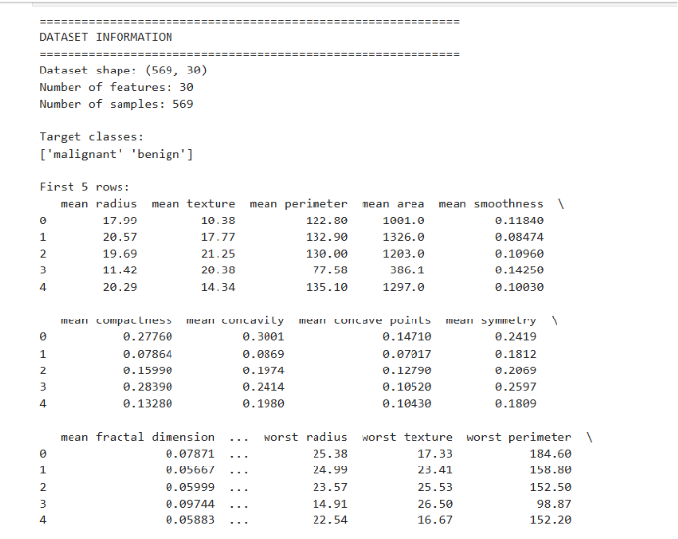
Figure 1: Loading and exploring the Breast Cancer dataset
2 – Data Preprocessing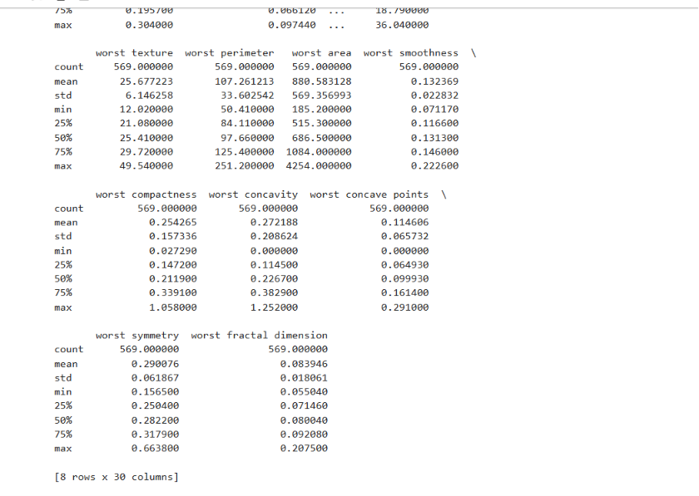

Figure 2: Data preprocessing and train-test split

3 – Model Training
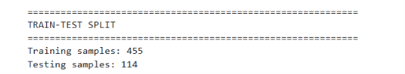
Figure 3: Random Forest model training

4 – Model Evaluation
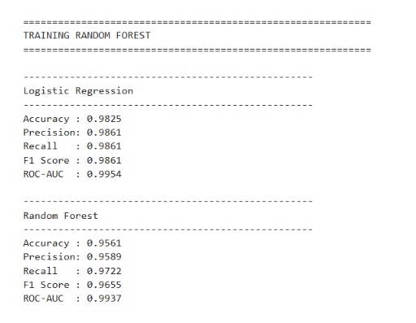
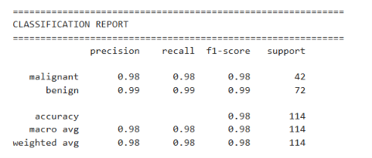

Figure 4: Model evaluation results

5 – Confusion Matrix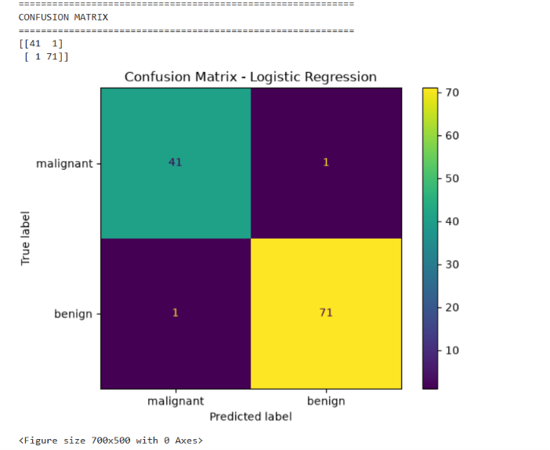
Figure 5: Confusion matrix of the classification model

6 – Prediction

Figure 6: Prediction output

7 – Saved Model
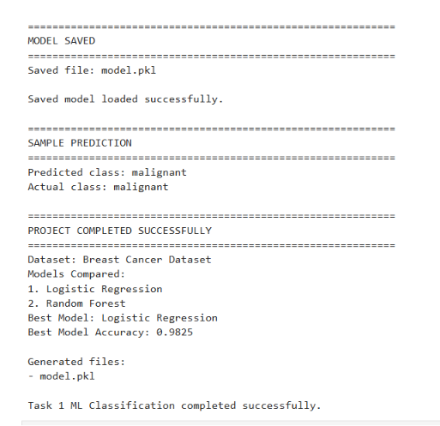
Figure 7: Saved trained model

Code Snippets
# -----------------------------
# 1. IMPORT LIBRARIES
# -----------------------------
import numpy as np
import pandas as pd
import matplotlib.pyplot as plt

from sklearn.datasets import load_breast_cancer
from sklearn.model_selection import train_test_split, cross_val_score
from sklearn.preprocessing import StandardScaler
from sklearn.pipeline import Pipeline

from sklearn.linear_model import LogisticRegression
from sklearn.ensemble import RandomForestClassifier

from sklearn.metrics import (
accuracy_score,
precision_score,
recall_score,
f1_score,
roc_auc_score,
confusion_matrix,
classification_report,
ConfusionMatrixDisplay,
RocCurveDisplay
)

import joblib

# ============================================================
# 2. LOAD DATASET
# ============================================================

data = load_breast_cancer()

X = pd.DataFrame(data.data, columns=data.feature_names)
y = pd.Series(data.target, name="target")

print("=" * 60)
print("DATASET INFORMATION")
print("=" * 60)

print("Dataset shape:", X.shape)
print("Number of features:", X.shape[1])
print("Number of samples:", X.shape[0])

print("\nTarget classes:")
print(data.target_names)

print("\nFirst 5 rows:")
print(X.head())

# ============================================================
# 3. CHECK MISSING VALUES
# ============================================================

print("\n" + "=" * 60)
print("MISSING VALUE CHECK")
print("=" * 60)

missing_values = X.isnull().sum()

print(missing_values)

if missing_values.sum() == 0:
print("\nNo missing values found.")
else:
print("\nMissing values are present.")

# ============================================================
# 4. BASIC DATA STATISTICS
# ============================================================

print("\n" + "=" * 60)
print("DATASET STATISTICS")
print("=" * 60)

print(X.describe())

# ============================================================
# 5. TARGET DISTRIBUTION
# ============================================================

print("\n" + "=" * 60)
print("TARGET DISTRIBUTION")
print("=" * 60)

print(y.value_counts())

plt.figure(figsize=(6, 4))

y.value_counts().sort_index().plot(
kind="bar"
)

plt.title("Target Class Distribution")
plt.xlabel("Class")
plt.ylabel("Number of Samples")
plt.xticks(
ticks=[0, 1],
labels=data.target_names,
rotation=0
)

plt.tight_layout()
plt.show()

# ============================================================
# 6. TRAIN-TEST SPLIT
# ============================================================

X_train, X_test, y_train, y_test = train_test_split(
X,
y,
test_size=0.20,
random_state=42,
stratify=y
)

print("\n" + "=" * 60)
print("TRAIN-TEST SPLIT")
print("=" * 60)

print("Training samples:", X_train.shape[0])
print("Testing samples:", X_test.shape[0])

# ============================================================
# 7. CREATE MODELS
# ============================================================

# Logistic Regression with StandardScaler
logistic_model = Pipeline([
("scaler", StandardScaler()),
("classifier", LogisticRegression(max_iter=5000))
])

# Random Forest
rf_model = RandomForestClassifier(
n_estimators=100,
random_state=42
)

# ============================================================
# 8. TRAIN LOGISTIC REGRESSION
# ============================================================

print("\n" + "=" * 60)
print("TRAINING LOGISTIC REGRESSION")
print("=" * 60)

logistic_model.fit(X_train, y_train)

logistic_pred = logistic_model.predict(X_test)
logistic_prob = logistic_model.predict_proba(X_test)[:, 1]

# ============================================================
# 9. TRAIN RANDOM FOREST
# ============================================================

print("\n" + "=" * 60)
print("TRAINING RANDOM FOREST")
print("=" * 60)

rf_model.fit(X_train, y_train)

rf_pred = rf_model.predict(X_test)
rf_prob = rf_model.predict_proba(X_test)[:, 1]

# ============================================================
# 10. FUNCTION TO CALCULATE METRICS
# ============================================================

def calculate_metrics(model_name, y_true, y_pred, y_prob):

accuracy = accuracy_score(y_true, y_pred)

precision = precision_score(
y_true,
y_pred,
zero_division=0
)

recall = recall_score(
y_true,
y_pred,
zero_division=0
)

f1 = f1_score(
y_true,
y_pred,
zero_division=0
)

roc_auc = roc_auc_score(
y_true,
y_prob
)

print("\n" + "-" * 50)
print(model_name)
print("-" * 50)

print("Accuracy :", round(accuracy, 4))
print("Precision:", round(precision, 4))
print("Recall :", round(recall, 4))
print("F1 Score :", round(f1, 4))
print("ROC-AUC :", round(roc_auc, 4))

return {
"Model": model_name,
"Accuracy": accuracy,
"Precision": precision,
"Recall": recall,
"F1 Score": f1,
"ROC-AUC": roc_auc
}

# ============================================================
# 11. EVALUATE BOTH MODELS
# ============================================================

logistic_results = calculate_metrics(
"Logistic Regression",
y_test,
logistic_pred,
logistic_prob
)

rf_results = calculate_metrics(
"Random Forest",
y_test,
rf_pred,
rf_prob
)

# ============================================================
# 12. COMPARE RESULTS
# ============================================================

results = pd.DataFrame([
logistic_results,
rf_results
])

print("\n" + "=" * 60)
print("MODEL COMPARISON")
print("=" * 60)

print(results.to_string(index=False))

# ============================================================
# 13. CROSS-VALIDATION
# ============================================================

print("\n" + "=" * 60)
print("5-FOLD CROSS-VALIDATION")
print("=" * 60)

logistic_cv = cross_val_score(
logistic_model,
X,
y,
cv=5,
scoring="accuracy"
)

rf_cv = cross_val_score(
rf_model,
X,
y,
cv=5,
scoring="accuracy"
)

print(
"Logistic Regression CV Accuracy:",
round(logistic_cv.mean(), 4)
)

print(
"Random Forest CV Accuracy:",
round(rf_cv.mean(), 4)
)

# ============================================================
# 14. SELECT BEST MODEL
# ============================================================

if rf_results["F1 Score"] >= logistic_results["F1 Score"]:

best_model = rf_model
best_model_name = "Random Forest"
best_prediction = rf_pred

else:

best_model = logistic_model
best_model_name = "Logistic Regression"
best_prediction = logistic_pred

print("\n" + "=" * 60)
print("BEST MODEL")
print("=" * 60)

print("Selected Model:", best_model_name)

# ============================================================
# 15. CLASSIFICATION REPORT
# ============================================================

print("\n" + "=" * 60)
print("CLASSIFICATION REPORT")
print("=" * 60)

print(
classification_report(
y_test,
best_prediction,
target_names=data.target_names
)
)

# ============================================================
# 16. CONFUSION MATRIX
# ============================================================

print("\n" + "=" * 60)
print("CONFUSION MATRIX")
print("=" * 60)

cm = confusion_matrix(
y_test,
best_prediction
)

print(cm)

disp = ConfusionMatrixDisplay(
confusion_matrix=cm,
display_labels=data.target_names
)

disp.plot()

plt.title(
"Confusion Matrix - " + best_model_name
)

plt.tight_layout()
plt.show()

# ============================================================
# 17. ROC CURVE
# ============================================================

plt.figure(figsize=(7, 5))

if best_model_name == "Random Forest":

RocCurveDisplay.from_predictions(
y_test,
rf_prob
)

else:

RocCurveDisplay.from_predictions(
y_test,
logistic_prob
)

plt.title(
"ROC Curve - " + best_model_name
)

plt.tight_layout()
plt.show()

# ============================================================
# 18. RANDOM FOREST FEATURE IMPORTANCE
# ============================================================

if best_model_name == "Random Forest":

feature_importance = pd.DataFrame({
"Feature": X.columns,
"Importance": rf_model.feature_importances_
})

feature_importance = feature_importance.sort_values(
by="Importance",
ascending=False
)

print("\n" + "=" * 60)
print("TOP 10 IMPORTANT FEATURES")
print("=" * 60)

print(
feature_importance.head(10).to_string(
index=False
)
)

plt.figure(figsize=(10, 6))

plt.barh(
feature_importance.head(10)["Feature"][::-1],
feature_importance.head(10)["Importance"][::-1]
)

plt.title("Top 10 Feature Importances")
plt.xlabel("Importance")
plt.ylabel("Feature")

plt.tight_layout()
plt.show()

# ============================================================
# 19. SAVE BEST MODEL
# ============================================================

joblib.dump(
best_model,
"model.pkl"
)

print("\n" + "=" * 60)
print("MODEL SAVED")
print("=" * 60)

print("Saved file: model.pkl")

# ============================================================
# 20. LOAD SAVED MODEL
# ============================================================

loaded_model = joblib.load(
"model.pkl"
)

print("\nSaved model loaded successfully.")

# ============================================================
# 21. TEST ONE SAMPLE
# ============================================================

sample = X_test.iloc[[0]]

sample_prediction = loaded_model.predict(
sample
)

print("\n" + "=" * 60)
print("SAMPLE PREDICTION")
print("=" * 60)

print("Predicted class:",
data.target_names[sample_prediction[0]])

print("Actual class:",
data.target_names[y_test.iloc[0]])

# ============================================================
# 22. FINAL SUMMARY
# ============================================================

print("\n" + "=" * 60)
print("PROJECT COMPLETED SUCCESSFULLY")
print("=" * 60)

print("Dataset: Breast Cancer Dataset")
print("Models Compared:")
print("1. Logistic Regression")
print("2. Random Forest")
print("Best Model:", best_model_name)

print(
"Best Model Accuracy:",
round(
accuracy_score(
y_test,
best_prediction
),
4
)
)

print("\nGenerated files:")
print("- model.pkl")
print("\nTask 1 ML Classification completed successfully.")
Result
The ML Classification project was successfully implemented using Python and Scikit-learn. The dataset was preprocessed and divided into training and testing sets. The Random Forest classification model was trained and evaluated successfully. The model generated predictions and its performance was analyzed using accuracy, precision, recall, F1-score, and confusion matrix. The trained model was also saved as model.pkl for future use and API deployment.
GitHub Repository link:
https://github.com/bhanusrivangaveti03-beep/InternSpark-AI-Internship
Name:VANGAVETI BHANUSRI
Candidate-Id: IS-2026-15339
Domain:ARTIFICIAL INTELLIGENCE

