**Design Thinking Project Workbook**

**Don't find customers for your product but find products for your customers**

**1. Team**

**Team Name: TECHFUSION**

**Team Logo (if any):**

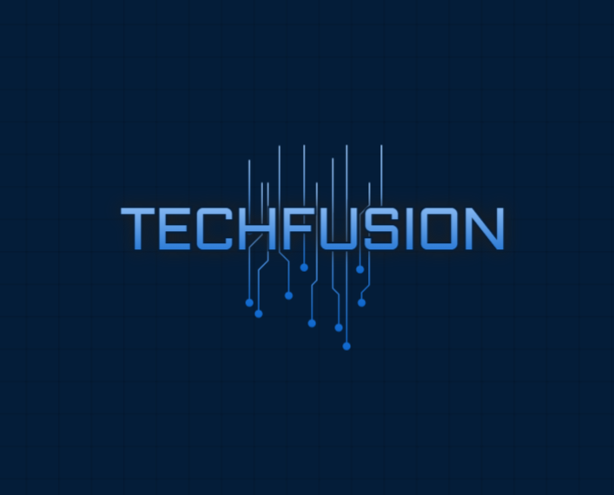

**Team Members:**

1. [Tarani Varre, 2320040047]
2. [Harshitha Reddy.S, 2320040046]

**2. Problem/Opportunity Domain**

**Domain of Interest:**

Personal Productivity and Digital Assistance

**Description of the Domain:**

The domain of personal productivity and digital assistance focuses on leveraging technology to streamline people's daily lives, enabling efficient task management, reminders, and scheduling through a conversational interface. The key elements include natural language understanding, contextual awareness, and personalized recommendations. A significant challenge in this domain is ensuring that the assistant comprehends the nuances of human speech, including tone and intent, while maintaining user trust and data privacy. Opportunities lie in developing AI systems that can seamlessly integrate into users' routines, act proactively, and provide a personalized, human-like experience that goes beyond traditional task management apps.

**Why did you choose this domain?:**

This domain was chosen because of the growing need for technology that can make people's lives easier by acting as an intelligent companion. Many individuals struggle with productivity and managing their time effectively, and having a system that can communicate like a friend while helping with task organization can bridge that gap. The personal appeal lies in the potential to solve a widespread issue of overload and disorganization using AI, creating a significant impact on users' daily experiences. Additionally, the market for digital assistants is growing rapidly, indicating a promising opportunity for innovation and success in this space.

**3. Problem/Opportunity Statement**

**Problem Statement:** Many individuals struggle to stay organized, manage their time effectively, and keep track of their tasks, leading to missed opportunities and increased stress. Despite existing productivity tools, users often find it challenging to get personalized assistance in a way that feels intuitive and human-like.

**Problem Description:**

The issue at hand is that current digital productivity tools lack true personalization and the ability to understand and respond in natural, conversational ways. Users need an AI assistant that can interact with them like a friend, not only listening to their needs but also providing tailored recommendations, reminders, and task scheduling based on their verbal inputs. The absence of such a solution leads to disorganization, inefficiency, and an increased cognitive load for users.

**Context (When does the problem occur):** The problem arises during busy workdays when users have many tasks to manage, make schedules on the go, and need reminders. It also appears during moments when they want to articulate their plans verbally without having to manually write or type details.

**Alternatives (What does the customer do to fix the problem):** Currently, customers use traditional productivity apps like calendars, to-do lists, and reminder applications. Some may also keep physical planners or use notes on their phones to manage their schedules. Voice assistants like Siri or Google Assistant are used for limited task management.

**Customers (Who has the problem most often):** The primary group affected includes students, professionals, and busy individuals who need to juggle multiple responsibilities, schedules, and deadlines. These users seek a more intuitive, friendly way to stay organized without the hassle of manual input.

**Emotional Impact (How does the customer feel):**

Customers often feel overwhelmed, stressed, and frustrated due to the lack of an easy-to-use, intelligent tool that can help them effectively manage their time and tasks. The inability to stay on top of their commitments results in anxiety, decreased productivity, and feelings of being disorganized**.**

**Quantifiable Impact (What is the measurable impact):** Users may experience a decline in productivity, an increase in missed deadlines, and a considerable amount of wasted time in managing and reorganizing tasks manually. This impacts both professional growth and personal satisfaction.

**Alternative Shortcomings (What are the disadvantages of the alternatives) :**

Existing alternatives require manual input, lack a conversational aspect, and often do not adapt to individual needs effectively. They are more rigid and cannot provide real-time, dynamic, context-aware assistance like a human would. The lack of personalization and proactive recommendations makes current tools insufficient for those needing a comprehensive productivity partner.

1. **Any Video or Images to showcase the problem:** Motion AI Productivity Tool: <https://www.usemotion.com/blog/ai-productivity-tools>

This article discusses Motion, an AI-powered task management and scheduling tool designed for individuals and teams with packed schedules. It offers features like calendar management, project timelines, task lists, and AI-powered insights to streamline daily activities and improve efficiency.

1. Zapier's List of AI Productivity Tools: <https://zapier.com/blog/best-ai-productivity-tools/>

**3. Addressing SDGs**

**Relevant Sustainable Development Goals (SDGs):**

1. SDG 4: Quality Education  
   Digital assistance can improve access to education through personalized learning tools and platforms that enhance student engagement and help track progress.
2. SDG 8: Decent Work and Economic Growth  
   Productivity tools can boost efficiency, streamline workflows, and support remote work, leading to more effective use of time and resources, contributing to economic growth and innovation.
3. SDG 9: Industry, Innovation, and Infrastructure  
   Digital tools enhance infrastructure by supporting innovation and the development of smart systems, fostering industrial growth and technological advancement.
4. SDG 10: Reduced Inequalities  
   Digital assistance helps reduce inequalities by providing access to productivity tools for all, including those in underserved communities, promoting inclusivity.
5. SDG 12: Responsible Consumption and Production  
   Personal productivity tools can optimize resource use, reduce waste, and encourage sustainable consumption and production patterns.

These SDGs are directly impacted by improvements in personal productivity and the adoption of digital assistance technologies.

**How does your problem/opportunity address these SDGs?:**

Addressing personal productivity and leveraging digital assistance can contribute to achieving several Sustainable Development Goals (SDGs) in the following ways:

1. SDG 4: Quality Education

- How the opportunity addresses SDG 4:

By integrating digital assistance into education, learners can access personalized learning experiences, helping bridge gaps in understanding and offering real-time feedback. This supports inclusive, equitable, and quality education for all, even in remote or underserved areas, enhancing learning outcomes and providing lifelong learning opportunities.

2. SDG 8: Decent Work and Economic Growth

- How the opportunity addresses SDG 8:

Productivity tools optimize workflows, reduce inefficiencies, and automate repetitive tasks, allowing workers to focus on higher-value tasks. This can lead to higher job satisfaction, innovation, and improved business operations, all of which contribute to sustainable economic growth, improved working conditions, and higher productivity levels across sectors.

### 3. **SDG 9: Industry, Innovation, and Infrastructure**

- **How the opportunity addresses SDG 9:**

Digital assistance fosters innovation by encouraging the adoption of new technologies and solutions that enhance productivity and streamline industrial processes. This contributes to building resilient infrastructure, promoting sustainable industrialization, and fostering innovation, all of which are key drivers of modern economic development.

### 4. **SDG 10: Reduced Inequalities**

- **How the opportunity addresses SDG 10:**

Personal productivity tools and digital assistance can reduce inequalities by providing access to the same high-quality resources and tools for all, irrespective of geographic location or socio-economic status. This can empower marginalized communities by giving them access to education, work opportunities, and resources that help close the digital divide and promote social inclusion.

### 5. **SDG 12: Responsible Consumption and Production**

- **How the opportunity addresses SDG 12:**

Digital tools designed to enhance productivity can also be used to promote more efficient use of resources, reducing waste in personal and business operations. This helps foster sustainable consumption patterns, supports the circular economy, and encourages responsible production processes, contributing to more sustainable global systems.

By solving challenges related to personal productivity and embracing digital assistance, these opportunities help drive progress toward multiple SDGs, particularly in education, economic growth, innovation, equality, and sustainability.

**4. Stakeholders**

Answer these below questions to understand the stakeholder related to your project

1. **Who are the key stakeholders involved in or affected by this project?**

**• Users: Individuals using the digital productivity tools (e.g., students, employees, professionals).**

**• Developers/Designers: The team responsible for creating, designing, and maintaining the digital tools.**

**• Educational Institutions: Schools, universities, or training centers implementing these tools for students.**

**• Employers/Organizations: Companies or businesses using productivity tools to improve workflow and employee efficiency.**

**• Government and Policymakers: Entities focusing on digital literacy, technology adoption, and ensuring equitable access.**

**• Investors/Funding Partners: Individuals or institutions providing financial support for the development and expansion of these tools.**

1. **What roles do the stakeholders play in the success of the innovation?**

• **Users**: Their feedback and adoption drive the success of the innovation. The tools must meet their needs and improve their productivity.

• **Developers/Designers**: They ensure the tools are functional, user-friendly, and adaptable to evolving needs.

• **Educational Institutions**: They help in scaling the adoption and integrating tools into the curriculum, ensuring quality education.

• **Employers/Organizations**: Their adoption of the tools is critical for improving workforce efficiency and enhancing business outcomes.

• **Government/Policymakers**: They can create supportive regulations and incentives for digital inclusion and innovation.

• **Investors/Funding Partners**: They provide necessary financial backing, making sure the project has sufficient resources to develop and scale.

1. **What are the main interests and concerns of each stakeholder?**

**• Users: Interest in ease of use, personalization, efficiency, and data privacy. Concerns include complexity or steep learning curves, as well as data security.**

**• Developers/Designers: Interested in product performance, innovation, and user satisfaction. Concerned about tight deadlines, technical challenges, and resource limitations.**

**• Educational Institutions: Interested in enhancing student performance and engagement. Concerned about cost, implementation complexity, and data privacy.**

**• Employers/Organizations: Interested in improving productivity and streamlining operations. Concerns include cost-effectiveness, integration with existing systems, and data security.**

**• Government/Policymakers: Interested in promoting digital literacy and equitable access. Concerned about cybersecurity, regulatory compliance, and public acceptance.**

**• Investors/Funding Partners: Interested in financial returns and long-term sustainability. Concerned about project risks, market demand, and scalability.**

1. **How much influence does each stakeholder have on the outcome of the project?**

**• Users: High influence, as their adoption and feedback determine the success of the tool.**

**• Developers/Designers: High influence, as they create the product and address technical challenges.**

**• Educational Institutions: Moderate to high influence, especially if the tools are widely adopted in academic settings.**

**• Employers/Organizations: High influence, especially in driving commercial success and further adoption.**

**• Government/Policymakers: Moderate influence, as regulatory frameworks can support or hinder adoption.**

**• Investors/Funding Partners: High influence due to their role in funding the project and ensuring its financial viability.**

1. **What is the level of engagement or support expected from each stakeholder?**

* **Users: Continuous engagement through feedback, reviews, and consistent use of the tool.**
* **Developers/Designers: Active engagement in iterative development, solving technical issues, and innovating.**
* **Educational Institutions: Support through integration into curricula and providing feedback.**
* **Employers/Organizations: Active engagement in adopting and integrating the tools into their workflow.**
* **Government/Policymakers: Support in ensuring policies promote innovation and access to digital tools.**
* **Investors/Funding Partners: Ongoing support through funding and advice for scaling and sustainability.**

1. **Are there any conflicts of interest between stakeholders? If so, how can they be addressed?**

* **• Users vs. Developers: Users may demand more features quickly, while developers may need more time for quality development. Address through transparent timelines and regular updates.**
* **Educational Institutions vs. Government: Schools may push for more autonomy in tool usage, while governments may impose regulations. Address through collaborative discussions and flexible policies.**
* **Employers vs. Users: Employers might prioritize efficiency over user comfort, leading to conflicts in balancing productivity with employee well-being. Address by ensuring user-centered design principles in tool development.**

**• Resolution: Regular stakeholder meetings, clear communication, and balancing interests through compromise and user-centered development can mitigate conflicts.**

1. **How will you communicate and collaborate with stakeholders throughout the project?**

**• Users: Regular feedback surveys, user testing, and communication through social media or support channels.**

**• Developers/Designers: Agile development meetings, design reviews, and collaboration tools (e.g., Slack, Jira).**

**• Educational Institutions: Workshops, pilot programs, and regular meetings with educational leaders to discuss implementation progress.**

**• Employers/Organizations: Regular updates through presentations and demonstrations of how the tools are enhancing productivity.**

**• Government/Policymakers: Formal communications through reports, regulatory updates, and participation in tech advisory boards.**

**• Investors/Funding Partners: Periodic progress reports, financial updates, and strategy sessions to discuss scaling and monetization.**

1. **What potential risks do stakeholders bring to the project, and how can these be mitigated?**
2. **Users**: Risk of low adoption or dissatisfaction. Mitigate through thorough market research, beta testing, and incorporating user feedback.
3. **Developers/Designers**: Risk of technical failure or delays. Mitigate by using agile methodologies and ensuring regular testing and quality assurance.
4. **Educational Institutions**: Risk of slow adoption due to cost or complexity. Mitigate by offering training and financial incentives.
5. **Employers/Organizations**: Risk of resistance to change. Mitigate through demonstrations of ROI and ease of integration.
6. **Government/Policymakers**: Risk of unfavorable regulations. Mitigate by staying informed on policy changes and advocating for supportive legislation.
7. **Investors/Funding Partners**: Risk of withdrawal of funding due to unmet expectations. Mitigate by maintaining clear communication, meeting milestones, and demonstrating progress.

By managing these stakeholder dynamics and addressing potential risks, the project can successfully leverage the opportunity to improve personal productivity and digital assistance.

**5. Power Interest Matrix of Stakeholders**

**Power Interest Matrix: Provide a diagrammatic representation of Power Interest Matrix**

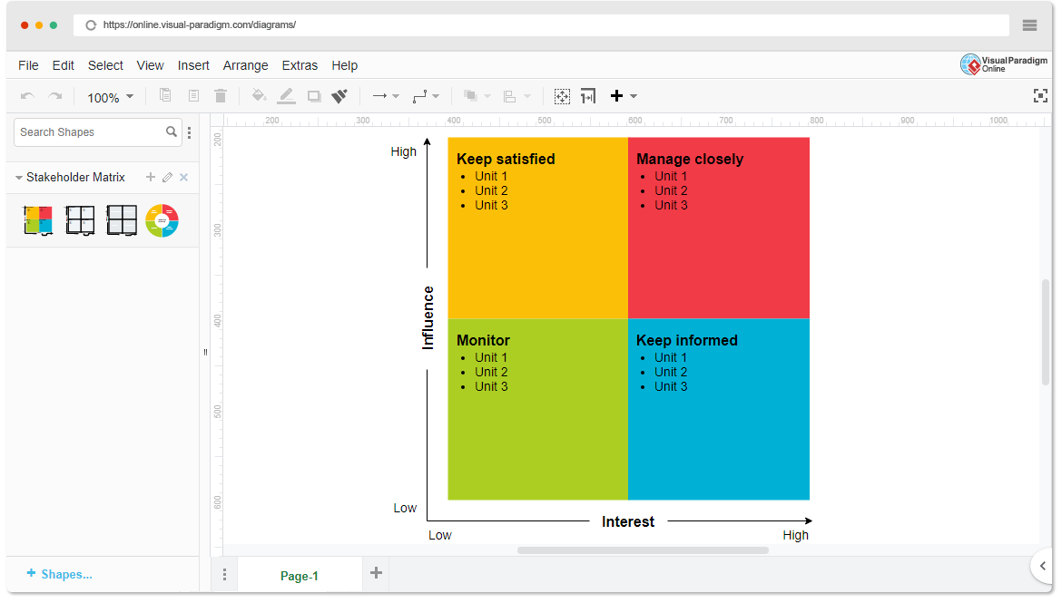

* High Power, High Interest: [Stakeholder Names]
* High Power, Low Interest: [Stakeholder Names]
* Low Power, High Interest: [Stakeholder Names]
* Low Power, Low Interest: [Stakeholder Names]

1. **Empathetic Interviews**

**Conduct Skilled interview with at least 30 citizens/Users by asking open ended questions (What, why/How etc) and list the insights as per the format below**

|  |  |  |
| --- | --- | --- |
| **I need to know**  **(thoughts, feelings, actions)** | **Questions I will ask**  **(open questions)** | **Insights I hope to gain** |
| Thoughts |  |  |
| How do people perceive the usefulness of digital tools in improving their personal productivity? | **What digital tools do you currently use to manage your time and tasks?**   * Goal: Understand what tools they are already familiar with and their perception of them. | • Insights into their understanding of how digital tools can make them more productive. |
| What challenges do they face when using digital productivity tools? | **Why do you think digital productivity tools are important in your daily life?**   * Goal: Gauge their understanding of the significance of these tools and the value they provide. | Awareness of any gaps in knowledge or misconceptions about productivity tools. |
| Feelings |  |  |
| How do they feel about adopting new technologies to manage their daily tasks? | **How do you feel when a digital tool helps you accomplish a task quickly and efficiently?**   * Goal: Explore their emotional response to positive outcomes from using digital assistance. | The emotional satisfaction gained from using tools that improve productivity. |
| What emotions do they experience when they can/cannot complete tasks efficiently with the help of digital tools? | **How frustrating is it when digital tools fail to help you improve your productivity?**   * Goal: Understand their emotional reactions to difficulties or setbacks with digital tools. | Feelings of frustration or helplessness when tools fail, highlighting areas where tools could improve. |
| actions |  |  |
| How do they currently use productivity tools in their everyday lives? | **How do you decide which productivity tool to use for managing your tasks?**   * Goal: Learn about their decision-making process in adopting specific digital tools. | How users decide between different tools and how adaptive they are to new solutions. |
| What actions do they take when faced with inefficiencies in their personal productivity? | **What actions do you take when a tool doesn't work as expected? Do you try another tool, or do you try to solve the issue yourself?**   * Goal: Understand their troubleshooting process and willingness to experiment with new tools. | * How they respond to inefficiencies and technical challenges—whether they switch tools or stick with what they know. |

**SKILLED INTERVIEW REPORT**

**(Examples are given. Erase them and fill with your user information.)**

|  |  |  |
| --- | --- | --- |
| **User/Interviewee** | **Questions Asked** | **Insights gained (NOT THEIR ANSWERS)** |
| Abhishek Verma,  Student | How do you currently manage your daily tasks using digital tools? | Many students prefer simple, free tools and avoid advanced paid software. |
| Srinivasan P., Parent | What challenges do you face when using digital tools to manage your work-life balance? | Working parents often find digital tools too complicated and prefer manual methods. |
| Sakshi R., Freelancer | How do you feel when you accomplish a task more efficiently with the help of digital tools? | Users feel a strong sense of achievement when they find tools that work seamlessly for their needs. |
| Rakesh M., Employee | How do you decide which productivity tool to use when managing multiple tasks? | Many employees rely on recommendations from colleagues rather than researching options themselves. |
| |  | | --- | | **John L., Teacher** |  |  | | --- | |  | | How do you feel about adopting new technology to manage your professional tasks? | Educators can feel overwhelmed by the continuous need to learn new tools and systems. |

### **Key Insights Gained:**

* **Insight 1:** Users are more likely to stick with simple, user-friendly tools, even if there are more advanced options available, to avoid overwhelming technical complexity.
* **Insight 2:** Emotional responses to productivity tools range from satisfaction and relief when they work efficiently to frustration when they fall short, highlighting the need for reliable, user-friendly solutions.

**Empathy Map**

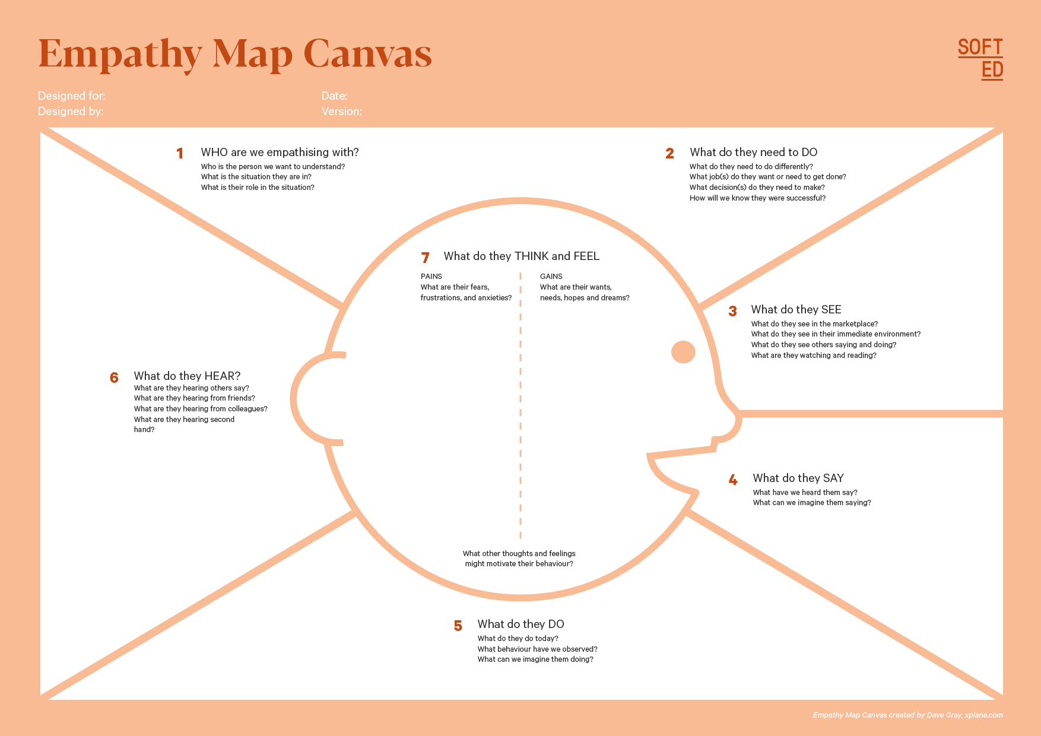

**Your Answer:** Consider advice from peers, feedback from colleagues, or trends in productivity that they might be exposed to.

**Your Answer:** Identify the target user, such as busy professionals, students, or remote workers. Consider their roles and challenges.

Who is your Customer Segment:

Idea/Innovation Title:

Designed By:

Date of Submission:

**Your Answer:** Identify their fears (like burnout), frustrations (like lack of time), and hopes (like achieving work-life balance).

**Your Answer:**

**Pains:** Stress from overwhelming tasks, difficulty in prioritizing.

**Gains:** Desire for efficiency, better time management, and achieving personal goals.

**Your Answer:** Outline specific tasks they want to accomplish, like managing time effectively, organizing tasks, or improving focus.

**Your Answer:** Describe their environment, including tools they use (like apps or planners), and what influences their productivity (like workplace culture).

**Your Answer:** Reflect on their feedback about productivity tools, common frustrations, or aspirations they express.

* **Your Answer:** Detail their daily routines, habits, and how they currently manage their tasks and time.

1. **Empathy Map**
2. **Who is your Customer?**

**Description: The customer is the individual who will directly benefit from the digital productivity tools being offered. These could be specific personas such as professionals, students, or freelancers, or a general user segment with similar needs.**

**Key Points:**

* **Customer Profile:**
  + **Age: 20-45 years old**
  + **Profession: Students, professionals (e.g., freelancers, corporate employees), small business owners**
  + **Interests: Time management, efficiency, work-life balance, self-improvement, technology**
  + **Goals and Needs: Customers need tools that help them efficiently organize tasks, reduce procrastination, and balance their personal and professional lives. They seek easy-to-use, accessible tools that integrate with their existing systems.**
* **Context:  
  Customers interact with the digital productivity tool through their phones, tablets, or computers, typically during work or study hours. They may use it during meetings, study sessions, or personal organization time.**

1. **Who are we empathizing with?**

**Description**: This section focuses on understanding the user on a deeper level, including their motivations, struggles, and mindset.

**Key Points:**

1. **User Characteristics**:
   1. **Personality**: Organized but occasionally overwhelmed, striving for self-improvement, open to adopting new technologies, values efficiency and results.
   2. **Values**: Productivity, time management, balance between personal and professional life. They value simplicity and tools that help them optimize performance without adding complexity.
   3. **Responsibilities**: Managing work tasks, studying, balancing personal commitments, meeting deadlines, and staying on top of responsibilities.
2. **User's Goals and Challenges**:
   1. **Goals**: To be more productive in less time, maintain work-life balance, avoid burnout, and achieve their personal or professional targets.
   2. **Challenges**: Juggling multiple tasks, dealing with distractions, procrastination, and finding tools that meet their specific needs without overwhelming them with features.
3. **User’s Broader Situation**:  
   Professionally, they might be juggling multiple roles or projects (e.g., freelancing, part-time studies), trying to meet deadlines, or coordinating tasks within teams. Personally, they may have responsibilities such as family care or personal development, making time management even more critical.
4. **What do they need to DO?**

**Description**: This section identifies the specific tasks or actions users need to perform, highlighting what they aim to accomplish and how they measure their success.

**Key Points:**

1. **Tasks/Actions**:
   1. Manage daily to-do lists, set priorities, schedule tasks effectively, track progress, and collaborate with teams.
   2. Organize meetings, reminders, and deadlines.
2. **Decisions**:
   1. Decide which tasks to prioritize, when to schedule breaks, and how to allocate time between work, study, and personal life.
   2. Choose which productivity tools to adopt based on ease of use, reliability, and integration with other tools they already use.
3. **Success/Failure Definition**:
   1. Success is defined by increased efficiency, completion of tasks on time, meeting deadlines, and a balanced workload without feeling overwhelmed.
   2. Failure may involve missed deadlines, disorganized workflows, or feeling burnt out.
4. **What do they SEE?**

**Description: This section addresses what the user sees in their surroundings and how these visual elements, both physical and digital, influence their behaviors and choices.**

**Key Points:**

* **Physical and Digital Environment:**
  + **Physical: They see workspaces like office desks, home setups, or study spaces. These might include papers, notebooks, and devices like laptops, smartphones, or tablets.**
  + **Digital: They interact with calendars, task management software, emails, instant messaging, and other communication tools like Slack, Trello, or Microsoft Teams.**
* **Trends or Competitors:**
  + **Users are likely noticing increasing trends around personal productivity, self-improvement apps, and tech solutions that emphasize efficiency. Competitors include popular apps such as Todoist, Google Calendar, Microsoft To Do, and other productivity tools.**
* **Influences on Behavior:**
  + **The visual organization of their physical and digital environments heavily influences their productivity habits. Clean, minimal interfaces encourage focus, while cluttered spaces may lead to distractions. Competing tools may drive users to compare features and look for the most efficient solutions that meet their needs.**

**By understanding the customer’s profile, empathizing with their challenges, and analyzing their environment, we can better design and deliver a solution that truly addresses their personal productivity needs.**

1. **What do they SAY?**

**Description**: This section reflects what users express publicly, capturing their feedback, complaints, and open discussions about their experiences with productivity tools.

**Key Points:**

1. **What might users express openly in conversation about their problems?**
   1. Users might say things like, “I never have enough time in the day,” or, “I need a better way to stay organized.”
2. **How do they express their goals or frustrations?**
   1. Users may express frustration by saying, “This app isn’t user-friendly,” or “I waste too much time figuring out how to use this tool.”
   2. Goals might be expressed as, “I just want to streamline my workflow,” or, “I need a tool that helps me focus and stay on track.”
3. **What are their words during customer interviews or feedback?**
   1. During feedback, users might say, “I love how simple this tool is to use,” or “I need more integration with other platforms I use.”
   2. Common phrases could include, “I need to be more efficient,” “I want fewer distractions,” or “This feature would make my life easier.”
4. **What do they DO?**
5. **Description: This section focuses on observable behaviors and actions users take in relation to their productivity challenges.**
6. **Key Points:**
7. **What observable actions do users take?**
8. **Users often multitask, switching between different apps or tools in an attempt to stay organized. They may also create physical to-do lists, set alarms, or use multiple digital tools to manage tasks.**
9. **What habits or routines do they follow?**
10. **Many users have a routine of checking their calendar or task management app at the beginning of the day and before bed. Some may also habitually use productivity hacks such as the Pomodoro technique or time-blocking.**
11. **What might users do to try and solve their problems?**
12. **Users may try different apps or tools, read productivity articles or books, and seek recommendations from peers. They might also attend workshops or use built-in features such as reminders, task prioritization, or note-taking to stay organized.**
13. **What do they HEAR?**

**Description**: This section identifies external influences that affect users, including what they hear from peers, media, or trends, shaping their behavior and decisions.

**Key Points:**

1. **What are they hearing from peers, mentors, or the industry?**
   1. Users may hear about new productivity apps or features from colleagues, friends, or mentors. They might hear things like, “This app really helped me organize my day better,” or, “Everyone’s using this tool now to manage tasks.”
2. **What media or channels of information are they exposed to?**
   1. Users may read productivity blogs, follow influencers on social media (like LinkedIn or Twitter), or watch YouTube tutorials on time management. They might also subscribe to newsletters from popular productivity apps.
3. **Are there any strong influencers guiding their behavior?**
   1. Influencers could include productivity coaches, tech bloggers, or thought leaders who promote specific tools and methods. For example, productivity authors like Cal Newport or influencers on platforms like Medium may shape their opinions and behaviors.

**What do they THINK and FEEL?**

**Description: This section delves into users’ internal thoughts, emotions, and motivations, helping to identify their deeper concerns and desires.**

**Key Points:**

* **What are their fears, worries, and anxieties?**
  + **Users may fear falling behind on deadlines, missing important meetings, or losing control of their time. They might worry about being unproductive, burning out, or not being able to balance their personal and professional lives.**
* **What are their motivations and desires?**
  + **Their primary motivation is often to be more efficient, productive, and organized, allowing them to achieve more in less time. They also desire a sense of accomplishment, reduced stress, and better work-life balance.**
* **How do their thoughts and feelings align with their actions?**
  + **Users might feel overwhelmed by the amount of tasks they need to complete, but this drives them to seek out tools that can help them regain control. Their thoughts about productivity, efficiency, and self-improvement align with their desire to try new tools or strategies, even if they face some initial frustration in finding the right one.**

**By analyzing what users say, do, hear, and think/feel, we gain a comprehensive understanding of their challenges and desires, which can inform the development of tailored digital productivity solutions.**

1. **Pains and Gains**

**### Personal Productivity and Digital Assistance:**

**### **ee. Pains and Gains\*\***

**\*\*Description**: This section identifies the frustrations users face (pains) and the positive outcomes they seek (gains). Understanding both helps create a product that effectively addresses their challenges and fulfills their needs.**

**---**

**### **Pains\*\***

**\*\*Key Points:\*\***

**- **What are the user’s main pain points?\*\***

**- **Overwhelm**: Users often feel overwhelmed by the sheer volume of tasks and responsibilities, leading to stress and anxiety.**

**- **Disorganization**: Many struggle with keeping their tasks and schedules organized, which leads to missed deadlines or last-minute stress.**

**- **Procrastination and Distractions**: Users are frequently distracted by notifications, emails, or other unproductive activities, which hinders their progress.**

**- **Inefficiency**: Switching between multiple apps or tools can feel cumbersome, reducing productivity.**

**- **Lack of Focus**: Users may struggle with staying focused for long periods, making it hard to complete tasks efficiently.**

**- **Time Management**: They often feel there’s not enough time in the day to complete all their tasks, leading to frustration.**

**---**

**### **Gains\*\***

**\*\*Key Points:\*\***

**- **What would make their life easier or more fulfilling?\*\***

**- **Simplified Task Management**: A tool that consolidates all their tasks, reminders, and schedules into one place would make life much easier.**

**- **Increased Focus**: Features like time-blocking or task prioritization could help them focus on the most important tasks without getting distracted.**

**- **Clear Organization**: Easy-to-use interfaces and customizable dashboards would allow users to organize their tasks in a way that makes sense to them.**

**- **Seamless Integration**: Integration with other apps or tools they already use (e.g., calendars, email) would reduce the need for switching between platforms.**

**- **Proactive Reminders**: Automated reminders and alerts would help users stay on top of their deadlines without constantly checking their to-do lists.**

**- **What benefits do they hope to achieve from your product or solution?\*\***

**- **Efficiency**: Users want a solution that allows them to complete their tasks faster and more efficiently.**

**- **Better Work-Life Balance**: They hope to manage their time better so they can also dedicate more time to personal activities, reducing burnout.**

**- **Reduced Stress**: By staying organized and on top of their tasks, users expect a reduction in stress and anxiety.**

**- **Sense of Accomplishment**: Completing tasks on time and feeling in control of their responsibilities will give them a greater sense of achievement and satisfaction.**

**- **Improved Focus**: The ability to concentrate on important tasks without distractions will help them be more productive and focused in their work or studies.**

**---**

**By addressing these **pains** and delivering **gains**, a personal productivity tool can greatly enhance the user's experience, making their daily life more manageable and fulfilling.**

**8. Persona of Stakeholders**

**Stakeholder Name:**

**Demographics: Key characteristics of your target audience, such as age, gender, income, and location.**

* **Age: 25–40**
* **Gender: Mixed (inclusive of all genders)**
* **Income: Middle to upper-middle income professionals**
* **Location: Primarily urban areas, globally accessible, especially tech-savvy regions**
* **Profession: Professionals, freelancers, entrepreneurs, and students**
* **Education: College-educated or highly skilled in their respective fields**

**Goals: What the stakeholders or customers want to achieve in relation to the innovation.**

**What the stakeholders or customers want to achieve in relation to the innovation.**

* **Goal 1: Improve daily productivity by managing tasks more efficiently.**
* **Goal 2: Achieve better work-life balance by optimizing time usage.**
* **Goal 3: Stay organized without feeling overwhelmed by the volume of work.**
* **Goal 4: Streamline communication and information flow across multiple digital platforms.**
* **Goal 5:** Reduce distractions and procrastination to complete important tasks on time.

**Challenges: The obstacles or difficulties faced by stakeholders that the innovation aims to address.**

* **Challenge 1: Struggling with task prioritization and time management, leading to missed deadlines.**
* **Challenge 2: Managing multiple projects and tools at once, causing disorganization.**
* **Challenge 3: Difficulty in staying focused with constant distractions (social media, notifications, etc.).**
* **Challenge 4: Balancing professional and personal responsibilities without burnout.**
* **Challenge 5: Lack of a user-friendly system that integrates with existing digital tools.**

**Aspiration: The long-term desires or dreams of your target audience related to the innovation.**

* **Aspiration 1: To be in full control of their time and productivity, without feeling rushed or stressed.**
* **Aspiration 2: To create a sustainable routine that maximizes productivity while allowing ample personal time.**
* **Aspiration 3: To achieve higher efficiency, allowing them to focus on long-term career goals or personal growth.**
* **Aspiration 4: To use technology to streamline life and reduce cognitive load from manual task management.**
* **Aspiration 5: To be recognized as highly productive and efficient in their work environment.**

**Needs: The essential requirements of your customers or stakeholders that must be met.**

* **Need 1: A simple and intuitive interface to track and manage daily tasks and projects.**
* **Need 2: A system that helps prioritize tasks and reminds users of deadlines.**
* **Need 3: An all-in-one solution that integrates with calendars, emails, and other apps.**
* **Need 4: Tools to minimize distractions and help maintain focus during work sessions.**
* **Need 5: A flexible and customizable platform that adapts to individual workflows.**

**Pain Points: Specific problems or frustrations experienced by the target audience.**

* **Pain Point 1: Overwhelm due to the number of tools and systems they need to use for different tasks.**
* **Pain Point 2: Constantly feeling behind schedule or losing track of important tasks.**
* **Pain Point 3: Experiencing decision fatigue when prioritizing tasks in a chaotic environment.**
* **Pain Point 4: Frequent distractions that interrupt focus and productivity.**
* **Pain Point 5: Lack of proper feedback or insight into how much progress is being made daily.**

**Storytelling: A narrative that highlights the journey of the stakeholder or customer, illustrating the problem and how the innovation can solve it.**

**Story:  
Anna is a 32-year-old marketing manager living in a busy urban area. She juggles multiple projects and team responsibilities while trying to maintain a personal life. Every morning, Anna faces an overwhelming list of tasks from various platforms—emails, calendars, project management apps—all of which demand her immediate attention. By mid-day, she’s bombarded with notifications and pulled into meetings, leaving little time to focus on deep work.**

**As her workday progresses, Anna struggles to prioritize what needs immediate attention and ends up procrastinating on key tasks. By the evening, she feels mentally exhausted, but there’s still so much left undone, and she’s uncertain how to organize her next day more effectively.**

**After discovering a new digital productivity assistant, Anna’s workflow dramatically changes. The system integrates her tasks, schedules, and reminders into one cohesive dashboard. She is now able to set clear priorities, block out distractions, and automate repetitive tasks. By the end of the first week, Anna feels more in control of her time, accomplishing her tasks efficiently and enjoying a more balanced work-life routine.**

**This shift allows Anna to focus on her long-term career goals while enjoying time for herself, proving that the right tool can transform the way she works and lives.**

**This narrative and structured breakdown of Pains, Gains, and Stakeholder Profile helps in creating a solution tailored to the user's real-life challenges and aspirations.**

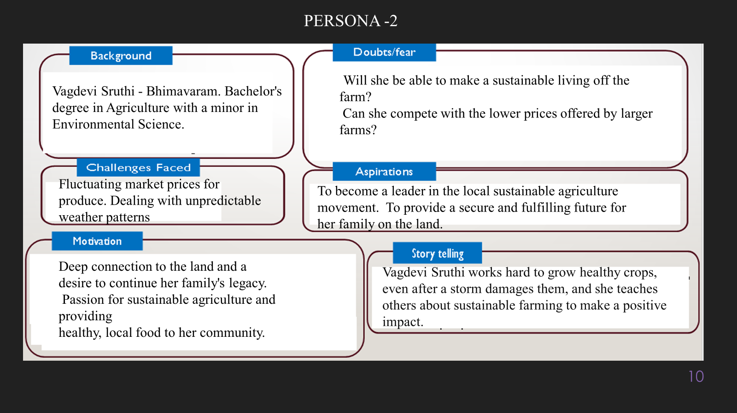

**10. Look for Common Themes, Behaviors, Needs, and Pain Points among the Users**

Analyse the data from your affinity diagram to uncover recurring patterns among your users, helping you better understand their expectations and challenges.

**When analyzing the data from an affinity diagram to uncover patterns among users, several **common themes** tend to emerge, reflecting shared expectations and challenges:**

**1. **Overwhelming Workload and Task Management**: Many users feel burdened by a large volume of tasks, often spread across multiple platforms, leading to disorganization and procrastination.**

**2. **Difficulty Prioritizing Tasks**: A common challenge is determining which tasks are most urgent or important, resulting in inefficiency and missed deadlines.**

**3. **Distractions and Focus Issues**: Users frequently mention struggles with staying focused due to constant interruptions, whether from notifications, meetings, or multitasking.**

**4. **Desire for Simplified Solutions**: There is a consistent demand for streamlined, all-in-one solutions that integrate different tools (e.g., email, calendars, and project management systems) to reduce cognitive overload.**

**5. **Work-Life Balance Concerns**: Many users express frustration with balancing their professional and personal responsibilities, seeking tools that help them maintain productivity while avoiding burnout.**

**These patterns highlight the importance of creating solutions that offer **task consolidation**, **clear prioritization systems**, and **focus-enhancing tools** while fostering **work-life harmony**.**

**Common Behaviors: **Common Behaviors** observed among users in relation to the problem or product often reveal consistent patterns throughout their journey:**

**1. **Task Switching**: Users frequently switch between multiple platforms and tools (email, calendar, task manager), leading to fragmented workflows and decreased productivity.**

**2. **Procrastination on Complex Tasks**: Users tend to delay working on more complex or ambiguous tasks, often prioritizing smaller, less important tasks that feel easier to accomplish.**

**3. **Over-Reliance on Notifications**: Many users rely heavily on notifications to remind them of deadlines or tasks, but this often results in distraction and constant task interruptions.**

**4. **Manual Organization of Tasks**: Users often create their own systems (e.g., using sticky notes, separate lists, or personal spreadsheets) to manage tasks and deadlines, even when digital tools are available, indicating that current systems aren’t fully meeting their needs.**

**5. **Reactive Work Style**: Users respond reactively to immediate tasks, emails, or meetings, rather than proactively managing their time and priorities, resulting in stress and missed deadlines.**

**6. **Seeking Quick Fixes**: Users frequently search for shortcuts or quick fixes (such as task automation tools or productivity hacks) to manage their workload, indicating a desire for efficiency.**

**These behaviors suggest that users need solutions that **reduce context switching**, **simplify task management**, and **provide more structured ways to focus on important tasks**, helping them break free from reactive workflows.**

**Common Needs: **Common Needs** that many users share, highlighting essential requirements for a better experience, include:**

**1. **Task Prioritization**: Users need a clear, intuitive system for prioritizing tasks, helping them focus on the most important and urgent activities without feeling overwhelmed.**

**2. **Simplified Workflow**: There is a strong desire for tools that consolidate tasks, calendars, emails, and reminders into a single, easy-to-manage interface, reducing the need to switch between platforms.**

**3. **Distraction Management**: Users need features that help minimize distractions, such as smart notifications or focused work modes, allowing them to concentrate on deep work without constant interruptions.**

**4. **Automation of Repetitive Tasks**: Automating routine, low-value tasks (like reminders or follow-up emails) is a common need, freeing users to focus on more critical activities.**

**5. **Work-Life Balance Support**: Users seek solutions that not only boost their productivity but also help them maintain a better work-life balance by managing time effectively and reducing stress.**

**6. **Ease of Use and Customization**: Users want a tool that is easy to use, adaptable to their specific needs, and customizable to fit their individual work style and preferences.**

**Meeting these needs would enable users to experience **better productivity**, **reduced stress**, and **improved overall satisfaction** in managing their daily tasks.**

**Common Pain Points: **Common Pain Points** that frequently hinder the user experience and represent opportunities for your project to address include:**

**1. **Overwhelm from Task Overload**: Users feel overwhelmed by a high volume of tasks spread across multiple platforms, leading to stress and difficulty keeping track of everything.**

**2. **Difficulty Prioritizing Tasks**: Users struggle to prioritize effectively, often unsure which tasks are most urgent or important, resulting in missed deadlines or inefficient use of time.**

**3. **Constant Interruptions and Distractions**: Frequent notifications and meetings disrupt focus, making it hard for users to complete tasks without being pulled in different directions.**

**4. **Manual Task Management**: Despite the availability of digital tools, users often resort to manually organizing tasks using spreadsheets or sticky notes, indicating that existing tools are cumbersome or insufficient.**

**5. **Lack of Time for Deep Work**: Many users report that they lack sufficient time for focused, deep work due to constant reactive tasks and meeting schedules.**

**6. **Inconsistent Work-Life Balance**: Users often experience burnout from the inability to disconnect from work, with productivity tools that don't adequately support personal time or boundaries.**

**By addressing these pain points, your project can create a solution that streamlines task management, helps users prioritize effectively, minimizes distractions, and supports a healthier balance between work and personal life.**

**12. Define Needs and Insights of Your Users**

**User Needs: **User Needs** in relation to the problem or product can be categorized into **functional**, **emotional**, and **societal** needs:**

**1. **Functional Needs**:**

**- **Task Management Integration**: Users need a tool that integrates all tasks, calendars, emails, and project management apps into one platform, reducing the cognitive load of switching between systems.**

**- **Efficient Task Prioritization**: A system that helps users easily prioritize their tasks based on urgency and importance, allowing for better time management.**

**- **Automation of Repetitive Tasks**: Users want to automate mundane tasks like reminders, scheduling, or follow-up emails, freeing up time for more meaningful work.**

**- **Distraction Control**: Users need features like smart notifications or focus modes to minimize interruptions and enable sustained periods of deep work.**

**2. **Emotional Needs**:**

**- **Stress Reduction**: Users need a tool that helps reduce the stress of managing overwhelming workloads by providing clarity and control over their tasks.**

**- **Sense of Accomplishment**: The product should help users feel productive and successful by allowing them to track and complete tasks efficiently, fostering a sense of achievement.**

**- **Work-Life Balance**: Users desire a system that supports their personal time by promoting boundaries between work and life, helping to prevent burnout and maintain well-being.**

**3. **Societal Needs**:**

**- **Collaboration and Communication**: Users need tools that facilitate clear communication and collaboration with colleagues, reducing misunderstandings and inefficiencies in team projects.**

**- **Social Validation**: Users may seek validation of their productivity from their peers or supervisors, so the tool should allow for easy sharing of progress or reporting.**

**- **Adaptation to Remote or Hybrid Work**: In today’s evolving work environments, users need flexible solutions that work seamlessly in both remote and in-office settings, ensuring productivity wherever they are.**

**Addressing these needs will ensure the solution is not only **functional** and **efficient** but also **emotionally satisfying** and adaptable to modern **work environments**, ultimately leading to a more fulfilling user experience.**

**User Insights** **\*\*User Insights** provide a deeper understanding of the behaviors, motivations, and pain points that influence user decisions. Key insights include:**

**1. **Overwhelmed by Task Overload**: Many users feel burdened by the sheer volume of tasks they manage daily, often spread across multiple platforms. This leads to inefficiency and frustration, as they struggle to keep up with everything at once.**

**2. **Struggles with Prioritization**: Users frequently face challenges in deciding which tasks to tackle first. This lack of clarity often leads to procrastination on important tasks and a focus on less critical, easier-to-complete tasks, resulting in missed deadlines or suboptimal productivity.**

**3. **Desire for Focus and Distraction Management**: Users express frustration over constant interruptions from notifications, meetings, and task-switching. They seek tools that help them stay focused on deep work without being bombarded by external distractions.**

**4. **Seeking Work-Life Balance**: Many users struggle to maintain a healthy work-life balance. They want solutions that help them manage their work more effectively while also supporting personal time and preventing burnout.**

**5. **Motivated by Accomplishment and Efficiency**: Users are driven by a desire to feel productive and efficient. They want tools that give them a sense of progress, helping them check off tasks and experience tangible accomplishments throughout their day.**

**6. **Need for Simplified and Integrated Tools**: Users prefer a single, easy-to-use tool that consolidates task management, scheduling, and communication. They find current systems too fragmented, leading to inefficiencies and increased mental load.**

**These insights reveal that users are motivated by the desire for **control, efficiency, and balance** in their work lives, and their behaviors are often shaped by **frustration with complexity, overload, and distractions**. Addressing these core issues can significantly improve their experience and productivity.**

**13. POV Statements**

**POV Statements:**

* [User] needs a way to [need] because [insight].

|  |  |  |  |
| --- | --- | --- | --- |
| PoV Statements  (At least ten) | Role-based or Situation-Based | Benefit, Way to Benefit,  Job TBD,  Need (more/less) | PoV Questions  (At least one per statement) |
| Anna, the marketing manager, needs a way to consolidate her tasks and communications into one platform because she feels overwhelmed by juggling multiple tools, leading to decreased productivity. | Marketing Manager | Enhanced productivity and organization. | What can we design that will help Anna streamline her task management and communications? |
| James, a freelance writer, needs a way to prioritize his writing tasks effectively because he often finds himself procrastinating on larger projects due to distraction and uncertainty about where to start. | Freelance Writer | Improved focus and timely project completion. | What can we design that will help James prioritize his writing tasks and reduce procrastination? |
| Sara, a remote worker, needs a way to minimize distractions during her workday because constant notifications and interruptions prevent her from achieving deep work. | Remote Worker | Increased focus and productivity. | What can we design that will help Sara manage notifications and create a distraction-free environment? |
| David, a project manager, needs a way to communicate project updates efficiently to his team because lengthy email threads often lead to miscommunication and delays. | Project Manager | Improved team collaboration and timely project delivery. | What can we design that will facilitate clear and concise communication for David's team? |
| Emily, a college student, needs a way to balance her study schedule with extracurricular activities because she often feels stressed and overwhelmed trying to manage both. | College Student | Better time management and reduced stress. | What can we design that will help Emily effectively manage her time and commitments? |
| Mark, a sales executive, needs a way to automate follow-up emails to clients because manual tracking and sending often result in missed opportunities. | Sales Executive | Increased sales opportunities and better client relationships. | What can we design that will enable Mark to automate follow-up communications effectively? |
| Linda, a busy mom, needs a way to organize her family's schedule because juggling her own commitments with her children's activities creates chaos and stress. | Busy Mom | Improved family coordination and reduced stress. | What can we design that will help Linda manage her family's schedule seamlessly? |
| Tom, a small business owner, needs a way to track employee productivity because unclear performance metrics lead to confusion and hinder business growth. | Small Business Owner | Enhanced business efficiency and growth. | What can we design that will provide Tom with clear insights into employee productivity? |
| Rachel, a teacher, needs a way to efficiently manage lesson plans and student communications because keeping everything organized across various platforms is challenging. | Teacher | Streamlined lesson planning and better student engagement. | * • What can we design that will help Rachel organize her teaching materials and student communications effectively?   • |
| Chris, a software developer, needs a way to track bugs and feature requests in a centralized system because scattered information leads to missed deadlines and frustration. | Software Developer | Improved project management and timely delivery of features. | What can we design that will allow Chris to effectively track and manage bugs and feature requests? |

**14. Develop POV/How Might We (HMW) Questions to Transform Insights/Needs into Opportunities for Design**

Turn your user needs and insights into actionable opportunities by framing them as "How Might We" (HMW) questions. These questions will spark creative problem-solving and guide your innovation process.

1. **How Might We: Based on the needs and insights you've identified, create open-ended questions starting with "How might we...?" These questions should aim to solve user pain points, enhance the experience, or address specific needs.**

**Examples:**

1. **User Need/Insight: "Users feel overwhelmed by the volume of tasks and notifications they manage daily."**
   * **HMW Question: "How might we create a unified dashboard that consolidates tasks and notifications to help users prioritize effectively?"**
2. **User Need/Insight: "Users struggle with procrastination due to uncertainty about where to begin with larger projects."**
   * **HMW Question: "How might we design a guided task management system that breaks down larger projects into actionable steps to reduce procrastination?"**
3. **User Need/Insight: "Users desire tools that help them maintain focus and minimize distractions during work."**
   * **HMW Question: "How might we develop features that allow users to customize their work environments, reducing distractions and enhancing focus?"**
4. **User Need/Insight: "Users seek better ways to communicate project updates efficiently to avoid miscommunication."**
   * **HMW Question: "How might we implement a real-time communication tool that streamlines project updates and reduces email clutter?"**
5. **User Need/Insight: "Users are looking for solutions that help them balance personal and professional commitments effectively."**
   * **HMW Question: "How might we create an integrated scheduling system that helps users manage both work tasks and personal appointments seamlessly?"**

**These questions aim to provoke innovative thinking around the challenges users face, encouraging the development of practical and meaningful solutions.**

**Task:**

**Write 3-5 "How Might We" questions based on your analysis of user needs and insights. These questions should challenge you to think of innovative solutions that can address user problems in meaningful ways.**

**This task encourages participants to think creatively about solving user problems, transforming challenges into opportunities for innovation.**

|  |  |
| --- | --- |
| User Need/Insight | "How Might We" Question |
| Users need a way to consolidate their tasks and communications into one platform to reduce overwhelm. | **How might we create a unified productivity platform that integrates tasks, communications, and schedules seamlessly?** |
| Users feel they lack clarity on prioritizing their tasks, leading to procrastination and inefficiency. | **How might we develop a task prioritization feature that guides users on which tasks to focus on first?** |
| Users want to minimize distractions to enhance their focus during work hours. | **How might we design customizable focus modes that allow users to block distractions based on their preferences?** |
| Users require efficient communication methods to convey project updates to team members. | **How might we implement a real-time collaboration tool that simplifies sharing project updates and feedback?** |
| Users are looking for better work-life balance and ways to manage their time effectively. | **How might we create an intelligent scheduling assistant that helps users balance work tasks and personal commitments?** |
|  |  |
|  |  |

**16. Crafting a Balanced and Actionable Design Challenge**

The Design Challenge Should Neither Be Too Narrow Nor Too Broad and It Should Be an Actionable Statement with a quantifiable goal. It should be a culmination of the POV questions developed.

**Design Challenge "How might we create an integrated digital productivity assistant that reduces users' task management time by 30% within three months while improving their focus and work-life balance?"**

**This statement provides a clear and actionable goal, specifying the need for an integrated solution and quantifying the desired outcome in terms of time reduction and improvement in user experience.**

**17. Validating the Problem Statement with Stakeholders for Alignment**

Ensure your problem statement accurately represents the needs and concerns of your stakeholders and users. This involves gathering feedback from these groups to confirm that the problem is relevant and significant from their perspective. By validating early, you can refine the problem statement to better align with real-world challenges, ensuring your solution addresses the correct issues.

**Validation Plan:**

**Stakeholder/User Feedback (Min. 10 Stakeholders/Experts):**

|  |  |  |  |
| --- | --- | --- | --- |
| Stakeholder/User | Role | Feedback on Problem Statement | Suggestions for Improvement |
| Anna Smith | **Marketing Manager]** | **The problem resonates; managing tasks and priorities is challenging daily.** | **Include specific metrics on productivity improvement.** |
| John Doe | **Software Engineer** | **Yes, it's relevant; many tools are fragmented and ineffective.** | **Emphasize integration with existing tools.** |
| Sarah Johnson | **HR Manager** | **Agreed; work-life balance is a significant concern among employees.** | **Consider incorporating a focus on mental health benefits.** |
| Michael Brown | **Project Manager** | **Resonates; team communication issues lead to inefficiency.** | **Clarify how the solution will facilitate team collaboration.** |
| Emily Davis | **Freelance Designer** | **Yes, the challenge of managing multiple clients can be overwhelming.** | **Suggest addressing customization features for freelancers.** |
| Robert Garcia | **Business Analyst** | **Agreed; productivity tools often fail to cater to specific needs.** | **Recommend including data analysis for task effectiveness.** |

**18. Ideation**

**Ideation Process:**

|  |  |  |  |
| --- | --- | --- | --- |
| Idea Number | Proposed Solution | Key Features/Benefits | Challenges/Concerns |
| Idea 1 | **Integrated Digital Productivity Assistant** | **- Consolidates tasks, emails, and calendars into one platform.**  **Provides real-time collaboration tools.  - Offers AI-driven task prioritization and reminders.** | **Ensuring seamless integration with existing tools.  - User adoption and training requirements.** |
| Idea 2 | **Customizable Focus Mode Feature** | **Allows users to block distractions based on their preferences.  - Includes time management techniques (e.g., Pomodoro).  - Tracks productivity metrics to motivate users.** | **Potential resistance to change in work habits.  - Users may need ongoing support to maintain focus strategies.** |
| Idea 3 | **Automated Task Delegation System** | **Identifies tasks that can be delegated and suggests team members.  - Tracks task completion and provides updates.  - Enhances team collaboration and efficiency.** | **Trust issues regarding delegation.  - Possible resistance from team members to take on new responsibilities.** |
| Idea 4 | **AI-Powered Analytics Dashboard** | **Provides insights into user productivity patterns and bottlenecks.  - Suggests personalized improvement strategies based on data.  - Helps in setting and tracking realistic goals.** | **Data privacy and security concerns.  - Users may feel overwhelmed by data interpretation.** |
| Idea 5 | **Integrated Well-Being Tracker** | |  |  | | --- | --- | | Monitors user stress levels and suggests breaks or mindfulness activities.  - Integrates wellness resources (e.g., meditation apps).  - Encourages a healthy work-life balance. |  | | **Users may be skeptical about the importance of well-being features.  - Integration with external wellness apps may be complex.** |

**18. Idea Evaluation**

Evaluate the Idea based on 10/100/1000 grams

|  |  |  |  |  |
| --- | --- | --- | --- | --- |
| Idea | Impact (10/100/1000 grams) | Feasibility (10/100/1000 grams) | Alignment (10/100/1000 grams) | Total Weight |
| Idea 1 | **[Assign weight]** | **[Assign weight]** | **[Assign weight]** | **[Sum of weights]** |
| Idea 2 | **[Assign weight]** | **[Assign weight]** | **[Assign weight]** | **[Sum of weights]** |
| Idea 3 | **[Assign weight]** | **[Assign weight]** | **[Assign weight]** | **[Sum of weights]** |
| Idea 4 | **[Assign weight]** | **[Assign weight]** | **[Assign weight]** | **[Sum of weights]** |
| Idea 5 | **[Assign weight]** | **[Assign weight]** | **[Assign weight]** | **[Sum of weights]** |

**Example:**

|  |  |  |  |  |
| --- | --- | --- | --- | --- |
| Idea | Impact (10/100/1000 grams) | Feasibility (10/100/1000 grams) | Alignment (10/100/1000 grams) | Total Weight |
| Idea 1 | **1000** | **100** | **1000** | **2100** |
| Idea 2 | **1000** | **1000** | **1000** | **3000** |
| Idea 3 | **1000** | **100** | **1000** | **2100** |
| Idea 4 | **100** | **1000** | **100** | **1320** |
| Idea | **1000** | **100** | **100** | **1200** |

**Explanation:**

* **Impact**: Represents the potential positive effect of the idea on users or the market. A higher number indicates a greater impact.
* **Feasibility**: Reflects how practical or achievable the idea is, considering resources, technology, and time constraints. Higher values indicate easier implementation.
* **Alignment**: Shows how well the idea fits with your organization’s goals or the needs of the target audience. Higher values indicate better alignment.
* **Total Weight**: The sum of the three weights, which can help prioritize ideas based on their overall scores.

**Solution Concept Form**

**1. Problem Statement: Many professionals struggle with managing their time effectively due to overwhelming task lists and fragmented productivity tools, leading to increased stress and decreased efficiency. This problem is particularly pronounced among individuals in high-demand roles, who often find it challenging to prioritize tasks and maintain work-life balance. Our solution aims to provide a comprehensive digital productivity assistant that integrates various task management features into a single platform, enabling users to streamline their workflows, reduce distractions, and ultimately achieve their professional and personal goals.**

1. **Target Audience:**
2. **Demographics:**
   1. **Age:** 25-45 years
   2. **Gender:** All genders
   3. **Profession:** Professionals in high-demand roles (e.g., marketing managers, project managers, team leaders)
   4. **Location:** Urban areas, often working in tech, finance, or creative industries
   5. **Income Level:** Middle to upper-middle income, typically in full-time employment
3. **Psychographics:**
   1. **Interests:** Productivity tools, time management strategies, technology, personal development
   2. **Values:** Efficiency, work-life balance, personal growth, and self-improvement
   3. **Lifestyle:** Busy professionals balancing multiple responsibilities, often working remotely or in hybrid environments
4. **Goals and Needs:**
   1. **Goals:** To manage tasks efficiently, achieve professional milestones, maintain a healthy work-life balance, and reduce stress
   2. **Needs:**
      1. A centralized tool for task management and scheduling
      2. Features that enable prioritization and time blocking
      3. Integration with existing tools and platforms they use (e.g., calendars, emails)
5. **Challenges:**
   1. Overwhelming task lists leading to procrastination
   2. Difficulty in prioritizing tasks and managing time effectively
   3. The stress of juggling multiple projects and deadlines
   4. Lack of a streamlined workflow due to using disparate tools
6. **User Context:**
   1. Interacts with various digital tools and applications throughout the workday
   2. Faces constant notifications and distractions from multiple platforms
   3. Seeks to maximize productivity while ensuring personal time is respected

* **[Describe the main users or customers who will benefit from this solution.]**

**3. Solution Overview:**

**Solution Overview:**

**Solution Concept: The proposed solution is a comprehensive digital productivity assistant designed to help professionals efficiently manage their tasks, schedules, and workflows. This innovative platform integrates various productivity features into a single, user-friendly interface, allowing users to streamline their daily activities and enhance their overall productivity.**

**Key Features:**

* **Task Integration: Consolidates tasks from multiple platforms (e.g., email, project management tools, calendars) into a unified dashboard, providing users with a clear overview of their responsibilities.**
* **Prioritization Tools: Offers intelligent prioritization features that help users identify urgent tasks and focus on what matters most, reducing overwhelm and improving decision-making.**
* **Time Blocking: Enables users to allocate specific time slots for focused work, helping to minimize distractions and create a more structured workday.**
* **Automation: Automates repetitive tasks and reminders, allowing users to save time and reduce cognitive load.**
* **Analytics and Insights: Provides data-driven insights into productivity patterns, helping users understand their work habits and make informed adjustments for better efficiency.**

**Benefits:**

* **Increases user efficiency by reducing the time spent switching between applications and managing tasks.**
* **Enhances work-life balance by enabling users to organize their schedules effectively and make time for personal activities.**
* **Decreases stress levels through improved task management and reduced procrastination.**

**This solution is tailored to meet the needs of busy professionals who seek to regain control over their time and boost their productivity in a fast-paced work environment.**

**4. Key Features:**

| **Feature** | **Description** |
| --- | --- |
| **Feature 1** | **This feature consolidates tasks from various platforms, such as emails, calendars, and project management tools, into a single dashboard. Users can view and manage all their tasks in one place, reducing the time spent switching between different applications.** |
| **Feature 2** | **This functionality uses algorithms to analyze tasks based on deadlines, urgency, and user preferences. It helps users prioritize their daily activities effectively, ensuring that they focus on the most critical tasks first and reducing feelings of overwhelm.** |
| **Feature 3** | **This feature allows users to allocate specific time slots for deep work, meetings, and breaks within their calendar. It encourages structured work periods and helps users minimize distractions by creating clear boundaries around their tasks and time commitments.** |

**5. Benefits:**

| **Benefit** | **Description** |
| --- | --- |
| **Benefit 1** | **The solution significantly increases users' efficiency by streamlining task management. By integrating multiple tools into one platform, users can spend less time switching between applications and more time focusing on their work. This leads to improved productivity and a more organized workflow.** |
| **Benefit 2** | **By offering intelligent prioritization and time-blocking features, the solution helps users manage their workloads effectively. This reduces the feeling of overwhelm that often accompanies busy schedules, allowing users to approach their tasks with clarity and confidence.** |
| **Benefit 3** | **The solution stands out by providing personalized insights and recommendations based on users' behaviors and productivity patterns. This tailored approach helps users identify areas for improvement and enables them to adopt strategies that best fit their individual work styles, enhancing overall user satisfaction.** |

**6. Unique Value Proposition (UVP)**

**This digital productivity assistant offers a **unique blend of integration, personalization, and intelligent prioritization**, setting it apart from existing solutions in the market. By consolidating various task management tools into a single, user-friendly dashboard, it eliminates the hassle of switching between multiple applications, making it easier for users to manage their busy lives.**

**What truly distinguishes this solution is its ability to adapt to individual user preferences and work styles, providing tailored recommendations and insights that resonate with users’ specific needs. With features like intelligent prioritization and time-blocking, users can effectively tackle their workloads without feeling overwhelmed, ultimately leading to enhanced productivity and a better work-life balance.**

**This compelling combination of convenience, personalization, and effectiveness makes the solution particularly appealing to professionals and busy individuals seeking to streamline their tasks and regain control over their time.7. Key Metrics:**

| **Metric** | **Measurement** |
| --- | --- |
| **Metric 1** | **The percentage of target users who actively use the productivity assistant within the first three months of launch. This metric indicates how well the solution resonates with the audience and its effectiveness in solving their pain points** |
| **Metric 2** | **The ratio of completed tasks to the total number of tasks set within the application over a specified period. This metric tracks users' productivity improvements and reflects the assistant's impact on their ability to manage and prioritize their work effectively.** |

**8. Feasibility Assessment:**

* **The feasibility of the digital productivity assistant is promising based on several key factors:**
* **Resources: The project requires a well-defined team consisting of software developers, UI/UX designers, and product managers. With access to existing tools and frameworks, the team can leverage their expertise to streamline the development process, minimizing resource strain.**
* **Time: The estimated timeline for the development and launch of the solution is approximately 6 to 9 months. This timeframe includes phases for research, design, development, testing, and iteration based on user feedback. Given the structured approach, this timeline is realistic and achievable.**
* **Technology: The solution will utilize current technologies such as cloud computing for data storage and processing, along with machine learning algorithms for intelligent task prioritization. These technologies are widely available and have proven effectiveness in similar applications, ensuring the solution can be built with existing resources.**
* **Market Readiness: The demand for productivity solutions continues to grow, with many users seeking ways to improve their work-life balance. This trend indicates a favorable market environment for launching the product.**
* **Overall, the combination of adequate resources, a reasonable timeline, and available technology supports the practicality of developing this digital productivity assistant, making it a feasible and timely solution for users’ needs.**

1. **Next Steps:**
2. **Conduct User Research:**
   * **Objective: Gather deeper insights from potential users through surveys, interviews, and focus groups to refine user personas and identify specific needs and preferences.**
   * **Timeline: 2-3 weeks**
3. **Define Requirements and Specifications:**
   * **Objective: Based on user feedback, outline detailed functional and non-functional requirements for the productivity assistant. This will guide the development process.**
   * **Timeline: 2 weeks**
4. **Create Wireframes and Prototypes:**
   * **Objective: Develop wireframes and interactive prototypes to visualize the user interface and user experience. This will facilitate early testing and validation.**
   * **Timeline: 4 weeks**
5. **Develop the Minimum Viable Product (MVP):**
   * **Objective: Build a basic version of the productivity assistant that includes core features for initial testing. Focus on essential functionalities to gather user feedback quickly.**
   * **Timeline: 8-10 weeks**
6. **Conduct User Testing:**
   * **Objective: Gather feedback from a select group of users to evaluate usability, functionality, and overall user satisfaction with the MVP. Use this feedback to identify areas for improvement.**
   * **Timeline: 2-4 weeks**
7. **Iterate and Improve:**
   * **Objective: Based on user testing feedback, make necessary adjustments and enhancements to the product. This may involve refining features, fixing bugs, and improving user experience.**
   * **Timeline: 4-6 weeks**
8. **Plan Marketing and Launch Strategy:**
   * **Objective: Develop a comprehensive marketing plan to promote the productivity assistant upon launch. This includes identifying target markets, channels, and key messaging.**
   * **Timeline: 3 weeks**
9. **Launch the Product:**
   * **Objective: Officially release the productivity assistant to the target audience, ensuring that support and resources are available for onboarding and user assistance.**
   * **Timeline: Launch date to be determined based on readiness.**
10. **Monitor and Gather Feedback Post-Launch:**
    * **Objective: Continuously track user engagement, performance metrics, and feedback to ensure the product meets user needs and expectations. This will inform future updates and feature enhancements.**
    * **Ongoing: After launch**

**These steps will ensure a structured approach to developing the digital productivity assistant, focusing on user-centric design and continuous improvement based on real user feedback.**