KHOJ: A Lost & Found and Safety Assistance System for Railway Passengers
Every day millions of peoples will utilize Railway transport system to reached destination but sometime some passenger may lost items and may suffer from health issue during journey or some women’s may feel insecurity. Currently no tool or systems exists at railway system to provide solution for all the above mentioned issues.
To combat against above issue we are developing an online tool which can be access from web browser or mobile browser to easily raised complaints o railway system.
Propose solution can be managed by 3 different users and all users’ identity will be secured using BCRYPT password protection and each user allows to access their own module by employing Role based technique. Each user operations are describing below.
- Railway Admin/Employee: Railway admin can login to system using username and password as ‘admin and admin’. After login admin or employee add passenger and issue ticket to each passenger. Admin will add different volunteers to database and admin able to check available volunteers and details of each complaint.
- User Sign up: user can sign up with the application post ‘Lost’ complaints and to perform other activities like companion search for safe journey, medical assistance or complaint status check.
- User Login: user can login to system and then perform below activities
- Lost & Found Complaint: raise lost items complaint
- Medical Assistance: can request medical assistance
- Safety/Companion Search: can search companion details like phone number who is travelling on same date and compartment
- Complaint Status: can track status of Lost & Found Complaint
- Volunteer Login: volunteer can login to system and then perform below activities
- Check Complaint: can view list of raised complaint and then search description of lost items using image or webcam. Volunteer can upload image to detect objects and then verify detected objects from user complaint and if match found then email notification will be sent. Volunteer can detected objects from webcam also
- Update status: can update status if item found
- Check Medical Assistance Request: can view list of medical assistance and then visit passenger on given compartment and seat no to provide assistance.
SCREEN SHOTS
To run project install python 3.10 and then install all packages given in requirements.txt file and then install MYSQL database and then copy content from ‘database.txt’ file and paste in MYSQL console to create database.
Now double click on ‘runServer.bat’ file to start python web server and then will get below page
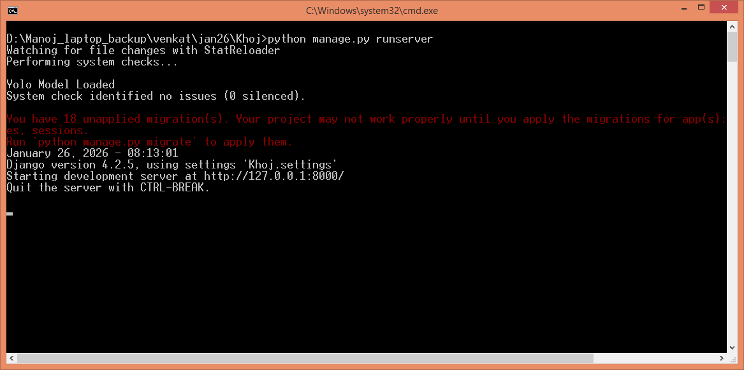
In above screen python server started and now open browser and enter URL as http://127.0.0.1:8000/index.html and then press enter key to get below page
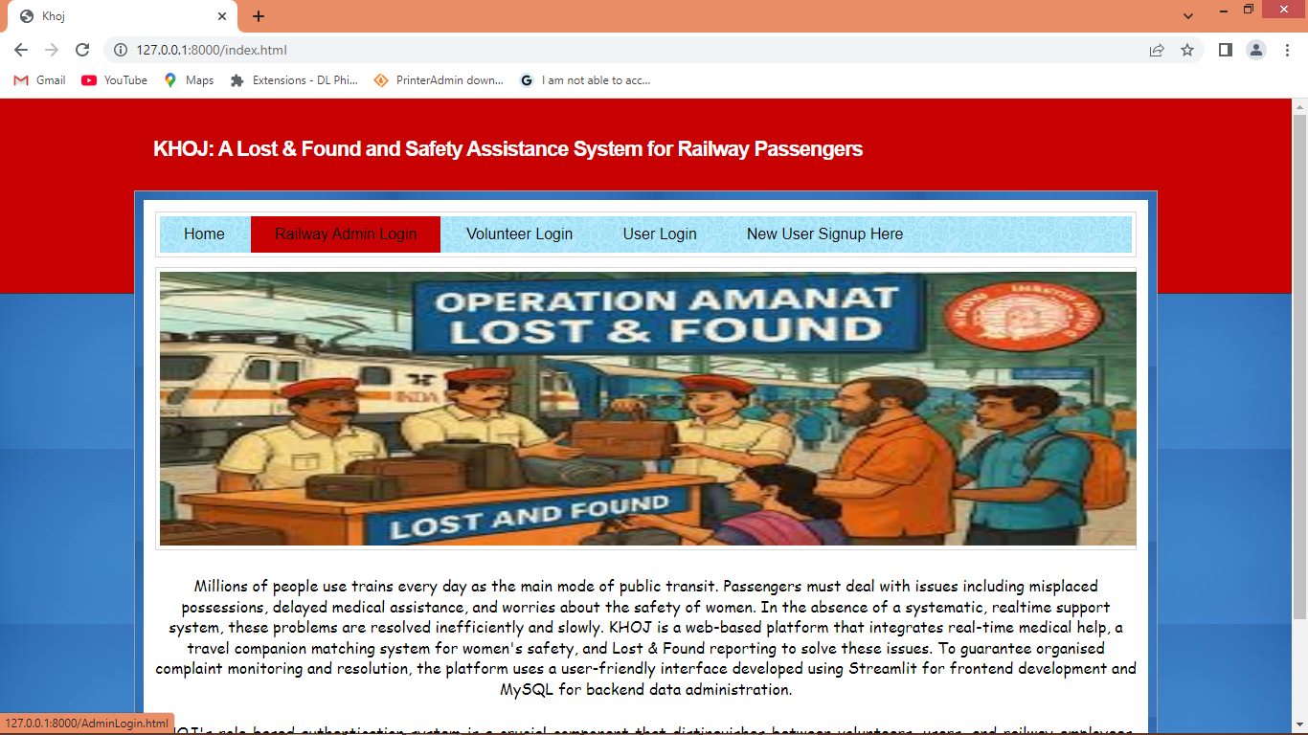
In above screen click on ‘Railway Admin Login’ link to get below page
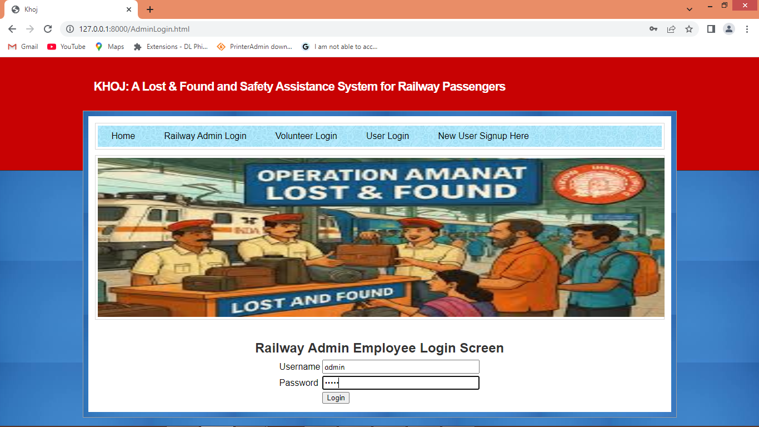
In above screen admin is login and after login will get below page
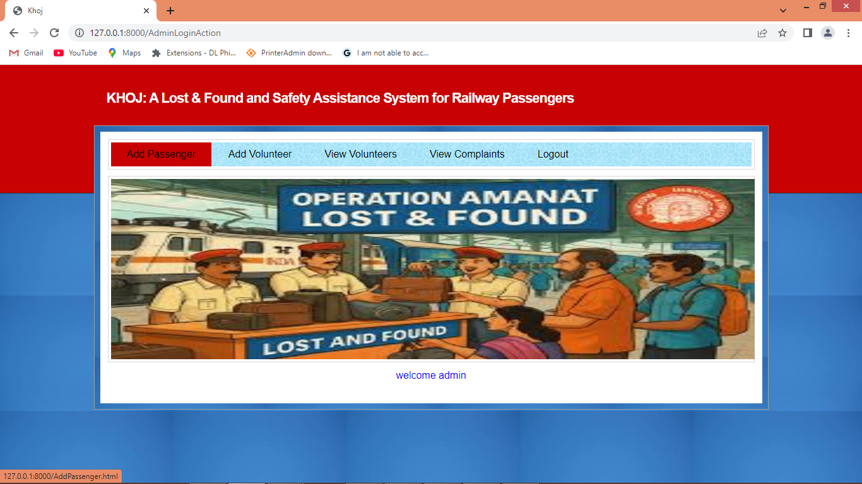
In above screen admin employee can click on ‘Add Passenger’ link to get below page
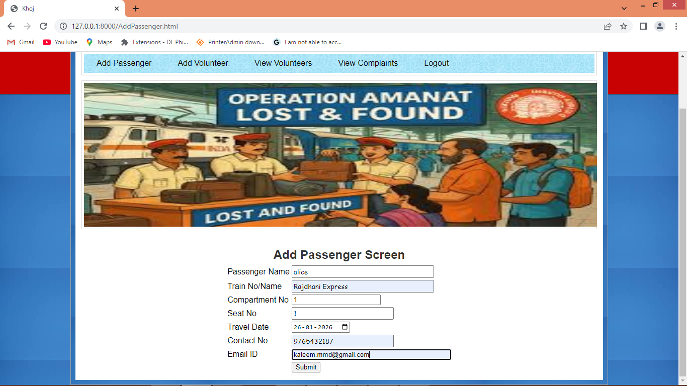
In above screen admin are adding passenger details to issue ticket and then press button to get below page
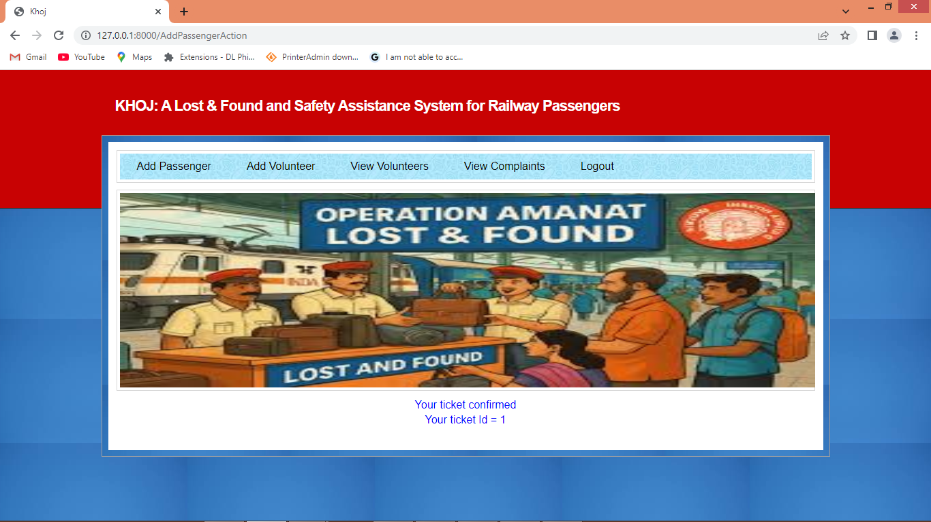
In above screen passenger ticket created with ID as 1 and similarly can add as many passengers as you want and give valid email to send notification of lost item found. Now click on ‘Add Volunteer’ link to get below page
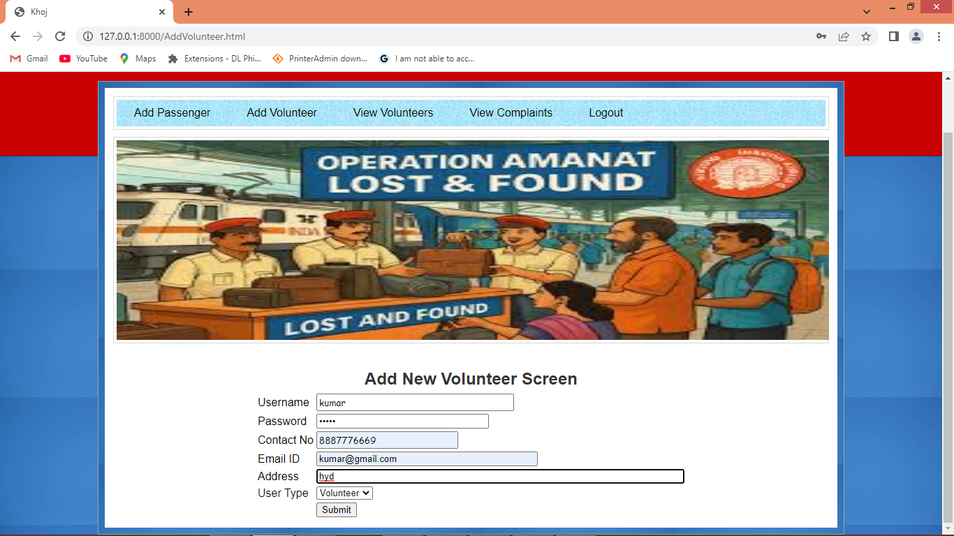
In above screen admin is adding volunteer details and then press button to get below page
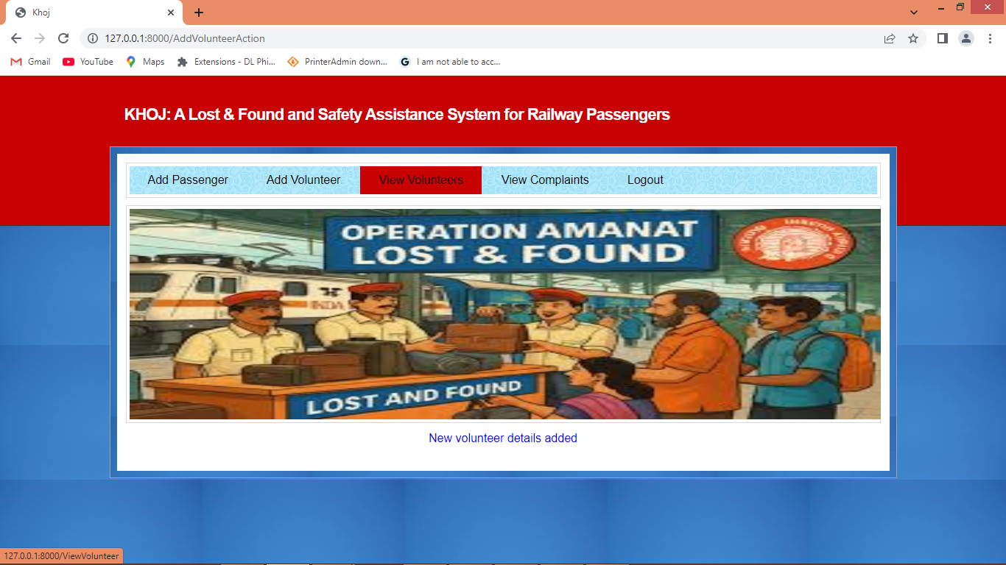
In above screen volunteer details added and now click on ‘View Volunteers’ link to view list of volunteer details
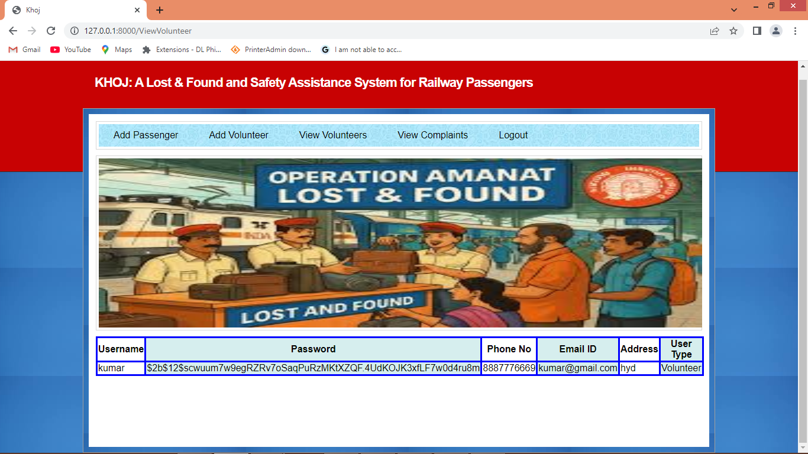
In above screen can see list of volunteer details and can see password i encrypted and now logout and sign up new user to raise complaints
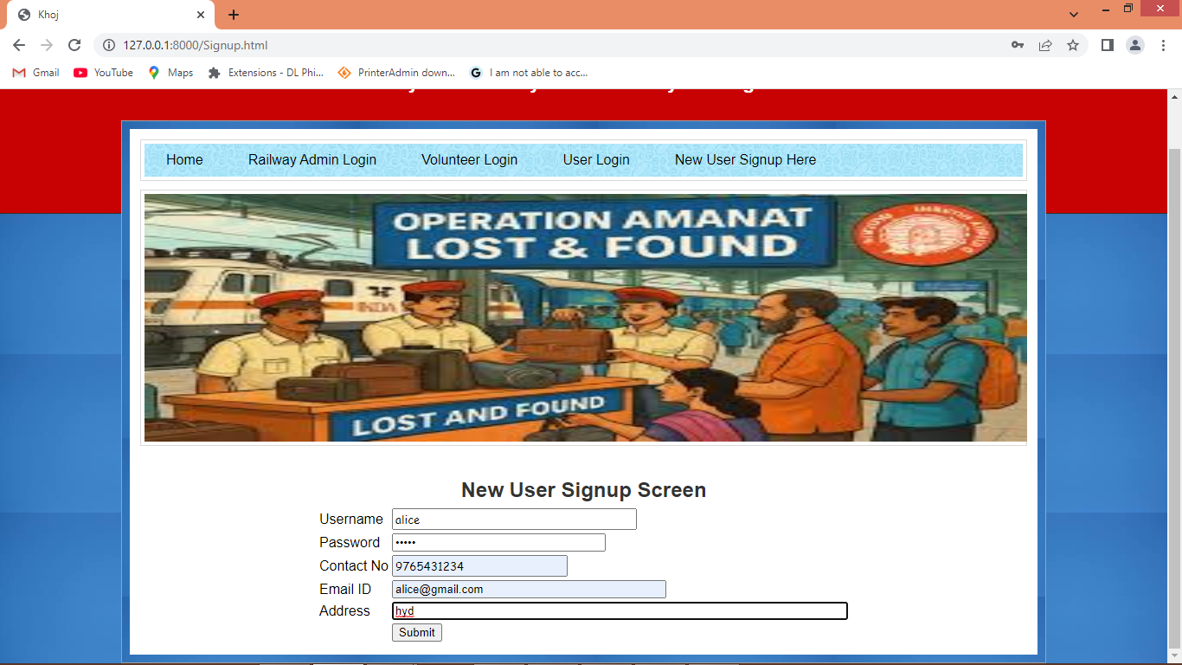
In above screen new user is getting sign up and then press button to get below page
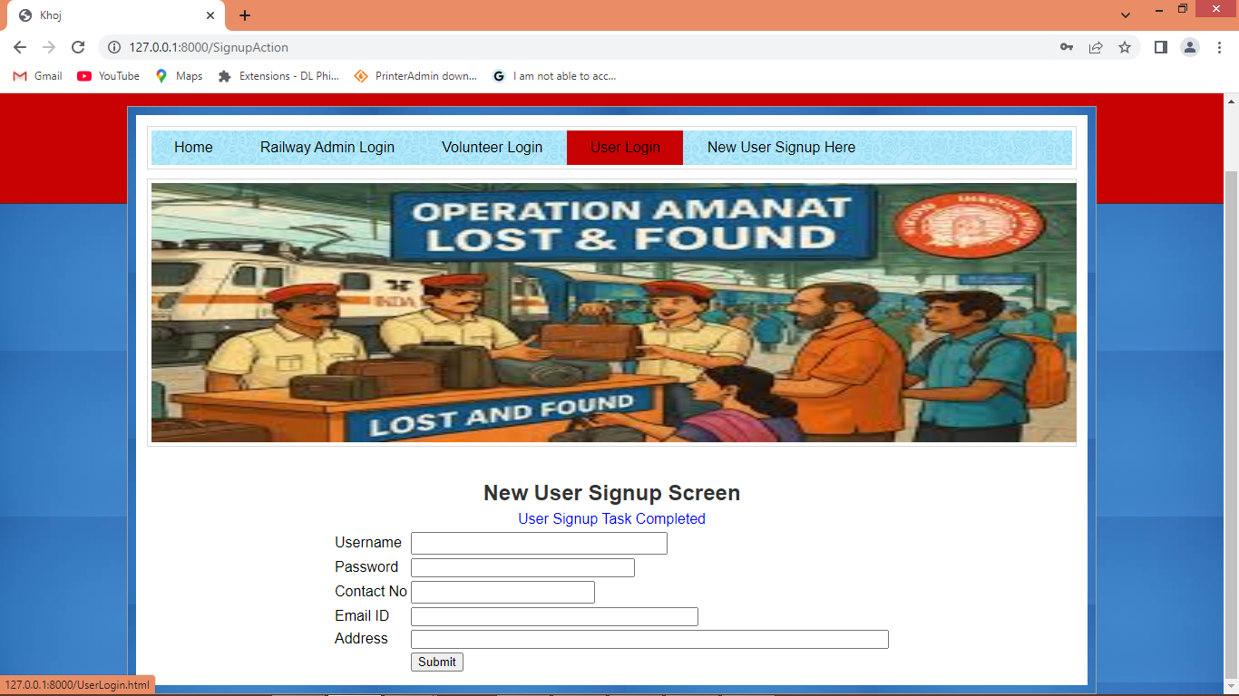
In above screen user sign up task completed and now click on ‘User Login’ link to get below page
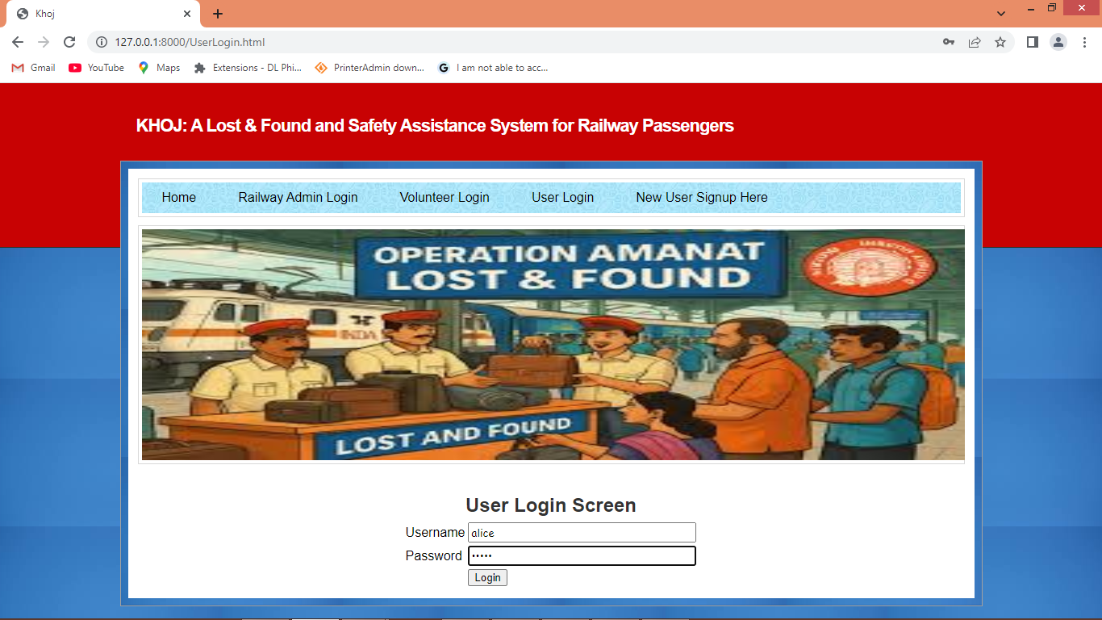
In above screen user is login and after login will get below page
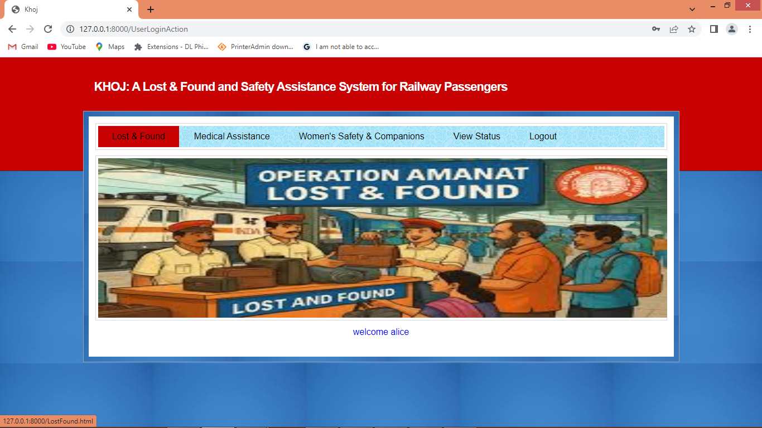
In above screen user can click on ‘Lost & Found’ link to raise complaint of loss items
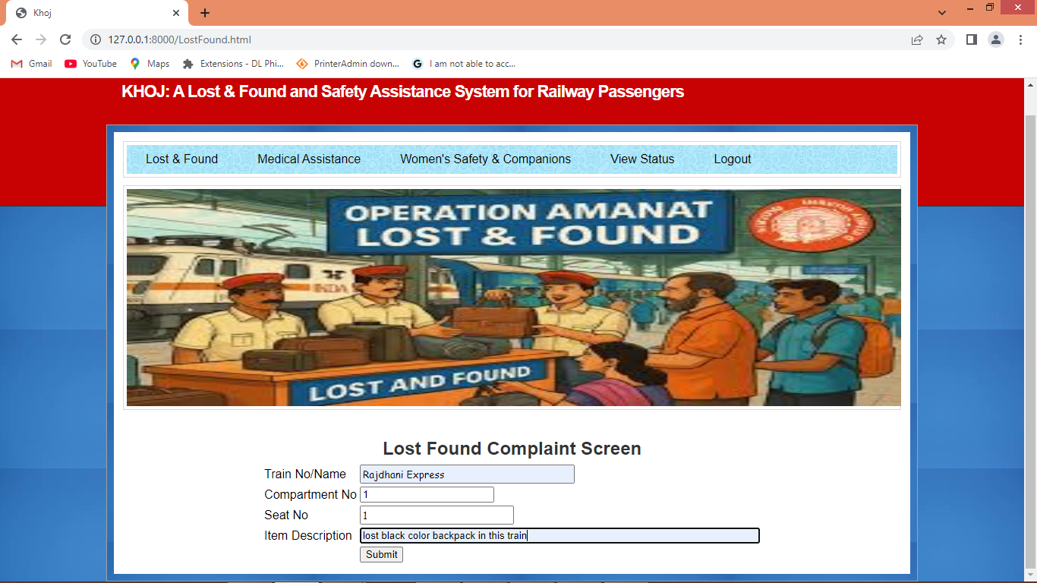
In above screen user is entering train and lost item description and then press button to get below page
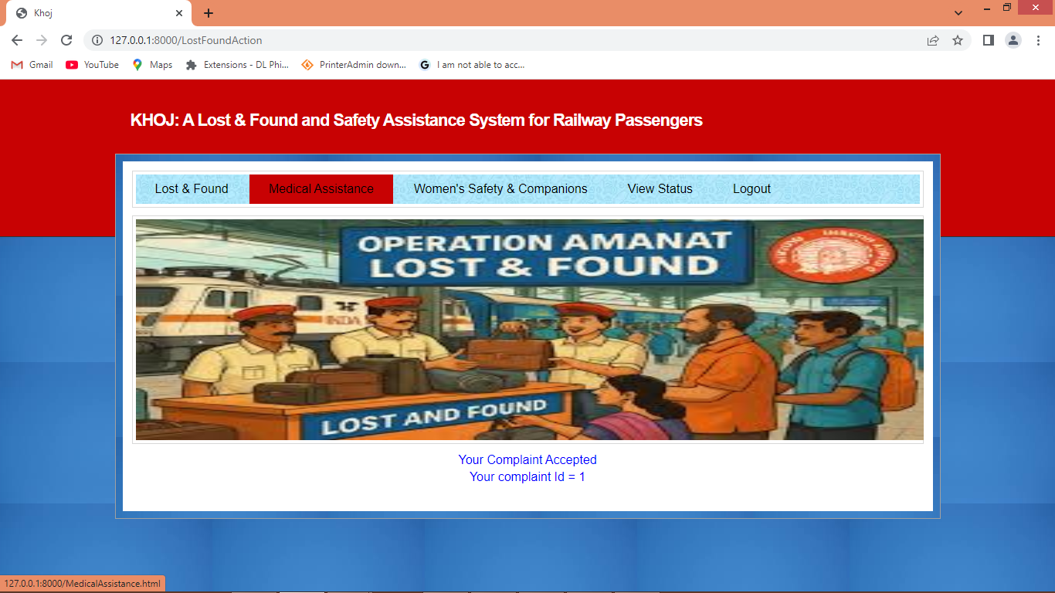
In above screen in blue text can see user complaint accepted and now click on ‘Medical Assistance’ link to get below page
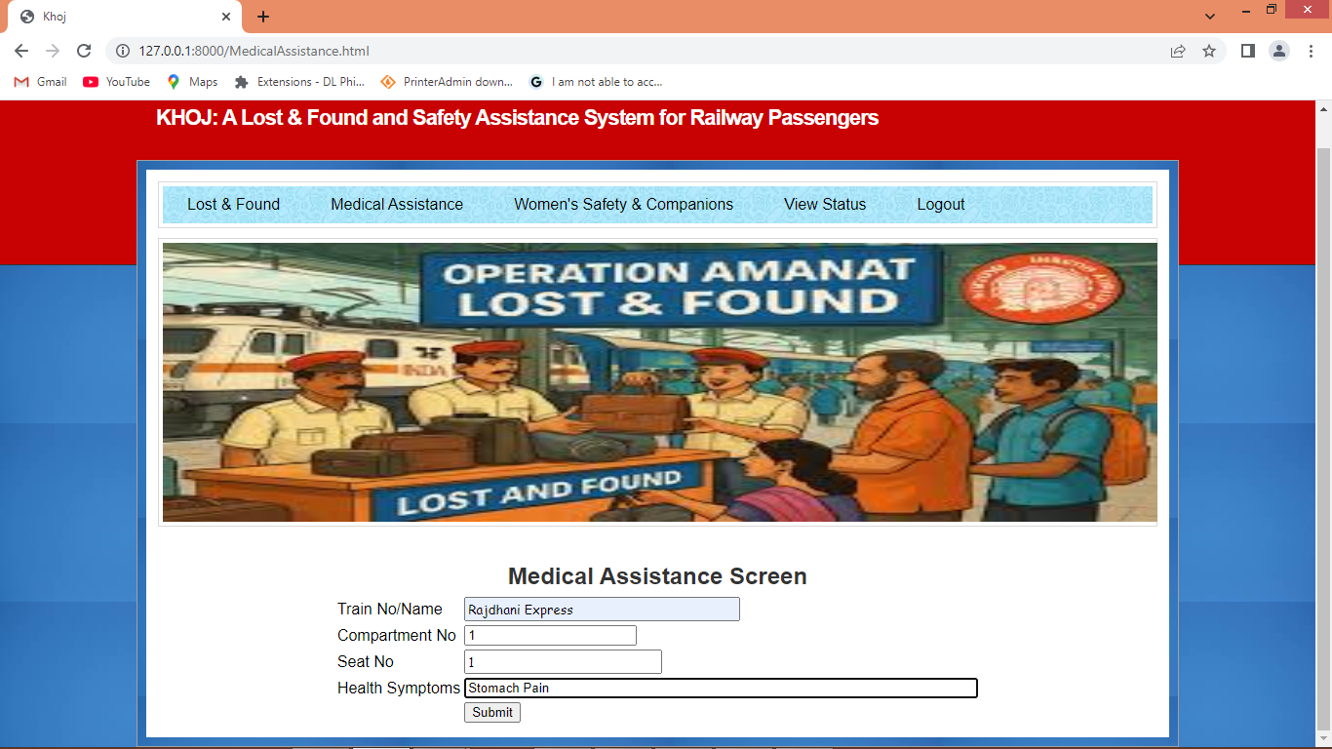
In above screen passenger raising health assistance request and then press button to get below page
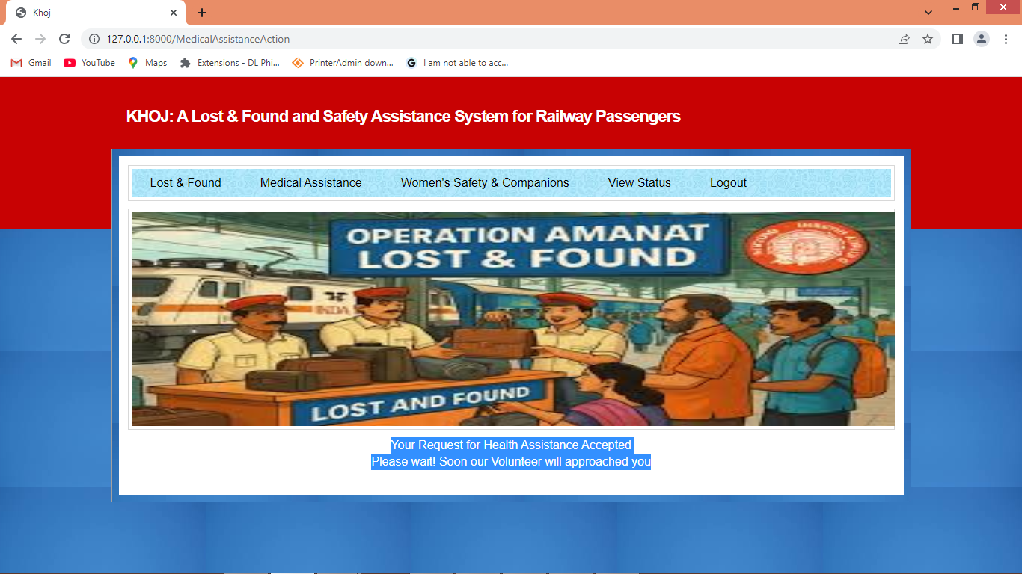
In above screen in blue text can see ‘Volunteer will visit passenger to provide assistance’ and now click on ‘Women Safety & Companion’ link to know about other companions travelling in same compartment
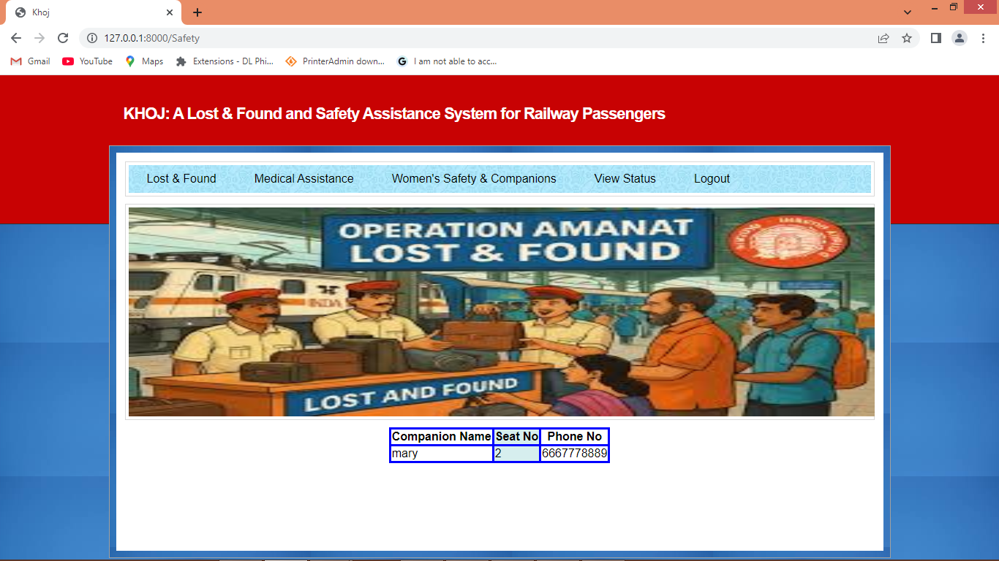
In above screen one passenger can get details of other companion’s passenger to feel safer during journey. Now click on ‘View Status’ link to check complaint status
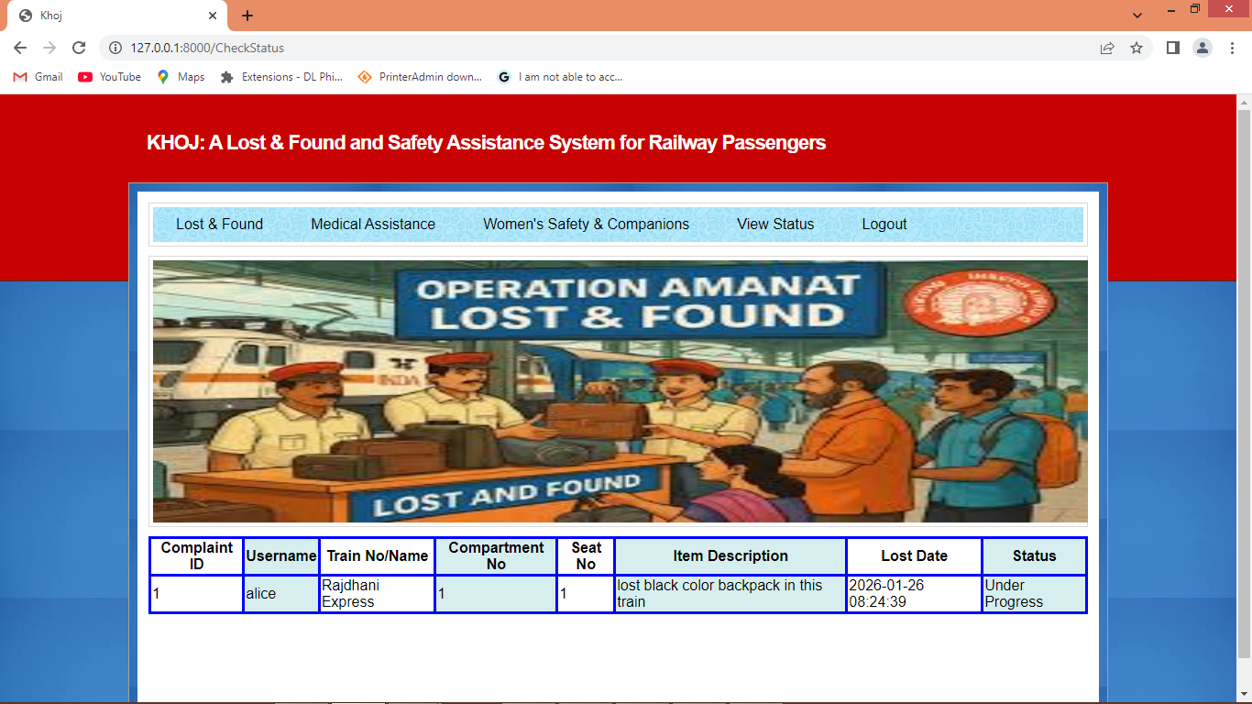
In above screen user can view complaint details which is in ‘Under Progress’ status and now logout and login as ‘Volunteer’ to update status
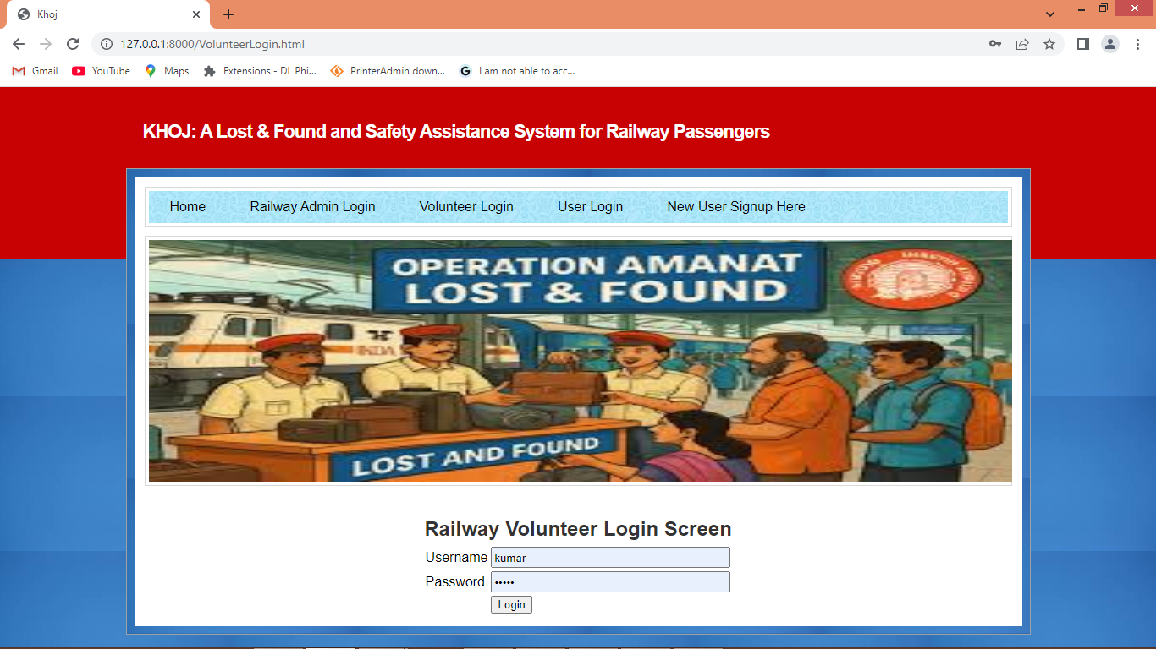
In above screen volunteer is login and after login will get below page
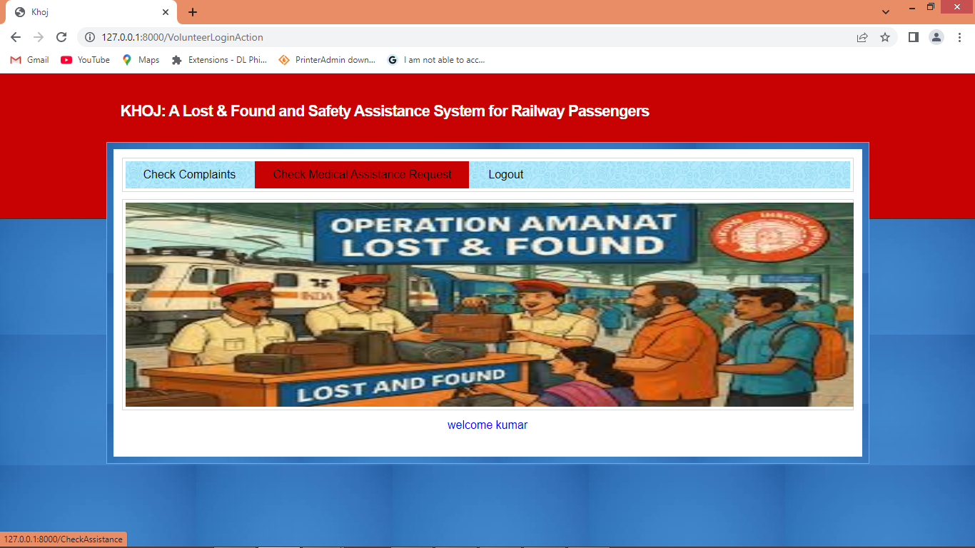
In above screen volunteer can click on ‘Check Medical Assistance Request’ link to view all pending request
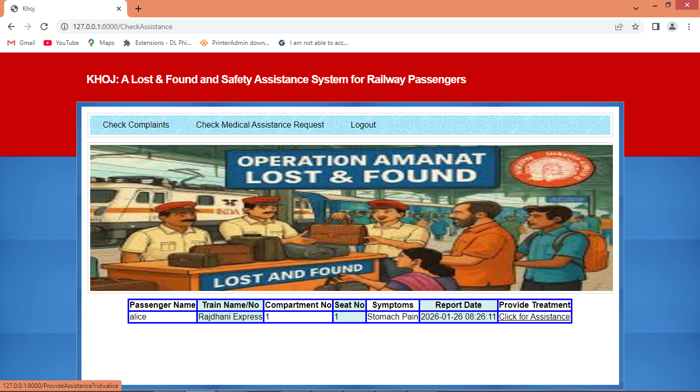
In above screen volunteer can view list of request and can click on ‘Click for Assistance’ link to provide treatment like below page
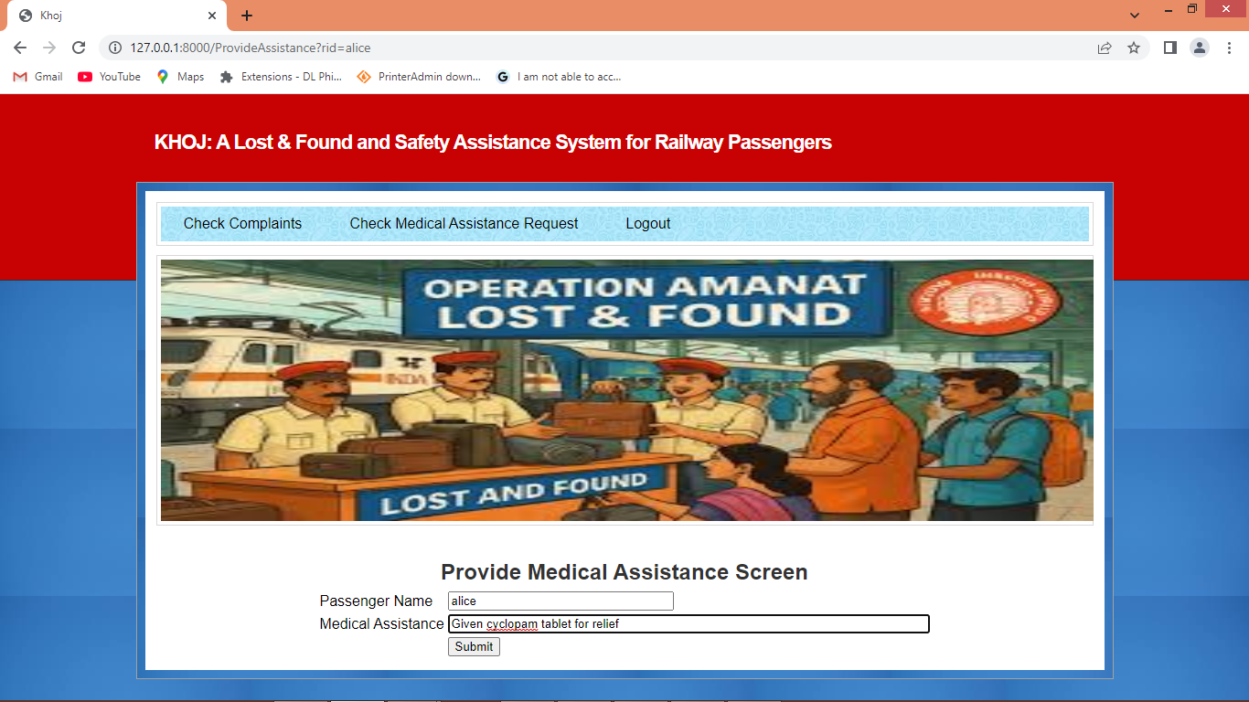
In above screen volunteer will provide treatment and write description about treatment and then press button to get below page
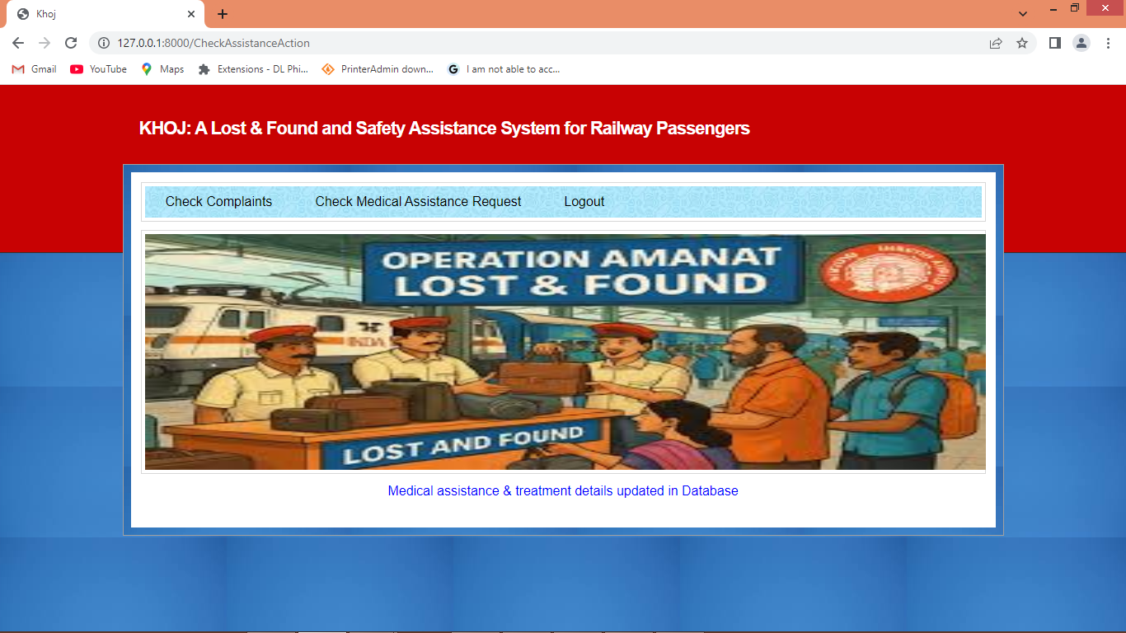
In above screen can see volunteer treatments details updated in database and now click on ‘Check Complaint’ link to get below page
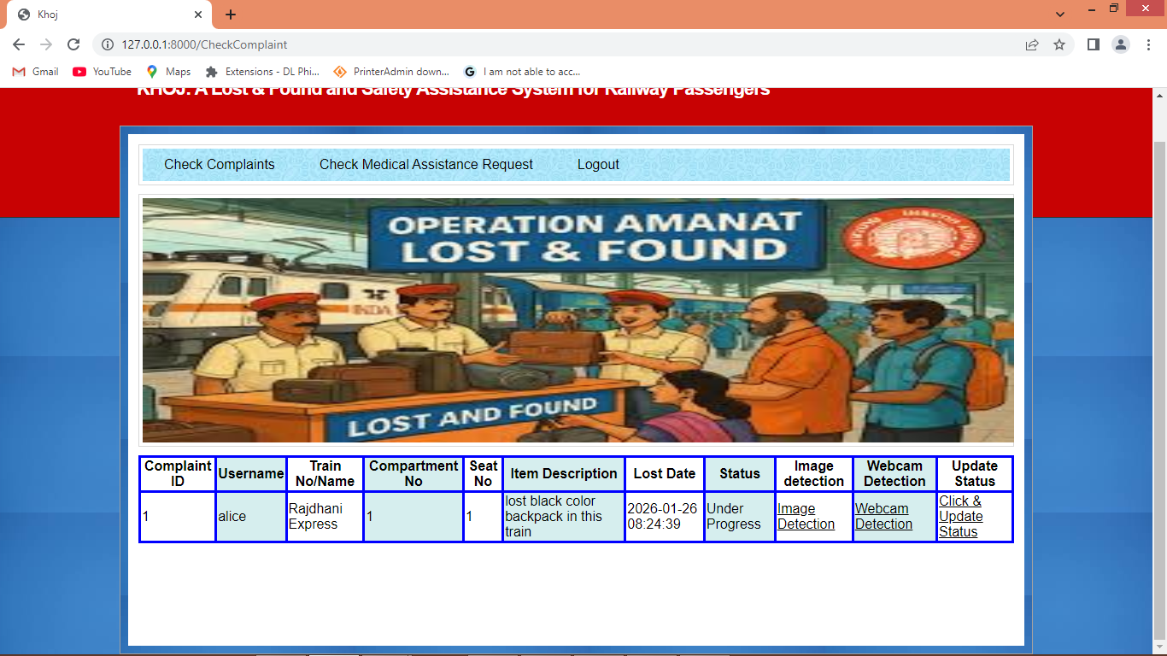
In above screen volunteer can view list of lost complaint and can click on ‘Image Detection’ link to detect objects from images
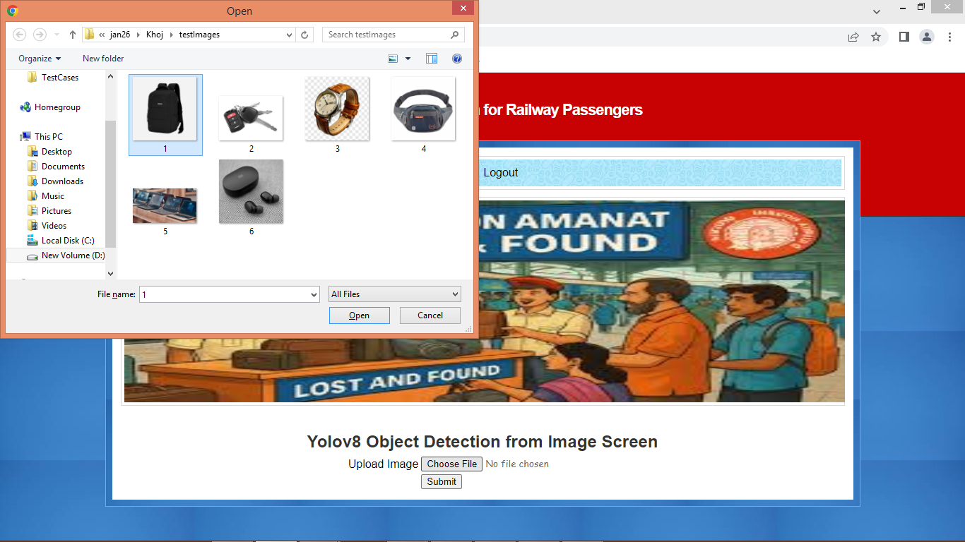
In above screen volunteer can upload available images and then press button to get below page
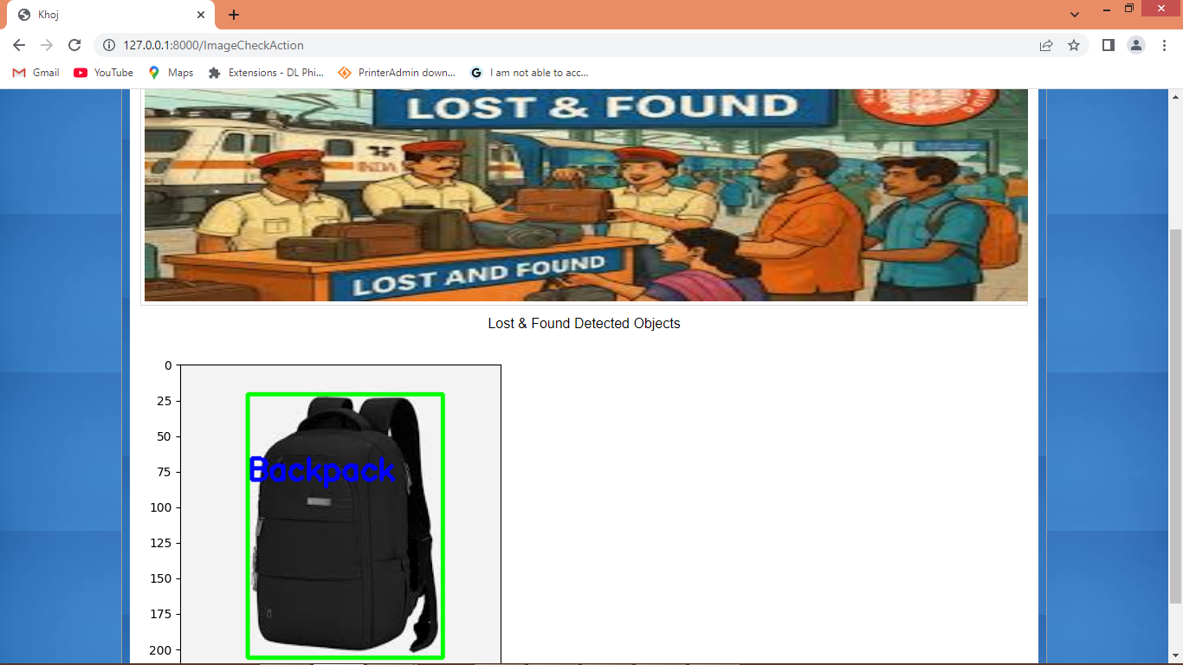
In above screen in green bounding box can see “backpack’ object detected and similarly you can upload and detected any image. Now from same screen click on ‘Webcam detection’ to detect from webcam like below page
In above screen click on ‘Webcam Detection’ link to get below page
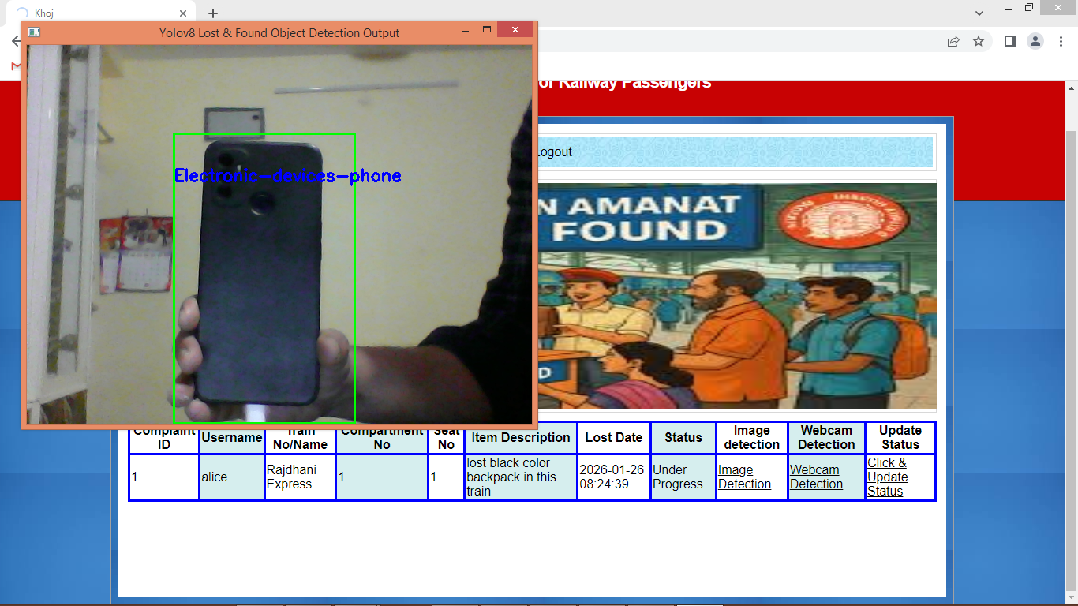
In above screen from webcam system detected ‘electron device phone’ and similarly you can detect any image and now click on ‘Click & Update Status’ link to send notification to user upon item matching item found.
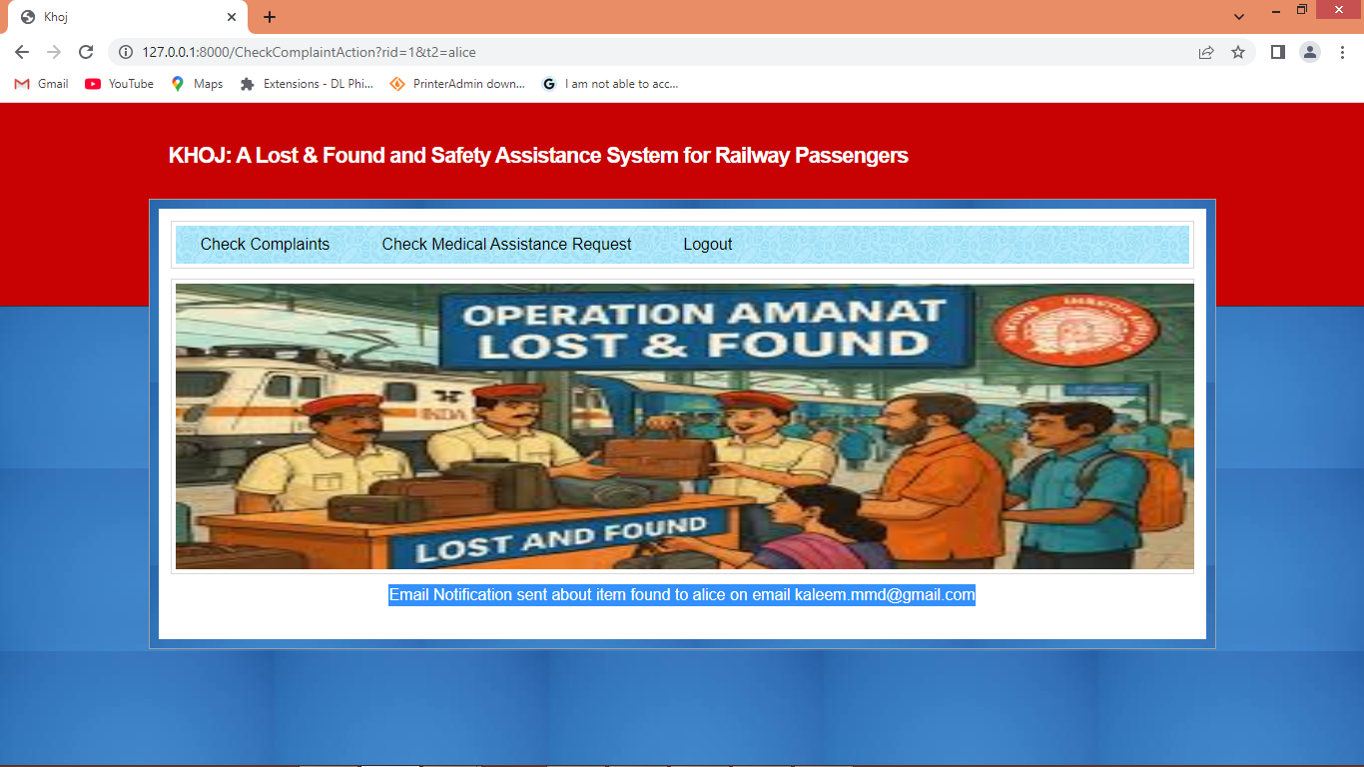
In above screen in blue text can see email notification sent to user about lost item found and then will get below email notification
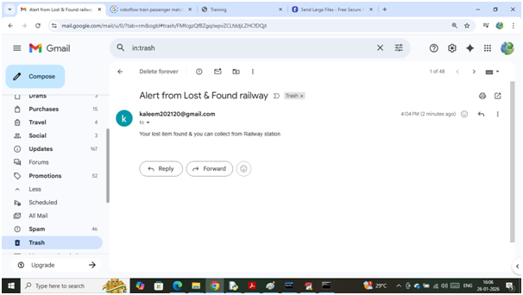
In above screen user will get above email notification and now logout and login as user to view status

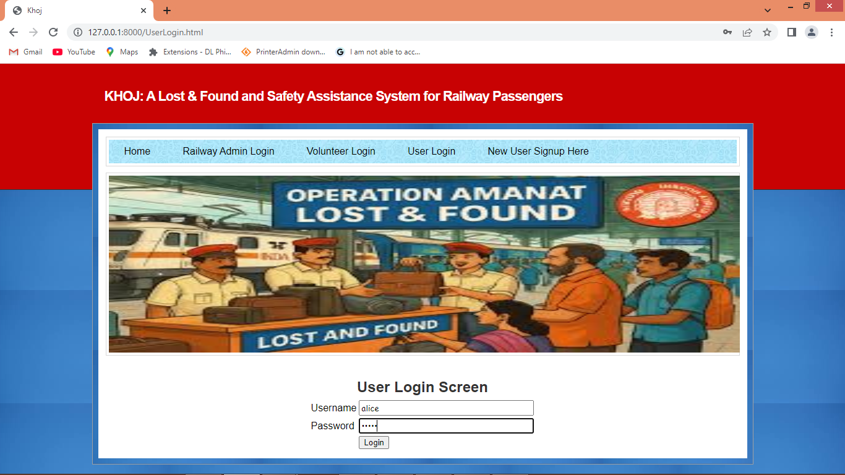
In above screen user is login and after login will get below page
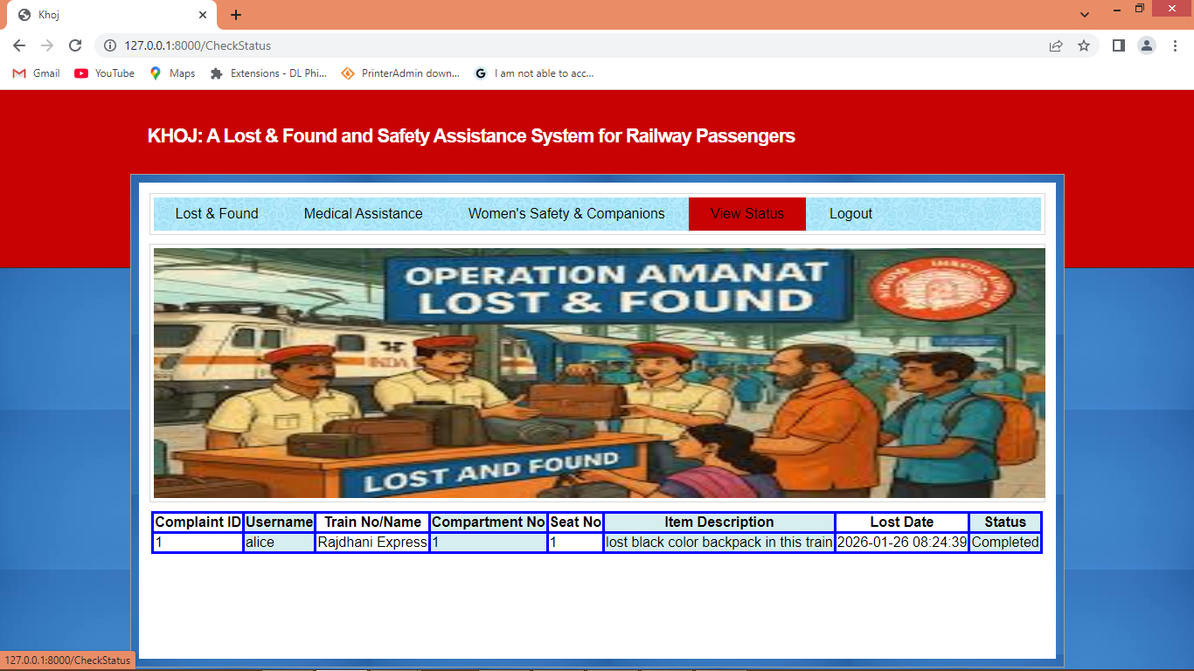
In above screen in status column can see complaint is ‘Completed’.
Similarly by following above screens you can raise any number of complaints

