Docker Hands-On Practice

Objective
The objective of this hands-on practice is to learn fundamental Docker commands, understand basic containerization concepts, and gain practical experience in pulling images, creating and managing containers, removing Docker resources, and verifying the Docker environment through both the command line and Docker Desktop.

Prerequisites
- Docker Desktop installed
- Docker Engine running
- Windows Command Prompt / PowerShell
- Internet connection

Commands Used
docker version docker pull ubuntu docker images
docker run -it --name ubuntu-practice ubuntu pwd
ls
cat /etc/os-release echo "Hello Docker" exit
docker ps -a
docker stop ubuntu-practice docker rm ubuntu-practice docker rmi ubuntu
Hands-On Execution and Output

Docker Version and Ubuntu Image Pull
Verified the Docker installation and successfully pulled the latest Ubuntu image from Docker Hub.
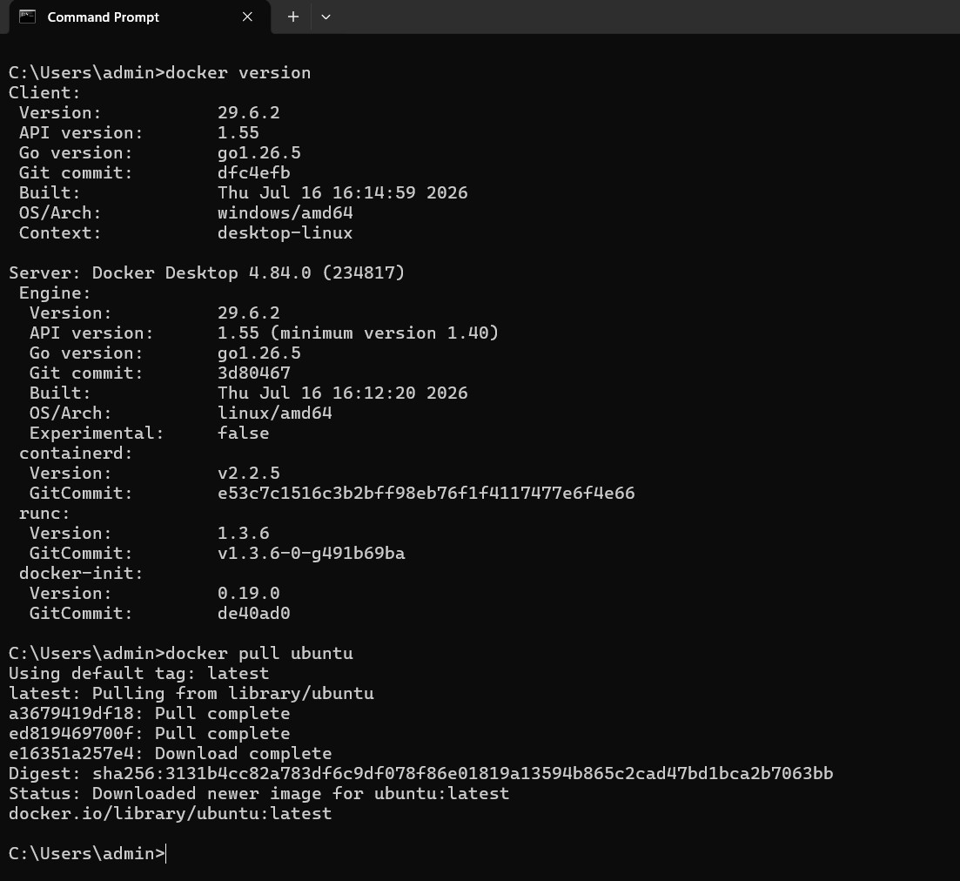

Docker Images
Displayed the Docker images available in the local image repository, including hello-world, nginx, and Ubuntu.

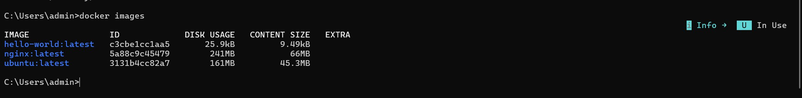

Ubuntu/Linux Environment Verification
Verified the Ubuntu operating-system information and executed a basic command using cat /etc/os-release and echo "Hello Docker".
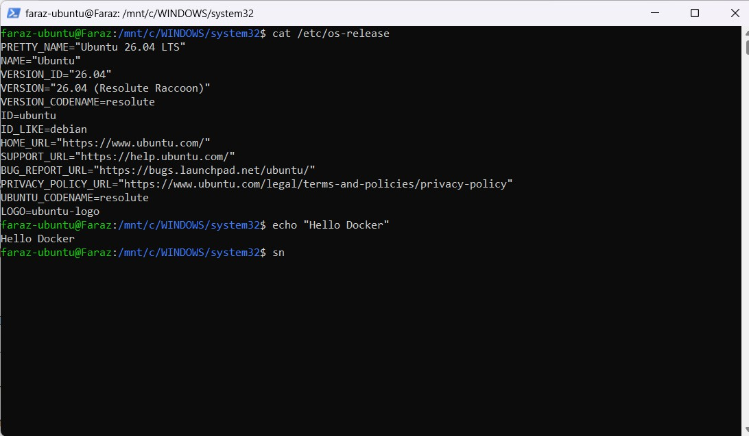

Create Container and Verify Container Status
Created an interactive container named ubuntu-practice, exited it, and verified its status using docker ps -a.

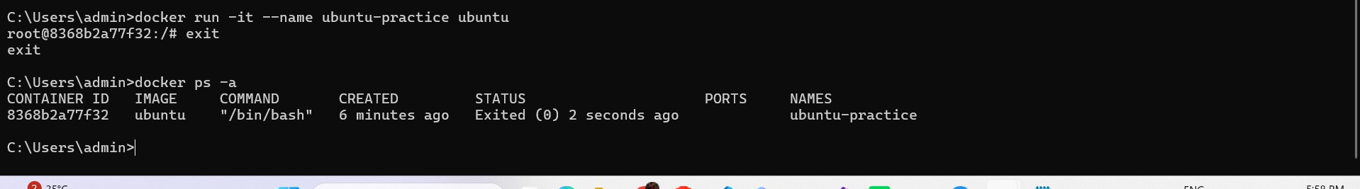

Stop and Remove Container
Stopped the ubuntu-practice container and removed it successfully.

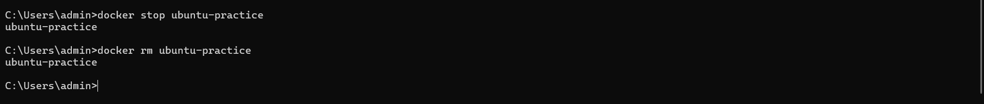

Remove Ubuntu Image
Removed the Ubuntu image from the local Docker image repository using docker rmi ubuntu.
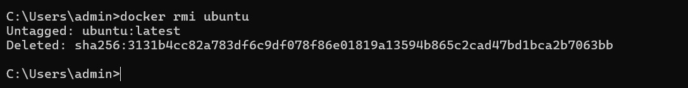

Docker Desktop Verification
Verified Docker images through the Docker Desktop graphical interface.
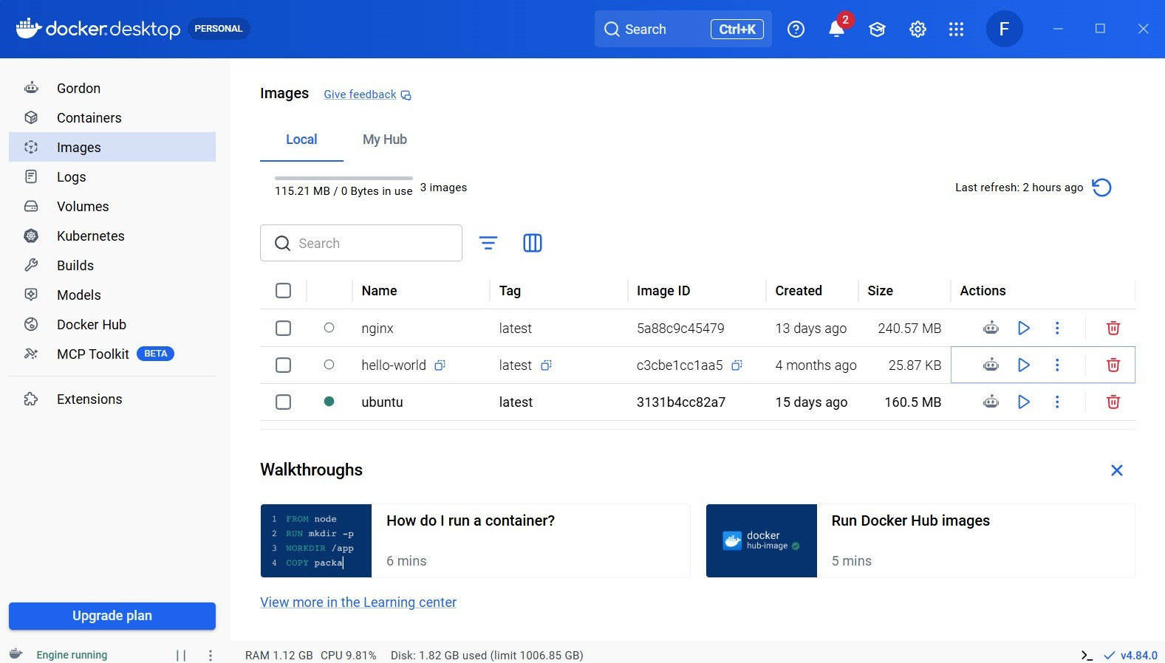

Command Summary

Command | Purpose
docker version | Verify Docker client and server installation.
docker pull ubuntu | Download the Ubuntu image from Docker Hub.
docker images | List locally available Docker images.
docker run -it --name ubuntu-practice ubuntu | Create and enter an interactive Ubuntu container.
docker ps -a | Display running and stopped containers.
docker stop ubuntu-practice | Stop the named container.
docker rm ubuntu-practice | Remove the container.
docker rmi ubuntu | Remove the Ubuntu image.

Learning Outcomes
  - Verified Docker installation and Docker Engine availability.
  - Pulled Docker images from Docker Hub and listed local images.
  - Created and used an interactive Ubuntu container.
  - Executed basic Linux commands in an Ubuntu environment.
  - Viewed container status and managed container lifecycle operations.
  - Stopped and removed containers and removed local images.
  - Verified Docker resources using both CLI commands and Docker Desktop.
  - Understood the basic Docker image → container → management workflow.

Conclusion
This hands-on practice provided practical exposure to Docker fundamentals. The Docker environment was verified, an Ubuntu image was downloaded, a container was created and managed, Docker resources were inspected and removed, and the environment was also checked through Docker Desktop. The exercise demonstrates the essential workflow required for basic container-based application development.

