Angular Hands-On Practice
Student Course Portal

Objective
To build a complete Student Course Portal using Angular and progressively apply core and advanced Angular concepts, including components, data binding, lifecycle hooks, directives, pipes, forms, services, dependency injection, routing, HTTP integration, NgRx state management, RxJS, and unit testing.

Software and Tools Used
- Node.js and npm
- Angular CLI / Angular application
- Visual Studio Code
- Chrome Browser and Developer Tools
- JSON Server for the mock REST API
- NgRx Store and Redux DevTools
- Jasmine and Karma for unit testing

Project Overview
The hands-on exercises build one unified Angular application: a Student Course Portal. The portal supports a dashboard, course catalog, enrollment forms, student profile, API-based course data, shared services, routing, state management, and automated tests.

Commands Used
ng serve
npm run server
ng test
ng test --code-coverage

Execution and Output Screenshots

1. Student Dashboard
The Student Course Portal dashboard displays the welcome section, course statistics, navigation menu, search box, and component-level notification provider demonstration.
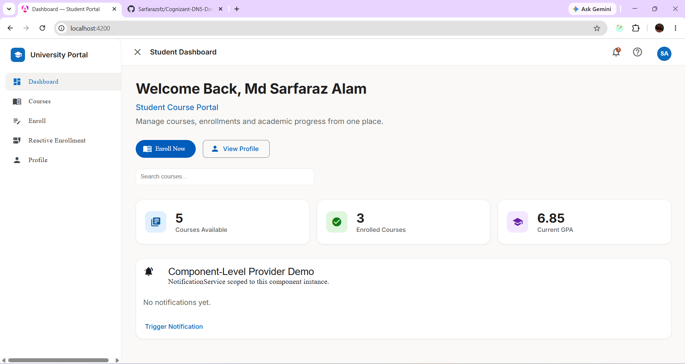

2. Course Catalog
The Courses page displays five course cards with course code, credits, availability, grade status, details, and enrollment actions. This demonstrates reusable components, bindings, directives, and pipes.
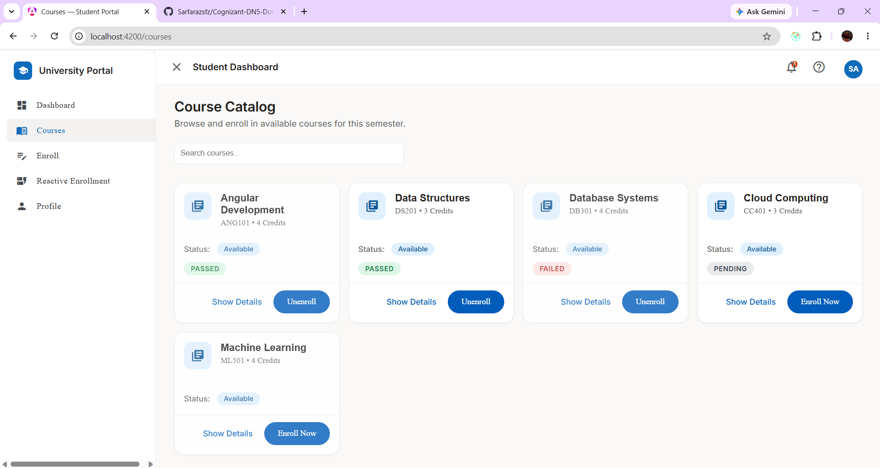

3. Template-Driven Enrollment Form
The enrollment page demonstrates a template-driven form with student details, semester selection, terms acceptance, submission handling, and a successful enrollment message.
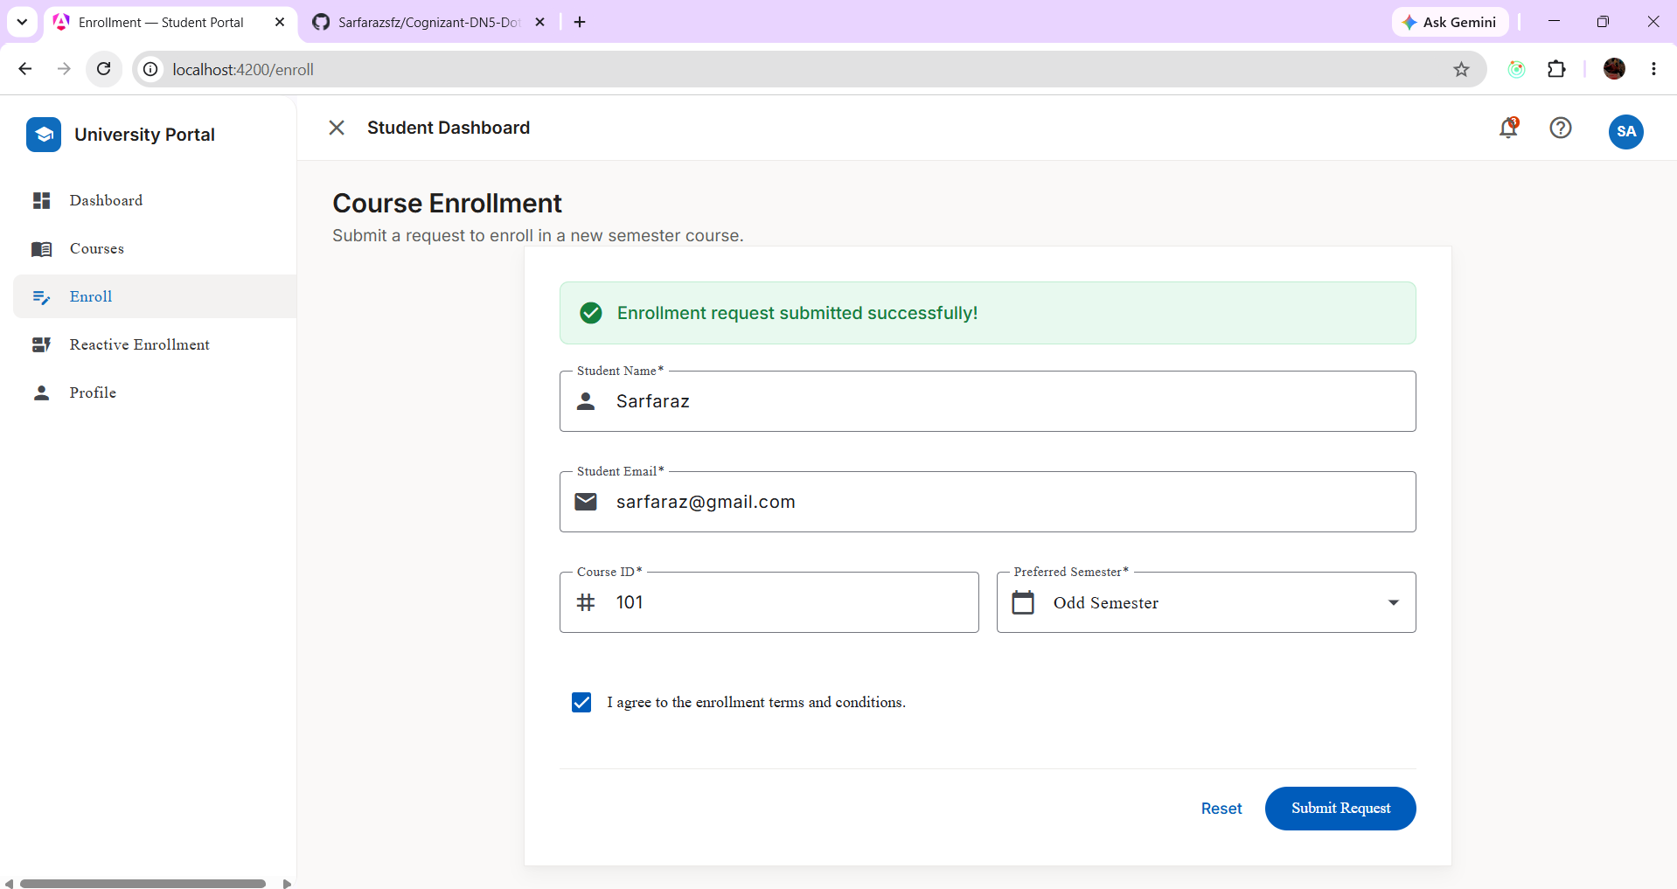

4. Reactive Enrollment Form
The reactive enrollment page demonstrates FormGroup/FormBuilder-based controls, validation, terms acceptance, and a dynamic Additional Courses section.
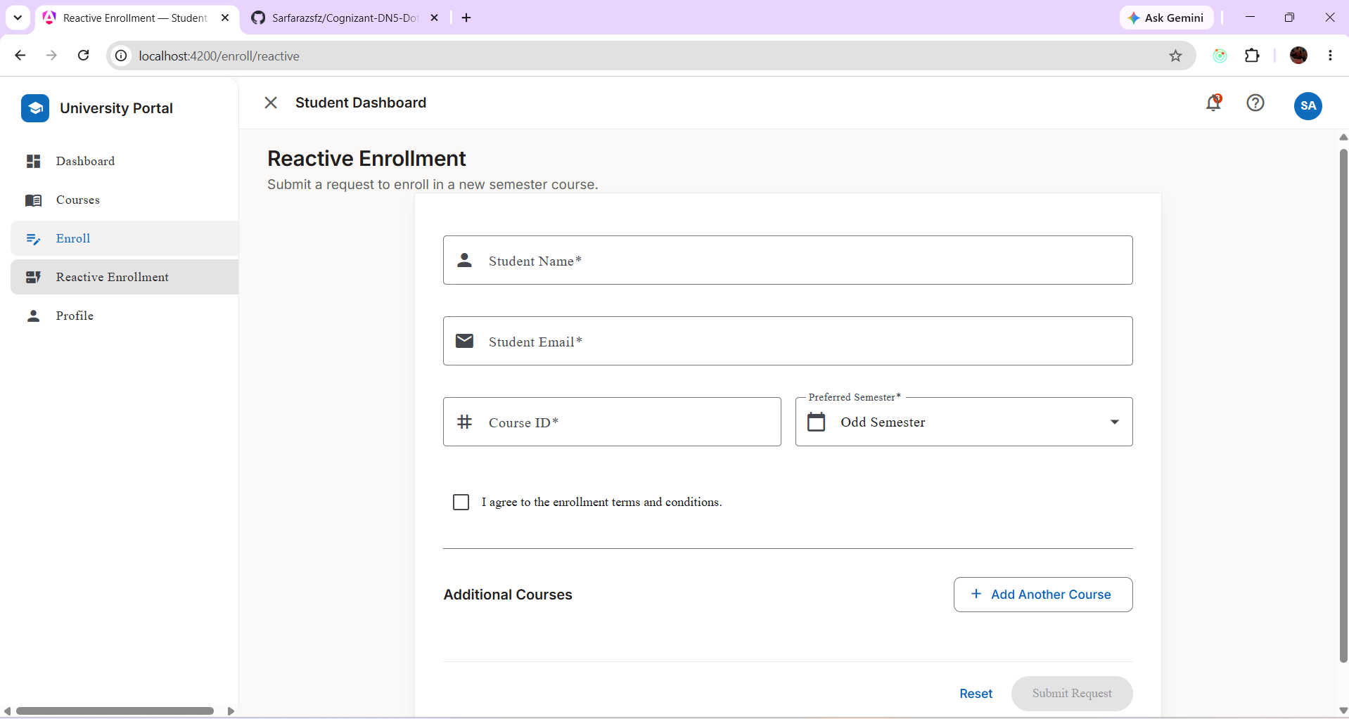

5. Student Profile and Enrolled Courses
The profile page displays student information and enrolled courses, demonstrating routing and shared enrollment data through Angular services.
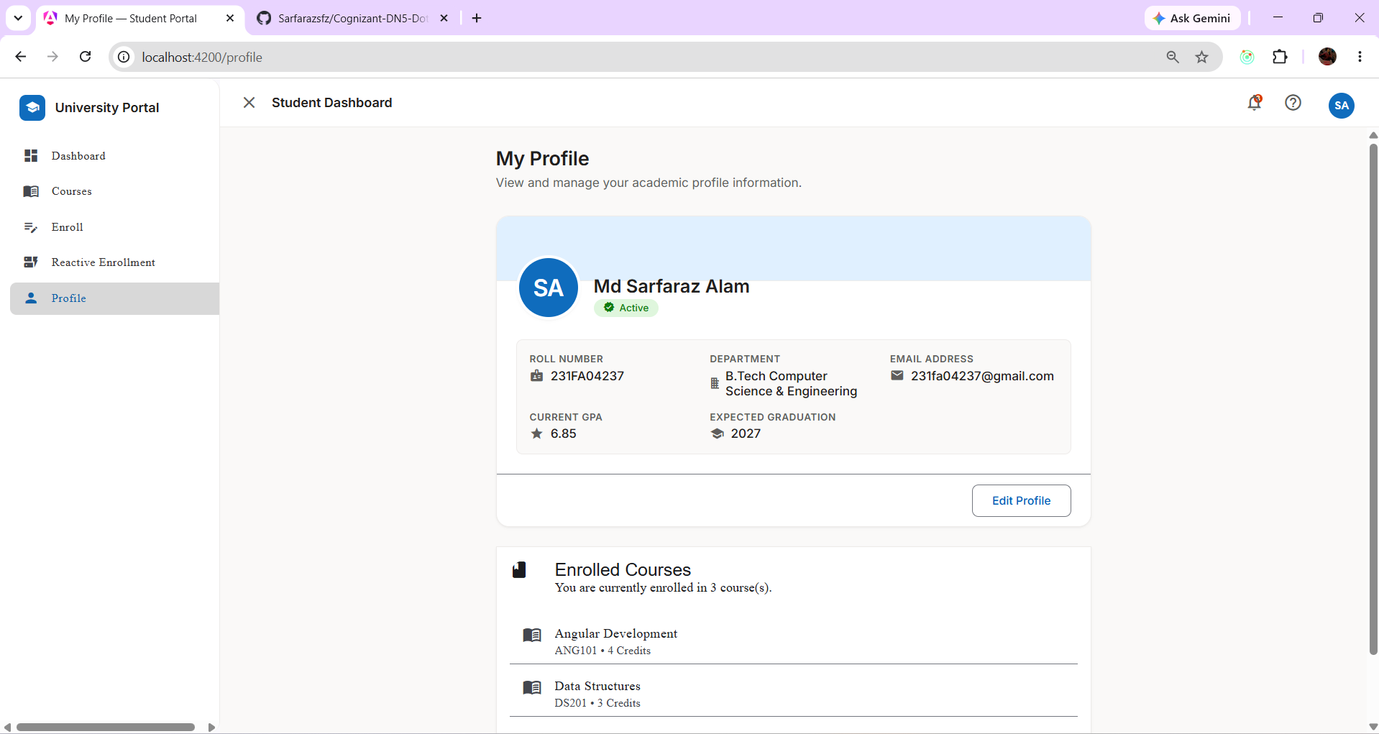

6. NgRx Store Verification
Redux DevTools shows the course and enrollment state along with Course Load Courses and Course Load Courses Success actions, verifying NgRx actions, reducers, effects, and state updates.
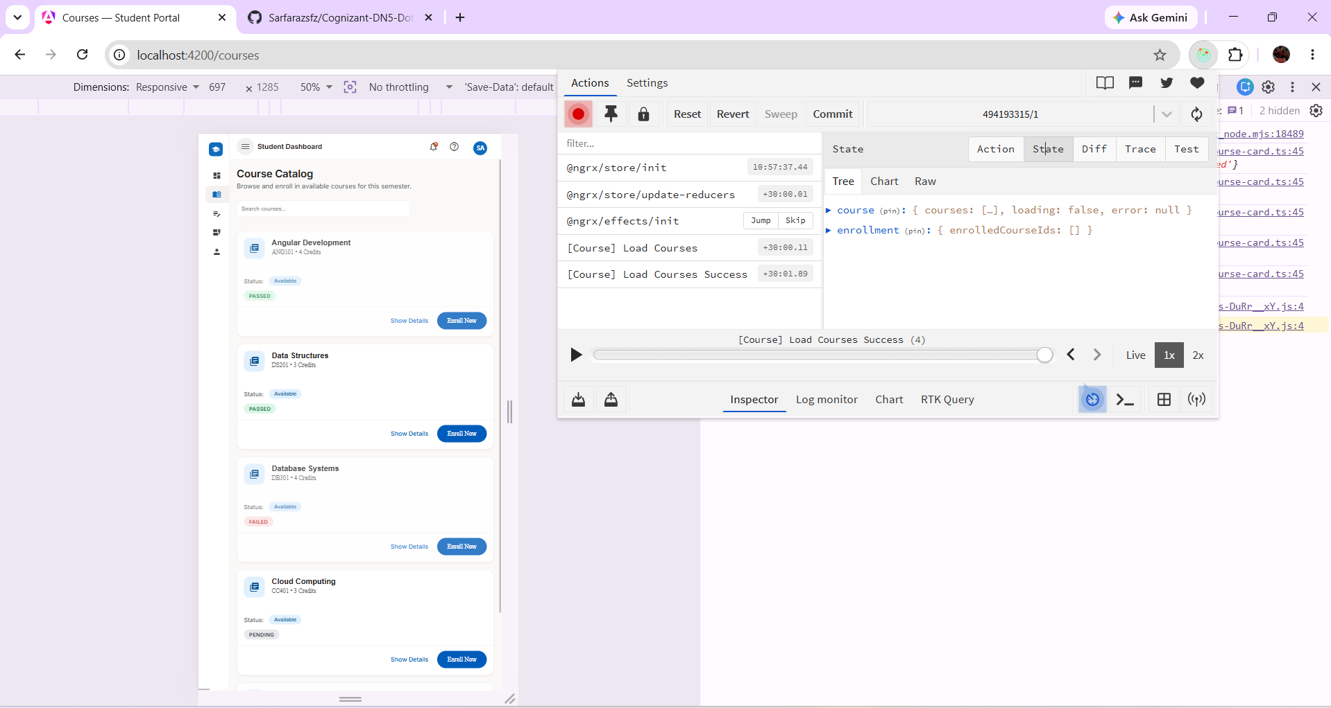

7. Karma/Jasmine Unit Test Results
Karma reports 11 specs with 0 failures. The displayed tests cover CourseService, CourseCardComponent, the application, and CourseListComponent.
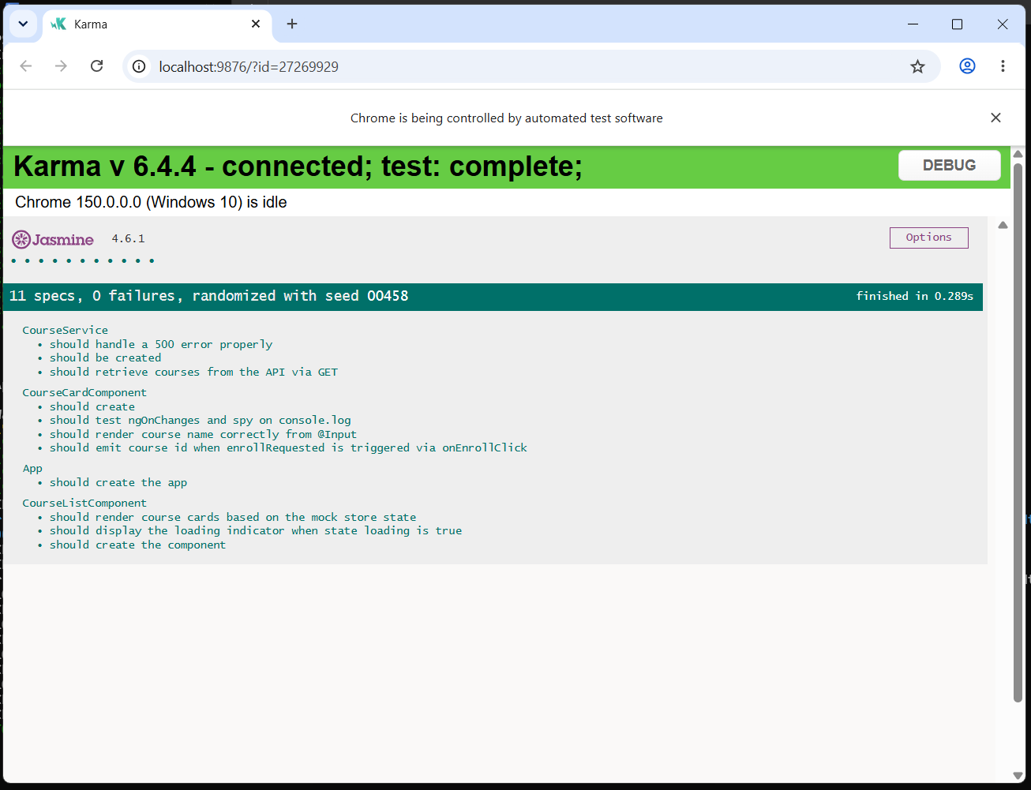

8. Angular Test Coverage
The ng test --code-coverage output shows all 11 tests passing and reports statement, branch, function, and line coverage.
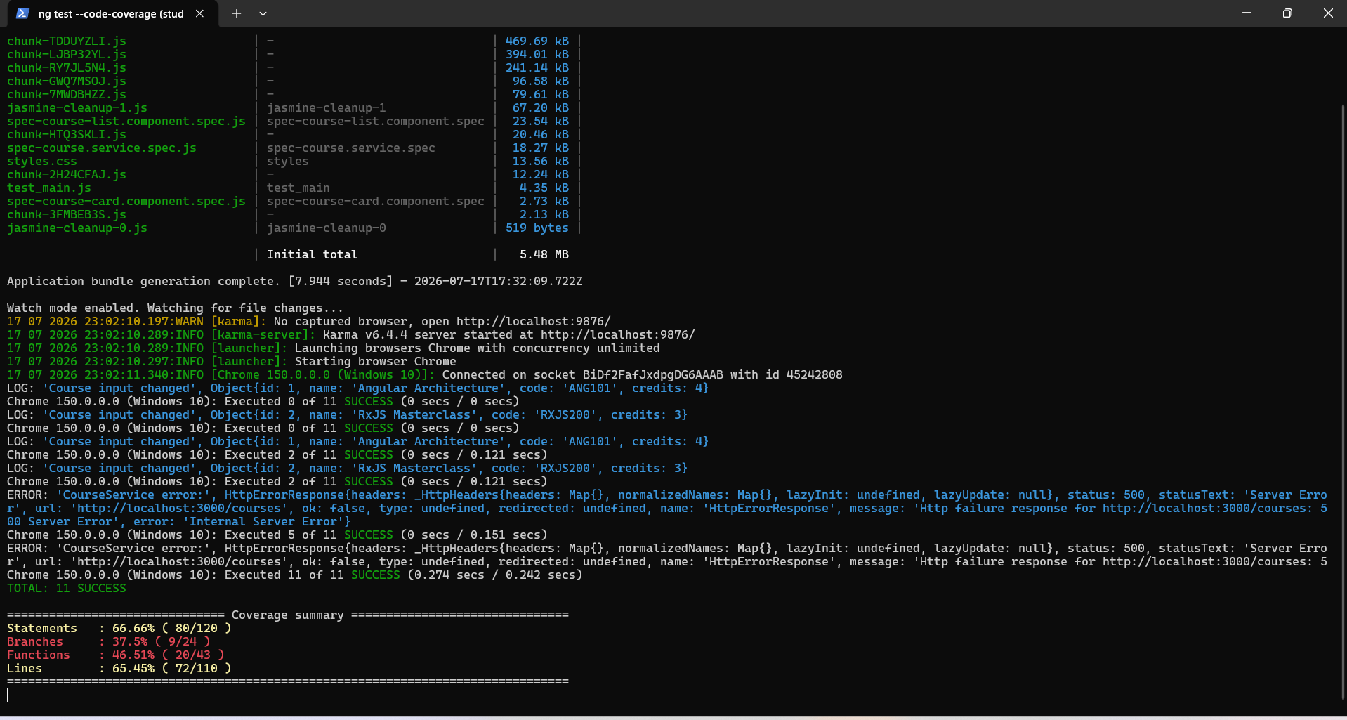

9. JSON Server
The mock REST API is running on port 3000 and exposes courses, students, and enrollments resources used by the Angular application.
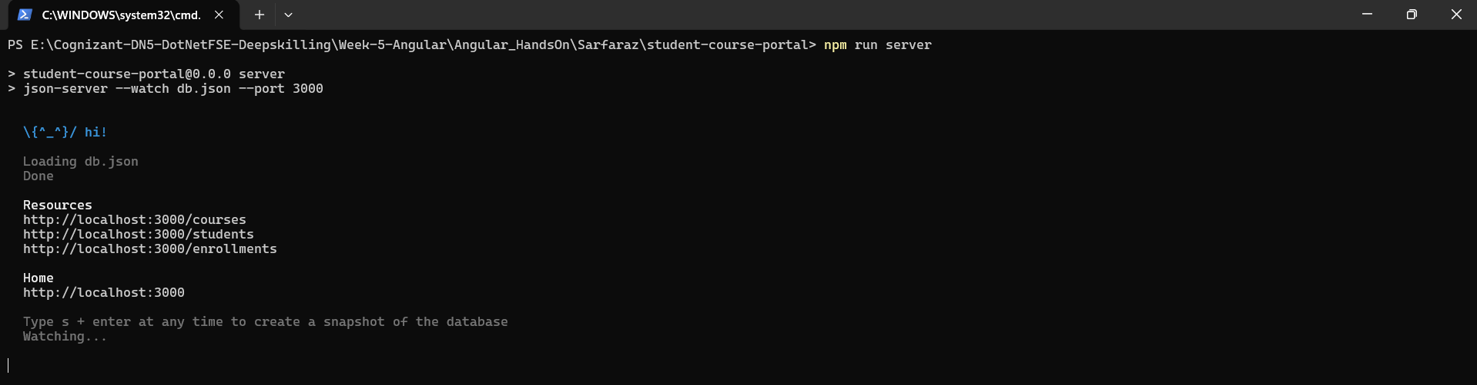

10. Angular Development Server
The Angular development server successfully builds the application and serves it locally on port 4200. The output also shows a lazy-loaded enrollment module chunk.
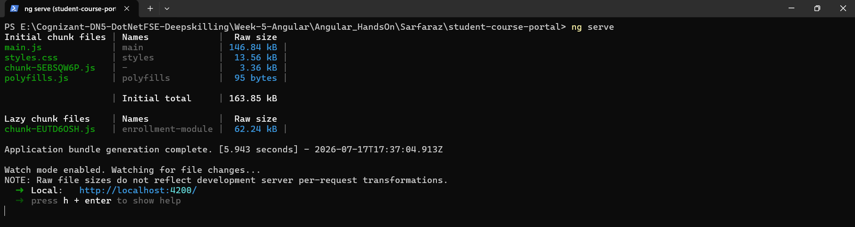
The Angular application was tested using Jasmine and Karma. The test execution completed successfully with 11 specs and 0 failures. Tests covered CourseService, CourseCardComponent, the root application, and CourseListComponent. Code coverage was also generated using ng test --code-coverage.
Coverage Metric | Result
Statements | 66.66% (80/120)
Branches | 37.5% (9/24)
Functions | 46.51% (20/43)
Lines | 65.45% (72/110)

Learning Outcomes
- Created and structured a multi-page Angular application using reusable components.
- Applied interpolation, property/event/two-way binding and component lifecycle hooks.
- Implemented directives, pipes, template-driven forms and reactive forms with validation.
- Used Angular services and dependency injection for shared application logic and data.
- Configured application routing, navigation and lazy-loaded functionality.
- Integrated a mock REST API using JSON Server and Angular HttpClient.
- Managed application state with NgRx actions, reducers, effects and selectors.
- Tested Angular components and services using Jasmine, Karma and TestBed.
- Generated and reviewed unit-test code coverage.

Result
The Student Course Portal was successfully developed and executed as a unified Angular application. The required Angular concepts from project setup through state management and testing were implemented and verified. The application successfully runs on the Angular development server, communicates with the JSON Server mock API, uses NgRx for application state, and passes all 11 configured unit tests.

