**REQUIREMENTS**

**FOR PPE-RTK TECHNOLOGY:**

**Antenna** :

* The antennas used within smartphones are much lower quality than those used in surveying and other professional activities.
* The experts interviewed gave differing views on how this will impact their ability to achieve PPP-RTK on smartphones.
* Many experts said that the low-quality antennas are preventing smartphones from being able to achieve high-accuracy positioning, this viewpoint has also been reinforced in the available literature. However, some experts debated this and said that the quality of the antenna does not significantly impact the ability of the smartphone to receive and solve the carrier phase solutions.
* Whilst the quality of the antenna does impact the accuracy, it is not an insurmountable barrier to the uptake of PPP-RTK on smartphones. This provides an excellent demonstration of the complexity of the problem facing organisations attempting to deploy PPP-RTK and use novel technologies. **It is worth noting that all experts interviewed believed that further smartphone antenna development would enable them to achieve high-accuracy positioning.**
* Recent experimentation compared the accuracies of GNSS measurements between the Samsung Galaxy S4 (2013) and the Samsung Galaxy S7 (2016), with the S4 achieving an average (2D – root mean squared) horizontal accuracy of 6.59m and the S7 averaging 10.54m.Additional experiments suggest that the use of RTK on smartphones (Huawei P10+ - 2017) does not provide a significant advantage as it is unable to fix the phase ambiguities

**Battery**

The battery is not expected to be a critical limiting factor in the application of PPP-RTK to smartphones. This battery would become a consideration after issues with the antenna are resolved, the battery drain would be similar the that experienced when using the standard GNSS chip in current smartphones.

The **chipset** and **receiver** technologies are closely linked to the development of the service providers, with some receiver manufacturers directly supporting the development of PPP-RTK.

**Satellite:**

* IRNSS-1A of IGSO type with longitude 55 degree East with an inclination 29 degree
* IRNSS-1G of GEO type with longitude 129.5 degree East
* India has been aspiring to have its own satellite-based positioning and navigation system for defense and civilian applications.
* To fulfill this, the Indian Space Research Organization (ISRO) developed the concept of an independent regional satellite navigation system, which provides service only to a particular region.
* The Indian Regional Navigation Satellite System (IRNSS) has been implemented by ISRO to provide navigation services with an accuracy better than 20 m. IRNSS service area has been specified between 40o E to 140o E in longitude and ± 40o in latitude (i.e., India and 1500 Km beyond it). It provides single and dualfrequency services with L-band and S-band signals.

**Frequency** L5 = **1176.45 MHz**

**CORS** network:

There are GAGAN stations where some information is available.

The overall working of PPE-RTK technology is as shown in figure below:

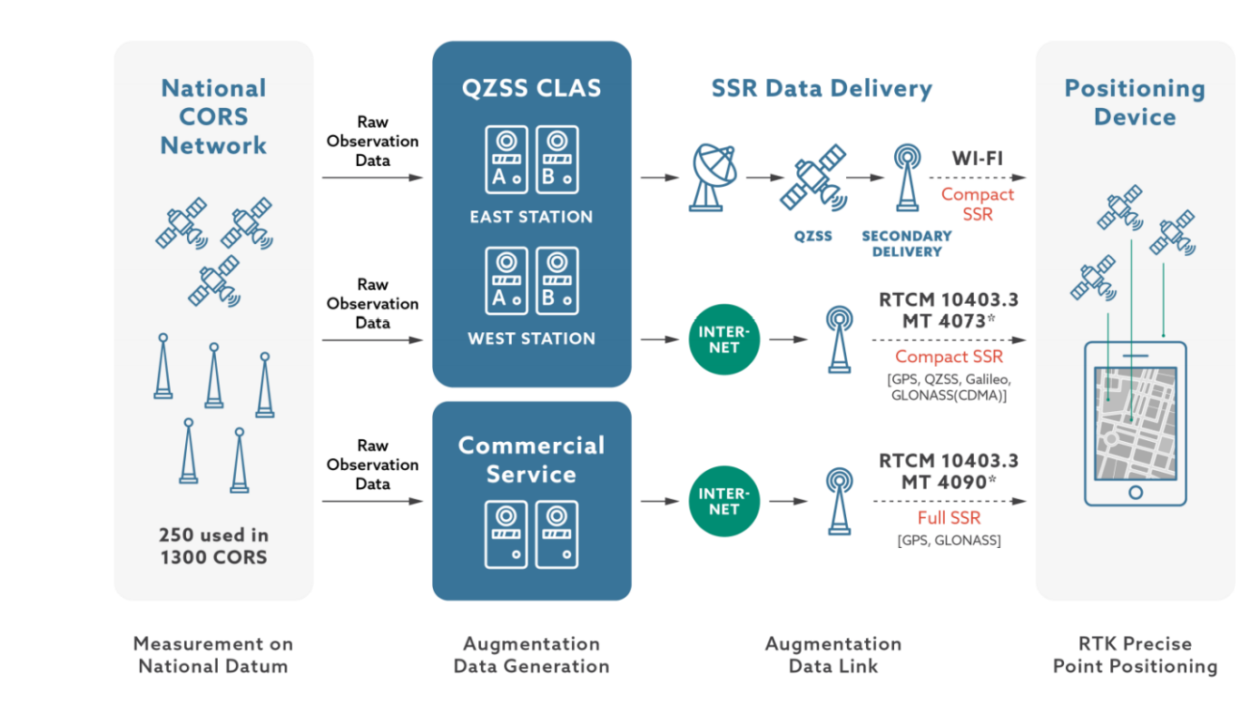

**For TVWS Technology:**

* There is only one terrestrial TV broadcaster in India - Doordarshan. Doordarshan transmits only two channels at any location in the country each channel occupying a bandwidth of 7 MHz in VHF band or 8 MHz in UHF band. A detailed quantitative assessment of TV White Space in India reveals that 12 out of 15 channels of UHF Band IV (470-585 MHz) are available at any location . Digital switchover of terrestrial TV is in progress for most of the developing countries. After digital switchover in India, the terrestrial TV broadcasting needs to shift to 585-698 MHz band. Hence, the 470-590 MHz band will be completely vacant . This unused band may prove to be very effective in connecting the rural and remote parts of the country.
* So We need to make use of TV signals of 470-590MHz band.
* The IEEE standards for TV white space are as follows:
* IEEE 802.22: IEEE 802.22 was the first standard based on Cognitive techniques that has been developed to access the TV White Spaces . The most important application of this standard is to provide wireless broadband access in rural and remote areas. The standard specifies that a large range of 33 km can be achieved with only 4 W of Effective Isotropically Radiated Power (EIRP). The standard uses both geo-location database and sensing based techniques to access the TV White Spaces. As, the Indian scenario is almost static, the use of geo-location database can suffice. This standard is capable of working in any regulatory regime (e.g. US, Japan, UK, Canada, etc.). The operational range of this band is 54-862 MHz and can work with various TV channel bandwidths i.e. 6, 7 and 8 MHz .

IEEE 802.22 follows a Point to Multi-Point (PMP) topology with a Base Station (BS) and its associated Customer Premise Equipment’s (CPEs). To protect the incumbents, it follows a strict master-slave relation where BS is a master and the CPEs are its slaves. No CPE can transmit before receiving an authorization from the BS.

* IEEE 802.11af: IEEE 802.11af standard or the White-Fi was formulated to adapt the existing IEEE 802.11 for TV band operation [18]. IEEE 802.11af systems operate on frequencies below 1 GHz and uses geo-location database to access the TV band. This standard was designed due to the congestion in unlicensed band i.e. 2.4 GHz and 5 GHz spectrum. There are two operating scenarios of IEEE 802.11af viz. indoor and outdoor. The indoor scenario has a range of up to 100 m similar to Wi-Fi. The outdoor scenario has a range of about few kilometres and is more suited for the rural setting. As TV channels may have varying bandwidths of 6, 7 or 8 MHz, it is required to aggregate the bandwidth. This standard works with the bandwidth of 5, 10, 20 and 40 MHz and hence depending on the availability of the channel, this bandwidth can be adapted.
* There are a total of 254 Doordarshan TV transmitters in the four zones operating in the 470-590MHz. Currently, in these zones, 14 out of the 15 channels (channels 21-34) are sparsely used for transmissions. For instance, out of the 254 transmitters, only 24 transmitters in the four zones operate on channel 21. The below algorithm shows a channel allocation scheme such that the minimum number of TV channels are used in each zone, while ensuring that the coverage areas of different transmitters do not overlap.
* ALOGRITHM:

for All transmitters in the four zones;

do

Check if coverage areas of adjacent transmitters

overlap;

If Overlap then

Check channel numbers of overlapping

transmitters;

if Channel numbers are same then

Change operating channel of one tower;

Calculate coverage area of towers with new

operating channels;

else

exit

end

else

exit

end

end

* Using the algorithm described above, the minimum number of distinct channels required without any overlap of the coverage areas for four zones are given in Figure below. Under this channel allocation scheme, the maximum number of distinct TV channels required in the entire zone is four, which is much smaller than the fourteen channels currently used in India. To avoid adjacent channel interference, the overlapping channels must be non-adjacent.

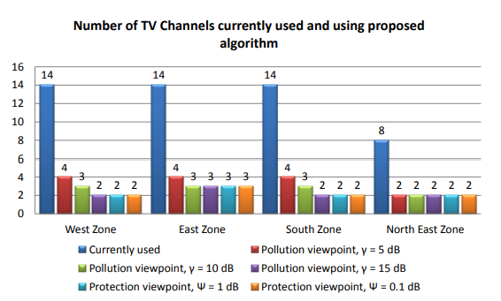

* TV white space (TVWS) geolocation database is being used for the protection of the terrestrial TV broadcast receivers, and the coexistence of secondary devices. The source code of for implementation has been released under the GNU general public license version 2.0.We need to make use of it.