# JIRA- PROJECT MANAGEMENT SOFTWARE:

## CLIENT MANAGEMENT EPIC:

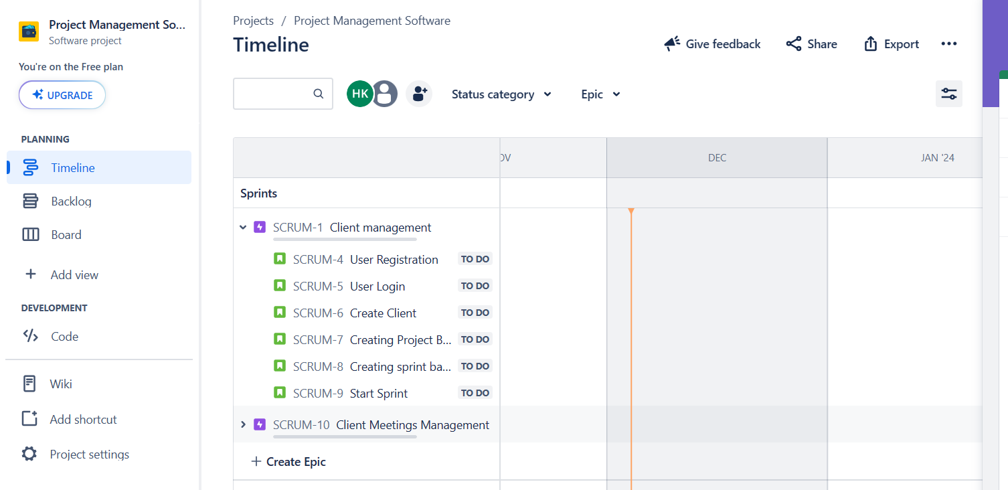

## CLIENT MEETINGS MANAGEMENT:

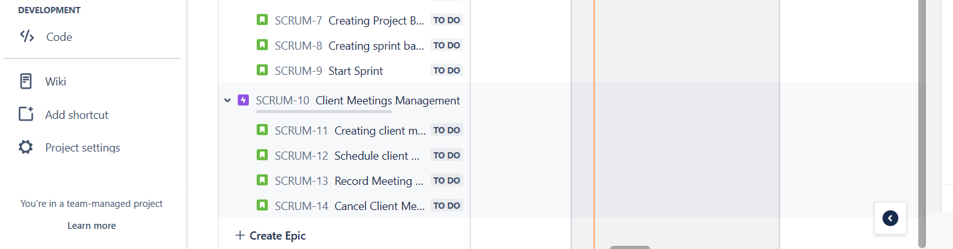

## SPRINT BACKLOG:

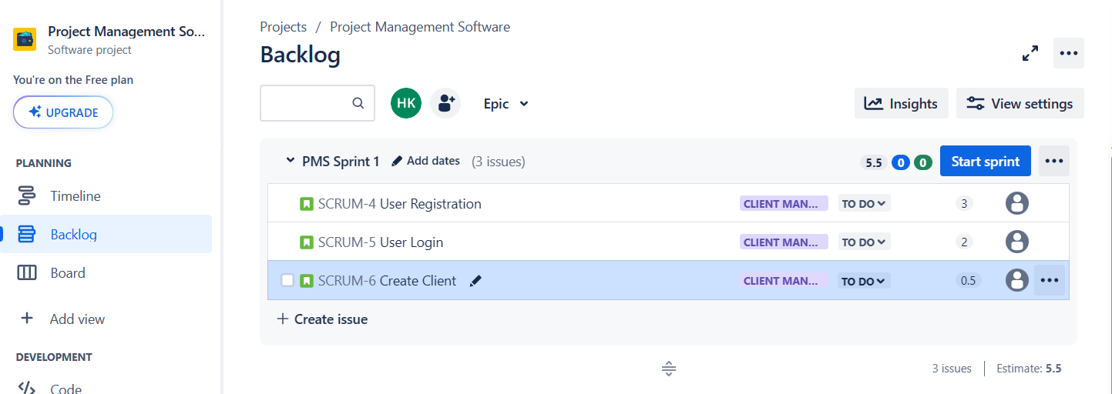

## PRODUCT BACKLOG:

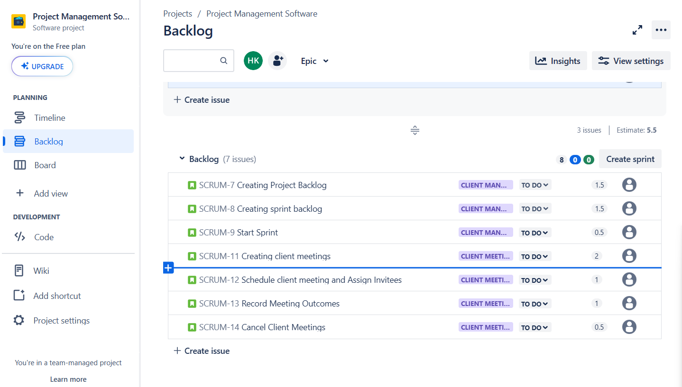

## CLIENT CREATION USER STORY:

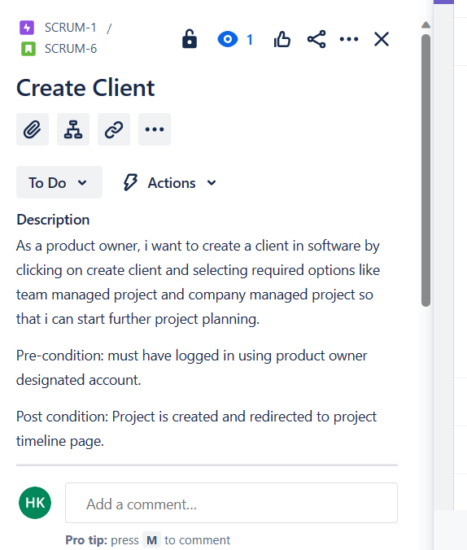

## CREATE MEETINGS USER STORY:

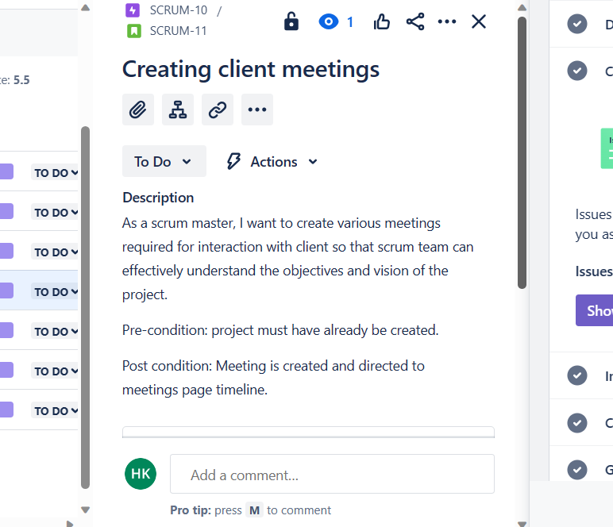

## SCHEDULE MEETINGS USER STORY:

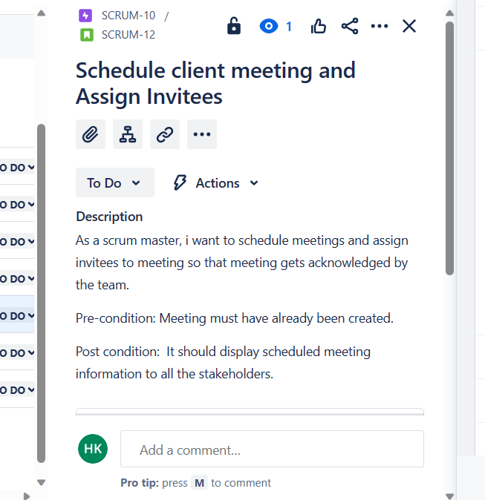

## CANCEL CLIENT MEETINGS USER STORY:

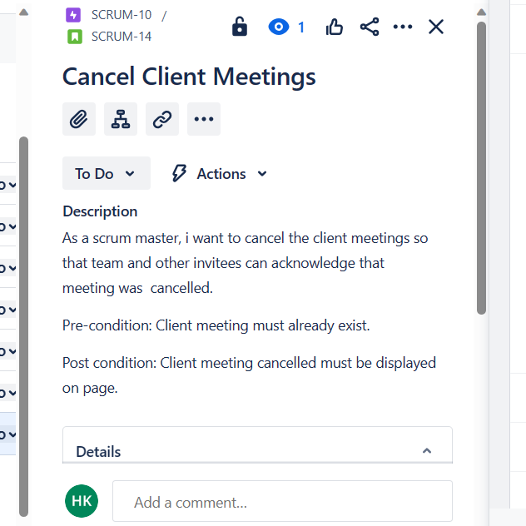

## SPRINT STARTED:

