GYM MANAGEMENT SOFTWARE

# BATCH CRUD OPERATIONS:

## CREATION:

### CREATING BATCH IN batch.html FILE:



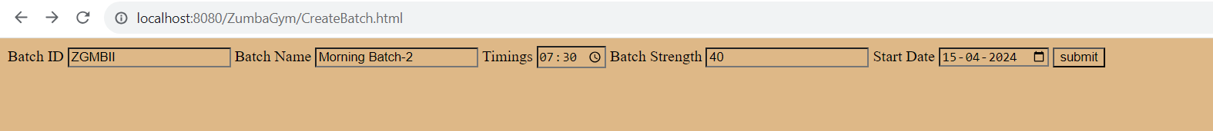

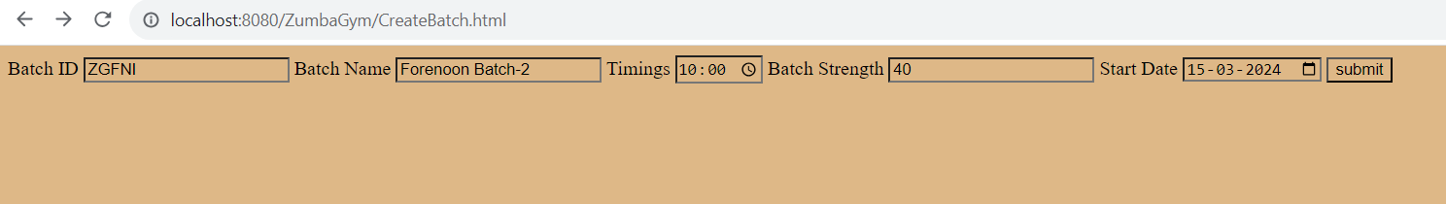

#### CREATING EVENING BATCH-1:

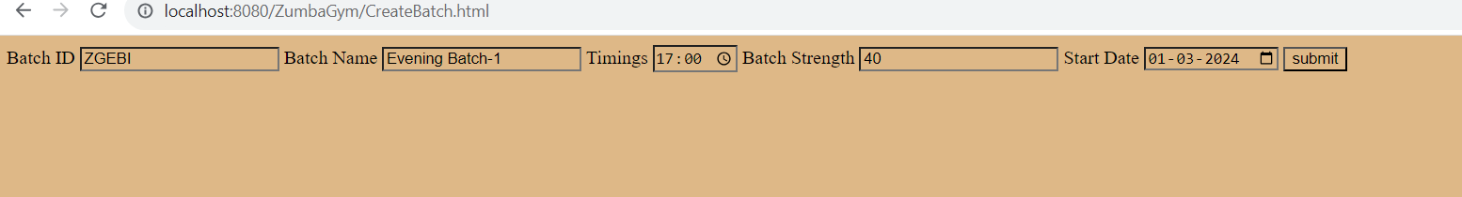

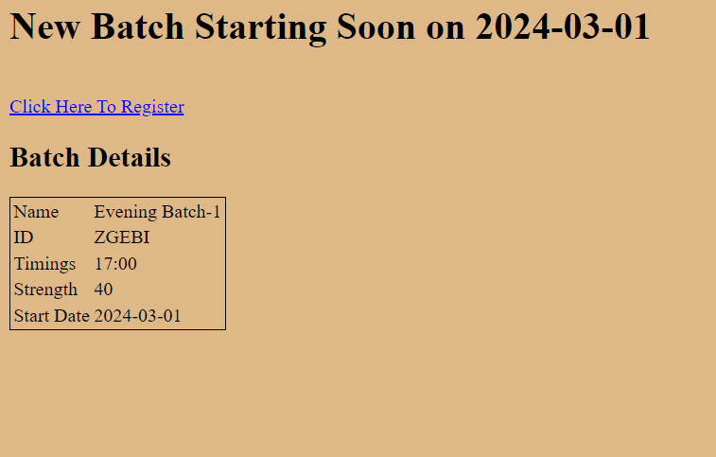

#### CREATING FORENOON-1 BATCH:

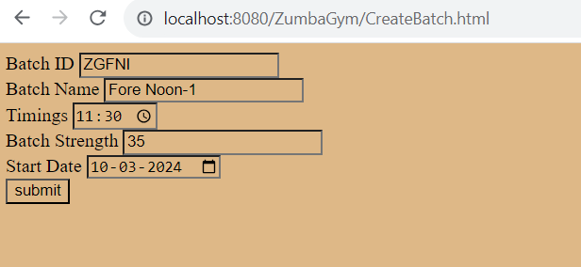

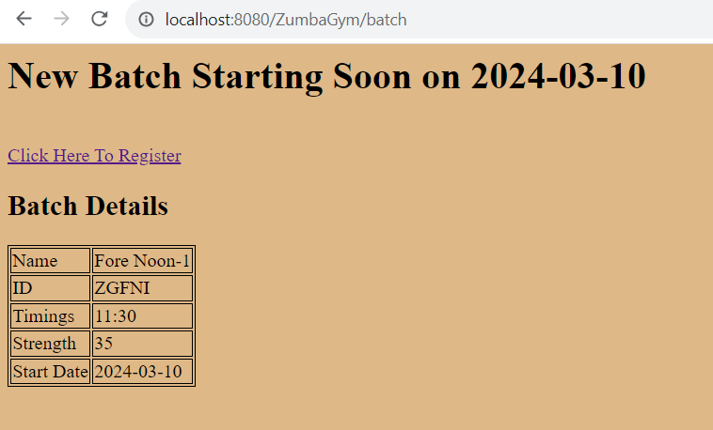

#### CREATING EVENING BATCH-3:

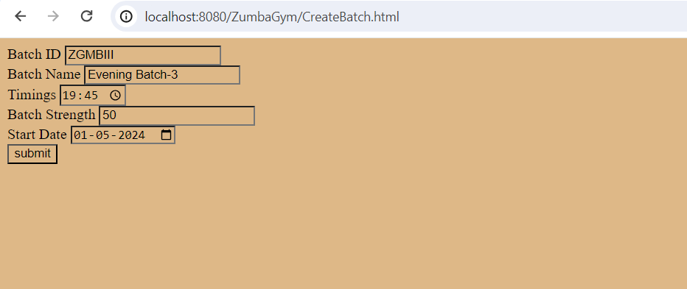

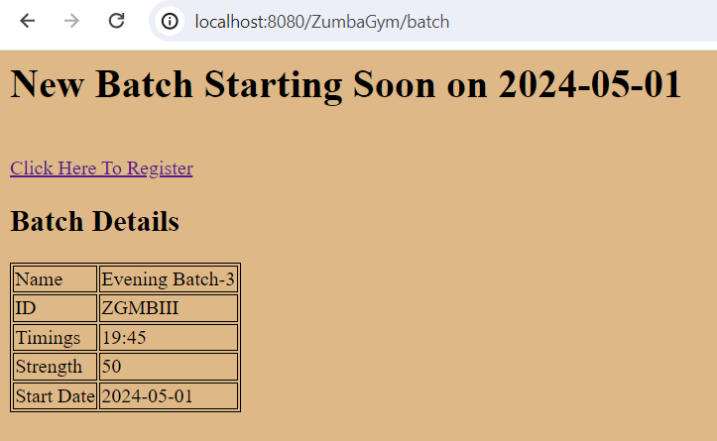

## RETRIEVING OPERATION:

### TEST CASE-1:

#### BATCH DETAILS OF EVENING BATCH-1:

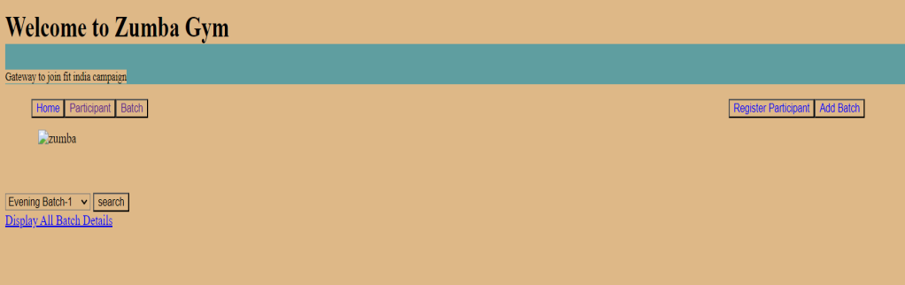

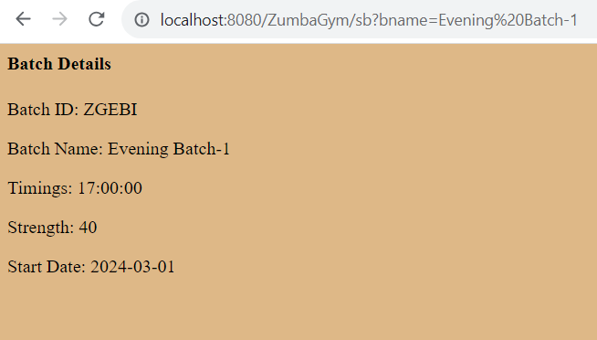

### TEST CASE-2:

#### BATCH DETAILS OF MORNING BATCH-1:

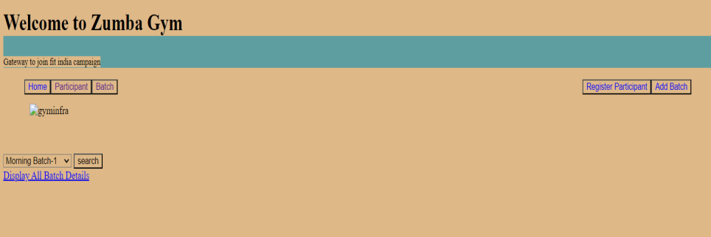

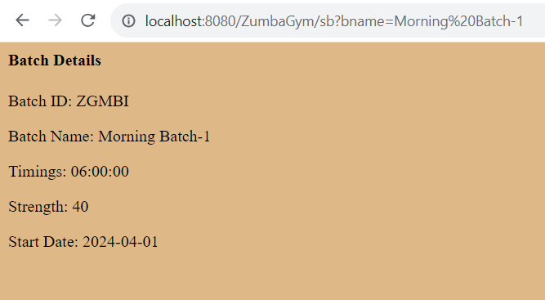

### RETRIEVING LIST OF BATCHES TO PERFORM CRUD OPERATIONS:

#### BATCH DETAILS IN BatchDetails.jsp FILE:

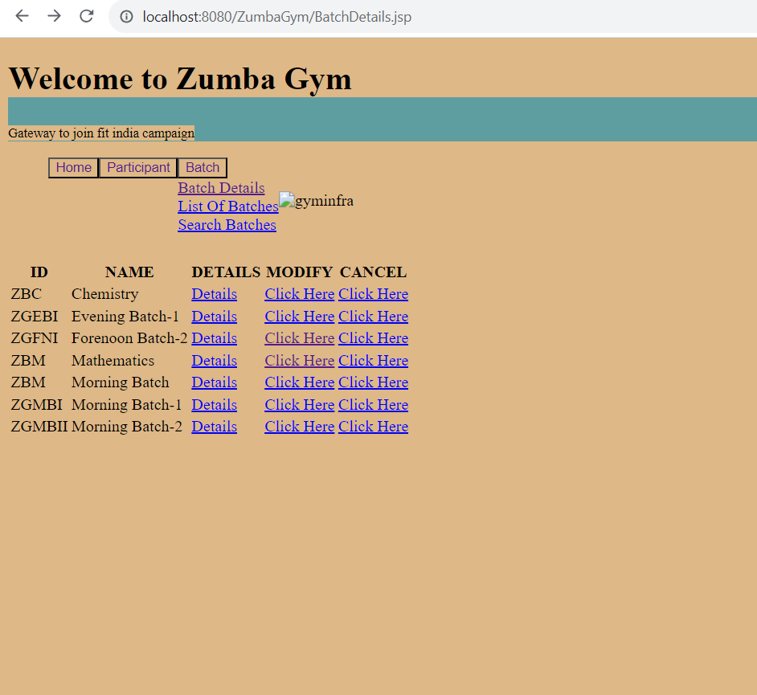

### RETRIEVING LIST OF BATCHES:

#### LIST OF BATCHES:

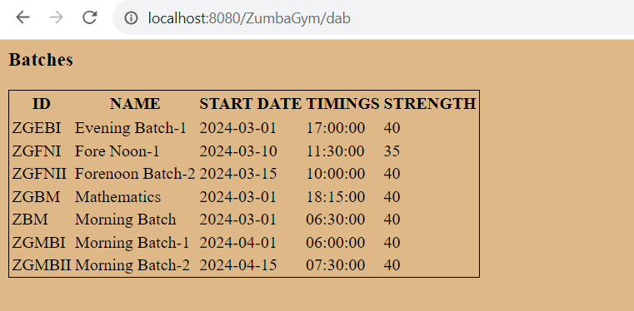

## EDITING BATCH DETAILS:

### TEST CASE-1:

#### Changing Batch ID from ZGFNI to ZGFNII:

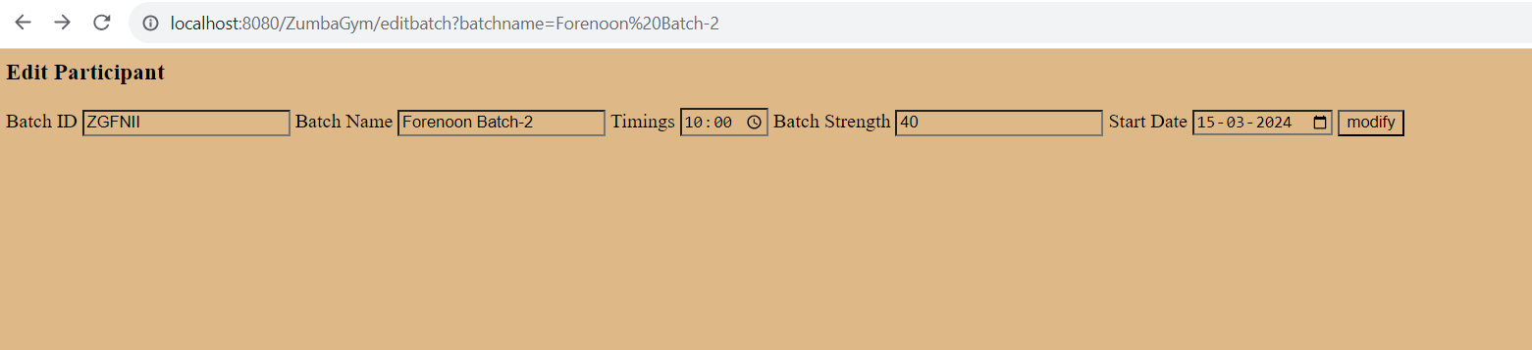

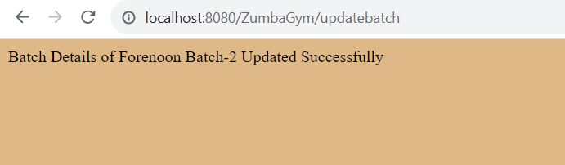

#### BATCH ID BEFORE MODIFYING:

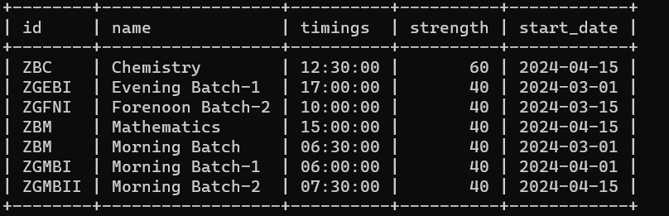

BATCH ID AFTER MODIFYING:

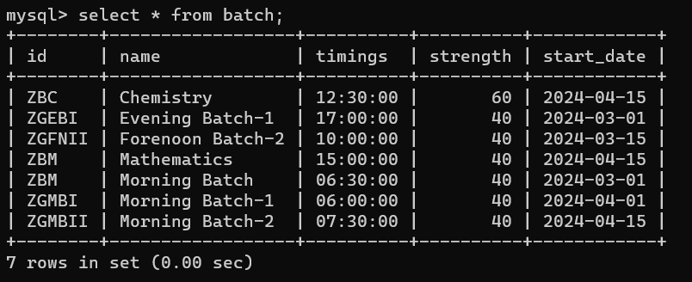

### TEST CASE-2:

#### MODIFYING TIMINGS, STRENGTH, DATE OF FORENOON-1:

#### DETAILS BEFORE MODIFYING:

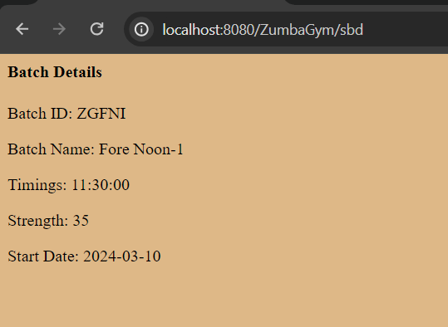

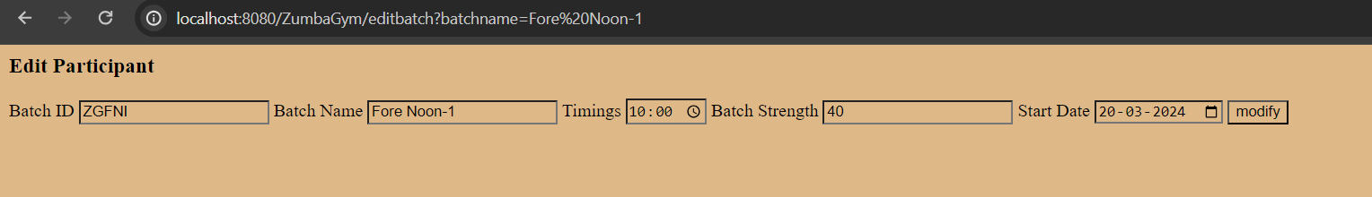

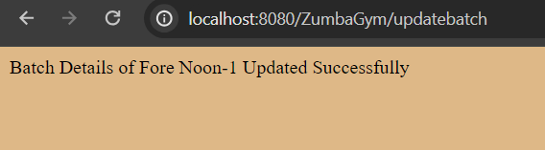

#### DETAILS AFTER MODIFYING:

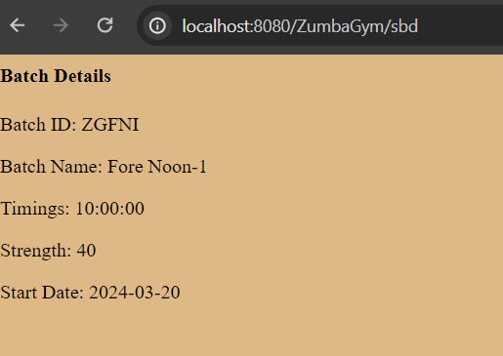

### TEST CASE-3:

#### MODIFYING TIME OF FORENOON BATCH-2:

#### DETAILS OF BATCH BEFORE MODIFYING:

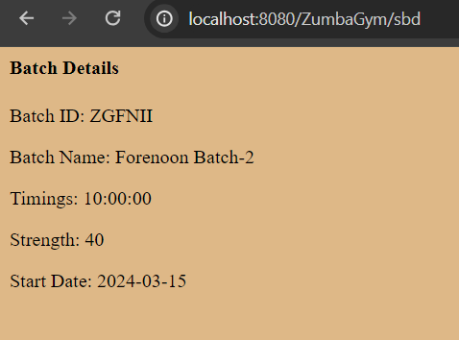

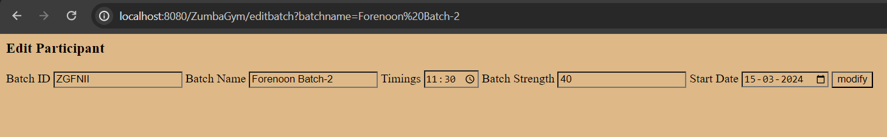

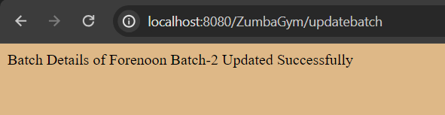

#### DETAILS OF BATCH AFTER MODIFYING:

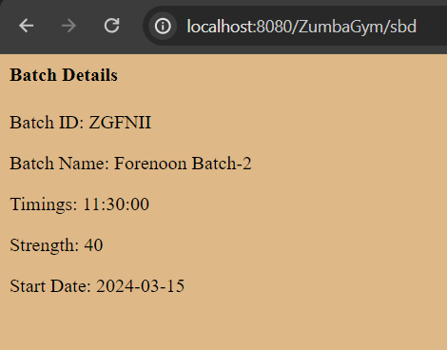

## DELETE OPERATION:

### TEST CASE-1:

#### DELETING AFTERNOON-1A BATCH:

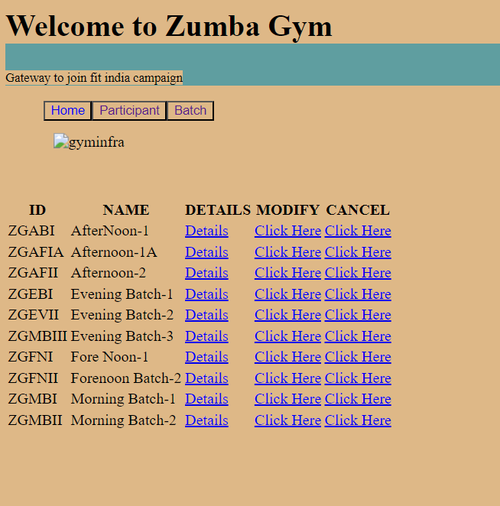

#### LIST OF BATCHES BEFORE DELETION:

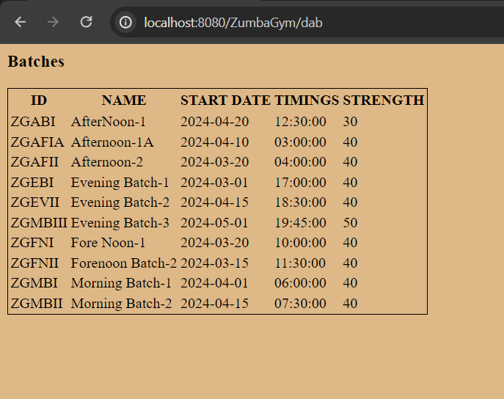

#### LIST OF BATCHES AFTER DELETION:

#### 

### TEST CASE-2:

#### DELETING MORNING BATCH:

#### LIST OF BATCHES BEFORE DELETION:

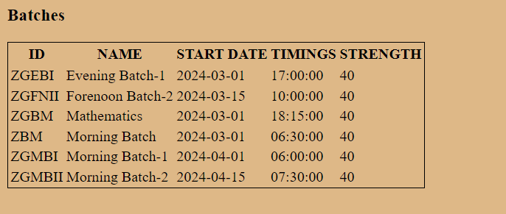

#### LIST OF BATCHES AFTER DELETION:

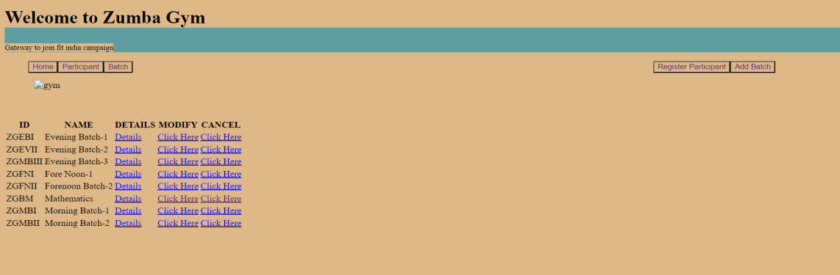

### TEST CASE-3:

#### DELETING AFTERNOON-2 BATCH:

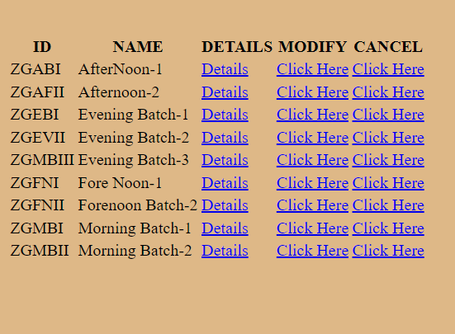

#### LIST OF BATCHES BEFORE DELETION:

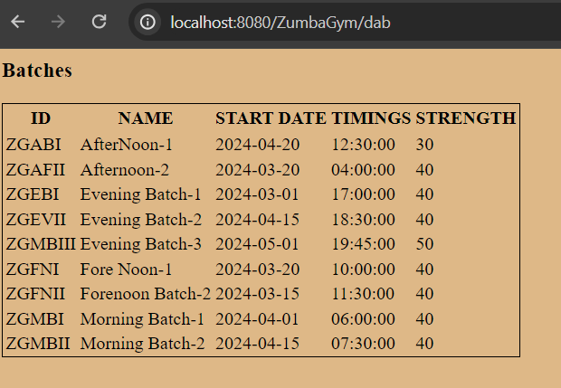

#### LIST OF BATCHES AFTER DELETION:

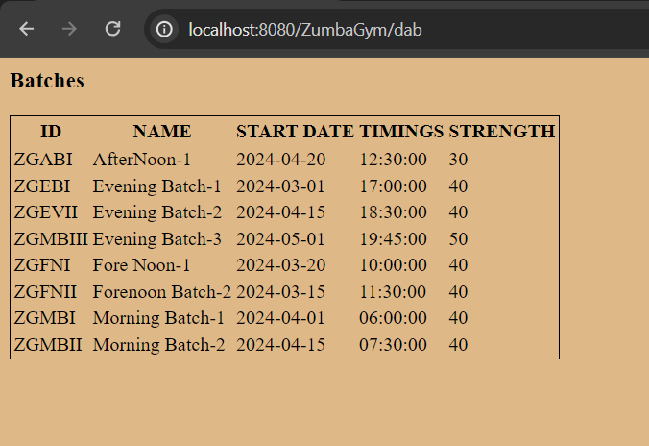

# PARTICIPANT CRUD OPERATIONS:

## REGISTERING PARTICIPANT IN Participant.jsp FILE:

### TEST CASE-1:

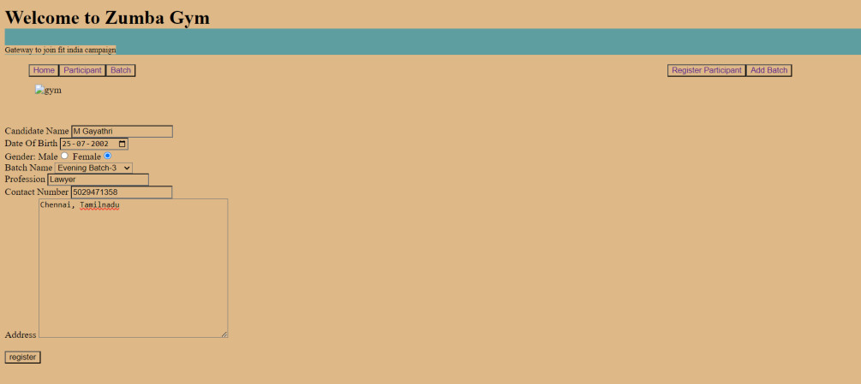

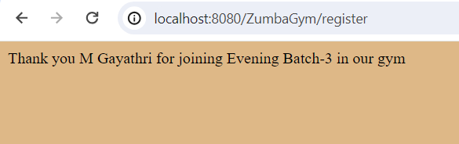

#### TEST CASE-2:

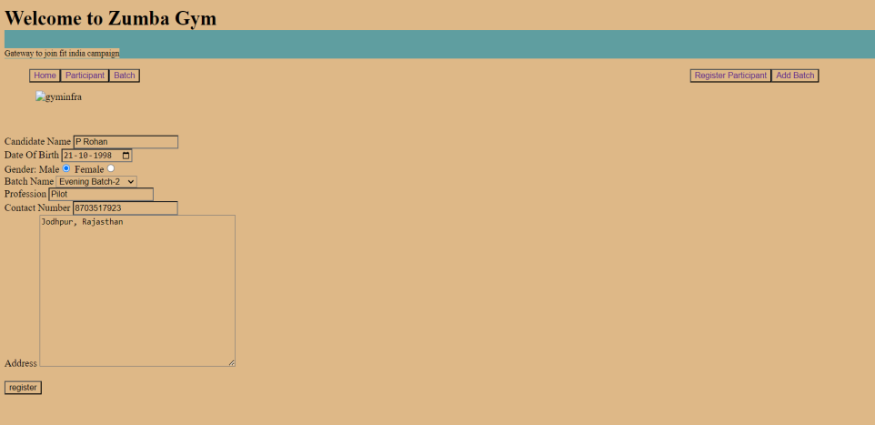

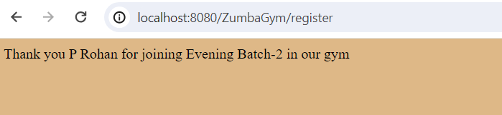

#### TEST CASE-3:

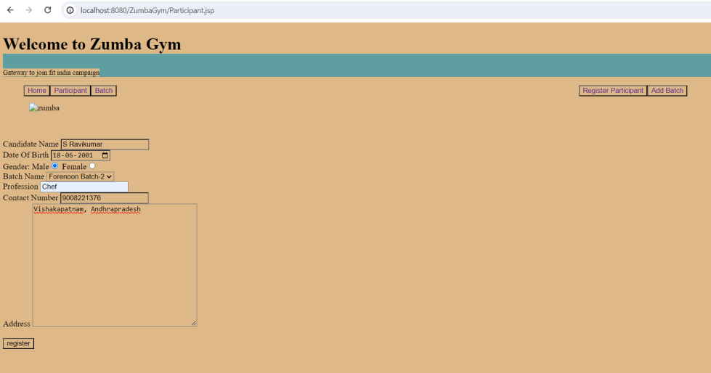

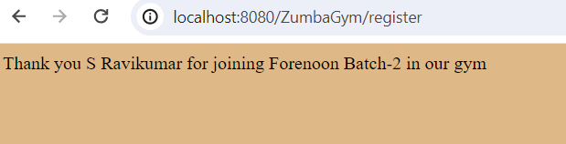

#### TEST CASE-4:

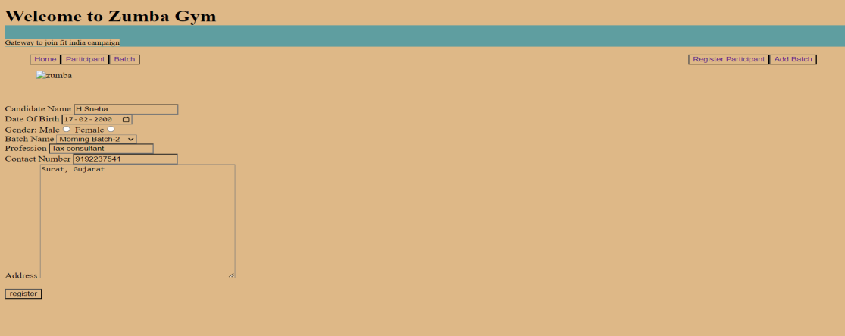

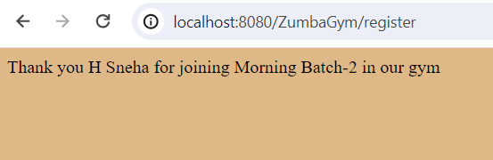

## RETRIEVING PARTICIPANTS:

### SEARCH PARTICIPANT BY BATCH:

#### TEST CASE-1 : EVENING BATCH-2

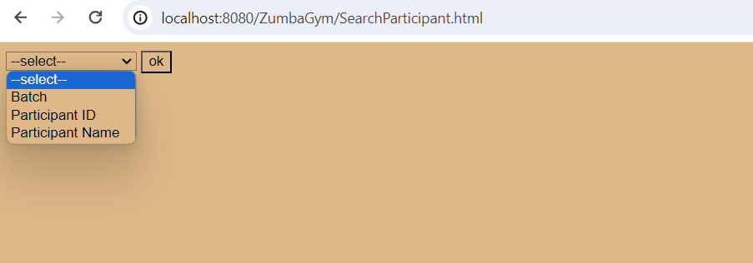

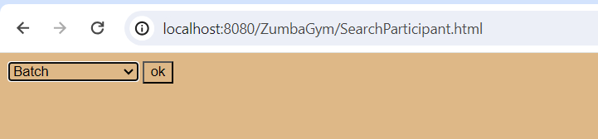

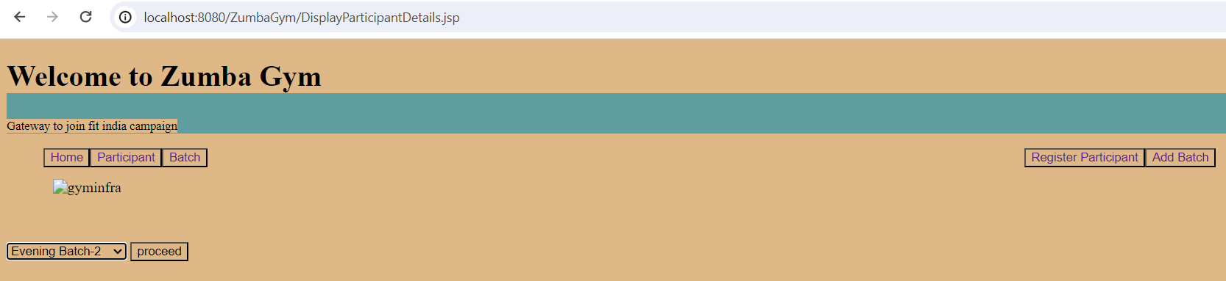

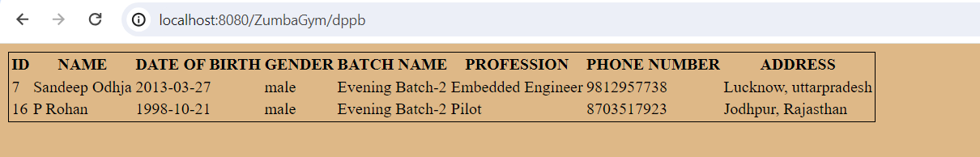

#### TEST CASE-2: EVENING BATCH-1

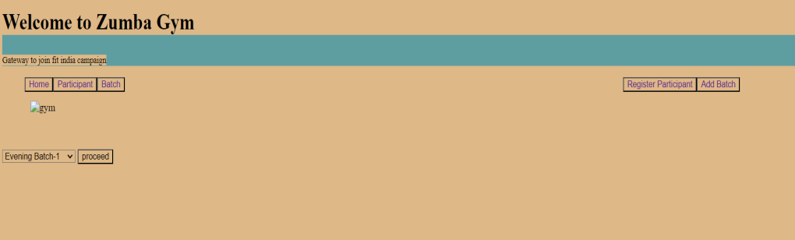

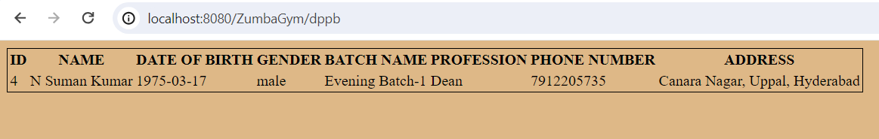

#### TEST CASE-3:

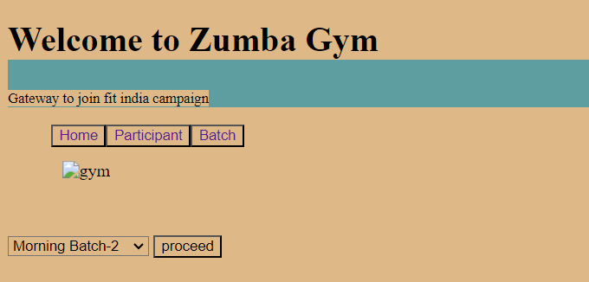

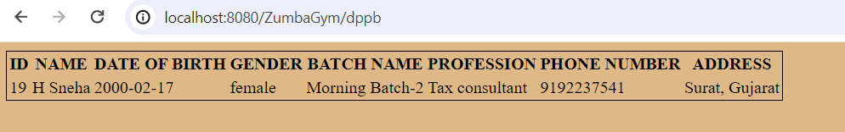

### SEARCH PARTICIPANTS BY ID:

#### TEST CASE-1:

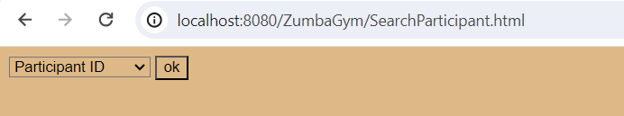

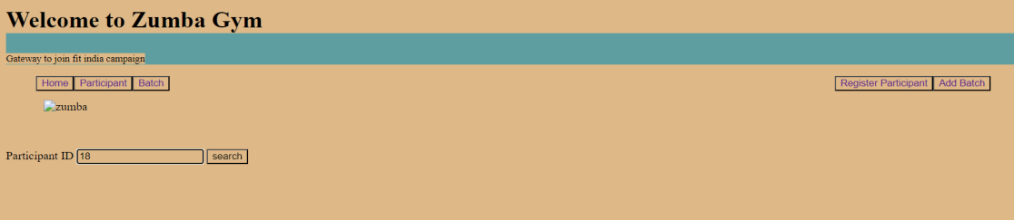

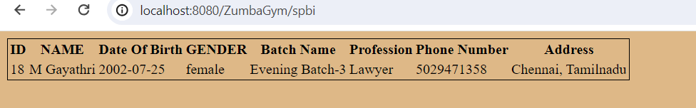

#### TEST CASE-2:

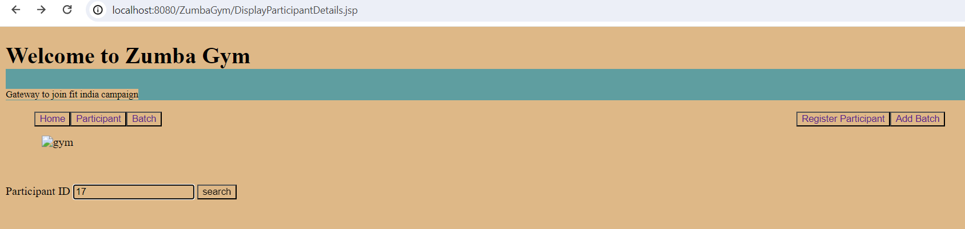

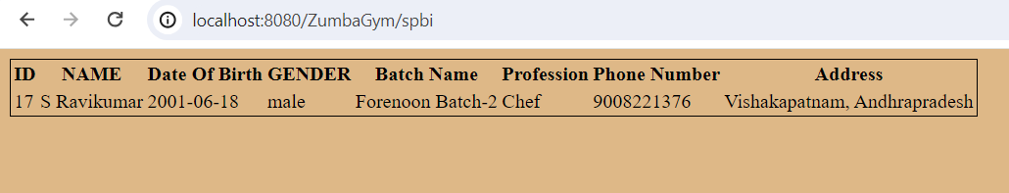

#### TEST CASE-3:

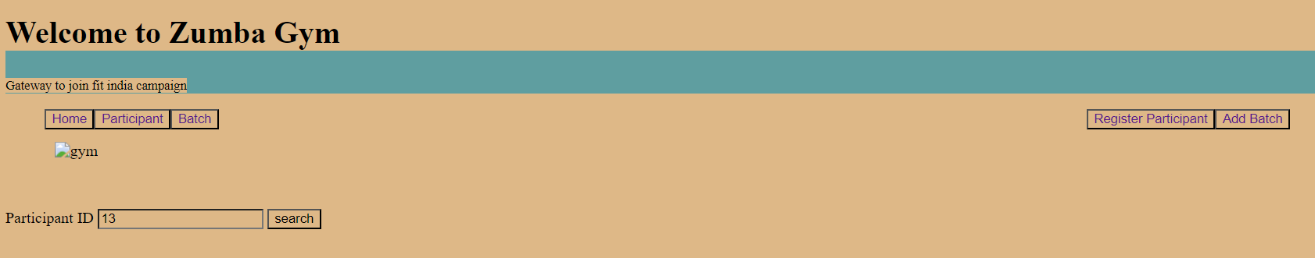

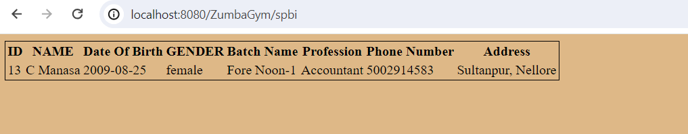

### SEARCH PARTICIPANT BY NAME:

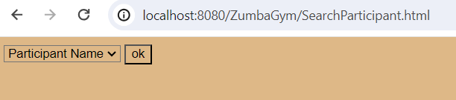

#### TEST CASE-1:

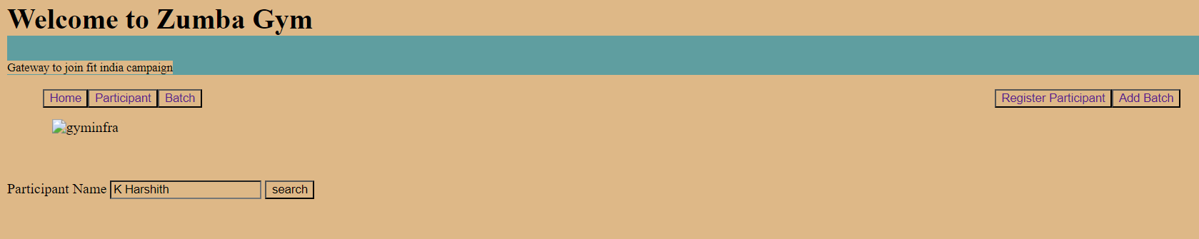

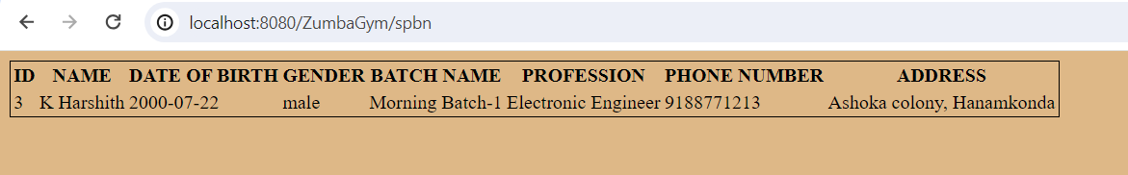

### TEST CASE-2:

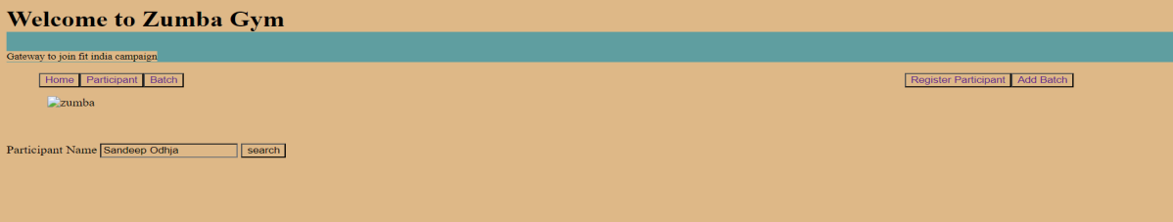

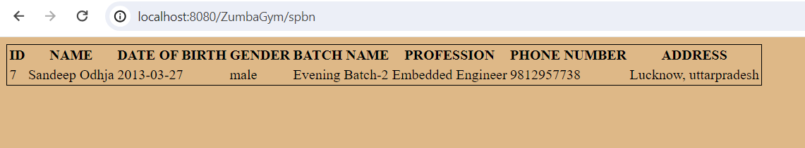

#### TEST CASE-3:

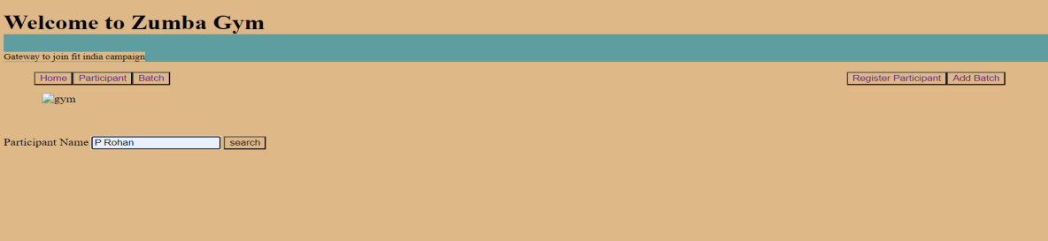

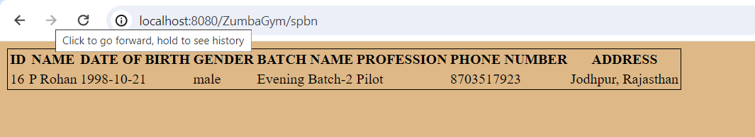

### LIST OF PARTICIPANTS:

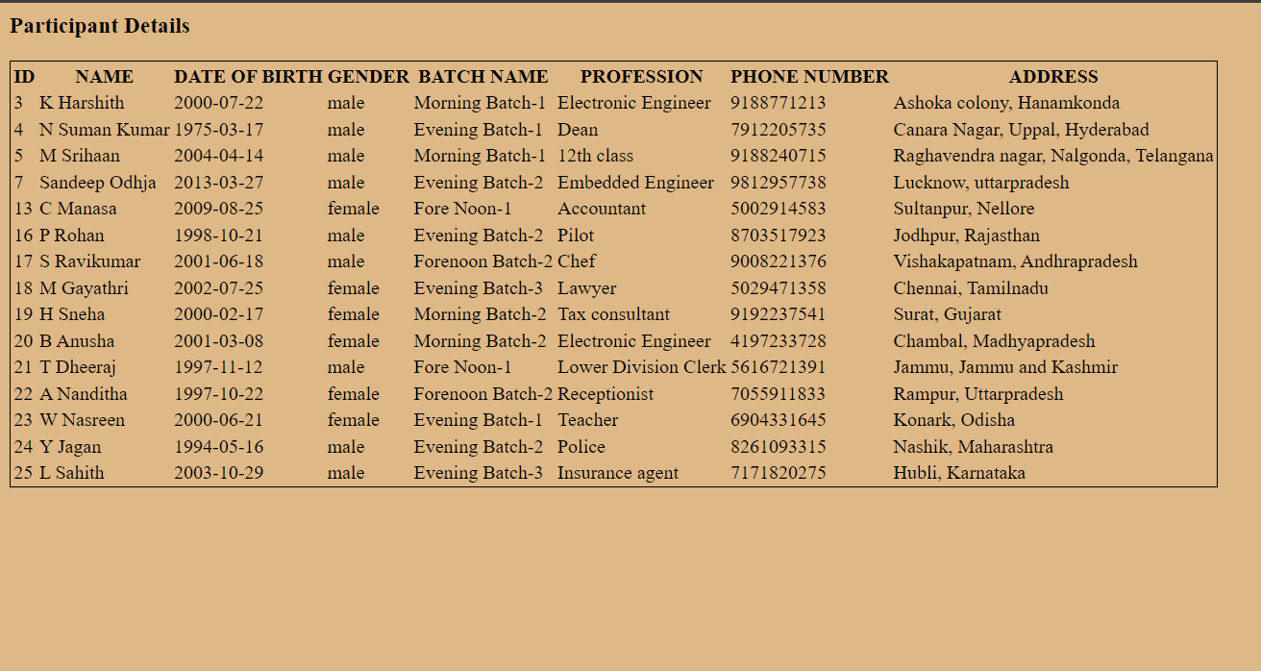

## EDIT PARTICIPANT OPERATIONS:

### TEST CASE-1:

#### EDITING BATCH, PHONE NUMBER AND PROFESSION OF K.HARSHITH WITH ID:3:

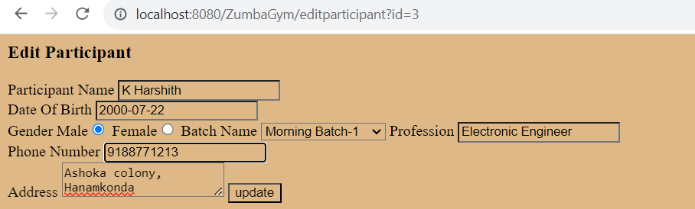

#### DETAILS OF K.Harshith Before Modifying:

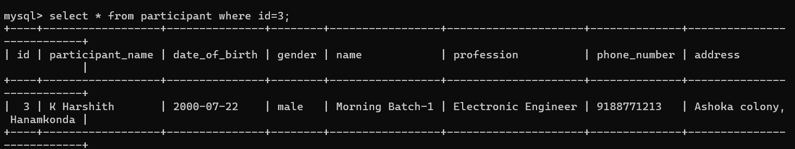

#### DETAILS OF K.Harshith after modifying:

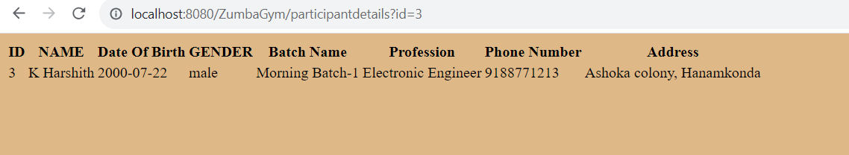

### TEST CASE-2:

#### MODIFYING NAME, PROFESSION, BATCH OF PARTICIPANT WITH ID 4:

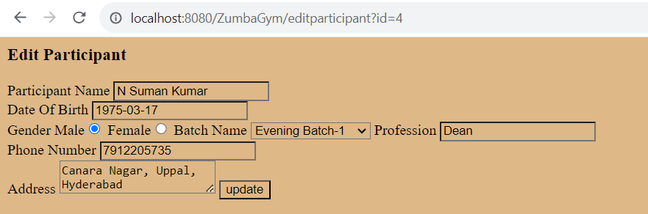

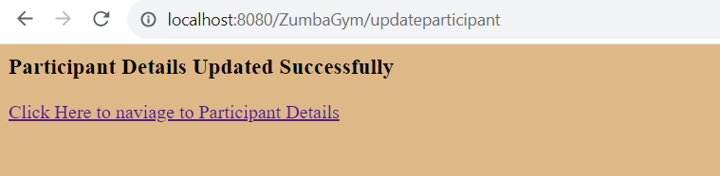

#### DETAILS OF PARTICIPANT BEFORE MODIFYING:

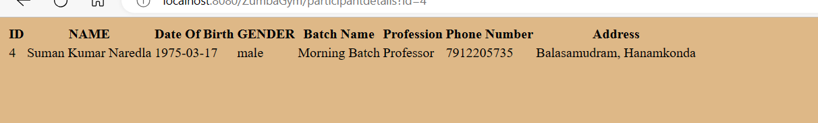

#### DETAILS OF PARTICIPANT AFTER MODIFYING:

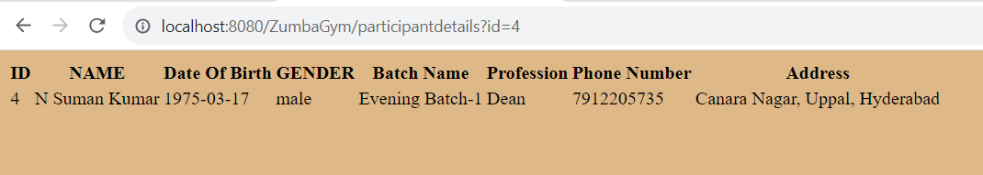

## DELETE PARTICIPANT OPERATIONS:

### TEST CASE-1:

#### DELETING PARTICIPANT V Sandhya with ID 10:

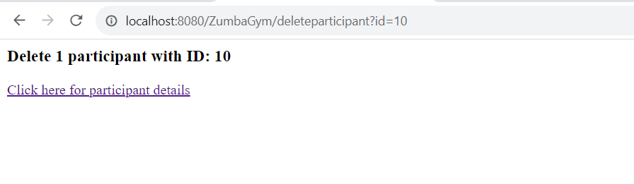

#### LIST OF PARTICIPANTS BEFORE DELETION:

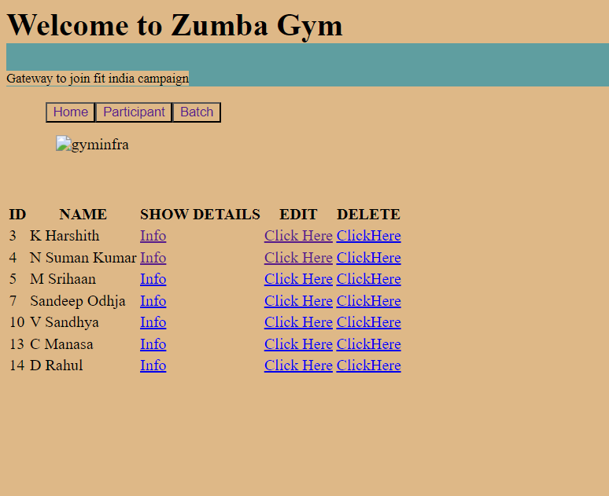

#### LIST OF PARTICIPANTS AFTER DELETION:

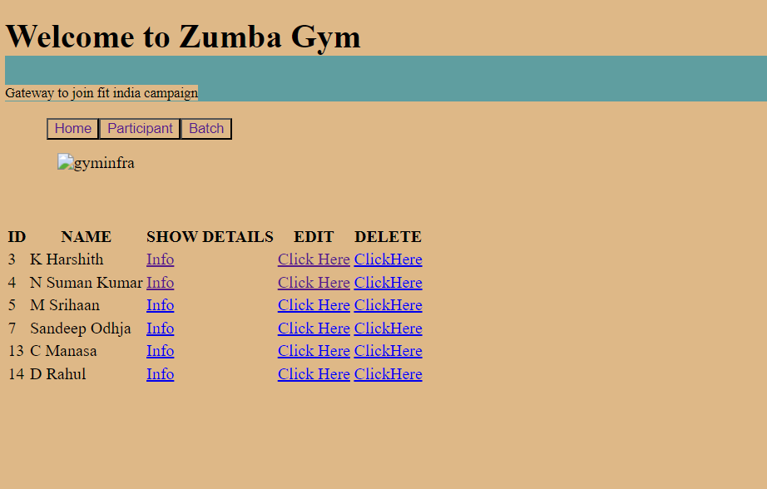

# MYSQL :

## DATABASE ICON:

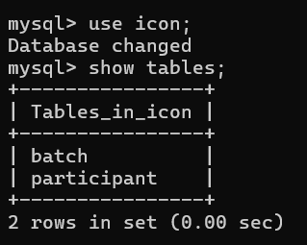

## BATCH TABLE:

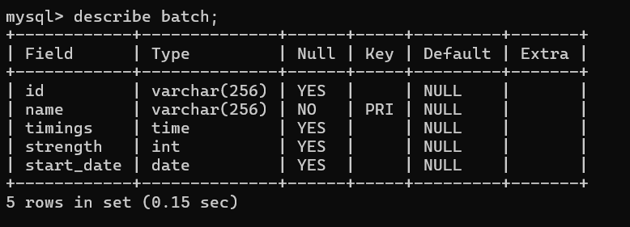

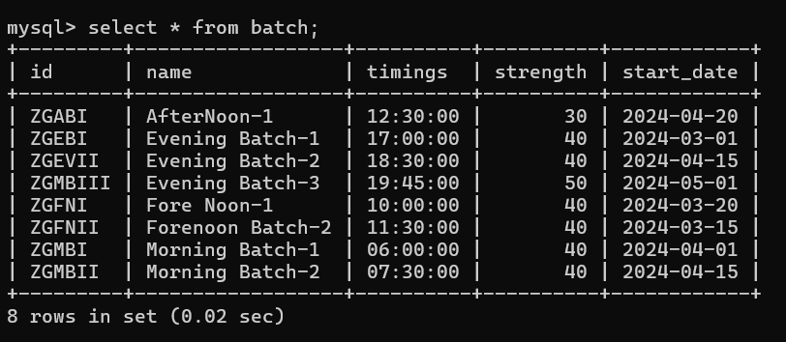

## PARTICIPANT TABLE:

