# CREATING BATCH IN batch.html FILE:



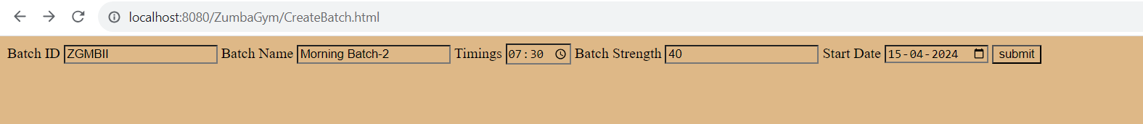

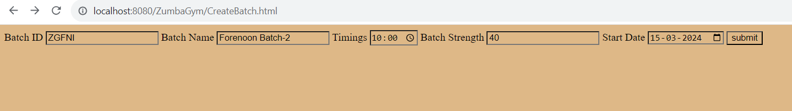

CREATING EVENING BATCH-1:

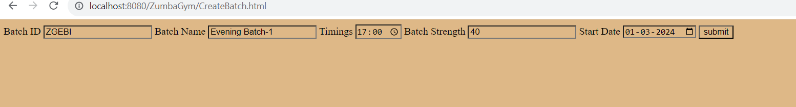

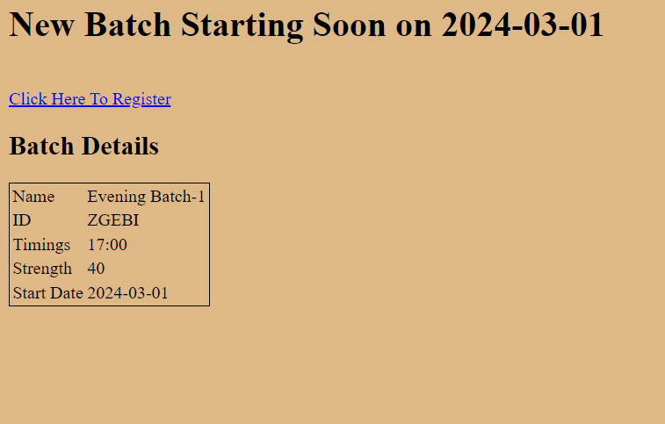

CREATING FORENOON-1 Batch:

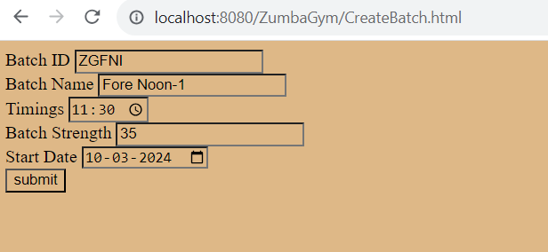

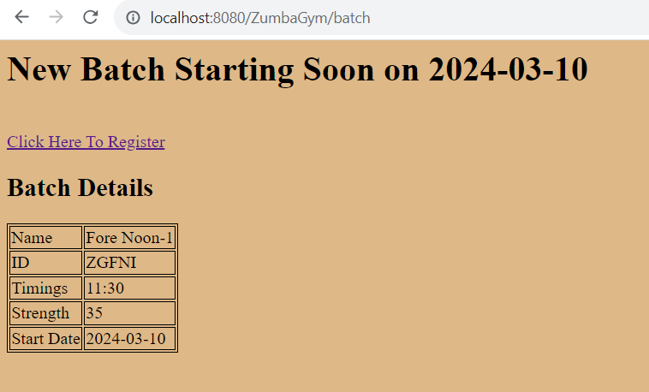

# BATCH DETAILS IN BatchDetails.jsp FILE:

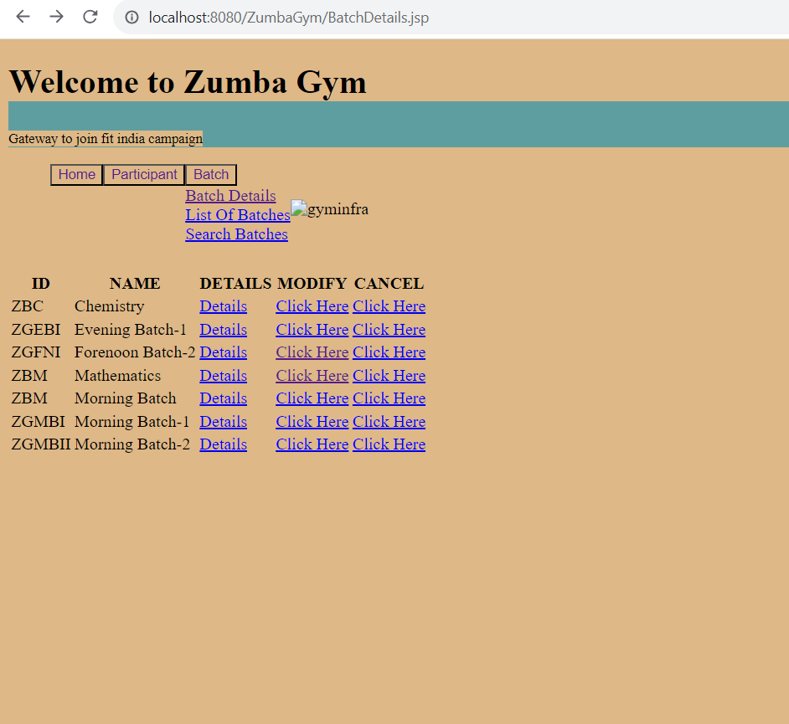

# LIST OF BATCHES:

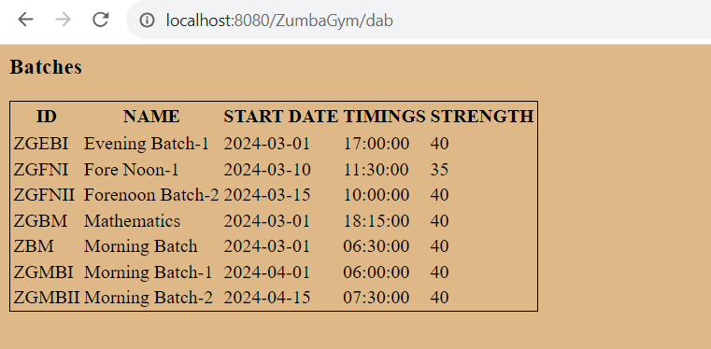

# REGISTERING PARTICIPANT IN Participant.jsp FILE:

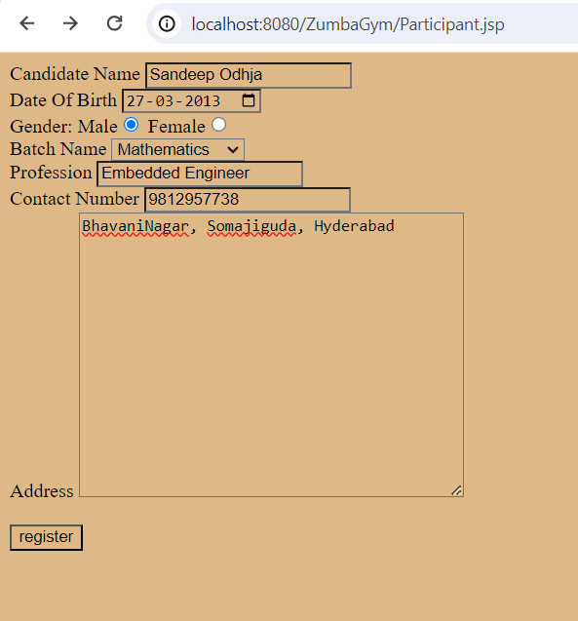

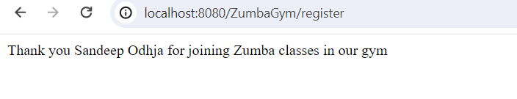

TEST CASE-2:

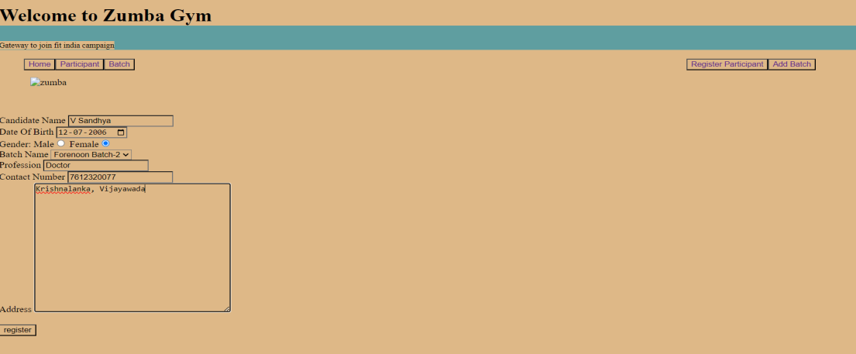

EDITING PARTICIPANT DETAILS:

EDITING BATCH, PHONE NUMBER AND PROFESSION OF K.HARSHITH WITH ID:3:

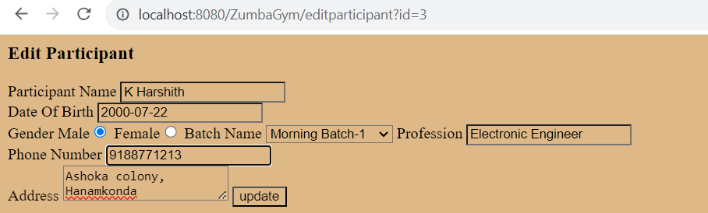

DETAILS OF K.Harshith Before Modifying:

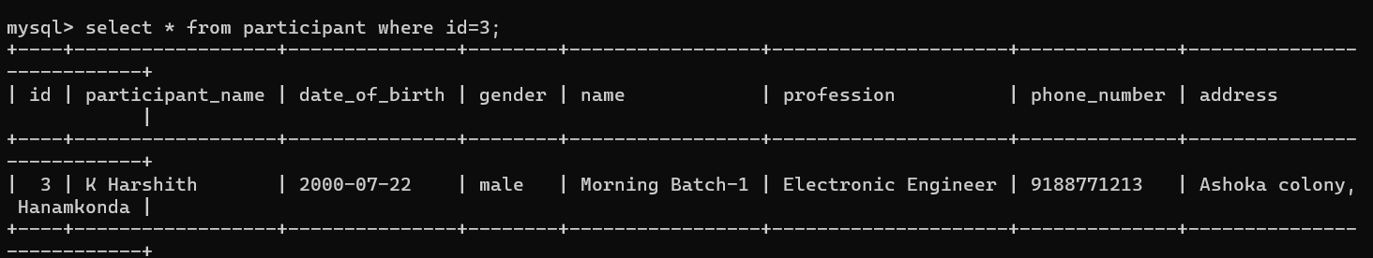

DETAILS OF K.Harshith after modifying:

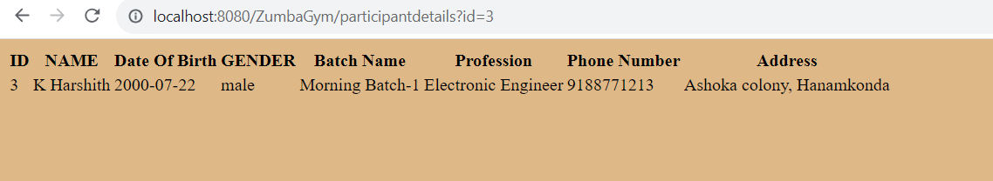

MODIFYING NAME, PROFESSION, BATCH OF PARTICIPANT WITH ID 4:

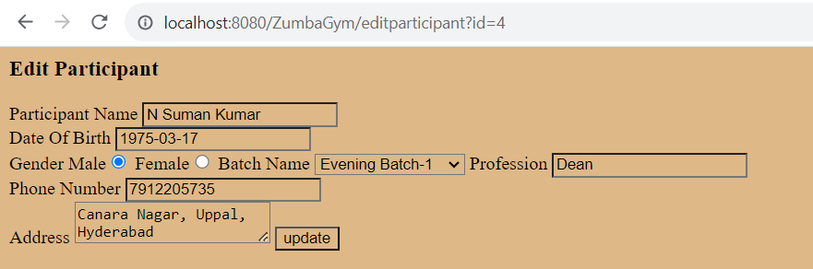

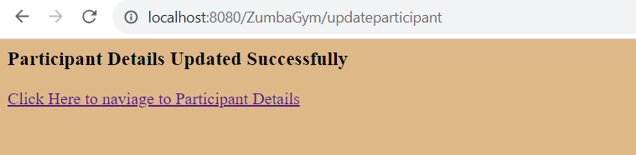

Details of participant before modifying:

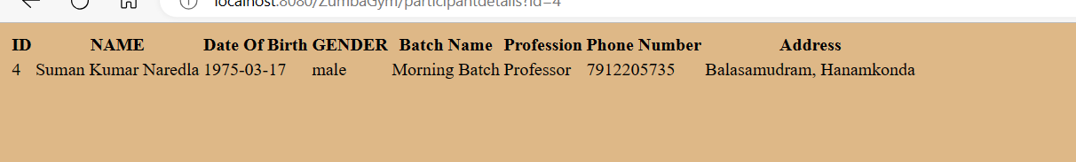

Details of participant after modifying:

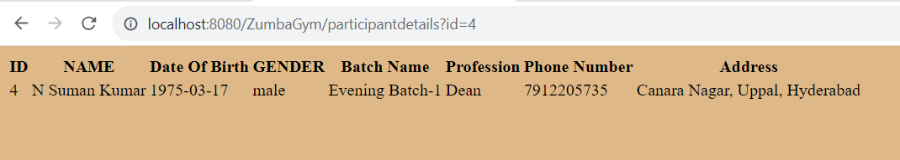

DELETING PARTICIPANTS:

DELETING PARTICIPANT V Sandhya with ID 10

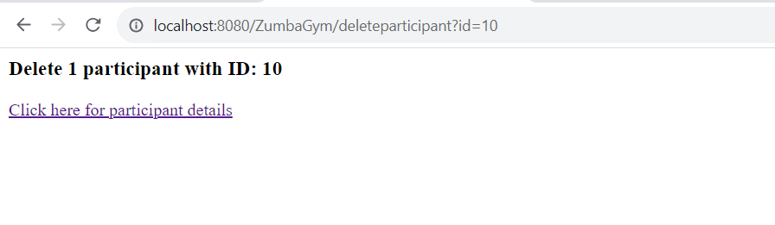

List Of Participants before deletion:

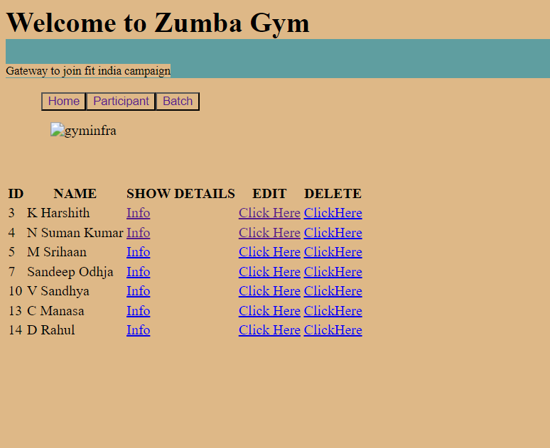

LIST OF PARTICIPANTS AFTER DELETION:

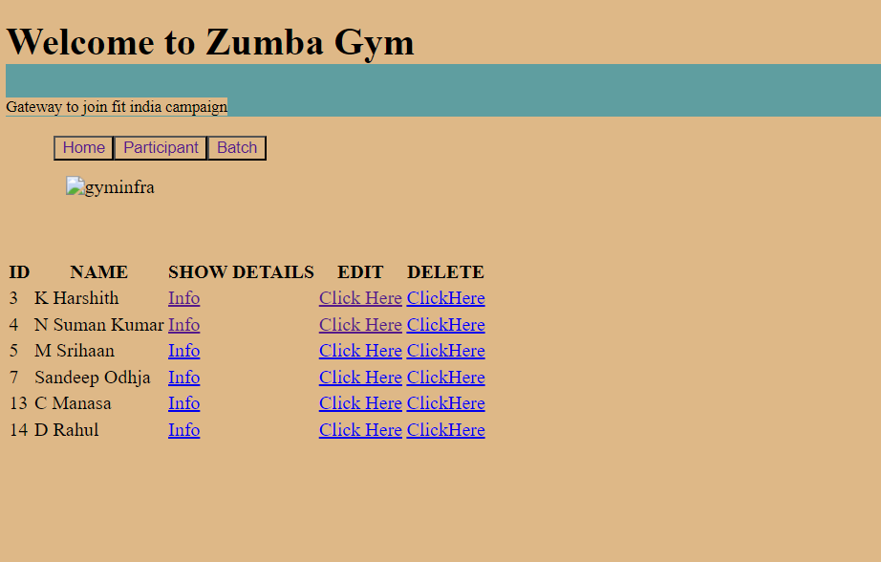

DELETING Participant with ID 14

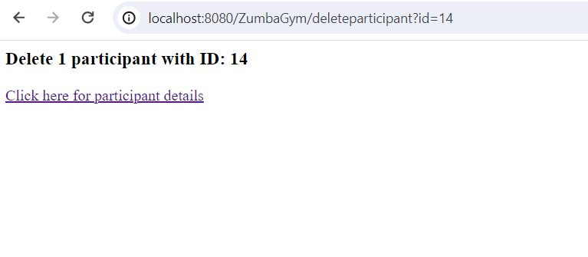

LIST OF PARTICIPANTS BEFORE DELETION:

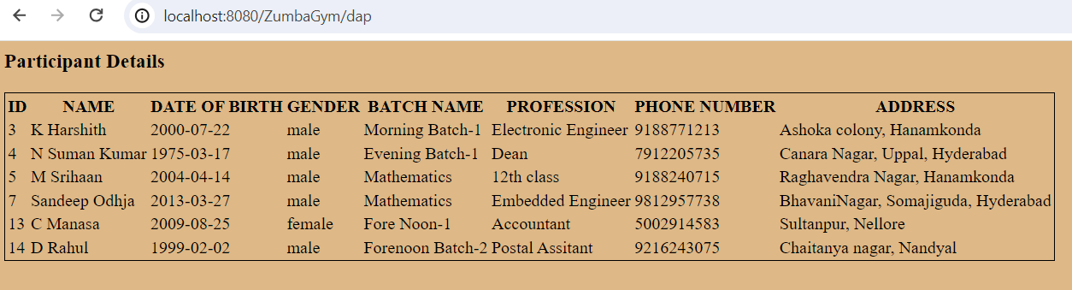

LIST OF PARTICIPANTS AFTER DELETION:

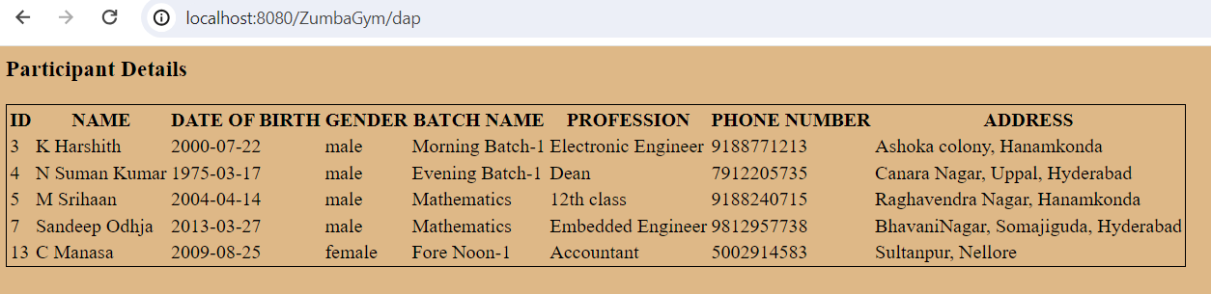

RETRIEVING AND QUERYING BATCH DETAILS:

BATCH DETAILS OF EVENING BATCH-1:

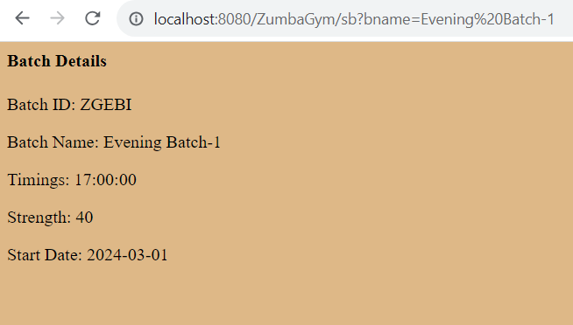

BATCH DETAILS OF MORNING BATCH-1:

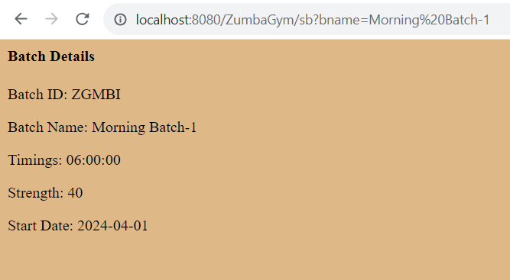

# EDITING BATCH DETAILS:

Changing Batch ID from ZGFNI to ZGFNII.

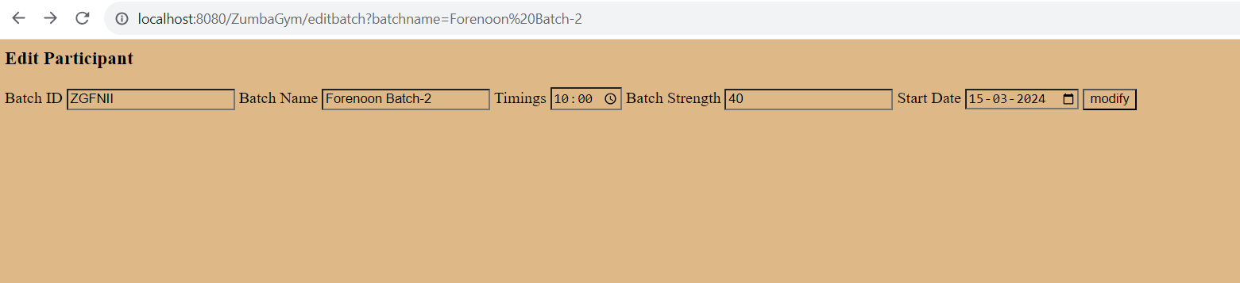

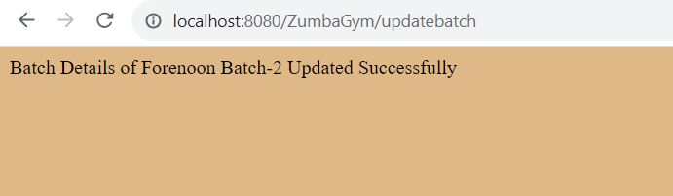

BATCH ID BEFORE MODIFYING:

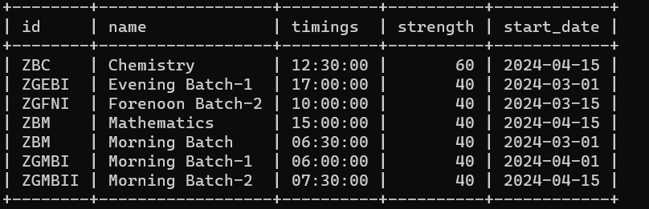

BATCH ID AFTER MODIFYING:

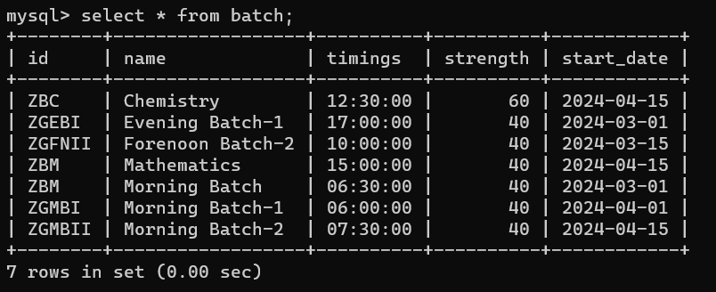

MODIFYING BATCH ID, TIMINGS, STRAT DATE OF MATHEMATICS BATCH:

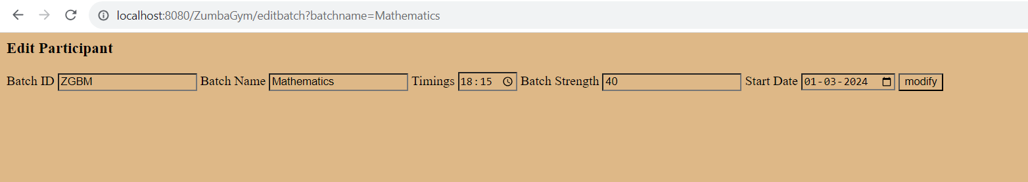

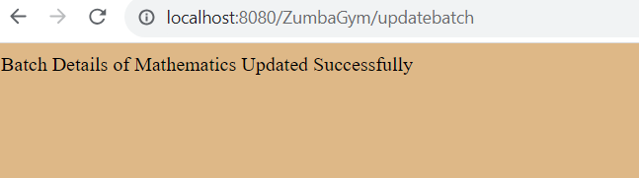

DETAILS OF MATHEMATICS BEFORE UPDATION:

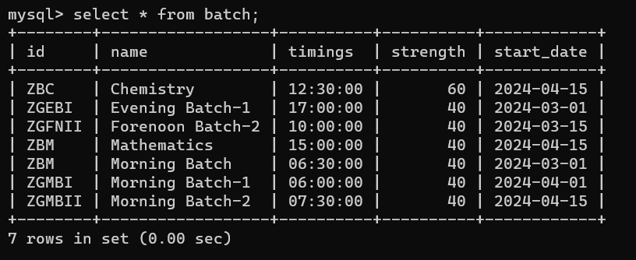

DETAILS OF MATHEMATICS AFTER UPDATION:

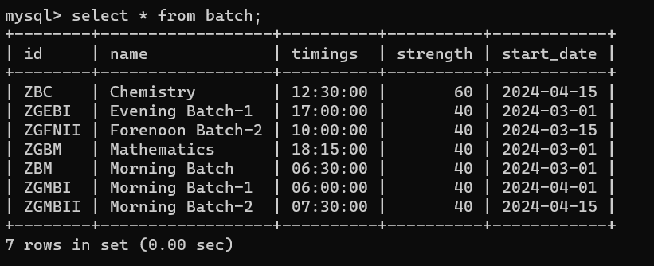

DELETING BATCHES:

DELETE CHEMISTRY BATCH:

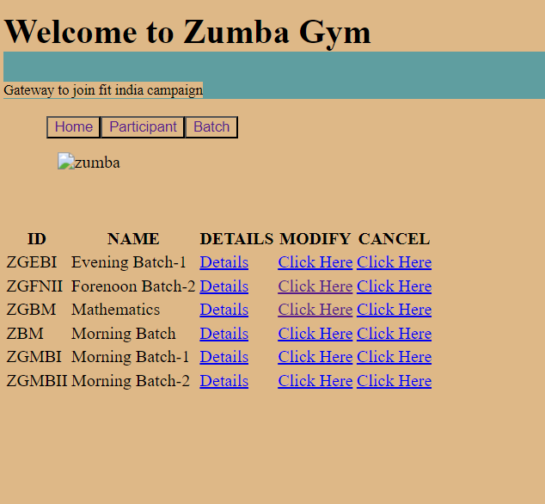

LIST OF BATCHES BEFORE DELETION:

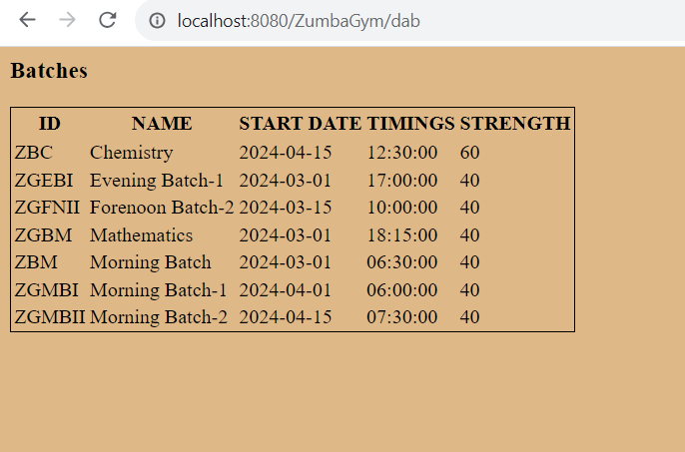

LIST OF BATCHES AFTER DELETION:

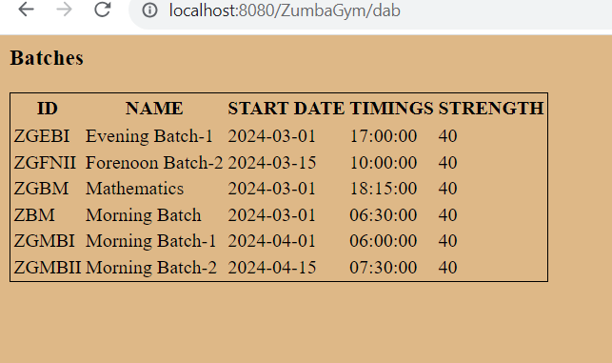

DELETING MORNING BATCH:

LIST OF BATCHES BEFORE DELETION:

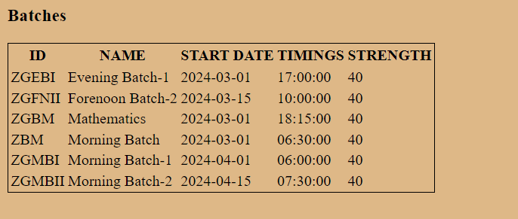

LIST OF BATCHES AFTER DELETION:

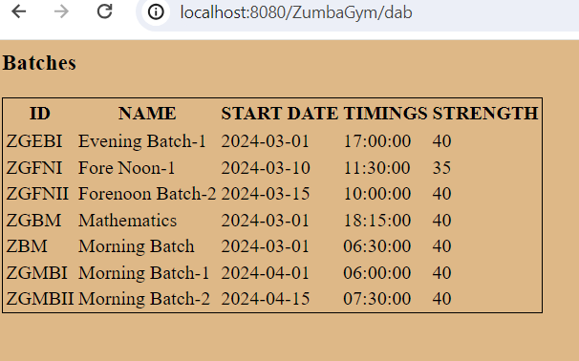

SEARCH BATCHES:

