Smarana Memory Games

1. Association Game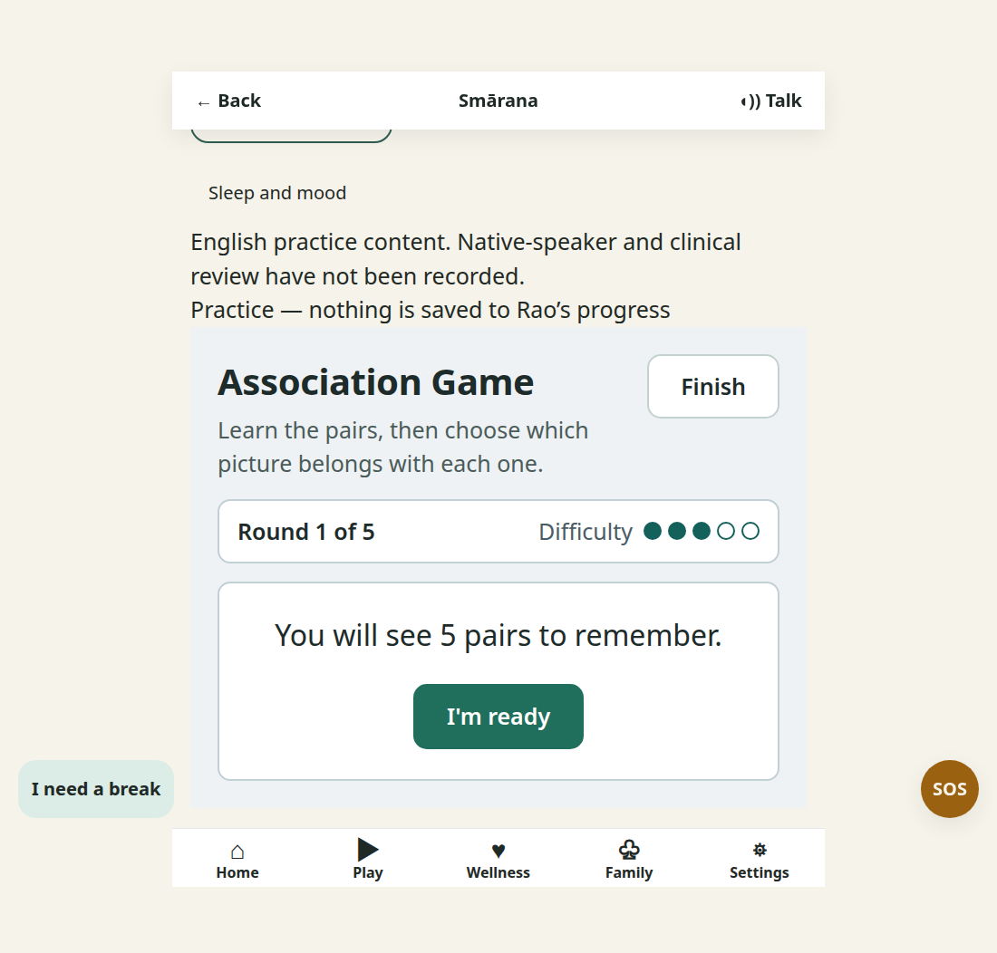
Figure 1 Gameplay screenshot
How it works Learn a set of picture pairs, then choose which image belongs with each one.
The game gradually changes the number and difficulty of pairs.
Memory benefit It practices associative memory by linking related images and recalling the link later.

2. Attention Tap

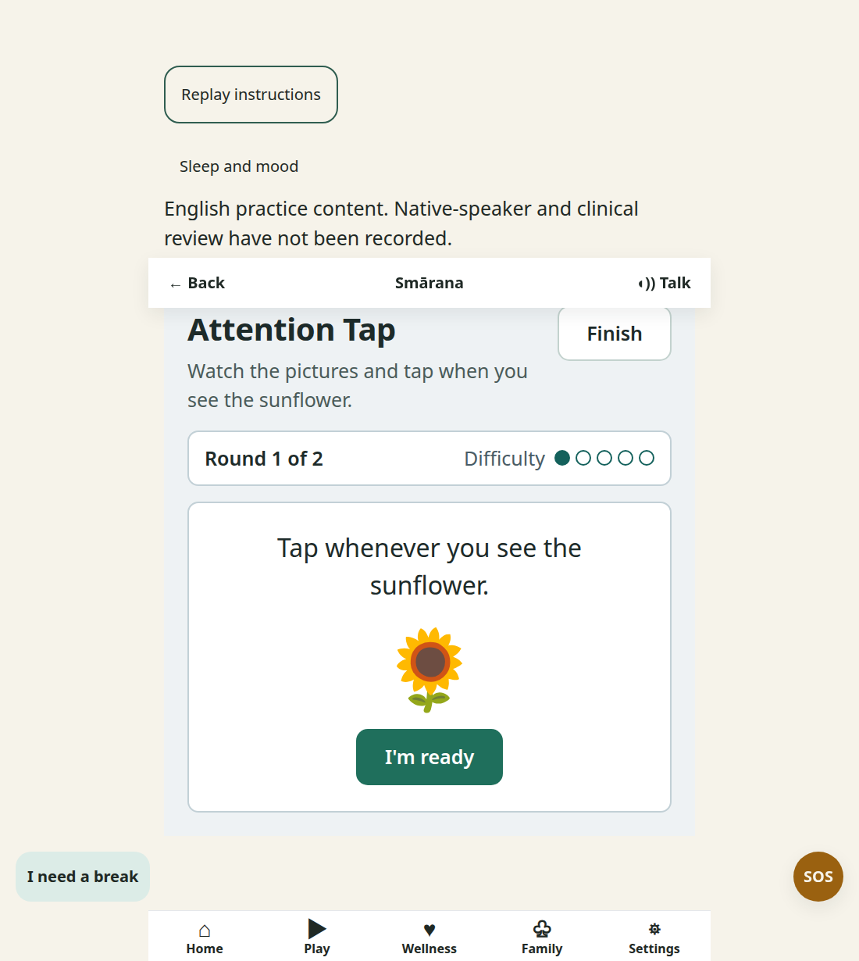
How it works Watch for the target picture and tap whenever it appears.
Distractor images make the player hold the target in mind while scanning the screen.
Memory benefit It supports attention control, which helps the brain encode information for recall.

3. Assam Rhythm Practice
Verified playable view from the Smarana website practice flow
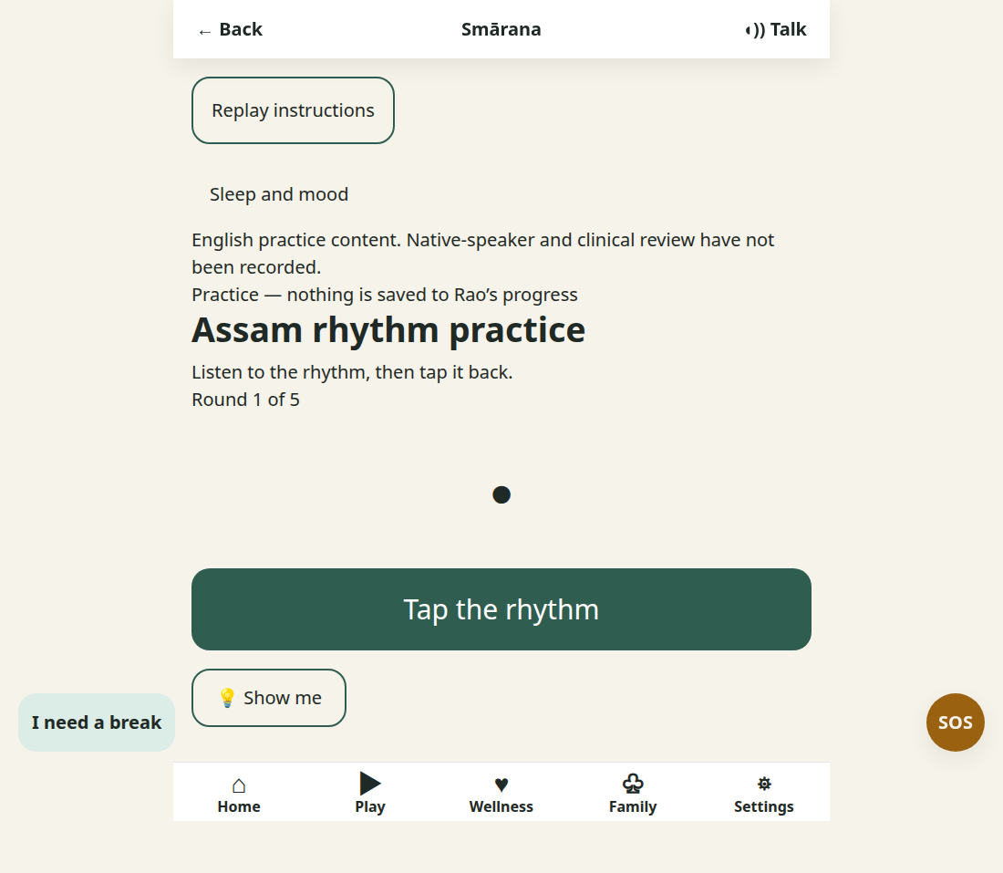
How it works Listen to a short rhythm and tap it back in the same order.
The task combines visual timing cues with auditory sequence recall.
Memory benefit It exercises auditory working memory by holding and reproducing a rhythm.

4. Daily Life Sequencing
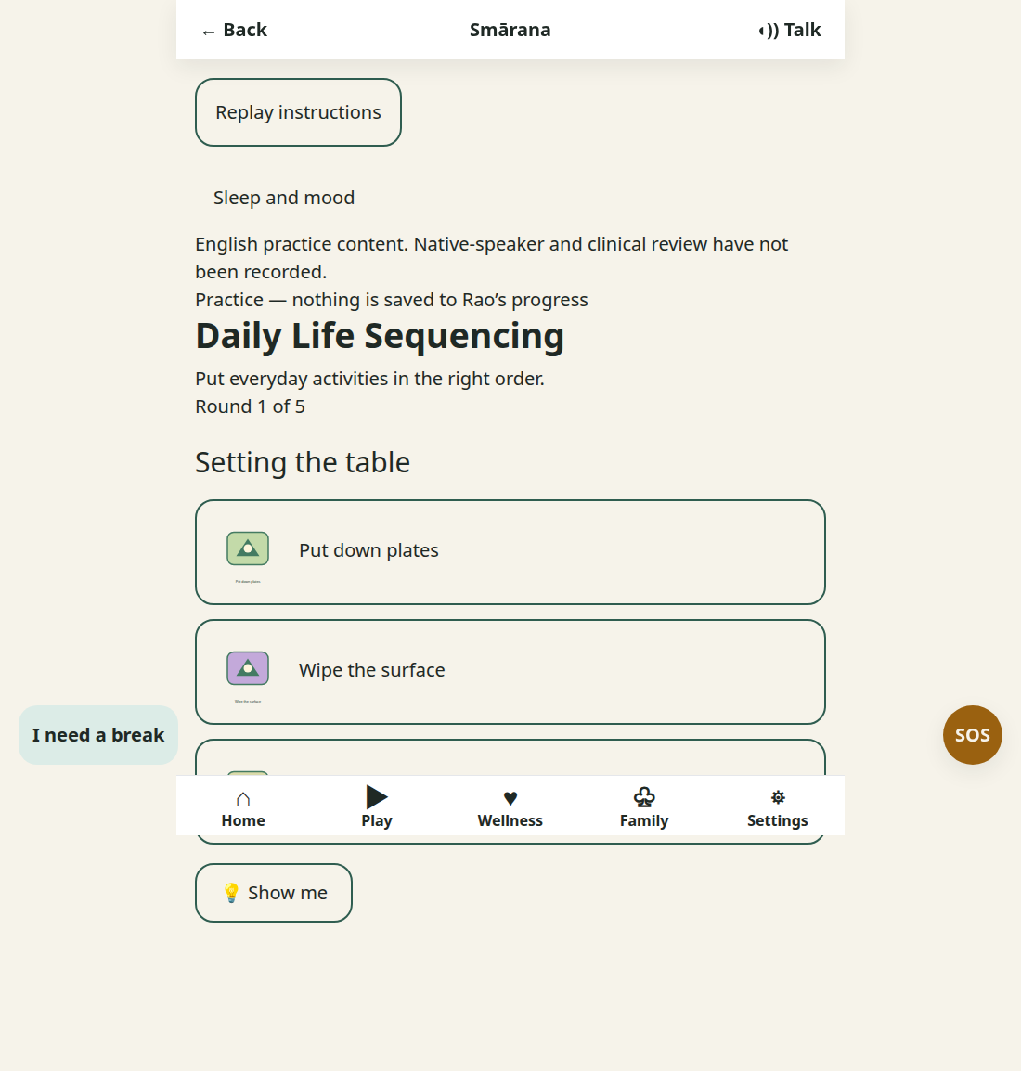
Figure 4 Gameplay screenshot
How it works Place familiar activities, such as packing a picnic, in the order they should happen.
The player taps each step and builds a complete everyday routine.
Memory benefit It reinforces the order and procedural memory of everyday activities.

5. Daily Routine Builder
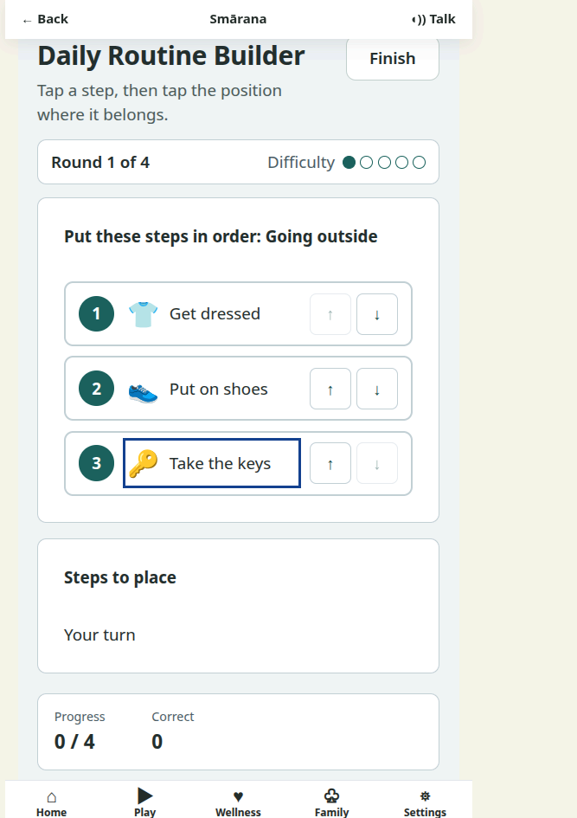

How it works Tap a routine step and then place it in the position where it belongs.
The player arranges the steps until the daily routine makes sense.
Memory benefit It practices remembering familiar actions and planning the next step.

6. Familiar Place Recall
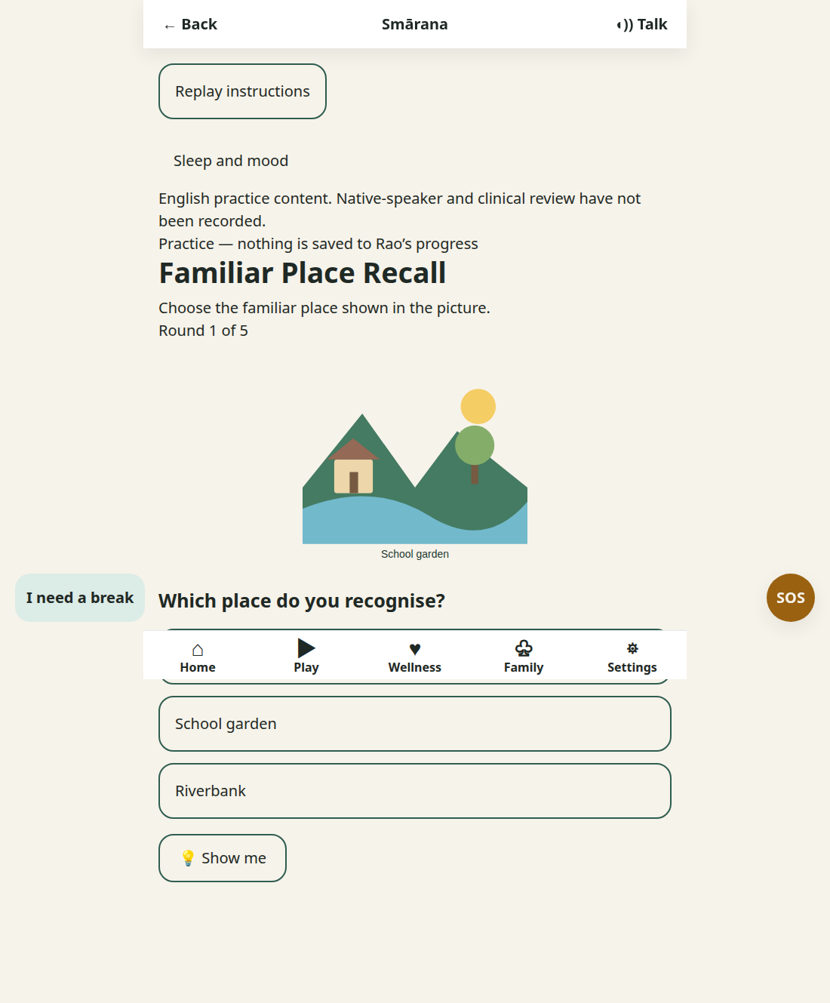
How it works Look at an illustrated place and choose the matching familiar location from the options.
The game uses visual cues to prompt recognition of places.
Memory benefit It strengthens visual recognition and recall of familiar places.

7. Festival Calendar
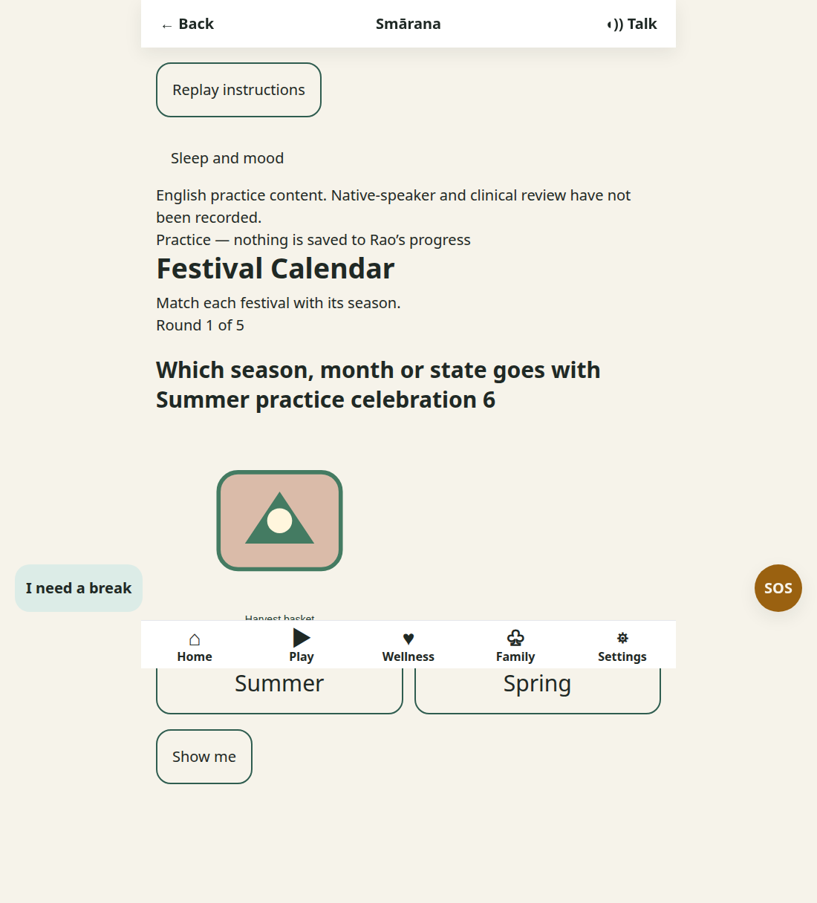
Figure 7 Gameplay screenshot
How it works Look at a festival image and match it with the correct season.
The choices encourage the player to connect an event with a calendar cue.
Memory benefit It links festivals, images, and seasons to support semantic memory.

8. Find the Change
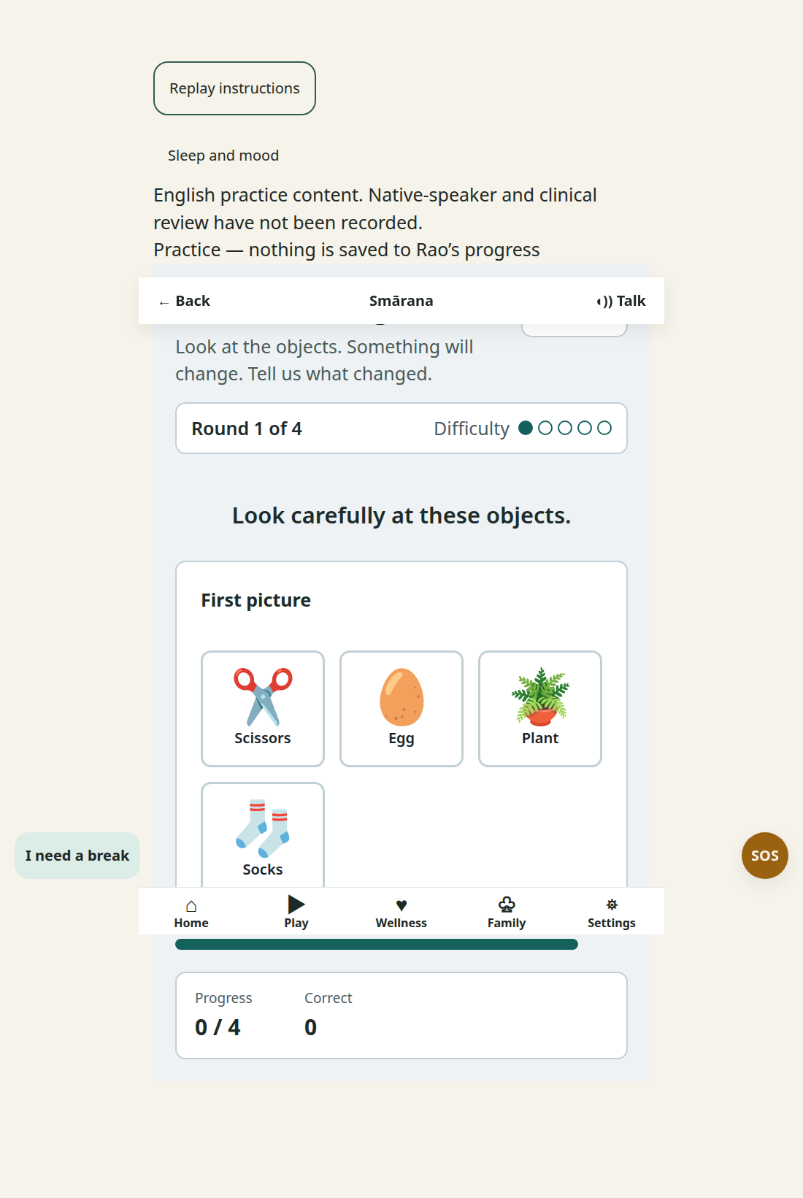
How it works Study a group of objects, then identify what changes between views.
The player reports the changed item from a small set of choices.
Memory benefit It trains visual working memory by comparing a remembered scene with a new one.

9. Memory Match
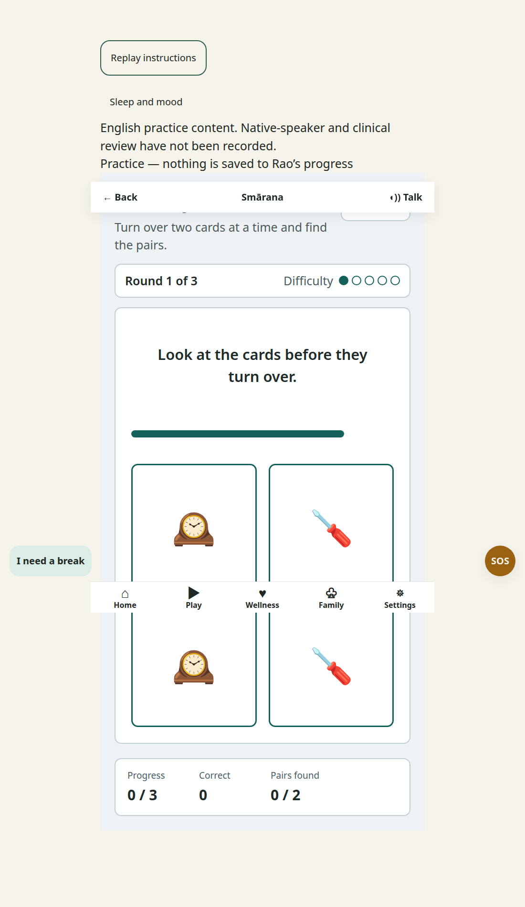
How it works Turn over two cards at a time and remember where matching pictures are hidden.
Continue until all pairs are found.
Memory benefit It exercises visual memory, location recall, and concentration.

10. Object Sorting
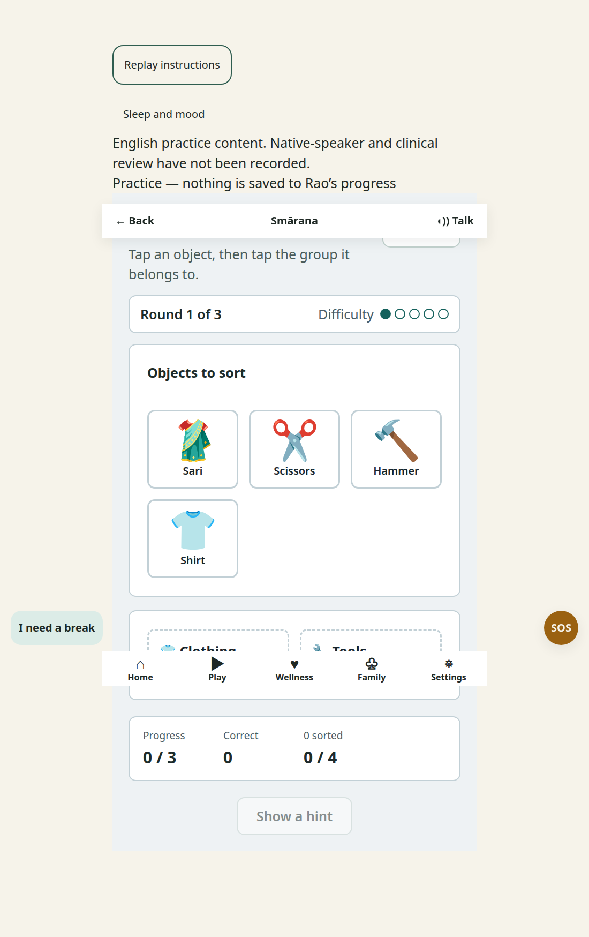
How it works Tap an object and then tap the group it belongs to.
The game asks the player to recognize everyday items and sort them by category.
Memory benefit It strengthens memory for objects by linking them to categories.

11. Pattern Completion
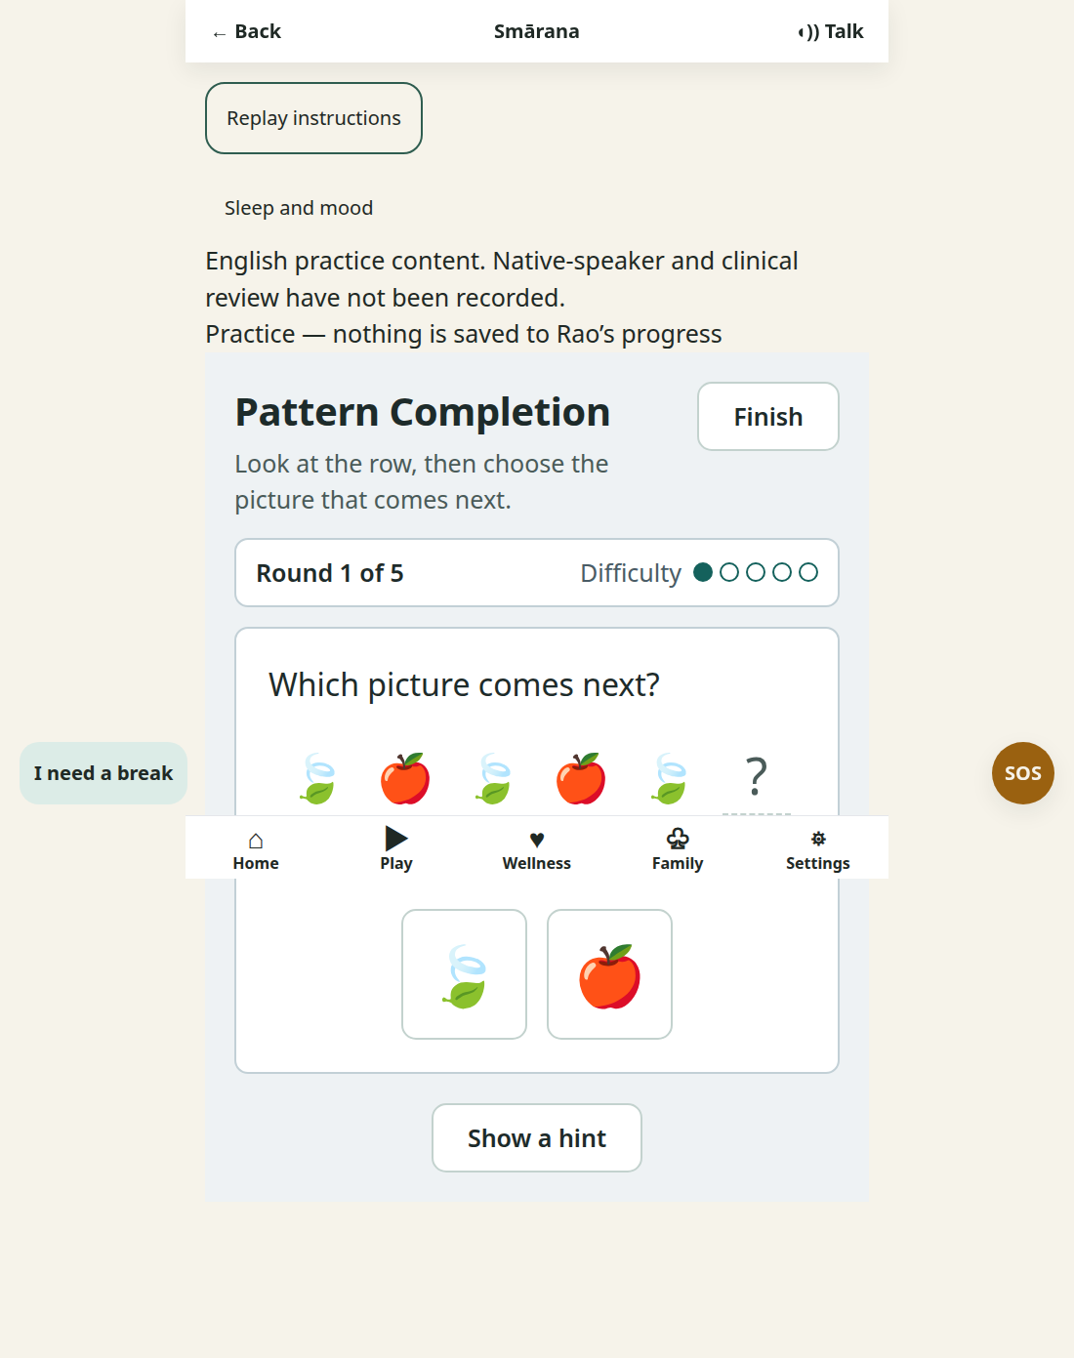
How it works Look at the picture sequence and choose the image that comes next.
The player uses the visible pattern to predict the missing item.
Memory benefit It exercises working memory and ordered recall through visual patterns.

12. Sequence Recall
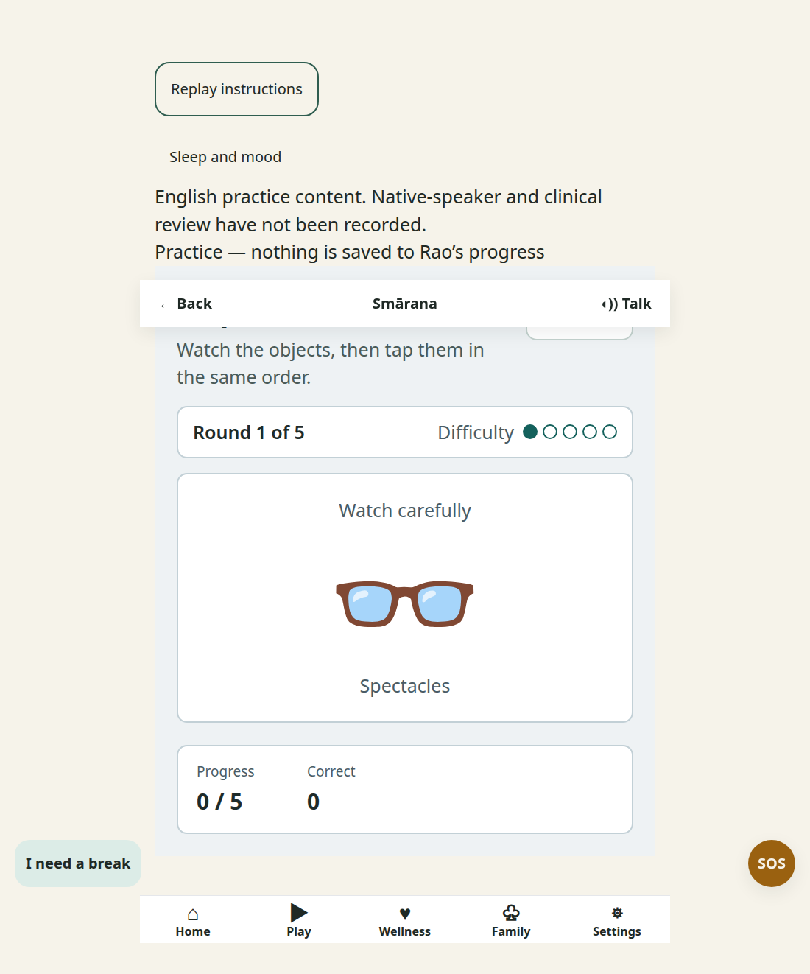
How it works Watch a sequence of objects, then tap them in the same order.
The sequence is shown first and recalled immediately afterward.
Memory benefit It practices short term and working memory through ordered visual recall.

13. Sound Match
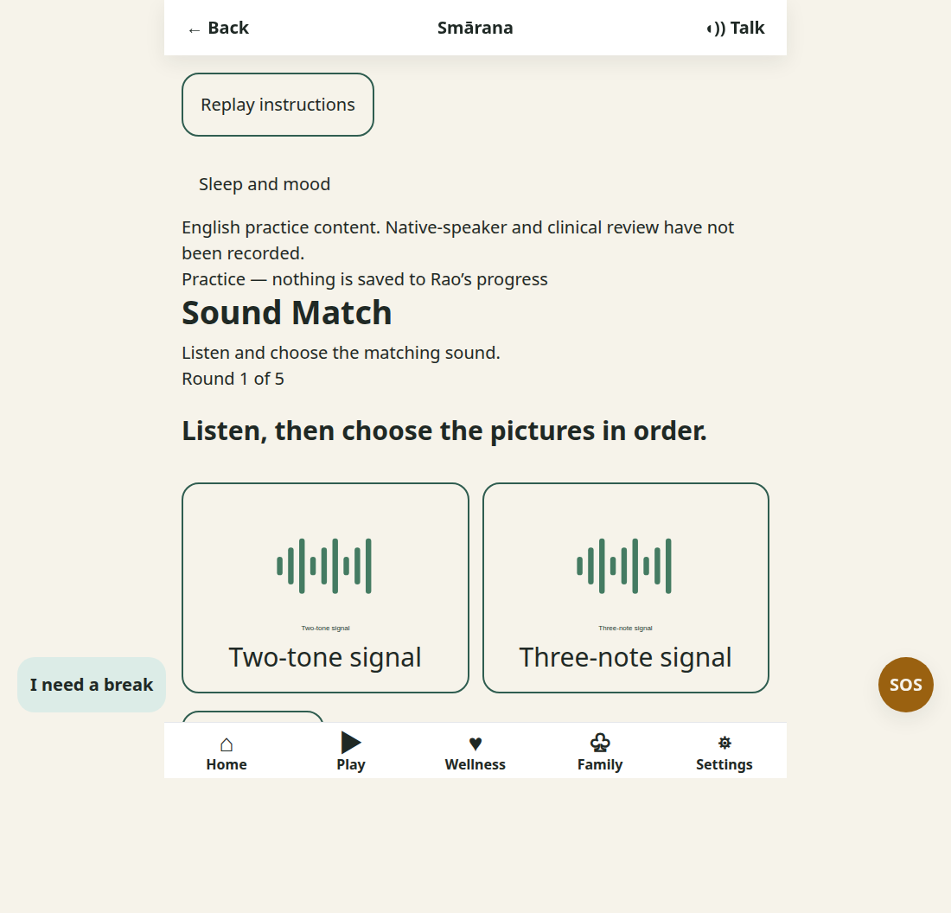
How it works Listen to a sound cue and choose the picture that matches it.
The activity connects tones and everyday sounds with visual choices.
Memory benefit It links sounds to their sources to support auditory recognition and memory.

15. Spot the Change
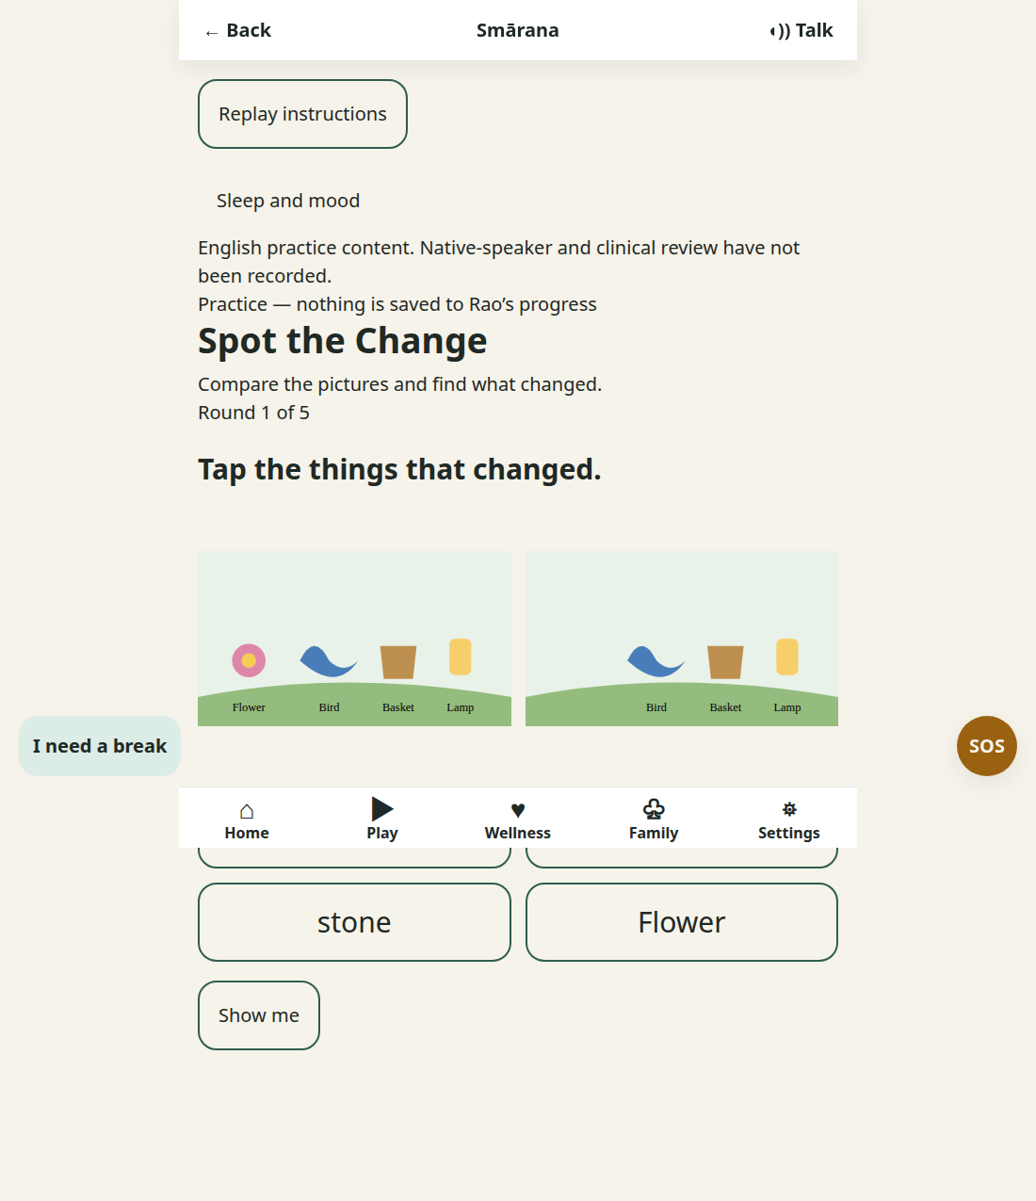
How it works Compare two illustrated scenes and find what changed.
The player taps the changed object or feature.
Memory benefit It strengthens visual attention and memory for scene details.

16. Tea Garden Attention
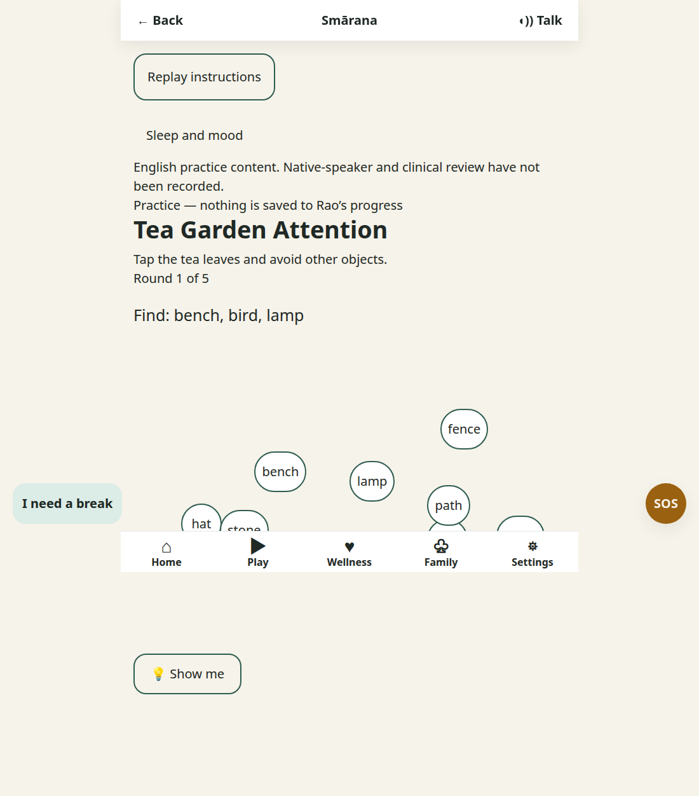
How it works Search a busy tea garden scene and tap the tea leaves while avoiding other objects.
The player scans the scene and selects only the target items.
Memory benefit It practices focus and memory for relevant details in a busy scene.

17. Visual Search
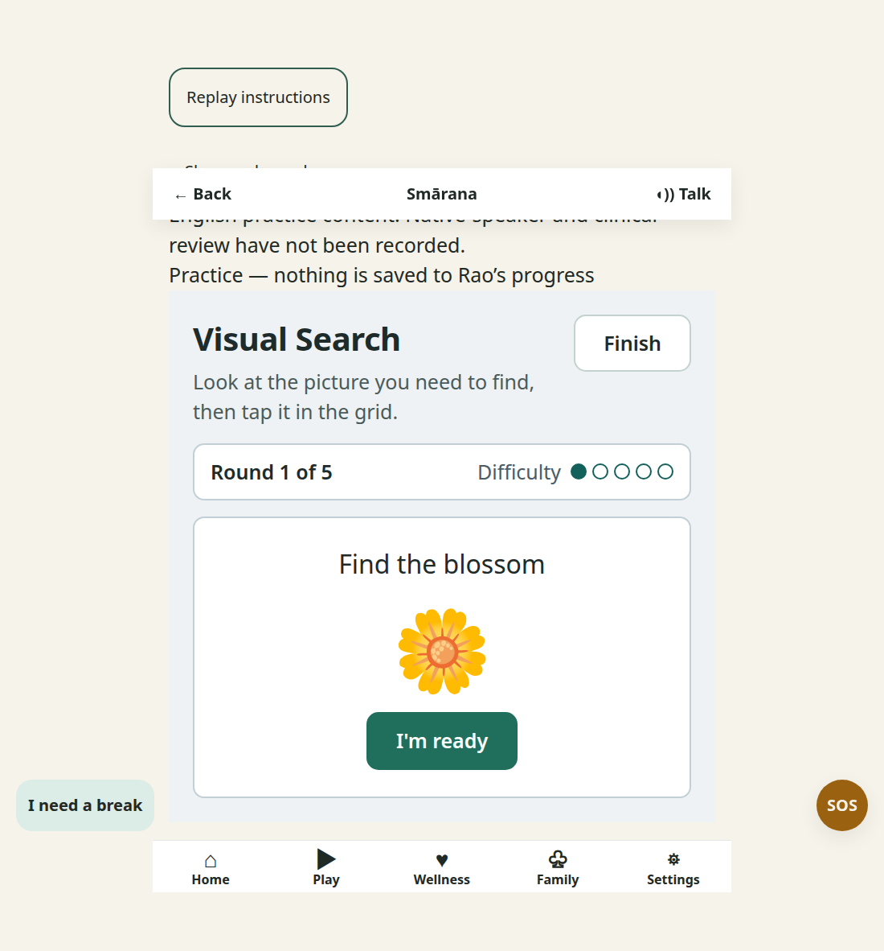
How it works Look at the target picture, then find and tap it in the grid.
Other images make the player keep the target in mind while searching.
Memory benefit It supports visual working memory during focused scanning.
ow it works Tap a routine step and then place it in the position where it belongs.
The player arranges the steps until the daily routine makes sense.
Memory benefit It practices remembering familiar actions and planning the next step.

18. Word Pairs
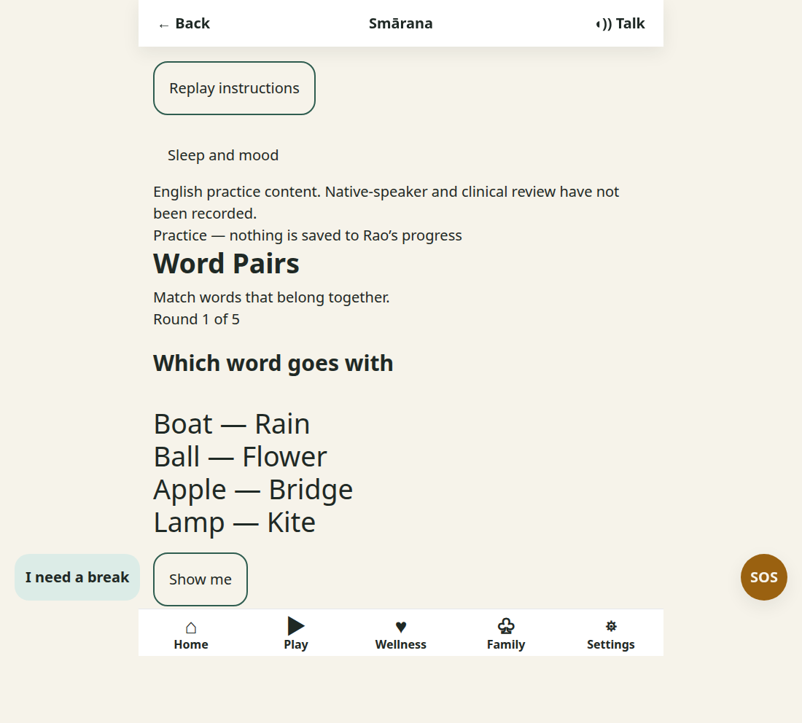
How it works Match words that belong together, such as butterfly and lamp or boat and rain.
The player reads the pairings and chooses the related word.
Memory benefit It reinforces verbal association and language based memory.

19. Word Recall
Verified playable view from the Smarana website practice flow
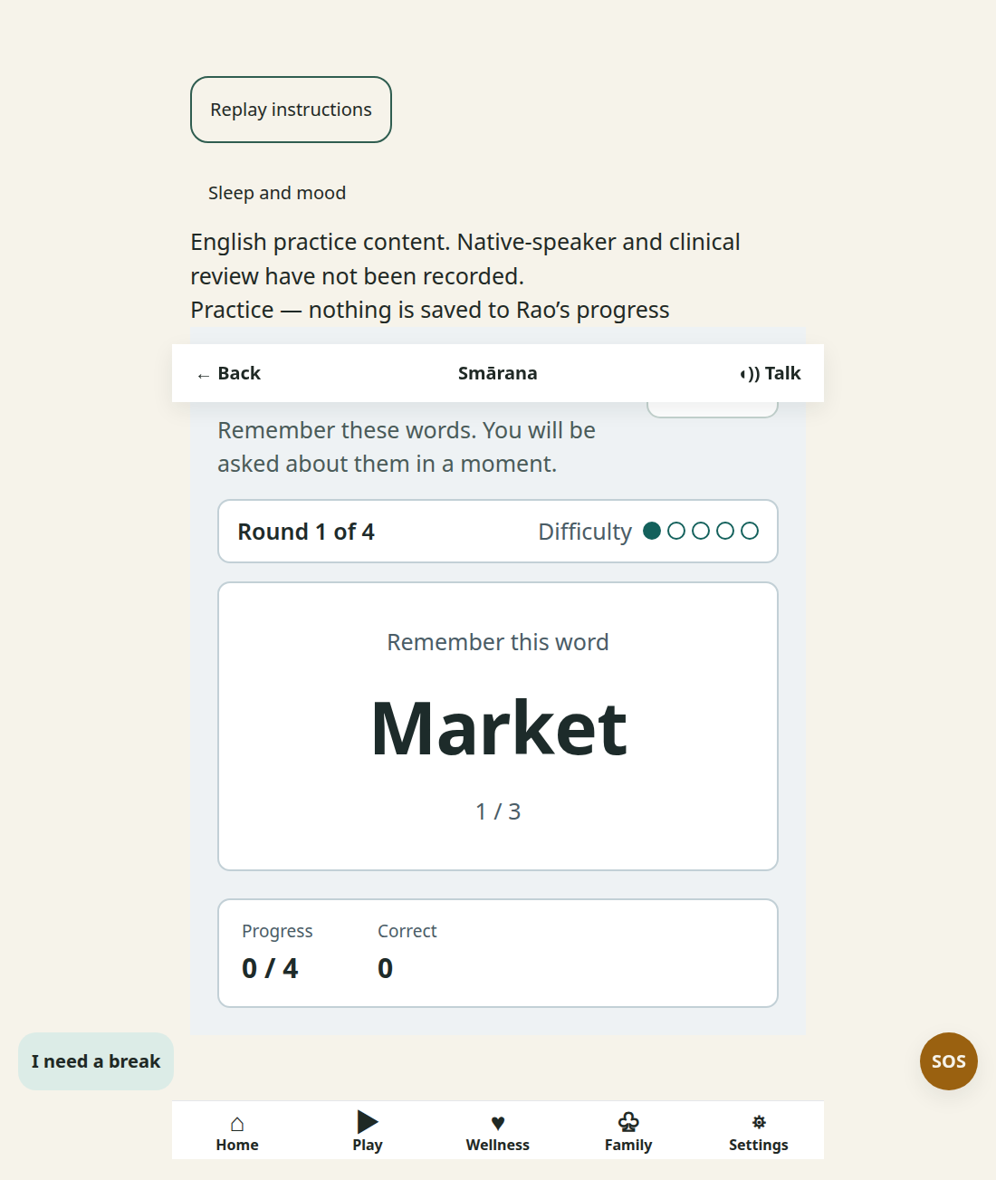
How it works Remember a word shown on screen, then answer when it appears in the recall task.
The game gives a short delay before asking the player to retrieve it.
Memory benefit It practices delayed verbal recall for names and everyday information.

