COPY : copy files from your local machine into the container's filesystem.

specific file

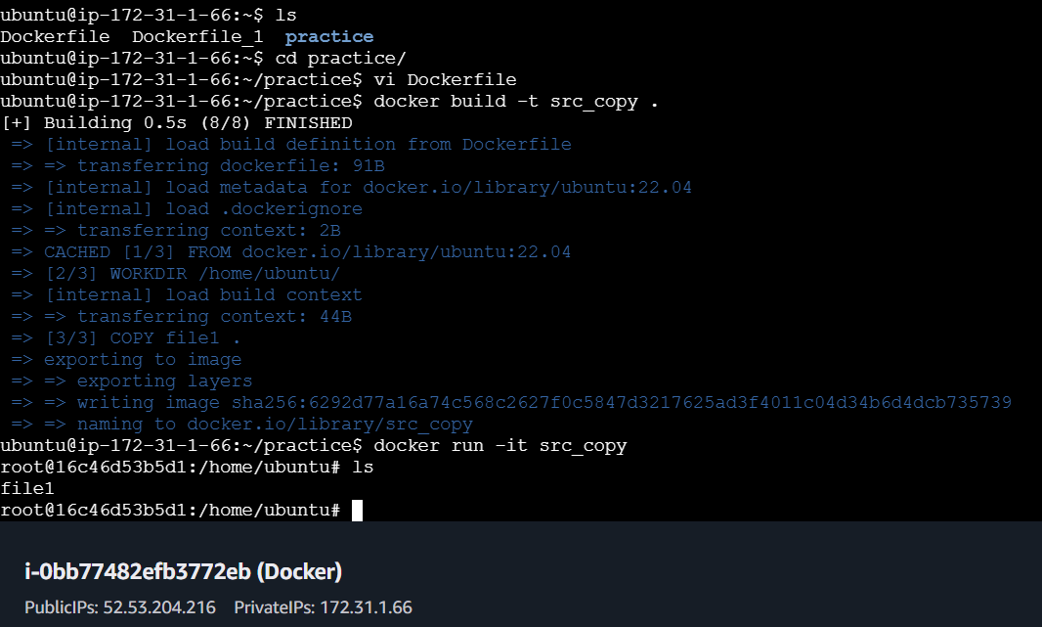

all files

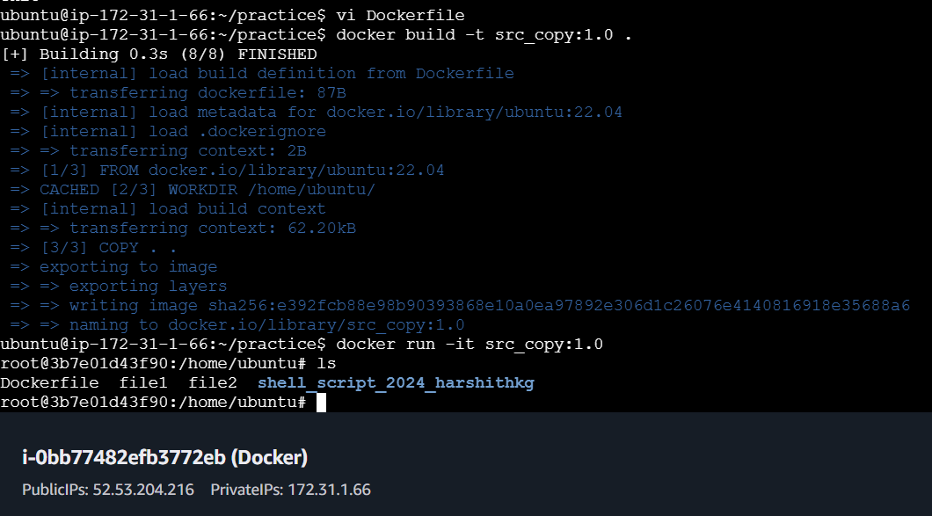

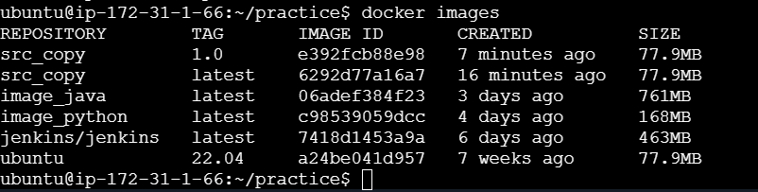

**ADD :**

The ADD instruction in a **Dockerfile** is used to copy files and directories from a source location to a destination inside the Docker image. It is similar to the COPY instruction but with added functionality, such as the ability to:

1. **Copy local files or directories** from the build context (your local machine) into the image.
2. **Download files from remote URLs** and copy them into the image.
3. **Automatically extract compressed files** (like .tar, .gz, .zip, etc.) when copying them into the image.

### Syntax:

ADD <src> <dest>

**Dockerfile to download zip file :**

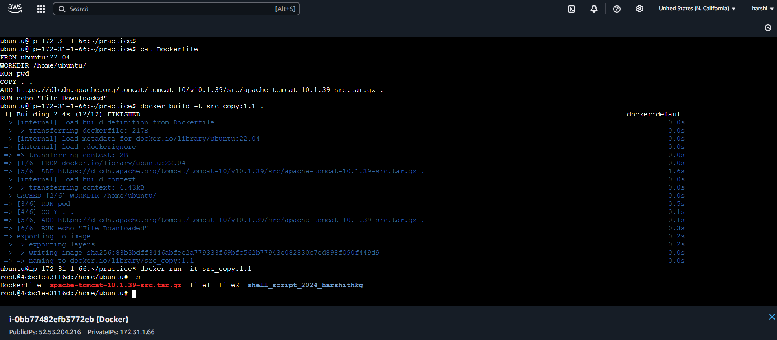

**Dockerfile to unzip and copy file :**

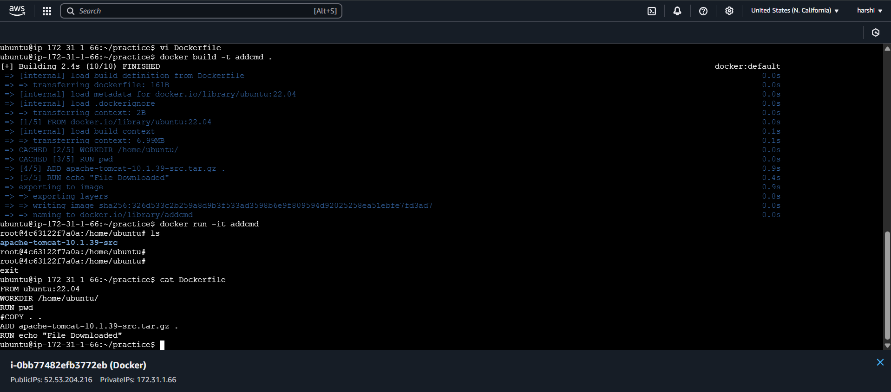

CMD / ENTRY POINT: It is a default command runs when new container starts.

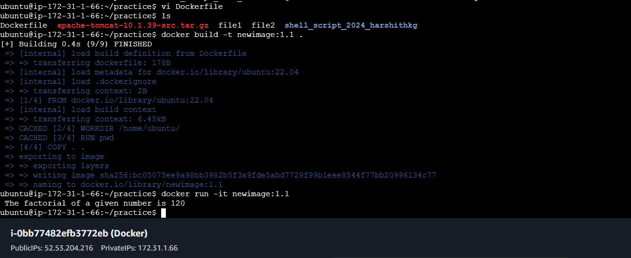

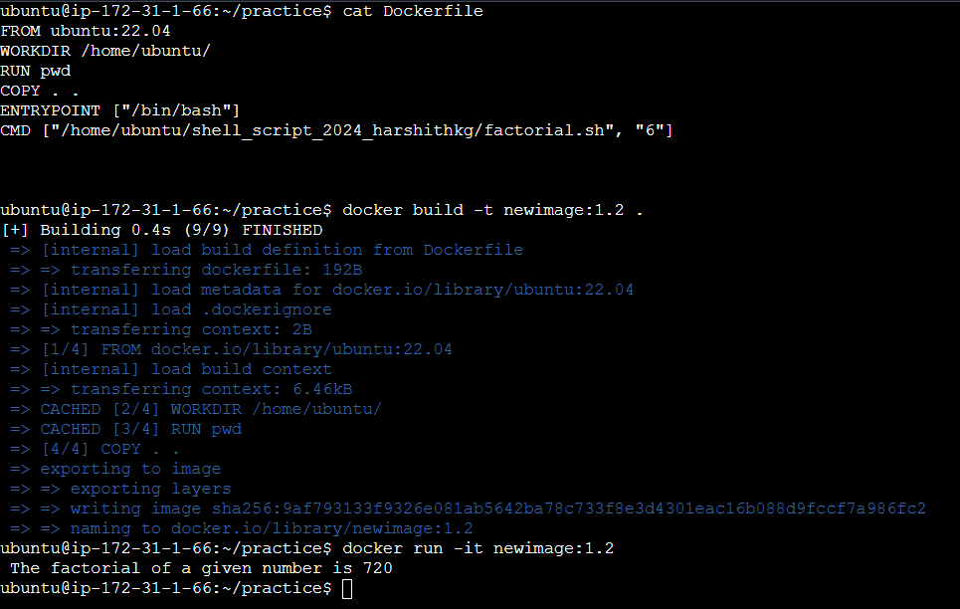

To override the cmd line argument at runtime

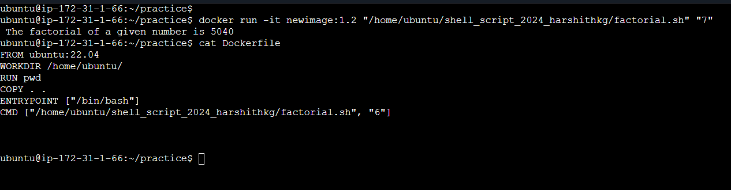

ARG

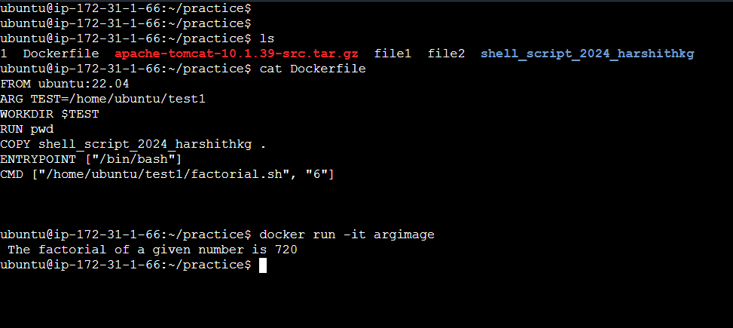

To override the ARG at runtime

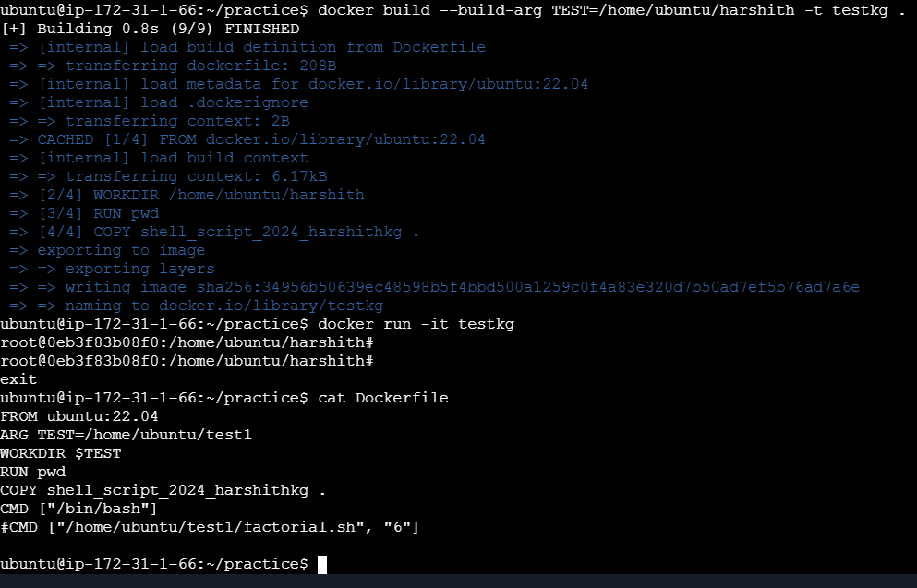

Values are available in docker file & during building the docker image

values are not available after image is built or running container won’t have access.

ENV :

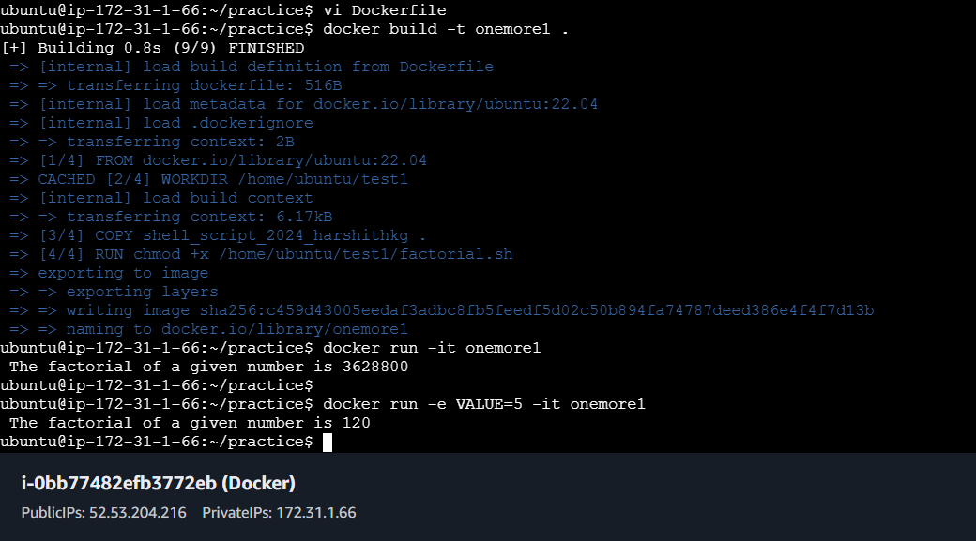

Dockerfile :

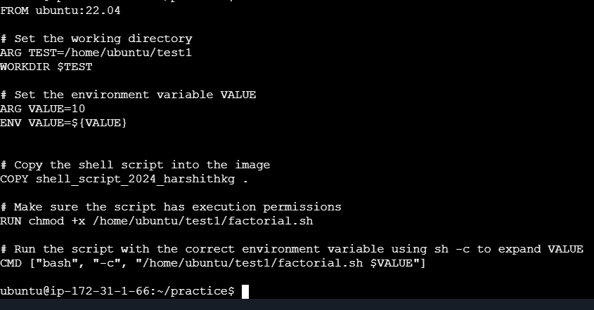

It is mainly meant to provide default values for your future environment variables.

Running docker applications can access environment variables.