**CI/CD using Dockerfile and Jenkins pipeline**

**Dockerfile:**

FROM maven:3.8.2-openjdk-8 AS builder

WORKDIR /build

COPY . .

RUN mvn clean package

RUN ls target/

FROM tomcat:jre8-temurin-focal

COPY --from=builder /build/target/hello-world-war* /usr/local/tomcat/webapps

**Writing a jenkins file and Docker file inside a Git repo :**

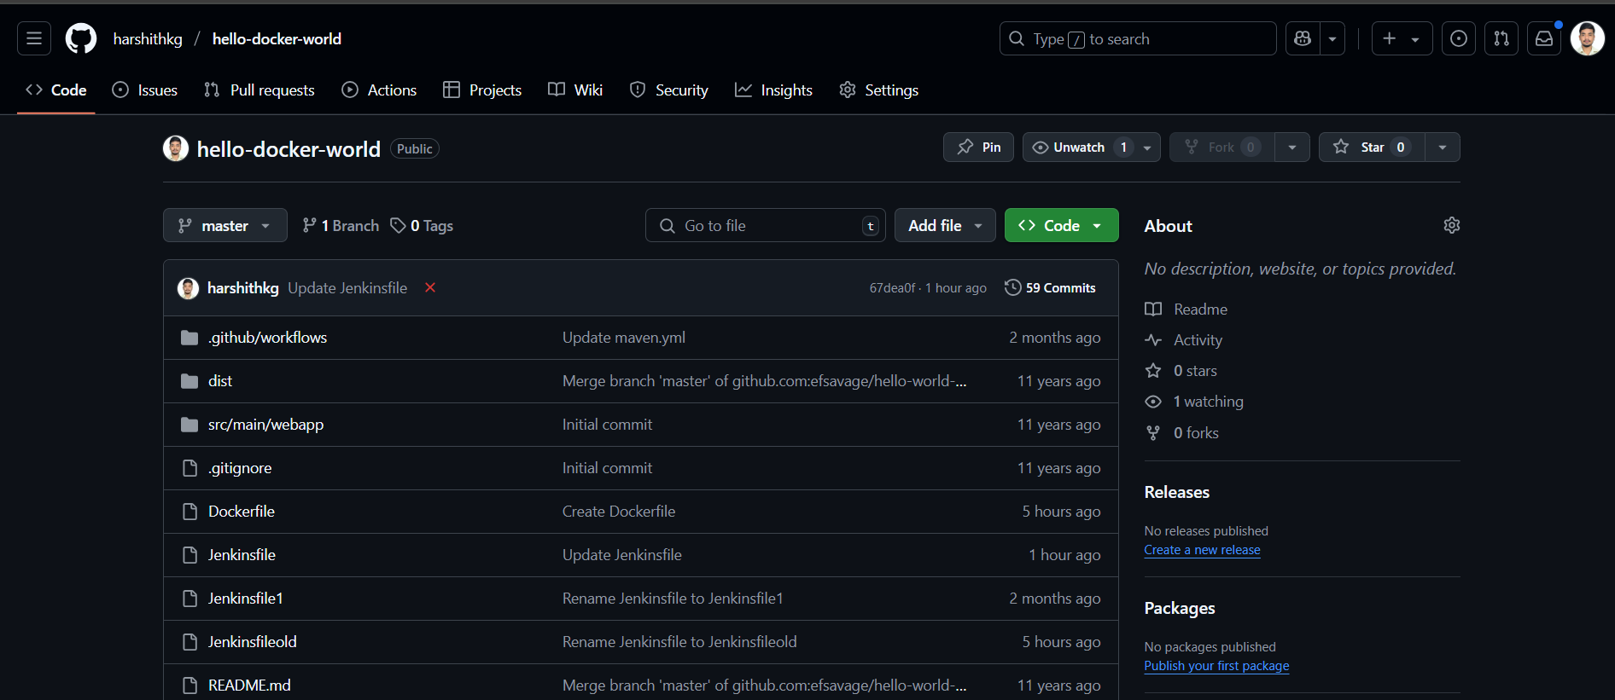

Jenkins and docker should be installed in the same server

**Adding the Docker-hub credentials as username and password :**

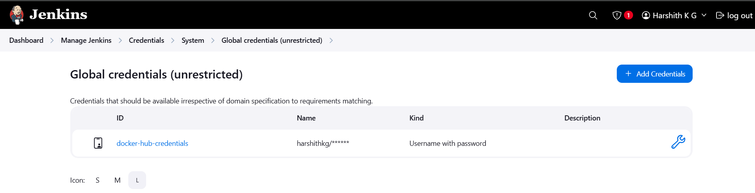

**Running a jenkins pipeline from Docker container using github source code :**

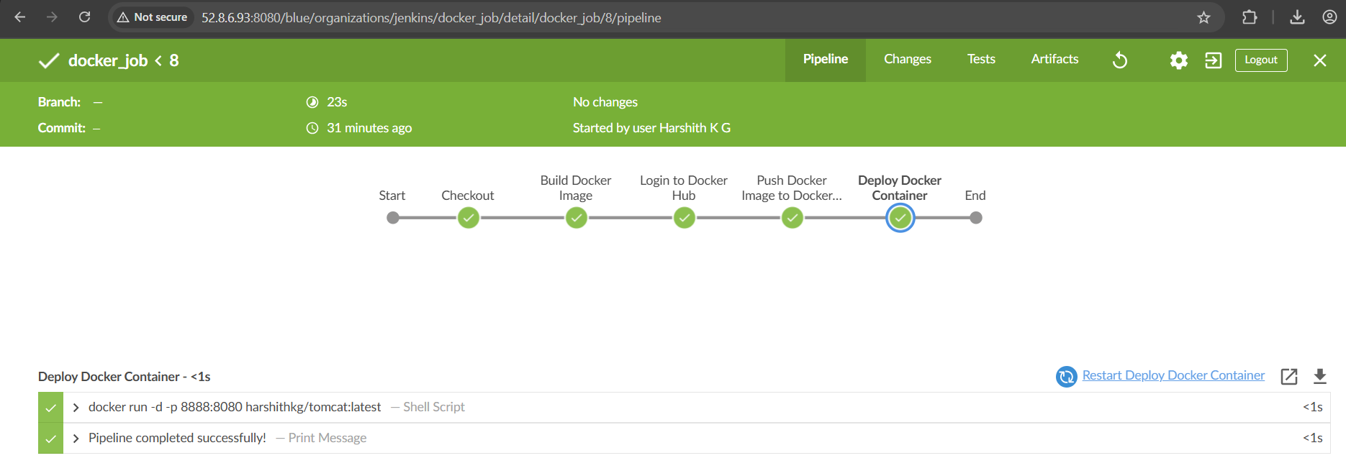

**In Docker hub Registry :**

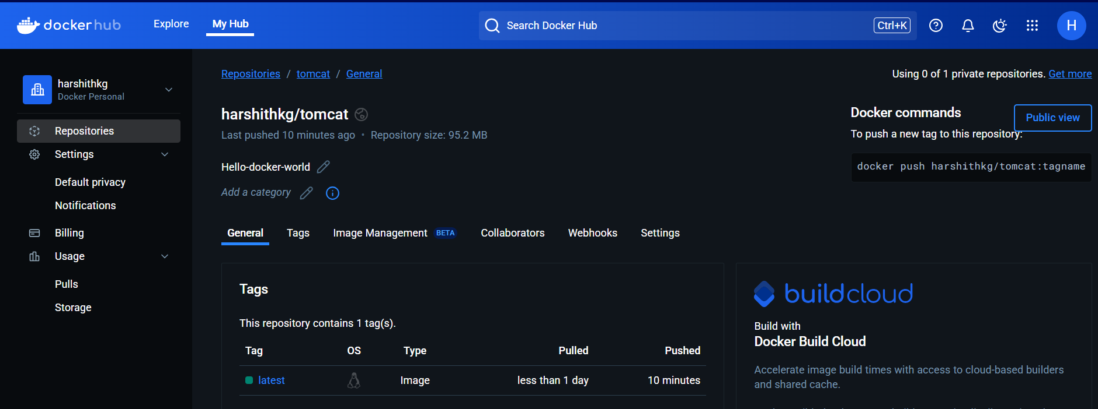

**Project as been successfully deployed using docker image and that as been pulled from the docker hub using jenkins pipeline :**

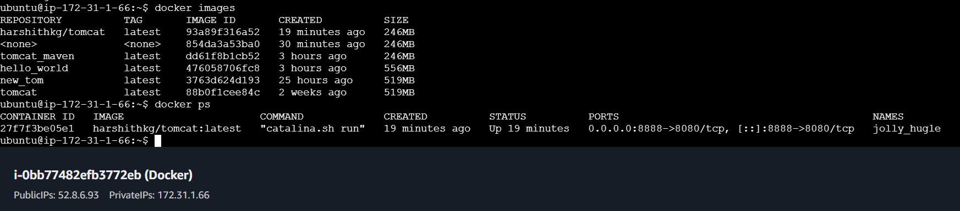

**Final output of hello-world-war CICD :**

