Installing Docker Compose :

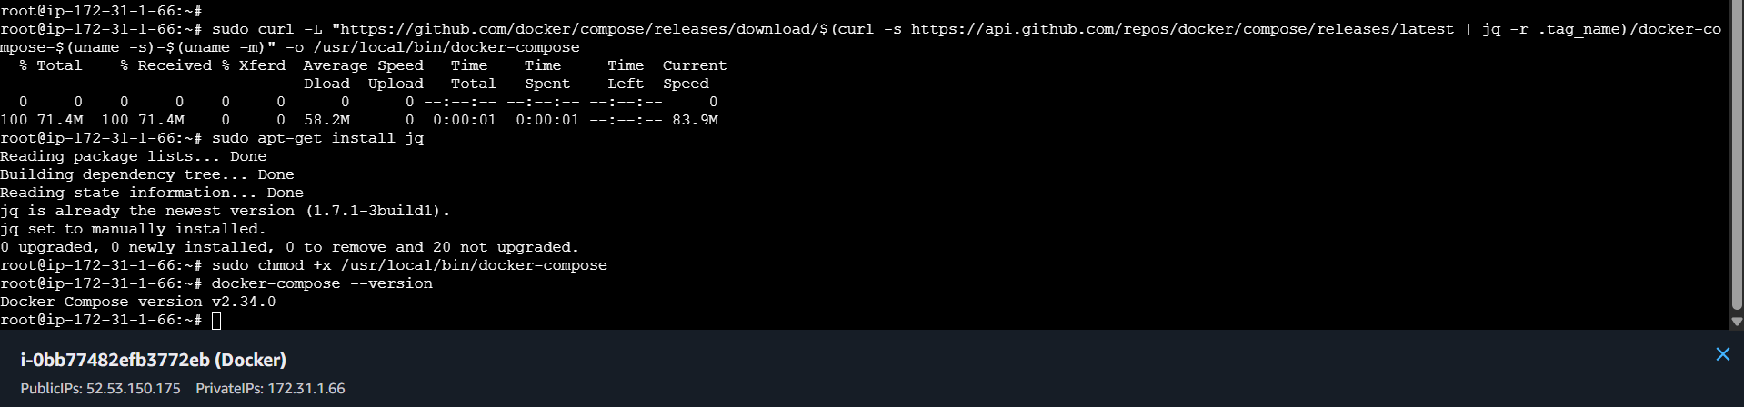

docker-compose.yml

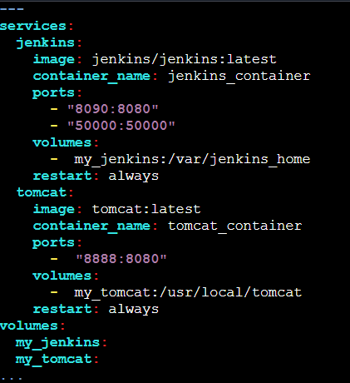

Running docker compose :

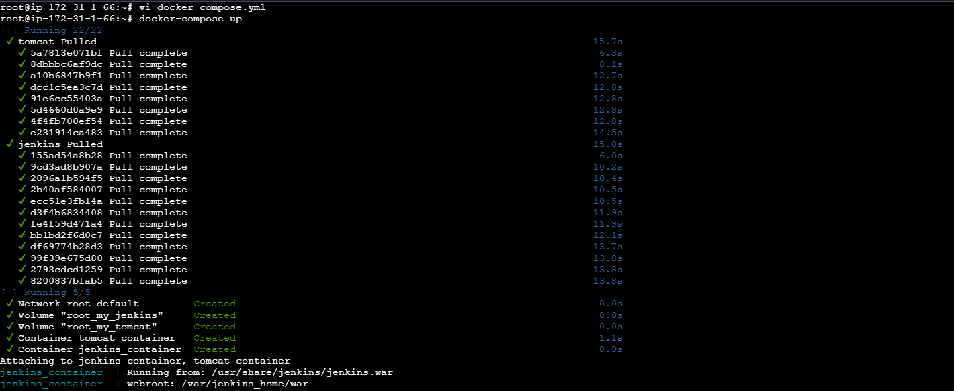

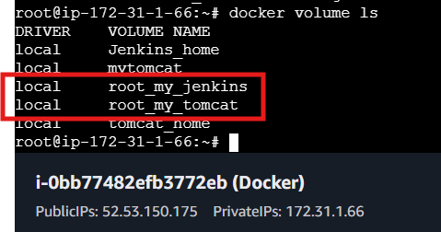

### docker ps : This command shows you a list of **running containers** on your system.

### docker compose ps : This command specifically lists the containers related to a **Docker Compose project**.It only shows containers that are defined in your docker-compose.yml file and are part of that specific project.

