Lab 1: Requirements Engineering & UML Use-Case Modelling
Problem Statement #27 — Smart Cities, Transport & Logistics: Warehouse Inventory & Pallet Location Tracker

1. Requirements Table

Req ID | Type | Description | Priority | Acceptance Criteria | Rationale
FR-001 | Functional | The system shall validate proposed pallet placement coordinates against the rack maximum load capacity before confirming storage. | High | Pass: Pallet assigned to valid rack. Fail: Placement permitted on rack where total weight exceeds rated structural limit. | Prevents structural damage and safety hazards caused by rack overloading.
FR-002 | Functional | The system shall record a stock movement event, including pallet ID, location, timestamp, and operator ID, whenever a pallet's barcode or RFID tag is scanned. | High | Pass: Every scan produces a corresponding movement log entry within 2 seconds. Fail: A scan occurs with no matching log entry. | Maintains an accurate, auditable trail of all inventory movement for stock reconciliation.
FR-003 | Functional | The system shall allow a warehouse operator or logistics supervisor to retrieve the current bin coordinates of any pallet by entering its SKU or pallet ID. | High | Pass: Query returns the correct rack, aisle, and bin coordinates for the SKU. Fail: Query returns no result, or an incorrect location, for an in-stock SKU. | Enables fast pallet retrieval and directly supports the lookup-latency non-functional requirement.
FR-004 | Functional | The system shall allow a logistics supervisor to override a rejected pallet placement, provided a justification is entered, and shall log the override with the supervisor's ID and timestamp. | Medium | Pass: Override is accepted only from a supervisor account, requires a justification, and creates an audit record. Fail: Override succeeds without a justification or without an audit record. | Provides controlled flexibility for exceptional cases while preserving accountability.
FR-005 | Functional | The system shall generate a daily inventory and movement report summarizing pallet counts, rack utilization, and stock movements per rack. | Medium | Pass: Report is generated automatically by 6:00 AM daily and its totals reconcile with the movement log. Fail: Report is missing, delayed, or its totals do not reconcile. | Supports supervisor decision-making for capacity planning and staffing.
NFR-001 | Nonfunctional | The warehouse item lookup service must locate any SKU pallet coordinate across 100,000 bins in under 100 ms, meeting applicable security standards. | High | Pass: Benchmarking tests confirm target latency and security standards under simulated peak load. Fail: Lookup exceeds 100 ms or fails a security check under peak load. | Ensures operators are not delayed during high-volume picking and putaway operations, and protects location data from unauthorized access.
NFR-002 | Nonfunctional | The system shall retain an immutable audit log of all placement, movement, and override transactions for a minimum of 12 months. | Medium | Pass: Log entries older than 12 months are archived rather than deleted, and no entry can be modified after creation. Fail: A transaction record is missing, altered, or purged before 12 months. | Supports regulatory compliance, traceability, and dispute resolution for warehouse operations.

2. UML Use-Case Diagram
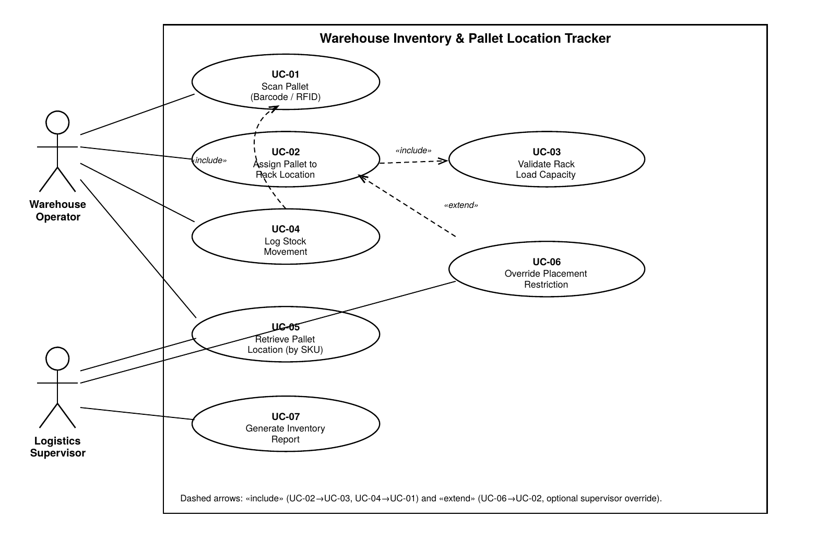
Includes: UC-02 → UC-03 (Validate Rack Load Capacity) and UC-04 → UC-01 (Scan Pallet). Extends: UC-06 → UC-02 (optional supervisor override).

3. Use-Case Flow Specification
Use Case: UC-02 — Assign Pallet to Rack Location
Primary Actor: Warehouse Operator | Secondary Actor: Logistics Supervisor (override path)
Preconditions
- The warehouse operator is authenticated and logged into the system.
- The pallet has already been scanned (UC-01) and its SKU, weight, and dimensions are recognized by the system.
- Rack location data, including current load and maximum load capacity, is available in the system.
Postconditions
- Success: The pallet's bin coordinates are stored in the system and immediately reflected in the pallet-location lookup (UC-05); a stock movement record is created (UC-04).
- Failure: The pallet remains unassigned, the rejected attempt is logged, and the pallet is flagged as pending placement.
Main Success Scenario
1. The warehouse operator scans the pallet's barcode or RFID tag (includes UC-01: Scan Pallet).
2. The system retrieves the pallet's SKU, weight, and dimensions from the inventory database.
3. The operator scans or selects a target rack, aisle, and bin location.
4. The system validates the proposed placement against the rack's maximum load capacity (includes UC-03: Validate Rack Load Capacity).
5. The system confirms the rack has sufficient remaining capacity for the pallet.
6. The system assigns the pallet to the specified bin coordinates and updates the inventory database.
7. The system logs the stock movement event with pallet ID, location, timestamp, and operator ID (UC-04).
8. The system displays a confirmation message showing the assigned rack, aisle, and bin to the operator.
9. The use case ends successfully.
Alternate Flow — 5a: Rack Capacity Exceeded
5a1. The system displays a "Placement Rejected — Capacity Exceeded" message, showing the rack's current load and maximum capacity.
5a2. The operator selects a different rack location and the flow resumes at step 3; OR
5a3. The logistics supervisor invokes UC-06 (Override Placement Restriction) and enters a justification for the override.
5a4. If the override is approved, the system logs the override with the supervisor's ID, timestamp, and justification, then resumes the main flow at step 6.
5a5. If the override is not approved, the pallet placement is cancelled, and the pallet is flagged as "unassigned" in the pending-placement queue.

