Proctora - System User Manual
Real-Time Online Examination System with Proctoring & Suspicious Event Detection

1. Adarsh Bellamane  (241IT004) | 2. Harshith Vellapha  (241IT033) | 3. Rushi Hiren Patel  (241IT065)

Department of Information Technology
National Institute of Technology Karnataka (NITK), Surathkal
Software Engineering Course Project

Table of Contents / Overview of Flows
- Flow 1: System Landing Page & Public Navigation
- Step 1.1: System Landing Page
- Flow 2: User Registration & Authentication
- Step 2.1: Candidate Account Registration
- Step 2.2: Candidate & User Login
- Step 2.3: Administrator Login Interface
- Flow 3: Candidate Examination Flow
- Step 3.1: Candidate Dashboard & Entering Test ID
- Step 3.2: Pre-Flight Hardware Diagnostics & AI Face Calibration
- Step 3.3: Candidate Exam Portal & Lockdown Interface
- Step 3.4: Answering Single-Choice Multiple Choice Questions (MCQ)
- Step 3.5: Answering Multiple-Select Questions (MSQ)
- Step 3.6: Coding Environment with Monaco Editor & Real-Time Telemetry
- Step 3.7: Answering Descriptive & Essay Questions
- Step 3.8: Final Exam Submission Modal
- Step 3.9: Submission Confirmation & Receipt
- Flow 4: Administrator / Instructor Management & Invigilation Flow
- Step 4.1: Administrator Dashboard
- Step 4.2: Instructor Test Studio Overview
- Step 4.3: Exam Details & Metadata Configuration
- Step 4.4: Question Bank Builder & Multi-Format Authoring
- Step 4.5: Seating Plan & Classroom Coordinate Upload
- Step 4.6: Real-Time Live Invigilation & Proctoring Monitor
- Step 4.7: Candidate Graded Answer Sheet & Telemetry Inspector

Flow 1: System Landing Page & Public Navigation
This flow covers accessing the platform, viewing system capabilities, and navigating to candidate or administrator authentication.

Step 1.1: System Landing Page
The landing page introduces Proctora's real-time online examination features, including AI-driven gaze tracking, Monaco editor telemetry, and classroom seating deconfliction. Users can click 'Candidate Portal' to take tests or 'Admin Login' to manage examinations.
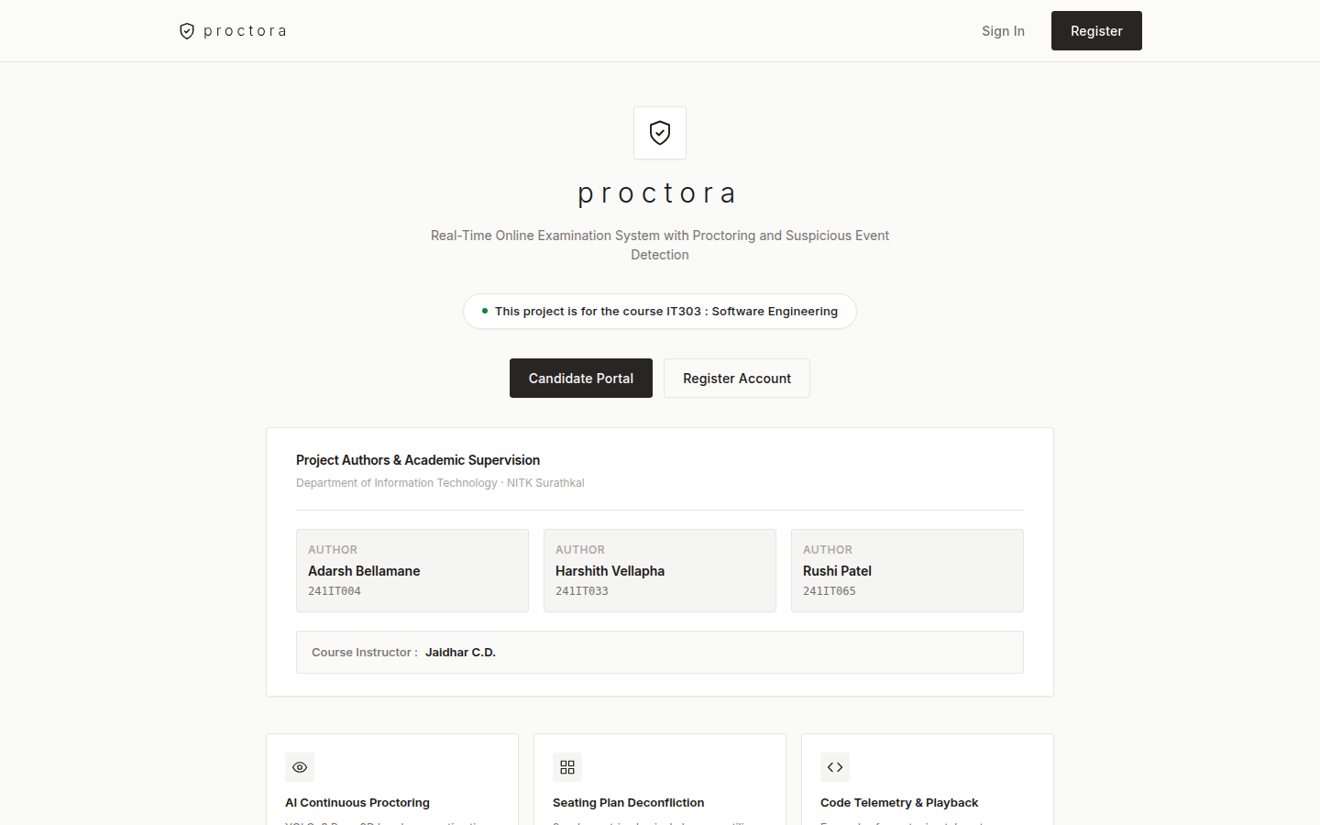

Flow 2: User Registration & Authentication
This flow covers candidate account registration and secure credential login with role-based redirection.

Step 2.1: Candidate Account Registration
New candidates register by providing their full name, institutional email address, institutional roll number, and password. Client and server validation verify password strength and email formatting.
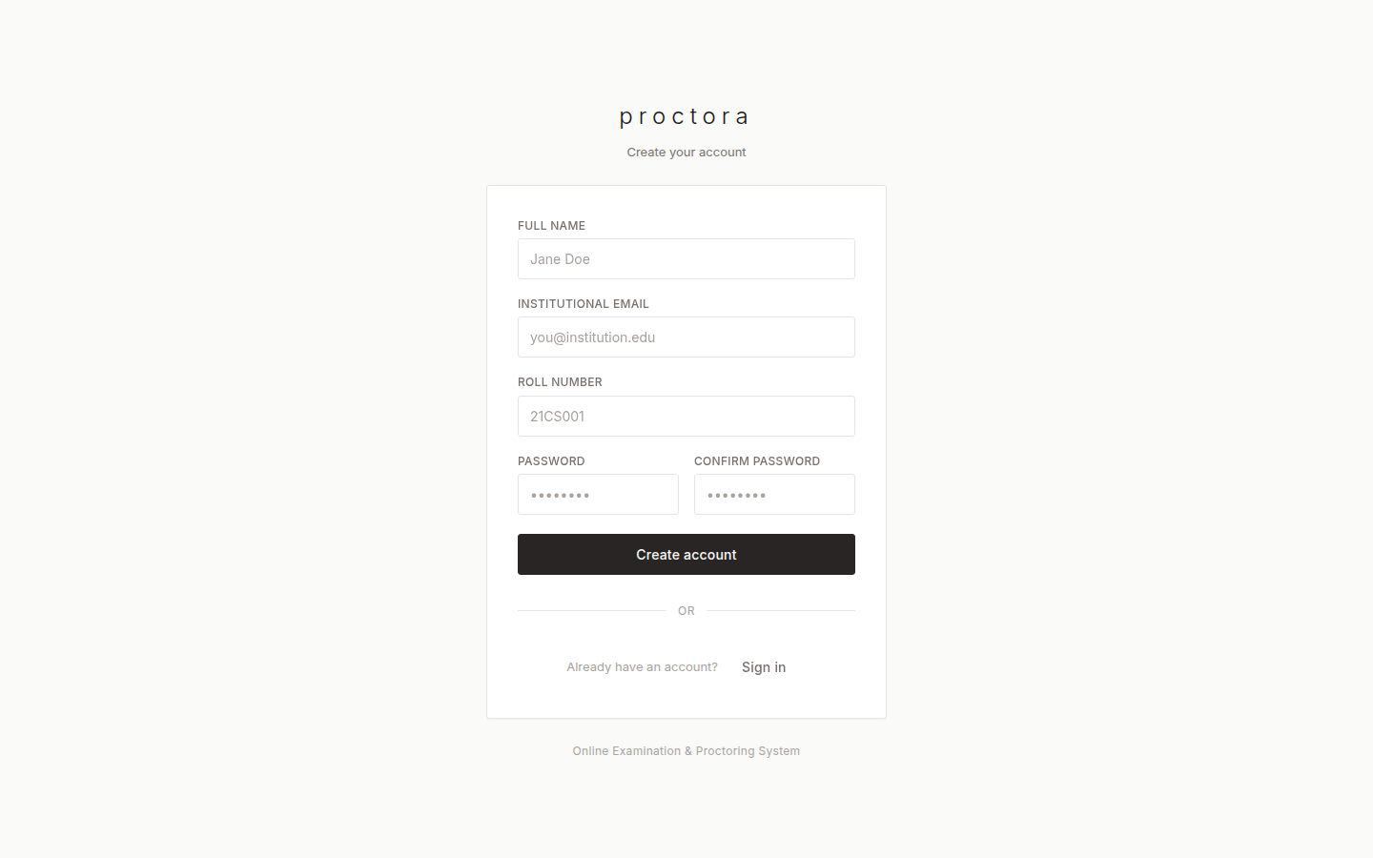

Step 2.2: Candidate & User Login
Candidates sign in using their registered email and password. Upon successful verification, candidates are issued secure session cookies and redirected to the Candidate Dashboard.
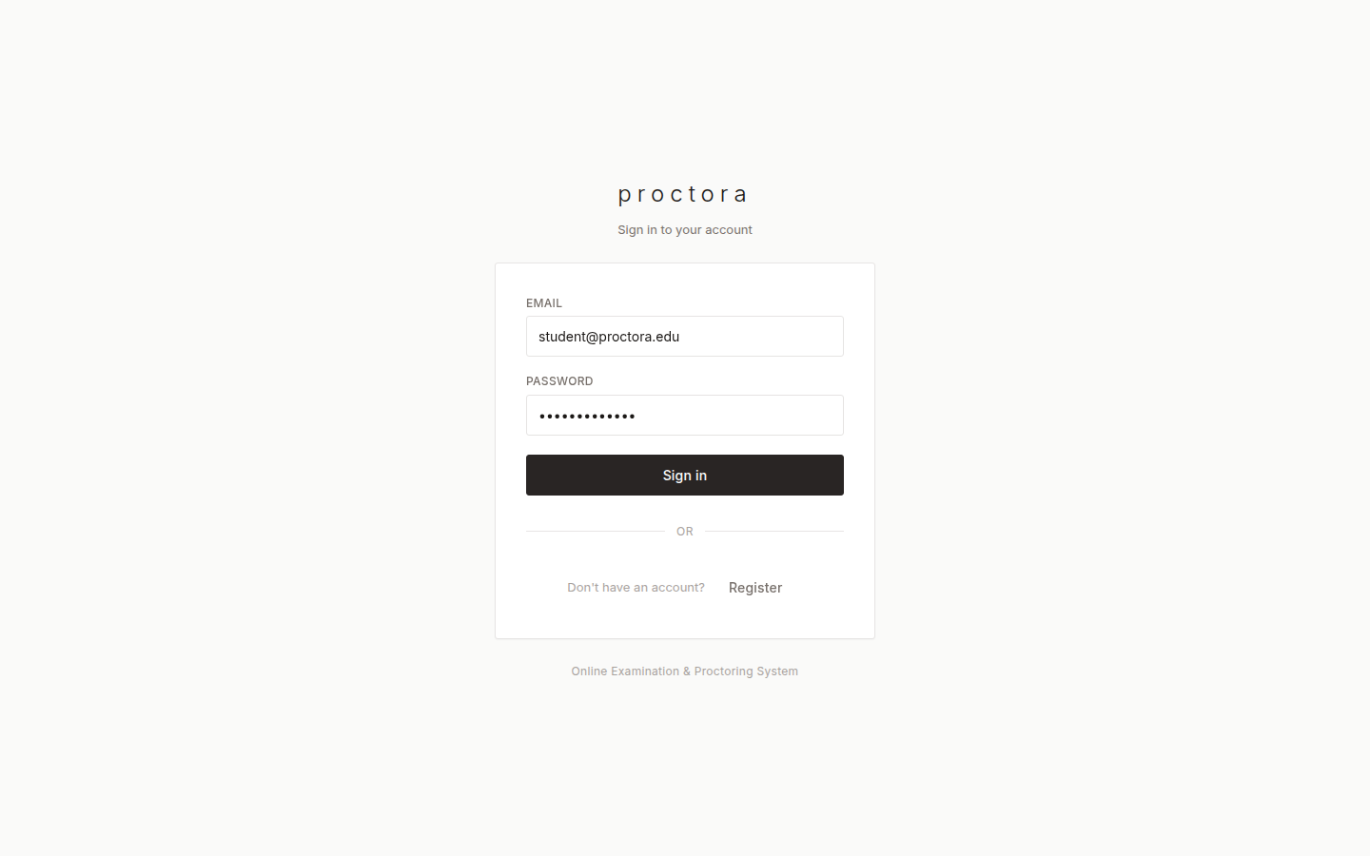

Step 2.3: Administrator Login Interface
Faculty and administrators log in through the same secure authentication gateway. Users with administrative privileges are granted access to the Test Studio and Live Invigilation Monitor.
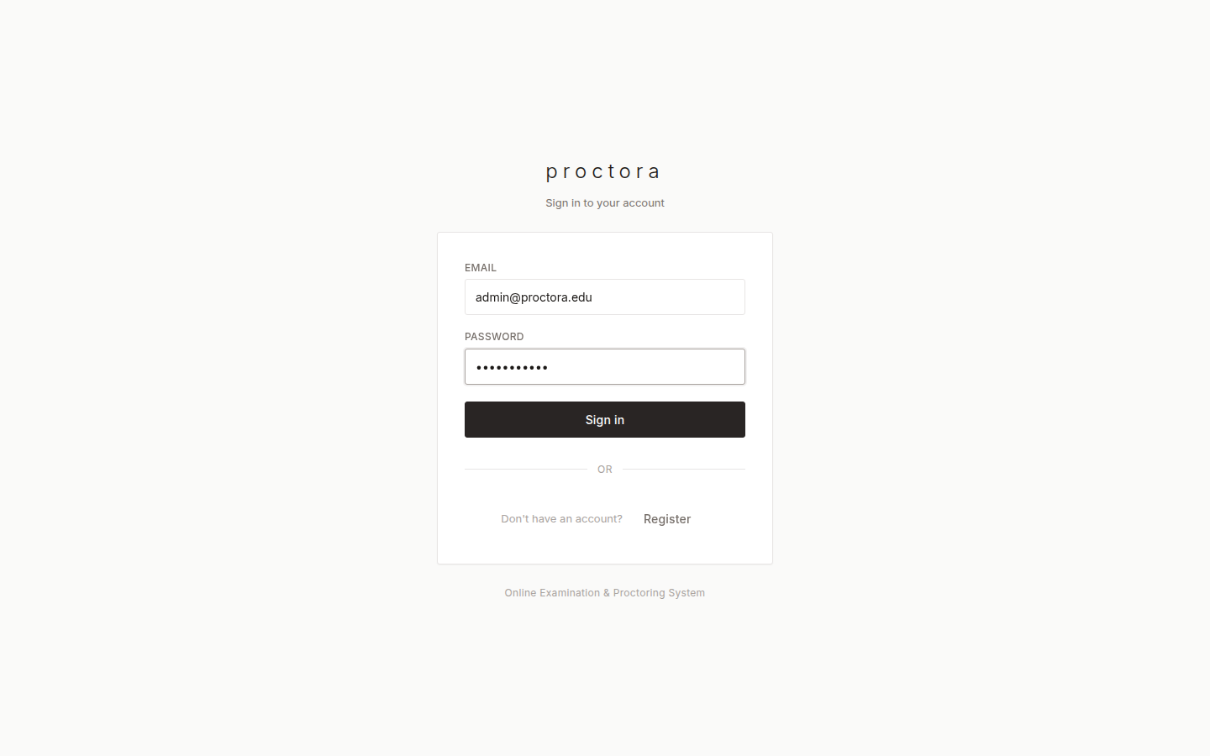

Flow 3: Candidate Examination Flow
This flow details the complete candidate testing lifecycle from test entry, hardware calibration, answering diverse question formats, to final submission.

Step 3.1: Candidate Dashboard & Entering Test ID
Upon logging in, candidates view a minimalist portal with an input field labeled 'Paste your exam link or Test ID here:'. Candidates enter the assigned Test ID (e.g., TEST-MS2026) and click 'Proceed to Examination'.
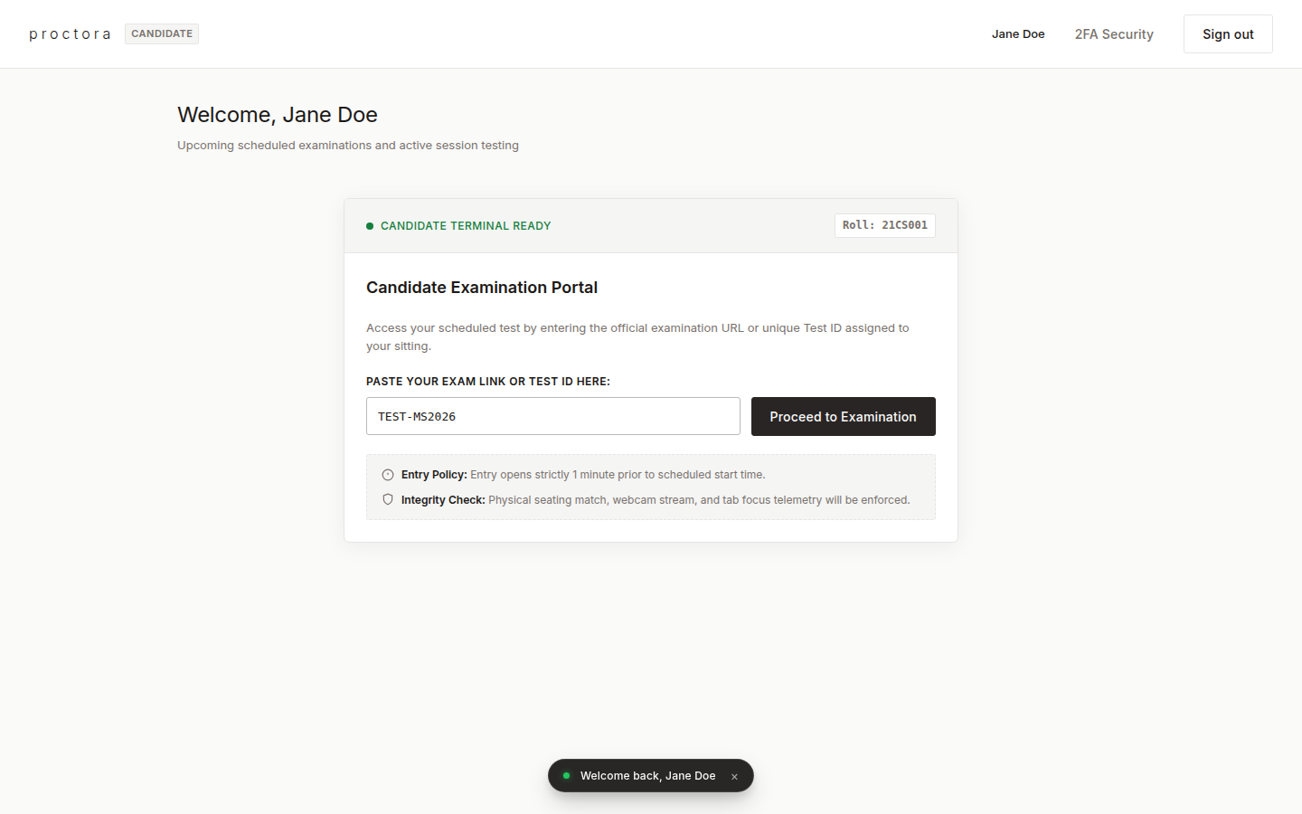

Step 3.2: Pre-Flight Hardware Diagnostics & AI Face Calibration
Before starting the test, candidates undergo mandatory hardware verification: Webcam feed, Microphone audio, Browser resolution, and Network latency. The AI engine validates camera framing and illumination using a centering reticle. Once verified, the candidate clicks 'Enter Exam Portal'.
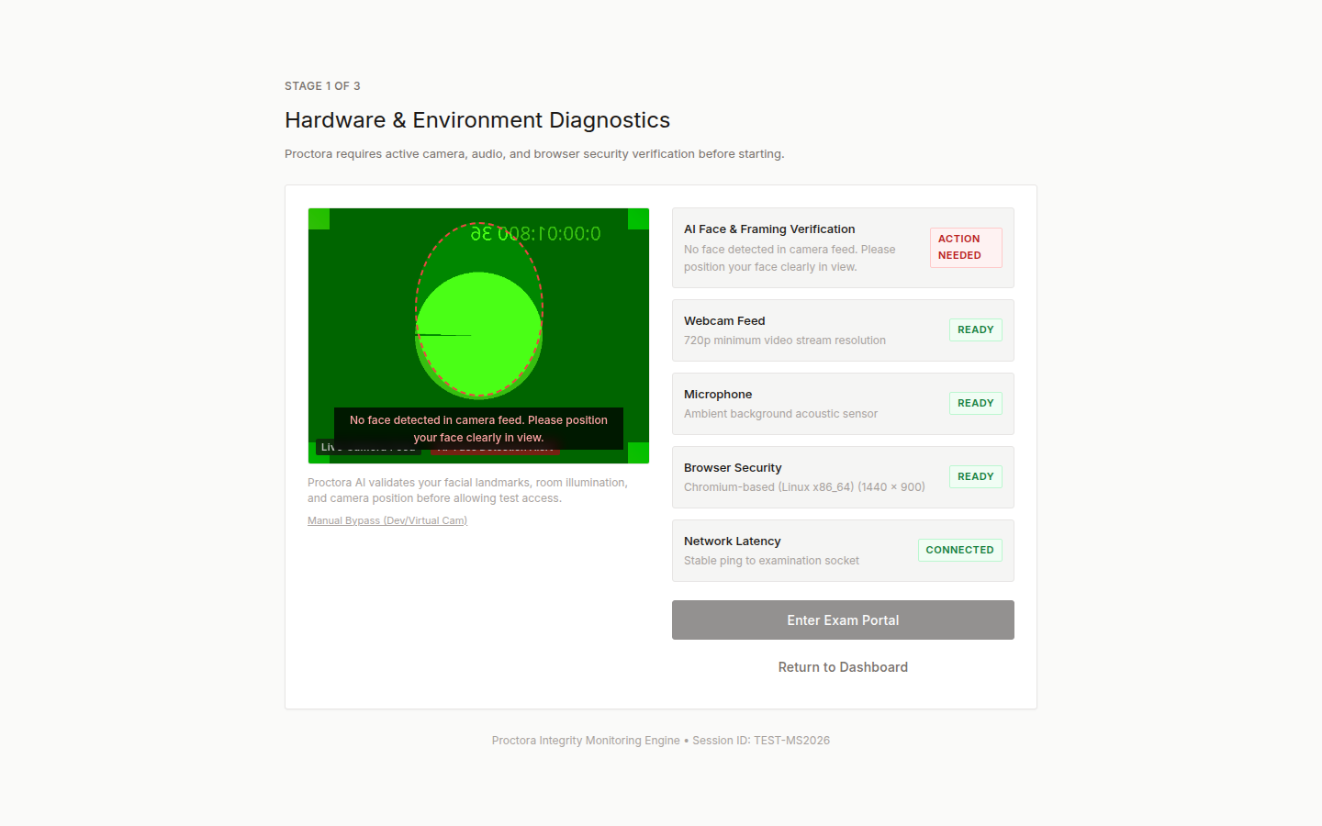

Step 3.3: Candidate Exam Portal & Lockdown Interface
The Exam Portal initiates browser lockdown enforcement (fullscreen monitoring, focus tracking). The interface displays the test title, live remaining timer, candidate live camera feed preview, and a numbered question navigation palette.
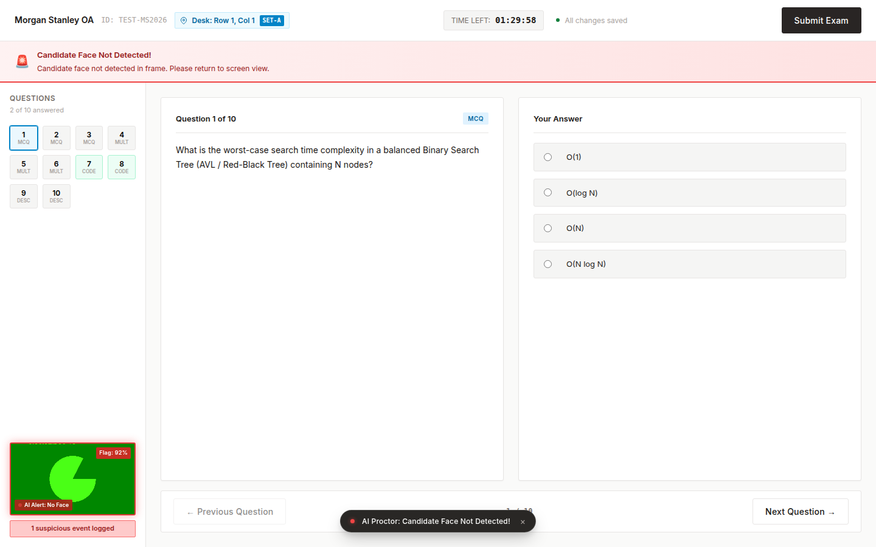

Step 3.4: Answering Single-Choice Multiple Choice Questions (MCQ)
For single-choice questions, candidates select their desired answer from the options. The response is immediately recorded and periodically autosaved. Candidates click 'Next' or use the palette to jump between questions.
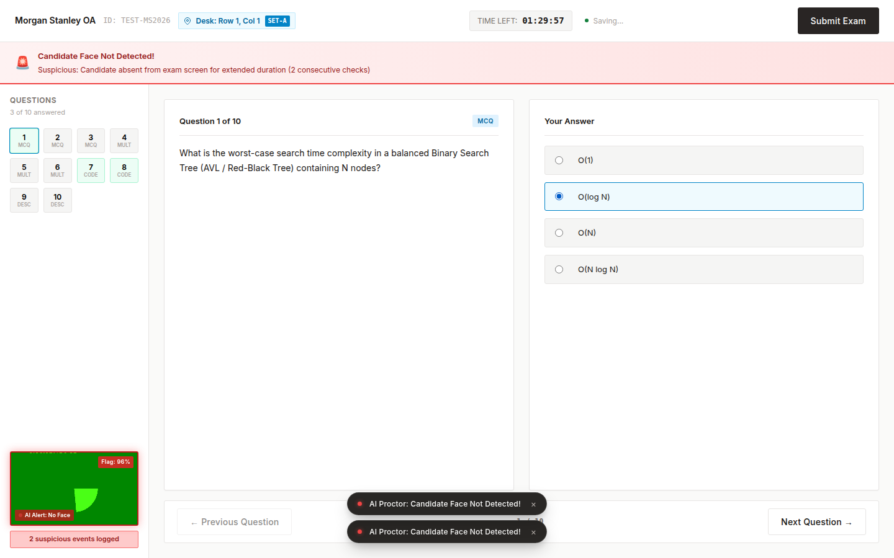

Step 3.5: Answering Multiple-Select Questions (MSQ)
For questions with multiple valid solutions, candidates select all matching checkboxes. The system keeps track of all checked options and updates question palette status in real time.
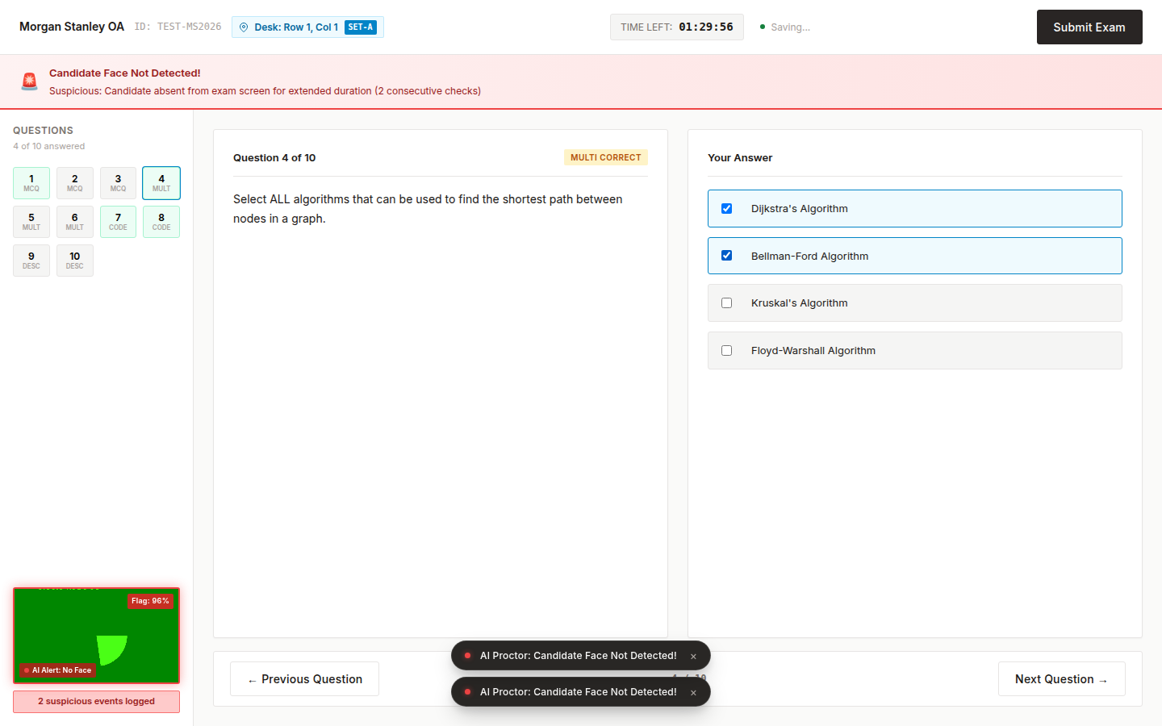

Step 3.6: Coding Environment with Monaco Editor & Real-Time Telemetry
For coding assessments, candidates write solutions within the embedded Monaco Editor (the editor powering VS Code) with syntax highlighting and auto-indentation. Keystroke timing, paste anomalies, and text deltas are continuously captured for academic integrity replay.
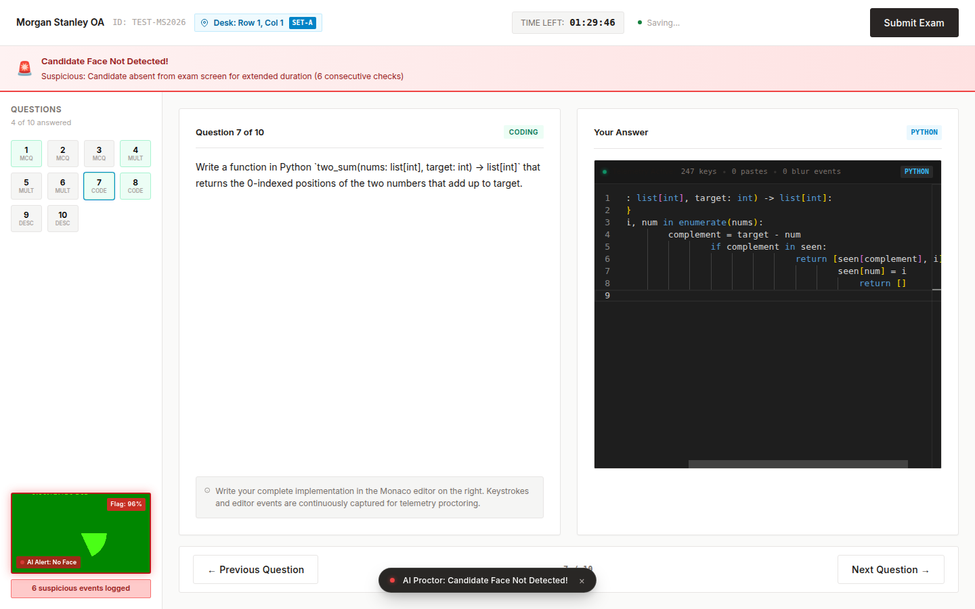

Step 3.7: Answering Descriptive & Essay Questions
Descriptive questions provide a multi-line response area. Candidates write comprehensive theoretical explanations, which are continuously synchronized to the backend via fault-tolerant autosave.
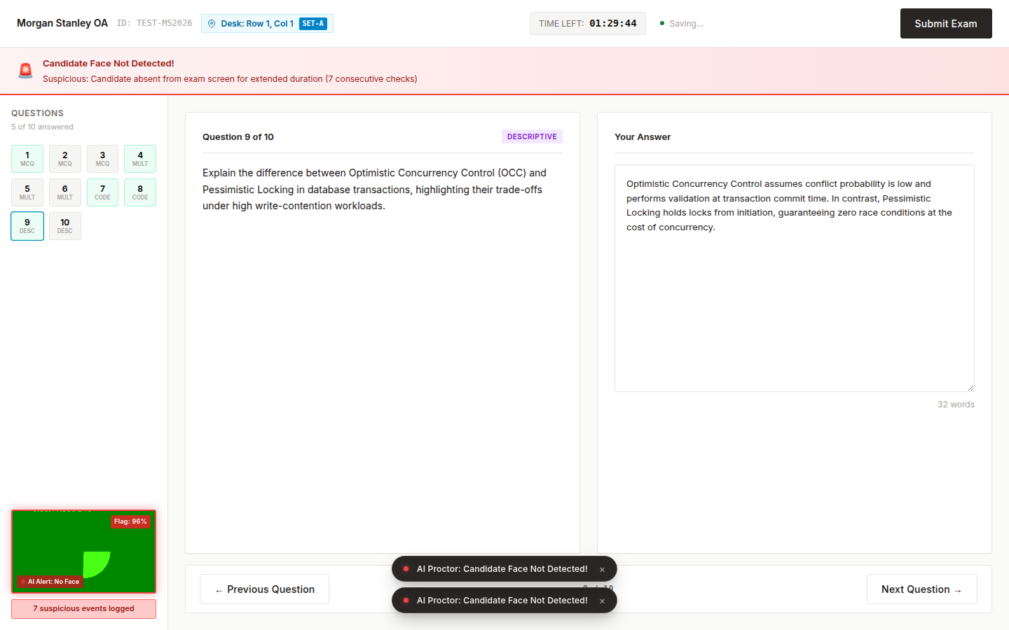

Step 3.8: Final Exam Submission Modal
When finished, candidates click 'Submit Exam' in the header. A confirmation dialog appears summarizing the total answered questions and warning that further changes cannot be made after confirmation. The candidate clicks 'Confirm & Submit Exam'.
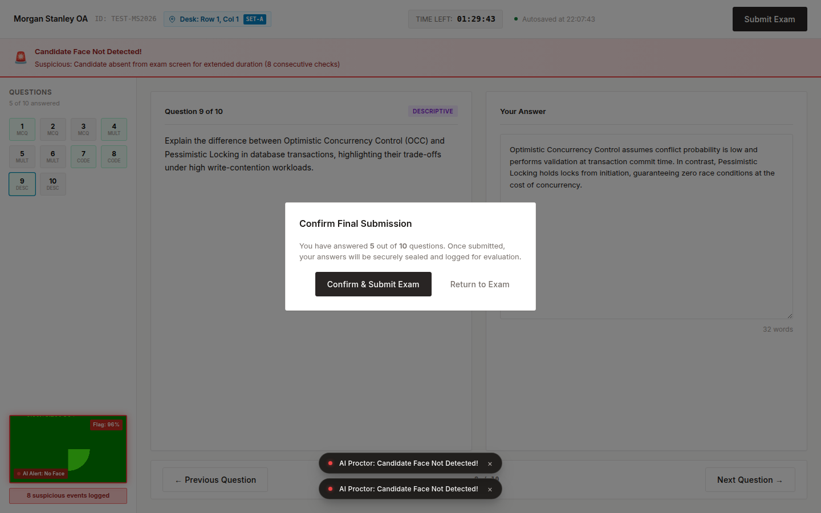

Step 3.9: Submission Confirmation & Receipt
Following submission, the candidate arrives at the completion receipt screen, which records the exam completion timestamp and guarantees that all responses and telemetry were successfully persisted.
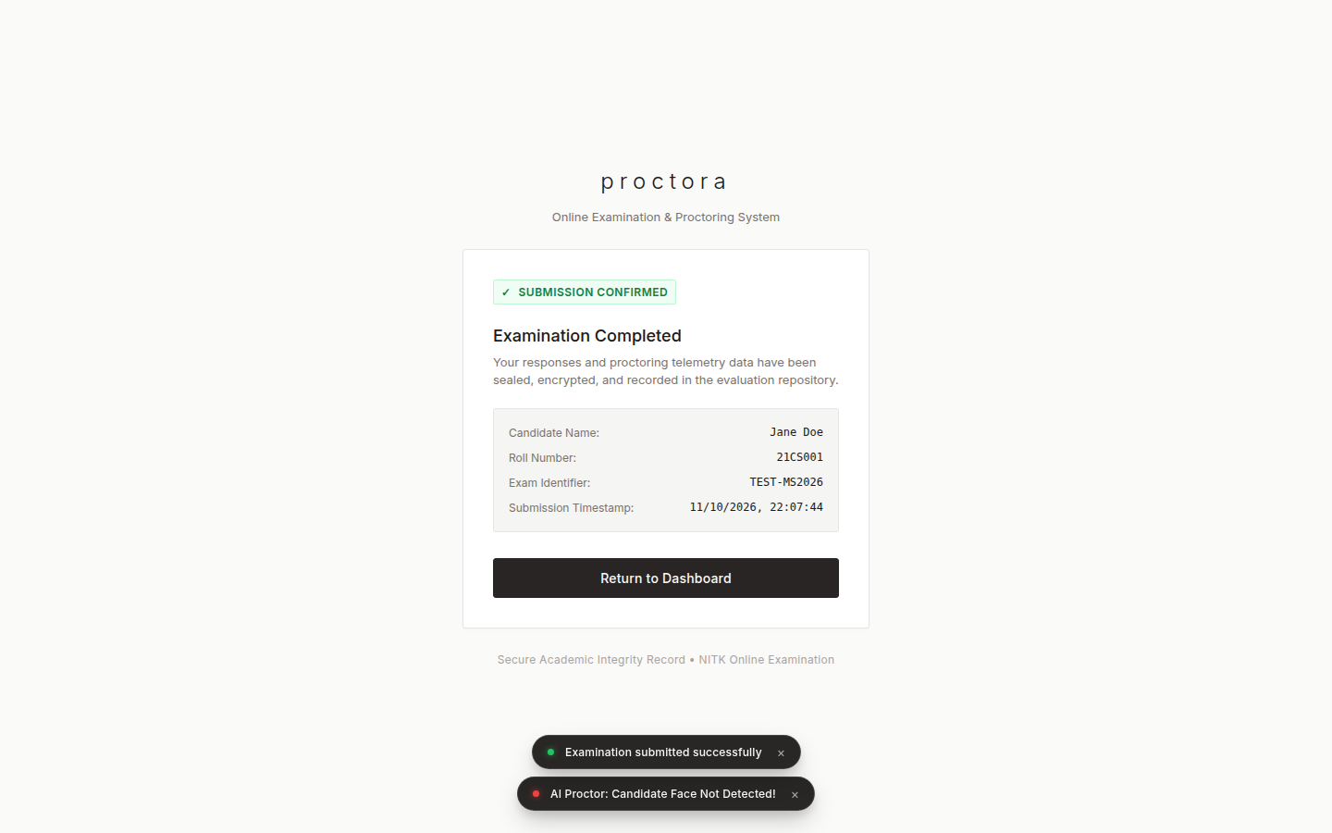

Flow 4: Administrator / Instructor Management & Invigilation Flow
This flow guides instructors through test authoring, question management, seating plan configuration, live proctoring supervision, and graded sheet reviews.

Step 4.1: Administrator Dashboard
The Administrator Dashboard provides an overview of active exams, total candidate registrations, and quick action shortcuts to the Test Studio and Live Monitor.
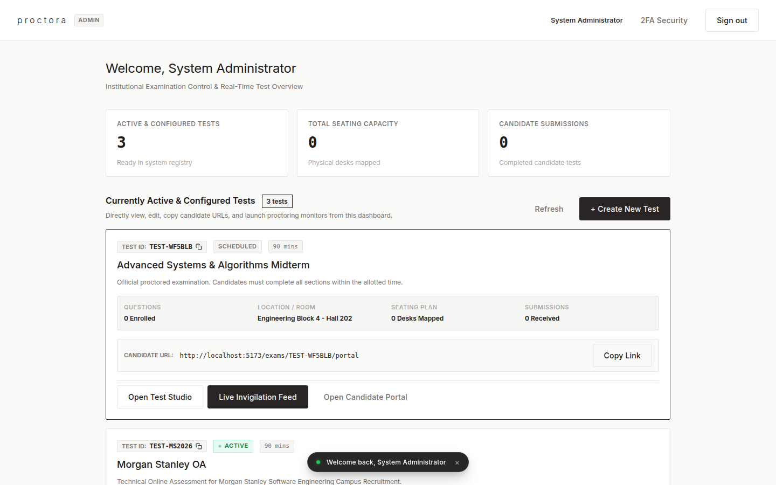

Step 4.2: Instructor Test Studio Overview
The Test Studio (/admin/exams) provides centralized management for all examinations. Instructors can create new exams, edit existing configurations, adjust question banks, and launch the invigilator monitor.
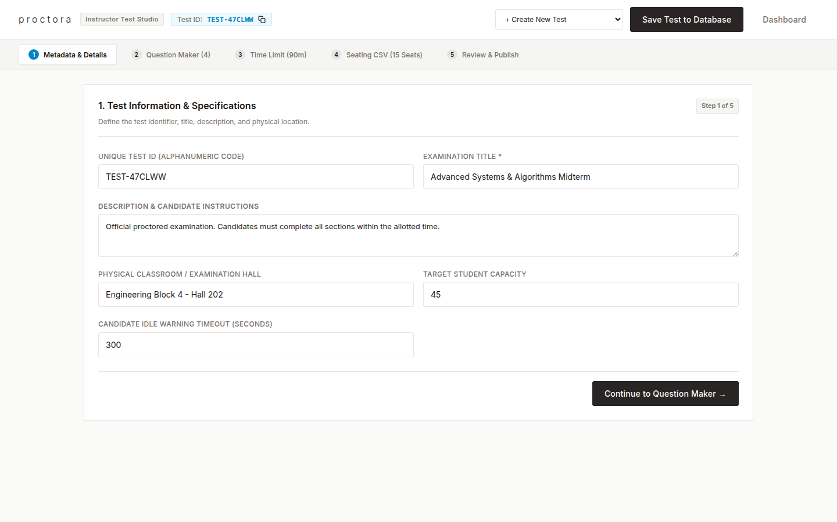

Step 4.3: Exam Details & Metadata Configuration
In the 'Metadata & Details' tab, instructors configure the Test ID, title, description, testing hall location, maximum candidate capacity, and idle auto-logout timeout.
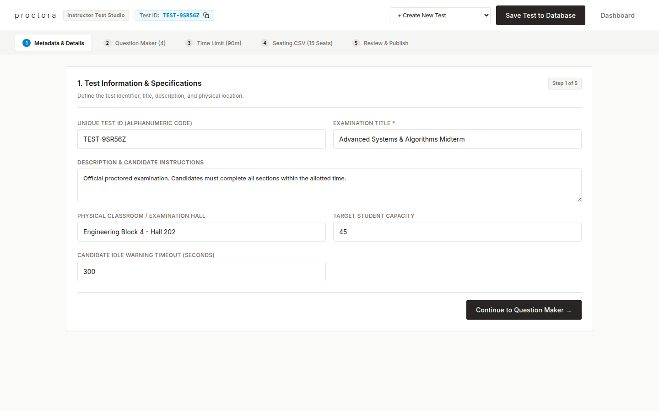

Step 4.4: Question Bank Builder & Multi-Format Authoring
In the 'Question Maker' tab, instructors create and edit questions across multiple formats (MCQ, Multi-Correct, Monaco Coding, Descriptive) with points, starter code, and answer keys.
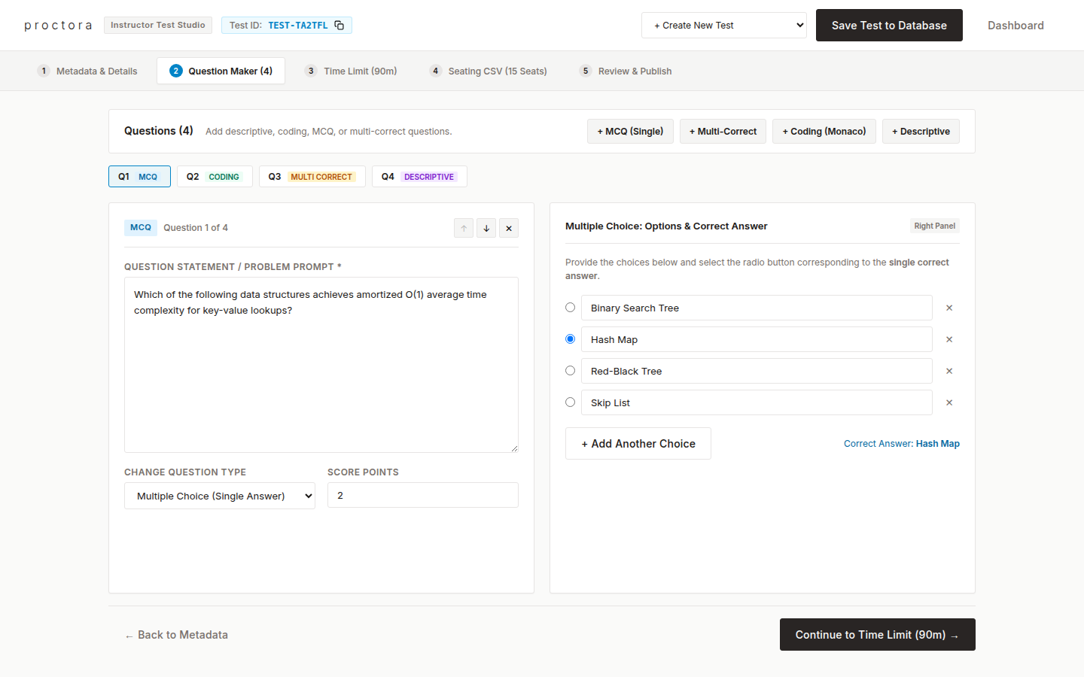

Step 4.5: Seating Plan & Classroom Coordinate Upload
In the 'Seating CSV' tab, instructors upload or define classroom desk coordinates (row and column mappings). Proctora uses these coordinates to deconflict question orders so adjacent students receive different question sequences.
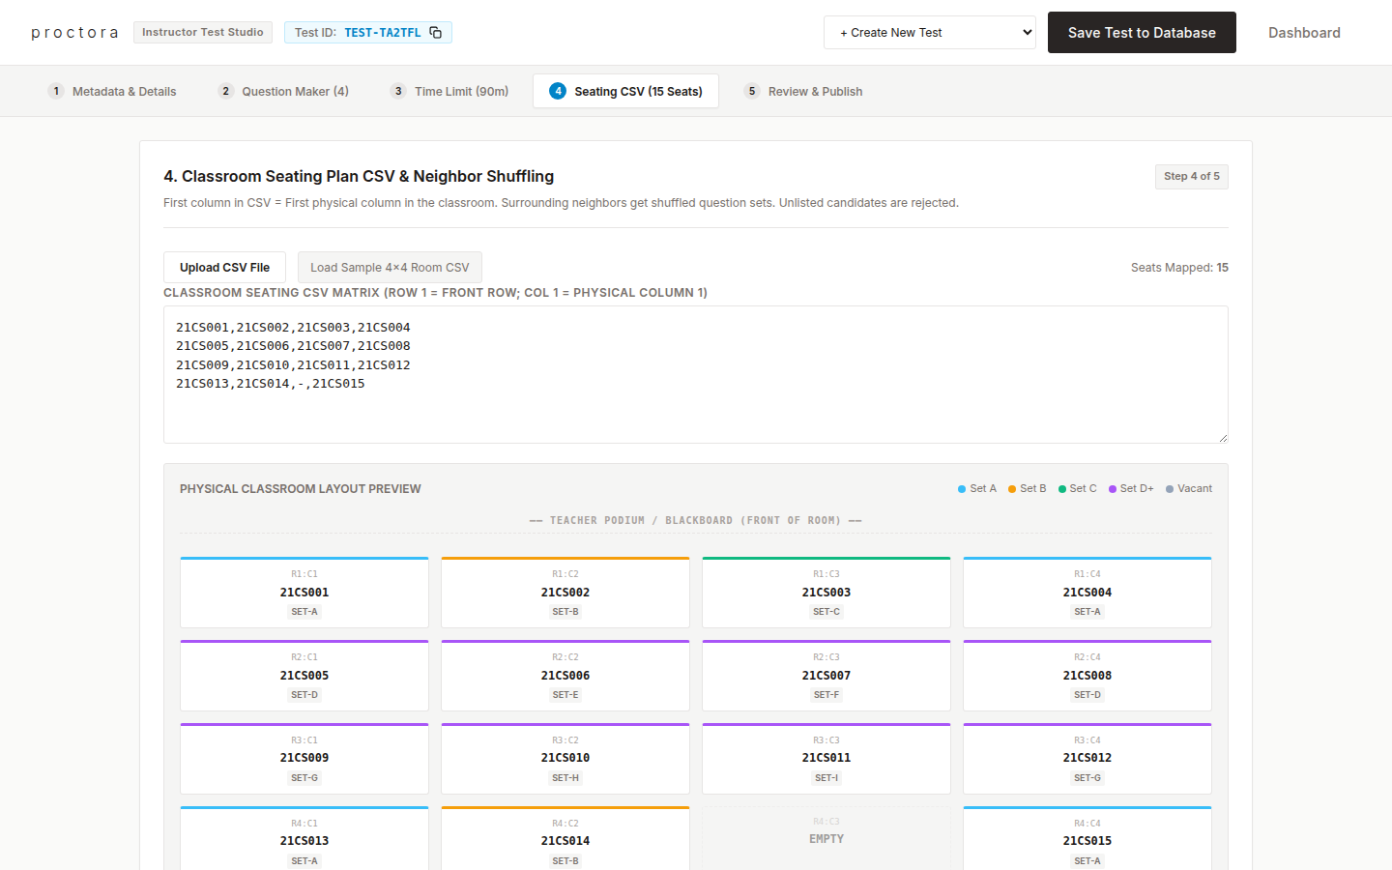

Step 4.6: Real-Time Live Invigilation & Proctoring Monitor
The Live Invigilation Monitor (/admin/exams/:examId/monitor) connects to real-time WebSockets. Instructors monitor student status cards, AI-detected infraction flags (looking away, missing face, multiple faces), tab focus loss, and live cheating risk scores.
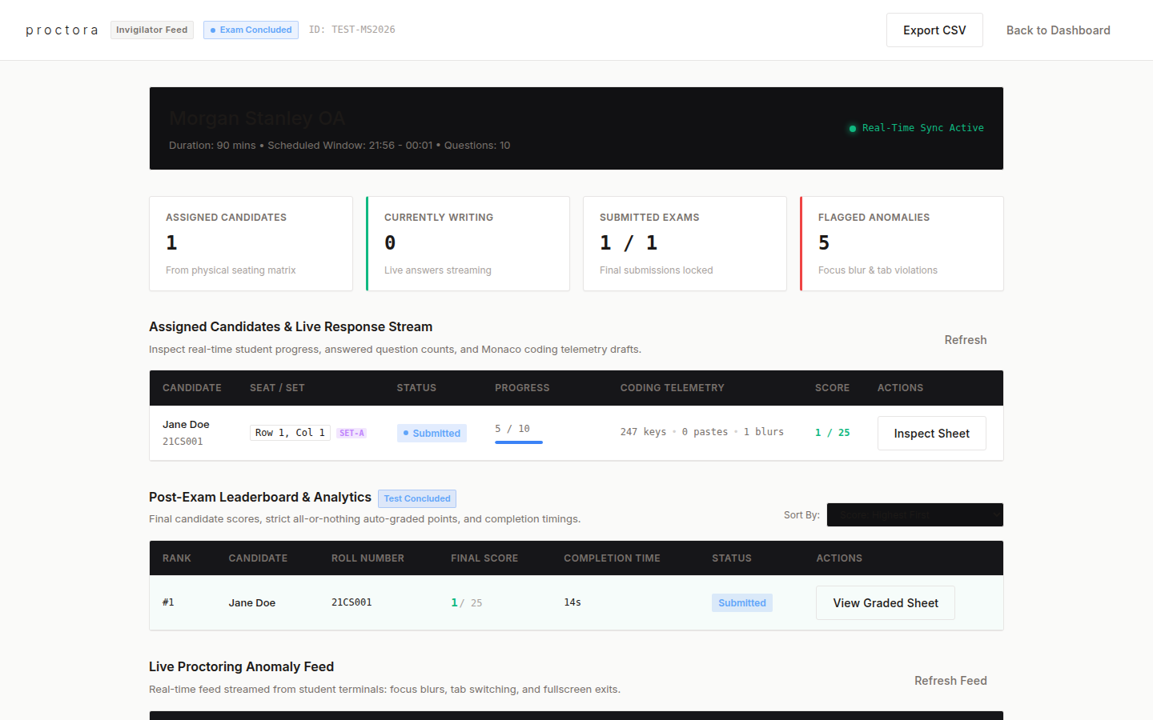

Step 4.7: Candidate Graded Answer Sheet & Telemetry Inspector
Instructors click 'Inspect Sheet' on any candidate card to open the Graded Sheet Viewer. This modal provides question-by-question candidate answers, code submissions, awarded points, and timestamped infraction logs.
