**Design – Program**

|  |
| --- |
| **Database** |
| Con  Cur |
| Fetch()  Insert()  Search()  Oldest_transaction_date()  Newest_transaction_date()  Get_unique_stock_symbols()  Get_cheapest_stock()  Get_expensive_stock()  Get_most_traded_stock()  fakeData() |

Database class consists of 2 properties and 10 methods

**Class Initialization**

DEFINE CLASS Database:

DEFINE FUNCTION __init__(self, db):

SET self.conn TO sqlite3.connect(db)

SET self.cur TO self.conn.cursor()

self.cur.execute(

"CREATE TABLE IF NOT EXISTS activities (id INTEGER PRIMARY KEY, date text, symbol text, t_type text, qty text, price text)")

self.conn.commit()

**FETCH**

DEFINE FUNCTION fetch(self):

self.cur.execute("SELECT * FROM activities")

SET rows TO self.cur.fetchall()

RETURN rows

**INSERT**

DEFINE FUNCTION insert(self, date, symbol, t_type, qty, price):

self.cur.execute("INSERT INTO activities VALUES (NULL, ?, ?, ?, ?, ?)",

(date, symbol, t_type, qty, price))

self.conn.commit()

**SEARCH**

DEFINE FUNCTION search(self, date, symbol, t_type, qty, price):

SET query TO f"SELECT * FROM activities WHERE date='{date}' AND symbol='{symbol}' AND t_type='{t_type}' AND qty='{qty}' AND price='{price}'"

self.cur.execute(query)

self.conn.commit()

SET rows TO self.cur.fetchall()

RETURN rows

**OLDEST TRANSACTION DATE**

DEFINE FUNCTION oldest_transaction_date(self):

SET query TO "SELECT MIN(date), symbol FROM activities"

self.cur.execute(query)

self.conn.commit()

SET row TO self.cur.fetchall()

RETURN row

**NEWEST TRANSACTION DATE**

DEFINE FUNCTION newest_transaction_date(self):

SET query TO "SELECT MAX(date), symbol FROM activities"

self.cur.execute(query)

self.conn.commit()

SET row TO self.cur.fetchall()

RETURN row

**GET UNIQUE STOCK SYMBOLS**

DEFINE FUNCTION get_unique_stock_symbols(self):

SET query TO "SELECT DISTINCT symbol FROM activities"

self.cur.execute(query)

self.conn.commit()

SET row TO self.cur.fetchall()

RETURN row

**OLDEST TRANSACTION DATE**

DEFINE FUNCTION get_cheapest_stock(self):

SET query TO "SELECT symbol, MIN(price) FROM activities"

self.cur.execute(query)

self.conn.commit()

SET row TO self.cur.fetchall()

RETURN row

**EXPENSIVE STOCK**

DEFINE FUNCTION get_expensive_stock(self):

SET query TO "SELECT symbol, MAX(price) FROM activities"

self.cur.execute(query)

self.conn.commit()

SET row TO self.cur.fetchall()

RETURN row

**MOST TRADED STOCK**

DEFINE FUNCTION get_most_traded_stock(self):

SET query TO "SELECT `symbol`, COUNT(`symbol`) AS `value_occurrence` FROM `activities` GROUP BY `symbol` ORDER BY `value_occurrence` DESC LIMIT 1"

self.cur.execute(query)

self.conn.commit()

SET row TO self.cur.fetchall()

RETURN row

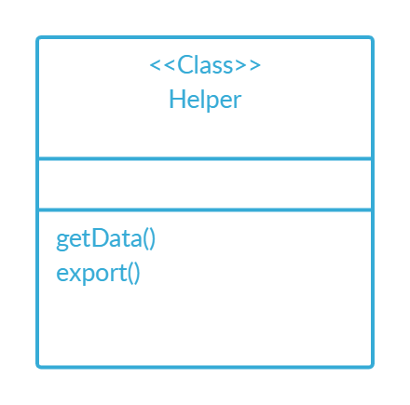

**HELPER METHOD TO DISPLAY SUMMARY DETAILS**

DEFINE FUNCTION getData(self):

# oldest transaction date & format text

SET oldest_transaction TO ", ".join(db.oldest_transaction_date()[0][:5])

self.oldest_transaction_date_label.config(

text=f"Oldest Transaction date: {oldest_transaction}")

# newest transaction date & format text

SET newest_transaction TO ", ".join(db.newest_transaction_date()[0][:5])

self.newest_transaction_date_label.config(

text=f"Newest Transaction date: {newest_transaction}")

# delete existing

FOR i IN self.treeview1.get_children():

self.treeview1.delete(i)

# get unique stock symbols & populate

SET symbols_count TO 0

FOR row IN db.get_unique_stock_symbols():

self.treeview1.insert("", 'end',

values=row)

symbols_count += 1

self.no_unique_stocks_label.config(

text=f"Number of unique stock symbols: {symbols_count}")

# Cheapest stock

SET cheapest_stock TO db.get_cheapest_stock()[0]

self.cheapest_stock_label.config(

text=f"Cheapest stock: {cheapest_stock[0]} (Price - ${cheapest_stock[1]})")

# Expensive stock

SET expensive_stock TO db.get_expensive_stock()[0]

self.expensive_stock_label.config(

text=f"Expensive stock: {expensive_stock[0]} (Price - ${expensive_stock[1]})")

# Most Traded stock

SET most_traded_stock TO db.get_most_traded_stock()[0]

self.most_traded_stock_label.config(

text=f"Most traded stock: {most_traded_stock[0]} ({most_traded_stock[1]} times)")

**HELPER METHOD TO EXPORT AS TXT**

DEFINE FUNCTION export(self):

SET text_file TO open("stock_activity.txt", "w")

FOR row IN db.fetch():

SET line TO ' '.join(str(x) FOR x IN row)

text_file.write(line + '\n')

text_file.close()

messagebox.showinfo(

'Success', 'TXT file exported successfully! Check your folder')

**FUNCTION TO POPULATE DATA IN ACTIVITIES TABLE**

DEFINE FUNCTION populate_list(self):

FOR i IN self.treeview1.get_children():

self.treeview1.delete(i)

FOR row IN db.fetch():

self.treeview1.insert("", 'end',

values=row)