PROJECT ONE PROPOSAL
Adaptive Focus Studio
Team Boomers
CSC 6360 - Mobile App Development
Section 002
Graduate Pathway
Proposal Date: October 17, 2026
Final Project Due: October 27, 2026

GitHub: https://github.com/harshitjain25/adaptive-focus-studio
ClickUp: https://app.clickup.com/90141778423/v/l/li/901422381505

1. Proposed Group Members and Ownership
Member | Student ID | Pathway | Main area | Shared work
Harshit Jain | 002916196 | Graduate | UI, Riverpod state, timer flow, Session Scout integration | CRUD review, testing, documentation, demo, and Q&A
Parsh Jadon | 002936134 | Graduate | SQLite data layer, repository and DI, automated tests, notifications, and file features | UI review, smart-helper evaluation, documentation, demo, and Q&A
The roles below show who will lead each area, but both of us will work across the whole project. We will both take part in planning, coding, testing, documentation, review, and the final presentation. Since we are both graduate students, we will also understand and explain the full core app and the graduate requirements.

2. Project Summary
Adaptive Focus Studio is a Flutter app for students who want a simple way to plan study sessions, use a focus timer, and learn from their own study history. The app will not use accounts, feeds, or cloud services. Users can create focus presets, start and control a study session, save the completed session, review and correct their history, and get a simple duration suggestion that they can accept or ignore.
The app will use SQLite for the main app records and SharedPreferences for simple settings. The important features will work without the internet. Our goal is to build a small and useful study app that is easy to understand, keeps the user in control, saves data correctly, and handles timer changes safely.

3. Target Users and User Stories
The target users are university students who study on their own and want a simple focus timer with saved local history instead of a complicated productivity app.
- As a student, I want to create reusable focus presets so I can quickly start a session for a subject or mood. This works when I can create, view, edit, and delete a preset, and the saved preset is still there after I restart the app.
- As a student, I want to start, pause, resume, finish, or reset a study session so I can record the time I actually completed. This works when the timer state is clear, paused time does not keep increasing, and pressing Finish more than once does not create duplicate logs.
- As a student, I want to review my study history and get a simple duration suggestion so I have a useful starting point for my next session. This works when the app explains the suggestion and lets me use it, change it, or ignore it.

4. Equal-Scope Contract Mapping
Requirement | Adaptive Focus Studio plan | How we will show it
Five screen roles | Dashboard, Preset Editor, Focus Session, History & Insights, Settings | Working navigation with clear Back and Cancel actions
Two related SQLite entities | FocusPreset and SessionLog | Validated CRUD for both and a clear parent-delete policy
Session workflow | Start, pause or resume, finish once, reset | Correct timer state, cleanup, and no duplicate saves
Filter and aggregate | Mood or preset filter; average completed session time with sample count | Dashboard and history update after add, edit, or delete
Settings | Default duration, reminder, motion, and optional sound settings | SharedPreferences keeps settings after restart
Widgets and controls | Reusable StatelessWidget cards, StatefulWidget form/activity, buttons, dialogs, slider | Clear difference between temporary screen state and saved data
Offline checks | SQLite and local settings only | Restart tests and tests on two devices or emulators
Peer-tested change | One usability issue found and improved | Before and after wireframes plus a repeat test

5. Local Data and Storage Plan
SQLite will store the two related types of app records. SharedPreferences will store simple settings. The app will not use cloud storage, remote login, live feeds, streaming services, or cloud AI.
Entity | Planned fields | Where users work with it
FocusPreset | id, label, moodTag, plannedSeconds | Dashboard, create/edit form, and delete action
SessionLog | id, presetId, startedAt, completedSeconds, moodTagSnapshot, status, source, note | Finish/manual entry, history, edit, and delete
One FocusPreset can have many SessionLog records. We will store all durations in seconds so the data stays consistent. We will also save the selected mood inside each session log, so changing a preset later does not change old history.
Delete policy: if a preset already has session logs, the app will not delete it immediately. The user will see a clear message and can remove the related logs first. This helps prevent accidental loss of study history.

6. Five-Screen Experience

Screen 1: Dashboard / Catalog
Shows saved focus presets, a mood filter, the average completed session time with the number of sessions used, an Add Preset button, and the Session Scout suggestion when there is enough history.

Screen 2: Create / Edit Preset
The same form will be used to create and edit a preset. It will include a preset name, mood tag, and study duration. A labeled duration slider will show the value clearly. The form will also show Save, Cancel, validation messages, and a saving state.

Screen 3: Focus Session
This screen controls the study session. It will include Start, Pause or Resume, Finish, and Reset. It will show the planned time, completed time, and current state. Reset will ask for confirmation, and the timer will stop safely if the user leaves the screen.

Screen 4: History & Insights
Shows saved session logs and supports adding a manual log, viewing history, editing a log, and deleting a log. Users can filter the list by mood or preset. The screen will also show the average completed time and how many sessions were used. If there is no history, it will show a clear empty message.

Screen 5: Settings
Stores the default duration, reminder setting, reduced-motion setting, and optional sound setting. It will also include a local session-summary export for the graduate file feature.

7. Required Smart Helper: Session Scout
Session Scout is a simple local smart helper that suggests a starting study duration. It uses clear rules based on saved local history. It is not a trained AI model. The user always makes the final choice.
- Inputs: the completed minutes from the three most recent finished sessions with the same saved mood tag. Cancelled, unfinished, and invalid sessions will not be used.
- Method: convert the saved seconds to minutes, find the median of the three values, and keep the final suggestion between 10 and 60 minutes.
- Explanation: the app will show the suggested duration and a short reason, for example, 'Based on your three most recent finished Calm sessions.'
- User control: pressing Apply only fills the duration field. The user can still change the value, choose Not now, or pick another duration. The helper will never start a timer or save a session by itself.
- Not enough data: if there are fewer than three matching finished sessions, the app will show 'Not enough history.'
- Baseline: we will compare Session Scout with a simple fixed suggestion of 25 minutes.
- Alternative considered: using the mean. We chose the median first because one very long or very short session has less effect on it.
- Example limitation: a student may have several short sessions during a busy week, so recent history may not match what they want today. Past duration also cannot tell us how focused the student was. Because of this, the suggestion is only a starting point.
Graduate evaluation: before the final test, we will keep the Session Scout rule and the 25-minute baseline fixed. We will compare both on at least five valid test cases that were not used to adjust the rule. We will record the two outputs, the expected result, the error or metric, the sample size, and any limits we notice. Invalid and no-data cases will be checked for correct feedback instead of giving them made-up scores.

8. Graduate Implementation Plan
Graduate requirement | Our plan | Primary lead
Advanced state management | Use Riverpod for shared session state, settings, and loading, error, and success states | Harshit
Architecture | Separate UI, app logic, and data code; use repositories, dependency injection, and ARCHITECTURE.md | Parsh
Background processing | Run session-summary work outside the main UI path when it makes sense | Parsh
Local notifications | Add a local focus reminder with clear permission and error messages | Parsh
File operations | Export a local session summary file | Parsh
Animations | Add a custom progress animation with reduced-motion support | Harshit
Testing | At least 10 useful unit tests, plus widget tests, integration tests, and a coverage report | Parsh with Harshit
Helper evaluation | Compare Session Scout with the fixed 25-minute baseline using held-out test cases | Harshit with Parsh

9. Must-Solve Reliability Challenge
The main reliability problem is making sure the timer behaves correctly when the user pauses, resets, finishes, or leaves the screen at the same time a timer update happens. We will prevent old timer updates from changing the screen and prevent duplicate finished-session logs. Tests with controlled time will check that paused time does not increase, Resume continues correctly, Finish saves only once, leaving the screen cleans up the timer, and saved sessions are still available after an offline restart.

10. Proposed Wireframes and Navigation
These wireframes are simple on purpose. They show the screen structure, controls, data flow, navigation, and error states instead of visual decoration. The create and edit screen can be shared. Dialogs and empty states are not counted as extra core screens.
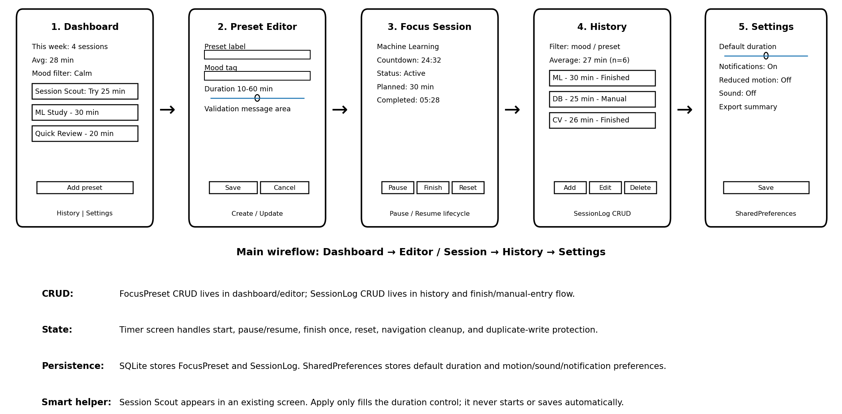
Figure 1. Proposed five-screen wireflow and local-data annotations.
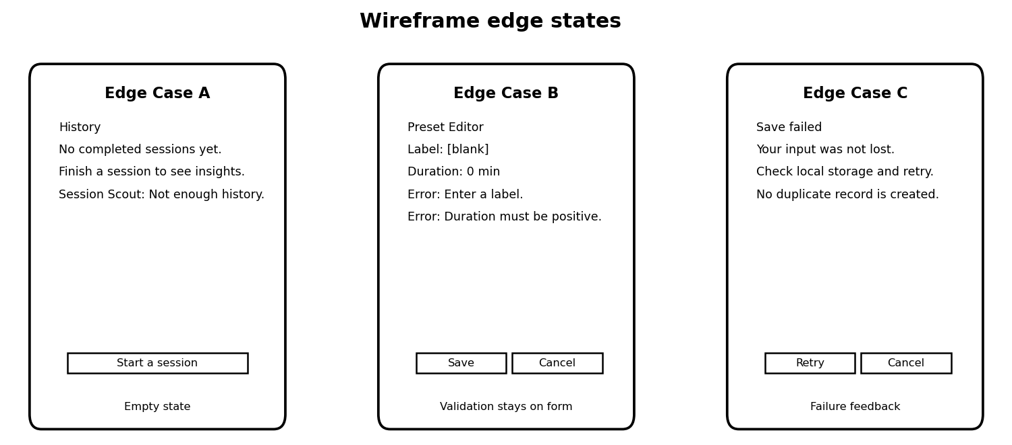
Figure 2. Planned edge states: empty history, invalid preset, and failed save.

11. Iterative Design and Test Plan
- Peer task 1: find a preset, change its duration, then cancel a second edit. Expected result: the saved change appears once, and the cancelled edit saves nothing.
- Peer task 2: start a short test session, pause it, resume it, finish it, and check the history. Expected result: the session states are easy to understand and only one completed log is saved.
- Peer task 3: enter invalid data and recover from a test save failure. Expected result: the form keeps the user's input and shows a clear message about what to fix or try again.
- Peer task 4: change a setting and restart the app while offline. Expected result: the setting and saved records are still there.
- Revision plan: we will note where the peer gets confused, improve one label, control, or layout, keep before-and-after wireframes, and repeat the same task to check whether the change helped.

12. ClickUp / Kanban Workflow
Board URL: https://app.clickup.com/90141778423/v/l/li/901422381505
Statuses: Backlog, Ready, In Progress, Review / Test, and Done.
WIP limits: each member can have one active In Progress task at a time, and the team can have no more than two tasks in Review / Test. A blocked task still counts until we resolve it or move it back for replanning.
Definition of Done: the task meets its acceptance criteria, the needed code or document is complete, the related commit or pull request is linked once coding begins, and the review or test result is recorded before the task moves to Done.
Task | Owner | Due | Done when
Project proposal | Harshit | Oct 17 | Proposal includes the team, links, scope, helper, Kanban plan, and wireframes
Signed team statement | Parsh | Oct 17 | All names, signatures, and dates are readable
Five-screen wireframes | Harshit | Oct 17 | All five screen roles, main navigation, CRUD actions, and at least two edge cases are shown
SQLite schema design | Parsh | Oct 17 | Both entities, their relationship, fields, validation, and delete policy are written down
Session Scout plan | Harshit | Oct 17 | Inputs, median rule, 10 to 60 minute limit, baseline, user override, no-data case, and evaluation are written down
GitHub repository setup | Parsh | Oct 17 | New repository is accessible and both members are collaborators
ClickUp planning setup | Harshit | Oct 17 | Statuses, WIP limits, owners, dates, and the Oct 17 board snapshot are ready
Graduate requirements plan | Parsh | Oct 17 | State management, architecture, advanced features, and testing work are listed on the board

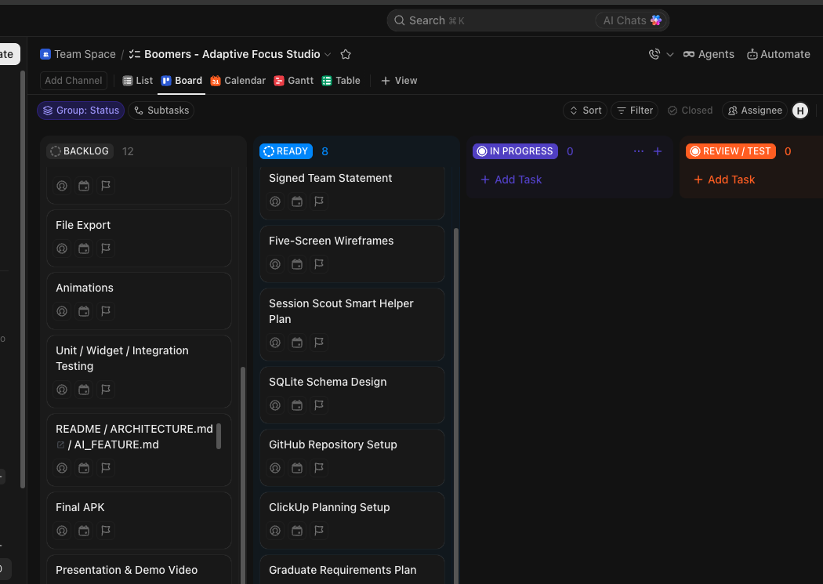
Figure 3. October 17 planning board snapshot for Team Boomers.

13. Milestone Plan
Date | Focus | What we plan to show
Oct 17 | Proposal and approval gate | Proposal, signed statement, GitHub and ClickUp links, wireframes, and board snapshot
Oct 18-20 after approval | Foundation and UI/navigation | Flutter structure, navigation, validated editor, first CRUD flow, settings, and Oct 20 board snapshot
Oct 21-23 | Core functionality and helper | Both CRUD flows, timer, filter and average, Session Scout, graduate features, and Oct 23 board snapshot
Oct 24-25 | Testing, accessibility, redesign | Two-device offline and restart tests, held-out helper test, peer revision, and documentation
Oct 26 | Release and presentation | Release APK, slides, selected questions, and rehearsed 20 to 25 minute video
Oct 27 | Final individual submission | Final board snapshot, final evidence package, working links, and verified upload receipt

14. Repository, Planning Links, and Signed Statement
GitHub Repository: https://github.com/harshitjain25/adaptive-focus-studio
ClickUp Board: https://app.clickup.com/90141778423/v/l/li/901422381505
Signed Statement: the completed team acknowledgment will be included with the official proposal submission as a signed PDF or clear image. All names, signatures, and dates will be readable. This proposal does not copy or create signatures.

15. Approval Gate
Team Boomers will wait for instructor approval before starting the app implementation. Before approval, we will only work on planning, wireframes, the GitHub repository, the ClickUp board, and the proposal. After approval, we will follow the project schedule and make regular, meaningful GitHub commits and ClickUp updates throughout the project.

