**DOCUMENTATION OS SELENIUM GRID**

1. Download selenium-server-standalone-<latest-version>.jar from <https://selenium-release.storage.googleapis.com/3.5/selenium-server-standalone-3.5.0.jar>
2. To start selenium hub open cmd in selenium-server-standalone.jar location
3. Run command “java -jar selenium-server-standalone-<latest-version>.jar -role hub”

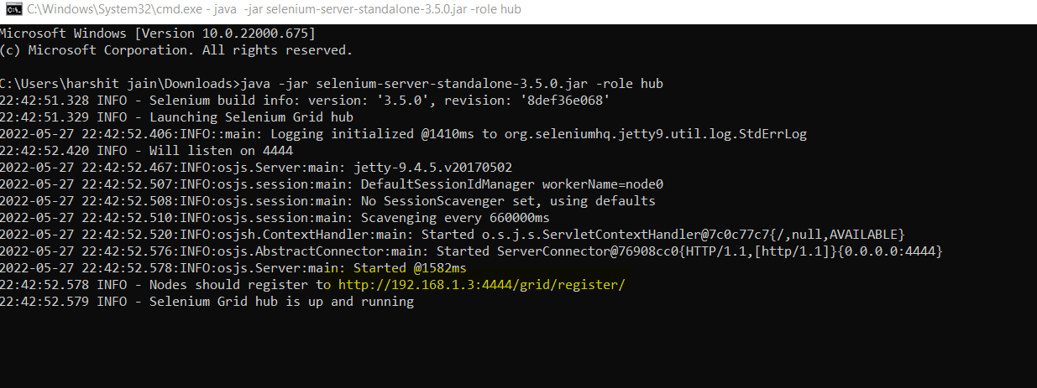

1. Copy the https url showing in command prompt. [ highlighted in above screenshot]
2. To register node again open cmd in selenium-server-standalone.jar location
3. Run command “java -Dwebdriver.chrome.driver="<chromedriver.exe location>" -Dwebdriver.gecko.driver="<geckodriver.exe location>" -jar selenium-server-standalone-3.4.0.jar -role webdriver -hub <http://192.168.1.3:4444/grid/register>”

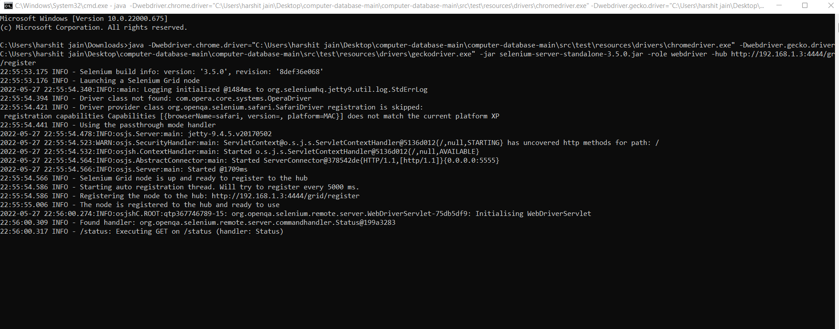

1. Now open chrome or firefox and run command “<http://192.168.1.3:4444/grid/console>“to see console

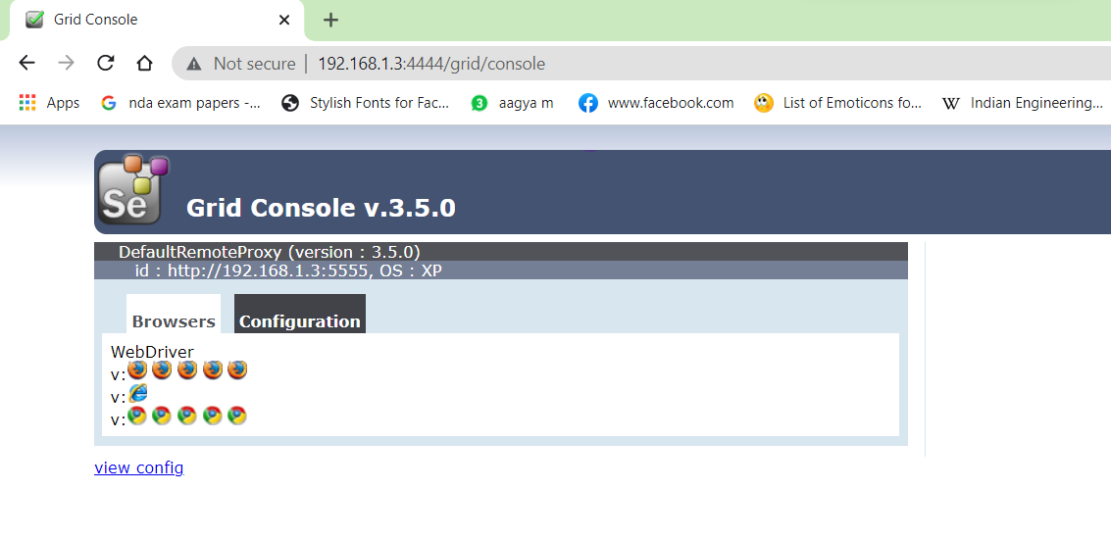

**Changes required to run this project on remote:**

1. **Go to config.properties**
2. **Change executionMode to remote**

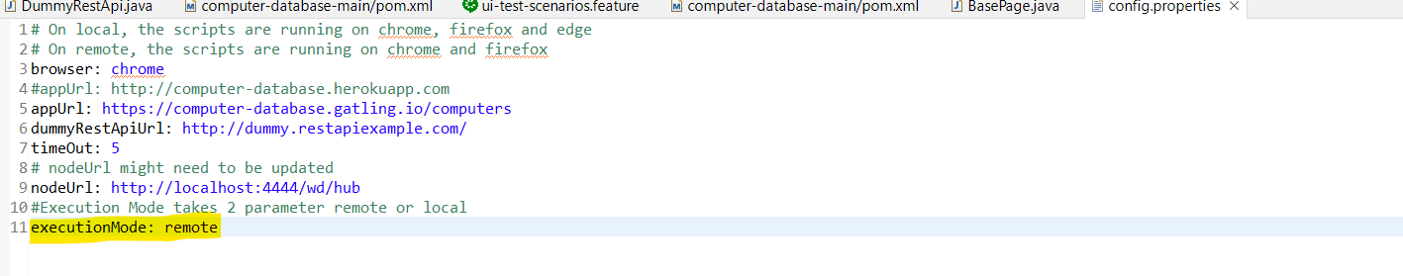

1. **Use browser chrome or firefox**