**MINI PROJECT REPORT**

**TIGER PUGMARK DETECTION**

*by*

**Abhinav Saxena**

**Entry. No.:19BCS004**

**HarshitJoshi**

**Entry .No.: 19BCS038**

Submitted in partial fulfillment of the requirements for the award of the degree

of

**BACHELOR OF TECHNOLOGY**

in

COMPUTER SCIENCE & ENGINEERING



**SHRI MATA VAISHNO DEVI UNIVERSITY, KATRA**

**(School of Computer Science & Engineering)**

# JAMMU & KASHMIR – 182 320

**Session 2021-22**

# ACKNOWLEDGMENTS

Date: ____________

I would like to express my sincere thanks to Dr. Ajay Kaul for his valuable guidance and support in completing my project.

I would also like to express my gratitude towards our HOD Dr. Baijnath kaushik for giving me this great opportunity to do a study project on Tiger Pugmark Detection. Without their support and suggestions, this project would not have been completed.

Abhinav Saxena

Harshit Joshi

Signature.

# DECLARATION

I the undersigned solemnly declare that the study project report Tiger pugmark detectionis based on my own work carried out during the course of our study under the supervision of Dr. Ajay Kaul.

I assert the statements made and conclusions drawn are an outcome of my research work. I further certify that

1. The work contained in the report is original and has been done by me under the supervision of mysupervisor.
2. The work has not been submitted to any other Institution for any other degree/diploma/certificate in this university or any other University of India orabroad.
3. Whenever we have used materials (data, theoretical analysis, and text) from other sources, we have given due credit to them in the text of the report and giving their details in the references.

## Signature of the student along with Date

*Abhinav Saxena Harshit Joshi*

19BCS004 19BCS038

B. Tech, 5th Sem B. Tech, 5th Sem

School of Computer Science & Engineering Shri Mata Vaishno Devi University, Katra

I endorse the above declaration of the Student.

(Name and Signature of the Supervisor)

# ABSTRACT

The protection of wildlife and forests is a major responsibility of human beings.  
Forest officials have to survey the tigers For monitoring there population,growth and there well being. There are several methods for tracking the movements of individual tigers. Earlier collaring was used by forest department to track tiger, but it is not an easy task, because collaring affects the natural habitat of tigers as radio collars are about 3-4 kgs heavy. Pugmarks are an alternative to tracking individual tigers. So in this study project we are performing study of various method on pugmark identification in order to identify and analyze the tiger living in forest. We are performing study of various image processingtechniques proposed by researchers and highlighting some of the important details related to the pugmark identification.

# TABLE OF CONTENTS

Acknowledgments i

Declaration ii

Abstract iii

Table of Contents iv

List of Figures vi

List of Tables vii

Abbreviations and Nomenclature viii

Chapter 1: INTRODUCTION 1

Chapter 2: LITERATURE REVIEW………………………………………………………13

Chapter 3: REQUIREMENT SPECIFICATION 15

Chapter 4: DESIGN………………………………………………………………….

Chapter 4: RESULTS AND DISCUSSION 9

Chapter 6: CONCLUSION ANDFUTURESCOPE 10

REFERENCES 11

# LIST OF FIGURES

Figure 9.1: Box 2

Figure 9.2: Rice 2

# LIST OF TABLES

Table 1.1: Tiger Breed Description 2

Table 1.2: Comparison between algorithms(box) 2

Table 2.1: Comparison between algorithms(rice) 4

# ABBREVIATIONS AND NOMENCLATURE

* + - PIP : Pug Impression Pad
    - PML : Pugmarklength
    - PMB : Pugmarkbreadth
    - DFA : Discriminant functionanalysis
    - MIL : Matrox imaginglibrary
    - SURF : Speeded Up RobustFeatures
    - SIFT : Scale-invariant featuretransform
    - ORB : Oriented Fast and RotatedBRIEF
    - PCA : Principal Component Analysis
    - DCT : Discrete Cosine Transform
    - RBFNN : Radial Basis Function Neural Network
    - PCA-DCT : COMBINATION OF PCAAND DCT

# 

# CHAPTER 1: INTRODUCTION

The tiger is one of the world's most recognizable animals connected with strength and untamed nature. Sadly tigers are on the brink of extinction. Just over a century ago, 100000 wild tigers roamed across Asia. Today, fewer than 3900 live in a mere four percent of their historic range. Much of this decline has occurred in the past few decades.

Due to this endangered status accurate population estimates are required, therefore monitoring of individual tigers in their natural habitat is needed.

Previously, a method called collaring was used to locate tigers, but collaring affects the natural habitat of tigers as radio collars are about 3-4 kg heavy. And process is also very difficult and time consuming.

There is also an alternate method named as pugmark detection for identification of individual tigers, an expert can identify pugmarks by inspecting visually. Pugmark is the term used to refer to the footprint of most animals (here tigers). Tiger’s pugmarks are used to analyze or distinguish between different breeds, gender, getting approximate population, age, etc

Table 1:Tiger Breeds

|  |  |  |  |  |  |  |
| --- | --- | --- | --- | --- | --- | --- |
| **Tigers** | **Latin Name** | **Range** | **Weight**  **(male/female)** | **Size**  **(male/female)** | **Endangered Status** | **Unique feature** |
| **Siberian Tiger** | Panthera Tigris altaica | North Asia | 389-475lbs 260-303lbs | 70-82 in/ 66-72 in | Endangered | Big size pale fur |
| **Bengali tiger** | Panthera Tigris Tigris | Indian subcontinent | 397-569lbs/220-350lbs | 110-120in/94-104in | Endangered | Large bodies,  white mutation |
| **Indochinese tiger** | Panthera Tigris corbetti | South East Asia | 331-430lbs/220-290lbs | 100-112in/92-100in | Near critically Endangered | Short,narrow,single stripe |
| **Malayan tiger** | Panthera Tigris malayensis | Southeast Asia | 220-308lbs/165-224lbs | 75-112in/70-103in | Critically endangered | Small |
| **South China Tiger** | Panthera Tigris amoyensis | Central and east china | 287-386lbs/220-254lbs | 91-104in/87-94in | Critically endangered and nearly extinction | Small ,rare,blue mutation |
| **Sumatran tiger** | Panthera Tigris sumatrae | Indonesia | 220-310lbs,165-243lbs | 87-100in/85-91in | Critically endangered | Small breed ,genetically isolated |
| **Caspian tiger** | Panthera Tigris virgata | Central Asia and Middle East | 370-530lbs/187-298lbs | 106-116in/94-102in | Extinct | Large bodies, muted colors |
| **Bali Tiger** | Panthera Tigris balica | Indonesia | 200-220lbs/143-176lbs | 87-91in/75-83in | Extinct | Formerly smallest tiger species |
| **Javan Tiger** | Panthera Tigris sondaica | Indonesia | 220-311lbs/165-254lbs | Around 90-100in | Extinct | Extinct but possible hiding |

.  
Goal of this project is to extract as much information from the given pugmarks of tiger using some kind of image processing techniques to get the output from the input pugmarks images. The Goal Of using this technique (pugmark detection), is to get approximate data about tigers in their natural habitat.

**LITERATURE REVIEW**

Sandeep Sharma et al. [1] have proposed a technique to identify tigers through their pugmarks. Author has identified parameters for the training of system. Parameter matching technique has been used for classification. Author has taken pugmarks which is 0.5 to 1cm deep in soil. The efficiency of technique was 92 percent

Gopinath Mahale, et al. [2] has implemented scale-able modular hardware solution for real-time Face Recognition (FR) on large databases. Author has used Weighted Modular Principle Component Analysis (WMPCA) and Radial Basis Function Neural Network (RBFNN) for implementation on hardware. Author used a novel format to store large database on off-chip memory so that it does not effect on performance of algorithm. Virtex-6 LX550T FPGA is used for implementation and testing. The speed of processor is 450 recognition per second on image of size 128 X 128 with 450 classes.

Bai Limin, et. al. [3] described different algorithms for face recognition and analyses. The database contains variety of pose, shelter, illumination, and expressions of various faces. The algorithms were tested for different applications. After analysis author concluded that efficiency of LBP algorithm is better than other algorithms.

Ramu Endluri et. al. [4] has developed FPGA based embedded platform using TSK 3000a processor for real time face recognition. Author has implemented PCA algorithm on FPGA processor. The model consists of a camera which can capture image and process through embedded processor to recognize image of a person. Author has tested the model in real time with a webcam attached to hardware. Due to the limitation of memory only two images were stored in database for testing.

Qasim Al-Shebani et. al. [5] presented existing hardware implementation for face recognition. The authors described different face recognition algorithm and importance of hardware developed on FPGA processor. Author has suggested hybrid feature extraction technique to improve accuracy of face recognition system. Author has developed door access control system using FPGA device.

Manzoor Ahmad Lone et. al. [6] has developed face recognition algorithm based on multi algorithmic approach. Author used four different algorithms Principal Component Analysis (PCA), Discrete Cosine Transform (DCT), Template Matching using Correlation (Corr) and Partitioned Iterative Function System (PIFS) for classification of image. Author has found the recognition rate of PCA-DCT technique is better than by individual PCA and DCT techniques and recognition rate by PCA-DCT-Corr technique is better than the PCA-DCT technique.

Janarbek Matai et. al. [7], presented a complete real-time face recognition system consisting of a face detection, a recognition and a down sampling module using an FPGA. Author has developed a system which captures video input from a camera, detects the locations of the face(s) using the Viola-Jones algorithm, subsequently recognizes each face using the significance algorithm, and outputs the results to a display and it operates at 45 frames per second on a Virtex-5 FPGA.

**CHALLENGES:-**

***Surveying the entire area****:* In reality, only an unknown fraction of the 3,00,000 km2 that is considered habitable by tigers, is searched intensively during censuses. For example, logistical constraints (e.g. in Namdapha, Sundarban), security concerns (e.g. in Nagarjuna Sagar, Indravati and Manas reserves) or staff shortages (almost everywhere) restrict the proportion of the area covered by field teams.

***Locating the tracks of every individual tiger:*** The probabilities of finding the tracks of each individual tiger in the surveyed area are low, except in a few reserves with high road density and suitable soil type.

***Selecting the appropriate pugmark:*** Lifting pugmarks from firm soil overlaid with dust or sand is an essential precondition to obtaining accurate pugmarks. Unless clear impressions of all the four paws on the right soil are detected for each individual tiger, it is impossible to pick the same hind pugmark of each individual for comparisons, as prescribed by the pugmark method. In reality, census personnel often do not find clear prints of all four paws, and consequently lift prints of the different paws of the same animal from different localities.

***Recording and recognizing tiger tracks:***The shape of the same tiger footprint traced by different persons may vary considerably. This variation can be reduced by using well-trained persons in controlled trials, but not in field censuses involving thousands of personnel with varying levels of skills.

**REQUIREMENTS SPECIFICATION:**

Pugmark Detection is carried out through image processing techniques.

* Pugmark (Tiger) image Data sets with proper labeling of its gender, age, and breed etc.
* A powerful Programming language used in image, such as Python or R.
* Algorithms to implement (such as SURF, SIFT, ORB etc).
* Libraries such as cv2 , matplotlib , pandas , numpy , tenser flow , sci-py etc.

**DESIGN**

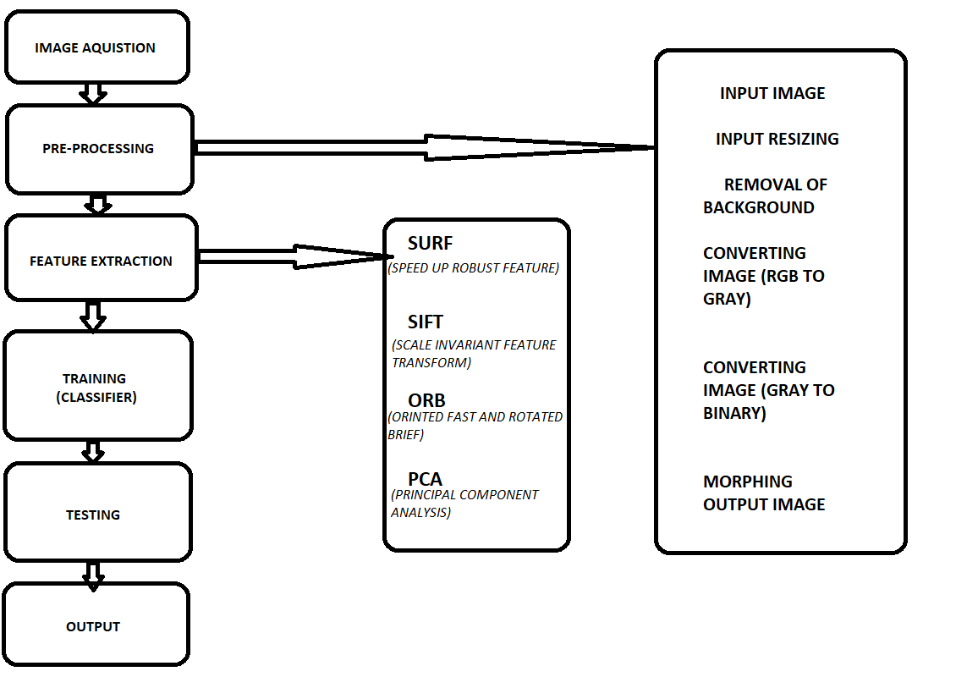

**Image Acquisition**

The image acquisition is done using a digital camera and it is loaded and saved using MIL software. MIL works with images captured from any type of color or monochrome source.

 MIL supports the saving and loading of images. It supports file formats such as TIF (TIFF), JPG (JPEG), BMP (bitmap), as well as raw format. Here the input image got is an RGB image.

**Pre-Processing image**

It includes resizing of image and DE-noising, conversion of RGB to gray scale and then binary image , and at last morphing of image.

* ***Image Enhancement=***Image enhancement is basically improving the interpret ability or perception of information in images for human viewers and providing better input for other automated image processing techniques.
* ***Background Subtraction=***Background subtraction is a process of extracting foreground objects in a particular scene. A foreground object can be described as an object of attention which helps in reducing the amount of data to be processed.
* ***Gray Scale=***Gray scale images have the only color which is a shade of only gray in between. Monochromatic is another name of gray image, denoting the presence of only one (mono) color (chrome). To convert any color to a gray scale representation of its luminescence, we must obtain the values of its red, green, and blue (RGB) primaries in linear intensity encoding, by gamma expansion. A gray scale image usually requires that each pixel be stored as a value between 0 – 255 (byte),where the value represents the shade of gray of the pixel. The number of gray levels typically is an integer power of 2 (L=2K).
* ***Binary Image=***A Binary Image is a digital image where the image has two assigned pixel values. Typically the two colors used for a binary image are black and white. The gray image of tomatoes is converted to binary image this means that each pixel is stored as a single bit (0 or 1).
* ***Morphing=***Morphing is an image processing technique used for the metamorphosis from one image to another. The idea is to get a sequence of intermediate images which when put together with the original images would represent the change from one image to the other. The simplest method of transforming one image into another is to cross-dissolve between them.

**Feature Extraction:-**

here are 14 parameters were identified for recognition of tiger thorough their pugmarks. The features identified for pugmark is as follows:

* ***SURF:-***
  + In computer vision, speed up robust features (SURF) is a patented local feature detector and descriptor. Mainly To detect interest points, it uses an integer approximation of the determinant of Hessian blob detector, which can be computed with 3 integer operations using a pre-computed integral image.
  + To detect interest points, SURF uses an integer approximation of the determinant of Hessian blob detector, which can be computed with 3 integer operations using a pre-computed integral image.
* ***SIFT-***
  + SIFT, or Scale Invariant Feature Transform, is a feature detection algorithm in Computer Vision. SIFT helps locate the local features in an image, commonly known as the 'key-points' of the image.
  + The scale-invariant feature transform (SIFT) is an algorithm used to detect and describe local features in digital images. It locates certain key points and then furnishes them with quantitative information (so-called descriptors) which can for example be used for object recognition.
* ***ORB*:-**
  + ORB is a fusion of FAST key-point detector and BRIEF descriptor with some added features to improve the performance. ... ORB is an efficient alternative to SIFT or SURF algorithms used for feature extraction, in computation cost, matching performance, and mainly the patents.
* ***PCA*:**
  + Pulse-code modulation (PCM) is a method used to digitally represent sampled analog signals. In a PCM stream, the amplitude of the analog signal is sampled regularly at uniform intervals, and each sample is quarantined to the nearest value within a range of digital steps.

**RESULTS AND DISCUSSION**

We use various research test data(few images) to check this. we check working of different algorithms by comparing 2 images(original, rotated image). We also use this to test some images of landmark. Result from above process is below:

Following algorithm(SIFT,SURF,ORB)[7][9] is tested by openCv in python on below image:



SAMPLE 1: Box.png

Result:

Table 2.1: Comparison between algorithms(box)

|  |  |  |  |  |
| --- | --- | --- | --- | --- |
|  | Box | Box(180) | Matches | Rate% |
| SIFT | 603 | 603 | 538 | 44.65 |
| SURF | 997 | 999 | 929 | 46.54 |
| ORB | 453 | 453 | 100 | 100 |

We tested this first on normal image of Box then checked it also on 180 rotated Box image.

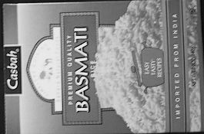

Sample 2: Rice.png

Result:

Table 2.1: Comparison between algorithms(rice)

|  |  |  |  |  |
| --- | --- | --- | --- | --- |
|  | Rice | Rice(180) | Matches | Rate% |
| SIFT | 489 | 491 | 452 | 46.12% |
| SURF | 607 | 600 | 559 | 46.31% |
| ORB | 383 | 383 | 383 | 100% |

So, here we can notice that SIFT and SURF get different key points for the same image when it rotated, also it gets less match. But if we consider about ORB it give same no. of key points (results) both original and rotated images and matches 100%. Here, we can notice that ORB is faster then others.

Important points to be noted down:

* After comparing SIFT, SURF and ORB, we can notice ORB is the fast algorithm.
* From the result, we can assume ORB gets key point more efficient than others. SIFT doing great work, but I assume that the ORB will give a more good result for researches.
* Note: SURF is not used now days.

**CONCLUSION AND FUTURE SCOPE**

After the complete examination of pugmarks of different species, it was concluded that in each and every different species pugmark number of different characteristics was present and according to which we can successfully identified the specific species through their pugmarks. Both in fore foot and hind foot of different animal species different characteristic were found. We can not only identify the species by their pugmark but also, we can identify weather it is fore foot or hind foot of the specific animal species.  
Through pugmark we can differentiate different species and also differentiate between if it is hind foot or fore foot of the different animal species. There was also some characteristic which were same in different type of species pugmark. Pugmarks of different species are distinct it is not same. There were some specific characteristics features found in each pugmark through which we can differentiate between the same family species. Cow, bull, and buffalo almost have same type of pugmark as they belong to same family but there was some specific feature in each animal pugmark through which we can differentiate between them.

There are still many problems in this project,…for an example it does not give right idea about current population of tiger. As image processing algorithm improve we will unlock many more ideas related to pugmark in near future.

REFERENCES

1. Sandeep Sharma, Yadvendradev Jhala and Vishwas B. Sawarkar “Identification of individual tigers (Panthera tigris) from their pugmarks” Journal of Zoology, pp: 9-18, 2005
2. Gu J, Alibhai SK, Jewell Z, Jianzhang MA (2014) Sex determination of Amur tigers (Panthera tigris altaica) from footprint in snow, Wildlife society bulletin 38: 495-502.
3. Patil SK, Shambhulingappa YB, Prasad RV, Jamuna K, Ramkrishna V, et al. (2012) Investigation of veterolegal case using hair and pugmark as a forensic tool. Indian wildlife yearbook 11-12: 134-6.
4. Sharma S, Jhala Y, Sharma V, Sawarkar B (2005) Identification of individual tigers (Panthera tigress) from their pugmarks. J Zool 267: 9-18.
5. Raj A, Choudhary P, Suman P (2015) Identification of tigers through their pugmark using pattern recognition. Int J Innov Res 15
6. Singh R, Qureshi Q, Sankar K, Krausman RP, Joshi BD, et al. (2014) Distinguishing sex of free-ranging tigers using pugmark measurements. Ital J Zool 81: 304-9.
7. Ebrahim Karami, Siva Prasad, and Mohamed Shehata” Image Matching Using (1) SIFT, (2) SURF, (4) BRIEF and ORB: Performance Comparison for Distorted Images” Faculty of Engineering and Applied Sciences, Memorial University, Canada
8. E. Karami, M. Shehata, A. Smith, “Image Identification Using SIFT Algorithm: Performance Analysis Against Different Image Deformations,” in Proceedings of the 2015 Newfoundland Electrical and Computer Engineering Conference,St. john’s, Canada, November, 2015.
9. Ethan Rublee, Vincent Rabaud, Kurt Konolige and Gary Bradski, “ORB: and efficient alternative to SIFT or SURF,” IEEE International Conference on Computer Vision, 2011.
10. Y.Ke and R. Sukthankar, “PCA-SIFT: A more distinctive representation for local image descriptors.” in Proc. CVPR. Vol. 2, pp. 506–513, 2004.
11. Herbert Bay, Tinne Tuytelaars and Luc Van Gool, "Speeded-up robust features (SURF)," Computer vision and image understanding, vol.110,No.3, 2008, pp. 346-359.
12. P. M. Panchal, S. R. Panchal, and S. K. Shah, “A Comparison of SIFT and SURF,” International Journal of Innovative Research in Computer and Communication Engineering, vol. 1, no. 2, pp. 323-327, 2013