Game Design Document

Fill up the following document

1. Write the title of your project.

Mad zombie killer.

1. What is the goal of the game?

To get safe from the zombies by killing them .

1. Write a brief story of your game.

A preson is stucked into a graveyard and after moving around he saw

that there are too many zombies around him .To live he need to kill

all of the zombies and save himself .

1. Which are the playing characters of this game?

* Playing characters are the ones who respond to the user based on the input from the user.
* Cars, monkeys, dinos, wizards, etc., are the playing characters in the game.

|  |  |  |
| --- | --- | --- |
| Number | Character Name | What can this character do? |
| 1 | Zombie killer | He has the skill to kill zombies |
| 2 |  |  |
| 3 |  |  |
| 4 |  |  |
| 5 |  |  |
| 6 |  |  |
| 7 |  |  |
| 8 |  |  |

1. Which are the Non-Playing Characters of this game?

* Non-Playing characters are the ones that don't have an action or behavior when the user interacts with the game.
* Hurdles, stones, bananas, coins, etc., are non-playing characters in the game.

|  |  |  |
| --- | --- | --- |
| Number | Character Name | What can this character do? |
| 1 | zombies | These can decrease  The lifebar of hero or even can kill him |
| 2 | hearts | Increase the lifeline of the player |
| 3 |  |  |
| 4 |  |  |
| 5 |  |  |
| 6 |  |  |
| 7 |  |  |
| 8 |  |  |

Draw your imagination of this game. What does this game look like?

* Draw the game either on your computer or on paper.
* Add images of the game scenes to show each of the playing and non-playing characters at least once.

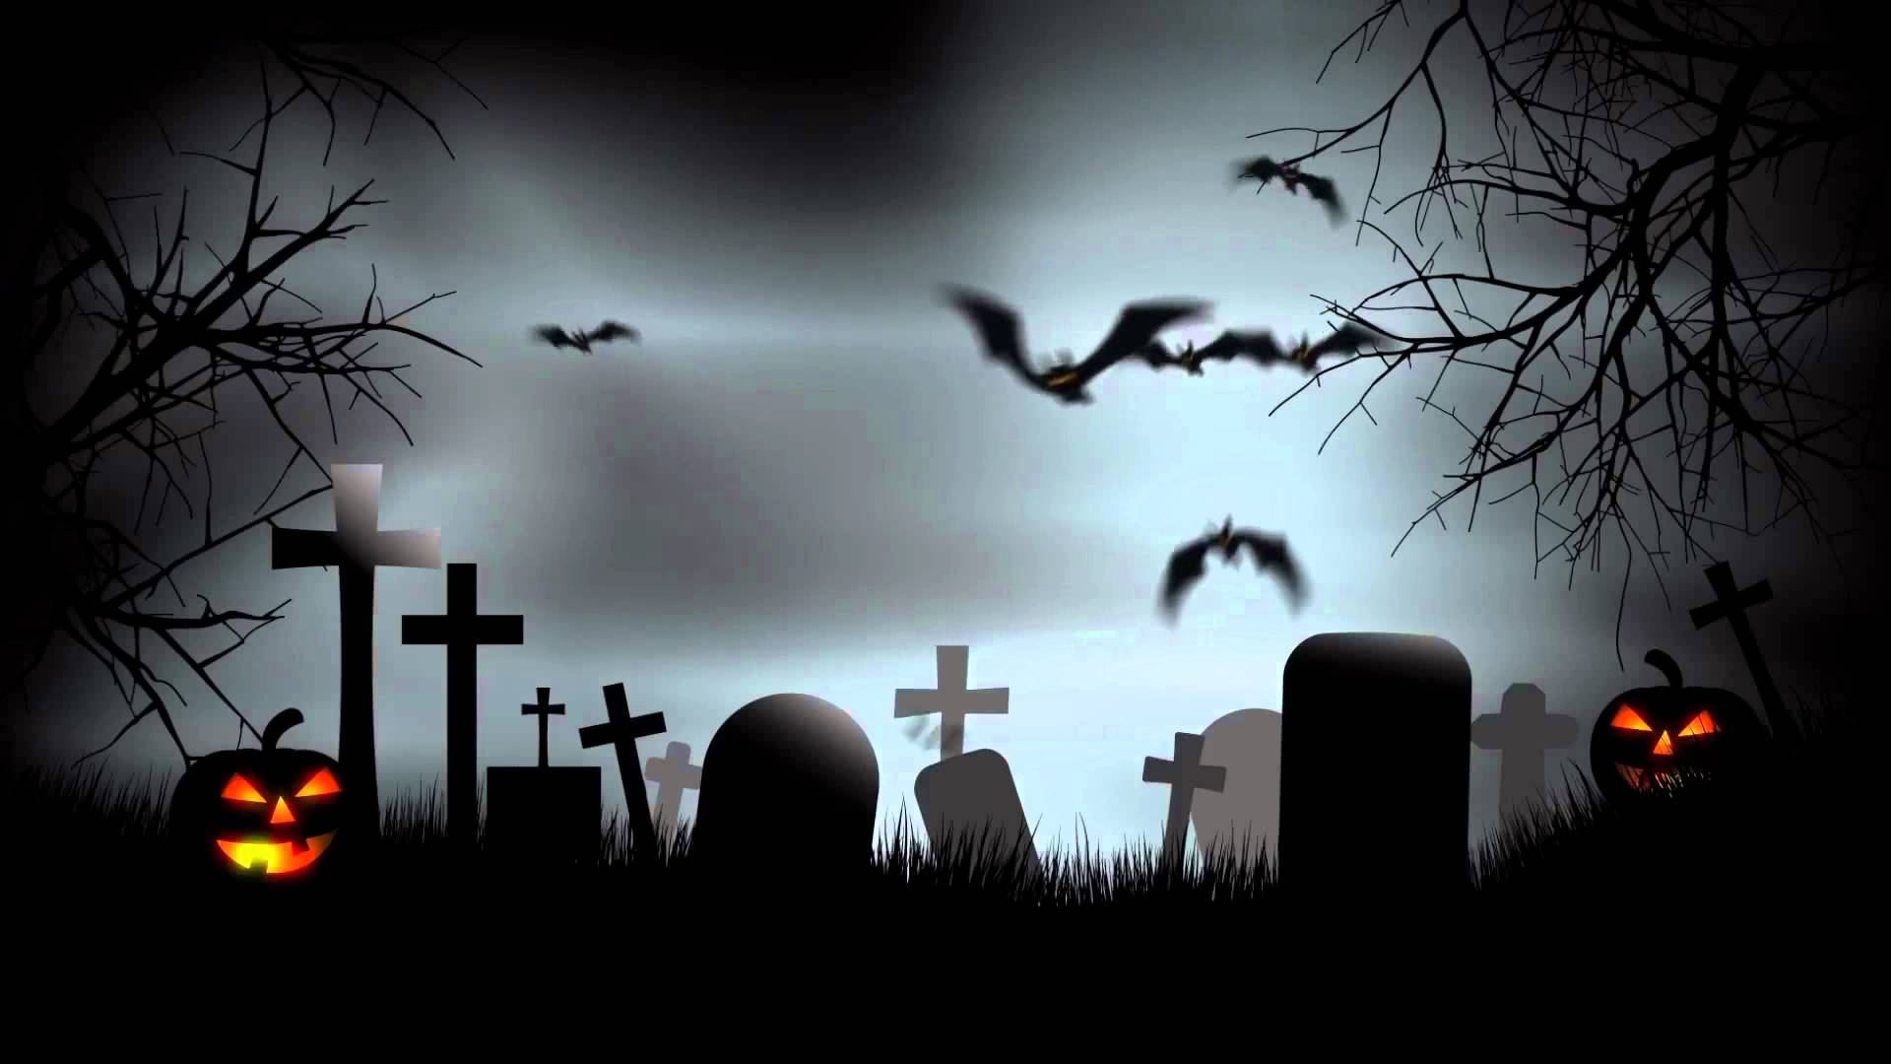

How do you plan to make your game engaging?

By adding

● Characters (PC and NPC) ● Story ● Goals ● Rules ● Balance ● Adaptivity ● Chance vs Skill ● Feedback