Practical 05
Tool 1: TubeBuddy
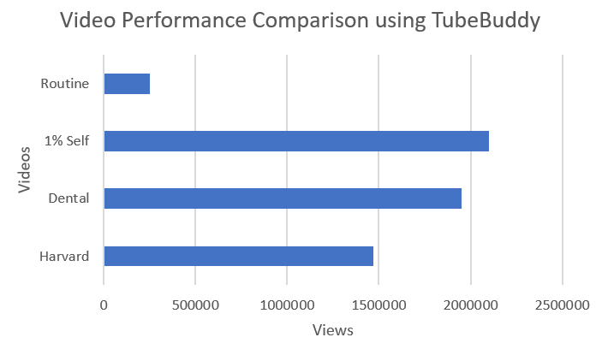
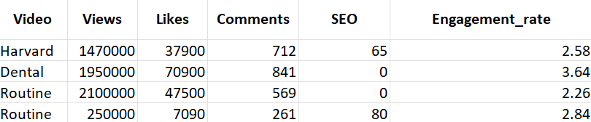
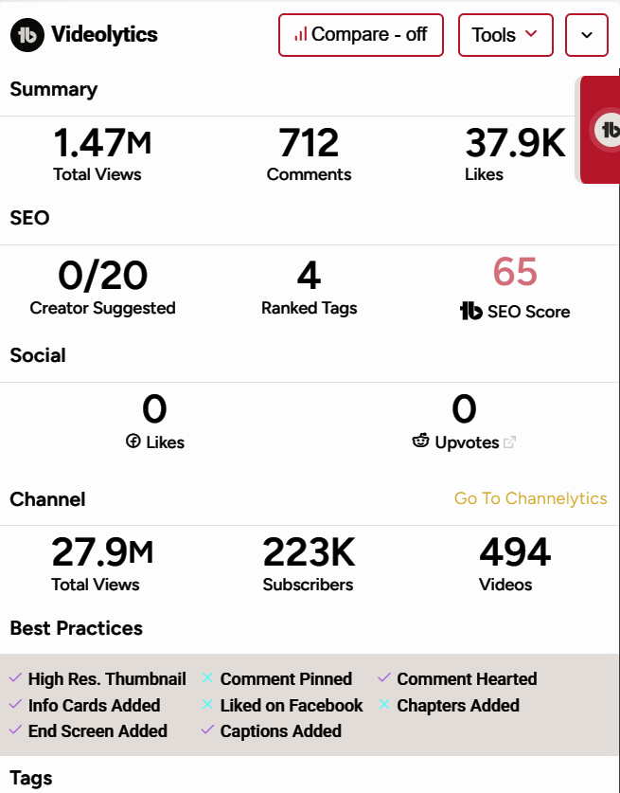
The selected “Day in Life” videos were analyzed using TubeBuddy. Among the four videos, the Productive Routine video has the highest views (2.10M), indicating greater audience reach. The Dental Student vlog shows the highest engagement rate (3.64%), suggesting strong audience interaction. The Self-Improvement video has the highest SEO score (80), but comparatively lower views, indicating that SEO alone does not guarantee high performance. Overall, TubeBuddy helps in comparing video performance and optimizing content strategy.

Tool 2: VidIQ
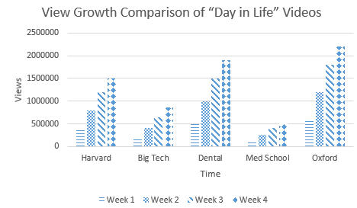
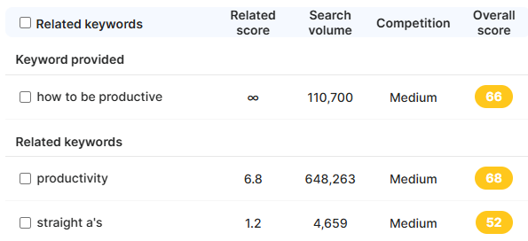
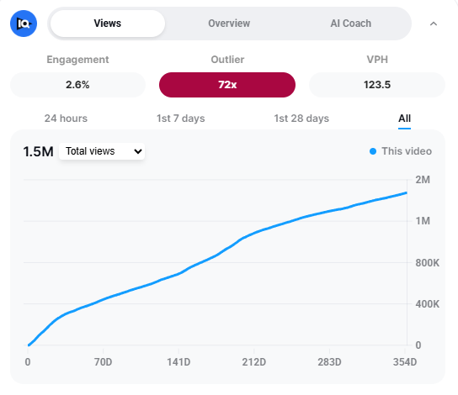
The Keyword Inspector feature of VidIQ was used to analyze keyword performance. Keywords with low overall score and low search volume were identified as low-performing and excluded from analysis. High scoring keywords such as “productivity” (68) and “how to be productive” (66) were retained for optimization.

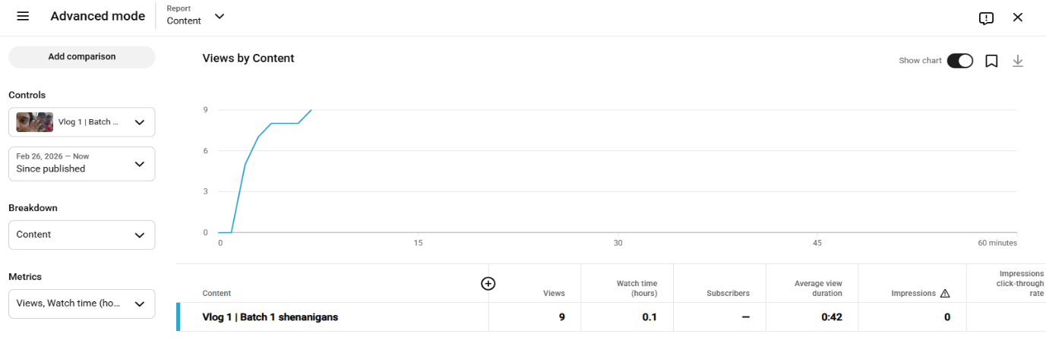
Tool 3: YouTube Studio

