**Name: Harshit Dave**

**Roll No.: 2019IMT-036**

**AI-Project**

**Title: Rock-Paper-Scissors game**

**Submitted to:**

**Dr. Pinku Ranjan**

**Introduction:**

As we know **game playing** is an important domain of **artificial intelligence**. Games don’t require much knowledge, the only knowledge we need to provide is the **rules, legal moves and the condition of winning or losing the game**. Both the player and computer try to win the game. So, both of them try to make their best move possible at each turn.

Rock paper scissors is a hand game that is usually played between 2 people, each player can randomly form any one of the three from their hand.

The objective of this project is to build a game for a single player that plays with a computer, anywhere, and anytime.

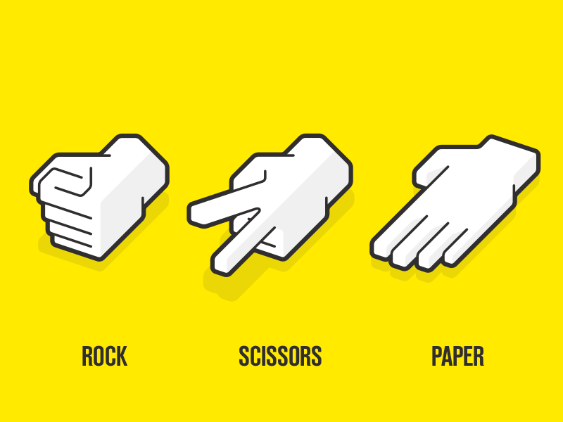

**Rules:**

This project is based on the rules that:

* Rock blunts scissor, so rock wins
* Scissors cut the paper, so scissors win
* Paper cover rock, so paper wins
* If both players choose the same then the game is tied.

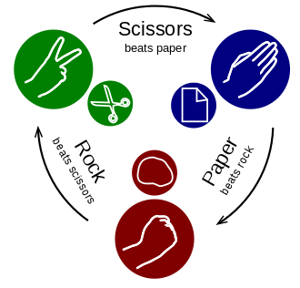

**Project Prerequisites:**

To implement this project, we will use the basic concept of python with tkinter and random modules.

* Tkinter is a standard GUI library which is one of the easiest ways to build a GUI application.
* random module is used to generate random numbers.

**Code:**

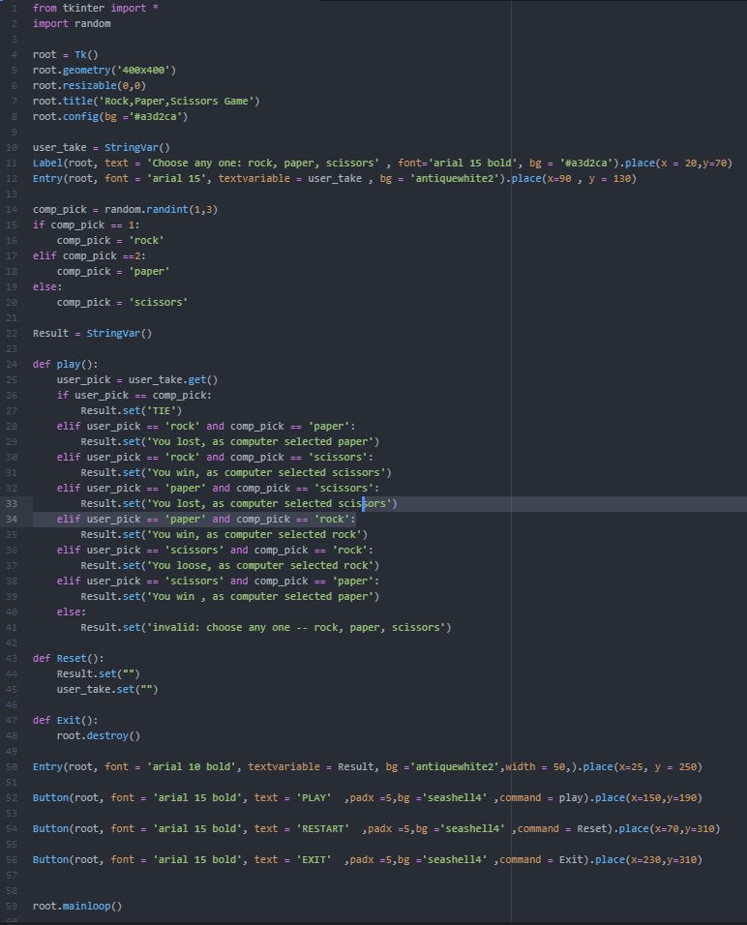

**Methodology:**

1. Importing the libraries

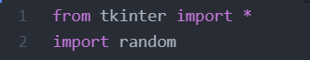

Here, we required two modules so we need to import tkinter and random modules.

1. Initialize window

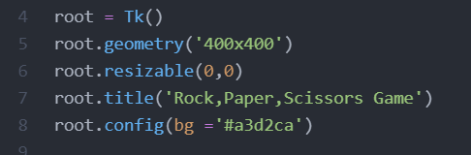

Here, Tk() is used to initialize Tkinter to create window, geometry() sets the window width and height, title() is used to set the title of the window, bg sets the background colour.

1. User’s choice



Through this user will be able to input rock, paper or scissor.

1. Computer’s choice

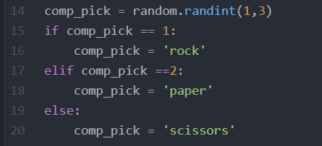

random.randint() will generate any number from the given range of numbers. So, if computer choose 1 then rock will set to comp_pick variable, similarly for paper and scissors.

1. Result

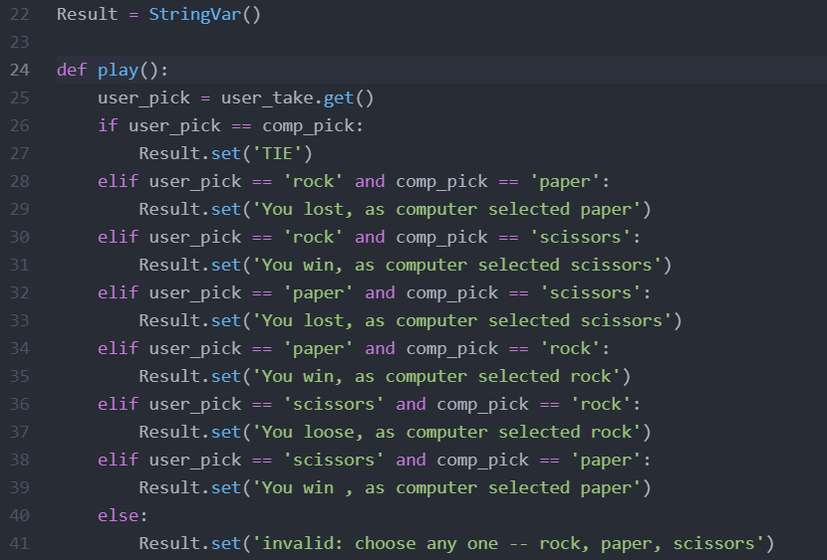

Here, we give the if-else() condition to get the result of the game. If user_pick is equal to comp_pick, its tie and if there are not equal, then on the basis of the rules mentioned above, the winner is declared.

If the user didn’t write among rock, paper, scissors, then an invalid message would be shown to the user.

1. Reset or Exit:

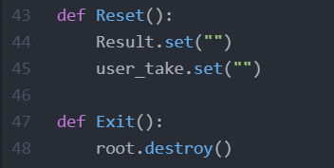

After getting the winner, either we can reset the game so that we can play it again or we can click on the exit button to exit the game.

**Result & Discussion:**

We will get the output of this project by writing ***python game.py*** on the terminal to run the program.

* Output 1

Here, the user has written rock and after that computer has chosen scissors.

As mentioned in the rules above, rock blunts scissor. So the winner is the user.

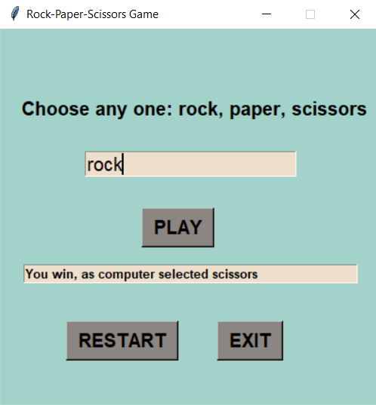

* Output 2

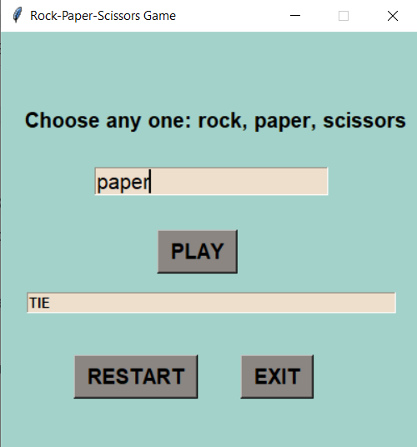

Here, user_pick = comp_pick, so according to the rules, this game is tie.

* Output 3

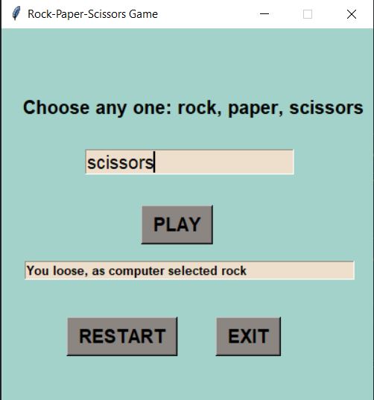

Here, the user has written scissor and after that the computer has chosen rock.

As mentioned in the rules above, rock blunts scissor. So the winner is the computer.

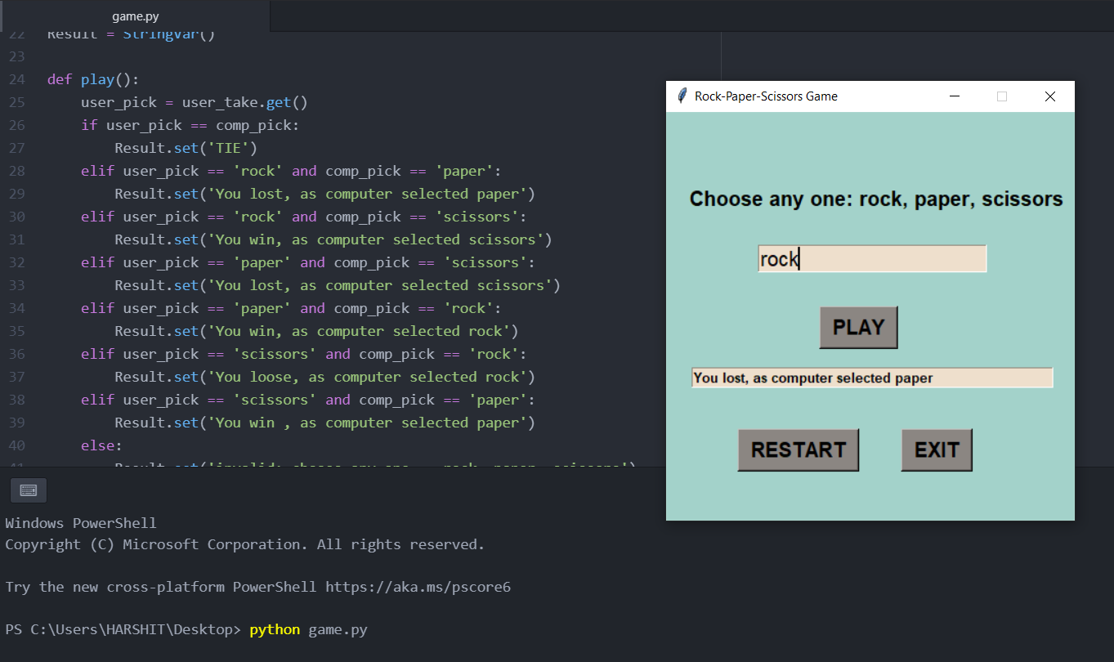

**Conclusion:**

In this project I have used [Tkinter library](https://docs.python.org/3/library/tkinter.html) for rendering graphics, [random](https://docs.python.org/3/library/random.html) module to generate random choices. Afterwards I created a button and called the function using that button, and this way I created this project.

Packages used:

* Python 3.9
* Tkinter library
* Random

Atom was used for compiling the code for this project.