Index

1. Introduction 3
1.1 Background and Context 3
1.2 Problem Statement 3
1.3 Social & Environmental Relevance 4
1.4 Project Objectives 4
1.5 Scope of the Project 5
1.5.1 Core Features 5
1.5.2 Boundaries 5
2. Design 6
2.1 Flowchart 6
2.2 Class Diagram 6
3. Results and Output 7
4. Conclusion 12
i. Summary 12
ii. Future Work and Recommendations 12
5. References 13
Appendix 13

Introduction

1.1 Background and Context
The modern entrepreneurial landscape is highly dynamic, requiring aspiring business leaders to possess a deep understanding of resource allocation, product life cycles, and financial management. The "Startup Ecosystem Simulator" is a console-based business simulation application developed using C++. The system simulates a simplified startup environment where users can create and manage startup companies. By abstracting real-world economic variables into programmable logic, the simulator provides an interactive medium for users to explore the consequences of their managerial decisions through a menu-driven console interface.
Historically, learning the intricacies of business administration and startup management has been largely theoretical. While theoretical knowledge is foundational, it frequently fails to capture the practical pressures of managing a company's operational budget against its ongoing expenses. Existing corporate simulation tools are often prohibitively expensive, demand high computational resources, or involve a steep learning curve due to convoluted graphical user interfaces.
In contrast, fundamental software development education requires practical, hands-on projects to solidify core programming paradigms. This project bridges both gaps by demonstrating key object-oriented programming concepts such as classes, inheritance, operator overloading, and file handling. A console-based approach was selected to maintain a lightweight footprint while focusing the user's attention purely on strategic decision-making and logic execution. Through this medium, the application demonstrates how robust software architecture can effectively simulate complex business workflows.

1.2 Problem Statement
Every day, aspiring entrepreneurs and students struggle to grasp the delicate balance of operational expenses, workforce management, and product development timelines. Without an interactive platform, the impact of poor budget allocation or premature product launches remains abstract.
Currently available educational approaches may not always cater to the needs of all users. Conventional learning lacks active monitoring, while modern software tools may require high system resources or internet connectivity. The issue that has been addressed by the present project is the lack of an effective, offline, and computationally inexpensive educational tool that simulates core business mechanics. This issue has been solved by developing the Startup Ecosystem Simulator, which allows users to monitor critical metrics such as company budget, number of employees, and products under development. This ensures that users experience the direct financial consequences of their administrative choices.

1.3 Social & Environmental Relevance
This project has a positive impact on both society and the environment by promoting awareness of entrepreneurship, innovation, and digital business management. The Startup Ecosystem Simulator helps users understand how startups operate in real-world scenarios, including employee management, product development, budgeting, and revenue generation. By simulating these processes through software, the project encourages learning about business planning and decision-making in an interactive and practical way. It can help students develop problem-solving, analytical thinking, and management skills while also increasing interest in startup culture and technology-driven innovation. From a societal perspective, startups contribute to employment generation, economic growth, and the development of new solutions to modern problems, and this project reflects those concepts through simulation. Environmentally, the project has minimal impact because it is completely software-based and reduces dependence on physical paperwork and manual record management. Digital systems like this promote efficient data handling, resource optimization, and sustainable practices by encouraging the use of computerized management solutions instead of traditional paper-based methods.

Primary SDG: Industry, Innovation and Infrastructure
Secondary SDG: Decent Work and Economic Growth

1.4 Project Objectives
The primary objective of this project is to create a reliable and educational business simulation platform. The specific objectives include:
- To design and implement a console-based business simulation application developed using C++.
- To successfully integrate and demonstrate key object-oriented programming concepts, explicitly focusing on Classes and Objects, Inheritance, and Operator Overloading.
- To utilize File Handling (fstream) mechanisms so that user progress is preserved even after the program is closed.
- To implement effective Menu Driven Programming logic utilizing conditional statements (if-else / switch) and loops (while / for).
- To accurately simulate a business lifecycle where products require development cycles before they can be launched, and once launched they generate revenue for the startup.

1.5 Scope of the Project

1.5.1 Core Features
Startup Management: The application supports multiple startups, allowing users to initialize a company with a specific budget and employee count. Users can hire employees and monitor the company budget.
Product Development: Users can assign employees to develop products. The system tracks product development progress across business cycles.
Financial Simulation: The system allows users to generate revenue by launching products in the simulated market. Furthermore, the system deducts employee salaries during each business cycle to simulate operational expenses.
Data Persistence: The system stores startup data using file handling, ensuring that all session data is saved and loaded accurately.

1.5.2 Boundaries
Offline Console Application: The project is strictly a console-based application without a Graphical User Interface (GUI). It does not require internet connectivity or cloud synchronization.
Simplified Market Dynamics: The simulation operates within a simplified environment. Real-world external economic factors like inflation, stock market crashes, or competitor AI are outside the current scope of this prototype.

Design

2.1 Flowchart
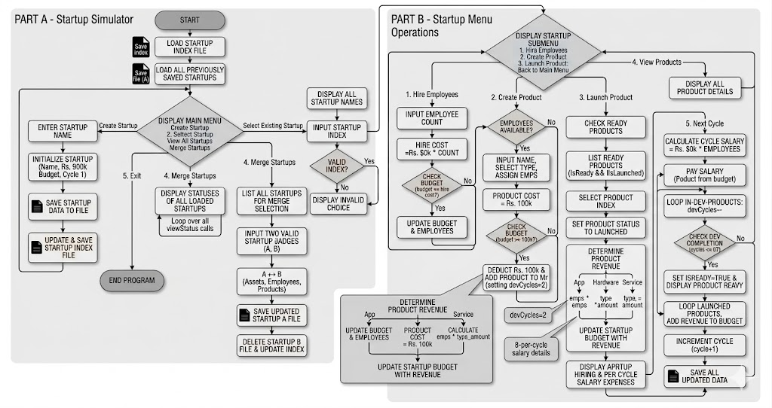

2.2 Class Diagram
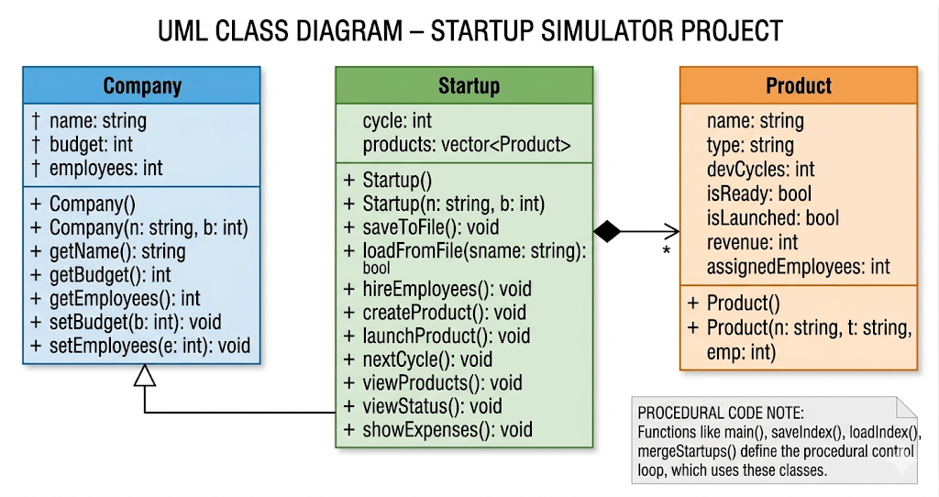

Results and Output
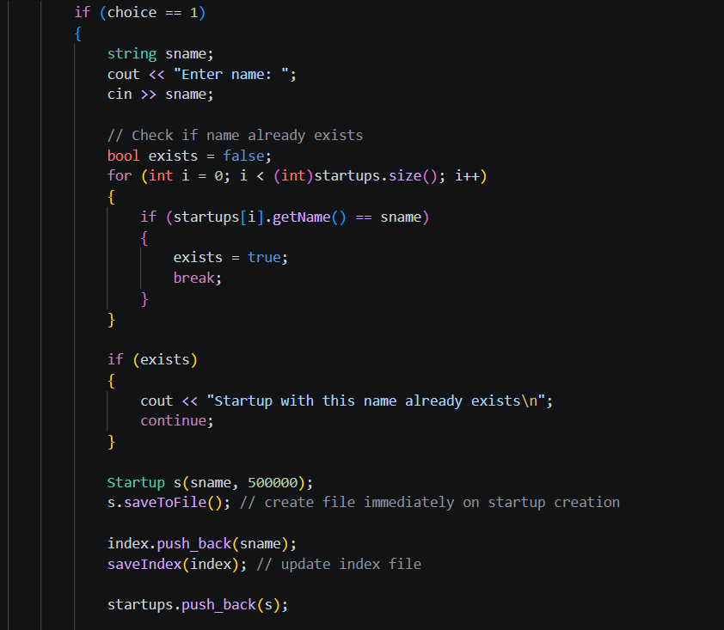
Feature 1: Creating a Startup
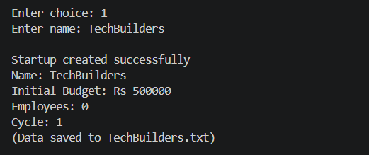

Feature 2: Hiring Employees
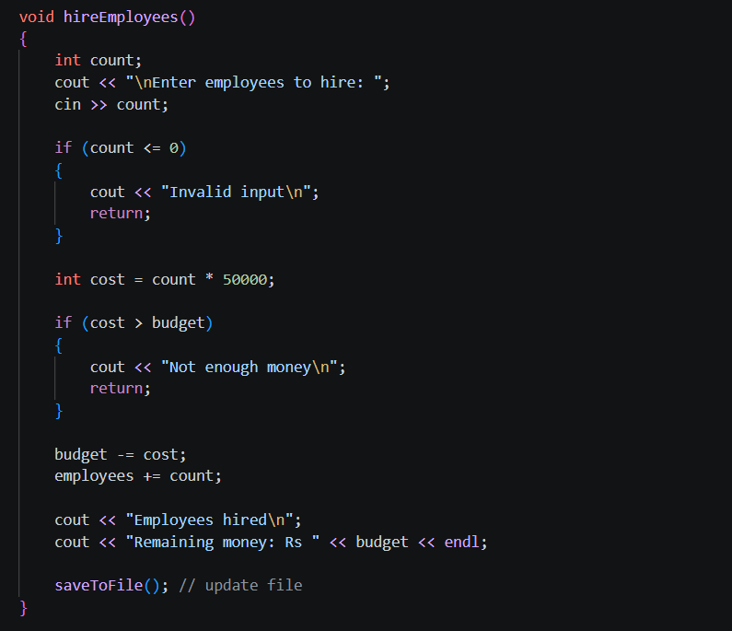
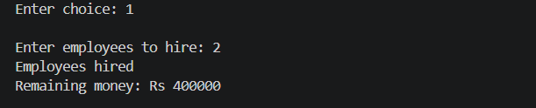

Feature 3: Creating a Product
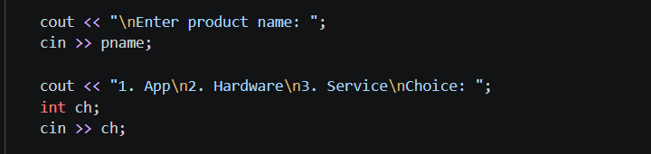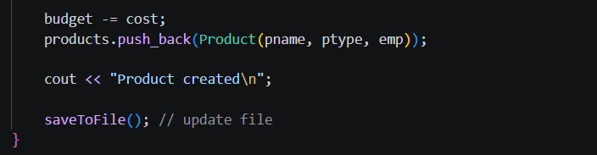
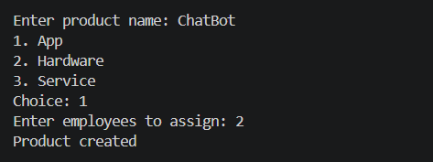

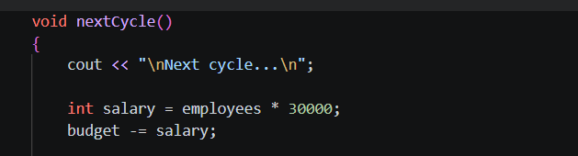
Feature 4: Product Development
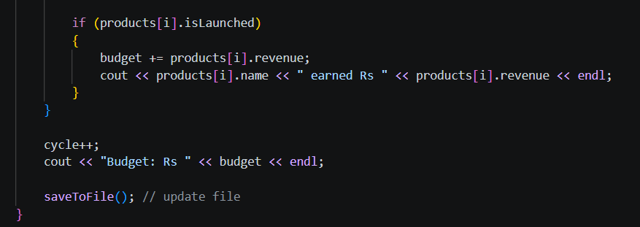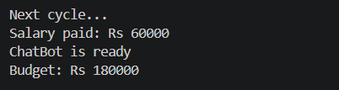

Feature 5: Launching Product
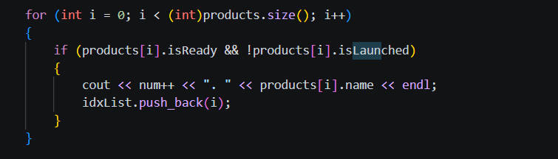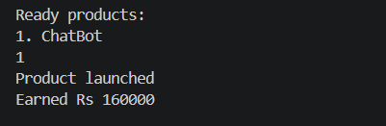

Feature 6: File Saving
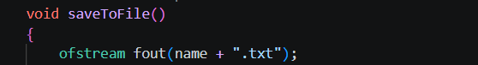
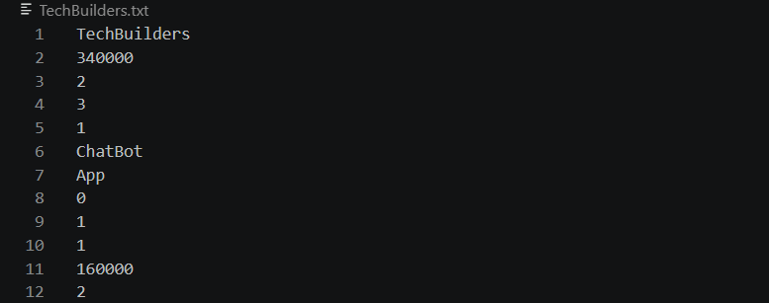

Feature 7: Merge Startups:
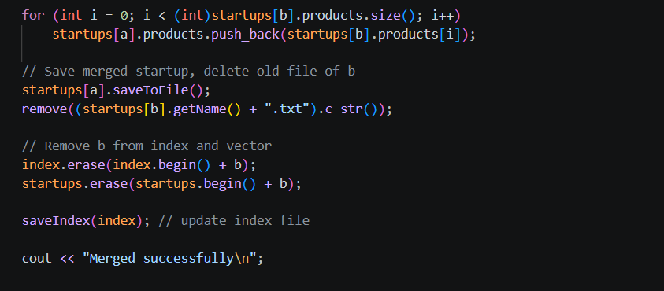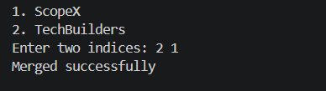

Conclusion

Summary
The development of the Startup Ecosystem Simulator successfully bridges the gap between theoretical software engineering principles and practical application design. By leveraging the C++ programming language, the project delivers a highly functional, console-based business simulation that operates efficiently without the overhead of a graphical interface.
The system effectively fulfills its primary objective: providing users with a simulated environment to manage operational budgets, hire personnel, and navigate product development cycles. The strict adherence to Object-Oriented Programming concepts—specifically encapsulation, inheritance, and operator overloading—resulted in a highly modular, maintainable, and scalable codebase. Furthermore, the successful integration of file handling mechanisms guarantees that all simulation data is reliably preserved across multiple user sessions. Ultimately, the project stands as a comprehensive demonstration of fundamental software development techniques applied to a complex, state-driven problem.
The Startup Ecosystem Simulator is an educational C++ application designed to model the operational and financial challenges of running a business. Users interact with a menu-driven console to create startup profiles, manage initial budgets, and hire employees. The core simulation loop revolves around assigning employees to develop products over multiple business cycles.
The software rigorously tracks variables such as developmental progress and operational expenses, automatically deducting employee salaries to simulate real-world financial pressure. Once a product completes its necessary development cycles, it can be launched to generate revenue, thereby replenishing the startup's budget. Built as a partial fulfillment for the SDF-II course, the project heavily utilizes foundational C++ topics including classes, loops, conditional logic, and the fstream library for persistent data storage, resulting in a stable, engaging, and technically sound software product.

Future Work and Recommendations
While the current iteration of the Startup Ecosystem Simulator successfully meets all foundational objectives, several enhancements could significantly expand its utility, realism, and user experience in future versions:
- Graphical User Interface (GUI) Integration: Transitioning the application from a console-based CLI to a graphical interface using frameworks such as Qt or ImGui would drastically improve user accessibility, allowing for visual dashboards, progress bars, and interactive financial graphs.
- Advanced Economic Simulation: Future iterations should introduce external market variables. Simulating economic inflation, market crashes, or randomized competitor actions would require users to develop more robust, adaptive business strategies rather than relying on predictable linear growth.
- Database Migration: Currently, the system utilizes basic text file handling for data persistence. Migrating the storage backend to a lightweight relational database (such as SQLite) would allow for faster data retrieval, secure data encryption, and the capacity to handle thousands of complex startup profiles simultaneously.
- Multiplayer and Cloud Synchronization: Implementing network sockets to allow for competitive multiplayer functionality would transform the simulator. Users could compete in a shared simulated economy, and cloud integration would allow users to access their startup data across multiple devices.

References

- H. Schildt, *C++: The Complete Reference*, New York, NY: McGraw-Hill Education, 2017.
- Y. Kanetkar, *Let Us C++*. New Delhi, India: BPB Publications, 2020.
- GeeksforGeeks – C++ Programming and File Handling
https://www.geeksforgeeks.org
- “Stack Overflow,” Stack Overflow. [Online]. Available: https://stackoverflow.com [Accessed: April 22, 2026].
- Investopedia – Startup Definition and Concepts
https://www.investopedia.com/terms/s/startup.asp

Appendix
Shreshtha Gupta: File handling and Report
Ritvik Garg: Main Function, Menus and Report
Harshit Kukreja: Functions creation, operator overloading and Report
Dhruv Bhargava: Classes, Inheritance and Report

