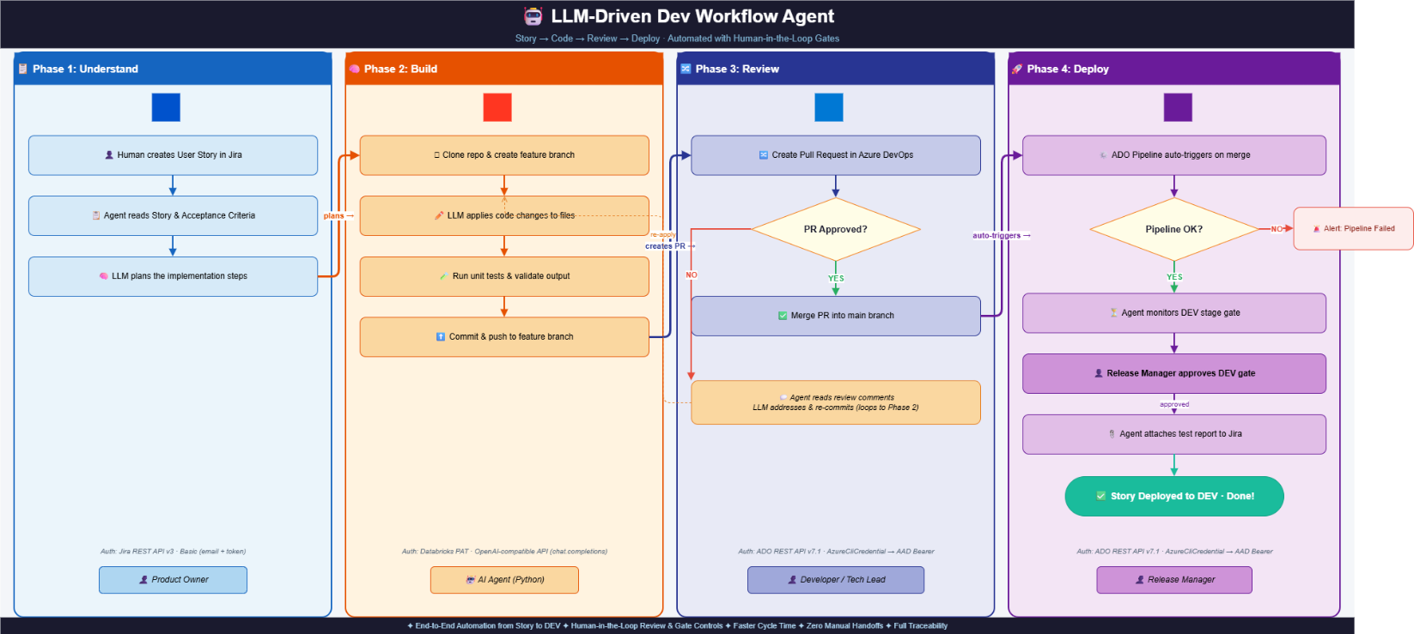
Project Files — Roles & Purpose
File | Role
main.py | Orchestrator — Entry point. Runs the agent loop, maps each LLM decision to the right tool, tracks completed actions, and enforces post-review sequences.
agent_core.py | LLM Brain — Holds the LLMClient that calls the LLM and returns the next action to take (decide_next_action). Also defines shared data classes (WorkItem, AgentDecision).
tools.py | Integration Layer — All real-world interactions live here: Jira story fetch, Git clone/branch/commit/push, ADO PR create/poll/merge, pipeline monitoring, and timeline audit log.
requirements.txt | Dependencies — Four libraries: openai (LLM calls), python-dotenv (env config), requests (REST APIs), azure-identity (AAD auth for ADO).

Agent Flow (Text)
