**ASSIGMENT JAVA DAY17**

**Harshit Kushmakar| 16896**

1. **Create a JAR file of the BRD 1 – Validation Functions and install it in the .m2 repository. Use the same as a dependency in another Project and call the Validation methods to test the inclusion.**

package com.validation.kushmakar;  
  
import java.time.LocalDate;  
import java.time.format.DateTimeFormatter;  
import java.util.List;  
  
public class Validation {  
 public boolean dataTypeValidation(Object fieldValue, String dataType) {  
 if(dataType.equals(fieldValue.getClass().getSimpleName())){  
 return true;  
 }  
 return false;  
 }  
  
 public boolean dataLengthValidation(Object value, int maxLength){  
 if(value.toString().length()<=maxLength){  
 return true;  
 }  
 return false;  
 }  
  
 public boolean specialCharacterValidation(String value, String specialChar) {  
 for (int i = 0; i < specialChar.length(); i++) {  
 if (value.contains(specialChar.charAt(i) + "")) {  
 return true;  
 }  
 }  
 return false;  
 }  
  
 public <T> boolean domainValueValidation(Object value, List<T> domain){  
 for(T t:domain){  
 if(value.equals(t)){  
 return true;  
 }  
 }  
 return false;  
 }  
  
  
 public boolean formatValidation(LocalDate value, String format){  
 DateTimeFormatter formatObj = DateTimeFormatter.*ofPattern*(format);  
 String newValue = value.format(formatObj);  
 if(newValue.equals(value.toString())){  
 return true;  
 }  
 return false;  
 }  
  
  
 public boolean validateEmail(String email)  
 {  
 if(email.contains("@")&& email.contains(".com")&&!email.contains(" ")){  
 return true;  
 }  
 return false;  
 }  
  
}

**main:**

package com.validation.kushmakar;  
  
import java.time.LocalDate;  
import java.util.ArrayList;  
import java.util.List;  
  
public class ValidationMain {  
 public static void main(String[] args) {  
 int a = 90;  
  
 Validation validation = new Validation();  
 System.*out*.println(validation.dataTypeValidation(a, "Integer"));  
 System.*out*.println(validation.dataLengthValidation(100000, 1));  
 System.*out*.println(validation.specialCharacterValidation("hhhj", "#"));  
 List<Integer> domainList = new ArrayList<>();  
 domainList.add(5);  
 domainList.add(6);  
 domainList.add(7);  
  
 System.*out*.println(validation.domainValueValidation(7, domainList));  
 System.*out*.println(LocalDate.*now*());  
 System.*out*.println(validation.formatValidation(LocalDate.*now*(), "YYYY-MM-DD"));  
 System.*out*.println(validation.validateEmail("abc@email.com"));  
  
  
 }  
}

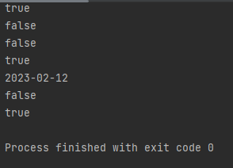**OUTPUT**

**Created a tester class and Added dependency of Brd-validation in pom.xml and build it.**

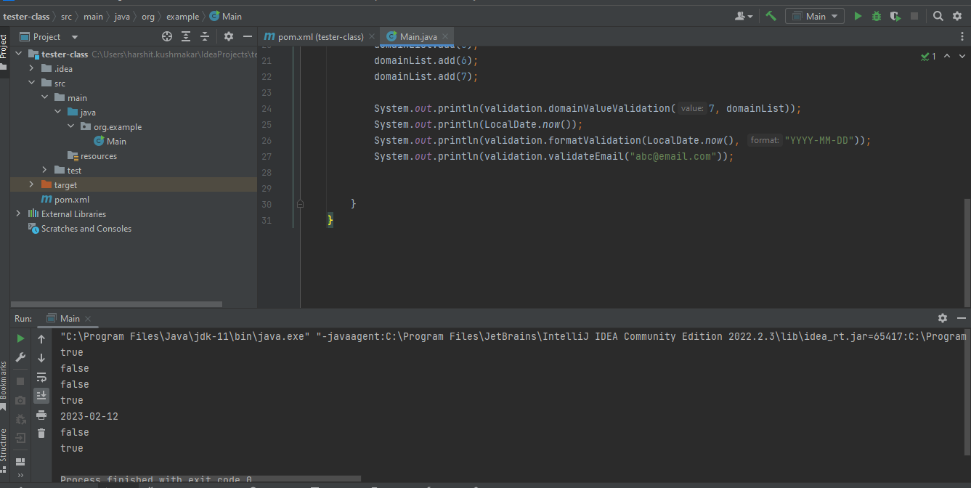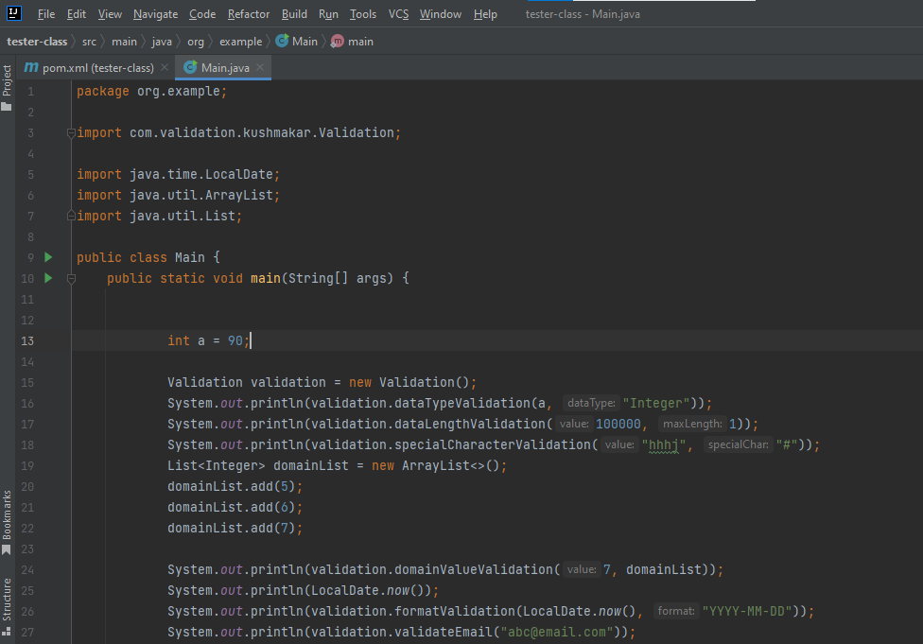**output(**created a tester class in the new project to call the methods**).**

**.jar file of BRD-Validation.**

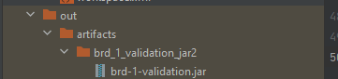

**2. Given below is the class diagram for the classes already created during the Inheritance and Collections assignments. Reuse the same classes. Create multi-module project for the above diagram as mentioned below:**

**1. Take Bank class in module1 and rest of the classes in module2.**

**2. Main class is in module1.**

**Test the functionalities.**

**Module 1:**

Bank class

package org.example;  
  
public class Bank extends Customer {  
  
  
  
 private Customer[] customers = new Customer[1000];  
 private int size = 0;  
  
 public void setCustomers(Customer[] customers) {  
 this.customers = customers;  
 }  
  
 public Customer[] getCustomers() {  
 return customers;  
 }  
  
 public boolean registerCustomer(Customer c) {  
 if (c == null) {  
 return false;  
 }  
 customers[size++] = c;  
 return true;  
 }  
  
 public boolean deleteCustomer(Customer customerId) {  
 return false;  
 }  
  
  
  
  
 public boolean findCustomer(Customer customer) {  
 for (Customer c : customers) {  
 if (c.equals(customer)) {  
 return true;  
 }  
 }  
 return false;  
 }  
  
 public void printAllCustomers() {  
 for (Customer c : customers) {  
 System.*out*.println(c.toString());  
 }  
 }  
  
 public boolean deleteCustomer(int customerId) {  
 int check = 0;  
 for (int i = 0; i < customers.length; i++) {  
 if (customers[i].getCustomerId() == customerId) {  
 check = 1;  
 break;  
 }  
 }  
 if (check == 0) {  
 return false;  
 }  
 for (int i = 0; i < customers.length; i++) {  
 customers[i] = customers[i + 1];  
 }  
 return true;  
 }  
  
 public boolean findCustomer(String customer) {  
 return false;  
 }  
  
  
  
 }

Main

package org.example;  
  
public class Main {  
 public static void main(String[] args) {  
 Bank bank = new Bank();  
 System.*out*.println(bank.findCustomer("aman"));  
 }  
}

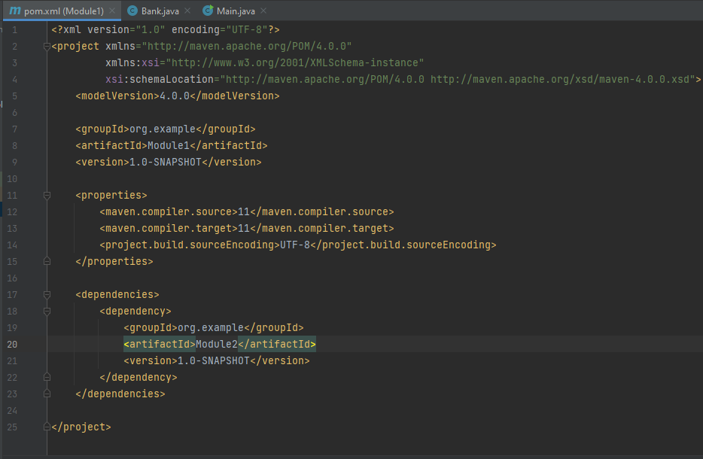pom.xml

**Module 2:**

**LoanAgreement:**

package org.example;  
  
import java.time.LocalDate;  
  
public class LoanAgreement{  
  
 private LocalDate loanDisbursalDate;  
  
 private double income;  
 public LoanAgreement( String loanDisburseDate, double salary){  
  
 this.loanDisbursalDate = LocalDate.*parse*(loanDisburseDate);  
 this.income = salary;  
  
 }  
  
  
 private int loanAgreementId;  
 private class LoanProduct{}  
 private double loanAmount;  
 private int tenure;  
 private double roi;  
 private enum loanStatus{}  
 private double emiPerMonth;  
 // private LocalDate loanDisbursalDate;  
 private int repaymentFrequecy;  
  
 public int getLoanAgreementId() {  
 return loanAgreementId;  
 }  
  
 public void setLoanAgreementId(int loanAgreementId) {  
 this.loanAgreementId = loanAgreementId;  
 }  
  
 public double getLoanAmount() {  
 return loanAmount;  
 }  
  
 public void setLoanAmount(double loanAmount) {  
 this.loanAmount = loanAmount;  
 }  
  
 public int getTenure() {  
 return tenure;  
 }  
  
 public void setTenure(int tenure) {  
 this.tenure = tenure;  
 }  
  
 public double getRoi() {  
 return roi;  
 }  
  
 public void setRoi(double roi) {  
 this.roi = roi;  
 }  
  
 public double getEmiPerMonth() {  
 return emiPerMonth;  
 }  
  
 public void setEmiPerMonth(double emiPerMonth) {  
 this.emiPerMonth = emiPerMonth;  
 }  
  
 public LocalDate getLoanDisbursalDate() {  
 return loanDisbursalDate;  
 }  
  
 public void setLoanDisbursalDate(LocalDate loanDisbursalDate) {  
 this.loanDisbursalDate = loanDisbursalDate;  
 }  
  
 public int getRepaymentFrequecy() {  
 return repaymentFrequecy;  
 }  
  
 public void setRepaymentFrequecy(int repaymentFrequecy) {  
 this.repaymentFrequecy = repaymentFrequecy;  
 }  
  
 public void calculateEMI(double rate, int installmentsPerYear, int totalInstallments, double loanAmount, double residualValue) {  
 double roiPerInst = rate / (installmentsPerYear * 100);  
 double powerVal = Math.*pow*((1 + (roiPerInst)), totalInstallments);  
 double emi= ((loanAmount * (roiPerInst)) - ((residualValue * (roiPerInst)) / powerVal)) / (1 - (1 / powerVal));  
 System.*out*.println(emi);  
 }  
  
 public void generateRepaymentSchedule(double openBalance, double rate, double numberOfInstallment, double tenure, double installmentAmount, double inteterComponent){  
 for(int i=1;i<numberOfInstallment;i++){  
 double openingAmount = openBalance-((numberOfInstallment-1) * installmentAmount);  
 double intComponent = openBalance * (rate / 100) * (1.0 / 12);  
 double principalCompo = installmentAmount - inteterComponent;  
 if(openingAmount < 0){  
 break;  
 }  
  
 System.*out*.println(i + " | " + openingAmount + " | " + intComponent + " | " + principalCompo + " | " + installmentAmount + "\n");  
 }  
 }  
  
 public double LatePenalty(LocalDate currentDate){  
 if(currentDate.compareTo(loanDisbursalDate)>0) {  
 System.*out*.println("No Late Penalty");  
 }  
 else  
 System.*out*.println("Late Penalty will be charged");  
 return 0;  
 }  
  
 public double loanToValueRatio(double loanAsked, double propertyValue) {  
 return (loanAsked / propertyValue)*100;  
 }  
  
 @Override  
 public String toString() {  
 return "LoanAgreement{" +  
  
 ", loanDisbursalDate=" + loanDisbursalDate +  
 ", income=" + income +  
 ", loanAgreementId=" + loanAgreementId +  
 ", loanAmount=" + loanAmount +  
 ", tenure=" + tenure +  
 ", roi=" + roi +  
 ", emiPerMonth=" + emiPerMonth +  
 ", repaymentFrequecy=" + repaymentFrequecy +  
 '}';  
 }  
}

**Customer:**

package org.example;  
  
import java.time.LocalDate;  
  
public class Customer {  
  
 private int customerId = 0;  
 private String customerName;  
 private LocalDate dateOfBirth;  
 private String emailAddress;  
  
 public Customer(String test1, int i, int i1) {  
 }  
  
 public int getCustomerId() {  
 return customerId;  
 }  
  
 public void setCustomerId(int customerId) {  
 this.customerId = customerId;  
 }  
  
 private double monthlyIncome;  
 private String profession;  
 private double totalMonthlyExpenses;  
 private double maxEligibleLoanAmount;  
 private String designation;  
 private String companyName;  
 static int *count* = 0;  
  
 Customer() {  
  
 *count*++;  
 }  
  
 public double getMonthlyIncome() {  
 return monthlyIncome;  
 }  
  
 @Override  
 public String toString() {  
 return "Customer{" +  
 "customerId=" + customerId +  
 ", customerName='" + customerName + '\'' +  
 ", dateOfBirth=" + dateOfBirth +  
 ", emailAddress='" + emailAddress + '\'' +  
 ", monthlyIncome=" + monthlyIncome +  
 ", profession='" + profession + '\'' +  
 ", totalMonthlyExpenses=" + totalMonthlyExpenses +  
 ", maxEligibleLoanAmount=" + maxEligibleLoanAmount +  
 ", designation='" + designation + '\'' +  
 ", companyName='" + companyName + '\'' +  
 '}';  
 }  
  
 Customer(int customerId, String customerName,  
 LocalDate dateOfBirth, String emailAddress, double  
 monthlyIncome, String profession, double  
 totalMonthlyExpenses, String designation, String  
 companyName) {  
 this.customerId = customerId;  
 this.customerName = customerName;  
 this.dateOfBirth = dateOfBirth;  
 this.emailAddress = emailAddress;  
 this.monthlyIncome = monthlyIncome;  
 this.profession = profession;  
 this.totalMonthlyExpenses = totalMonthlyExpenses;  
 this.designation = designation;  
 this.companyName = companyName;  
 *count*++;  
 }  
  
 public static void display() {  
 System.*out*.println("The number of objects created of customer are: " + *count*);  
 }  
  
}

**RepaymentSchedule:**

package org.example;  
  
public class RepaymentSchedule {  
 private double in;  
 private double pn;  
  
 private double outstandingPrincipal;  
  
 public double getIn() {  
 return in;  
 }  
  
 public void setIn(double in) {  
 this.in = in;  
 }  
  
 public double getPn() {  
 return pn;  
 }  
  
 public void setPn(double pn) {  
 this.pn = pn;  
 }  
  
 public double getOutstandingPrincipal() {  
 return outstandingPrincipal;  
 }  
  
 public void setOutstandingPrincipal(double outstandingPrincipal) {  
 this.outstandingPrincipal = outstandingPrincipal;  
 }  
  
 public void setIn(double opn, double rate) {  
 this.in = (opn * rate)/1200;  
 }  
}

**OUTPUT:**

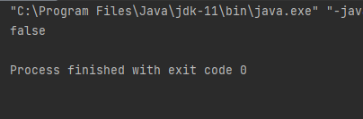

**3. Import this Project using SVN and perform the checkout, update, revert commands on it.**

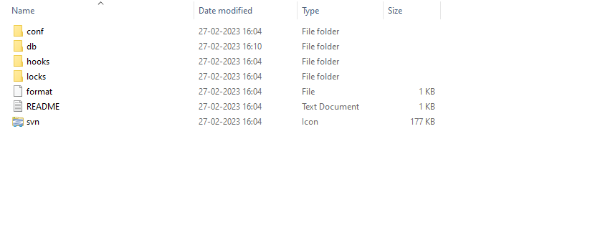

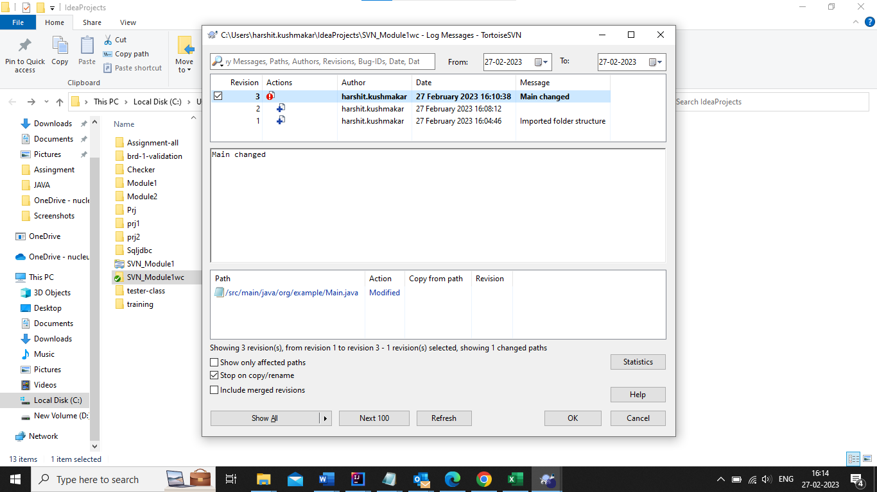**Update**

**Revert**

