**ASSIGNMENT|**

**HARSHIT KUSHMAKAR| 16896**

1. **Write a program which keeps track of the number of customer objects that are created and display the count in a method called display().**
2. package assignment4;  
     
   import java.time.LocalDate;  
   import java.util.Scanner;  
     
   public class Customer {  
     
    private int customerId =0;  
    private String customerName;  
    private LocalDate dateOfBirth;  
    private String emailAddress;  
    private double monthlyIncome;  
    private String profession;  
    private double totalMonthlyExpenses;  
    private double maxEligibleLoanAmount;  
    private String designation;  
    private String companyName;  
    static int *count*=0;  
    Customer(){  
     
    *count*++;  
    }  
    Customer(int customerId , String customerName ,  
    LocalDate dateOfBirth , String emailAddress , double  
    monthlyIncome , String profession ,double  
    totalMonthlyExpenses , String designation , String  
    companyName){  
    this.customerId=customerId;  
    this.customerName=customerName;  
    this.dateOfBirth = dateOfBirth;  
    this.emailAddress = emailAddress;  
    this.monthlyIncome = monthlyIncome;  
    this.profession = profession;  
    this.totalMonthlyExpenses = totalMonthlyExpenses;  
    this.designation = designation;  
    this.companyName = companyName;  
    *count*++;  
    }  
    public static void display(){  
    System.*out*.println("The number of objects created of customer are: " + *count* );  
    }  
   }

package assignment4;  
import assignment4.Customer;  
public class TesterMain {  
  
 public static void main(String[] args) {  
  
 Customer obj1 = new Customer();  
 Customer obj2 = new Customer();  
 Customer obj3 = new Customer();  
 Customer obj4 = new Customer();  
 Customer.*display*();  
  
  
 }  
 }

**OUTPUT:**

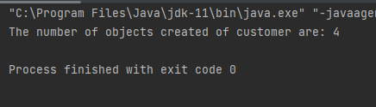

**2. Add the functionality of automatically generating Loan Agreement Id and Customer Id in Loan class and Customer class respectively. The series for both Id’s should start from 1.**

package assignment4;  
  
import java.time.LocalDate;  
  
public class CustomerLoan {  
 final int customerId ;  
 private String customerName;  
 private LocalDate dateOfBirth;  
 private String emailAddress;  
 private double monthlyIncome;  
 private String profession;  
 private double totalMonthlyExpenses;  
 private double maxEligibleLoanAmount;  
 private String designation;  
 private String companyName;  
 static int *count*=0;  
 CustomerLoan(){  
 *count*++;  
 this.customerId = *count*;  
 }  
 CustomerLoan( String customerName , LocalDate dateOfBirth  
 , String emailAddress , double monthlyIncome , String  
 profession ,double totalMonthlyExpenses , String  
 designation , String companyName){  
 *count*++;  
 this.customerId=*count*;  
 this.customerName=customerName;  
 this.dateOfBirth = dateOfBirth;  
 this.emailAddress = emailAddress;  
 this.monthlyIncome = monthlyIncome;  
 this.profession = profession;  
 this.totalMonthlyExpenses = totalMonthlyExpenses;  
 this.designation = designation;  
 this.companyName = companyName;  
 }  
}

package assignment4;  
public class TesterMain {  
 public static void main(String[] args) {  
 CustomerLoan obj1 = new CustomerLoan();  
 CustomerLoan obj2 = new CustomerLoan();  
 CustomerLoan obj3 = new CustomerLoan();  
 CustomerLoan obj4 = new CustomerLoan();  
  
 Customer.*display*();  
 // Printing all the customer id  
 System.*out*.println("Customer id of obj1 is: " +obj1.customerId);  
 System.*out*.println("Customer id of obj2 is: " +obj2.customerId);  
 System.*out*.println("Customer id of obj3 is: " +obj3.customerId);  
 System.*out*.println("Customer id of obj4 is: " +obj4.customerId);  
 }  
}

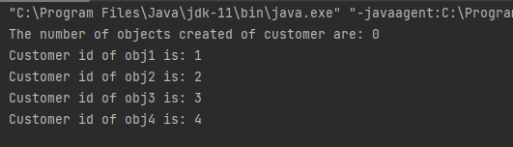

**3. Create the constructor as private in the Question – 1 of Day-3 and using the static method create only 3 instances of the Employee class. When user tries to create the fourth instance, it returns null.**

package assignment4;  
  
public class Employee {  
 private int id;  
 private String firstName;  
 private String lastName;  
 private int salary;  
 static int *count* =0;  
 private static Employee *employeeInstance*;  
 private Employee(){  
 *count*++;  
 }  
 public static Employee getInstance(){  
 if(*count*<3){  
 *employeeInstance* = new Employee();  
 return *employeeInstance*;  
 }  
 *employeeInstance* = null;  
 return *employeeInstance*;  
 }  
}

import assignment4.Employee;  
public class TesterMain {  
  
 public static void main(String[] args) {  
 Employee emp = Employee.*getInstance*();  
 Employee emp1 = Employee.*getInstance*();  
 Employee emp2 = Employee.*getInstance*();  
 Employee emp3 = Employee.*getInstance*();  
 System.*out*.println(emp);  
 System.*out*.println(emp1);  
 System.*out*.println(emp2);  
 System.*out*.println(emp3);  
  
 }  
}

1. **Extend the above Question-3 to have only one object created (maintain Singleton). User can create as many numbers of references as required.**

package assignment4;  
  
public class Employee {  
 private int id;  
 private String firstName;  
 private String lastName;  
 private int salary;  
 static int *count* =0;  
 private static Employee *employeeInstance*;  
 private Employee(){  
 *count*++;  
 }  
 // Singleton  
 public static Employee getEmployeeInstance(){  
 if(*employeeInstance* ==null){  
 *employeeInstance* = new Employee();  
 }  
 return *employeeInstance* ;  
 }  
}

package assignment4;  
public class TesterMain {  
 public static void main(String[] args) {  
 Employee emp = Employee.*getEmployeeInstance*();  
 Employee emp1 = Employee.*getEmployeeInstance*();  
 Employee emp2 = Employee.*getEmployeeInstance*();  
 System.*out*.println("Employee " +emp);  
 System.*out*.println("Employee1 " +emp1);  
 System.*out*.println("Employee2 " +emp2);  
 }  
}

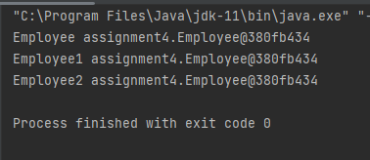

**5. Create a class named 'PrintNumber' to print various numbers of different datatypes by creating different methods with the same name 'printn' having a parameter for each datatype.**

package assignment4;  
  
public class PrintNumber {  
 void printn(int a){  
 System.*out*.println("Integer: " +a);  
 }  
 void printn(float a){  
 System.*out*.println("Float: " +a);  
 }  
 void printn(String a){  
 System.*out*.println("String: " +a);  
 }  
 void printn(char a){  
 System.*out*.println("Char: " +a);  
 }  
 void printn(double a){  
 System.*out*.println("Double: " +a);  
 }  
 void printn(boolean a){  
 System.*out*.println("Boolean: " +a);  
 }  
  
}

import assignment4.PrintNumber;  
public class TesterMain {  
  
 public static void main(String[] args) {  
 PrintNumber p = new PrintNumber();  
 p.printn(4);  
 p.printn((float) 24.8);  
 p.printn("kushmakar");  
 p.printn('b');  
 p.printn(3.14567);  
 p.printn(true);  
 }  
}

**OUTPUT:**

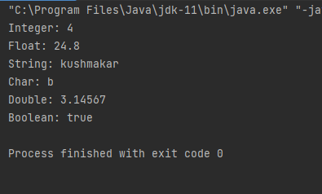

**6. Create a class User with three data members which are name, age, and address. The constructor of the class assigns default values name as "unknown", age as '0' and address as "not available". It has two methods with the same name 'setInfo'. First method has two parameters for name and age and assigns the same whereas the second method takes has three parameters which are assigned to name, age, and address respectively. Print the name, age, and address of 10 users.**

package assignment4;  
  
public class User {  
  
 private String name;  
 private int age;  
 private String address;  
  
 public User() {  
 this.name = name;  
 this.age = age;  
 this.address = address;  
  
 }  
  
 public String getName() {  
 return name;  
 }  
  
 public int getAge() {  
 return age;  
 }  
  
 public String getAddress() {  
 return address;  
 }  
  
 public void setInfo(String name, int Age) {  
 this.name = name;  
 this.age = age;  
  
 }  
  
 public void setInfo(String name, int Age, String address) {  
 this.name = name;  
 this.age = age;  
 this.address = address;  
 }  
  
 @Override  
 public String toString() {  
 return super.toString();  
 }  
  
}

public class TesterMain {  
 public static void main(String[] args) {  
  
 User a = new User();  
 System.*out*.println(a);  
  
 User a1 = new User();  
 a1.setInfo("kushmakar",21);  
 User a2 = new User();  
 a1.setInfo("harshit",21);  
  
 User a3 = new User();  
 a1.setInfo("Shivani",22,"BHuneswar" );  
  
 User a4 = new User();  
 a1.setInfo("armaan",21,"punjab" );  
 User a5 = new User();  
 a1.setInfo("aman",22 , "koderma");  
  
 User a6 = new User();  
 a1.setInfo("Ayush",22,"JHumri teliya" );  
 User a7 = new User();  
 a1.setInfo("rohan",32,"JHumri teliya" );  
 User a8 = new User();  
 a1.setInfo("Saurab",22,"Hazribhagh" );  
  
 User a9 = new User();  
 a1.setInfo("shubham",44,"Bhopal" );  
  
  
  
  
 }  
}

**7. Given three strings S, S1, and S2 consisting of N, M, and K characters respectively, create a**

**program to modify the string S by replacing all the substrings S1 with the string S2 in the**

**string S.**

package assignment4;  
  
public class StringsRecursion {  
  
 public String replaceSubstringWithString(String S ,  
 String S1 , String S2){  
 String s = S.replace(S1, S2);  
 return s;  
 }  
 public static void main(String[] args) {  
 StringsRecursion ss =new StringsRecursion();  
  
 System.*out*.println(ss.replaceSubstringWithString("Welcome To Nucleus","genpact","Walmart"));  
 }  
  
}

**8. Write a program to reverse String using the below three ways**

**a. Using StringBuffer class:**

package assignment4;  
  
public class StrBuffer {  
 public static void main(String[] args)  
  
 {  
 String str = "String";  
  
 // conversion from String object to StringBuffer  
  
 StringBuffer sbfr = new StringBuffer(str);  
  
 // To reverse the string  
  
 sbfr.reverse();  
  
 System.*out*.println(sbfr);  
  
 }  
  
}

**OUTPUT:**

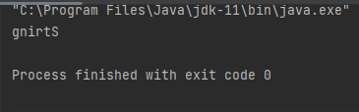

**b. Using StringBuilder class:**

package assignment4;  
  
public class StrBuilder {  
  
 //ReverseString using CharcterArray.  
  
 public static void main(String[] arg) {  
  
// declaring variable  
  
 String stringinput = "Independent";  
  
 // convert String to character array  
  
 // by using toCharArray  
  
 char[] resultarray = stringinput.toCharArray();  
  
 //iteration  
  
 for (int i = resultarray.length - 1; i >= 0; i--)  
  
 // print reversed String  
  
 System.*out*.print(resultarray[i]);  
  
 }  
}

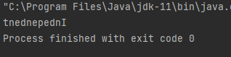 **OUTPUT:**

**c. Using recursion:**

package assignment4;  
  
public class StringReverse {  
  
 public String reverseString(String str){  
  
 if(str.isEmpty()){  
 return str;  
 } else {  
 return reverseString(str.substring(1))+str.charAt(0);  
 }  
 }  
 public static void main(String[] args) {  
 StringReverse obj = new StringReverse();  
 String result = obj.reverseString("Kushmakar");  
 System.*out*.println(result);  
 }  
 }

**OUTPUT:**

