**ASSIGMENT JAVA FUNDAMENTAL**

**Harshit Kushmakar| 16896**

1. **Write a program called CheckPassFail which prints "PASS" if the int variable "mark" is more than or equal to 50; or prints "FAIL" otherwise. The program shall always print “DONE” before exiting.**
2. package assignementday1;  
     
   import java.util.Scanner;  
     
   public class CheckPassFail {  
    private int marks;  
    public int getMarks() {  
    return marks;  
    }  
     
    public void setMarks(int marks) {  
    this.marks = marks;  
    }  
    public void passOrFail(){  
    CheckResult();  
    if(getMarks()>=60){  
    System.*out*.println("PASS");  
    }  
    else {  
    System.*out*.println("FAIL");  
    }  
    System.*out*.println("DONE");  
    }  
    public void CheckResult(){  
    Scanner sc = new Scanner(System.*in*);  
    System.*out*.println("Enter the marks: ");  
    marks = sc.nextInt();  
    setMarks(marks);  
    }  
   }

**main:**

import assignementday1.CheckPassFail;  
  
public class Main {  
 public static void main(String[] args) {  
 CheckPassFail c1 = new CheckPassFail();  
 c1.passOrFail();  
 }  
}

**Output:**

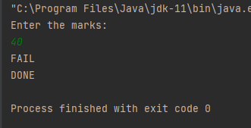

1. **Write a program called PrintDayInWord which prints “Sunday”, “Monday”, ... “Saturday” if the int variable "dayNumber" is 0, 1, ..., 6, respectively.  Otherwise, it shall print "Not a valid day". Use**
2. **"nested-if" statement.**

package day1;  
  
import java.util.Scanner;  
  
public class PrintDayInWord {  
 public static void main(String[] args) {  
 int number = 5;  
   
  
 if(number == 1) {  
 System.*out*.println("Monday");  
 }  
 else if(number==2){  
 System.*out*.println("Tuesday");  
 }  
 else if(number==3) {  
 System.*out*.println("Wednesday");  
 }  
 else if(number==4) {  
 System.*out*.println("Thursday");  
 }  
 else if(number==5) {  
 System.*out*.println("Friday");  
 }  
 else if(number == 6) {  
 System.*out*.println("Saturday");  
 }  
 else if(number == 7) {  
 System.*out*.println("Sunday");  
 }  
   
 }  
}

**OUTPUT:-**

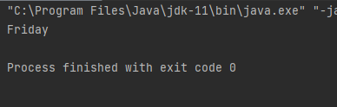

1. **"switch-case-default" statement**

switch (number){  
 case 1:  
 System.*out*.println("Monday");  
 break;  
 case 2:  
 System.*out*.println("Tuesday");  
 break;  
 case 3:  
 System.*out*.println("Wednesday");  
 break;  
 case 4:  
 System.*out*.println("Thursday");  
 break;  
 case 5:  
 System.*out*.println("Friday");  
 break;  
 case 6:  
 System.*out*.println("Saturday");  
 break;  
 case 7:  
 System.*out*.println("Sunday");  
 break;  
 default:  
 System.*out*.println("NOt valid");  
  
}

**OUTPUT:-**

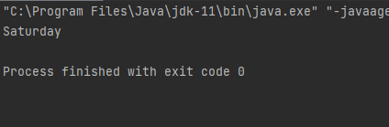

**Try dayNumber = 0, 1, 2, 3, 4, 5, 6, 7 and verify your results.**

1. **The progressive income tax rate is mandated as follows:**

|  |  |
| --- | --- |
| **Taxable Income** | **Rate (%)** |
| **First $20,000** | **0** |
| **Next $20,000** | **10** |
| **Next $20,000** | **20** |
| **The remaining** | **30** |

**For example, suppose that the taxable income is $85000, the income tax payable is $20000*0% + $20000*10% + $20000*20% + $25000*30%.**

**Write a program called IncomeTaxCalculator that reads the taxable income (in int). The program shall calculate the income tax payable (in double); and print the result rounded to 2 decimal places. For examples,**

1. **Enter the taxable income: $41234**

**The income tax payable is: $2246.80**

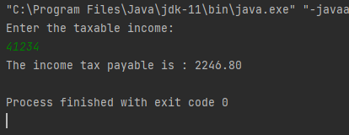

1. **Enter the taxable income: $67891  
   The income tax payable is: $8367.30**

1. **Enter the taxable income: $85432**

**The income tax payable is: $13629.60**

1. **Enter the taxable income: $12345**

**The income tax payable is: $0.0**

**Code:**

package day2;  
  
  
import java.util.Scanner;  
  
  
public class IncomeTaxCalculator {  
  
 public static void main(String[] args) {  
 Scanner sc = new Scanner(System.*in*);  
 System.*out*.println("Enter the taxable income: ");  
 double amount = sc.nextDouble();  
 double incomeTax = 0;  
 if(amount > 20000 && amount <=40000)  
  
 incomeTax = (amount - 20000) * 0.1;  
 else if(amount > 40000 && amount <= 60000)  
 incomeTax = (0.1 * 20000) + ((amount - 40000) * 0.2);  
 else if(amount > 60000)  
 incomeTax = (0.1 * 20000) + (0.2 * 20000) + ((amount - 60000) *  
 0.3);  
 System.*out*.println("The income tax payable is : " + String.*format*("%.2f", incomeTax));  
 }  
}

1. **Write a program in Java to check whether an input number is even, odd-non-prime or odd-Prime.**

package assignementday1;  
  
import java.util.Scanner;  
  
public class EvenOddPrime {  
 private int num;  
  
 public int getNum() {  
 return num;  
 }  
  
 public void setNum(int num) {  
 this.num = num;  
 }  
  
 public void checkNum() {  
 toCheckNum();  
 if (getNum() % 2 == 0) {  
 System.*out*.println("Even");  
 } else {  
 if (getNum() == 1) {  
 System.*out*.println("Odd Non prime Number: ");  
  
  
 }  
 for (int i = 3; i < getNum() / 2; i += 2) {  
 if (getNum() % i == 0) {  
 System.*out*.println("odd Non prime number");  
 break;  
 } else {  
 System.*out*.println("odd prime Number");  
 break;  
  
 }  
 }  
 }  
  
 }  
  
  
 public void toCheckNum() {  
 Scanner sc = new Scanner(System.*in*);  
 System.*out*.println("Enter a number: ");  
 num = sc.nextInt();  
 setNum(num);  
  
 }  
}

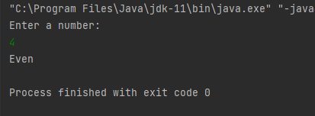

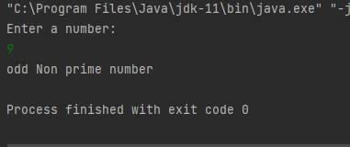

1. **Write a program in Java to print the Pascal triangle up to nth level; n being an input from the user : Use multidimensional array only**

package assignementday1;  
  
import java.util.Scanner;  
  
public class PascalsTriangle {  
  
 private int num;  
 public int getNum() {  
 return num;  
 }  
 public void setNum(int num) {  
 this.num = num;  
 }  
 public void printPascal(){  
 ToPascal();  
 int[][] arr = new int[getNum()][getNum()];  
 for(int i=0;i<getNum();i++){  
 for(int j=0;j<=i;j++){  
 if(j==0||j==i){  
 arr[i][j]=1;  
 }  
 else{  
 arr[i][j]= arr[i-1][j-1]+arr[i-1][j];  
 }  
 }  
 }  
 int s = getNum()-1;  
 for(int i=0;i<getNum();i++) {  
 for (int j = 0; j <=s; j++) {  
 System.*out*.print(" ");  
 }  
 s--;  
 for (int j = 0; j <= i; j++) {  
 System.*out*.print(arr[i][j] + " ");  
 }  
 System.*out*.println();  
 }  
 }  
 public void ToPascal(){  
 Scanner sc = new Scanner(System.*in*);  
 System.*out*.println("Enter the number");  
 num = sc.nextInt();  
 setNum(num);  
 }  
}

import assignementday1.PascalsTriangle;  
 public class Main {  
 public static void main(String[] args) {  
 PascalsTriangle p1 = new PascalsTriangle();  
 p1.printPascal();  
 }  
}

**OUTPUT:**

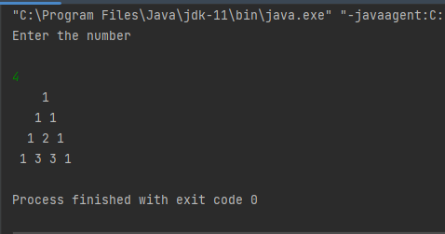

1. **Shyam wants to apply for Home Loan with ABC Bank. The bank has to calculate DBR (Debt to Burden ratio) to find out whether Loan can be approved or not. The formula to calculate DBR is as below:**

**DBR = expenses / monthly income**

**Wherein:**

**Expenses - sum of all the expenses like rent, credit card payment, existing car loan EMI, existing student loan EMI, any other existing loan EMI**

**Monthly income - total of all the combined sources of income like salary or any rent income or any other income coming from interest paid on the saving amount.**

**The loan can be approved if the DBR is 20% or less. If DBR is more than 40%, the loan application is rejected.**

**Create a java program to calculate the DBR and specify whether loan should be approved or rejected.**

package assignementday1;  
  
public class CalDbr {  
 private double expense;  
 private double monthlyIncome;  
 private double dbr;  
 public double getDbr() {  
 dbr = expense/monthlyIncome;  
 return dbr;  
 }  
 public void setExpense(double expense) {  
 this.expense = expense;  
 }  
 public void setMonthlyIncome(double monthlyIncome) {  
 this.monthlyIncome = monthlyIncome;  
 }  
 public void Inputloan(){  
 if(getDbr() < 0.2)  
 System.*out*.println("Loan is accepted.");  
 else if(getDbr() > 0.4)  
 System.*out*.println("Loan is rejected.");  
 else  
 System.*out*.println("Loan can't be given.");  
 }  
}

**Main:**

import assignementday1.CalDbr;  
  
import java.util.Scanner;  
  
public class Main {  
 public static void main(String[] args) {  
  
 Scanner sc = new Scanner(System.*in*);  
 System.*out*.print("Enter your monthly expense : ");  
 double expense = sc.nextDouble();  
 System.*out*.print("Enter your monthly income : ");  
 double monthlyIncome = sc.nextDouble();  
 CalDbr obj = new CalDbr();  
 obj.setExpense(expense);  
 obj.setMonthlyIncome(monthlyIncome);  
 obj.Inputloan();  
 }  
 }

**OUTPUT:**

1. **Shyam has applied for a Home Loan with ABC Bank. The bank has to calculate LTV. LTV is Loan to Value ratio which describes the size of a loan compared to the value of the property securing the loan. The bank policy is that LTV can be maximum 80%.**

**The formula to calculate LTV is:**

**LTV = Loan amount asked / property value**

**Write a Java program to calculate the LTV.**

package day2;  
  
  
class LTVCalculation{  
 private float loanAmtAsked;  
 private float propVal;  
  
 public float getLoanAmtAsked() {  
 return loanAmtAsked;  
 }  
  
 public void setLoanAmtAsked(float loanAmtAsked) {  
 this.loanAmtAsked = loanAmtAsked;  
 }  
  
 public float getPropVal() {  
 return propVal;  
 }  
  
 public void setPropVal(float propVal) {  
 this.propVal = propVal;  
 }  
  
 public double ltvcalculate(double loanAmtAsked,double propVal){  
 double ltv=loanAmtAsked/propVal;  
 if(ltv<=80)  
 System.*out*.println("LTV is "+ ltv);  
 else  
 System.*out*.println("LTV is higher than the allowed value:"+ ltv);  
  
 return ltv;  
 }  
  
}  
  
public class calcLTv {  
 public static void main(String[] args) {  
  
 LTVCalculation l=new LTVCalculation();  
 l.setLoanAmtAsked(50000);  
 l.setPropVal(20000);  
 System.*out*.println(l.ltvcalculate(l.getLoanAmtAsked(),l.getPropVal()));  
  
 }  
}

**OUTPUT:**

1. **Before a Loan can be processed by a Bank, the Bank must find out the Maximum Loan Amount which can be given to a particular applicant. The formula to calculate the Maximum Eligible Loan Amount is as below:**

**Max_eligible_Loan_amount = E * (( 1 + R) ^t) -1 )/ (R * (( 1 + R) ^t)**

**Where:**

**E = Max eligible EMI (50% of effective monthly salary after deducting 20% DBR)**

**R = effective Monthly Rate**

**T = tenure (Max tenure which can be considered is 7 years)**

**Create a java program to calculate Max Eligible Loan Amount for an applicant.**

package assignementday1;  
  
public class MaxEmi {  
  
 private double maximumEMI;  
 private double dbr;  
 public double getDbr(double expense, double monthlyIncome) {  
 this.dbr = expense/monthlyIncome;  
 return 0.2 * dbr;  
 }  
 public double getMaximumEMI() {  
 return maximumEMI;  
 }  
 public void setMaximumEMI(double rate, double monthlySalary, double tenure,  
 double expense) {  
 double numerator = Math.*pow*(1 + rate, tenure);  
 numerator -= 1;  
 double denominator = Math.*pow*(1+rate, tenure);  
 denominator = denominator * rate;  
 this.maximumEMI = (numerator/denominator) * ((monthlySalary -  
 getDbr(expense ,monthlySalary)) * 0.5);  
 }  
}

**main:**

import assignementday1.MaxEmi;  
  
import java.util.Scanner;  
  
public class Main {  
  
public static void main(String[] args) {  
 Scanner sc = new Scanner(System.*in*);  
 System.*out*.println("Enter your monthly expense : ");  
 double expense = sc.nextDouble();  
 System.*out*.print("Enter the monthly rate : ");  
 double rate = sc.nextDouble();  
 System.*out*.print("Enter your monthly salary : ");  
 double monthlySalary = sc.nextDouble();  
 System.*out*.println("Enter the tenure in years : ");  
 double tenure = sc.nextDouble();  
 MaxEmi obj = new MaxEmi();  
 obj.setMaximumEMI(rate, monthlySalary, tenure, expense);  
 System.*out*.println("Maximum EMI is : " + String.*format*("%.2f",  
 obj.getMaximumEMI()));  
 }  
 }

**OUTPUT:**

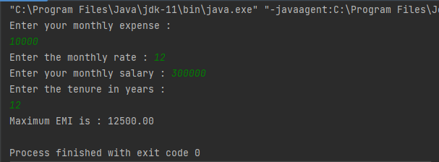

1. **Calculate the installment amount of a loan given the following terms of loan:**

* **Loan Amount**
* **Rate of Interest**
* **Tenure**
* **Number of installments in a year**

**Formula for calculating installment amount is as below:**

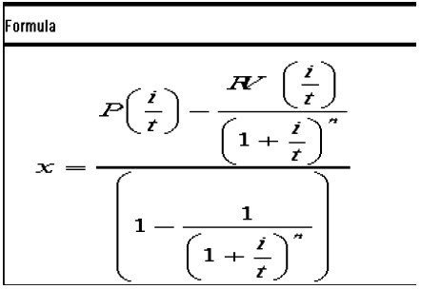

**Where**

**X = installment amount**

**P = original Loan Principal Amount**

**I = interest rate pa**

**T = Number of payments in a year**

**N = tenure or number of installments**

**RV = Residual Value of a loan at the end of tenure**

package assignementday1;  
  
import java.util.Scanner;  
  
public class MaxLoanAmount {  
 private double maxLoanAmount;  
 private double salary;  
 private double rate;  
 private int tenure;  
 private double maxEligibleEmi;  
 private double dbr;  
  
 public double getMaxLoanAmount() {  
 return maxLoanAmount;  
 }  
  
 public void setMaxLoanAmount(double maxLoanAmount) {  
 this.maxLoanAmount = maxLoanAmount;  
 }  
  
 public double getDbr() {  
 return dbr;  
 }  
  
 public void setDbr(double dbr) {  
 this.dbr = dbr;  
 }  
  
 public double getSalary() {  
 return salary;  
 }  
  
 public void setSalary(double salary) {  
 this.salary = salary;  
 }  
  
 public double getRate() {  
 return rate;  
 }  
  
 public void setRate(double rate) {  
 this.rate = rate;  
 }  
  
 public int getTenure() {  
 return tenure;  
 }  
  
 public void setTenure(int tenure) {  
 this.tenure = tenure;  
 }  
  
 public double getMaxEligibleEmi() {  
 return maxEligibleEmi;  
 }  
  
 public void setMaxEligibleEmi(double maxEligibleEmi) {  
 this.maxEligibleEmi = maxEligibleEmi;  
 }  
  
 public void EligibleLoanAmount(){  
 ToMaxLoan();  
 maxLoanAmount = (getMaxEligibleEmi() *  
 (Math.*pow*((1 + getRate()) ,getTenure())-1 )/ (getRate() *  
 Math.*pow*(( 1 + getRate()) ,getTenure())));  
 setMaxLoanAmount(maxLoanAmount);  
 System.*out*.println("Maximum Eligible Loan Amount: " + getMaxLoanAmount());  
 }  
  
public void ToMaxLoan(){  
  
 Scanner sc = new Scanner(System.*in*);  
 System.*out*.println("Enter the DBR value :");  
 dbr = sc.nextFloat();  
 setDbr(dbr);  
 System.*out*.println("Salary");  
 salary = sc.nextFloat();  
 setSalary(salary);  
 System.*out*.println("Effective Monthly Rate");  
 rate = sc.nextFloat()/1200;  
 setRate(rate);  
 System.*out*.println("Tenure in Months");  
 tenure = sc.nextInt();  
 setTenure(tenure);  
 maxEligibleEmi = ((getSalary()-  
 getSalary()*(0.2*getDbr()))*0.5);  
 setMaxEligibleEmi(maxEligibleEmi);  
}  
}

**main:**

import assignementday1.MaxLoanAmount;  
public class Main {  
 public static void main(String[] args) {  
 MaxLoanAmount m1 = new MaxLoanAmount();  
 m1.EligibleLoanAmount();  
 }  
}

**OUTPUT:**

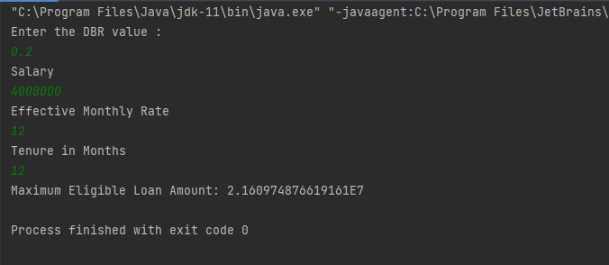

1. **Generate the Repayment Schedule for the entire Loan period i.e. calculate the return Principal and interest component of each installment given the same parameters as in Question 4. The Java code will return a complete repayment schedule i.e. the following information for the entire period in question (one for each month/installment):**

**Installment Number**

**Opening Balance**

**Interest component**

**Principal component**

**Installment**

**\*\* The above will be repeated for the number of installments**

**Formula for creating Principal and Interest Component of an installment is as below (monthly installment is assumed). Installment is calculated in Question 4, use the same formula.**

* + **In = OPn * (r /100) * (1/12)**
  + **Pn = Installment – In**
  + **OPn+1 = OPn – Pn**

**Where:**

**In : Interest component of the nth Installment**

**OPn : Outstanding Principal at the beginning of the nth Installment period**

**r : Interest rate per annum**

**Pn : Principal component of the nth installment**

**OPn+1 : Outstanding Principal at the end of the nth Installment period.**

package assignementday1;  
  
public class RepaymentSchedule {  
 private double in;  
 private double pn;  
  
 private double outstandingPrincipal;  
  
 public double getIn() {  
 return in;  
 }  
  
 public void setIn(double in) {  
 this.in = in;  
 }  
  
 public double getPn() {  
 return pn;  
 }  
  
 public void setPn(double pn) {  
 this.pn = pn;  
 }  
  
 public double getOutstandingPrincipal() {  
 return outstandingPrincipal;  
 }  
  
 public void setOutstandingPrincipal(double outstandingPrincipal) {  
 this.outstandingPrincipal = outstandingPrincipal;  
 }  
  
 public void setIn(double opn, double rate) {  
 this.in = (opn * rate)/1200;  
 }  
}

**Main:**

import assignementday1.RepaymentSchedule;  
  
import java.util.Scanner;  
  
public class Main {  
 public static void main(String[] args) {  
 Scanner sc = new Scanner(System.*in*);  
  
 System.*out*.println("Enter Principle:");  
 double opn = sc.nextDouble();  
 System.*out*.print("Enter the interest rate per annum : ");  
 double rate = sc.nextDouble();  
 System.*out*.print("Enter the installment amount : ");  
 double inRate = sc.nextDouble();  
 sc.close();  
 RepaymentSchedule obj = new RepaymentSchedule();  
 obj.setIn(opn, rate);  
 obj.setPn(inRate);  
 obj.setOutstandingPrincipal(opn);  
 System.*out*.println("Interest Compound : " + obj.getIn());  
 System.*out*.println("Principle Component : " + obj.getPn());  
 System.*out*.println("Outstanding Component : " +  
 obj.getOutstandingPrincipal());  
 }  
}

**OUTPUT:**

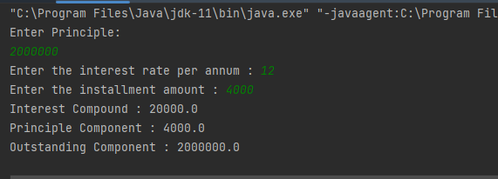

1. **Calculate the Principal and interest component of an installment given:**

* **The same parameters as Question 4**
* **The installment number for which the breakup is required.**

**Use the same formula as in Question 5.**

package assignementday1;  
  
public class PrincipleInterest {  
 private double in;  
 private double pn;  
  
 private double outstandingPrincipal;  
  
 public double getIn() {  
 return in;  
 }  
  
 public void setIn(double in) {  
 this.in = in;  
 }  
  
 public double getPn() {  
 return pn;  
 }  
  
 public void setPn(double pn) {  
 this.pn = pn;  
 }  
  
 public double getOutstandingPrincipal() {  
 return outstandingPrincipal;  
 }  
  
 public void setOutstandingPrincipal(double outstandingPrincipal) {  
 this.outstandingPrincipal = outstandingPrincipal;  
 }  
  
 public void setIn(double opn, double rate) {  
 this.in = (opn * rate)/1200;  
 }  
}

**Main:**

import assignementday1.PrincipleInterest;  
  
import java.util.Scanner;  
  
public class Main {  
 public static void main(String[] args) {  
 Scanner sc = new Scanner(System.*in*);  
  
 System.*out*.println("Enter Principle:");  
 double opn = sc.nextDouble();  
 System.*out*.print("Enter the interest rate per annum : ");  
 double rate = sc.nextDouble();  
 System.*out*.print("Enter the installment amount : ");  
 double inRate = sc.nextDouble();  
 sc.close();  
 PrincipleInterest obj = new PrincipleInterest ();  
 obj.setIn(opn, rate);  
 obj.setPn(inRate);  
 obj.setOutstandingPrincipal(opn);  
 System.*out*.println("Interest Compound : " + obj.getIn());  
 System.*out*.println("Principle Component : " + obj.getPn());  
  
 }  
}

**OUTPUT:**

